 CHEMICAL ENGINEERING TRANSACTIONS  VOL. xxx, 2026 | A publication of  
The Italian Association
of Chemical Engineering
Online at www.cetjournal.it

Guest Editors: Laura Capelli, Marzio Invernizzi, Selena Sironi
Copyright © 2026, AIDIC Servizi S.r.l.
ISBN 979-12-81206-xx-x; ISSN 2283-9216

A comparative study of dynamic flux chambers for H₂S emissions
Laíze Nalli de Freitas^{a,*}, Bruno Furieriª, Thais Nunes Guerrero^{b}, Ademir Abdala Prata Jr.^{c}, Ruth Fisher^{b}, Richard Stuetz^{b}, Jane Meri Santosª, Neyval Costa Reis Juniorª
ªFederal University of Espírito Santo
^{b}University of New South Wales
^{c}São Paulo State University
*laize.freitas@edu.ufes.br
Hydrogen sulphide ($H_{2}S$) emissions from wastewater surfaces are commonly measured using dynamic flux chambers, although chamber construction and operating conditions may influence the results. This study compared two dynamic flux chambers, DFC1 and DFC2, both built according to USEPA geometric specifications, to evaluate how chamber type and internal fan configuration affect the overall mass transfer coefficient ($K_{L}$) of $H_{2}S$. The chambers differed mainly in construction material, with DFC1 made of acrylic and DFC2 of fiberglass, and were tested under five operating conditions: no fan, small fan up, small fan down, large fan up, and large fan down. Experiments were carried out using standard aqueous $H_{2}S$ solutions with an initial concentration of 5 mg/L, and $K_{L}$was obtained from the liquid-phase concentration decay. Mean $K_{L}$values ranged from 1.30 to 5.11 cm/h for DFC1 and from 1.64 to 3.64 cm/h for DFC2, with the highest values observed under forced ventilation. A two-way ANOVA with replication showed that chamber type, fan configuration, and their interaction significantly affected $K_{L}$($F=15.87$, $p=0.000731$; $F=40.26$, $p<0.001$; and $F=6.63$, $p=0.00145$, respectively). The highest mass transfer coefficient was obtained for DFC1 under the large fan up condition, whereas the lowest values were observed under no fan operation. These results show that even chambers designed under the same regulatory concept may produce different $H_{2}S$ transfer measurements, highlighting the importance of clearly reporting chamber characteristics and internal ventilation conditions when comparing data across studies.
  - Introduction
Hydrogen sulphide ($H_{2}S$) is one of the most relevant odorants associated with wastewater systems because it is commonly emitted from anaerobic and quiescent liquid surfaces and can be perceived by the human nose at very low concentrations. For this reason, even relatively small emissions may be enough to generate nuisance, complaints, and concern in urban areas located near wastewater infrastructure (Czarnota et al., 2023). At the same time, reliable $H_{2}S$ emission data are essential for source characterization, impact assessment, and the design of odour control strategies (Jonca et al., 2025; Moreno-Silva et al., 2020; Prata Jr. et al., 2016).

To obtain these data, enclosure devices such as Dynamic Flux Chambers (DFC) are widely used as direct measurement methods (Mu et al., 2022; Capelli et al., 2013). They are comparatively simple to operate, allow measurements at specific points of a surface, and are frequently adopted in studies involving wastewater-related emissions. However, the literature has also made it clear that these devices do not behave as neutral observers (Liu et al., 2022). The chamber itself can modify the conditions above the emitting surface, and this may influence the measured emission rate. Factors such as airflow pattern, gas accumulation, turbulence close to the interface, and the configuration of the sampling system can all affect the final result (Liu et al., 2022; Barzak et al., 2017). This issue becomes especially important when chambers follow the same general regulatory concept but differ in practical details. Liu et at. (2024) and Liu et al. (2022) have pointed out that operational and geometric factors such as purge gas flow, insertion depth, and the presence of fans can influence emission measurements, yet these details are not always consistently reported or evaluated.

Recent work has reinforced this point by showing that flux chamber configuration can alter measured emissions through changes in turbulence, dilution, and headspace conditions, with sweep flow often emerging as a dominant factor and fan use and chamber volume also contributing to differences in mass transfer behaviour (Liu et al., 2022). For $H_{2}S$, this discussion is even more relevant because its transfer from liquid to gas is closely linked to mass transfer conditions at the interface (Andreão and Feroni, 2022; Prata Jr. et al., 2016). Previous work with the US EPA flux chamber showed that, although the chamber headspace can be reasonably well mixed, local stagnation and concentration build-up may still occur, especially near chamber walls. They also showed that the flow generated inside the chamber does not truly reproduce atmospheric boundary-layer conditions, meaning that the measured emission rate may reflect not only source behaviour, but also the hydrodynamic conditions imposed by the device (Andreão et al., 2019; Prata Jr. et al., 2018; Prata Jr. et al., 2016). This helps explain why different chambers may produce different results even when they are based on the same regulatory model. Differences in dome shape, material, intrusion height, and internal fan arrangement may modify internal circulation and, consequently, the overall mass transfer coefficient. In practice, that means two chambers that appear equivalent from a regulatory standpoint may not be equivalent from a hydrodynamic standpoint.

In this context, the present study compares two Dynamic Flux Chambers (DFC), DFC1 and DFC2, both designed according to USEPA principles, to evaluate differences in the overall mass transfer coefficient ($K_{L}$) of H₂S under distinct fan configurations. The analysis also considers fan size and flow orientation. By examining these effects experimentally, this study seeks to clarify how different USEPA chambers can influence $H_{2}S$ mass transfer measurements and to contribute to more consistent interpretation, reporting, and comparison of results obtained with flux chambers.

2. Methodology
Two dynamic flux chambers were evaluated in this study, here referred to as DFC1 and DFC2. Importantly, both chambers were built according to the USEPA flux chamber geometric specifications, based on the design proposed by Kienbusch (1986). Therefore, both devices followed the same standard geometric concept, allowing the comparison to focus on the influence of construction and operational details rather than on differences in the fundamental chamber design.

Both chambers had dome-shaped geometry and were operated under the same experimental principle, with sweep gas introduced through the inlet line and withdrawn through the outlet line. The chambers were designed according to the USEPA dynamic flux chamber described by Kienbusch (1986), which has an enclosed surface area of 0.130 m² and an internal volume of approximately 0.030 m³. The chamber base has an internal diameter of approximately 0.4064 m and a height of 0.178 m, supporting a dome of roughly the same diameter. Despite complying with these geometric specifications, the chambers differed in some practical aspects, including construction material. DFC1 consisted of an acrylic dome (Figure 1.a), whereas DFC2 consisted of a fiberglass dome (Figure 1.b). The standard sampling procedure was adopted for both devices. Nitrogen was used as sweep gas, and the flow rate was maintained at 5 L/min. Before each experiment, a stabilization period of 30 min was allowed to minimize transient effects and ensure stable operating conditions.
Five operating conditions were evaluated. The first corresponded to the chamber without an internal fan. The other four conditions included two 12 V computer fans of different sizes, each tested with upward and downward airflow orientation. The small fan measured 40 × 40 × 10 mm and operated at 6000 rpm, while the large fan measured 80 × 80 × 25 mm and operated at 3100 rpm. The fan was positioned at the center of the chamber, close to the dome. The tested configurations were: no fan (NF), small fan up (SFU), small fan down (SFD), large fan up (LFU), and large fan down (LFD).

Mass transfer experiments were carried out using standard aqueous $H_{2}S$ solutions prepared from sodium sulfide nonahydrate dissolved in deionized or Milli-Q® water. The target initial concentration was 5 mg $H_{2}S$ /L. Sulfuric acid was added to adjust the solution to pH below 4, ensuring that sulfide remained predominantly in the H₂S form and favoring volatilization. The solution was transferred to an acrylic tank placed below the flux chamber. The tank diameter was slightly larger than that of the chamber, allowing chamber deployment while minimizing losses outside the enclosed area.
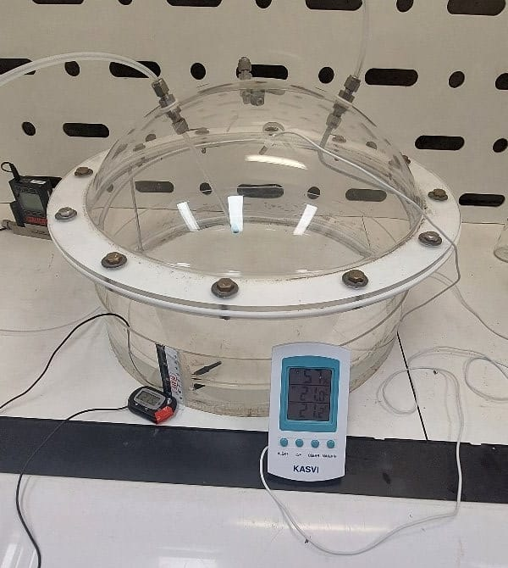 | 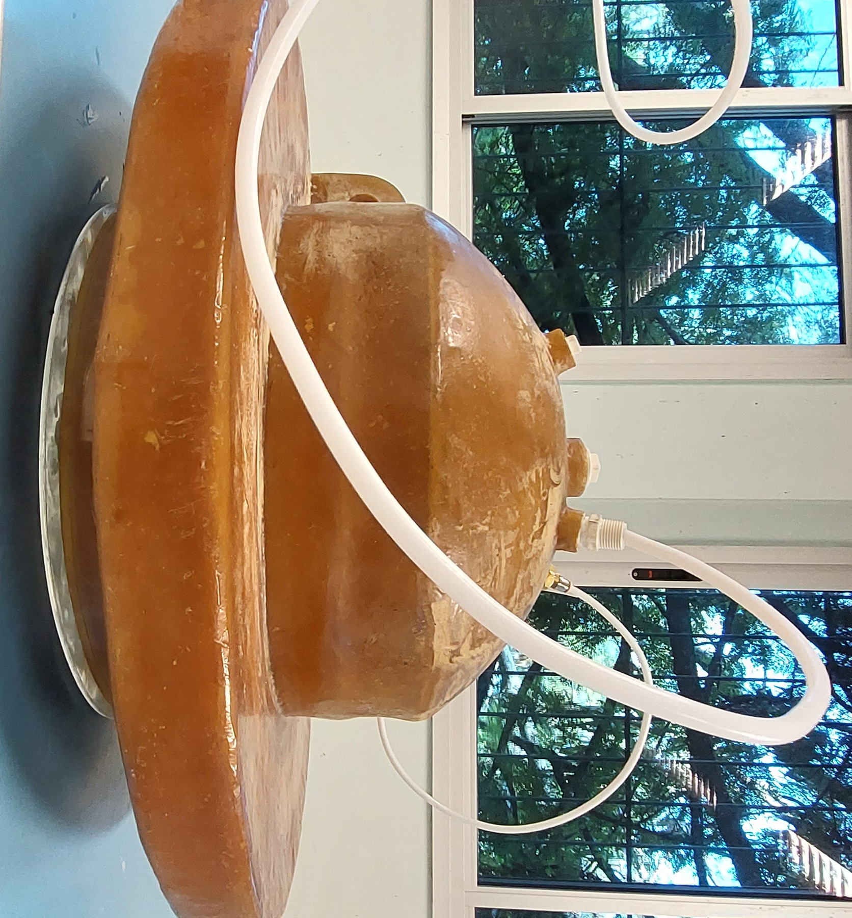
(a) | (b)
Figure 1: Dynamic flux chambers evaluated in this study. (a) DFC1; (b) DFC2.
For each run, the flux chamber was positioned above the tank, the nitrogen sweep gas was started, and the system was allowed to stabilize for 30 min. After this period, liquid samples were periodically collected from the tank at fixed six minutes intervals. To preserve sulfide in solution during the analysis, sodium hydroxide solution was added to raise the sample pH to approximately 11–12 before reading. Liquid-phase sulfide concentration was then measured by UV-Vis spectrophotometry at 231 nm. Calibration curves were prepared for each experimental batch using standard solutions with known concentrations. Liquid-phase temperature, chamber headspace temperature, room temperature, and room humidity were monitored during the experiments using digital probe thermometers. Each tested condition, corresponding to a specific combination of chamber type and fan configuration, was performed in triplicate, resulting in three independent runs per condition.. The resulting liquid-phase concentration decay curves were used to calculate one $K_{L}$value for each independent run. These $K_{L}$values were then used in a two-way ANOVA with replication to evaluate the effects of chamber type and fan configuration, as well as their interaction.

The overall mass transfer coefficient in the liquid phase, $K_{L}$, was determined from the temporal decay of liquid-phase $H_{2}S$ concentration. The analysis followed the two-resistance framework originally proposed by Lewis and Whitman (1924), assuming that the liquid phase was well mixed, that the gas-phase concentration at the initial time was negligible, and that concentration changes were tracked only in the liquid phase. Under these assumptions, the decrease in liquid-phase concentration can be expressed as shown in Equation 1.

$\frac{dC_{L}}{dt}=-K_{L}\frac{A}{V}C_{L}$ (1)
where $C_{L}$is the liquid-phase concentration, $A$ is the free liquid surface area, $V$is the liquid volume, and $t$ is time. Integration of this expression gives in Equation 2.

$K_{L}=-ln\left(\frac{C_{L}(t)}{C_{0}}\right)\frac{V}{At}⁡$ (2)
where $C_{0}$is the initial liquid-phase concentration and $C_{L}(t)$is the concentration at time $t$. Finally, $K_{L}$values were corrected to 25°C using the Schmidt number relationship is expressed in Equation 3.
$K_{L,25}=K_{L,T}{\left(\frac{Sc}{Sc_{25}}\right)}^{-0.5}$ (3)
where $Sc$is the Schmidt number, calculated as the ratio between water kinematic viscosity and H₂S diffusivity in water. This correction allowed comparison of the results under a common reference temperature.

3. Results and discussion
The mean $K_{L}$values obtained in the experiments are presented in Table 1. Overall, the mass transfer coefficient varied considerably across the tested chamber and fan conditions. Under the no fan condition, DFC1 showed a mean $K_{L}$of 1.30 cm/h, whereas DFC2 presented a slightly higher mean value of 1.64 cm/h. This difference is noteworthy because both chambers followed the USEPA flux chamber geometry specifications. In other words, the observed variation cannot be explained by one chamber being outside the standard design concept, but rather by differences that may still arise between chambers built under the same regulatory basis.
Table 1: Mean overall mass transfer coefficient ($K_{L}$) values in cm/h for DFC1 and DFC2 under different fan configurations.
Device | No fan | Small fun up | Small fan down | Large fan up | Large fan down
DFC1 | 0.94 | 2.21 | 3.12 | 5.11 | 3.81
DFC2 | 1.64 | 1.95 | 2.06 | 3.15 | 3.64
It is important to note that, although both chambers followed the USEPA guidelines, the dome may exhibit small modifications or surface irregularities that influence the internal chamber geometry. Another relevant factor is the chamber material, since DFC1 is made of acrylic whereas DFC2 is made of fiberglass. The observed difference may therefore also be related to differences in the internal surface characteristics of the chambers, including possible differences in roughness between acrylic and fiberglass. Such differences may affect near-wall flow patterns and local mixing conditions inside the chamber, which in turn can influence the measured mass transfer coefficient. However, this effect was not isolated in the present study and should therefore be interpreted as a plausible contributing factor rather than a confirmed cause.
A two-way ANOVA with replication (Table 2) showed that chamber type, fan configuration, and their interaction significantly affected $K_{L}$. The effect of device was significant ($F=15.87$, $p=0.000731$), as was the effect of fan configuration ($F=40.26$, $p<0.001$). In addition, the interaction between device and fan configuration was also significant ($F=6.63$, $p=0.00145$), indicating that the effect of fan setup depended on the chamber type. These results suggest that both the physical characteristics of the chamber and the internal ventilation condition influenced the measured mass transfer coefficient. This interpretation is consistent with previous studies showing that flux chamber measurements are sensitive to operational parameters that modify turbulence, dilution, and headspace conditions. Liu et al. (2024), for example, reported that fan use and headspace volume also contributed to changes in mass transfer behaviour. Although that study focused on VOC emissions from porous media, its conclusions reinforce the broader idea that enclosure-based measurements are strongly affected by internal hydrodynamics. Similarly, Prata Jr. et al. (2016) demonstrated for the US EPA flux chamber that, despite a reasonably mixed headspace, local stagnation and concentration build-up may still occur, especially near the chamber walls, and that the internal flow does not reproduce typical atmospheric boundary-layer conditions.
Table 2: Analysis of variance of the effects of chamber type, fan configuration, and their interaction on the overall mass transfer coefficient ($K_{L}$).
Factor | df | SS | MS | F | p-value
Device | 1 | 2.9328 | 2.9328 | 15.87 | 0.000731
Fan | 4 | 29.7664 | 7.44416 | 40.26 | 2.68E-09
Device vs fan | 4 | 4.9004 | 1.2251 | 6.63 | 0.00145
Error | 20 | 3.6966 | 0.1848

Figure 2 highlights clear differences in $K_{L}$values across both chamber types and fan configurations. Overall, DFC1 produced higher mass transfer coefficients than DFC2 under most of the tested conditions, with the largest differences observed for small fan down, large fan up, and large fan down. For both chambers, the presence of internal ventilation increased $K_{L}$compared with the no fan condition, indicating that air circulation inside the chamber enhanced mass transfer. Among all configurations, large fan up yielded the highest $K_{L}$values, particularly for DFC1, suggesting that this setup promoted greater renewal at the interface and reduced resistance to transfer. In contrast, under the no fan and small fan up conditions, the differences between DFC1 and DFC2 were smaller, indicating a more similar response between the two chambers. Taken together, the figure confirms that both chamber type and fan configuration influenced the experimentally measured mass transfer behaviour.

Overall, the results demonstrate that $H_{2}S$ mass transfer measurements are sensitive to flux chamber operating conditions, even when the chambers follow the same USEPA geometric specifications. This is an important methodological finding, because it shows that differences in measured $K_{L}$may arise even among chambers designed under the same regulatory framework. These findings support the view that measured $K_{L}$values are not only a function of the emitting surface itself, but also of the hydrodynamic environment created by the chamber configuration.

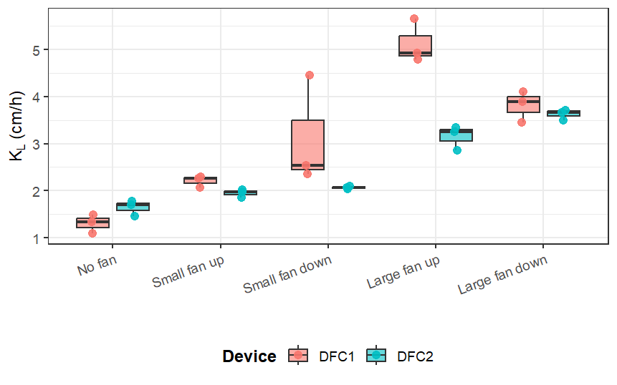
Figure 2: Distribution of the overall mass transfer coefficient ($K_{L}$) for DFC1 and DFC2 under different fan configurations. Points represent individual replicates, and boxplots summarize the variation within each setup.

4. Conclusion

The results showed that the measured H₂S overall mass transfer coefficient was significantly affected by both chamber type and internal ventilation condition, even though both devices followed the USEPA flux chamber geometric specifications. Under the no fan condition, the mean K_{L} was 0.94 cm/h for DFC1 and 1.64 cm/h for DFC2. With internal ventilation, the measured values increased in both chambers, but the maximum response differed between devices. For DFC1, the highest K_{L} was observed under the large fan up configuration, reaching 5.11 cm/h, whereas for DFC2 the highest value was obtained under the large fan down configuration, reaching 3.64 cm/h. The two-way ANOVA confirmed that chamber type (F = 15.87, p = 0.000731), fan configuration (F = 40.26, p < 0.001), and their interaction (F = 6.63, p = 0.00145) all had a significant effect on K_{L}, showing that the influence of fan setup depended on the chamber used.

These findings have an important methodological implication. Differences in measured $K_{L}$were observed even between chambers built under the same regulatory concept, indicating that compliance with USEPA geometric specifications alone does not ensure equivalent mass transfer conditions. The highest contrast between chambers was found under the large fan up condition, where DFC1 reached 5.11 cm/h and DFC2 3.15 cm/h, while under no fan the values were much closer. This pattern indicates that construction details and internal hydrodynamic conditions can substantially alter the measured transfer coefficient. Therefore, $H_{2}S$ mass transfer measurements obtained with dynamic flux chambers should be interpreted with caution, and parameters such as chamber type, internal ventilation, and construction characteristics should be clearly reported to improve comparability across studies.

Nomenclature
$A$ – liquid surface area, m
$C_{0}$ – initial liquid-phase concentration, mg/L
$C_{L}$ – liquid-phase concentration, mg/L
DFC1 – Dynamic flux chamber 1
DFC2 – Dynamic flux chamber 2
$H_{2}S$ – Hydrogen sulfide

$K_{L}$– overall mass transfer coefficient, cm/h
NF – no fan
SFU – small fan up (SFU)
SFD – small fan down
LFU – large fan up (LFU)
LFD – large fan down (LFD)
$Sc$– Schmidt number, -
$V$ – is the liquid volume, m³
$t$ – time, h

Acknowledgments
Authors acknowledge the UNSW Practicum Program and Odour Laboratory in School of Civil and Environmental Engineering, UNSW Sydney; and the Núcleo de Pesquisa em Qualidade do Ar, Departamento de Engenharia Ambiental, Universidade Federal do Espirito Santo, for logistics and financial support.

References
Andreão W.L., Feroni R.C., 2022, CFD modeling of different mass transfer coefficients on hydrogen sulfide emission in a flux chamber, Environmental Science and Pollution Research, 29, 14961–14974
Andreão W.L., Santos J.M., Reis Jr N.C., Prata Jr A.A., Stuetz R.M., 2019, Effects of flux chamber configuration on the sampling of odorous gases emissions, International Journal of Heat and Mass Transfer, 140, 918–930.
AS/NZS, 2009, Stationary source emissions, Method 4: Area source sampling—Flux chamber technique, Australian/New Zealand Standard AS/NZS 4323.4:2009, Standards Australia/Standards New Zealand.
Capelli L., Sironi S., Del Rosso R., Guillot J.-M., 2013, Measuring odours in the environment vs. dispersion modelling: A review, Atmospheric Environment, 79, 731–743.
Czarnota J., Masłoń A., Pajura R., 2023, Wastewater Treatment Plants as a Source of Malodorous Substances Hazardous to Health, Including a Case Study from Poland, International Journal of Environmental Research and Public Health, 20, 5379.
Eklund B., 1992, Practical guidance for flux chamber measurements of fugitive volatile organic emission rates, Journal of the Air & Waste Management Association, 42, 1583–1591.
Hudson N., Ayoko G.A., 2008, Odour sampling 2: Comparison of physical and aerodynamic characteristics of sampling devices: a review, Bioresource Technology, 99, 3993–4007.
Hudson N., Ayoko G.A., Dunlop M., Duperouzel D., Burrell D., Bell K., Gallagher E., Nicholas P., Heinrich N., 2009, Comparison of odour emission rates measured from various sources using two sampling devices, Bioresource Technology, 100, 118–124.
Kienbusch M., 1986, Measurement of Gaseous Emission Rates from Land Surfaces Using an Emission Isolation Flux Chamber, US EPA, Environmental Monitoring Systems Laboratory, Las Vegas, USA.
Jonca J., Bezyk Y., Miller U., Wrobel M., Arsen A., Szrek J., Muraszkowski A., Włoka A., Janicka A., Sowka I., 2025, Holistic approach to odour impact assessment on the basis of three waste management plants, Waste Management, 208, 115156.
Lewis W.K., Whitman W.G., 1924, Principles of gas absorption, Industrial and Engineering Chemistry, 16, 1215–1220.
Liu L., Abdala Prata Junior A., Fisher R.M., Stuetz R.M., 2022, Measuring volatile emissions from biosolids: a critical review on sampling methods, Journal of Environmental Management, 317, 115290.
Liu L., Prata A.A., Stuetz R.M., Fisher R.M., 2024, Understanding the role of flux chamber configuration in the measurement of VOC emissions from porous media, Chemosphere, 366, 143423.
Mackay D., Yeun A.T.K., 1983, Mass transfer coefficient correlations for volatilization of organic solutes from water, Environmental Science & Technology, 17, 211–217.
Mu J., et al., 2022, Dynamic chamber as a more reliable technique for measuring methane emissions from aquatic ecosystems, Science of The Total Environment, 851, 158147.
Parker D.B., Gilley J., Woodbury B., Kim K.-H., Galvin G., Bartelt-Hunt S., Li X., Snow D., 2013, Odorous VOC emission following land application of swine manure slurry, Atmospheric Environment, 66, 91–100.
Prata Jr A.A., Santos J.M., Beghi S.P., Fernandes I.F., Vom Marttens L.L., Neto L.I.P., Martins R.S., Reis Jr N.C., Stuetz R.M., 2016, Dynamic flux chamber measurements of hydrogen sulfide emission rate from a quiescent surface: a computational evaluation, Chemosphere, 146, 426–434.
Prata Jr A.A., Lucernoni F., Santos J.M., Capelli L., Sironi S., Le-Minh N., Stuetz R.M., 2018, Mass transfer inside a flux hood for the sampling of gaseous emissions from liquid surfaces: experimental assessment and emission rate rescaling, Atmospheric Environment, 179, 227–238.

