 CHEMICAL ENGINEERING TRANSACTIONS  VOL. xxx, 2026 | A publication of  
The Italian Association
of Chemical Engineering
Online at www.cetjournal.it
Guest Editors: xxx
Copyright © 2026, AIDIC Servizi S.r.l.
ISBN 979-12-81206-xx-x; ISSN 2283-9216

A citizen science approach following UNE 77270:2023 to address persistent odours in wastewater-related emissions
Rosa Arias, David Cubides*, Sergio Urioste Daza, Leticia Domingos
Science for Change S.L, Carrer de Vilamarí, 50, Planta 7, 08015 Barcelona, Spain.
david.cubides@scienceforchange.eu
Odour emissions associated with wastewater-related sources are among the most frequent causes of citizen complaints in urban areas, yet traditional assessment methods struggle to capture the temporal and spatial variability of episodic odour events. This study applies the recently published UNE 77270:2023 standard to the case of Vilanova i la Geltrú (Catalonia, Spain), focusing on the area surrounding the Torrent de la Pastera. Between 23 March and 4 June 2026, 19 active citizens reported 144 odour observations through the OdourCollect platform, of which 95 % presented a negative hedonic tone and 75% a strong-to-extremely strong intensity. Sewer-related odours were the most frequent subtype (53 %), followed by decomposed waste (15 %) and wastewater treatment plant emissions (14 %). Following the standard's criteria, 14 odour episodes were detected, predominantly associated with sewer odours (10 episodes). The Annoyance Degree (AD) was calculated for each episode, showing that 13 of 14 episodes fell within the Optimal range (AD < 20), while a single early episode reached a Serious level (AD = 47.62), attributable to the small size of the citizen panel at that stage rather than an exceptionally severe odour event. Wind plausibility verification, performed using an in-situ anemometer at the mouth of the torrent, showed that most episodes occurred under calm conditions or with wind directions outside the ±30° exposure sector, so none could be confirmed as plausible.
- Introduction
Odours form part of everyday life, but when they are intense and recur frequently, they can affect the quality of life of the population and generate annoyance - even when considered pleasant. This situation is especially complex in areas where housing, commercial activities, industrial operations, drainage channels and other potential emission sources coexist. Odour emissions from wastewater-related sources are among the most common causes of complaint in urban areas (Arias et al., 2022), and are among the main odour sources causing complaints in Spain, together with waste-management activities (D-NOSES Policy brief, Rüfenacht et al., 2019; Balestrini et al., 2018).
Traditional odour assessment methodologies, such as dynamic olfactometry (EN 13725:2022) and field inspections (EN 16841:2017), fail to capture the temporal and spatial variability of episodic odour events or adequately represent citizen perception of odour impact. Citizen science has emerged as a complementary and participatory approach that enables affected communities to generate geopositioned, real-time observations of odour phenomena, thereby enhancing transparency and facilitating evidence-based stakeholder engagement in odour management planning (Vlachos et al., 2021; Sideri et al., 2024). The publication of the UNE 77270:2023 standard ''Building Collaborative Odour Maps through Citizen Science'' (Izquierdo et al., 2024) represents a significant methodological advancement, providing the first standardized framework for unifying citizen-based odour monitoring criteria across diverse geographic and institutional contexts. Complementary work on co-creation models (Karakosta et al., 2025) underscores the importance of collaborative governance structures in addressing odour pollution.
This study applies the standardized UNE 77270:2023 methodology to the specific case of Vilanova i la Geltrú, integrating citizen observations to characterize odour episodes associated with an urban stream bed and the nearby wastewater treatment facilities. To strengthen the robustness of the plausibility assessment, an anemometer is deployed in situ to provide local measurements of wind velocity, complementing the meteorological data used to verify whether the reported odours could have been transported from the potential sources towards the registration points.
- Materials and Methods

  - Context of the study area

The study focuses on the area surrounding the Torrent de la Pastera in Vilanova i la Geltrú, a coastal municipality in Catalonia (Spain). This zone is predominantly residential, with some small commercial establishments, where residents have reported recurrent odour episodes. An anemometer was installed at the mouth of the torrent to obtain local wind velocity and direction measurements, providing in-situ meteorological data to support the plausibility assessment of the reported odours.
The diagnosis focused on analysing the times of day when odours occur, their possible seasonal variation, their relationship with meteorological conditions such as rainfall or wind, as well as the spatial distribution of the affected zones.

  - Citizen science methodology and action plan

The study was developed in three sessions following the participatory framework of the UNE 77270:2023 standard. In the first session, the project was presented, the odour problem was shared, and the study area and potential emission sources were identified. In the second session, training was provided to participants on the use of the OdourCollect application, explaining how to register the odour type, its intensity and its hedonic tone, through participatory sensory walks. Priority odours to be mapped were defined as those associated with wastewater, sewer, sludge, septic tanks, sulphur, rotten eggs, decomposed waste, chemical odours, barley, roasted coffee and food. In the third session, the collection and analysis of the odour data reported by citizens was carried out, and the results were presented.
According to the UNE 77270:2023 standard, the participating citizen panel can be configured either as a fixed, closed group of selected participants engaged throughout the whole study (hereafter referred to as Case 1), or as an open and dynamic panel in which citizens progressively join the project as it is communicated and as successive participatory sessions are held (Case 2). This study followed the Case 2 approach, consistent with a traditional citizen science methodology: rather than relying on a predefined fixed panel, participation grew organically over the monitoring period through community engagement and outreach activities.

  - Data collection

Data collection was carried out in the Torrent de la Pastera environment within the defined study area. The observation period ran from 23 March 2026 to 4 June 2026. During this period, participants registered the odours perceived in the area using the OdourCollect platform. Each record made through the app included geolocated information on the place where the odour was perceived, as well as data on the odour character, its intensity (VDI 3882-1:1992 scale) and its hedonic tone (VDI 3882-2:1994 scale). In this way, the application allowed citizen perceptions to be transformed into systematic, comparable and spatially located data.

  - Episode detection and AD calculation

The Annoyance Degree (AD) was calculated for each odour episode following UNE 77270:2023 §5.5.3. The AD is an index that quantifies the annoyance caused by an episode, resulting from the correlation between the odour intensity and the hedonic tone of the individual records, weighted through the Annoyance Matrix (AM). For each participant reporting in an odour episode, only the record with the highest intensity was considered. The AD of an episode was obtained as the sum of the weighted AM values divided by the total number of participants multiplied by seven, expressed as a percentage:

$${ AD}_{OE}= \frac{\sum{}{AM}_{t}}{Total participants x 7} (1)$$

  - Wind plausibility assessment

Plausibility verification of citizen observations was performed by cross-referencing reported odour events with anemometric data. Wind direction and velocity were analysed using local instrumental records from the anemometer installed at the mouth of the Torrent de la Pastera. A plausibility sector of ±30 ° was applied following VDI 3883-4:2017 Annex H methodology, with a minimum wind velocity threshold of 1.01 m/s per UNE 77270 §6.2.1. Episodes whose wind direction was inconsistent with known source locations were flagged for secondary analysis.

- Results and Discussion

  - Observations and odour character
The temporal evolution of the citizen panel followed the pattern expected for an open, dynamic panel (Case 2, Section 2.2). Figure 1 shows that most participants joined during the first weeks of the project, whereas the cumulative number of observations kept increasing throughout the monitoring period, indicating that a small group of active users sustained data collection once recruitment was established. As shown in Figure 1, most participants joined during the first weeks of the project —12 of the 19 users registered on the first participatory session— after which the panel size stabilised, while the number of reported observations continued to grow steadily until the end of the study. As a consequence, the contribution of observations was unevenly distributed among participants.
The distribution of the odour observations followed a long tail of participation typically found in citizen science projects, where many volunteers only participated once or twice (Boakes et al., 2016). In Vilanova i la Geltrú, 57.9 % of the participants reported at most two observations, jointly accounting for only 9 % of the data, whereas the three most active users (15.8 % of the participants) collected 61.8 % of the total observations, with a single participant contributing 34.7 % of all records.

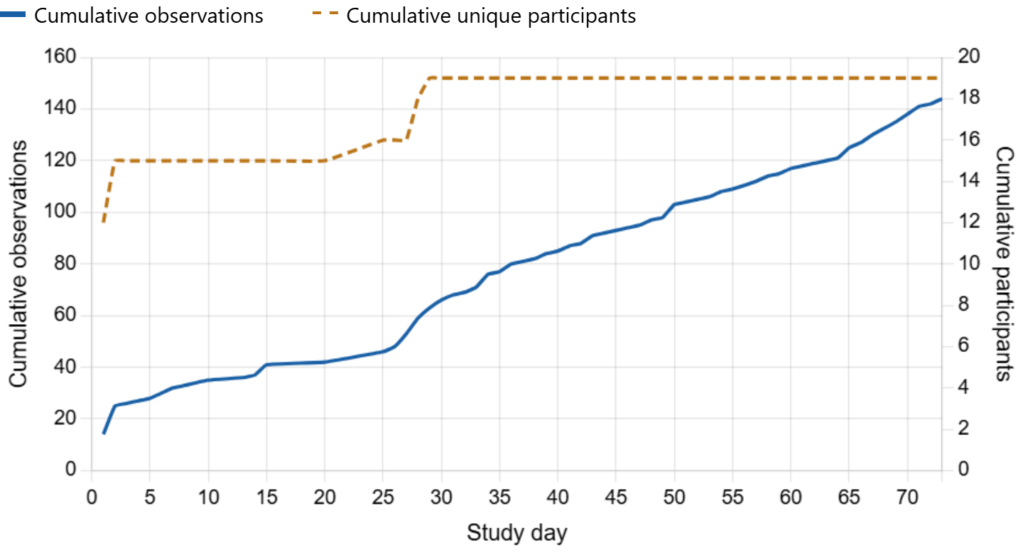

Figure 1 Temporal evolution of citizen participation: cumulative number of unique participants and odour observations reported through OdourCollect over the 73-day study period.
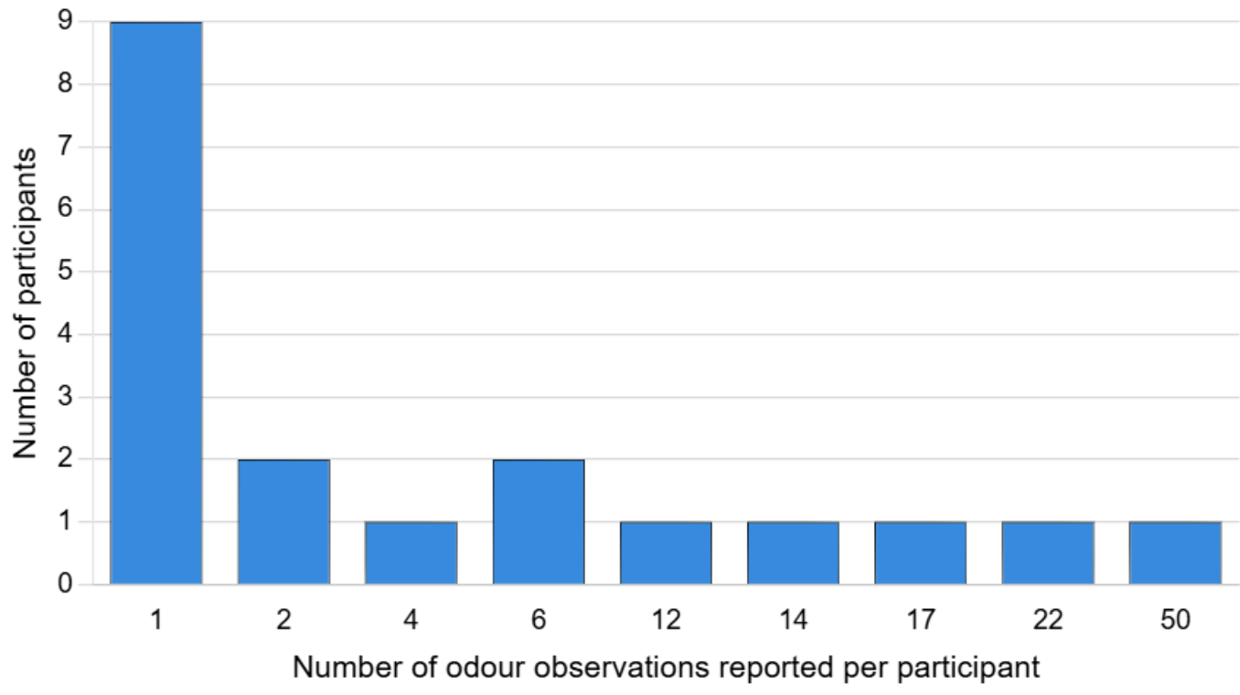
Figure 2: Number of participants by number of odour observations reported per participant.

During the observation period, between 23 March 2026 and 4 June 2026, 144 odour observations were collected through the OdourCollect platform. In total, 19 active users participated. The results show that 95% of observations presented a negative perception and 75% presented a strong intensity.
Regarding the odour character, most of the registered odour types were related to urban odours, representing 60 % of the total. The second most frequent category was wastewater and waste, with 38% of the total. Analysing the odour subtypes, the most frequent was the one associated with sewer at 53% of the records. This was followed by decomposed waste (15 %); wastewater treatment facilities (WWTP, 14%); sludge (6%); and urine (4 %). The remaining 8% corresponded to other odours, such as waste bins, faeces, wet soil and sour milk (see Figure 3).
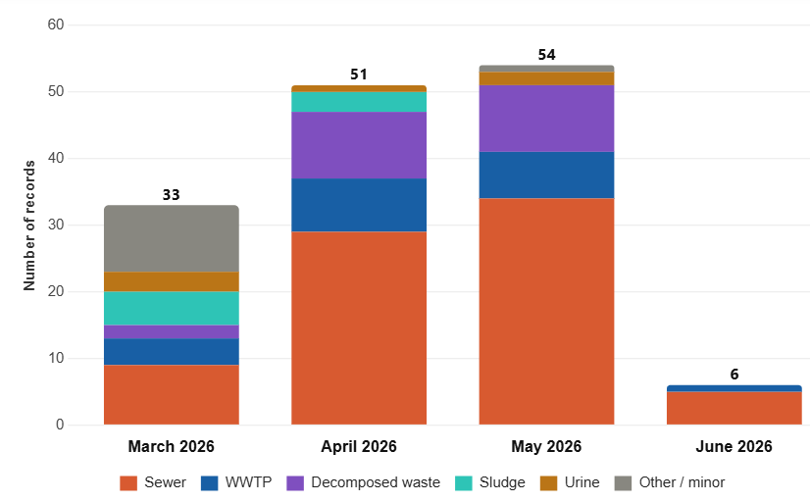

Figure 3 Monthly distribution of odour subtypes reported through the OdourCollect platform in Vilanova i la Geltrú (23 March–4 June 2026).

  - Intensity and hedonic tone of the reported odours

The intensity measures the strength of the odour stimulus and is expressed through an intensity scale categorized in six levels: very weak, weak, distinct, strong, very strong, and extremely strong. The records show that most of the observations concentrated in intermediate and high levels. The most frequent category was strong with 43 %, followed by distinct with 24 %; extremely strong with 19 %; very strong with 13 %; and weak with 1 % of the total. The categories of higher intensity—strong, very strong and extremely strong—represent 75 % of the records, indicating that most of the odours reported were perceived with a high intensity in the annoyance range (see Figure 4a).

a) 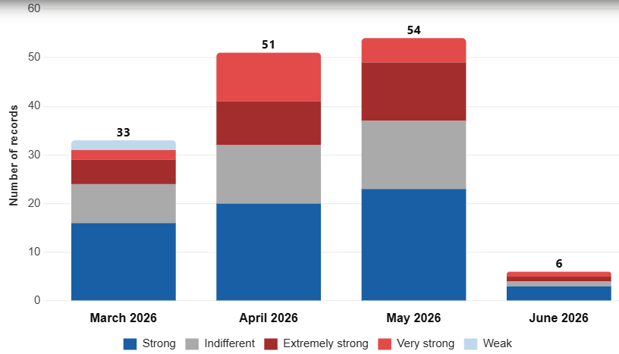 | b)  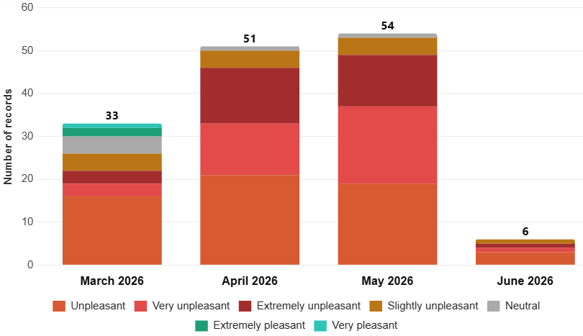
Figure 4. Monthly distribution of (a) odour intensity and (b) hedonic tone reported through the OdourCollect platform in Vilanova i la Geltrú (March–June 2026).

The hedonic tone is the subjective factor that defines whether an odour is pleasant or unpleasant (see Figure 4b), mathematically catalogued in a range from -4 (extremely unpleasant) to +4 (extremely pleasant), with the value 0 defined as neutral. As a result, the most frequent category was unpleasant, with approximately 41 % (see Figure 4b). This was followed by very unpleasant with 24%, extremely unpleasant with 20 %, and slightly unpleasant with 9 %. Overall, negative valuations reached approximately 94 % of the total. The neutral category represented only 4 %, while positive valuations barely represented around 2 %.

  - Analysis of the data plausibility, annoyance degree (AD) and occurrence of odour episodes

From the collected records, odour episodes were detected following the criteria of the UNE 77270:2023 standard. Records with the same odour character were grouped within a maximum temporal window of four hours, with a minimum number of records, at least two different users, and located within the study area.
As a result, 14 odour episodes were detected following the aforementioned criteria. The most frequent subtype was sewer (alcantarilla), with 10 registered episodes, indicating that it represents the predominant category compared to the other subtypes. In contrast, decomposed waste, WWTP, sludge and urine registered only 1 episode each.
The annoyance degree (AD) calculation according to UNE 77270:2023 §5.5.3 for the 14 odour episodes detected in Vilanova i la Geltrú shows that 13 of the 14 episodes are classified as Optimal (AD < 20), with values ranging from 9.02 to 14.29, while only episode VG_EP0001 (March 23, Sewer) reaches a Serious level with a AD of 47.62 (See Figure 5). This result is explained by the fact that this episode had 5 participants who simultaneously reported strong intensity and very unpleasant perception (MM=6 each), summing a total of 30 points over a denominator of only 9 active users at that point in the project — being one of the earliest episodes recorded, the citizen panel was still small —, which considerably raises the resulting index. As the user panel grew throughout the study period (from 9 to 19 active users), later episodes with a similar number of participants and comparable MM values show a proportionally lower AD, since the formula divides the sum of annoyance scores by an increasingly larger base of active users. This effect highlights a relevant methodological limitation: for Case 2, the AD does not depend solely on the perceived severity of the odour, but also on the size of the citizen panel available at each point in time, so direct comparison of episodes from different phases of the study should be interpreted with caution.

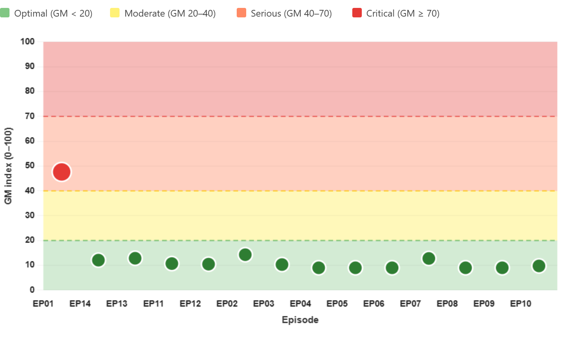
Figure 5. Annoyance Degree (AD) traffic light chart for the 14 odour episodes detected according to UNE 77270:2023 §5.5.3, classified by optimal, moderate, serious and critical thresholds.

Following UNE 77270:2023 §6.2.1, wind plausibility was assessed using the data recorded by the anemometer installed at the mouth of the Torrent de la Pastera. The analysis showed that most of the odour observations occurred under calm conditions for this point, with wind velocities below the 1.01 m/s threshold required to verify whether the odour could have been transported from the assumed source. As a result, none of the detected episodes could be confirmed as plausible with respect to this location: the majority were classified as non-verifiable due to calm winds, while the remaining episodes, although registering sufficient wind velocity, presented wind directions outside the ± 30° exposure sector (VDI 3883-4:2017 Annex H).

These results must be interpreted with methodological caution. The plausibility assessment relied on a single point assumed as the emission source —the mouth of the torrent, where the anemometer was located— which may not coincide with the actual point of odour emission. The predominance of calm conditions recorded at this specific location does not necessarily imply the absence of wind across the wider study area, since local topography and the channelled morphology of the torrent can generate highly localized wind regimes. Consequently, the high proportion of calm classifications may partly reflect the limitation of characterizing a diffuse and spatially extended source through a single fixed measurement point. This reinforces the need to consider that the real emission source may be located elsewhere along the torrent, and that the quebrada, as a linear diffuse source, cannot be adequately characterized as a standard point-source APGEMO under the strict sense of the standard.

- Conclusions

This study demonstrates the feasibility of applying the UNE 77270:2023 standard to characterize odour episodes through citizen science in a real urban setting. The active participation of 19 citizens over a ten-week period generated a robust, geolocated dataset that revealed a clear predominance of sewer-related odours, both at the individual-observation level (53 % of records) and at the episode level (10 of 14 episodes), consistently associated with negative hedonic perceptions and high intensity ratings. The Annoyance Degree calculation proved effective in identifying outlier episodes, although it also revealed an important methodological caveat: because the AD denominator depends on the number of active users at each point in time, episodes occurring early in the study — when the citizen panel was still small — can show disproportionately high AD values even with a moderate number of participants, as illustrated by episode VG_EP0001. This finding suggests that AD comparisons across different phases of a growing citizen panel should be interpreted with caution, specially for Case 2, and that panel size should be reported alongside AD values in future applications of the standard.
Regarding wind plausibility, the predominance of calm conditions and directions outside the ±30° exposure sector meant that none of the 14 episodes could be confirmed as plausible with respect to the anemometer location at the mouth of the torrent, when considering the torrent as a linear source. Rather than indicating an absence of transportable odour, this result more likely reflects the limitation of characterizing a diffuse and spatially extended emission source — the Torrent de la Pastera — through a single fixed measurement point, since local topography and the channelled morphology of the torrent can generate highly localized wind regimes that diverge from the conditions recorded at its mouth. Future applications of the standard to similar linear or diffuse sources should consider distributing multiple anemometers along the source or complementing in-situ measurements with local dispersion modelling, in order to strengthen the robustness of plausibility assessments and better support evidence-based odour management planning, and/or describing the source as superficial instead of linear.

- Acknowledgements

The authors would like to express their gratitude to the Vilanova i la Geltrú City Council (Ajuntament de Vilanova i la Geltrú) for their institutional support and collaboration throughout this study. We also thank Aigües de Vilanova i la Geltrú for their cooperation and for providing valuable technical information regarding the local wastewater infrastructure. Finally, the authors are especially grateful to the 19 citizens of Vilanova i la Geltrú who actively participated in all stages of the project, reporting odour observations through the OdourCollect platform on a voluntary basis.

- References

Arias R., Salas Seoane N., Burbano J., Hernández M., 2022, Validation of Citizen Observations to Assess the Odour Impact: the Barcelona Case Study of D-NOSES, Chemical Engineering Transactions, 95, 121–126, DOI:10.3303/CET2295021.
Balestrini, M., Creus, J., Errandonea, L., Arias, R., Salas Seoane, N., 2018, Map of odour issues and priorities. Multilevel engagement plan for stakeholders and communities. Zenodo. https://doi.org/10.5281/zenodo.5119629.
Boakes E.H., Gliozzo G., Seymour V., Harvey M., Smith C., Roy D.B., Haklay M., 2016, Patterns of contribution to citizen science biodiversity projects increase understanding of volunteers’ recording behaviour, Scientific Reports, 6, 33051, doi:10.1038/srep33051.
Izquierdo C., Diaz C.N., Antón A., Andrés F., Felisi J.M., de Lucas I., 2024, First Standard UNE 77270 ''Building Collaborative Odour Maps Through Citizen Science'', Chemical Engineering Transactions, 112, 1–6, DOI:10.3303/CET24112001.
Karakosta C., Vlachos S., Sideri V., Siskos A., 2025, Empowering Communities: A Co-creation model for addressing odour pollution in Thessaloniki, Greece, Social Sciences and Humanities Open, 11, DOI:10.1016/j.ssaho.2025.101595.
Rüfenacht S., Guiral C., Daher A.A., Roniotes A., Uribe J., Salas Seoane N., Arias R., 2019, D-NOSES consortium (2019) Odour Pollution - A growing societal concern. D-NOSES Policy Brief #1.
Sideri V., Karakosta C., Vlachos S., 2024, A Citizen Science Approach to Address Odour Pollution in Greece, Chemical Engineering Transactions, 112, 85–90, DOI:10.3303/CET24112015.
Vlachos S., Karakosta C., Sideri V., Antoniadis K., Siskos A., 2021, Improving the Impact of Odour Nuisance in Thessaloniki: A Stakeholder Engagement Approach, Chemical Engineering Transactions, 85, 133–137, DOI:10.3303/CET2185023.
UNE 77270:2023, Building Collaborative Odour Maps Through Citizen Science, Spanish Association for Standardization (UNE), Madrid.
VDI 3882 Part 1, 1992, Olfactometry; Determination of Odour Intensity, German Engineering Association VDI/DIN Commission on Air Pollution Control (KRdL), Germany.
VDI 3882 Part 2, 1994, Olfactometry – Determination of Hedonic Odour Tone, German Engineering Association VDI/DIN Commission on Air Pollution Control (KRdL), Germany.
VDI 3883 Part 4, 2017, Effects and Assessment of Odours – Processing Odour Complaint, German Engineering Association VDI/DIN Commission on Air Pollution Control (KRdL), Germany.

