 CHEMICAL ENGINEERING TRANSACTIONS  VOL. xxx, 2026 | A publication of  
The Italian Association
of Chemical Engineering
Online at www.cetjournal.it

Guest Editors: Laura Capelli, Marzio Invernizzi, Selena Sironi
Copyright © 2026, AIDIC Servizi S.r.l.
ISBN 979-12-81206-xx-x; ISSN 2283-9216

VOC Characterisation at an Abattoir Pilot: Feasibility and Implication on Animal Welfare, Health and Safety.
E. Gannon*ª, K.W. Faragª, J.A. Covington^{b}, T.K. Stewart^{b}, Y. Qureshi^{b}, G. Charlton^{b}, L. McIntyreª
ªHarper Adams University, Newport, Shropshire TF10 8NB
^{b}School of Engineering, University of Warwick, Coventry, CV4 7AL
*E.Gannon@harper.ac.uk
Abattoirs remain poorly characterised in terms of odour and volatile emissions despite their potential environmental, social, and economic impacts. This study characterised volatile organic compounds (VOCs) in a commercial cattle abattoir and assessed associations with animal welfare and production factors. Air samples were collected from the lairage and stun box throughout the working week and analysed using TD-GC-TOF-MS. A total of 200 compounds were identified, including alcohols, aldehydes, alkanes, amines, aromatic hydrocarbons, esters, ketones, nitriles, phenols, halogenated compounds, and silicones. Tweedie generalised linear models identified significant associations between VOC concentrations and production variables. Alcohol concentrations were 36% higher when overnight cattle were present (p = 0.030). Esters and nitriles increased by 41% with batch number (p < 0.05), while alkanes were 3.5-fold higher during morning periods (p = 0.015). Ketones increased with batch size (+15%, p = 0.010) and over time (p = 0.017), whereas aromatic hydrocarbons declined over time (p < 0.001). Machine learning models further demonstrated relationships between VOC profiles, production day, and shift hours. These findings indicate that abattoir VOC emissions are influenced by operational and animal-related factors and may provide useful indicators of environmental conditions, animal welfare, and occupational exposure.
Introduction
VOCs are associated with adverse human health outcomes, including respiratory, cardiovascular, and carcinogenic effects (Halios et al., 2022). In agriculture, Volatile Organic Compound (VOC) research has focused on livestock housing, where compounds such as volatile fatty acids, phenols, alcohols, and sulphur compounds dominate emissions (Trabue et al., 2011). In contrast, abattoirs remain understudied despite introducing additional emission sources, including blood, carcasses, wastewater, hide processing, and stunning gases (Bandaw & Herago, 2017). Decomposition of organic waste generates VOCs such as aldehydes, amines, sulphur compounds, and ammonia, contributing to odour and potential airborne hazards (Aizawa et al., 2022). Reported TVOC concentrations vary widely (1.02–3315 ppm), reflecting system variability and limited data (Mamhobu-Amadi et al., 2019). While occupational exposure limits exist for humans, equivalent thresholds for livestock are lacking. Evidence suggests animals may be more sensitive to inorganic airborne pollutants, such as sub-threshold ammonia levels inducing stress and avoidance behaviours (Von Borell et al., 2007), indicating that human-based standards may not adequately protect animal welfare (Conti et al., 2021). Poor air quality in abattoirs therefore has interconnected impacts animal welfare and health in wider livestock systems, and operational efficiency. Animals may exhibit stress and disrupted behaviour in response to odours and environmental contamination (Terlouw et al., 1998; Adamczyk et al., 2015). Conversely, improved hygiene and air quality management can reduce VOCs and enhance both environmental and operational outcomes (Tanaka et al., 2023). This study aimed to characterise VOC generation and distribution in a beef abattoir, identifying key emission sources and drivers to inform improved design, hygiene, and management, and to support VOC-based monitoring of animal welfare and production efficiency.
  - Methods
    - Site Description
The lairage and stun box of a commercial beef abattoir in England, United Kingdom, were sampled for VOCs on 10 sampling days between 15 August and 29 September 2025. The site was located in a rural area surrounded by farmland and primarily processed Aberdeen Angus-type animals, other beef or dual-purpose breeds, and dairy culls. Cattle were delivered throughout the day and were often held overnight in the lairage. Throughput averaged approximately 340 cattle per day, equivalent to around 42 animals per hour during a 9-hour shift, operating 5 days a week/365 days, excluding bank holidays. Site information was obtained from building plans, manual measurements, and discussions with staff regarding feeding, cleaning, and environmental management systems. The facility incorporated handling features based on Grandin design principles, including a serpentine race and circular crowd pen. Ventilation was mixed-mode, with mechanical fans activated ad-libitum. The lairage had capacity for up to 208 animals, with slatted flooring, daily cleaning, weekly disinfection, natural light, and HGV access.
    - VOC Sampling Procedure and Analysis
VOC sampling were captured using stainless-steel Tenax TA/Carbograph 5TD adsorbent; 6.4 mm o.d. thermal desorption (TD) tubes (Markes International, Llantrisant, UK; Bio-monitoring Inert-Coated Tubes). Target compound classes included sulphur-containing and nitrogen-containing compounds, alcohols, aldehydes, ketones, acids, alkanes, alkenes, indoles, phenols, terpenes, volatile fatty acids (VFAs), and aromatic and halogenated hydrocarbons. Air samples were collected in the lairage and stun box using an ACTI-VOC low-flow pump at 30-minute intervals and at a flow rate of 100 mL min⁻¹, resulting in 19 samples and 3 field blanks per day. Sampled tubes were capped, stored in standard Markes tube storage boxes, and transported at room temperature for analysis within two hours of sampling. VOC samples were analysed using a TD-GC-TOF-MS (Thermal Desorption Gas Chromatography Time-of-Flight Mass Spectrometry) system (Markes Centri, Thermo TRACE 1300 GC, BenchTOF). Tubes were desorbed by primary incubation at 70°C for 15 min, then helium purge (99.9999%) at 40°C for 3 min. Compounds were focused automatedly at 0°C using the cryogen-free Centri 360 Autosampler (Markes International, Llantrisant, UK), then thermally desorbed at 300°C and transferred to the GC via a 250°C transfer line. Separation was achieved using an Rxi-624SilMS column (20 m × 0.18 mm × 1.0 µm) with a helium constant carrier gas flow of 1.0 mL/min. Split injection (18:1) was applied at 200°C. The oven programme was: 40°C (1 min), ramp to 150°C at 8°C/min, to 200°C at 12°C/min, then to 250°C at 15°C/min (5 min hold). Data processing used ChromCompare+ with Dynamic Background Compensation (DBC2.0, 4.0s peak width). Chromatograms were deconvoluted and reintegrated (minimum ion count 2000) with thresholds set to height 45,000, width 0.065, and area 100,000. Compounds were identified using NIST2021 library matching (≥700 match factor). Area percentages were exported and standardized using a bespoke University of Warwick platform for comparative analysis.
    - Statistical Analysis: Animal Data Modelling & Binary Machine Learning Classification.
Abattoir records for transport arrivals, batch additions, and slaughter rate were compiled for each sampling day. Animal proportions by sex and breed were calculated per 30-minute interval using UK Cattle Tracing System codes (GOV.UK, 2014). These variables were analysed against VOC total ion counts. To reduce dimensionality and multicollinearity, compounds were grouped by chemical class and expressed as mean ion counts, with collinear predictors (e.g. breed proportions) combined into composite variables. Due to non-normal, right-skewed, and heteroscedastic data, a Tweedie GLM (compound Poisson–Gamma, log link) was applied. Model diagnostics indicated good fit, and interaction terms were excluded based on higher AIC, retaining a parsimonious additive model. For machine learning, samples were classified as start vs end of the working week. Logistic regression, XGBoost, and Random Forest models were trained (60:40 split, 10-fold cross-validation). Statistical comparisons used Brunner–Menzel or Mann–Whitney tests (p < 0.05). Of 197 compounds, 45 features were retained based on model performance
  - Results and Discussion
Following background subtraction and filtering to retain only compounds detected in at least 10 samples, the number of identified VOCs was reduced from 197 to 55 for further analysis. This filtering removed background artefacts, column derivatives, and random or uncommonly occurring compounds that may not be representative of consistent abattoir emissions. The retained compounds are identified in Table 1.

Table 1. Volatile organic compounds (VOCs) identified in air samples, grouped by chemical class in statistical analysis.
VOC class | Compounds detected
Alcohols (n = 17, 32%) | Ethanol, isopropyl alcohol, 1-propanol, acetic acid, 1-butanol, 1,2-ethanediol, α-terpineol, 1-dodecanol, 1-hexadecanol, 1-octadecanol, and other alcohols/silanols
Aldehydes (n = 5, 2.75%) | Hexanal, benzaldehyde, octanal, nonanal, decanal
Amines (n = 6, 3.3%) | Ethylenimine, dimethylmethylamine, tetramethylmethanediamine, aniline, methenamine, N-butylbenzenesulfonamide
Esters (n = 1, 0.55%) | Ethyl acetate
Haloalkanes (n = 4, 2.2%) | Trichloromonofluoromethane, 1,1,2-trichloro-1,2,2-trifluoroethane, trichloromethane, carbon tetrachloride
Alkanes (n = 5, 2.75%) | Isobutane, butane, 2-methylbutane, 2,2,4,6,6-pentamethylheptane, hexadecane
Alkenes (n = 3, 1.65%) | 2-methyl-2-butene, pinene, limonene
Aromatic hydrocarbons (n = 6) | Benzene, 1,3,5-triazine, toluene, phenylethyne, cymene, indole
Ketones (n = 5, 2.75%) | Acetone, 2,3-butanedione, 2-butanone, acetoin, acetophenone
Nitriles (n = 1, 0.55%) | Benzonitrile
Phenols (n = 3, 1.65%) | Phenol, cresol, 4-ethylphenol

Patterns of abundance varied across VOC groups and by time of day. However, only a small number of compounds showed clear temporal specificity. For example, heptane, 2,2,4,6,6-pentamethyl was detected only during the afternoon period, whereas trichloromethane and methenamine were detected only in the morning regardless of number of overnight animals held. Overall, the VOC profile was broadly similar between morning and afternoon sampling periods. Three machine-learning models (logistic regression, XGBoost, and Random Forest) were used to classify samples by production week (start vs end), with all models showing strong discriminatory performance (Figure 1). Shapley analysis identified terpineol, Methylamine, N,N-dimethyl-, phenol, 4-ethyl-, and propanol as key discriminatory features. Higher concentrations of these compounds were consistently associated with the start of the week (Class 0), whereas lower concentrations were associated with the end of the week (Class 1). Of 55 retained compounds, 37 were selected for statistically significant presence and intensity in samples, of which 13 were significantly associated with class separation (Cliff’s delta, p ≤ 0.05). Ten compounds were associated with the end of the week, spanning alcohols, aromatic hydrocarbons, haloalkanes, amines, phenols, and sulphur-containing compounds (Table 2).
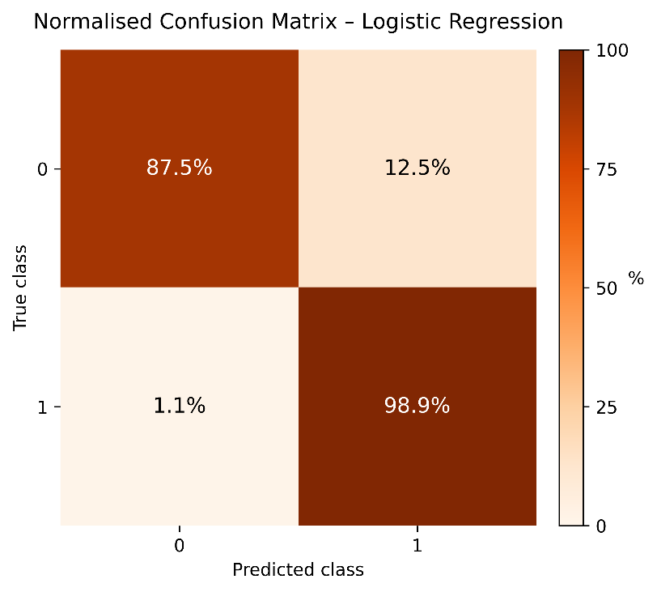 | 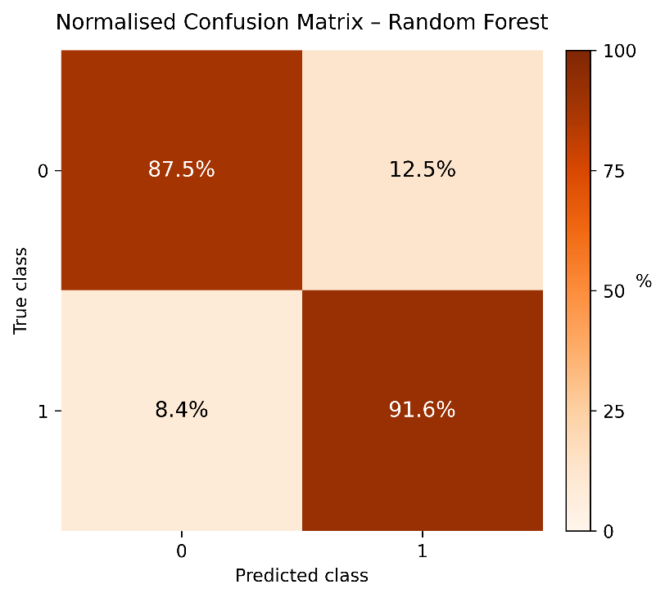
Figure 1. Model Performance for Abattoir A VOC Profile – Start vs End of Week. Confusion Matrices Of Model Sensitivity And Specificity.

Table 2. Statistically significant compounds associated with the classes Start and End of week.
Feature | Compound presence  (p value) | Compound Intensity  (Total Ion Count p value) | Model Significance  (p value) | Q value | Cliff's δ
1-Butanol | 2.45614 x 107 | 5.85519 x 10-7 | 4.16 x 10-7 | 7.4 x 10-6 | 0.31886
Dimethyl sulfone | 6.73003 x 10-7 | 8.91412 x 10-8 | 3.81 x 10-7 | 7.48 x 10-6 | 0.312061
1,2-Benzenedicarboxylic acid | 0.000158303 | 6.90186 x 10-6 | 8.26 x 10-5 | 0.000991 | 0.31425
1-Propanol | 0.000308408 | 2.82962 x 10-10 | 0.000154 | 0.00111 | 0.474342
Limonene | 0.000208926 | 9.57976 x 10-5 | 0.000152 | 0.00111 | 0.192325
Phenylethane | 0.000611329 | 0.000632471 | 0.000622 | 0.003731 | 0.18925
Ethanol, 2-butoxy- | 0.001059387 | 0.000943562 | 0.001001 | 0.004006 | 0.19167
Terpineol | 1.77069 x 10-16 | 0.001996008 | 0.000998 | 0.004006 | 0.458333
Phenol, 4-ethyl- | 1.92935 x 10-13 | 0.001996008 | 0.000998 | 0.004006 | 0.37895
Ethylenimine | 0.00376143 | 0.001892824 | 0.002827 | 0.010178 | 0.242105
Trichloromono  fluoromethane | 0.004928496 | 0.001996008 | 0.003462 | 0.011331 | 0.301096
Methylamine,  N,N-dimethyl- | 0.032814422 | 1.40636 x 10-30 | 0.016407 | 0.045435 | 0.735088
Dimethyl sulfide | 0.026541154 | 0.005988024 | 0.016265 | 0.045435 | 0.245943

Tweedie GLMs were used to identify predictors of VOC group ion counts in lairage air samples (Table 3). No significant associations were detected for aldehydes, haloalkenes, or alkenes. Alcohol concentrations were higher when overnight cattle were present (+36%, p = 0.030). Amines showed a marginal decline over time and were lower during the morning period (approximately 40%; 0.05 < p < 0.1), and a weak positive association with kill rate. Batch-related effects were observed for several VOC groups: esters (+41%, p = 0.028) and nitriles (+41%, p = 0.032) increased with batch number, while phenols showed a marginal increase (approximately 15%, p = 0.058). Alkanes were higher during the morning period (approximately 3.5-fold, p = 0.015), with a marginal increase with batch size. Ketones increased over time (p = 0.017) and batch size (approximately 15% per unit, p = 0.010), but were marginally lower when overnight cattle were present. Aromatic hydrocarbons declined over time (p < 0.001) and showed a weak negative association with total animals delivered.
Table 3. Tweedie Generalised Linear Model of VOC categories and animal factor predictors.
VOC Group | Predictor | Effect Size (β) | Direction | % Change / Trend | Significance
Alcohols | Overnight cattle | 0.304 ± 0.138 | Positive | 36% | p = 0.030
Amines | Time  Morning Period  Kill Rate | −2.86 × 10⁻⁵  −0.48  0.021 | Negative  Negative  Negative | Over time  40%  2% per unit | p = 0.057  p = 0.079  p = 0.060
Esters | Batch number | 0.41 | Positive | 41% | p = 0.028
Alkanes | Morning period  Batch Size | 1.26  0.17 | Positive  Positive | 3.5× increase over time  Marginal | p = 0.015  p = 0.076
Ketones | Time  Batch Size  Overnight Cattle | 3.23 × 10⁻⁵  0.136  -0.466 | Positive  Positive  Negative | over time  15% per unit  Marginal | p = 0.017  p = 0.010  p = 0.051
Aromatic hydrocarbons | Time  Total Animals | −1.05 × 10⁻⁴  -0.015 | Negative  Negatuve | Over time  Marginal | p < 0.001  p = 0.086
Nitriles | Batch number | 0.34 | Positive | 41% | p = 0.032
Phenols | Batch number | 0.138 | Positive | 15% | p = 0.058
Alcohols were the dominant VOC group and likely originated from a combination of biogenic emissions (breath, urine, microbial fermentation) and cleaning-related sources. Ethanol, acetic acid, 2,3-butanediol are established products of rumen fermentation and microbial metabolism (Ju et al., 2024). Alcohol concentrations increased significantly with overnight animal presence, indicating accumulation of emissions from cattle and waste, consistent with findings in feedlot systems (Yuan et al., 2017). Aldehydes were attributed primarily to lipid oxidation and microbial activity in animal tissues and waste (Chida et al., 2021), with additional links to stress-related oxidative processes (Chulayo & Munchenje, 2017) and meat quality deterioration (Fu et al., 2022). Despite biological relevance, aldehydes were not significantly associated with animal factors. Amines showed temporal variation, increasing during peak production. These were largely synthetic or material-derived plastics and formaldehyde-based cleaning breakdowns, with minor microbial contributions from protein degradation (Malheiros et al., 2023). Esters (ethyl acetate) increased strongly with batch number (+51%), likely reflecting fasting-induced disruption of rumen metabolism and reduced ester processing (Kristensen et al., 2007; Mizuguchi et al., 2020). Hydrocarbons were associated with time of day and batch activity, indicating fuel combustion and transport emissions during peak HGV movement (Kocakulak et al., 2024). Residual chlorinated compounds likely originated from cleaning by-products (Su et al., 2018). Ketones were significantly associated with time and overnight housing, with compounds such as acetone and acetoin reflecting metabolic stress and ketogenesis (Jiang et al., 2025). Phenols and cresols further manure and protein metabolism (Brebu et al., 2023). Identified VOCs can be broadly grouped into compounds that may reflect animal physiological status and compounds that may represent environmental or operational stressors, although source attribution remains inferential as the study used whole-air sampling. However, this study did not establish concentrations of compounds, nor matrix source sampling for identification, only their ionic presence and intensity, and implications should be interpreted cautiously. BTEX compounds as fuel combustibles are present in mechanical industry environments requiring petrochemicals or burning of materials and are not exclusive to animal environments. No inference on their physiological impact to animals can be ascertained without threshold identification. Biogenic VOCs may indicate metabolic stress associated with prolonged fasting and lairage duration, consistent with increased acetone following feed deprivation (Haddadi et al., 2022) and ketogenesis during negative energy balance (Asiku et al., 2025). These processes are linked to lipid mobilisation and affect meat quality (Pérez-Santaescolástica et al., 2018). Although further validation is needed, the detection of these compounds in ambient air suggests that VOC monitoring may have value as a non-invasive indicator of animal welfare, metabolic status, and product quality. These findings support VOCs as a indicative tool for system hygiene, environmental management, and welfare-relevant pre-slaughter conditions.
  - Conclusions
This study demonstrates that VOCs in a commercial abattoir are influenced by production activity and reflect a combination of biological emissions, waste decomposition, and operational sources. Several compounds relevant to animal welfare, metabolic status, and occupational health were identified, supporting the value of VOC monitoring in these environments. Commercial VOC sampling methods were shown to be feasible in high-capacity abattoirs, though further work is needed to confirm emission sources and biological significance. Future research should refine sampling protocols, expand profiling across processing areas, and target specific biological sources (e.g. blood, urine, faeces) to better understand VOC generation and transfer. Evaluation of mitigation strategies is also required to determine whether reducing VOC exposure can improve animal welfare, processing efficiency, and workplace conditions.
Acknowledgements
Our gratitude is extended to our commercial abattoir partners for the support of this project in providing an experimental site. The Biomedical Sensors group of School of Engineering, University of Warwick provided experimental instrumentation for the project analysis. This work was financially supported by: the Biotechnology and Biological Sciences Research Council (BBSRC), Harper Adams University and University of Warwick funded Midlands Integrative Biosciences Training Partnership (MIBTP) [grant number BB/J014532/1.]; and the Butchers and Drover Charitable Institution studentship (BDCI). This project was reviewed and approved by the Harper Adams University Ethics Committee, application number 18088900PHD-P0536, approved 07/05/2025.
References
Adamczyk, K., Górecka-Bruzda, A., Nowicki, J., Gumulka, M., Molik, E., Schwarz, T., Earley, B., Klocek, C. 2015. Perception of environment in farm animals: A review. Annals of Animal Science, 15(3), pp. 565–589.
Aizawa, A., Miyazaki, A., Tanaka, N. 2022. Emissions of volatile organic compounds from dairy cattle manure in a cattle shed in Japan. Asian Journal of Atmospheric Environment, 16(3), p. 2022024.
Asiku, J., Kalyesubula, M., Ross, M., Schwartz, B., Rosov, A., Dvir, H. 2025. Non-carbohydrate anaplerotic therapy counters empagliflozin-induced diabetic ketosis. Nutrition & Diabetes, 15(1), pp. 1–9.
Bandaw, T., Herago, T. 2017 Review on abattoir waste management. Global Veterinaria, 19(2), pp. 517–524.
Brebu, M., Simion, V.E., Andronie, V., Jaimes-Mogollon, A.L., Beleno-Saenz, K.D.J., Ionescu, F., Welearegay, T.G., Suschinel, R., de Lema, J.B., Ionescu, R., Cardoso, D.R. 2023. Putative volatile biomarkers of bovine tuberculosis infection in breath, skin and feces of cattle. Molecular and Cellular Biochemistry, 478(11), pp. 2473–2480.
Chida, S., Sakamoto, M., Takino, T., Kawamoto, S., Hagiwara, K. 2021. Changes in immune system and intestinal bacteria of cows during the transition period. Veterinary and Animal Science, 14, p. 100222.
Chulayo, A.Y., Muchenje, V. 2017. Activities of some stress enzymes as indicators of slaughter cattle welfare and their relationship with physico-chemical characteristics of beef. Animal, 11(9), pp. 1645–1652.
Conti, C., Borgonovo, F., Guarino, M. 2021. Ammonia concentration and recommended threshold values in pig farming: A review. In 2021 IEEE International Workshop on Metrology for Agriculture and Forestry (MetroAgriFor). Piscataway, NJ: IEEE, pp. 162–166.
Fu, Y., Cao, S., Yang, L., Li, Z. 2022. Flavor formation based on lipid in meat and meat products: A review. Journal of Food Biochemistry. 46(12), p. e14439.
GOV.UK. 2014. Official cattle breeds and codes. Available at: gov.uk/guidance/official-cattle-breeds-and-codes (Accessed: 06/02/2026).
Grandin, T. 2024. Behavioural principles of handling beef cattle and the design of corrals, lairages, races and loading ramps. In Grandin, T. (ed.) Livestock Handling and Transport. Wallingford: CABI, pp. 92–121.
Haddadi, S., Koziel, J.A., Engelken, T.J. 2022. Analytical approaches for detection of breath VOC biomarkers of cattle diseases: A review. Analytica Chimica Acta, 1206, p. 339565.
Halios, C.H., Landeg-Cox, C., Lowther, S.D., Middleton, A., Marczylo, T., Dimitroulopoulou, S. 2022. Chemicals in European residences – Part I: A review of emissions, concentrations and health effects of volatile organic compounds (VOCs). Science of the Total Environment, 839, p. 156201.
Jiang, K., Ma, J., Xu, J., Zhang, Y., Niu, H. 2025. Multi-omics revealed the effects of different feeding systems on rumen microorganisms, cellulose degradation, and metabolites in Mongolian cattle. Animals, 15(12), p. 1774.
Ju, Z., Li, R., Liu, W., Jiang, Q., Wang, J., Zhang, Y., Wang, X., Xiao, Y., Yang, C., Wei, X. Gao, Y. 2024. Characterizing the hindgut microbiome in healthy and ketotic cows. All Life, 17(1), p. 2393854.
Kocakulak, T., Boyacıoğlu, N.M., Dağoğlu, Y., Uyumaz, A., Aksoy, F. Arabacı, E. (2024). Experimental evaluation of gasoline-hexane fuel blends usage in a spark ignition engine. International Journal of Automotive Engineering and Technologies, 13(1), pp. 45–53.
Malheiros, J.M., Correia, B.S.B., Ceribeli, C., Bruscadin, J.J., Diniz, W.J., Banerjee, P., da Silva Vieira, D., Cardoso, T.F., Andrade, B.G.N., Petrini, J., Cardoso, D.R. 2023. Ruminal and feces metabolites associated with feed efficiency, water intake and methane emission in Nelore bulls. Scientific Reports, 13(1), p. 18001.
Mamhobu-Amadi, W.C., Kinigoma, B.S., Momoh, Y. Oji, A. 2019. Investigation of the impact of some abattoir activities on air quality. International Journal of Innovative Research and Advanced Studies, 6(7), pp. 174–181.
Mizuguchi, H., Kim, Y.H., Kanazawa, T., Ikuta, K., Sato, S. 2020. Effects of short-term fasting on ruminal pH and volatile fatty acids in cattle fed high-roughage versus high-concentrate diets. Journal of Veterinary Medical Science, 82(10), pp. 1415–1420.
Pérez-Santaescolástica, C., Carballo, J., Fulladosa, E., Garcia-Perez, J.V., Benedito, J., Lorenzo, J.M. 2018 Effect of proteolysis index level on instrumental adhesiveness, free amino acids content and volatile compounds profile of dry-cured ham. Food Research International, 107, pp. 559–566.
Su, F.C., Friesen, M.C., Stefaniak, A.B., Henneberger, P.K., LeBouf, R.F., Stanton, M.L., Liang, X., Humann, M., Virji, M.A. 2018. Exposures to volatile organic compounds among healthcare workers: Modeling the effects of cleaning tasks and product use. Annals of Work Exposures and Health, 62(7), pp. 852–870.
Tanaka, N., Aizawa, A., Miyazaki, A., Ando, Y. 2023. Effect of farm Hazard Analysis and Critical Control Point (farm HACCP) certification efforts on emissions of volatile organic compounds from livestock sheds in Japan. Animal Science Journal, 94(1), p. e13908.
Terlouw, E.C., Boissy, A., Blinet, P. 1998. Behavioural responses of cattle to the odours of blood and urine from conspecifics and to the odour of faeces from carnivores, Applied Animal Behaviour Science, 57(1–2), pp. 9–21.
Thevenet, F., Rossignol, G., Angulo-Milhem, S., Nicolas, M., Verriele, M. 2026. Formaldehyde releasers in cleaning products: Mapping an indoor issue, Journal of Hazardous Materials, p. 141393.
Trabue, S., Scoggin, K., McConnell, L., Maghirang, R., Razote, E., Hatfield, J. (2011). Identifying and tracking key odorants from cattle feedlots. Atmospheric Environment, 45(25), pp. 4243–4251.
Von Borell, E., Özpinar, A., Eslinger, K.M., Schnitz, A.L., Zhao, Y. and Mitloehner, F.M. (2007) 'Acute and prolonged effects of ammonia on hematological variables, stress responses, performance, and behavior of nursery pigs', *Journal of Swine Health and Production*, 15(3), pp. 137–145.
Yuan, B., Coggon, M.M., Koss, A.R., Warneke, C., Eilerman, S., Peischl, J., Aikin, K.C., Ryerson, T.B., de Gouw, J.A. 2017. Emissions of volatile organic compounds (VOCs) from concentrated animal feeding operations (CAFOs): Chemical compositions and separation of sources. Atmospheric Chemistry and Physics, 17(8), pp. 4945–4956.

