 CHEMICAL ENGINEERING TRANSACTIONS  VOL. xxx, 2026 | A publication of  
The Italian Association
of Chemical Engineering
Online at www.cetjournal.it

Guest Editors: Laura Capelli, Marzio Invernizzi, Selena Sironi
Copyright © 2026, AIDIC Servizi S.r.l.
ISBN 979-12-81206-xx-x; ISSN 2283-9216

Instrumental Odour Monitoring for the Anosmic Population: Bridging Human Perception and Electronic Sensing
Cristina Brugeraª, Alejandro Bernalª, Victor Gonzalezª, Angel Lópezª, Juan Alvaro Fernandezª, Jesús Lozano^{a*}
^{,a} Industrial Engineering School – University of Extremadura – Badajoz, Spain
jesuslozano@unex.es

This work presents a multigas monitoring system based on the ESP32-S3 platform for indoor air quality assessment. The aim is to evaluate IoT-based sensing capability for detecting VOC variations linked to human activity and emission sources. The system integrates a heterogeneous sensor array (BME688, ENS160, SGP40, SHT40, ZMOD4410) for VOC, estimated CO₂, AQI, temperature, and humidity monitoring. Data acquisition and processing are performed using an ESP32-S3 within an IoT framework enabling wireless transmission. Measurements were conducted in a controlled laboratory over one week with a 10 min sampling interval. Results show stable baseline conditions during non-occupancy periods. Significant VOC variations are observed during working days, especially during soldering activities. Controlled combustion and aerosol release also produce detectable responses. Temperature and humidity remain stable (25–26 °C), confirming environmental consistency. The system effectively distinguishes between baseline, occupancy, and high-emission events. These results support its use for real-time indoor air quality monitoring and early detection of environmental degradation.
  - Introduction
The human sense of smell constitutes a complex and highly specialised sensory system that enables the detection, identification, and evaluation of volatile chemical compounds present in the environment. This process begins in the olfactory epithelium, where sensory receptors transduce chemical stimuli into neural signals that are transmitted to the olfactory bulb and subsequently to higher brain regions. Doty (2019) provides a comprehensive description of the anatomical and functional organisation of the olfactory system. In addition, Shepherd (2004) highlights the role of cortical processing, particularly within the piriform and orbitofrontal cortices, in enabling odor identification and perceptual integration.

In parallel to the olfactory pathway, the trigeminal system contributes to the perception of irritative stimuli, such as pungency, cooling, or burning sensations. Frasnelli and Hummel (2007) demonstrate that this chemesthetic system plays a complementary role in the perception of airborne chemicals. Under normal conditions, both systems operate in an integrated manner, allowing not only the recognition of odorants but also the evaluation of their intensity and potential associated risks.

Anosmia, defined as the complete loss of the sense of smell, represents a significant disruption of this sensory system. Although its clinical recognition dates back centuries, its systematic scientific study has developed primarily within the framework of modern neuroscience, as described by Doty (2019). The etiology of anosmia is heterogeneous and includes viral infections, traumatic brain injuries, neurodegenerative diseases, and obstructive conditions affecting the nasal cavity.

In recent years, the prevalence of olfactory dysfunction has increased significantly. Parma et al. (2020) report that COVID-19 is associated with severe impairment of smell, taste, and chemesthetic perception, highlighting the relevance of olfaction in everyday life and its susceptibility to viral damage.

From a functional perspective, the loss of olfaction entails more than the inability to perceive odors. Frasnelli and Hummel (2007) show that, although trigeminal sensitivity may remain partially preserved, it is insufficient to compensate for olfactory loss. As a result, individuals with anosmia experience substantial difficulties in identifying volatile compounds that do not elicit trigeminal responses, impairing their ability to interpret their surrounding chemical environment.
    - Environmental, social and technological relevance
The limitations associated with anosmia are critical in terms of safety and environmental health. Olfaction acts as an early warning system against everyday hazards. Dalton (2003) explains that odor perception is closely linked to the detection of potentially harmful airborne chemicals. In the absence of this sense, individuals cannot detect risks such as gas leaks, smoke, or food spoilage in time, increasing vulnerability in domestic and urban environments.

Olfaction also plays an important role in the evaluation of indoor air quality. Jones (1999) demonstrates that indoor environments can accumulate pollutants such as carbon dioxide and volatile organic compounds. While normosmic individuals may perceive these changes indirectly through odor, this feedback is absent in individuals with anosmia, potentially leading to prolonged exposure without awareness.

Beyond safety, anosmia has social and psychological implications. It affects environmental awareness and interpersonal communication, particularly through body odors and contextual cues. Croy et al. (2014) identify olfactory dysfunction as a factor associated with reduced quality of life, as well as increased levels of anxiety and depression. In addition, smell loss impacts food perception, as flavour depends on retronasal olfaction, which may result in reduced appetite and changes in dietary behaviour.

Given these limitations, technological solutions are essential to compensate for olfactory loss. Devices capable of detecting environmental hazards and air quality variations provide an objective alternative to subjective perception. In this context, indoor air quality monitoring is particularly relevant, as parameters such as carbon dioxide and VOCs can indicate occupancy and ventilation conditions.

Experimental studies in controlled environments are necessary to evaluate the sensitivity and reliability of these systems and to assess their applicability in real scenarios. Overall, this approach contributes to improving safety and autonomy in individuals with olfactory dysfunction through objective environmental monitoring.
  - System description and hardware architecture
    - System architecture and IoT platform
The multigas monitoring module based on the ESP32 has been designed as a high-performance embedded system for continuous indoor and outdoor air quality monitoring, as shown in Figure 1. The system is built around the ESP32-S3 microcontroller, which integrates local processing capabilities and wireless connectivity through Wi-Fi and Bluetooth, enabling real-time data transmission to external devices and cloud-based platforms within an Internet of Things (IoT) environment.
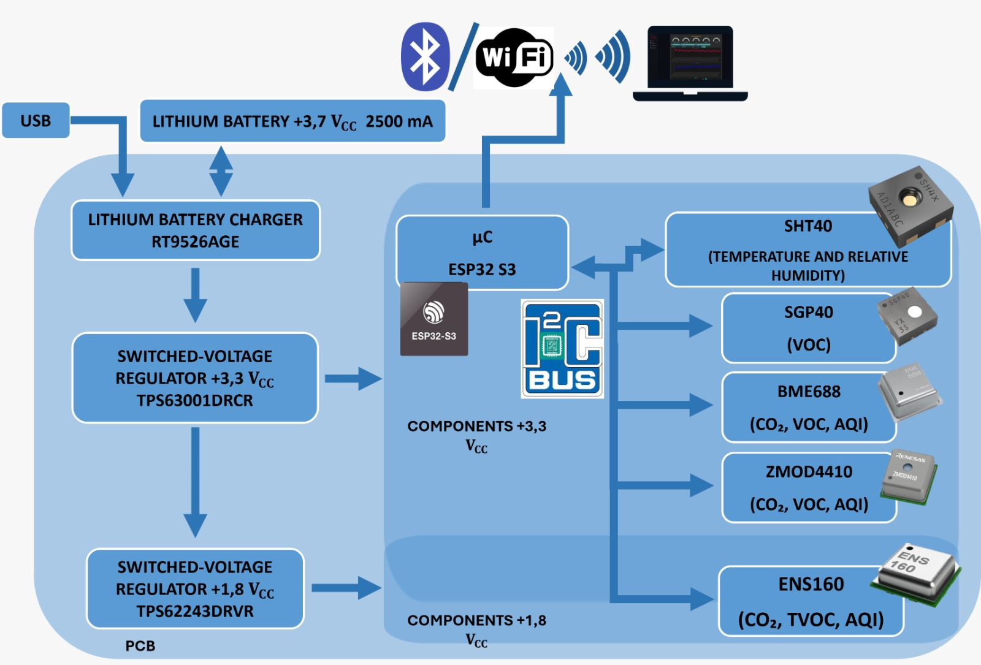
Figure 1: System block diagram.
The ESP32-S3 operates as a system-on-chip (SoC), managing both data acquisition and preliminary processing of signals from the sensor array through an I2C communication bus.
The device also implements a passive diffusion sampling strategy, eliminating the need for active air pumping systems, thereby reducing energy consumption and mechanical complexity. In addition, auxiliary interaction and diagnostic components are included, such as an RGB LED for system status indication and a reset button for system control and debugging purposes.

The data architecture is primarily oriented toward wireless transmission to external servers or platforms; however, the system also includes a MicroSD card slot, enabling local data logging in scenarios where network connectivity is unavailable.
    - Hardware architecture, sensors, and power management
The system integrates a compact and modular hardware architecture with dimensions of 66 × 36 mm, designed to facilitate integration into distributed sensor networks. The core system is complemented by a heterogeneous environmental sensor matrix intended for the monitoring of critical air quality parameters.
Table 1: Summarizes the integrated sensors and their measured variables.
Sensor | Measured parameters | Manufacturer
BME688 | VOC, eCO2, AQI, temperature, relative humidity, atmospheric pressure | Bosch
ENS160 | VOC, eCO2, AQI | ScioSense
SGP40 | VOC | Sensirion
SHT40 | Temperature, relative humidity | Sensirion
ZMOD4410 | VOC, eCO2, AQI | Renesas

This sensor combination enables comprehensive monitoring of air quality parameters, particularly VOC dynamics associated with human activity.

From an energy perspective, the system is powered by a 3.7 V lithium battery with a capacity of 2.5 Ah, enabling autonomous operation. Battery charging is managed by the RT9526AGE integrated circuit via a Micro USB interface. Power regulation is implemented using DC-DC converters (TPS63001DRCR and TPS62243DRVR), which provide stabilized output voltages of 3.3 V and 1.8 V for the correct operation of the different electronic subsystems.
  - Experimental setup
The experimental evaluation of the multigas monitoring system was conducted in the Sensors Laboratory at the University of Extremadura, in a controlled indoor environment. The device described in the previous section was deployed continuously over a period of one week.

The module was installed in a corner of the laboratory, next to the soldering workstation. This location was selected due to its ventilation characteristics, as it is located near a window that is typically partially open, allowing natural air exchange and enabling the analysis of environmental variations under realistic laboratory conditions.

The laboratory thermal conditions are maintained stable through climate control systems, with temperatures typically ranging between 25 °C and 26 °C. Consequently, temperature and relative humidity exhibit negligible variations during the experimental period. These variables were nonetheless recorded to confirm environmental stability.

The primary variable considered in this study is the concentration of volatile organic compounds (VOC), due to its sensitivity to human activity and processes such as space occupancy or the use of electronic equipment. This parameter enables an indirect evaluation of air quality and variations associated with human presence in the laboratory.

A detailed log of laboratory activities was maintained during the experimental period to correlate VOC variations with specific events such as working sessions, use of the soldering station, and meetings. These activities are summarised in Table 2.
Table 2: Laboratory activity log during the experimental period.
Day | Hour | Activity | Occupation |  | Observations
Monday 9 | 8:00-10:00 | Work in laboratory | 3 |  | Work with computers
Monday 9 | 10:00-10:30 | Preparing for a meeting | 5
Monday 9 | 11:30-12:45 | Meeting outside the laboratory | 0
Monday 9 | 14:00-14:30 | Testing controlled burns | 3 |  | Small paper burnings
Monday 9 | 15:00-23.59 | End of the workday | 0
Tuesday 10 | 8:00-10:00 | Work in laboratory | 3 |  | Work with computers
Tuesday 10 | 11:00-12:00 | Aerosol release near sensor | 3 |  | Two short sprays of air freshener applied close to the device
Tuesday 10 | 12:00-12:35 | Work at a welding station | 3
Tuesday 10 | 15:00-23:59 | End of the workday | 0
Wednesday 11 | 8:00-10:00 | Work in laboratory | 3 |  | Work with computers
Wednesday 11 | 10:00-10:30 | Work at a welding station | 3
Wednesday 11 | 10:30-15:00 | Work in laboratory | 3 |  | Work with computers
Wednesday 11 | 15:00-23.59 | End of the workday | 0
Thursday 12 | 8:00-8:30 | Work at a welding station | 3
Thursday 12 | 10:30-15:00 | Work in laboratory | 3 |  | Work with computers
Thursday 12 | 15:00-23.59 | End of the workday | 0
Friday 13 | 8:00-12:00 | Work in laboratory | 4 |  | Work with computers
Friday 13 | 14:00-14:30 | Meeting in the laboratory
Friday 13 | 14:30-23:59 | End of the workday | 0
Saturday 14 | 0:00-23:59 | No activity | 0
Sunday 15 | 0:00-23:59 | No activity | 0

The system was configured to perform measurements at a sampling interval of 10 min. The data acquired from the sensor array were stored locally on a MicroSD card integrated into the device, enabling subsequent analysis without dependence on external connectivity.
  - Results and discussion
The results obtained during the experimental campaign are presented to evaluate the capability of the proposed system to detect variations in indoor air quality associated with human activity and volatile emission sources. Figure 2 shows the temporal evolution of volatile organic compounds (VOC), together with temperature and relative humidity, providing an overview of the environmental behaviour in the laboratory.
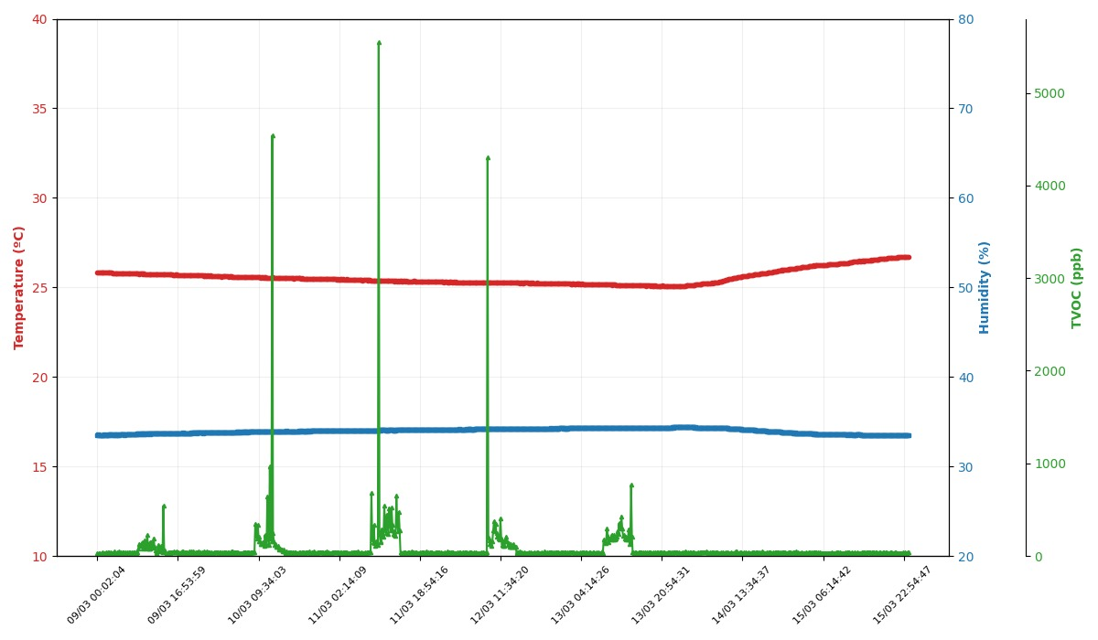
Figure 2: Temporal Evolution 7 days (VOC, temperature and humidity)
As can be observed, temperature and relative humidity remain nearly constant throughout the week, with values within a narrow range around 25–26 °C. This behaviour confirms the thermal stability of the experimental environment and allows the influence of these variables on the observed VOC variations to be disregarded. Consequently, changes in the VOC signal can be primarily attributed to human activity and specific events occurring in the laboratory.

A clear distinction can be observed between working days (Monday to Friday) and periods without activity (Saturday and Sunday). During non-activity days, VOC levels remain low and stable, with no significant fluctuations. In contrast, during working days, noticeable increases and dynamic variations in VOC concentration are observed, directly related to space occupancy and laboratory activities. Figure 3 presents the VOC evolution for each working day, correlated with the activity log in Table 2.
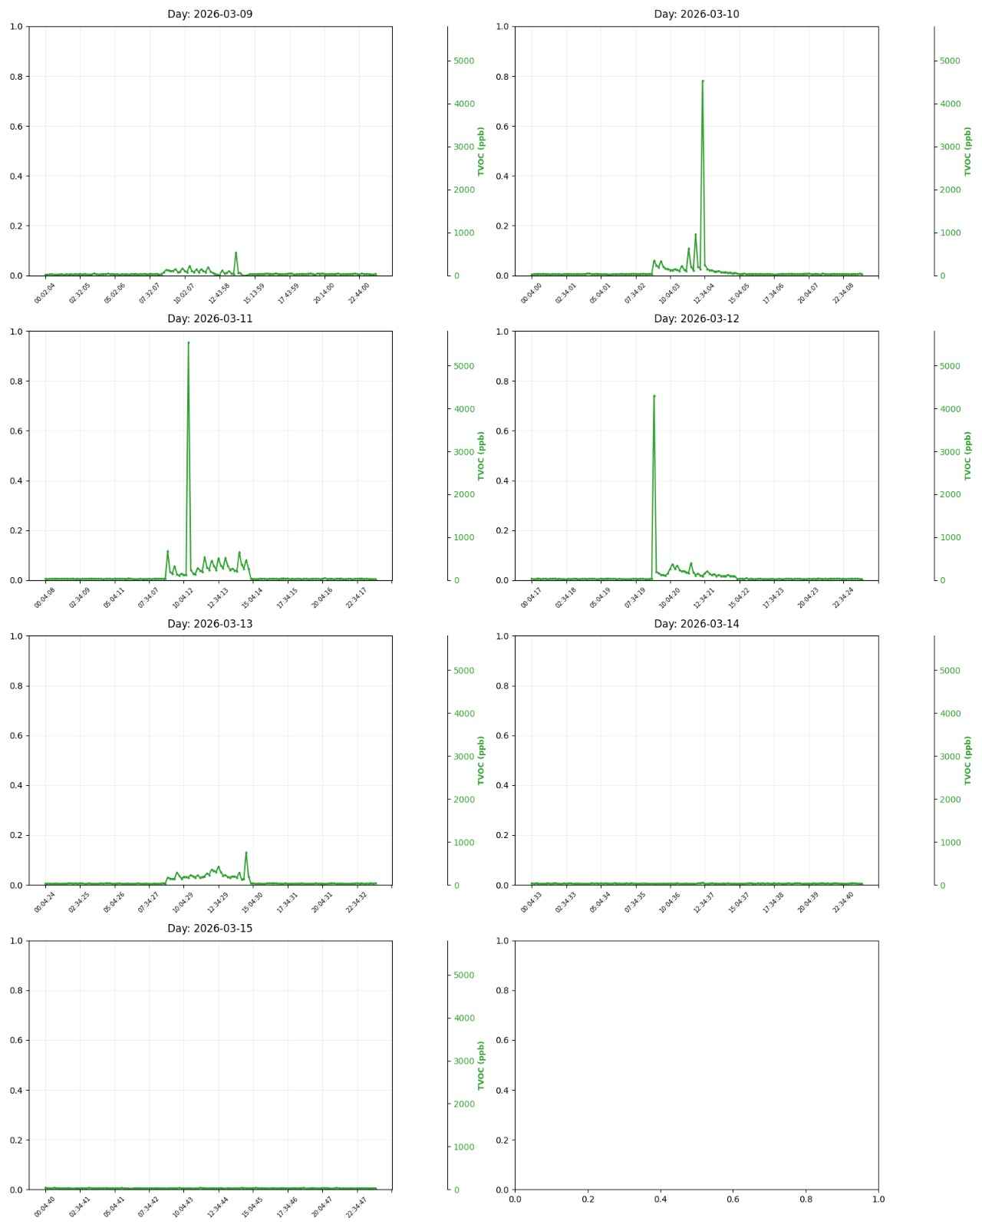
Figure 3: Evolution temporal VOC (Day a day)

On Monday, moderate increases in VOC levels are observed during laboratory working periods, mainly associated with human occupancy and the use of electronic equipment. A noticeable increase is also detected during the controlled combustion tests, where small paper burnings generate a measurable rise in volatile compounds, although of lower magnitude compared to other emission sources observed in the study.

Tuesday presents a clear and well-defined response of the system. A significant increase in VOC levels is observed during the use of the soldering station, which represents one of the most relevant emission sources in the experimental environment. This peak is higher than those associated with controlled combustion and aerosol release and can be attributed to the emission of flux vapours and compounds generated during the heating of solder materials. In addition, a smaller peak is observed during the controlled release of aerosol near the sensor, confirming the system’s sensitivity to localized volatile sources.

On Wednesday, a distinct and pronounced peak is again observed during soldering activities. This increase confirms the repeatability of the system response to emissions generated by the soldering process. Outside this event, the signal remains relatively stable, corresponding to normal laboratory operation without significant additional emission sources.

A similar behaviour is observed on Thursday, where soldering activity again produces a significant increase in VOC levels. As in the previous day, this peak is more prominent than those associated with human presence or routine laboratory tasks, reinforcing the conclusion that soldering represents the dominant source of volatile emissions in this environment.
On Friday, VOC levels remain comparatively stable throughout most of the day, with a minor increase observed during a meeting held in the laboratory. This variation is primarily associated with increased occupancy rather than specific emission sources, resulting in a smoother and lower-amplitude signal compared to previous working days.

Overall, the experimental results demonstrate that the proposed system is capable of reliably capturing temporal variations in indoor air quality associated with human presence and specific emission sources. The clear differentiation between background conditions, occupancy-driven changes, and high-intensity events such as soldering confirms the sensitivity and selectivity of the sensing approach. These findings validate the suitability of the system for continuous indoor environmental monitoring and support its potential use in applications where early detection of air quality degradation is critical.
  - Conclusions
This work has presented the design and validation of a multigas monitoring system based on the ESP32-S3 platform for indoor air quality assessment. The results demonstrate the system’s ability to detect temporal variations in volatile organic compounds (VOC) associated with human activity and emission sources under real laboratory conditions.
The system shows a stable baseline during non-activity periods (Saturday and Sunday), with low and consistent VOC levels. During working days, clear increases are observed due to occupancy and laboratory activities, with the highest peaks occurring during soldering operations. Temperature and relative humidity remain stable within 25 °C to 26 °C, indicating that VOC variations are not influenced by environmental fluctuations.
Overall, the system successfully distinguishes between baseline conditions, occupancy-driven changes, and high-emission events, demonstrating its suitability for real-time indoor air quality monitoring and early detection of environmental degradation.
Future work will focus on extending the experimental validation using standardized analytical methods. Dynamic olfactometry according to EN 13725 will be applied for odour quantification, while gas chromatography with thermal desorption tubes (Tenax TA) will be used to identify and characterize volatile organic compounds. These techniques will complement the sensing system and provide a more detailed chemical and sensory analysis, supporting applications in environmental monitoring and assistive technologies for individuals with anosmia.
Nomenclature
VOC- Volatile Organic Compounds, ppm or ppb
eCO2 – Estimated carbon dioxide concentration, ppm
AQI – Air Quality Index, -
Acknowledgments
This project has been funded by the European Union, the European Regional Development Fund, and the Regional Government of Extremadura. Managing Authority: Ministry of Finance, through the NEOS project (IB24180) and the research group grant (GR24182).
References
Croy I., Hummel T., 2017, Olfaction as a marker for depression, Journal of Neurology, 264(4), 631–638.
Dalton P., 2003, Upper airway irritation, odor perception and health risk due to airborne chemicals, Toxicology Letters, 140–141, 239–248.
Dennis J., Aono S., Vodyanoy V., Morrison E., 2015, Handbook of Olfaction and Gustation, Wiley, Hoboken, USA.
Frasnelli J., Hummel T., 2007, Interactions between the chemical senses: trigeminal function in patients with olfactory loss, International Journal of Psychophysiology, 65(3), 177–181.
Jones A.P., 1999, Indoor air quality and health, Atmospheric Environment, 33(28), 4535–4564.
Parma V., Ohla K., Veldhuizen M.G., Niv M.Y., Kelly C.E., Bakke A.J., Cooper K.W., Bouysset C., Pirastu N., Dibattista M., Kaur R., Liuzza M.T., Pepino M.Y., Schöpf V., Pereda-Loth V., Olsson S.B., Gerkin R.C., Rohlfs Domínguez P., Albayay J., Hayes J.E., 2020, More than smell—COVID-19 is associated with severe impairment of smell, taste, and chemesthesis, Chemical Senses, 45(7), 609–622.
Shepherd G.M., 2004, The human sense of smell: are we better than we think?, PLoS Biology, 2(5), e146.

