 CHEMICAL ENGINEERING TRANSACTIONS  VOL. xxx, 2026 | A publication of  
The Italian Association
of Chemical Engineering
Online at www.cetjournal.it

Guest Editors: Laura Capelli, Marzio Invernizzi, Selena Sironi
Copyright © 2026, AIDIC Servizi S.r.l.
ISBN 979-12-81206-xx-x; ISSN 2283-9216
Real-Time Monitoring of Odor and Gas Concentrations in Composting Plant Using WT1 IOMS Systems
Fatma Ayouniª, Jean-Christophe Mifsud^{b*}
ªELLONA 3, avenue Didier Daurat 31400 Toulouse
^{b*} ELLONA 3, avenue Didier Daurat 31400 Toulouse, jean.christophe.mifsud@ellona.io

This study presents the deployment of Ellona WT1 Pro Instrumental Odor Monitoring Systems (IOMS) at a composting plant to enable continuous monitoring of odor nuisance and atmospheric emissions. Odor and gas emissions vary significantly depending on operational phases such as reception, fermentation, and screening, making conventional discontinuous methods (EN 13725) insufficient for real-time assessment. WT1 Pro analyzers were installed at key location points and were coupled with a meteorological station and dispersion modeling to continuously track gases and odor intensity. The Ellonasoft platform was used to train WT1 Pro based on the FISOL method, integrating community feedback, while odor sources were identified through Linear Discriminant Analysis (LDA). Results show that odor nuisances are mainly driven by sludge, compost, and fermentation emissions, with strong correlations to operational activities and meteorological conditions. All gases concentration showed concentration with thresholds significantly lower than WHO health-based guideline values. Odor events were detected during non-operational periods, indicating contributions from passive and external sources confirmed near composting sites.
By combining odor anomalies, pollutant levels, and wind data, an early warning system was implemented to anticipate impact events and optimize operational responses. This approach highlights the value of continuous IOMS monitoring in providing actionable insights for real-time odor management and reducing off-site environmental impacts.
  - Introduction
Odor nuisance from composting facilities remains a major environmental challenge due to the diversity of emission sources and the variability of operating conditions. Emissions originate from biological degradation processes, material handling, and storage phases, leading to complex mixtures of odorant compounds (Pagans et al., 2006). A composting facility located in France, near residential areas, must manage odor impacts and control gas emissions to comply with local regulations.
The site processes more than 100,000 tonnes of organic waste per year across four treatment units, one of which produces nearly 5,000 tonnes of compost annually. The biological processes associated with waste treatment, including sewage sludge and fermentable substrates, generate variable gaseous and odorous emissions depending on the operational phase (reception, shredding, fermentation, screening).
Several waste management infrastructures are located near the site, including a sorting center and a wastewater treatment plant (WWTP), and transport routes for incoming waste and outgoing compost. Monitoring receptors are focused on school and residential areas to manage potential nuisances such as noise, odors, gas and particulate emissions.
Conventional spot measurements using dynamic olfactometry norm (EN 13725:2003. Air Quality) are not sufficient for continuous monitoring on large treatment platforms, especially in urban areas. To overcome this limitation, the site has implemented a WT1 Pro network for real-time tracking of H₂S, NH₃, mercaptans, methane, PM_{2.5}, PM₁₀, and odor intensity, enabling proactive odor and pollution management thanks to combination of sensor arrays with statistical modeling (Capelli et al., 2014) since
gas concentrations alone do not fully explain odor perception.
Previous studies demonstrated the ability of electronic noses to continuously monitor odor emissions, correlate them with process activities and improve source attribution (Sironi et al., 2007). These approaches are particularly relevant for composting environments, where emissions are driven by complex mixtures of volatile compounds and are strongly influenced by operational conditions and meteorology.
  - Material and methods
    - Ellona WT1 Pro monitoring systems
WT1 Pro analyzers were deployed at the site entrance and key emission zones, including the finished compost area (8450 OUE/m³), the green waste area (1180 OUE/m³), and near the biofilter (1700 OUE/m³) along the facility boundary. These locations were selected based on prevailing wind conditions, proximity to sensitive receptors, and odor emission characteristics (Figure 1).

Each WT1 Pro integrates gas sensors (NH₃, H₂S, RSH, PID, CH₄), sound and particle sensors (PM_{2.5,} PM₁₀), combined with pattern recognition algorithms to generate a multivariate signal representative of odor emissions.
Odor intensity is expressed as a relative indicator (Odor Unit), derived from statistical modeling of sensor responses using a baselining approach calculated from Statistical Quality Control (SQC) algorithm. This configuration, relying on MOX and environmental sensors, enables detection of complex odor patterns consistent with IOMS architectures (Capelli et al., 2014).
Continuous monitoring, with a 10-second resolution, provides high temporal insight and overcomes the limitations of discontinuous sampling methods (Nicolas et al., 2012).
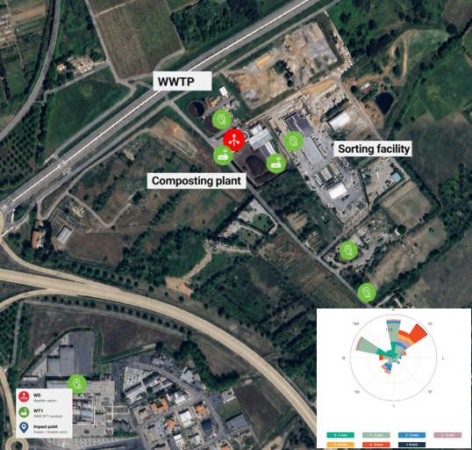
Figure 1: Monitoring network deployment - location of WT1 Pro analysers across the composting facility, showing source from composting plant and perimeter monitoring positions (<500 meters)

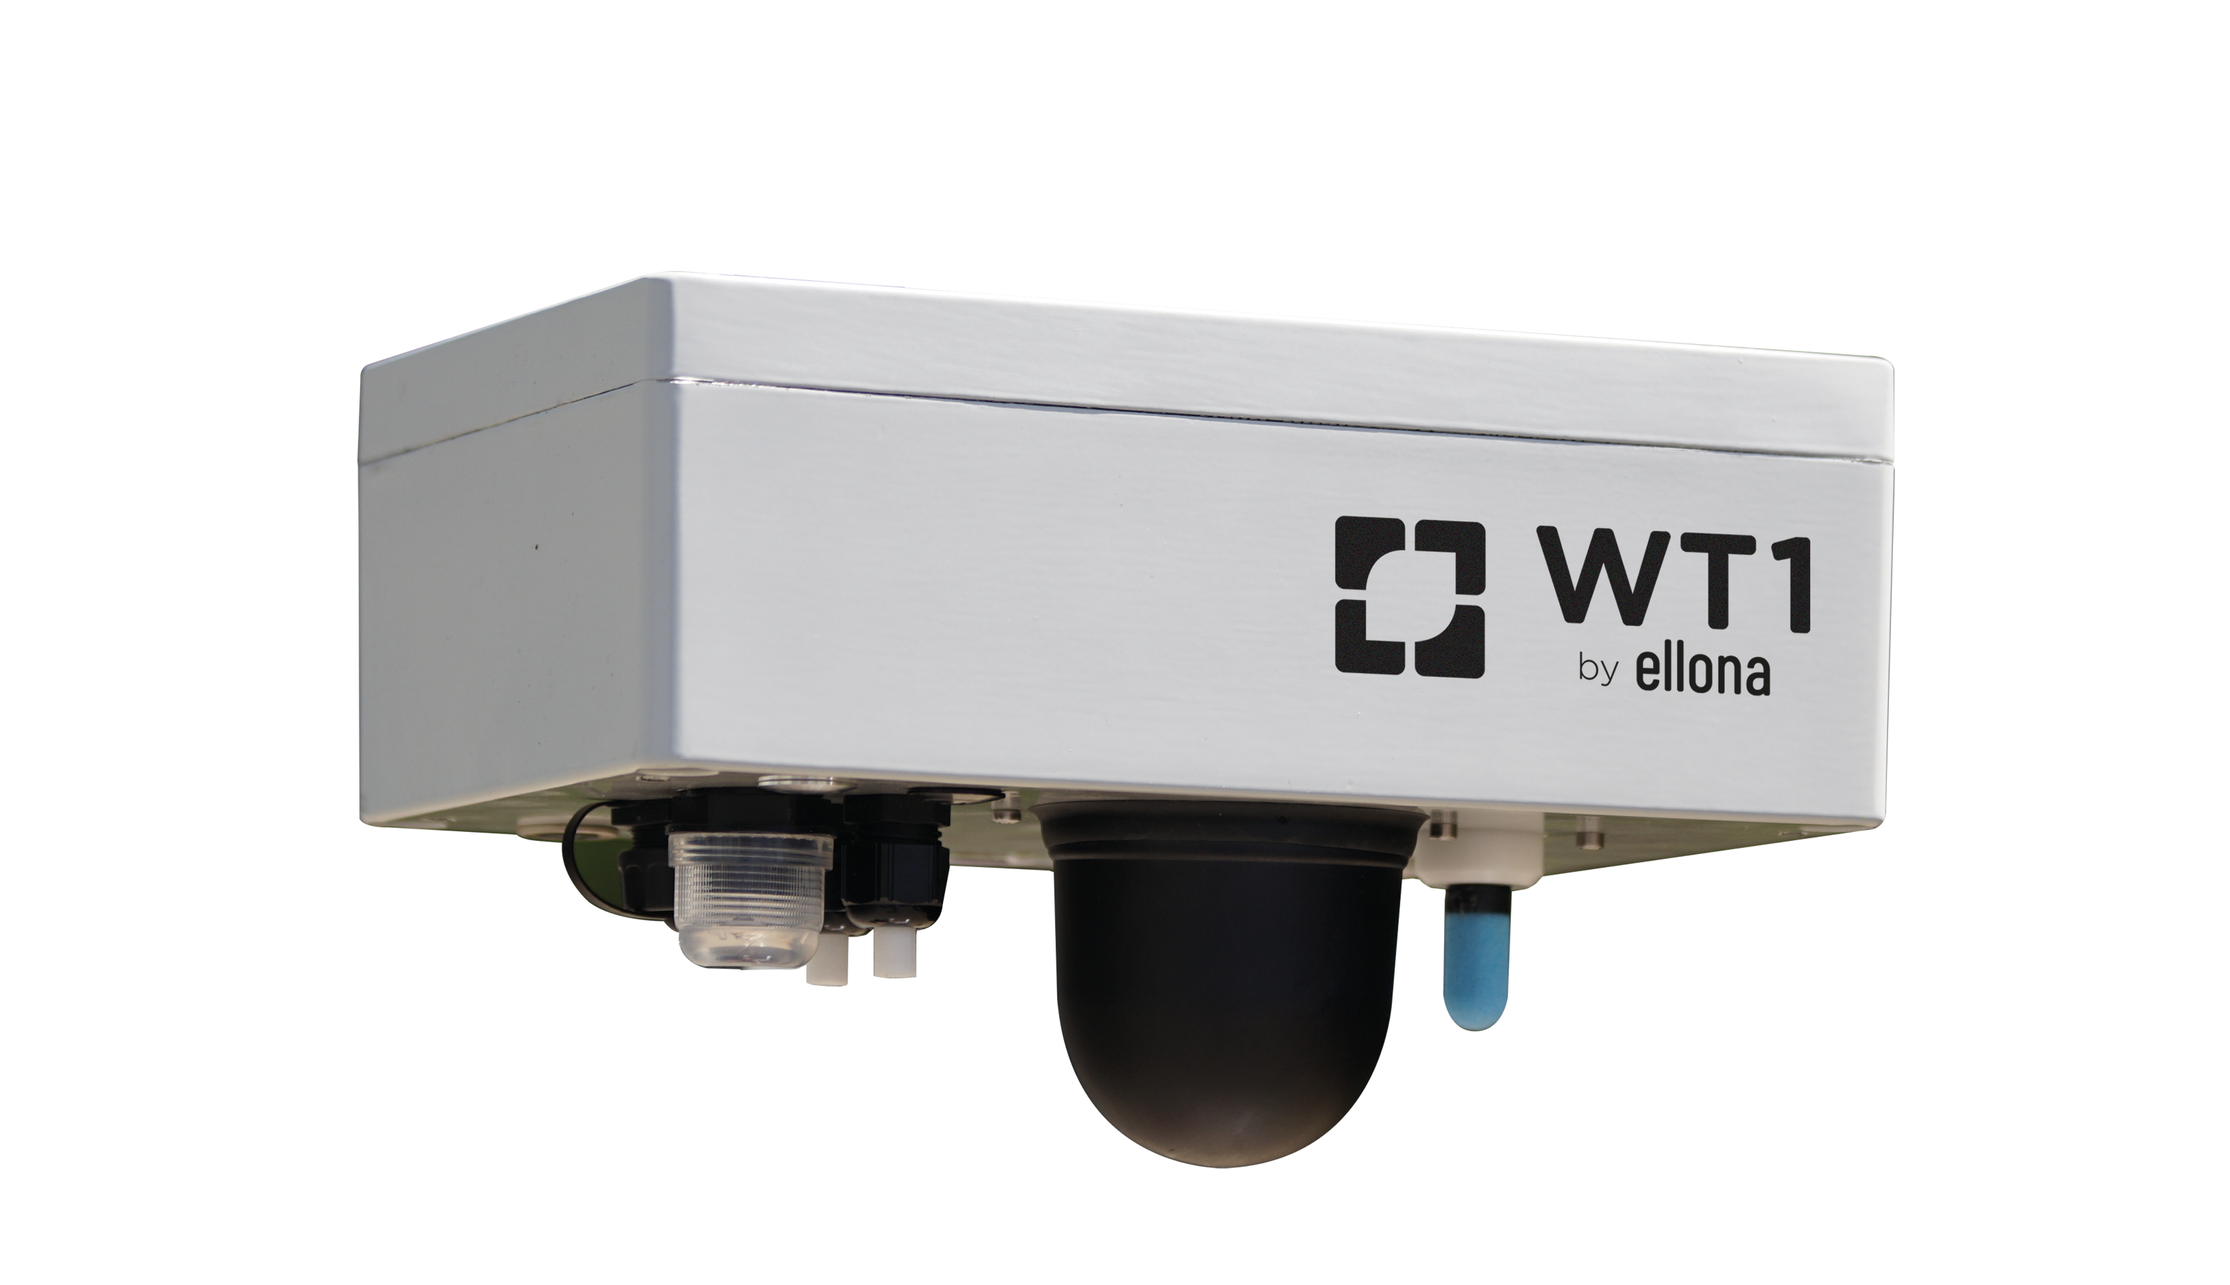  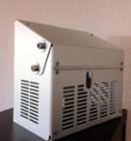 | 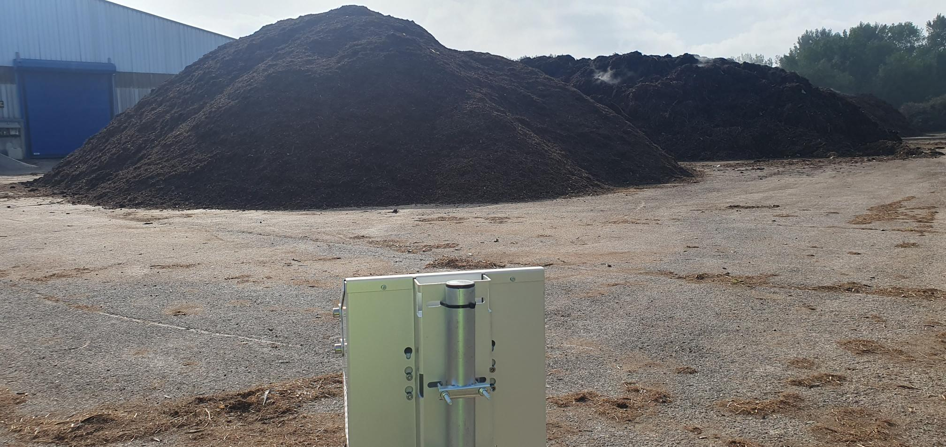
Figure 2. WT1 Pro and its shelter deployed on site at composting plant on its support, with Weather Station
The installation of WT1 Pro (Figure 2) was complemented by a meteorological station installed at 8 m height, enabling alignment of IOMS data with wind conditions to identify source–receptor relationships (Schauberger et al., 2012). Dispersion modelling was implemented within the Ellonasoft platform using an ADMS-based approach, providing updates every 15 minutes. This enables real-time visualization of plume transport and pollutant intensity, correlated with field observations, and objective assessment of site impact. The model allows evaluation of nuisance impacts at sensitive receptors within a radius of up to 10 km.
    - Odor baseline, training and classification
An odor learning phase was performed on each WT1 Pro to enable anomaly detection using a data-driven baselining approach combining operational conditions and citizen feedback supported by QR code surveys. An event logs of operation, was defined to calibrate detection thresholds at source.

Odor intensity was expressed in Instrumental Odor Units (IOU), representing the deviation from composting site baseline reference (Figure 1). A threshold of 500 IOU was defined as the minimum level at which source emissions are likely to impact receptor points. This approach supports initial model calibration and improves fingerprint database robustness (Mifsud and Ayouni, 2024).
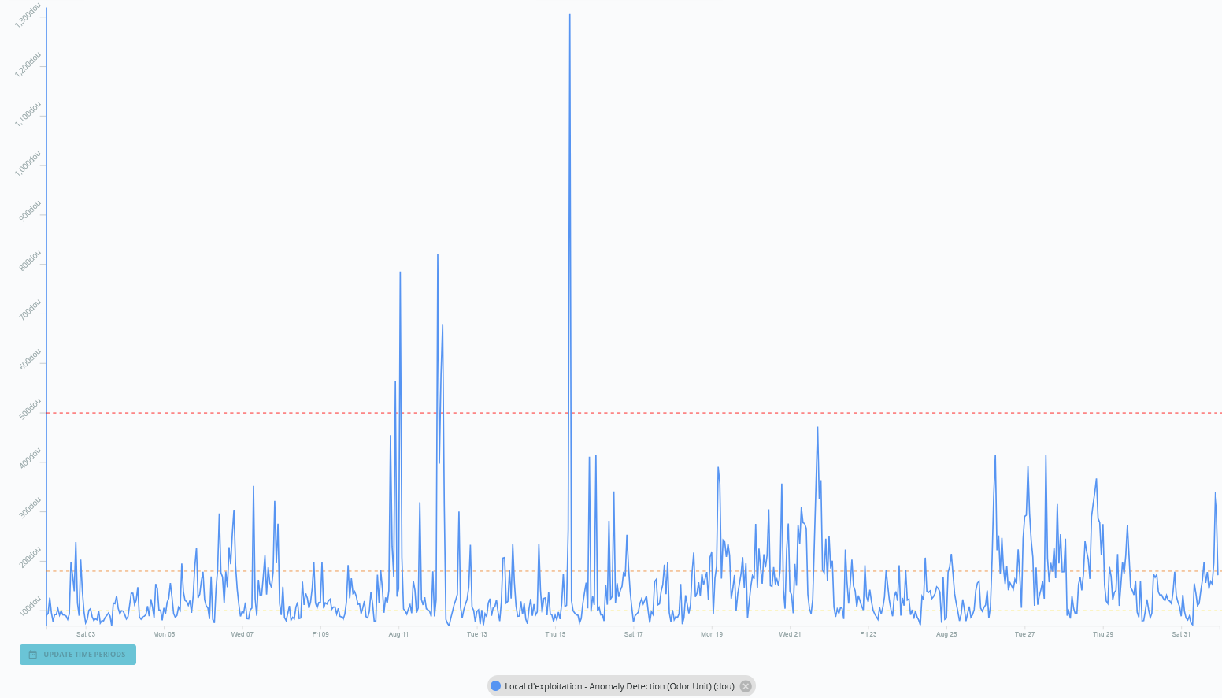
Figure 3: Ellona Odor Distance showing deviation from baseline odor conditions, calculated from MOX sensor data using a anomaly detection model trained during odor-free periods. The red dotted line indicates odor levels at the source likely to impact receptor points (citizen complaints).
The system was trained using the FISOL methodology, integrating sensor’s data, meteorological conditions, and geolocalized citizen feedback collected via QR surveys. Odor descriptors and intensity levels (odor scale range from 1 to 6), combined with operational events, were used to build a representative dataset of odor characteristics. A supervised multivariate model (e.g. Linear Discriminant Analysis LDA) was applied to classify odor signatures into three main categories: fermentation, compost, and sludge-related emissions (Figure 4). The continuous integration of new data ensures model adaptability and supports real-time odor identification and source attribution.

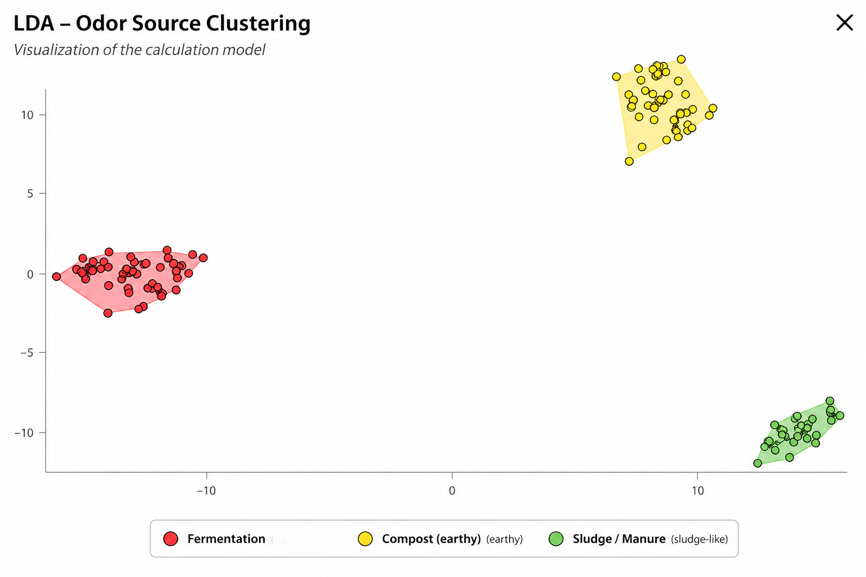
Figure 4. LDA-based odor classification model developed in Ellonasoft using QR-based complaint data.
  - Results and discussion
    - Gas and odor monitoring
Data was aggregated into hourly averages and classified into qualitative categories (normal, info, warning, critical related to WHO guidelines), enabling rapid visualization of temporal trends.
Heatmaps were used as exploratory tools to identify anomaly periodicity in parallel of odor detection. An alert system based on wind direction towards nearby area (school, hospitals, accommodation areas) was implemented for all gas and odor levels to prevent any complaints and optimize site operations.
All measured gas concentrations remained well below regulatory and health-based thresholds, confirming the absence of critical atmospheric pollution.
H₂S is showing clear diurnal patterns concentrations peaking around midday on weekdays linked to composting operations, particularly near compost zones, with slight weekend reductions (Figure 5) while concentrations remain lower at the fenceline, confirming effective biofiltration. NH₃ and RSH contributions are negligible. Particulate matter behaves differently, with peaks at the fenceline driven by dispersion and resuspension.
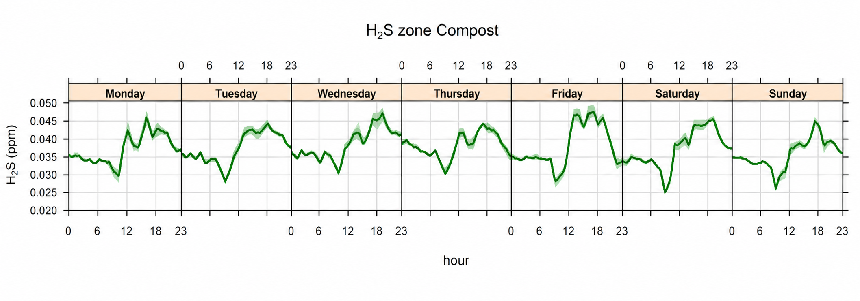
Figure 5. Hourly mean for H₂S concentration profile in the composting zone over 3 months period of monitoring
    - Odor detection and source attribution
After learning phase with FISOL feedback, continuous monitoring enabled real-time identification of three dominant odor families: compost, fermentation, and sludge, directly linked to process stages. The data were collected using the Ellona’s API. About 320 hours of odor events were recorded over the month, confirming that emissions occur intermittently and are mainly driven by operations.
The kinetics (Table 1) show clear differences between sources’ type. Fermentation generates rapid and short peaks, compost produces slower and more persistent emissions, while sludge contributes to a low but continuous background. The distribution (compost 47.1%, fermentation 42.9%, sludge 9.9%) confirms that odor nuisance is driven by odor families rather than single gas compounds.
Table 1: Typical emissions kinetics by operation types - average duration over observed period
Source | Start impact | Peak | End impact | Persistency
Fermentation | 0 -15 min | Rapid | Rapid | 0.5-2h
Compost | 30-60 min | Progressive | Slow | 2-6h
Sludge | variable | Low | Very slow | continuous

3.3 Online monitoring and operations matching
Operational data were analyzed using activity windows, with WT1 Pro signals averaged at one-minute resolution. Mixing, transfer, screening, and loading operations were matched with sensor data based on their timing, and wind direction was included in the analysis.
The combined analysis of operations, odor intensity (Odor Units), and meteorological conditions (Figure 6) provides a clear understanding of emission dynamics on composting platform.
Fermentation activities generate fast and short-lived peaks; compost handling produces delayed but more persistent emissions with a background remanence during the first weeks of monitoring.
Sludge-related odors show weak correlation with operations and exhibit longer persistence, suggesting passive odor from stored materials and potential contributions from external sources related to the nearby WWTP confirmed by the stakeholder after observing abnormal activities during weekend periods.
These results confirm that odor emissions are controlled by both process activities and atmospheric dispersion mechanisms as previously reported (Capelli et al., 2014; Stuetz and Frechen, 2001).
Odor levels are significantly lower at the fenceline (3 to 5 times lower), showing effective reduction through biofiltration.
A strong link is observed between operations and odor peaks at the source (>2000 OU), mainly during screening and mixing tasks. At the fenceline, signals are lower and smoother, indicating limited off-site impact under normal conditions. Odor signatures is mainly dominated by compost and fermentation, while sludge remains minor. Wind direction controls impact, and low-level signals during weekends suggest residual or external sources. Wind direction enables adaptive operational management to limit odor transport toward sensitive receptors, supported by an alert system on Ellonasoft informing operators in real time.

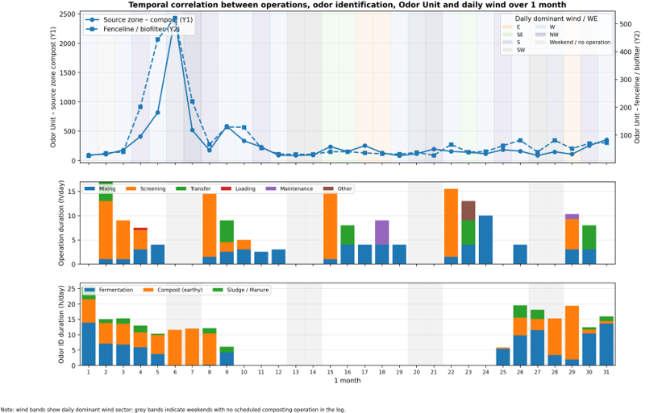
Figure 6. Temporal correlation between odor intensity, operational activities, odor identification, and wind conditions over one month
  - Conclusions
The deployment of Ellona WT1 Pro IOMS systems with associated software platform demonstrates that continuous monitoring enables robust real-time characterization of odor emissions and their relationship with operational activities and meteorological conditions.

The results confirm that odor nuisance at composting facilities is primarily event-driven, governed by process dynamics and atmospheric dispersion rather than individual gas concentrations, which remained low and non-critical throughout the monitoring period.
The integration of odor anomaly detection, odor identification, and meteorological data provides a reliable means for real-time source attribution and objective assessment of odor complaints.
In particular, the combination of WT1 Pro monitoring with dispersion modelling allows differentiation between internal emissions and external contributions, including neighboring installations.
Operationally, the implementation of alert systems based on wind conditions and odor intensity enables adaptive management of site activities, such as screening, turning, or material handling, to limit odor transport toward sensitive receptors.
This approach demonstrates that effective odor mitigation can be achieved through data-driven operational strategies without requiring major infrastructure modifications and the importance of deploying an IOMS network to control source and site boundaries.

References
Capelli L., Sironi S., Del Rosso R., 2014, Electronic noses for environmental monitoring applications, Sensors and Actuators B: Chemical, 130, 1–15.
EN 13725:2003. Air Quality – Determination of Odor Concentration by Dynamic Olfactometry.
European Committee for Standardization (CEN), Brussels, Belgium.
Mifsud J, Ayouni F., 2024, Online monitoring of odor emissions (OU) and odor sources identification by using a new generation of IOMS analyzers around an animal feed production plant, in IEEE International Symposium on Olfaction and Electronic Nose (ISOEN)
Nicolas, J., Cerisier, C., Delva, J., & Romain, A. C. (2012).
Identification of odor sources using an electronic nose in composting facilities.
Pagans E., Font X., Sánchez A., 2006, Emission of volatile organic compounds from composting of different solid wastes, Journal of Hazardous Materials, 131, 179–186.
Schauberger G. & al., 2012, Dispersion modelling of odor emissions from composting plants, Atmospheric Environment.
Sironi S., Capelli L., Céntola P., 2007, Continuous monitoring of odors from a composting plant using electronic noses, Sensors, 7, 143–156.

