 CHEMICAL ENGINEERING TRANSACTIONS  VOL. xxx, 2026 | A publication of  
The Italian Association
of Chemical Engineering
Online at www.cetjournal.it

Guest Editors: Laura Capelli, Marzio Invernizzi, Selena Sironi
Copyright © 2026, AIDIC Servizi S.r.l.
ISBN 979-12-81206-xx-x; ISSN 2283-9216

Cold Plasma Technology for Industrial Odour Mitigation: Mechanisms, Pilot-Scale Applications and Full-Scale Industrial Validation
Davide Pasini
Tecnosida srl, Italy
Vendite1@tecnosida.com
Industrial odour emissions are characterised by complex mixtures, variable operating conditions and very low perception thresholds, so treatment performance cannot be assessed from total volatile organic compound (VOC) measurements alone. This work examines odour mitigation by non-thermal plasma (NTP) using an indirect dielectric barrier discharge (DBD) system. The pilot dataset comprised 19 paired inlet-outlet tests from bitumen membrane production, rubber processing, pouring of animal fat processing and wastewater treatment. Dynamic olfactometry and gas chromatography-mass spectrometry (GC-MS) were used to compare odour reduction, VOC removal and compositional changes. A separate full-scale case study at a bitumen membrane facility included two emission points with a combined airflow above 110,000 m³ h⁻¹. Pilot and full-scale results are reported separately, together with the observed formation of oxygenated intermediates, the electrical energy input and the main limitations associated with olfactometric uncertainty, ozone and incomplete carbon balances.
1. Introduction
Industrial odour nuisance may occur even when conventional emission limits are met because sensory impact is often governed by a limited number of compounds with very low odour thresholds. Total VOC concentration therefore provides an incomplete indicator of odour impact, particularly for variable industrial mixtures (Oliva et al., 2018).
Conventional control options include absorption, adsorption, biological treatment and thermal or catalytic oxidation. Their applicability depends on pollutant load, airflow, variability, footprint, consumables and energy demand. NTP is of interest for dilute contaminants in large airflows because energy is transferred mainly to electrons rather than to the bulk gas (Kim, 2004; Kogelschatz, 2003).
This study investigates an industrial indirect-DBD system developed by Aerox B.V. The contribution is a cross-scale comparison between a multi-sector pilot dataset and one full-scale installation, using paired olfactometric and chemical indicators. The analysis focuses on the difference between odour and VOC removal, molecular transformation, measurement uncertainty and engineering performance.
2. NTP fundamentals
2.1 Plasma generation and oxidation mechanisms
NTP is a partially ionised gas in which electrons have much higher energy than ions and neutral molecules, while the bulk gas remains close to ambient temperature. Electron collisions with oxygen, nitrogen and water vapour generate ions, excited species and radicals. Industrial systems commonly use DBD or corona discharges; the system investigated here generates the discharge in a separate module and transfers reactive species to the polluted air stream (Fridman, 2008; Brandenburg, 2017).
Reactive oxygen species (ROS) include hydroxyl radicals (•OH), atomic oxygen (O•), hydroperoxyl radicals and ozone (O₃).
Odorous compounds are transformed through both direct electron interactions and indirect oxidation reactions promoted by plasma-generated oxidants. Initial radical attack induces bond cleavage and formation of reactive intermediates, which may subsequently evolve into oxygenated compounds such as aldehydes, ketones, alcohols and organic acids. Performance depends on electrical input, gas distribution, reaction time, humidity and the chemical matrix; complete mineralisation to CO₂ and H₂O is not generally expected at industrial conditions.
O₃ contributes to downstream oxidation but is also an undesirable and potentially harmful residual. O₃ was not systematically quantified in the archived pilot and full-scale campaigns; consequently, this dataset cannot support an outlet O₃ mass balance or a compliance conclusion. Industrial applications should therefore verify residual O₃ under representative conditions and include additional residence time or polishing where required. The same precaution applies to NOx and organic by-products (Veerapandian et al., 2017).
3. Pilot-scale investigation
All results in Section 3 refer exclusively to the mobile pilot unit. The dataset contains 19 validated paired inlet-outlet comparisons obtained under real process conditions; the full-scale installation is described separately in Section 5.
3.1 Pilot setup and measurements
A representative side-stream of 100-200 m³ h⁻¹ was extracted from each industrial exhaust and treated by the indirect-DBD pilot unit. Simultaneous inlet and outlet samples were collected for each operating condition. Odour concentration was determined by dynamic olfactometry according to EN 13725:2022, while VOC composition was assessed by GC-MS; airflow, temperature and relative humidity were also recorded.
Dynamic olfactometry has a laboratory-specific, approximately lognormal uncertainty that must be considered when comparing individual results (Harreveld, 2021; Scolieri et al., 2021). The archived campaign reports did not provide one homogeneous uncertainty parameter suitable for retrospective propagation across the entire dataset. Accordingly, the error bars in Figure 1 represent between-test standard deviation only, not combined measurement uncertainty; sector differences are interpreted descriptively rather than as statistically significant rankings.
3.2 Investigated sectors
The tests covered four industrial sectors with different dominant matrices and odour-generation mechanisms (Table 1).
Table 1: Pilot-scale sectors and characteristic emission matrices
Sector | Indicative compounds | Main issue
Bitumen membrane production | Heavy VOCs; aromatics; oxygenates | Persistent nuisance
Rubber processing | VOCs; sulfur compounds; additives | Variable process odours
Pouring of animal fat | Aldehydes; ketones; fatty acids | Intermittent peaks
Wastewater treatment | H₂S; NH₃; mercaptans | Low-threshold, corrosive odours

Inlet concentrations and compound distributions differed substantially among sites; therefore, cross-sector comparison was based primarily on paired removal efficiencies rather than on averaged outlet concentrations.
3.3 Pilot results
Across the 19 comparisons, mean odour removal was approximately 64%, whereas mean VOC removal was approximately 35%. Positive odour reduction was observed in all sectors, but variability was substantial and was influenced by inlet composition, operating conditions and the limited number of tests within each sector.
Figure 1 summarises sector means and between-test variability. Because olfactometric method uncertainty is not included in the error bars, the figure should be read as an overview of the pilot dataset, not as a formal comparison of sector performance.
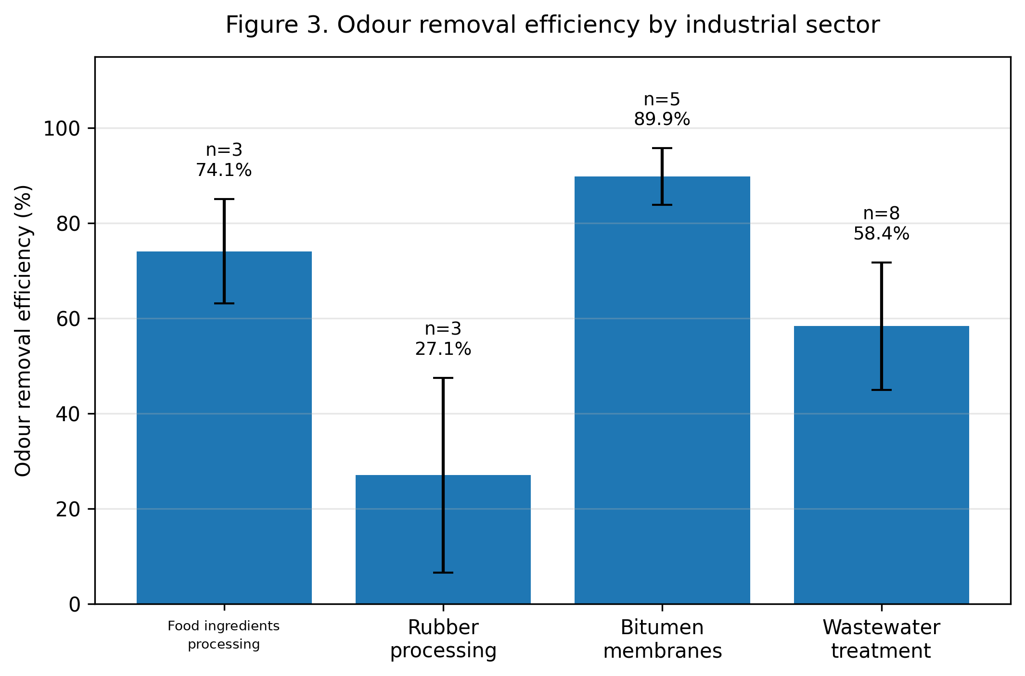
Figure 1. Pilot-scale odour removal by industrial sector. Bars show arithmetic means; error bars show the standard deviation among independent tests and do not include laboratory-specific olfactometric uncertainty.
The discrepancy between sensory and bulk chemical indicators was observed across different matrices. It is consistent with the possibility that a limited number of low-threshold compounds dominate odour perception, while total VOC includes many compounds with a smaller sensory contribution.
Figure 2 compares paired VOC and odour removal. Three tests show negative apparent VOC removal, i.e. a higher GC-MS-derived VOC sum at the outlet than at the inlet. These values should not be interpreted as a complete mass-balance proof of VOC generation because the analytical sum does not represent all carbon species and is affected by the appearance of new intermediates and by analytical variability at low concentrations. In all three cases, odour removal remained positive.

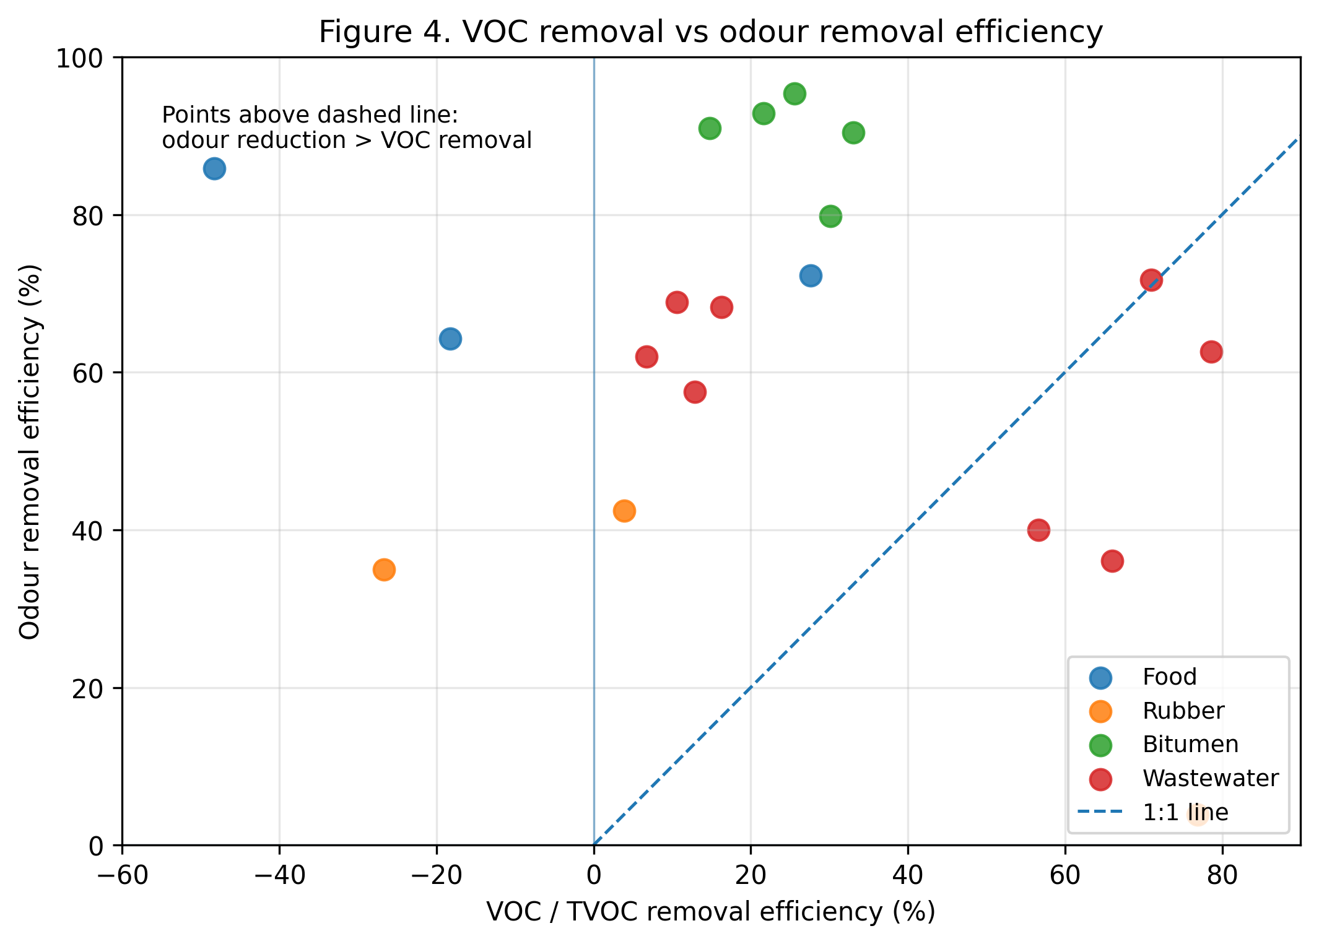
Figure 2. Pilot-scale VOC removal versus odour removal. The dashed line indicates equal removal; points above the line show greater odour reduction than VOC reduction.
The negative VOC points reinforce the need to combine compound-specific analysis, carbon balance and olfactometry. They do not by themselves demonstrate that the newly formed compounds are less hazardous or less odorous.
4. Molecular transformation and by-products
GC-MS profiles frequently changed after treatment: decreases in parent compounds were accompanied by the appearance or increase of aldehydes, ketones, alcohols and organic acids. These observations are compatible with radical attack, fragmentation and oxygen addition followed by further oxidation when reaction time and oxidant availability are sufficient.
Partial oxidation cannot be assumed to reduce odour in every matrix. Some aldehydes and volatile fatty acids have lower odour thresholds than their precursors, and NTP can also generate O₃, NOx and secondary organic products (Veerapandian et al., 2017). The net olfactometric reductions measured here indicate that the overall sensory balance was favourable in the tested conditions, but this outcome should not be generalised without simultaneous inlet-outlet olfactometry and by-product assessment.
The recurrent difference between odour and VOC removal is therefore interpreted as evidence of selective molecular transformation, not as proof of complete mineralisation. Identification of the compounds driving the sensory response remains necessary for a predictive mechanistic model.
5. Full-scale industrial validation
5.1 Process and treatment configuration
The full-scale case concerns one European facility producing modified-bitumen waterproofing membranes. Heated bitumen handling, mixing, coating and finishing generate complex emissions containing heavy VOCs, aromatic hydrocarbons and oxygenated compounds.
Two existing wet scrubbers, C45 and C46, were followed by indirect-DBD injection and approximately 1 s of downstream reaction time. The combined design airflow was 110,000 m³ h⁻¹. All performance values in Sections 5.2-5.3 refer to this installation; the pilot reductions in Table 2 were used only for system selection.
5.2 Design basis and electrical input
Pre-installation pilot tests were performed at both emission points to select plasma capacity. Table 2 reports the design airflow, installed plasma power, specific input energy (SIE) and preceding pilot performance.
Table 2: Full-scale design basis and preceding pilot performance
Point | Q [m³ h⁻¹] | P [kW] | SIE [Wh m⁻³] | Pilot ηod [%]
C45 | 75,000 | 28 | 0.37 | 80-95
C46 | 35,000 | 14 | 0.40 | 91-93

5.3 Full-scale results
Following commissioning, paired olfactometric campaigns were conducted under different production conditions between 2025 and 2026 according to EN 13725:2022. At C45, odour removal ranged from approximately 64% to 93%; C46 showed values of approximately 86-89%.
Although inlet concentrations varied with production, outlet concentrations occupied a narrower range, indicating attenuation of emission peaks. As for the pilot dataset, individual efficiencies remain subject to olfactometric measurement uncertainty and should be interpreted together with the complete campaign context.
The plasma generators required 28 kW at C45 and 14 kW at C46, corresponding to 0.37 and 0.40 Wh m⁻³ of treated air. These values provide a transparent volume-based benchmark, but not a complete plant energy balance: existing fan power and the existing scrubbers are excluded. Direct comparison with biofilters, scrubbers, adsorption and thermal oxidation is not robust without common boundaries for pressure drop, heating, consumables, pollutant load and target removal (Oliva et al., 2018).
The full-scale observations are consistent with the pilot trend of odour reduction exceeding bulk VOC removal, while extending the evidence to a large and variable industrial airflow.
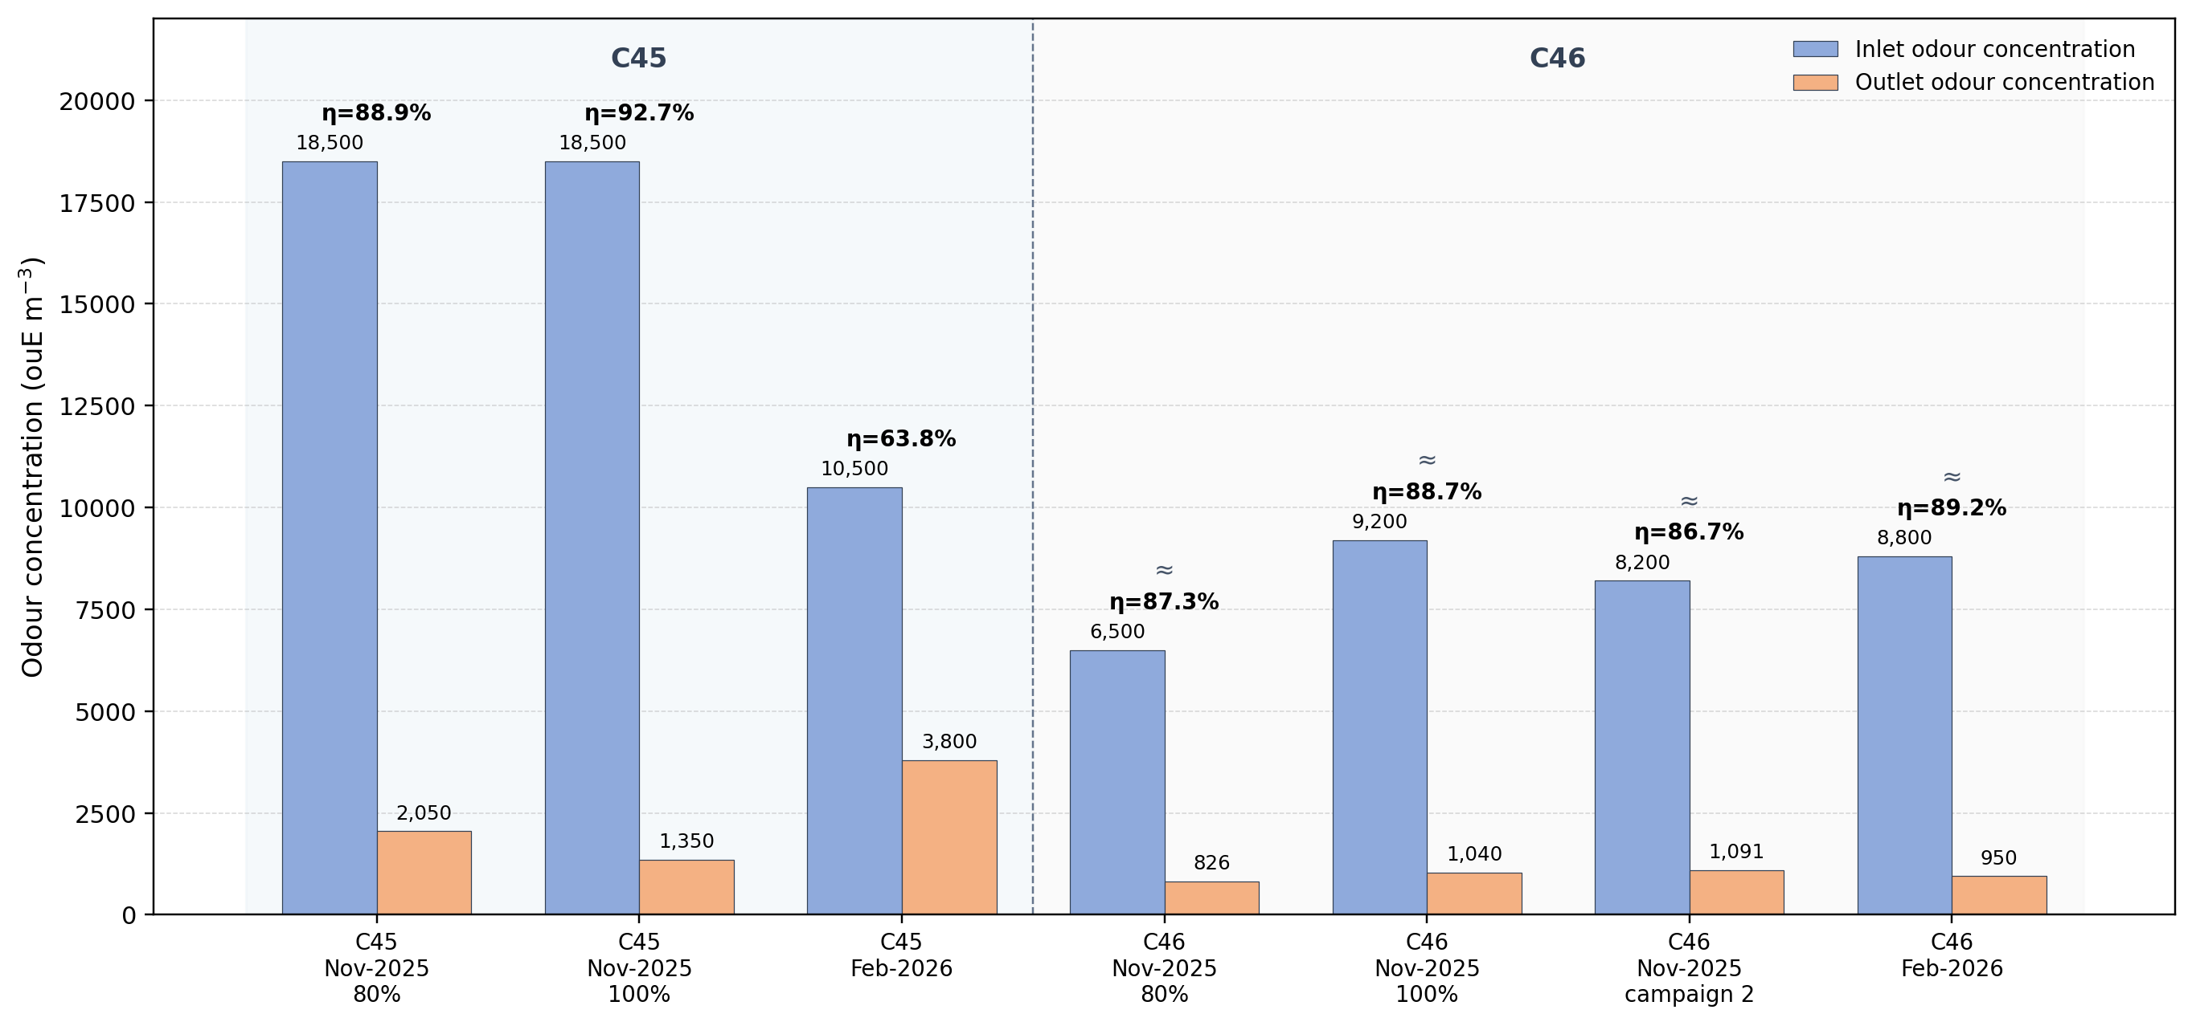
Figure 3. Full-scale inlet and outlet odour concentrations at C45 and C46 under different production conditions.
6. Conclusions
The 19 pilot-scale inlet-outlet comparisons yielded mean odour and VOC removals of approximately 64% and 35%, and an average odor outlet between 700-800 ou m⁻³. The persistent difference between the two indicators shows that bulk VOC reduction alone is not sufficient to describe sensory performance for complex industrial mixtures. The sector averages are descriptive, because the available error bars represent inter-test variability and a common retrospective olfactometric uncertainty could not be propagated.
GC-MS results showed formation of oxygenated intermediates and, in three tests, negative apparent VOC removal despite positive odour reduction. This supports molecular transformation as a relevant mechanism but does not imply that partial oxidation is intrinsically beneficial: some intermediates may be more odorous or hazardous than their precursors. O₃ and a complete carbon balance were not systematically measured and remain limitations of the present dataset.
At full scale, the two emission points treated a combined 110,000 m³ h⁻¹ and achieved odour removals of approximately 64-93%, with plasma-specific electrical inputs of 0.37-0.40 Wh m⁻³. The combined pilot and industrial evidence supports the use of paired sensory and chemical monitoring for NTP assessment. Future work should include laboratory-specific uncertainty propagation, residual O₃ and by-product monitoring, and identification of the compounds controlling odour perception.
Acknowledgments
The author acknowledges Aerox B.V. for access to operational data and the industrial partners that supported field sampling and monitoring.
References
Brandenburg R., 2017, Dielectric barrier discharges: progress on plasma sources and applications, Plasma Sources Science and Technology, 26, 053001.
CEN, 2022, EN 13725:2022 Stationary source emissions - Determination of odour concentration by dynamic olfactometry and odour emission rate, European Committee for Standardization, Brussels, Belgium.
Fridman A., 2008, Plasma Chemistry, Cambridge University Press, Cambridge, United Kingdom.
Harreveld A.P., 2021, Update on the revised EN 13725:2021, Chemical Engineering Transactions, 85, 115-120, DOI: 10.3303/CET2185020.
Kim H.H., 2004, Nonthermal plasma processing for air-pollution control: a historical review, current issues and future prospects, Plasma Processes and Polymers, 1, 91-110.
Kogelschatz U., 2003, Dielectric-barrier discharges: their history, discharge physics and industrial applications, Plasma Chemistry and Plasma Processing, 23, 1-46.
Meichsner J., Schmidt M., Schneider R., Wagner H.E., 2012, Nonthermal Plasma Chemistry and Physics, CRC Press, Boca Raton, USA.
Oliva G., Zarra T., Naddeo V., Munoz R., Lebrero R., Angeles R., Belgiorno V., 2018, Comparative analysis of AOPs and biological processes for the control of VOCs industrial emissions, Chemical Engineering Transactions, 68, 451-456, DOI: 10.3303/CET1868076.
Scolieri G., Invernizzi M., Sironi S., 2021, A crude Monte Carlo analysis for treating the influence of olfactometric uncertainty, Chemical Engineering Transactions, 85, 85-90, DOI: 10.3303/CET2185015.
Veerapandian S.K.P., Leys C., De Geyter N., Morent R., 2017, Abatement of VOCs using packed bed non-thermal plasma reactors: a review, Catalysts, 7, 113, DOI: 10.3390/catal7040113.

