 CHEMICAL ENGINEERING TRANSACTIONS  VOL. xxx, 2026 | A publication of  
The Italian Association
of Chemical Engineering
Online at www.cetjournal.it

Guest Editors: Laura Capelli, Marzio Invernizzi, Selena Sironi
Copyright © 2026, AIDIC Servizi S.r.l.
ISBN 979-12-81206-xx-x; ISSN 2283-9216

Sensitivity analysis of odour impact to source temporal variability: a case study of an asphalt plant with multiple operational configurations
Pietro Citterio, Francesca Tagliaferri*, Selena Sironi
Politecnico di Milano, Department of Chemistry, Materials and Chemical Engineering “Giulio Natta” - Piazza Leonardo da Vinci 32, 20133 Milano, Italy

*Corresponding author: Francesca Tagliaferri, francesca.tagliaferri @polimi.it; +39 02 2399 3149
This study addresses the challenge of assessing odour impacts, which differ from conventional air pollutants due to their sensitivity to short-term peak exposures. Even brief odour events can cause disturbance, making high-end percentile concentrations more relevant than long-term averages. For this reason, it is crucial to estimate the odour emission flux at high temporal resolution, so that short-term emission peaks, more representative of potential odour nuisance, are properly captured. The research evaluates odour dispersion from a bituminous conglomerate plant located in a densely urbanized area using the CALPUFF dispersion model. The analysis focuses on how different temporal emission patterns influence odour impact at nearby receptors. Two emission sources associated with distinct production units are considered, and their impacts are assessed under two modelling scenarios: (i) a realistic discontinuous schedule with emissions during working hours, including a stochastic one-hour peak linked to loading activities; (ii) a simplified and intentionally conservative continuous 24-hour emission scenario, providing a coarse, upper-bound estimate rather than a refined representation of actual conditions. Results show substantial differences in predicted odour impacts between the scenarios. The findings emphasize that emission timing and temporal variability play a crucial role in odour dispersion, highlighting that overly conservative assumptions may not reflect real conditions and can misrepresent actual impacts.
  - Introduction
Environmental odours emitted by industrial facilities are an increasing source of concern for nearby communities, often leading to complaints and social conflicts (Davoli et al., 2018; Palmiotto et al., 2014; Brancher and De Melo Lisboa, 2014). Unlike conventional air pollutants, odorous compounds are typically present in trace concentrations within complex mixtures, making it difficult to identify the responsible sources during nuisance episodes (Invernizzi et al., 2020). For this reason, effective odour management requires quantitative metrics such as odour concentration and odour emission rate (OER), which are essential inputs for dispersion modelling and impact assessment (Conti et al., 2020; Piringer and Schauberger, 2020; Davoli, et al., 2018).
Within this framework, the dispersion and impact of odour emissions are strongly influenced by meteorological conditions, including atmospheric stability, wind regime, and mixing height (Piringer and Schauberger, 2020). Stable conditions, low wind speeds, and reduced mixing heights tend to enhance the accumulation of odours, increasing the likelihood of nuisance events, while unstable conditions promote dilution (Conti et al., 2020; Vuolo et al., 2023; Tagliaferri et al., 2024).
Beyond meteorological effects, a key peculiarity of odour impact is that human perception is primarily driven by short-term peak concentrations rather than long-term average values (Invernizzi et al., 2020). Even brief episodes of high concentration can cause nuisance, meaning that the temporal variability of emissions plays a crucial role in determining actual impacts (Tagliaferri et al., 2026). This aspect becomes even more critical in the case of industrial processes operating under discontinuous or cyclic conditions, where emissions are not constant over time but occur in intermittent phases associated with specific operational steps. Under these conditions, short-term emission peaks may be significantly higher than average levels and can dominate the overall odour impact despite their limited duration. As a consequence, modelling approaches based on time-averaged or continuous emissions may fail to represent realistic exposure conditions.
Among industrial sources, bituminous conglomerate (asphalt) plants represent a particularly relevant case study. These facilities are typically medium-small sized and widely distributed across the territory, often located in proximity to residential areas or urban contexts. This spatial distribution makes odour emissions a critical issue for nearby communities, frequently leading to complaints and the need for detailed environmental assessments. The production process involves the drying, heating, and mixing of mineral aggregates with bitumen at high temperatures. These operations generate both channelled emissions (e.g., from stacks and process vents) and diffuse emissions (e.g., from material handling, storage areas, and truck loading/unloading). From a chemical standpoint, these activities can release a complex mixture of pollutants, including particulate matter, sulphur-containing compounds, and volatile organic compounds such as aromatic hydrocarbons. In particular, reduced sulphur compounds (e.g., hydrogen sulphide and mercaptans) are of concern due to their strong odour intensity, especially under suboptimal combustion or process conditions (Davoli et al., 2018; Germin-Aizac et al., 2023). Furthermore, the variability of operating conditions, such as changes in production rates, raw material characteristics, and combustion efficiency, can lead to significant temporal fluctuations in odour emissions.
The present study aims to evaluate how different emission temporal regimes can influence predicted odour impacts, highlighting the importance of adopting time-resolved approaches capable of capturing peak events and realistic operating conditions. To this end, the analysis focuses on a case study of a bituminous conglomerate plant characterized by a markedly discontinuous operational regime. The facility comprises multiple production lines with different operating schedules, including units that are inactive during nighttime and others that operate only during specific periods of the year. This results in a highly variable emission pattern, further influenced by transient conditions such as short-term increases in airflow associated with specific activities.
  - Methods
    - CALPUFF model
This study was carried out using the CALPUFF modelling system, a three-dimensional, non-steady-state Lagrangian puff dispersion model widely applied for the simulation of atmospheric transport and dispersion of pollutants, including gases, aerosols, and particulate matter (Scire et al., 2000).
CALPUFF is particularly suitable for applications involving complex environments, as it can account for spatial and temporal variability in meteorological conditions. The model represents emissions as a series of discrete puffs, each containing a fraction of the emitted mass, which are transported by the wind field while expanding both horizontally and vertically according to Gaussian distributions. This approach allows the model to capture variations in wind speed, wind direction, and atmospheric stability over time and space.
Meteorological input fields were generated using CALMET, the diagnostic meteorological preprocessor associated with CALPUFF. CALMET integrates multiple data sources, including terrain characteristics, surface and upper-air observations, and prognostic meteorological data, to produce high-resolution, gridded fields of wind, temperature, and atmospheric stability. These fields provide the basis for a physically consistent representation of dispersion processes under varying atmospheric conditions. All simulations were performed with CALPUFF version 7.2.1 over a full annual period (2025), using a temporal resolution of 3600 seconds. In line with standard practice in odour dispersion modelling, chemical transformation processes were not considered, assuming odourous compounds to be chemically inert. Similarly, dry and wet deposition processes were excluded, resulting in a conservative estimation of ground-level concentrations. The dispersion option was configured to derive horizontal and vertical dispersion coefficients from micrometeorological parameters provided by CALMET (MDISP=2), thereby ensuring a physically based representation of turbulence and atmospheric stability.
    - Site description and meteorological data
The computational domain is located in northern Italy and covers an area of 6 km × 6 km with a horizontal grid
resolution of 100 m. The area lies within the Po Valley and is characterized by relatively flat terrain, with elevations ranging between approximately 140 and 160 m above sea level. The asphalt plant is situated within a small industrial zone embedded in a mixed landscape of agricultural land and residential areas, with a few additional industrial clusters. This spatial configuration is typical of the region, where industrial, agricultural, and residential land uses coexist in close proximity, representing a key factor in the occurrence of odour nuisance. Land use data for the simulations were derived from the CORINE Land Cover (CLC 2018) database at 100 m resolution, while terrain elevation data were obtained from the SRTM Global dataset at 30 m resolution. Meteorological input fields for CALMET (version 6.5.0) were generated using a hybrid approach. Surface observations were taken from a ARPA Lombardia (Regional Environmental Protection Agency) meteorological station, located within the modelling domain and providing all required parameters, i.e. wind speed and direction at 10m height, air temperature, solar radiation, atmospheric pressure and relative humidity. Upper-air data were obtained from hourly three-dimensional outputs of a prognostic WRF model with a spatial resolution of 1 km. This combined approach allows for the reconstruction of spatially distributed, three-dimensional meteorological fields, overcoming the limitations of single-point measurements.
The dataset covers the entire year 2025, which was selected as the reference period for the simulations. An overview of the main meteorological features of the study area is provided through the analysis of wind regime and atmospheric stability. In particular, Figure 1 shows the annual wind rose (blowing-from) together with the frequency distribution of Pasquill–Gifford stability classes. The wind rose indicates that the prevailing wind directions are from the south-west and east, with a lower contribution from the northern sector.
The stability class distribution shows a predominance of stable atmospheric conditions (P.G. class F), followed by neutral conditions (P.G. class D). Such conditions are known to be unfavourable for pollutant dispersion, as they limit atmospheric mixing and promote the accumulation of pollutants near the ground.
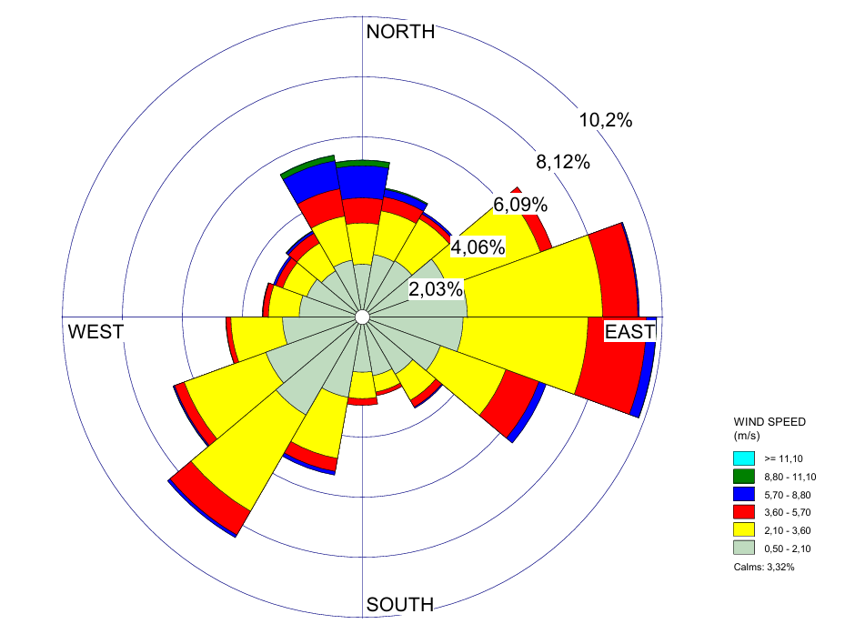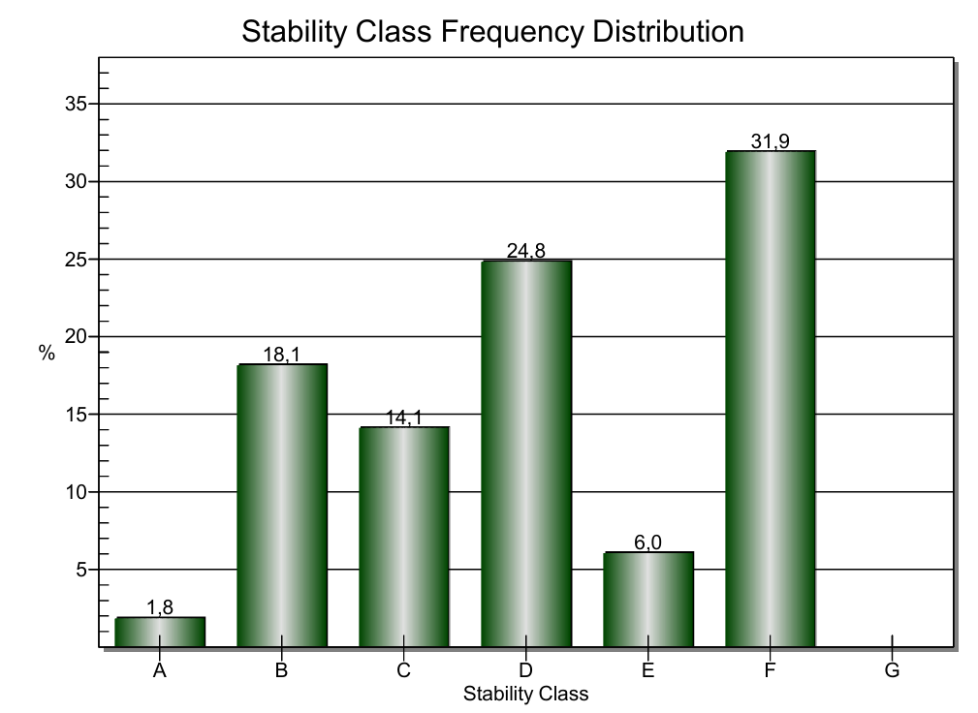
Figure 1: Annual wind rose (blowing-from) and stability class frequency distribution for the entire simulation year.

    - Emission Data and Sources Characterization
The plant configuration consists of two distinct process units, each connected to a dedicated stack, corresponding to two bituminous conglomerate production lines operating under different regimes: one continuous and the other intermittent. For stacks, and more generally for all point emission sources, the assessment of odour emissions cannot rely solely on odour concentration values. Instead, it is necessary to refer to the OER, defined as the product of odour concentration and airflow rate, and expressed in odour units per second (ou_{E}/s):
$$OER \left[\frac{{ou}_{E}}{s}\right]=\frac{Q\left[\frac{m^{3}}{h}\right]*C_{od}\left[\frac{{ou}_{E}}{m^{3}}\right]}{3600\left[\frac{s}{h}\right]}$$

(1)

According to EN 13725:2022 (CEN, 2022), the airflow rate must be normalized to a reference temperature of 20°C. In this study, odour concentration values, derived from samples collected at the plant’s emission points simultaneously with field measurements of air flow rates, were subsequently analysed by dynamic olfactometry in the laboratory.
As the objective of this study is to evaluate the importance of temporal resolution in odour impact assessment, two emission scenarios were defined. The first scenario (hereafter referred to as “continuous scenario”) in which both stacks operate continuously (24/7) throughout the entire year. The second scenario (hereafter referred to as “time-resolved scenario”) reflects a more realistic, discontinuous operating regime, representative of actual plant activity. In this case, operations occur daily between 07:00 and 15:00. The first stack, i.e. C1, operates on 80% of the working days of the year, with constant flow rate and odour concentration. The second stack, i.e. C2, operates throughout all working hours and is characterized by a daily peak emission period lasting one hour, associated with truck loading operations of the final product. During this phase, in order to limit diffuse emissions related to material handling, the extraction system operates at higher capacity, resulting in increased airflow directed to stack C2 and higher odour concentrations. The timing of this peak is randomly distributed within the daily operational window over the simulation year. This approach reflects the variability of real plant operations, where truck arrivals do not occur at fixed times, and allows the peak emissions to be associated with a range of meteorological conditions. The emissivity characteristics of the two scenarios are reported in Table 1.

Table 1: Emission scenarios
 | Continuous scenario |  | Time-resolved scenario
 | C1 | C2 | C1 | C2 | C2
 |  |  |  | Standard operating conditions | Truck loading conditions
Q [m³/h] | 65000 | 105000 | 65000 | 105000 | 125000
Cod [ou_{E}/m³] | 3500 | 6000 | 3500 | 6000 | 7500
OER [ou_{E}/s] | 73294 | 188044 | 73294 | 188044 | 223862

As illustrated in Figure 2 for an example week, the continuous scenario assumes a constant emission rate throughout the entire year, whereas the time-resolved scenario exhibits a more complex temporal pattern. This includes, for C2, intermittent peaks associated with activities such as truck loading, as well as differing operating schedules among stacks, including downtime periods, thus providing a more realistic representation of actual operating conditions.
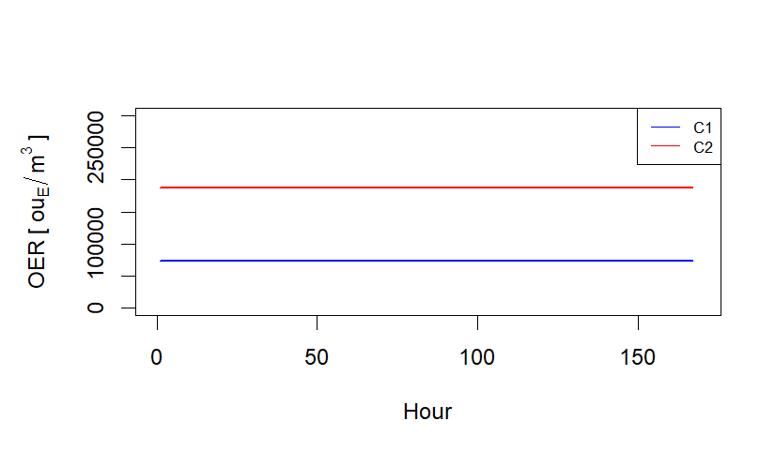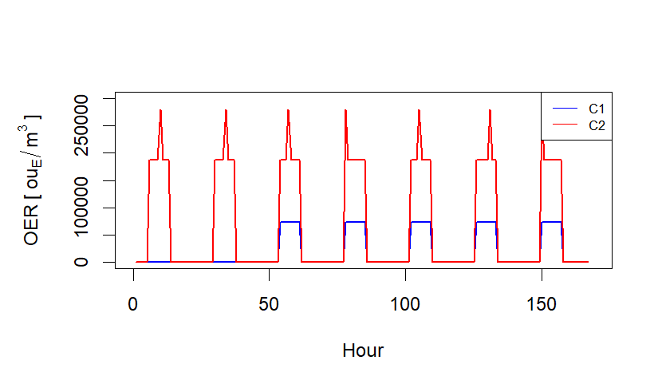
Figure 2: OER time variation for the continuous scenario (left) and time-resolved scenario (right). First week of the year example

The geometrical and physical parameters of the two simulated stacks are shown in the following table.

Table 2: Geometrical and physical parameters
Sources | H [m] | D [m] | T [K] | v [m/s]
C1 | 21 | 1.6 | 340 | 9
C2 | 25 | 1.6 | 315 | 14*/17**
*referred to “Standard operating conditions” configuration; **referred to “Truck loading conditions” configuration
  - Results
The results of the study are presented in terms of odour impact maps (Figure 3) and ground-level concentrations at sensitive receptors (Table 3). Odour impact was assessed using the 98th percentile of odour concentrations over the simulation year, in accordance with the Italian regulatory framework (Decreto direttoriale MinAmbiente 28 giugno 2023, n. 309, 2023). The analysis was based on hourly averaged concentrations (1-hour averaging time) generated by CALPUFF. To account for short-term fluctuations relevant to odour perception, a peak-to-mean factor was applied during post-processing using CALPOST (version 7.1.0). Specifically, hourly mean concentrations were multiplied by a constant factor of 2.3, as prescribed by Italian guidelines.

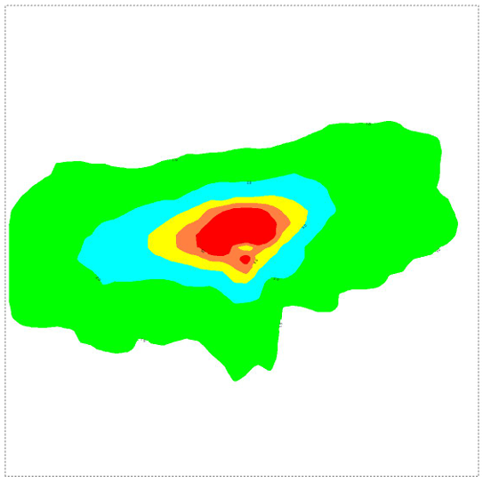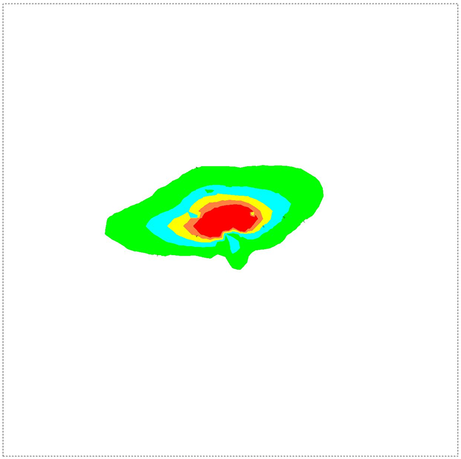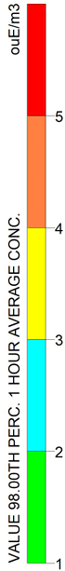
Figure 3: Odour impact maps (98°percentile, on an annual basis) simulated for the continuous scenario (left) and time-resolved scenario (right). The plant is located in the centre of the simulation domain (6x6 km²)

Table 3: Odour concentration (98° percentile, on an annual basis) at sensitive receptors
ID | Description | Source distance [km] | Continuous scenario  C98 [ou_{E}/m³] | Time-resolved scenario  C98 [ou_{E}/m³] | Increase [%]
R_1 | Residential | 0.35 | 2.39 | 2.23 | 7
R_2 | Residential | 0.65 | 1.57 | 1.16 | 35
R_3 | Residential | 0.5 | 1.99 | 1.86 | 7
R_4 | Residential | 0.85 | 0.38 | 0.09 | 322
R_5 | Fish Market | 0.6 | 1.72 | 1.38 | 25
R_6 | Farmstead | 1.6 | 0.23 | 0.10 | 130
R_7 | Service Area | 0.5 | 0.54 | 0.18 | 200
R_8 | Village | 1.7 | 0.29 | 0.10 | 190
R_9 | Village | 1.4 | 0.50 | 0.35 | 43
R_10 | Village | 1.5 | 0.73 | 0.42 | 74
R_11 | Hospital | 2.2 | 0.27 | 0.14 | 93

As expected, the continuous emission scenario results in substantially higher impacts compared to the time-resolved scenario. This difference is evident not only in the concentration levels at the receptors, but also in the much broader spatial extent of the affected area, as clearly illustrated by the impact maps.
Notably, the divergence between the two scenarios becomes more pronounced with increasing distance from the source, where the continuous emission assumption produces a wider and more persistent impact. The average increase across all receptors between the continuous and time-resolved scenarios is approximately 100%, with the largest differences observed at receptors located downwind and farther from the source.
These findings underscore how steady-state and low temporal resolution modelling approaches may not always provide a fully representative picture of actual conditions. Several factors contribute to the higher impacts observed in the continuous scenario. First, emissions occurring during night time are subject to reduced atmospheric dispersion due to stable conditions and limited mixing. While vertical mixing is suppressed, horizontal transport still occur, allowing pollutants to remain concentrated within the lower layers and be carried over longer distances, potentially affecting receptors far from the source. In contrast, the refined scenario is restricted to daytime hours, when enhanced solar radiation promotes atmospheric instability and vertical mixing, favouring dilution and reducing long-range impacts, even in the presence of short-term emission peaks.
Second, the continuous scenario leads to a much larger total odour mass emitted. Running 24 hours instead of eight (07:00 and 15:00) produces a higher cumulative load, raising the risk of exceeding odour thresholds at receptors. Moreover, in the time-resolved scenario, stack C1 operates for only 80% of the working time, more accurately reflecting real operating conditions, including intermittent shutdowns, malfunctions, and maintenance activities.
It is worth noting that, although the time-resolved scenario exhibits higher emission rates during the one-hour peak period (during truck loading), it results in lower overall odour impacts. This is because the peak is limited to a single hour per day and is not fixed at a specific time; instead, it is randomly distributed over the working hours. As a result, the peak does not systematically coincide with unfavourable dispersion conditions, reducing the likelihood of worst-case impacts.
  - Conclusions
The CALPUFF model was used to evaluate odour impacts from a bituminous conglomerate plant under two emission scenarios: continuous (24/7, continuous) and a more realistic time-resolved regime. The continuous scenario resulted in higher ground-level odour concentrations and a broader impacted area, with differences between the two scenarios becoming more pronounced with increasing distance from the source. This behaviour is mainly attributable to the persistence of emissions during stable night-time conditions, when limited vertical mixing enhances pollutant accumulation and long-range transport. In addition, the simultaneous operation of all sources increases the likelihood of unfavourable dispersion conditions. In contrast, the time-resolved scenario benefits from daytime operation and emission-free periods, promoting dilution and reducing overall impact. Although higher emission rates occur during a stochastic peak, its influence remains limited due to its short duration (one hour per day) and random temporal occurrence, which reduces the probability of coinciding with unfavourable meteorological conditions. Overall, while continuous scenarios provide a conservative upper bound, they may overestimate actual impacts. Incorporating realistic operational schedules is therefore essential for more accurate assessments and effective mitigation planning.
References
Brancher M., De Melo Lisboa H., 2014, Odour impact assessment by community survey, Chemical engineering transactions, 40, 1-6
Brancher M., Hoinaski L., Piringer M., Prata A., Schauberger G., 2021, Dispersion modelling of environmental odours using hourly-resolved emission scenarios: Implications for impact assessments., Atmospheric environment: X, 12, 1-13.
CEN, EN 13725:2022, Stationary source emissions - Determination of odour concentration by dynamic olfactometry and odour emission rate, 2022.
Conti C., Guarino M., Bacenetti J., 2020, Measurements techniques and models to assess odor annoyance: A review, Environment international, 134, 1-16.
Davoli E., Porro E., Piangerelli L., Foschi A., Paleari B., Rossi A.N., Bonati S., Il Grande M., Bonura A.,2018, Bituminous Conglomerates Industrial Production. Assessment of Odour Emissions in View of Regional Guidelines Publication, Chemical enginnering transactions, 68, 1-6.
Decreto direttoriale MinAmbiente, 28 giugno 2023, n. 309. 2023.
Germin-Aizac J., Maitre A., Balducci F., Montlevier S., Marques M., Tribouiller J., Demeilliers,C., Persoons R., 2023, Bitumen fumes and PAHs in asphalt road paving: Emission characteristics, determinants of exposure and environmental impact, Environmental reasearch, 128, 1-11.
Invernizzi M., Brancher M., Sironi S., Capelli L., Piringer M., SchaubFare clic o toccare qui per immettere il testo.erger G., 2020, Odour impact assessment by considering short-term ambient concentrations: A multi-model and two-site comparison, Environment international, 144, 1-17.
Lotesoriere B., Panzitta A., Capelli L., 2022, A Method to Evaluate Odour Impacts in the Case of Highly Variable Emission Scenarios: a Case Study in a Foundry, Chemical enginnering transactions, 95, 1-6
Palmiotto M., Fattore E., Paiano V., Celeste G., Colombo A., Davoli E., 2014, Influence of a municipal solid waste landfill in the surrounding environment: Toxicological risk and odor nuisance effects, Environment internation, 68, 16-24.
Piringer M., Schauberger G., 2020, Environmental Odour: Emission, Dispersion, and the Assessment of Annoyance, Atmosphere, 11, 896, 1-4.
Scire J.S., Strimaitis D.G., Yamartino R.J., 2000, A user's guide for the CALPUFF dispersion model, <www.calpuff.org/calpuff/download/CALPUFF_UsersGuide.pdf>.
Tagliaferri F., Facagni L., Invernizzi M., Ferrer Hernandez A.L., Hernández-Garces A., Sironi S., 2024, Odor Impact Assessment via Dispersion Model: Comparison of Different Input Meteorological Datasets, Apllied sciences, 14, 2457, 1-19.
Tagliaferri F., Sironi S., Invernizzi M., 2026, Assessing VOC Dispersion from Hydrocarbon Storage Tanks: A Case Study on Emission Temporal Resolution. Applied sciences, 16, 1-16.
Vuolo M.R., Acutis M., Tyagi B., Boccasile G., Perego A., Pelissetti S., 2023, Odour Emissions and Dispersion from Digestate Spreading, Atmosphere, 14, 619, 1-38.

