 CHEMICAL ENGINEERING TRANSACTIONS  VOL. xxx, 2026 | A publication of  
The Italian Association
of Chemical Engineering
Online at www.cetjournal.it

Guest Editors: Laura Capelli, Marzio Invernizzi, Selena Sironi
Copyright © 2026, AIDIC Servizi S.r.l.
ISBN 979-12-81206-xx-x; ISSN 2283-9216
A Temperature-Modulated Digital MOX Sensor as a Compact Alternative to Analog Sensor Array for Odour Monitoring
Catullo Eleonora¹, Bax Carmen¹, Zanni Emanuele², Gabriele Paroli², Marco Calì¹ Dellaca Raffaele², Capelli Laura Maria Teresa¹
¹ Politecnico di Milano, Department of Chemistry, Materials, and Chemical Engineering “Giulio Natta”, Milan, Italy
² Politecnico di Milano, Department of Electronics Information and Bioengineering, Milan, Italy
carmen.bax@polimi.it
Instrumental Odour Monitoring Systems (IOMS) are increasingly adopted for continuous environmental monitoring, although large-scale deployment in boundary monitoring networks is often constrained by the cost and complexity of conventional Metal-Oxide Semiconductor (SMOX) sensor arrays. This study investigates a digitally integrated temperature-modulated SMOX sensor as a compact alternative for odour source classification at a non-hazardous waste landfill. A custom platform integrating six analog TGS sensors and one digital SGP40 sensor was used to compare three sensing configurations - SGP40-only, TGS-only, and combined SGP40 + TGS - under identical sampling conditions. Odour samples from four landfill emission sources were characterized by dynamic olfactometry and classified using supervised models applied to Boruta-selected features. The TGS-only and combined configurations reached 100% accuracy across multiple classifiers, with the combined configuration achieving this with fewer selected features. The SGP40-only configuration reached a maximum of 88%. Despite lower performance, the single-sensor solution shows relevant potential for distributed field deployment owing to its reduced size, lower cost, and simplified architecture, and warrants further investigation for odour concentration quantification.
  - Introduction
Odour emissions represent an increasingly central issue in environmental management due to their impact on air quality, public well-being, and the rising frequency of conflicts between industrial facilities and surrounding communities (Bax C. & Capelli L., 2023). At the European level, odour regulation is governed by a composite framework that integrates technical standards with environmental-permitting procedures. In 2024, the revision of the Industrial Emissions Directive (IED 2024/1785) and the introduction of the Industrial Emissions Portal Regulation (IEP-R 2024) have reshaped authorisation processes, data-reporting requirements and digital workflows, with direct implications for odour management. The strengthened definition of Best Available Techniques (BAT) and the obligation for operators to adopt enhanced Environmental Management Systems (EMS) further reinforce the need for robust, transparent and integrated odour-control strategies. These provisions are particularly relevant for installations subject to Integrated Environmental Authorisation (AIA) (Zalin M. & Sironi S., 2024). In Italy, the regulatory landscape has evolved significantly with the publication of the MASE Guidelines (Decreto Direttoriale 309/2023), which today represent the main national reference for the prevention, assessment and limitation of odorous emissions. The guideline explicitly promotes a multilevel and integrated assessment approach, combining dispersion modelling with real-world evidence such as community complaints, field inspections and continuous monitoring. Moreover, it introduces national receptor-based acceptability thresholds, expressed as annual 98th percentile hourly peak concentrations, and ranging from 1 to 5 ouE/m³ depending on the territorial sensitivity. These criteria support a harmonised evaluation of odour impact across different territorial contexts.
IOMS, as regulated by UNI 11761:2019, are becoming a key element for continuous surveillance, source attribution and the validation of community-reported events. Increasingly, environmental agencies and permitting authorities request continuous ambient-air monitoring to obtain high-resolution, time-explicit information that cannot be captured through periodic sampling or dispersion modelling alone. In this context, a growing trend in the authorization of new installations and the revision of existing environmental permits involves the deployment of fenceline IOMS networks. This type of monitoring system provides data streams that are more easily correlated with specific operational conditions of the installation—such as changes in waste handling, aeration cycles, peak loading or malfunctions—as well as with validated citizen complaints, thereby serving a managerial function for the fast identification of odour problems and their management (Bax C. et al., 2024; Olivia G. et al., 2021). Whereas dispersion modelling offers a necessarily mediated and long-term representation of odour impact, typically based on annual meteorological datasets, IOMS enable real-time detection of short-lived events, transient emissions and episodic releases that would otherwise remain undocumented. For this reason, continuous instrumental monitoring is increasingly recognised as an essential component of integrated odour-assessment frameworks and a valuable complement to conventional olfactometric and modelling-based approaches (Prudenza et al., 2023). However, the large-scale deployment of IOMS networks is often constrained by the operational cost and complexity of traditional multi-sensor arrays based on analog SMOX sensors (Han J. et al., 2025).
Within the framework of an odour emissions monitoring project at a non-hazardous waste landfill, this study investigates the use of a single digitally integrated SMOX gas sensor operated under temperature modulation as a compact alternative or complement to conventional analog SMOX sensor arrays (Rock F. et al., 2008; Fine G.F. et al., 2010). Rather than directly replacing the information provided by an array, the approach explores whether the dynamic response generated during repeated thermal cycles can provide sufficient discriminative information for classification of odour samples collected at a landfill site. The performance of this temperature-modulated sensor was therefore compared with that of a six-sensor analog TGS array and with a combined configuration including both sensing approaches. This comparison allows the potential advantages of the single-sensor solution, in terms of reduced hardware complexity, lower cost, smaller size, and easier field deployment, to be evaluated against the classification performance obtained from array-based measurements, with direct implications for the design of cost-effective fenceline monitoring networks at waste management facilities.
  - Materials and Methods
    - IOMS involved
A custom IOMS was developed at the Politecnico di Milano and involved for the monitoring of landfill odours at the plant fenceline. The system includes a radial printed circuit board (PCB), handling gas sensors readout, signal acquisition, and data transmission for up to seven sensing elements. In the specific configuration used in the present case study, the array comprises six analog metal oxide sensors (SMOX) (models TGS2600, TGS2602, TGS2603, TGS2610, TGS2611, and TGS2620 from Figaro Engineering Inc., Japan) alongside one digital sensor operated under temperature modulation (SGP4x from Sensirion, Switzerland), and one STH40 sensor for measuring temperature and relative humidity. To guarantee strictly comparable sampling conditions while minimizing thermal interference, the sensors are positioned in close proximity within a custom-designed chamber featuring optimized fluid dynamics for equal sample distribution. The gas flow through this chamber is driven by a closed-loop controlled diaphragm pump, with an automated solenoid valve managing the switching between a clean air inlet and the sample inlet. Finally, a LabVIEW-based graphical user interface (GUI) manages real-time data acquisition and logs the stream for subsequent processing. The SGP sensor was operated using a stepwise temperature modulation cycle provided by the manufacturer. The thermal cycle consists of a periodic sequence of discrete temperature setpoints, each maintained for a predefined duration, alternating between high and low temperatures. This operating strategy enables the investigation of intermediate transient thermal states, thereby increasing the informational richness of the sensor response ( Di Giuseppe D. et al., 2021). Compared to conventional constant-temperature operation, the adopted modulation strategy allows the extraction of dynamic and pseudo-spectral features from a single sensing element, significantly enhancing discrimination capability (Smulko et al., 2015). The temperature cycle was identically repeated throughout the entire measurement campaign.
The signals from the analog sensors are collected by a dedicated analog front-end circuit operated by a microcontroller, while the digital sensor interfaces directly with the microcontroller. This setup ensures synchronized data collection from both sources. The collected data are then recorded and stored on a PC using the custom LabView GUI.
    - Samples
The odour samples were collected at emission sources representative of the main odour emissions at a municipal solid waste landfill: a leachate collection basin, landfill gas extraction wells, the active waste disposal face, and biogas engine exhaust from the on-site power generation plant. Three independent sampling campaigns were conducted under different meteorological and plant operating conditions to capture natural source variability and ensure class representativeness in the training dataset. Sampling was performed in accordance with EN 13725:2023 and each sample was characterized by dynamic olfactometry at Olfactometry Laboratory of Politecnico di Milano. Since odour concentrations at emission sources can be several orders of magnitude higher than those typically encountered at the landfill fenceline, to train the IOMS on conditions representative of real-world fenceline monitoring, each odour sample was diluted to a series of target concentrations prior to IOMS analysis. Dilution was carried out with ambient air collected at the landfill perimeter during confirmed odour-free periods, using an oil-free compressor and graduated gas syringes to ensure traceability and prevent contamination between sub-samples. Ambient air collected at the landfill perimeter during confirmed odour-free periods was also analysed to define instrument baseline.
During the training phase, each IOMS measurement was performed following a standardised three-phase exposure protocol designed to capture the full sensor dynamics:
- Baseline (2 min): odourless air is delivered to the measurement chamber until sensor resistances stabilise. The mean signal recorded over the final 30 seconds defines the reference baseline R₀, used to normalise subsequent responses and remove inter-session drift.
- Exposure (2 min): the diluted odour sample is presented to the IOMS. The duration was selected to allow signals to approach a quasi-steady state while limiting total analysis time; both the transient and steady-state responses carry discriminative information.
- Recovery (3 min): odourless air is restored for baseline recovery, whose dynamic is compound- and sensor-specific and provide complementary information to the exposure phase.
Each physical bag sample was measured in at least two replicates to assess reproducibility. In total, the dataset comprises 80 measurements across 10 independent samples (GroupIDs), which were grouped into four odour classes: leachate, biogas, fresh waste and engine exhaust. Table 1 summarizes, per each class, the number of independent samples collected at the relevant emissions sources, the number of diluted samples presented to the IOMS, the range of odour concentrations obtained for pure samples collected at emission sources and considered for IOMS training and the characteristic volatile compounds associated with each emission source.
Table 1 – Dataset summary.
Odour class | Independent samples  (n) | Diluted samples  (n) | Cod range of independent samples  (ouᵉ/m³) | Cod range of diluted samples (ouᵉ/m³) | Characteristic compounds
Leachate | 2 | 8 | 50 – 250 | 30–250 | H₂S, mercaptans, volatile fatty acids
Biogas | 3 | 24 | (6. 3 – 12) x10⁵ | 20–200 | CH₄, CO₂, H₂S, siloxanes
Fresh waste | 3 | 36 | 250 – 1 200 | 20–200 | VOCs, amines, aldehydes, terpenes
Engine exhaust | 2 | 12 | 800 – 3 700 | 30–90 | CO, NOₓ, unburnt hydrocarbons

    - Data Processing
Due to the intrinsic differences between the response behavior of conventional analog SMOX sensors and that of the temperature-modulated digital sensor, two distinct data-processing pipelines were adopted (Figure 1). In the case of the analog TGS sensor array, the signal was interpreted as a continuous and relatively slow temporal response to sample exposure. Since these sensors may exhibit differences in offset, drift, and absolute signal amplitude across channels, the first processing step consisted of baseline normalization. For each sensor, the average value of the first 10 s of acquisition was calculated and used as the reference value ($R_{0}$); the entire response curve was then normalized ($(R-R_{0})/R_{0}$). A set of descriptors (features) was extracted from the normalized TGS curves in order to capture both the intensity and the temporal evolution of the response of the singles sensors. Additional descriptors associated with the collective behavior of the sensor array were also included by comparing the responses of the different sensors with one another. Overall, this pipeline was designed to characterize a continuous response, in which the discriminative information arises both from the individual sensing channels and from the global response pattern of the array.
The processing strategy adopted for the temperature-modulated SGP sensor was intrinsically different, as the response was not interpreted as a single slow curve but rather as a sequence of repeated thermal cycles. In this case, the relevant information is associated with the evolution of the signal during the temperature profile, in which high-temperatures alternate with lower-temperatures. Prior to feature extraction, the SGP signals were aligned with respect to the thermal cycle. Then, the signal was segmented into fixed-length cycles, each corresponding to the same temperature profile. From these cycles, descriptors related to the evolution in time of the signal with respect to a reference cycle were extracted. To highlight more subtle cycle-to-cycle variations, an alternative representation based on the percentage variation relative to the reference cycle was also introduced. The SGP pipeline was specifically built around the periodic structure of the thermal modulation profile and aimed to describe how the sensor responded to individual temperature steps, rather than to a single continuous exposure event.
At the end of the extraction stage, all variables were organized into a global feature matrix. To reduce dimensionality and minimize redundancy among descriptors, a Random Forest/Boruta-based feature selection ( Kursa M.B. and Rudnicki W.R, 2010) procedure was subsequently applied. The selected features were ranked according to their importance and progressively combined into increasing subsets of variables. These subsets were then used for PCA visualization and supervised classification ( Greenacre M. et al., 2022).
Before model evaluation, the dataset was divided into training and test partitions using a stratified split performed at the experimental-group level: samples belonging to the same experimental group were always kept within the same partition, reducing the risk of assigning highly correlated measurements to both training and test sets.
A set of supervised classification models was then trained to evaluate the discriminative information contained in the different feature representations. The considered classifiers included PLS-DA, logistic regression with elastic-net regularization, support vector machines with both linear and radial basis function kernels, k-nearest neighbors, Random Forest, ExtraTrees, and histogram-based gradient boosting. These models were selected to cover complementary classification strategies. Applying the same modelling framework to the TGS, SGP, and combined feature sets enabled a direct comparison of the three sensing configurations under consistent analytical conditions.

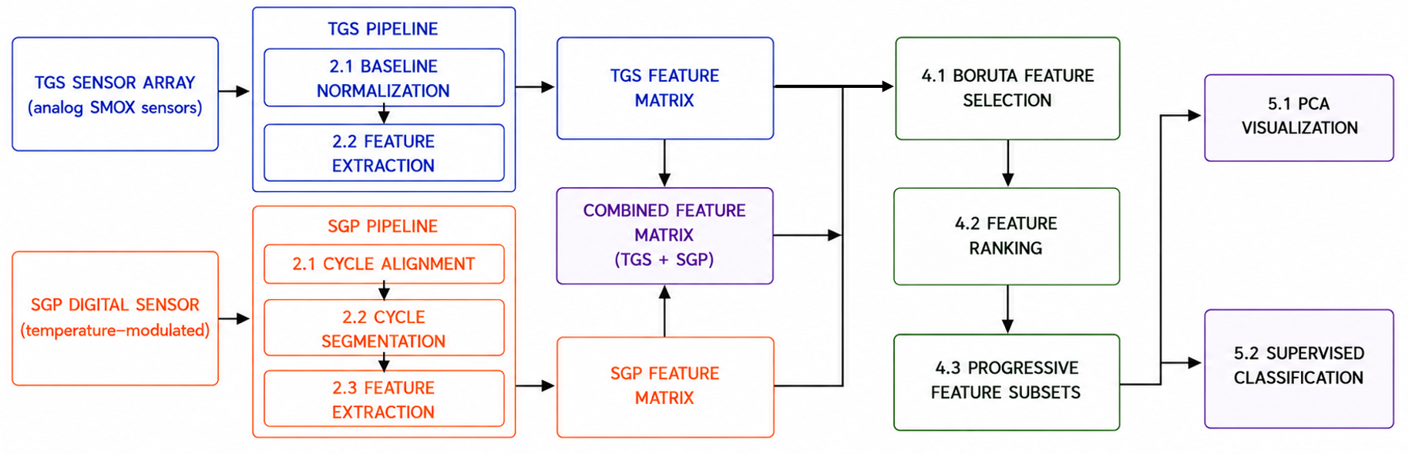
Figure 1 - Overview of the data-processing workflow adopted for the three sensing configurations.
  - Results
Prior to discussing the classification results, representative raw signal examples are reported to illustrate the typical response of the two sensor types to an odour exposure event. Figure 1a) shows the raw resistance signals of the six TGS analog sensors over a complete three-phase measurement cycle (Before, During, After). Each sensor exhibits a distinct baseline level and response amplitude, reflecting the different chemical sensitivity of each metal oxide formulation. A clear and consistent response is observed during the exposure phase, with sensors returning to near-baseline values during recovery. Figure 1b) shows the corresponding raw output of the digital SGP sensor. The characteristic oscillating pattern visible in the signal reflects the periodic temperature modulation applied to the sensing element. Although the sensor response to the odour sample may appear barely appreciable to the naked eye (given the dominant periodic structure of the signal) a subtle but consistent decrease in resistance values is nonetheless present during the exposure phase (During). This dynamic response constitutes the basis of the feature extraction pipeline described in Section 2.3.
The three sensing configurations - SGP-only, TGS-only, and combined SGP + TGS - were compared across multiple classifiers and progressively increasing feature subsets. Prior to the classification analysis, PCA was applied to the top Boruta-ranked features for each sensing configuration to provide a qualitative overview of the structure of each feature space (Figure 3). Following the Boruta feature selection procedure, retained variables were ranked by importance score, and the top eight were selected for visualisation because this number lies in the transition region where the TGS and SGP + TGS configurations had already reached very high classification performance across several models, while still maintaining a compact feature representation.
In the SGP-only projection (PC1: 76.6%, PC2: 18.2%), the plot revealed some class-related structure, but also partial overlaps between groups, with samples from different classes occupying neighboring regions in the PC1–PC2 plane. The TGS-only projection (PC1: 53.5%, PC2: 30.8%) showed a clearer organization of samples by class: Biogas, Leachate and Fresh-Waste formed distinct regions, while Engine-Outlet exhibited a broader spread along the second component. In the combined SGP + TGS projection (PC1: 47.8%, PC2: 32.2%), the four classes occupied more distinct areas with no overlap in the first two components, preserving the organized structure of the TGS-only space while incorporating information from both sensing modalities. Overall, the PCA plots suggest a progressive improvement in class separability from SGP-only to TGS-only to combined, a trend that is confirmed by the quantitative classification results.
The SGP-only configuration showed accuracy values that were strongly dependent on both the classifier and the number of selected features, ranging between 60% and 88% (k-NN, 12 features), with most classifiers stabilizing between 82% and 86%. The TGS-only configuration achieved higher and more consistent results, with multiple classifiers - including SVM, k-NN, Random Forest, ExtraTrees and PLS-DA - reaching 100% accuracy from approximately 8 selected features onward. The combined SGP + TGS configuration matched this maximum accuracy across most classifiers while requiring fewer selected features: k-NN reached 100% with only 3 features, Random Forest and SVM RBF with 4, and ExtraTrees and logistic regression elastic-net with 5. Classification accuracy obtained for the three sensor configurations as a function of the number of selected features are reported in Figure 4 for each sensor-array configuration.
  - Conclusion and Future Development
The SGP40-only configuration achieved classification performance comparable to, though not exceeding, that of the TGS array (maximum accuracy: 88% with k-NN; 82–86% for most other classifiers). Its integration into a combined array did not systematically increase the maximum accuracy—already reached by several classifiers in the TGS-only configuration—but reduced the number of features required to achieve it, with some classifiers reaching 100% accuracy with as few as 3 to 5 selected features. The compact form factor and lower cost of a single-sensor solution further support its relevance for practical deployment, particularly in distributed boundary monitoring applications where multiple devices must be installed across spatially constrained positions. The proposed workflow should nonetheless be regarded as a preliminary methodological framework. The dataset should be expanded to cover diverse seasonal and meteorological conditions, and the limited sample count for certain classes should be addressed to improve evaluation robustness. Trained models will require validation through long-duration field campaigns to assess drift stability and interference robustness. Future work should also investigate the minimum number of TGS sensors needed in the combined array to achieve the desired classification performance, with the aim of optimizing the trade-off between system complexity and accuracy. Additionally, the capability of the SGP40 for regression tasks should be explored, with a view to assessing its potential for odour concentration quantification.

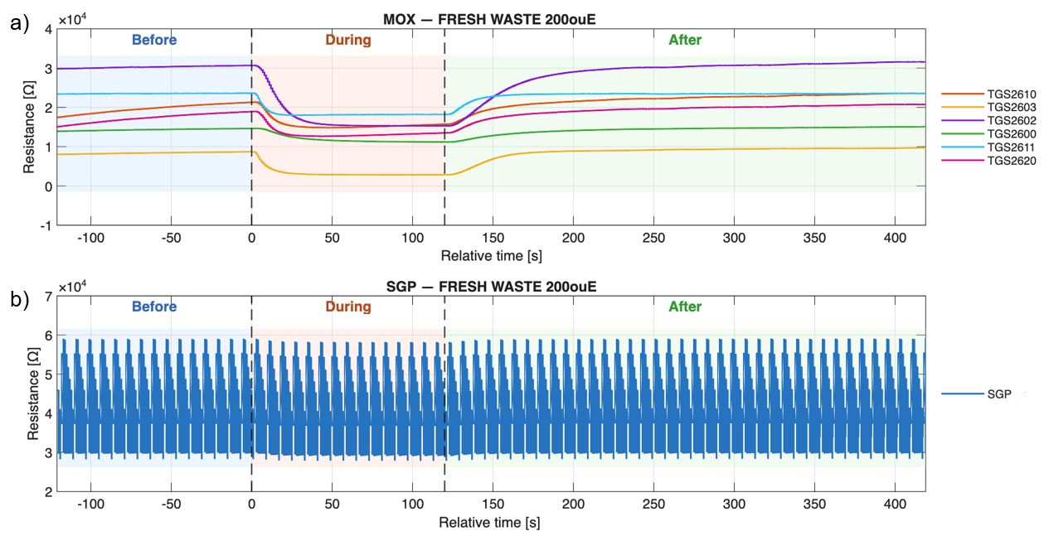
Figure 2 - a) Raw resistance signals of the six analog TGS sensors over a complete Before/During/After measurement. Shaded areas indicate the three measurement phases; b) Raw output of the digital SGP sensor over the full Before/During/After measurement.
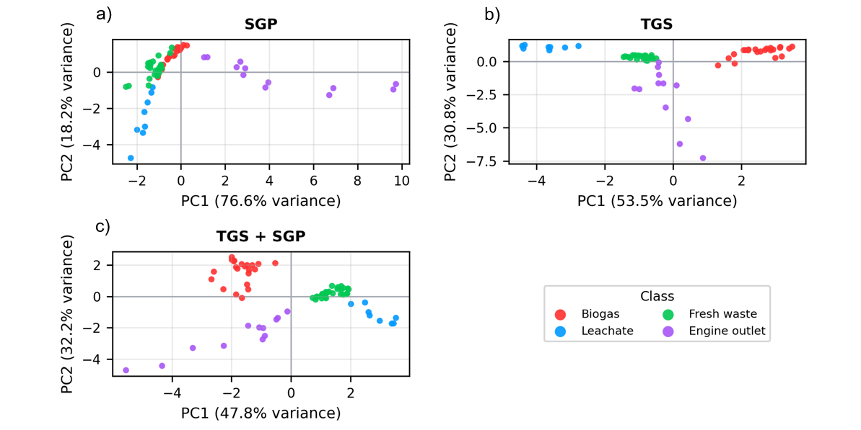
Figure 3 - Principal component analysis (PCA) score plots obtained using the eight selected features for the three sensor configurations: SGP (a), TGS (b), and combined TGS + SGP (c)
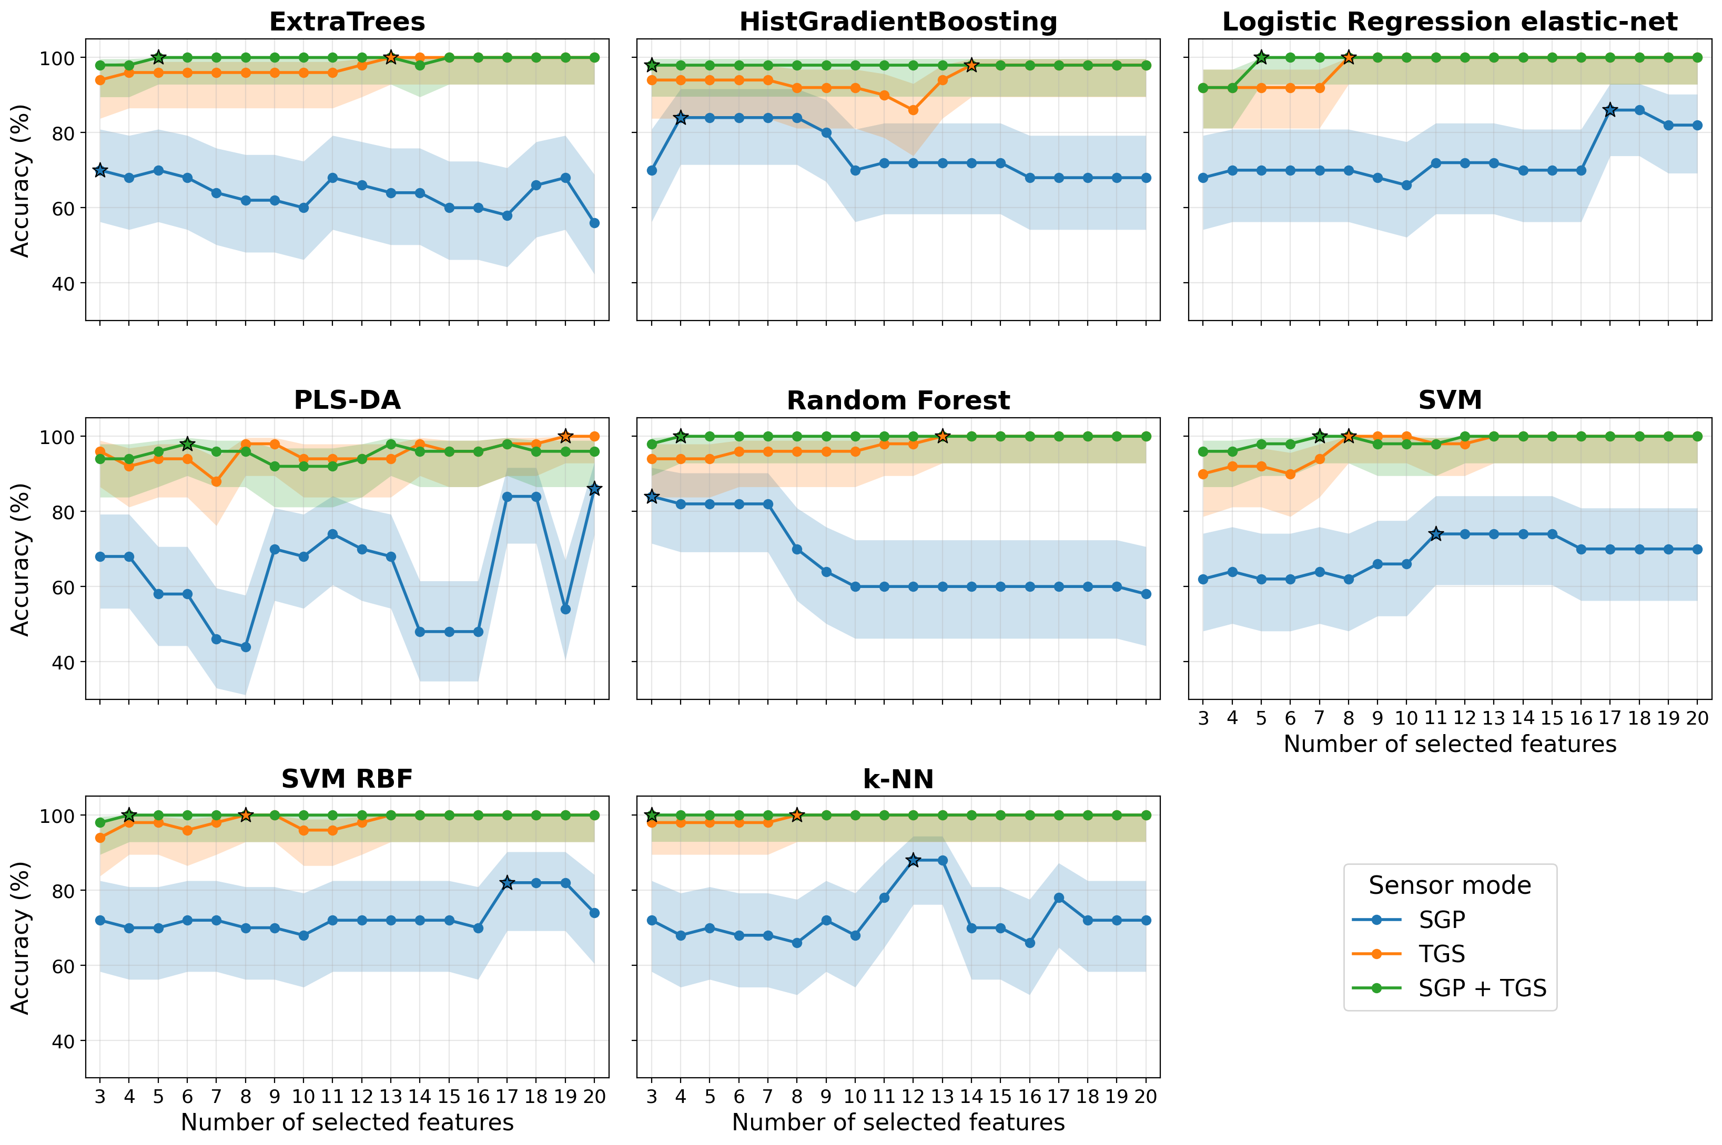

Figure 4 – Trend of the classification accuracy as a function of the number of selected features. Each panel reports the results for a different classification model, while the curves compare the SGP-only (blue), TGS-only (orange), and combined SGP + TGS (green) feature sets. The shaded areas indicate the 95% confidence interval of the test accuracy, and the star markers highlight the best accuracy reached by each sensor configuration within each model.
  - References
Di Giuseppe D. et al. (2021). Optimizing MOX sensor array performances with a reconfigurable self-adaptive temperature modulation interface. Sensors and Actuators: B. Chemical, 1-11.
Greenacre M. et al. (2022). Principal component analysis. Nature Reviews , 1-21.
Kursa M.B. and Rudnicki W.R. (2010). Feature Selection with the Boruta Package. Journal of Statistical Software, 1-13.
Bax C. & Capelli L. (2023). Odour Nuisance Monitoring. 95-113.
Bax C. et al. (2024). Continuous instrumental odor emission monitoring. Advances in Chemical Engineering, 63, 59-84.
Fine G.F. et al. (2010). Metal Oxide Semi-Conductor Gas Sensors in Environmental Monitoring. Sensors, 5469-5502.
Han J. et al. (2025). Advances in metal oxide semiconductor gas sensor arrays based on machine learning algorithms. Journal of Materials Chemistry C, 4285–4303.
Olivia G. et al. (2021). Nextgeneration of instrumental odour monitoring system (IOMS) for the gaseous emissions control in complex industrial plants. Chemosphere, 271.
Prudenza et al. (2023). Implementation of an electronic nose for real -time identification of odour emission peaks at a wastewater treatment plant. Heliyon.
Rock F. et al. (2008). Electronic Nose: Current Status and Future Trends. Chemical Reviews, 705-725.
Smulko et al. (2015). New approaches for improving selectivity and sensitivity of resistive gas sensors: a review. Sensor Review, 340-347.
Zalin M. & Sironi S. (2024). New Guidelines in Italy for the Regulation of Odour Emissions . Chemical Engineering Transactions, 13-18.

