 CHEMICAL ENGINEERING TRANSACTIONS  VOL. xxx, 2026 | A publication of  
The Italian Association
of Chemical Engineering
Online at www.cetjournal.it

Guest Editors: Laura Capelli, Marzio Invernizzi, Selena Sironi
Copyright © 2026, AIDIC Servizi S.r.l.
ISBN 979-12-81206-xx-x; ISSN 2283-9216

Instrumental Odour Monitoring Systems for early detection of Forest Fires
Ángel López, Cristina Brugera , José Luis Herrero , Patricia Arroyo , José Manuel Perea , Jesús Lozano*
Industrial Engineering School – University of Extremadura – Badajoz, Spain
jesuslozano@unex.es]
Early detection is one of the most effective strategies to reduce wildfire propagation, environmental damage and suppression costs. This work presents the design, development and experimental validation of an instrumental odour monitoring system (IOMS) for early forest fire detection based on autonomous gas sensing nodes. The proposed platform combines electrochemical gas sensors, photovoltaic energy harvesting and LoRaWAN wireless communications for deployment in remote areas without electrical infrastructure. The sensing nodes targeted early combustion markers, particularly carbon monoxide and volatile compounds. Experimental validation was performed in controlled combustion campaigns under wind tunnel conditions. Different enclosure and sampling configurations were compared, including active pumping, passive diffusion and solar radiation shielding. Results showed clear detection of smoke plumes at distances up to 40 m. Electrochemical CO sensors exhibited the highest sensitivity, while passive sampling inside a solar radiation shield provided the best compromise between sensitivity, thermal stability and energy autonomy. The system represents a scalable and cost-effective complement to conventional wildfire surveillance systems.
  - Introduction
Wildfires are among the most destructive environmental hazards affecting forest ecosystems, agricultural land and peri-urban areas. In addition to direct economic losses, fire events generate greenhouse gas emissions, particulate matter, soil degradation and biodiversity loss. Their incidence has increased in many regions due to climate change, prolonged droughts and accumulation of combustible biomass (Honary et al., 2025). Recent reviews confirm that efficient early detection remains one of the most critical factors for mitigating wildfire damage (Khan et al., 2026).
Extreme events such as the “Black Summer” in Australia (2019–2020) or the massive wildfires in California highlight the urgent need to improve prevention and early warning strategies. Early detection during the smouldering phase is crucial for containing fires. However, systems based on satellite imagery or ground-based cameras have limitations. Satellite and camera systems may be limited by terrain, weather, vegetation cover or night operation (Chan et al., 2024).
Combustion and pyrolysis processes release gaseous compounds before visible flames are fully developed. Carbon monoxide (CO), nitrogen oxides (NOx), ozone precursors and volatile organic compounds (VOCs) can therefore act as early chemical indicators of ignition. Gas sensing technologies have been proposed as complementary solutions for fire detection because they can operate continuously and independently of visibility conditions. Scorsone et al. (2006) demonstrated the potential of electronic noses for fire detection, while Fonollosa et al. (2018) reviewed the role of chemical sensor systems and signal processing strategies in this field.
Recent progress in miniaturised electronics, low-power communications and energy harvesting enables the deployment of distributed wireless sensor networks in remote natural environments. Among available technologies, electrochemical gas sensors offer low power demand, compact size and adequate sensitivity at ambient temperature. When integrated into autonomous nodes, they can support long-term monitoring applications (Wu et al. 2025). Recent field demonstrations based on distributed gas sensor networks further support the feasibility of autonomous wildfire monitoring platforms (De Rango et al., 2025).
The present work develops instrumental odour monitoring systems (IOMS) using two complementary sensing strategies: selective nodes based on electrochemical sensors and ultra-low power nodes based on metal oxide (MOX) sensors.
The objective of this paper was to evaluate both approaches under realistic biomass combustion scenarios and identify suitable configurations for autonomous wildfire early warning networks.
  - Materials and methods
This section summarises the architecture of the developed system, the sensing node configurations and the experimental validation campaigns.
    - General architecture of the IOMS
The proposed IOMS was conceived as a distributed wireless sensor network composed of autonomous sensing nodes and a central gateway connected to cloud services. Each node integrates the sensors, microcontroller, power management, and communication module.
Regarding the sensors, electrochemical sensors (CO, NO₂, O₃) or VOC/PM detectors (e.g., PID, MOS sensors) are used depending on the configuration. The microcontroller, an STM32WLE5JC, is responsible for acquiring sensor signals, processing them locally, and managing communication. The nodes also feature a solar power subsystem with a monocrystalline panel, an MPPT controller, and a rechargeable Li-ion battery (e.g., LIR1254). This system provides continuous autonomous power, enabling 24/7 maintenance-free operation. Extreme energy efficiency (sleep mode between measurements) is prioritized to maximize battery life. Finally, a LoRaWAN module (868 MHz ISM) is used for long-range communication. High transmission power is initially configured to establish a link under adverse conditions, and then the ADR (Adaptive Data Rate) algorithm is used to balance link range, network load, and power consumption.
The entire network is centralized through an IoT gateway, which is also powered by solar energy and equipped with 4G/LTE connectivity. The gateway receives LoRaWAN packets from the nodes and forwards them to the backend server (The Things Network) via MQTT. There, the data is stored in a temporary InfluxDB database and visualized on a Grafana dashboard for real-time monitoring and alert generation. The overall communication and energy architecture of the proposed platform is shown in Figure 1.

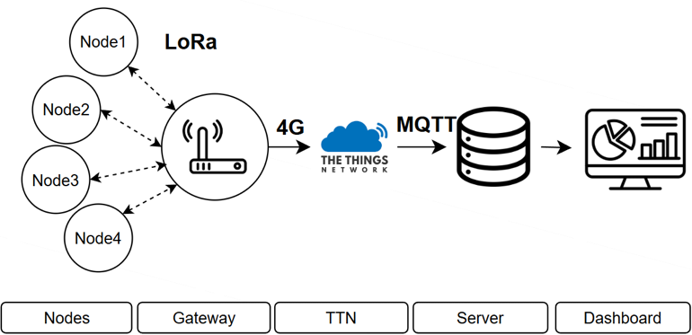
Figure 1: General architecture of the IOMS including sensor nodes, gateway, LoRaWAN communications and cloud platform.

    - Nodes design
Two types of nodes were built:
- Selective electrochemical nodes: They are equipped with an electrochemical front-end module (Texas Instruments LMP91000) that supports up to 2–4 electrodes, to which electrochemical sensors (CO, NO₂, O₃) or a PID detector for VOCs from Alphasense.
- Ultra-low-power MOX nodes: These incorporate low-cost metal oxide (MOX) sensors for general VOC mixtures, specifically ENS161 (ScioSense) and BME688 (Bosch Sensortec), with reduced power consumption. Different housings were tested: polycarbonate casing (PC) with waterproof membrane, similar enclosure without membrane, and solar radiation shield with passive ventilation. All configurations operated with passive sampling (without a pump). Their low power consumption allows fully autonomous operation using photovoltaic energy harvesting and rechargeable battery supply.

These variants were used to evaluate enclosure effects and compare selective and unselective sensing approaches.
    - Experimental campaigns
Controlled biomass combustion experiments were conducted in a wind tunnel at the National Institute for Agricultural and Food Research and Technology (INIA-CSIC, Madrid). The used fuel was dry pine needles (Pinus pinea), 500 g per test. Three speeds (1, 2, and 3 m/s) were configurated to simulate different dispersion conditions. Sixteen MOX nodes and two electrochemical nodes were deployed along the tunnel in sections separated by 5 m approx. (see Figure 2). Some MOX nodes were without a membrane, others were protected by a solar shield; some were in PC housings with or without a waterproof membrane. The SEC nodes (CO, NO2, VOC + PID) were in PC housings with an active pump. The farthest sensor was approximately 55 m from the source.
In each test, the pine needle sample was ignited at the tunnel entrance. The nodes recorded sensors responses at 1 Hz, and the signal from each sensor was collected. The experiment was repeated with different combinations of wind conditions and node arrangements. Figure 2 illustrates the spatial distribution of ULP and SEC nodes around the wind tunnel facilities.

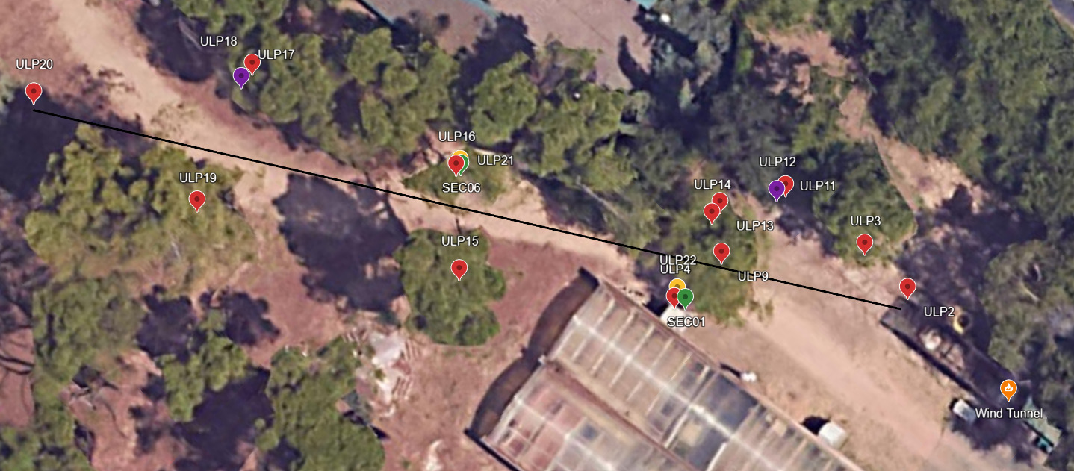
Figure 2: Layout of deployed nodes around wind tunnel facilities. ULP: MOX nodes; SEC: Electrochemical nodes.

  - Results and discussion
The following subsections describe the main experimental findings related to wind transport, sensing technologies and enclosure design.

    - Influence of plume transport and wind speed
All tested node families detected combustion events during the experimental campaigns, although the response strongly depended on airflow conditions and plume transport. At low wind speed (1 m/s), detection was limited to a reduced number of nodes, particularly those installed inside solar radiation shields. As wind velocity increased to 2 m/s, the smoke plume travelled more horizontally and a greater number of nodes registered measurable responses. Under the highest tested airflow (3 m/s), the plume reached additional distant devices, producing responses over a wider monitoring area.
Figure 3 compares the response of two MOX nodes located at different distances from the source. It can be seen that the nearest node (ULP2) showed an earlier and stronger response, whereas the farther node (ULP11) responded later. This behaviour confirms that gas-based wildfire detection is highly influenced by atmospheric transport conditions. Therefore, sensor placement should consider prevailing winds, local topography and likely ignition zones in real deployments.
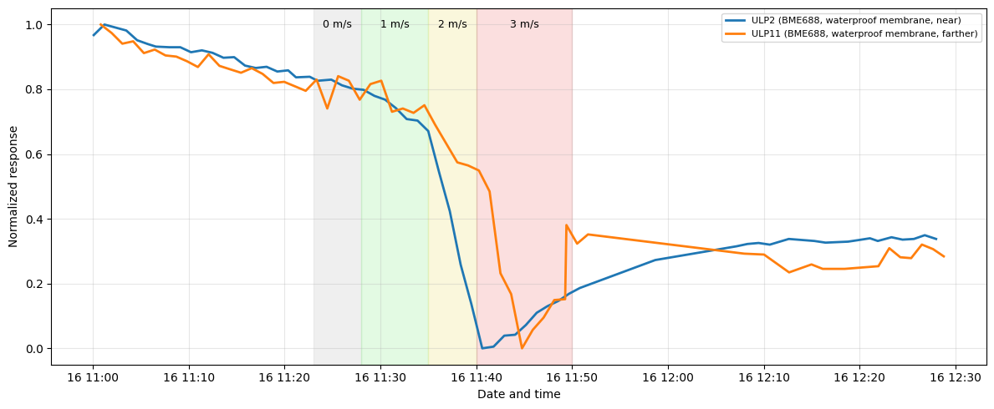
Figure 3: Representative sensor responses at different wind velocities.
    - Comparative performance of node technologies
The selective electrochemical nodes exhibited the highest sensitivity and fastest response during the combustion tests. Carbon monoxide sensors showed strong signal changes immediately after plume arrival, while NO₂ and VOC-related channels also responded depending on combustion stage and plume composition. These results indicate that electrochemical nodes are suitable for critical monitoring points where rapid and robust alarm capability is required.
The ultra-low power MOX nodes also detected smoke plumes successfully, although their signals were generally lower in amplitude and more affected by environmental conditions. However, their low energy demand, reduced cost and simpler integration make them attractive for dense spatial deployment.
Consequently, both technologies should be considered complementary rather than competitive: electrochemical nodes provide analytical robustness, whereas MOX nodes provide scalable territorial coverage. Figure 4 compares co-located sensing nodes. It can be noted that the shielded MOX node showed earlier and more sustained responses, the membrane-protected MOX node exhibited a weaker response, and the electrochemical CO sensor generated a sharp high-intensity peak during plume arrival.

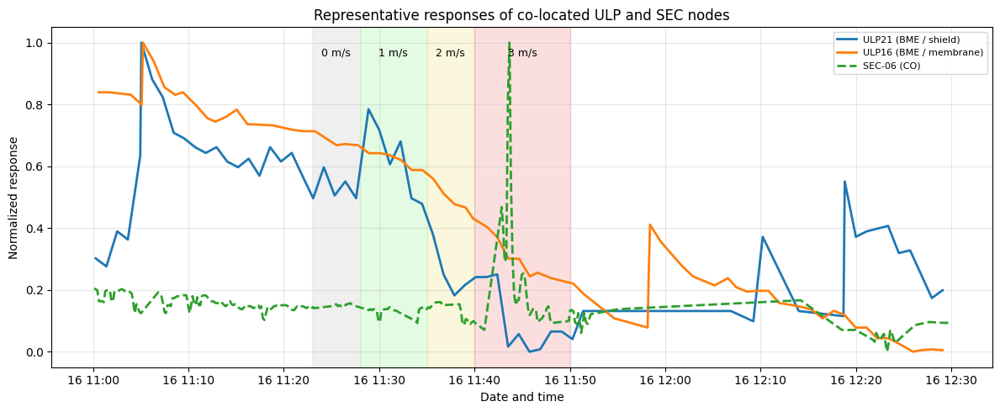
Figure 4: Normalized responses of co-located MOX and electrochemical nodes.
    - Influence of housing design on MOX nodes
The enclosure design had a significant impact on the behaviour of the ultra-low power MOX nodes. Table 1 summarises the practical advantages and limitations of each enclosure configuration.
Table 1: Effect of enclosure type on MOX node behaviour
Enclosure type | Response speed | Signal stability | Outdoor suitability
Waterproof membrane | Moderate / slow | Good | High
Open polycarbonate | Fast | Moderate / low | Medium
Solar radiation shield | Fast | High | Very high

Devices equipped with waterproof membranes showed slower and attenuated responses, suggesting partial resistance to gas diffusion into the sensing chamber. Although this configuration offers environmental protection, it may reduce analytical sensitivity.
Open polycarbonate housings provided faster responses because gases reached the sensors more easily. Nevertheless, these devices were more exposed to ambient fluctuations and direct solar radiation, which introduced signal drift.
The best compromise was obtained with the solar radiation shield configuration. This design preserved passive airflow while reducing thermal disturbances caused by direct sunlight. As a result, the nodes installed inside radiation shields showed more stable baselines together with clear responses during combustion events.
The influence of housing design on MOX behaviour is illustrated in Figure 5. Within it, membrane-protected nodes showed slower and attenuated responses, whereas the open node reacted rapidly but with larger signal fluctuations. The solar radiation shield provided the most stable and consistently responsive behaviour. These findings indicate that mechanical design is as important as sensor selection when developing outdoor chemical monitoring systems.
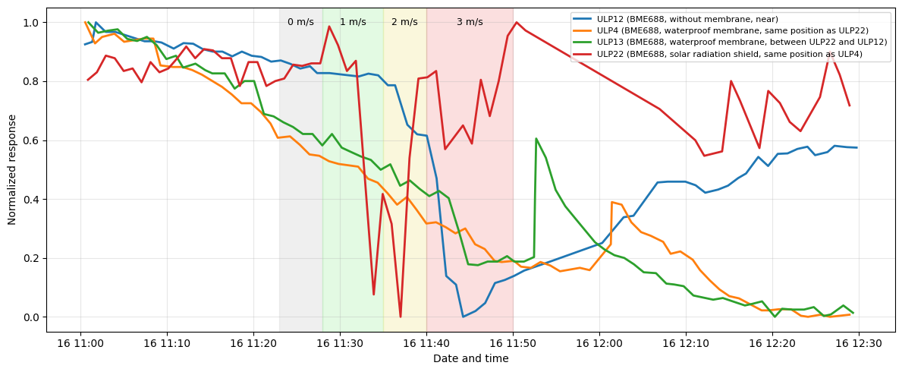
Figure 5: Comparative response of MOX nodes with waterproof membrane, open housing and solar radiation shield.
    - Deployment implications and operational observations
The furthest deployed sensor was located at approximately 55 m from the combustion source, while the maximum clearly confirmed detection distance for the ULP nodes was 40 m. These results support the feasibility of gas-based early warning systems for distributed wildfire monitoring.
From an operational perspective, a hybrid deployment strategy is recommended. Selective electrochemical nodes can be installed in strategic locations such as access roads, high-risk areas or critical infrastructures, where high-confidence alarms are required. In parallel, dense networks of ULP MOX nodes may provide broader territorial coverage at lower cost.
Several practical observations were also made during the campaigns. Isolated signal spikes were mainly associated with temporary communication interruptions, while sensor baselines became progressively more stable after several hours of continuous operation. In addition, compensation using temperature and relative humidity measurements may further improve long-term reproducibility, especially for MOX sensors.
  - Conclusions
Instrumental odour monitoring systems based on autonomous gas sensing nodes were successfully developed and validated for early forest fire detection. Two complementary sensing strategies were evaluated: selective electrochemical nodes and ultra-low power MOX nodes. From the experimental campaigns carried out under controlled combustion conditions, several relevant conclusions can be drawn regarding the use of autonomous gas sensing nodes for early forest fire detection.
Electrochemical nodes delivered the strongest responses and highest sensitivity to combustion emissions. MOX nodes also detected smoke plumes effectively, while offering lower cost, simpler integration and suitability for large-scale deployment.
The tests also showed that the enclosure design strongly influenced MOX behaviour. Passive sampling inside a solar radiation shield provided the best balance between sensitivity, thermal stability and outdoor robustness.
Clear detection was achieved up to 40 m, whereas the furthest deployed node was located at approximately 55 m from the source.
The results obtained support the implementation of hybrid wireless gas sensing networks with LoRaWAN connectivity and autonomous photovoltaic supply as an economically viable complement to conventional wildfire surveillance systems.
Acknowledgments
This work has been partially supported by the European Union, the European Regional Development Fund, and the Regional Government of Extremadura (GR24182). This work has also been funded by the Interreg Sudoe 2021–2027 programme under the SenForFire project (Grant Agreement No. S1/1.1/E0040), co-funded by the European Regional Development Fund (ERDF/FEDER).
References
Chan C. C., Alvi S. A., Zhou X., et al. (2024). A Survey on IoT Ground Sensing Systems for Early Wildfire Detection: Technologies, Challenges and Opportunities, IEEE Access, 12, 172785-172819.
De Rango A., Furnari L., Cortale F., Senatore A., Mendicino G., 2025, Wildfire Early Warning System Based on a Smart CO2 Sensors Network, Sensors, 25, 2012.
Fonollosa J., Solórzano A., Marco S., 2018, Chemical sensor systems and associated algorithms for fire detection: A review, Sensors, 18, 553.
Honary R., Shelton J., Kavehpour P., 2025, A review of technologies for the early detection of wildfires, ASME Open Journal of Engineering, 4, 031005.
Khan A.H., et al., 2026, A Review on Forest Fire Detection Techniques, Sensors, 26, 1609.
Scorsone E., Pisanelli A.M., Persaud K.C., 2006, Development of an electronic nose for fire detection, Sensors and Actuators B: Chemical, 116, 55–61.
Wu Q., Ding Z., Zhang W., 2025, Research progress on electrochemical gas sensors for fire detection, International Journal of Electrochemical Science, 101043.

