 CHEMICAL ENGINEERING TRANSACTIONS  VOL. xxx, 2026 | A publication of  
The Italian Association
of Chemical Engineering
Online at www.cetjournal.it

Guest Editors: Laura Capelli, Marzio Invernizzi, Selena Sironi
Copyright © 2026, AIDIC Servizi S.r.l.
ISBN 979-12-81206-xx-x; ISSN 2283-9216

3D-PRINTED BIO-DERIVED CATALYTIC STRUCTURES FROM SPENT COFFEE GROUNDS FOR VOC REMOVAL
Claudia Cirillo¹ , Mariagrazia Iuliano¹ , Giorgio Crescenzo^{1*}, Luca Gallucci¹ , Maria Sarno¹
¹Department of Physics “E.R Caianiello” and Centre NANO_MATES University of Salerno Via Giovanni Paolo II ,132 - 84084 Fisciano (SA), Italy
*gcrescenzo@unisa.it

The present study investigates the development of structured catalytic filters based on bio-derived materials for volatile organic compound (VOC) removal. A 3D-printed scaffold was fabricated using PLA filament containing spent coffee grounds (SCG), providing a sustainable and geometrically controlled support. The printed structures were subsequently modified through solvent treatment and impregnated with Co/Ce active phases to introduce catalytic functionality. The morphological and chemical properties of the materials were characterized, confirming the successful incorporation and homogeneous dispersion of the metal species without altering the macroporous architecture. The introduction of Co and Ce led to increased surface roughness and the formation of active metal oxide sites. The adsorption and catalytic performances were evaluated under continuous-flow conditions using toluene as a model VOC. The material exhibited a bifunctional behavior, with high adsorption efficiency at room temperature and increasing catalytic activity at elevated temperatures. The catalytic system reached a toluene conversion of 73% at 250 °C. The enhanced performance was attributed to the synergistic interaction between cobalt and cerium species, promoting oxygen mobility and redox activity. The results demonstrate that combining bio-derived materials, additive manufacturing, and catalytic functionalization represents a promising strategy for the design of efficient and sustainable structured filters for VOC abatement.
  - Introduction
Commuters spend nearly 8% of their lifetime inside vehicles, making the automotive cabin a critical microenvironment of exposure. Due to confined volumes and continuous interaction with traffic emissions, vehicle interiors can accumulate significant concentrations of volatile organic compounds (VOCs), originating from outdoor air infiltration, off-gassing of materials, and occupant activities (Chen et al., 2024; Sarno et al., 2017). These include aliphatic hydrocarbons, carbonyl compounds, and aromatics such as formaldehyde, acetaldehyde, benzene, toluene, and xylene, which are associated with respiratory diseases, neurological effects, and cancer risks (Bakeas et al., 2003). Cabin air filters are the main mitigation strategy, evolving from particulate removal to the inclusion of activated carbon for VOC adsorption. However, their limited adsorbent loading and lack of optimization between particulate and gaseous filtration reduce efficiency, especially under dynamic conditions (He et al., 2016). Catalytic oxidation has emerged as an effective alternative, converting VOCs into CO₂ and H₂O at relatively low temperatures (Du et al., 2020). While noble metals are highly active, transition metal oxides offer a cost-effective solution (Yusuf et al., 2020). In particular, cobalt oxides provide strong redox activity, while cerium oxide enhances oxygen mobility through the Ce³⁺/Ce⁴⁺ cycle (Zhu et al., 2023). Their combination leads to synergistic improvements in catalytic performance. Despite their potential, powder catalysts suffer from high pressure drop and poor integration into filtration systems. Structured catalysts produced via additive manufacturing offer a promising alternative, enabling precise geometry control, improved flow dynamics, and efficient material use (Quintanilla et al., 2018). Applications have been demonstrated in emission control, wastewater treatment, and chemical synthesis (Hajimirzaee et al., 2020; Quintanilla et al., 2018; Middelkoop et al., 2019), although studies on VOC oxidation, particularly for toluene, remain limited. Notably, enhanced catalytic performance has been reported in 3D-printed monoliths due to improved gas mixing and coating strategies (Davó-Quiñonero et al., 2019; Rokicinska et al., 2021). Adsorption remains effective at low temperatures but is limited by saturation and regeneration issues. Integrating adsorption and catalysis within a single structured material can overcome these limitations. In this work, structured filters were developed via additive manufacturing using spent coffee grounds as a sustainable and renewable carbon precursor (Wang et al., 2022; Wen et al., 2019). Through 3D printing, architectures with controlled geometry and engineered flow channels were fabricated, enabling enhanced mass transfer and uniform gas distribution. This approach allows precise tuning of structural parameters, overcoming the limitations typically associated with conventional packed or fibrous systems. The resulting PLA–coffee-based structures were subsequently functionalized with cobalt and cerium oxides to enhance catalytic activity toward toluene oxidation. The incorporation of Co/Ce active phases promotes the formation of redox-active sites and improves oxygen mobility, which are key factors in VOC catalytic oxidation processes. This design enables a synergistic adsorption–catalysis mechanism, in which the carbonaceous matrix acts as an efficient adsorbent for VOC molecules, while the Co/Ce active sites facilitate their catalytic conversion into less harmful products. Such integration allows the material to operate effectively across a wide range of conditions, combining high adsorption efficiency at low temperatures with increasing catalytic performance at elevated temperatures. Compared to conventional powder catalysts and granular adsorbents, the proposed structured system exhibits improved mechanical stability and enhanced pollutant removal efficiency under realistic operating conditions, highlighting its potential for advanced air purification applications.
  - Materials and Methods
2.1. Materials
PLA Café filament (diameter: 1.75 mm), containing spent coffee grounds (SCG), was supplied by Francofill. All chemical reagents, including acetone, cobalt nitrate, and cerium nitrate, were purchased from Sigma-Aldrich and used as received without further purification. Gas cylinders of toluene with a concentration of 1000 ppmv, pure O₂ (99.99 %), and N₂ gas (99.99 %) were provided by SOL S.p.A.

2.2. Fabrication of PLA/SCG scaffold
The PLA Café filament was used for fabrication. The three-dimensional model was designed in a CAD environment, specifically Autodesk Fusion 360, enabling the development of an adsorbent element with a controlled geometry. The main characteristics of the designed structure, including technical drawings, geometric dimensions, and the 3D model, are summarized in Table 1. The PLA Café filter was manufactured using fused deposition modeling (FDM) technology with a Bambu Lab P2S printer equipped with a 0.4 mm nozzle. The printing process was conducted at an extrusion temperature of 200 °C and a bed temperature of 50 °C. The composite filament was deposited layer by layer, adopting alternating raster orientations of 90° between successive layers to enhance structural integrity and mechanical performance. The printing speed was maintained at 40 mm/s. The resulting structure exhibited a well-defined cylindrical geometry.
Table 1. Geometrical dimensions and structural design parameters of the single PLA/SCG adsorbent structure.
Structure Description | 3D Model | Technical Drawing
The structure exhibited a cylindrical geometry with symmetrically distributed rectangular pores. The model had a diameter of 27 mm and a height of 3 mm | 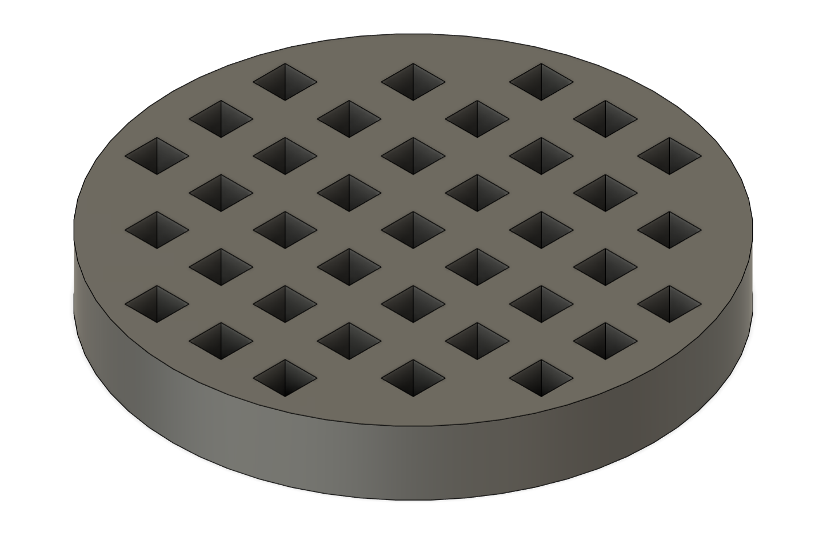 | 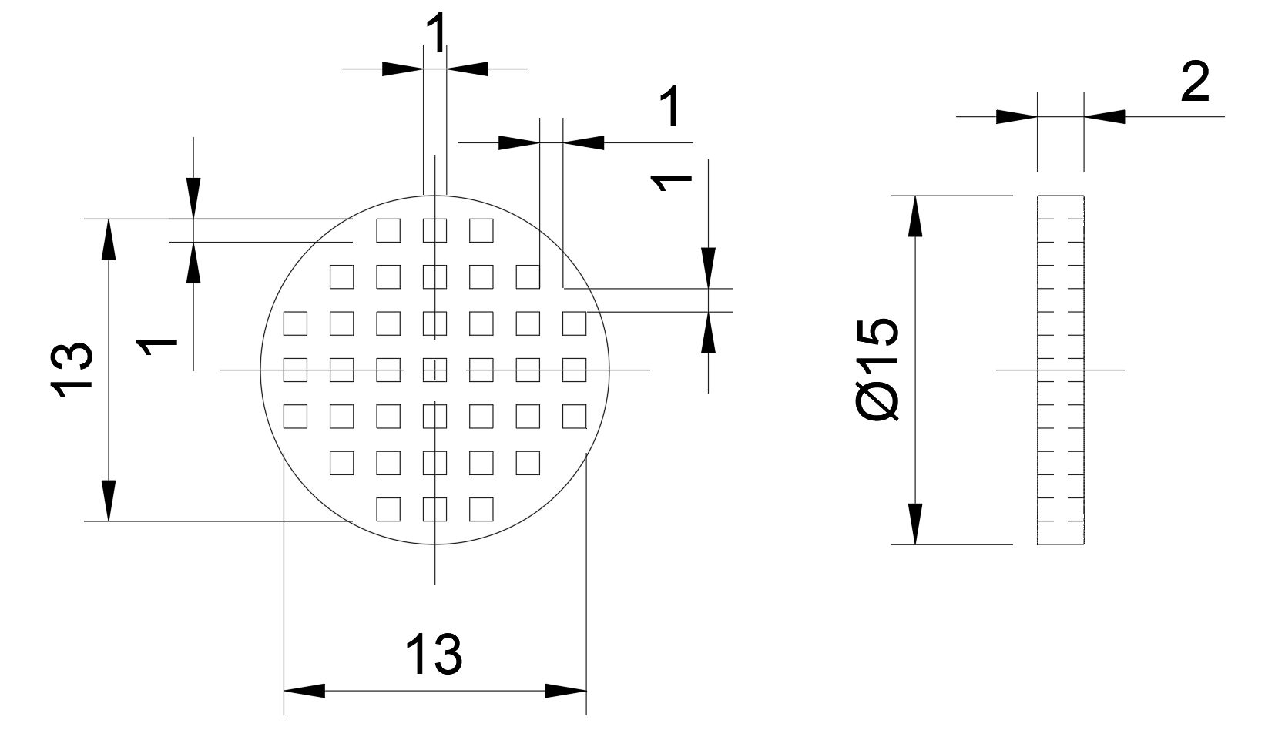
    - Surface modification and catalyst deposition on 3D-printed PLA Café structures
To tailor the surface properties and promote the exposure of embedded spent coffee grounds (SCG) particles, the 3D-printed PLA Café filter (3D-PLA Café filter) was subjected to a mild solvent treatment. Specifically, the samples were immersed in a diluted acetone solution (acetone: DI water = 95:5, v/v) for 24 h. This treatment induced a partial modification of the PLA matrix, increasing surface roughness and enabling the exposure of coffee-derived functional groups. Following treatment, the samples were carefully removed, extensively rinsed with deionized water, and sonicated to eliminate any loosely adhered residues. The filters were then dried in an oven at 60 °C to ensure homogeneous and complete solvent removal. Structured catalysts were subsequently prepared through iterative immersion–drying cycles. Each cycle involved the immersion of the 3D-PLA Café filter in a precursor solution containing cobalt and cerium nitrates (Co: Ce molar ratio = 90:10) for 1 min, followed by a drying step at 80 °C for 15 min. This procedure enabled the controlled deposition of the active phase onto the structured support. The catalyst loading was determined gravimetrically by measuring the mass of the samples before impregnation and after each drying step. The immersion–drying cycles were repeated until a total active phase loading of approximately 4 wt.% was achieved.
    - Performance assessment of structured filters for VOC abatement
The adsorption and catalytic oxidation performances of toluene over Co/Ce@3D-PLA Café filter were evaluated using a continuous fixed-bed reactor consisting of a quartz tube operating under atmospheric pressure. The sample was placed at the center of a tube between two layers of quartz wool (Figure 1). The reaction temperature was monitored using a thermocouple connected to a temperature controller. Before each experiment, the samples were pretreated at 120 °C for 1 h under a flow of N₂ (100 mL/min) to remove moisture and surface impurities. All experiments were carried out in duplicate, and the reported results correspond to the average values.The hourly gas space velocity (GHSV) was set at 20000 mL/(g·h). The adsorption test was conducted at 25 ± 2 °C using a gas stream containing 250 ppmv of toluene. The selected toluene concentration was chosen to represent typical VOC levels encountered in indoor air purification applications and low-concentration industrial emissions, particularly in confined environments such as vehicle cabins and advanced air filtration systems. Nevertheless, catalytic performance may vary significantly at higher pollutant concentrations due to mass transfer limitations, active site competition, and surface saturation effects. The inlet and outlet concentrations were measured using gas detection tubes for rapid and comparative evaluation under controlled and reproducible conditions. The catalytic activity was evaluated using a feed containing 250 ppmv of toluene and 10% O₂, under the same GHSV conditions. To ensure data reliability, each temperature was maintained for 25 min before measurement.

Figure 1. Schematic diagram of the experimental setup for evaluating the adsorption and catalytic oxidation performance.
    - Characterization
The morphology of the samples at different stages of preparation was analyzed using scanning electron microscopy (SEM) combined with energy-dispersive X-ray spectroscopy (EDX). The analysis was performed using a TESCAN VEGA LMH microscope (230 V). FT-IR spectra were recorded using a Nicolet iS50 spectrometer.
  - Results and Discussion
    - Characterization of 3D-PLA Café filter
The morphological and compositional properties of the materials before and after metal incorporation were investigated by SEM analysis, as shown in Figure 2. The pristine 3D-PLA Café filter (Figures 2a and 2b) exhibits a well-defined architecture with a compact surface. At higher magnification (Figure 2b), the surface appears smooth and dense, with low surface roughness, which is characteristic of PLA-based materials. After thermal treatment and subsequent impregnation with Co and Ce species (Figures 2c and 2d), significant changes in surface morphology are observed. The overall structure remains preserved, indicating that the impregnation process does not compromise the structural integrity of the 3D-printed support. However, the surface becomes noticeably rougher and more heterogeneous. Figure 2d highlights the formation of a porous and granular texture, which can be attributed to the deposition of metal oxide nanoparticles. The elemental mapping and EDX spectrum (Figure 2e) further confirm the successful incorporation of cobalt and cerium species onto the support. The mapping images show a relatively homogeneous distribution of Co and Ce over the material surface, without evident aggregation, indicating good dispersion of the active components. The presence of O is associated with both the oxidized forms of the metals and oxygen-containing functional groups of the carbonaceous matrix. The dominant signal of C is consistent with the polymeric and biomass-derived nature of the support. FT-IR spectra of the pristine 3D-PLA Café filter and the Co/Ce-impregnated sample were analyzed to investigate the surface functional groups and the effect of metal incorporation (Figure 2f). For the pristine material, the spectrum exhibits the characteristic bands of PLA. A strong absorption band around 1750 cm⁻¹ is assigned to the stretching vibration of the ester carbonyl group (C=O), which is a distinctive feature of PLA. The bands in the region of 1180–1080 cm⁻¹ correspond to C–O–C stretching vibrations, confirming the presence of ester linkages in the polymer backbone. Additionally, the peaks observed near 1450–1380 cm⁻¹ are attributed to –CH₃ bending vibrations, while those around 2990–2940 cm⁻¹ correspond to C–H stretching (Cirillo et al., 2025; Scarpa et al., 2024). After impregnation of Co and Ce species, significant changes are observed in the FT-IR spectrum. In particular, the appearance of a broad band in the 3200–3500 cm⁻¹ region indicates the presence of O–H stretching vibrations, which can be associated with metal–hydroxide species (Rajalekshmi et al., 2024) formed during the impregnation process. This suggests that the surface chemistry of the material is significantly modified after metal incorporation. These surface modifications may contribute to the enhanced catalytic activity by improving oxygen activation and interactions between toluene molecules and active sites. Furthermore, slight changes in the intensity and position of the carbonyl (C=O) band suggest possible interactions between metal species and oxygen-containing functional groups of the support.

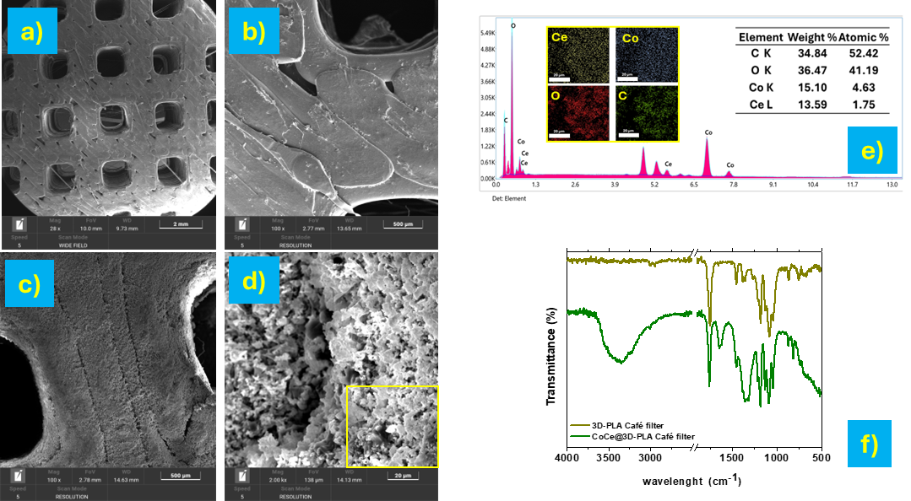
Figure 2 SEM images of pristine 3D-PLA Café filter (a, b) and Co/Ce-impregnated sample (c, d), along with elemental mapping and EDX spectrum (e), and FT-IR spectra of the materials before and after impregnation.
    - Adsorption and catalytic performance analysis
The obtained results clearly indicate that Co/Ce@3D-PLA Café filter exhibits a bifunctional behavior, combining effective adsorption capacity at room temperature with progressively enhanced catalytic activity as the temperature increases. This dual functionality suggests that the material can operate efficiently over a wide range of operating conditions, adapting the dominant toluene removal mechanism depending on the temperature (Figure 3). Regarding the adsorption behavior (Figure 3a), the sample exhibited a high initial toluene removal efficiency at 25 °C, followed by a gradual decrease over time due to progressive saturation of active sites. The removal curve shows a typical dynamic adsorption profile, characterized by a rapid initial uptake of toluene followed by a decline in efficiency. This behavior is characteristic of fixed-bed adsorption systems and highlights the importance of both surface accessibility and pore structure in determining adsorption performance. The observed trend is indicative of a physisorption-dominated process, in which toluene molecules are initially retained on the surface of the material through weak interactions, such as van der Waals forces and π–π interactions with the carbonaceous matrix. As time increases, the occupation of the available sites reduces the ability of the material to adsorb additional toluene molecules, resulting in a continuous decrease in removal efficiency. At prolonged contact times, the toluene removal decreases to very low values, indicating the progressive exhaustion of the adsorption capacity of the material. This behavior highlights that the adsorption process strongly depends on both the availability of active sites and the accessible surface structure. This adsorption stage plays a crucial role in the overall process, as it enables the temporary accumulation of toluene molecules on the surface, facilitating their subsequent catalytic oxidation at higher temperatures.
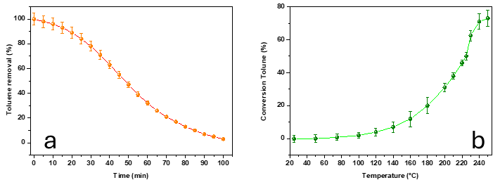
Figure 3 (a) Toluene removal efficiency during adsorption at 25 °C; (b) toluene conversion as a function of temperature over Co/Ce@3D-PLA Café filter.
In contrast, the catalytic oxidation performance (Figure 3b) shows a steady increase in toluene conversion with increasing temperature, rising from negligible values at low temperatures to 73% at 250 °C. This trend indicates that the process is governed by the thermal activation of catalytic sites and the increasing availability of reactive oxygen species. In particular, the more pronounced increase in conversion observed above 180–200 °C suggests the onset of more efficient activation of both toluene and oxygen on the catalyst surface, leading to an acceleration of oxidation reactions. The improved performance at elevated temperatures can be attributed to the synergistic interaction between Co and Ce species. A preliminary comparison with pure PLA and single-metal catalysts was performed, showing lower toluene conversion values (approximately 5–12% at 250 °C) compared to the Co/Ce-functionalized structure. These results suggest a synergistic effect between Co and Ce species, enhancing oxygen mobility and catalytic activity. Cobalt acts as the primary active phase, providing sites for toluene adsorption and activation, while cerium plays a key role in enhancing oxygen mobility through the Ce³⁺/Ce⁴⁺ redox cycle. This redox process facilitates the formation and rapid transfer of active oxygen species, including lattice and surface oxygen species, which directly participate in the oxidation mechanism. The reaction pathway is likely governed by a Mars–van Krevelen mechanism, in which lattice oxygen reacts with toluene to form oxidized products, generating oxygen vacancies that are subsequently replenished by gaseous oxygen. Furthermore, the presence of cerium promotes the formation of oxygen vacancies and improves the dispersion of cobalt species, thereby increasing the number of accessible active sites. The cooperative interaction between Co and Ce contributes to lowering the activation energy of the oxidation reactions and enhances the overall catalytic efficiency. Further investigations are required to evaluate product selectivity and confirm complete oxidation toward CO₂. In particular, gaseous products such as CO and partially oxidized intermediates were not quantified, since the experimental setup was primarily designed to evaluate toluene conversion efficiency and adsorption/catalytic behavior.
  - Conclusions
In this work, structured catalytic filters based on 3D-printed PLA/SCG composites were successfully developed and functionalized with Co/Ce active phases for VOC removal. The additive manufacturing approach enabled the fabrication of well-defined architectures with controlled geometry, while the impregnation process introduced catalytically active sites without compromising the structural integrity of the support. Characterization results confirmed that the pristine PLA-based material exhibited a smooth and compact surface, whereas the incorporation of Co and Ce led to increased surface roughness and the formation of dispersed metal oxide species. FT-IR analysis further demonstrated the modification of surface chemistry after impregnation, indicating the introduction of hydroxyl groups and metal–oxygen interactions. Performance tests revealed a dual-function behavior of the material. At room temperature, the system showed high adsorption capacity, governed by physisorption mechanisms, while at higher temperatures catalytic oxidation became dominant, with a progressive increase in toluene conversion up to 73% at 250 °C. The improved catalytic activity was attributed to the synergistic interaction between Co and Ce, enhancing oxygen mobility and facilitating redox processes, likely following a Mars–van Krevelen mechanism. These results suggest that the proposed system could be effectively applied in advanced air purification applications. Future work will focus on long-term stability and performance under realistic operating conditions.

References

Bakeas E.B., Argyris D.I., Siskos P.A., 2003, Carbonyl compounds in the urban environment of Athens, Greece, Chemosphere, 52, 805–813.
Chen B., Lian Y., Xu L., Deng Z., Zhao F., Zhang H., Liu S., 2024, State-of-the-art thermal comfort models for car cabin environment, Building and Environment, 262, 111825.
Cirillo C., Iuliano M., Funicello N., Iannone G., De Pasquale S., Sarno M., 2025b, Advanced electrochemical degradation of Methyl Orange using a silver-functionalized 3D-printed electrode, Journal of Water Process Engineering, 79, 108930.
Davó-Quiñonero A., Sorolla-Rosario D., Bailón-García E., Lozano-Castelló D., Bueno-López A., 2019, Improved asymmetrical honeycomb monolith catalyst prepared using a 3D printed template, Journal of Hazardous Materials, 368, 638–643.
Du Y., Zou J., Guo Y., Xu X., Chen H., Su C., Zeng Z., Li L., 2020, A novel viewpoint on the surface adsorbed oxygen and the atom doping in the catalytic oxidation of toluene over low-Pt bimetal catalysts, Applied Catalysis A: General, 609, 117913.
Hajimirzaee S., Doyle A.M., 2020, 3D printed catalytic converters with enhanced activity for low-temperature methane oxidation in dual-fuel engines, Fuel, 274.
He X., Brem B.T., Bahk Y.K., Kuo Y.-Y., Wang J., 2016, Effects of relative humidity and particle type on the performance and service life of automobile cabin air filters, Aerosol Science and Technology, 50, 542–554.
Middelkoop V., Slater T., Florea M., Neatu F., Danaci S., Onyenkeadi V., Boonen K., Saha B., Baragau I.A., Kellici S., 2019, Next frontiers in cleaner synthesis: 3D printed graphene-supported CeZrLa mixed-oxide nanocatalyst for CO₂ utilisation and direct propylene carbonate production, Journal of Cleaner Production, 214, 606–614.
Quintanilla A., Casas J.A., Miranzo P., Osendi M.I., Belmonte M., 2018, 3D-Printed Fe-doped silicon carbide monolithic catalysts for wet peroxide oxidation processes, Applied Catalysis B: Environmental, 235, 246–255.
Rajalekshmi S., Kumar S.M.S., Pandikumar A., 2024, Exploring transition metal hydroxides performance in membrane-free electrolyzer based decoupled water splitting for step-wise production of hydrogen and oxygen, Chemical Engineering Journal, 496, 154215.
Rokicinska A., Drozdek M., Bogdan E., Wegrzynowics A., Michorczyk P., Kustrowski P., 2021, Combustion of toluene over cobalt-modified MFI zeolite dispersed on monolith produced using 3D printing technique, Catalysis Today, 375, 369–376.
Sarno M., Ponticorvo E., Cirillo C., Ciambelli P., 2017, Polycyclic aromatic hydrocarbons extraction based on graphene coated magnetic alloy nanoparticles, Chemical Engineering Transactions, 60, 145–150.
Scarpa D., Iuliano M., Cirillo C., Iovane P., Borriello C., Portofino S., Ponticorvo E., Galvagno S., Sarno M., 2024, Self-assembled monolayers of reduced graphene oxide for robust 3D-printed supercapacitors, Scientific Reports, 14, 14998.
Wang P., Xuan J., Zhang R., Zhang H., Wang Q., Wang H., Liu H., Zhang L., 2022, Hierarchically structured components: design, additive manufacture, and their energy applications, Advanced Materials Technologies, 7, 2100672.
Wen X., Liu H., Zhang L., Zhang J., Fu C., Shi X., Chen X., Mijowska E., Chen M.-J., Wang D.-Y., 2019, Large-scale converting waste coffee grounds into functional carbon materials as high-efficient adsorbent for organic dyes, Bioresource Technology, 272, 92–98.
Yusuf A., Sun Y., Snape C., He J., Wang C., Ren Y., Jia H., 2020, Low-temperature formaldehyde oxidation over manganese oxide catalysts: potassium mediated lattice oxygen mobility, Molecular Catalysis, 497, 111204.
Zhu J., Yu J., Wu P., Liu J., Ji H., Cui P., Chao Y., Zhu W., Liu H., Liu Z., 2023, 3D printing of the multifunctional fixed-bed reactor and matched 3D-CeO₂/ATP monolithic adsorbent for adsorption desulfurization, Chemical Engineering Journal, 468, 143590.

