 CHEMICAL ENGINEERING TRANSACTIONS  VOL. | A publication of  
The Italian Association
of Chemical Engineering
Online at www.cetjournal.it
Guest Editors:
Copyright © AIDIC Servizi S.r.l.
ISBN 978-88-95608-xx-x ISSN 2283-9216

EXPERT STUDIES IN SANITATION NETWORKS AS A USEFUL TOOL TO MINIMIZE ODOR AND CORROSION IMPACTS IN WWTPS

Daniel Almarcha (*), Manuel Almarcha (*), Montserrat Puigcercós (*)
(*) Atmos-Tek. Rosselló 64, 7-1, 08029 Barcelona, Spain.

In most of the management, treatment and environmental recovery infrastructures, anaerobic biodegradation processes of organic matter occur that lead to the generation of volatile reduced sulphur compounds (VSC), among which hydrogen sulphide (H₂S) stands out, a substance that can also be generated by microbiological reduction of dissolved sulphate. The presence of H₂S is especially relevant in the case of the sanitation networks and wastewater treatment plants, where the formation and subsequent accumulation of H₂S occurs in the liquid phase, and from where it can be emitted into gas phase depending on factors such as: non-oxic environment, an acid-neutral pH range, moderate-high temperatures, agitation phenomena (mechanically forced or as a result of water jumps in transport) and others. The implications arising from the presence of significant concentrations of H₂S in the gas phase are: a) a recognized toxicity, b) a very pronounced odour potential and c) also a notable corrosive power of both the metallic elements and even the concrete of the pipes and other structures. Consequently, it is of interest to study, prospectively and preventively, the presence and levels of dissolved H₂S in wastewater (both urban and from certain industrial processes) since it constitutes the reservoir of H₂S accumulation and potential transfer to later stages of the wastewater cycle where it can be released into the gas phase with possible adverse effects.
In the present work, several cases are presented where the continuous measurement of dissolved H₂S (H₂S_{(d)}) and temperature in elements of wastewater circuits (pumping stations, manholes, reception ponds at the entrance of WWTP) have been carried out simultaneously with the analysis of various physicochemical parameter in a series of water samples, together with measurements of H₂S and other odorants in the gas phase at discrete intervals, as well as punctual samples in which odour concentration was also determined. The results obtained have allowed, among other aspects: a) determining a reservoir potential of H₂S_{(d)}, b) optimize reagent injection processes for the mitigation of H₂S_{(d)} levels, c) raise alerts for possible excesses of H₂S gas (H₂S_{(g)}) in the inlet stages of WWTPs and d) tentatively correlate H₂S_{(d)} / H₂S_{(g)} / odour concentration levels with events and operations carried out on the wastewater circuit.
1. Introduction
1.1. Global sulphur cycle H₂S emission
The scientific literature on global hydrogen sulphide (H₂S) emissions is quite fragmentary, as there is no sufficiently consistent "global inventory" for the aforementioned compound. Naturally occurring H₂S emissions, primarily related to dissimilatory sulphate reduction (DSR) in anaerobic environments by action of SRB, have been estimated at 4,4TgS/year, including vulcanism (Watts, 2000), although the existence of a high uncertainty due to the limitation of field data must be taken into account. However, it can be roughly estimated that the global formation of H₂S from anthropogenic sources (including the petroleum industry, sanitation networks and WWTPs, the paper industry, intensive livestock farming and food processing, organic waste fraction treatment infrastructures, as well as landfills) would be about 3.3TgS/year (Watts, 2000).

1.2. Significance and importance of H₂S presence and levels
Hydrogen sulphide (H₂S) formation in sewage systems is a well-documented phenomenon primarily driven by anaerobic microbial processes, particularly dissimilatory sulphate reduction. This process is mediated by sulphate-reducing bacteria (SRB), which utilize sulphate as a terminal electron acceptor in the absence of oxygen, producing sulphide as a metabolic byproduct (Muyzer, 2008).
The accumulation and emission of H₂S in sewer networks presents significant challenges, including odour nuisances, toxicity, and infrastructure degradation through biogenic sulphide corrosion of concrete structures, with corrosion rates that can range from 1.1 to 10 mm/year, which leads to high maintenance costs. It has been estimated that the costs attributed to corrosion in the USA amount to more than 14.000M$/year, and annual rehabilitation costs were estimated to reach over 400M$/year in Germany and 100M€/year in the UK (Fytianos et al., 2020). On the other hand, the total costs related to the effects of H₂S with respect to corrosion, occupational safety and mitigation of odoriferous impacts in sanitation and wastewater treatment systems in Europe have also been quantified at €410M-€460M/year, and a demand growth is projected at a compound annual rate of 5.5%–6.5% (INDEXBOX, 2026).
As can be seen in Figure 1, H₂S in sewer networks is primarily produced through anaerobic microbial processes, particularly sulphate reduction. This process becomes dominant when oxygen and nitrate are totally depleted, creating conditions favourable for the proliferation of SRB (Muyzer et al., 2008), which are a diverse group of anaerobic microorganisms (belonging to genres such as Desulphovibrio, Desulphobacter, Desulphomicrobium,...) capable of reducing sulphate (SO₄²⁻) to sulphide (H₂S / HS⁻ / S²⁻) using organic substrates (such as lactate, propionate, acetate, …) or hydrogen as electron donors. This process typically occurs in the rising mains (pressurized pipes), sediment layers in gravity sewers and biofilms attached to pipe walls (Muyzer and Stams, 2008). Table 1 summarizes the influencing factors that favour or mitigate the formation of dissolved H₂S and the release of this species into the gas phase, which occurs mainly in gravity sewers, pumping stations, drop structures, manholes and junctions with high turbulence (Hvitved-Jacobsen, 2020). It must be taken into account that, according to Hvitved-Jacobsen et al. (2002), H₂S concentrations in wastewater above 2mg/L are very likely to cause problems in the network such as bad odours, toxicity or corrosion, due to the emission of H₂S_{(g)}.
Table 1: Influencing factors in the formation and mitigation of H₂S in sanitation networks
Influence on H₂S production | Factors (*)
Increase of H₂S production | SRB population, biomass/biofilm concentration, organic matter concentration (COD/BOD), sulphate concentration, retention time, circulation through pressurised sections, conduction diameter, conduction roughness, sedimentation possibility, downtime, water temperature, seawater infiltration.
Reduction of H₂S production | pH > 8,5, ORP > -160mV, turbulence, circulation velocity, ventilation, flow breaks, rain, network cleaning, dosing of reagents.
Can contribute to increased or decreased H₂S production | Seasonality, pumping regime.
(*) Direct or inverse relationships with respect to H₂S production are not necessarily expressible by a simple function
Furthermore, the released H₂S_{(g)} can be oxidized by sulphur-oxidizing bacteria (SOB, such as Thiobacillus, Acidithiobacillus) in the aerobic biofilm adhered to the internal walls of the emerged areas, producing sulphuric acid which causes biogenic sulphide corrosion of the infrastructures (Vollersten et al., 2008).

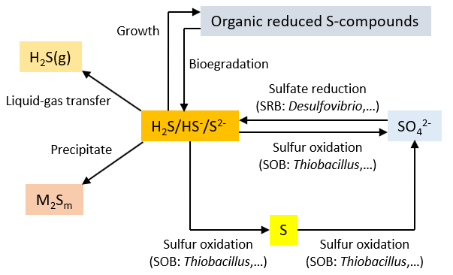 | 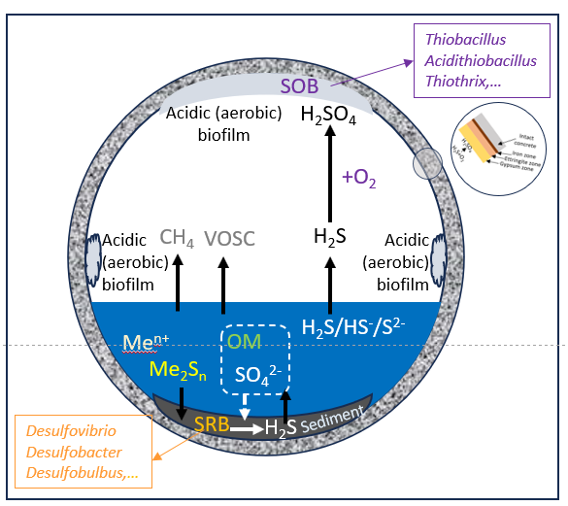
Figure 1: Diagrams of the S cycle processes in sanitation networks
(left image modified from Hvitved-Jacobsen et al., 2002)
1.2. Systematic determination of the formation and emission of H₂S in wastewater treatment and sanitation systems
The levels of H₂S formed and/or emitted in wastewater transport and treatment infrastructures can be estimated by applying models (Carrera et al., 2016 and Hvitved-Jacobsen et al., 2013) or also by punctual or continuous measurements of H₂S levels in the gas phase or dissolved in the aqueous medium. Table 2 provides a summary of the different options available for the measurement of H₂S in the liquid or gas phases.
Table 2: Alternatives for the determination of H₂S formation and/or emission in wastewater transport and treatment infrastructures
Method | Description
Continuous measurement of H₂S in emissions or ambient air | Fluorescent UV radiation technology + internal thermal catalytic converter, Electrochemical detectors (fixed or portable), Non-Dispersive Infrared Absorption (NDIR), Tuneable Diode Laser Absorption Spectroscopy (TDLAS), Gas Chromatography, Ratiometric Colorimetry.
Continuous measurement of H₂S dissolved in wastewater | FIA-Spectrophotometric (L. Sutherland-Stacey et al. 2008).  Electrochemical, where molecular H₂S diffuses through the membrane to an inner cell where it is oxidized at an electrode, generating a current proportional to its concentration. The measurement is done directly in the liquid phase, but is pH-dependent and reflects primarily free H₂S, not total sulphide (Despot et al. 2021).
In sanitation systems where odour and/or corrosion episodes occur, the most common way to control and reduce the formation of H₂S_{(d)} is by dosing chemicals such as nitrate and iron salts (Vink et al., 2017). In order to optimize the costs associated with the dosing of reagents (Frechen et al., 2014) and to assess its effectiveness, until now the preferred option has been to control this operation by continuous measurement of H₂S in the gaseous phase of the elements of the sanitation grids, but the circulation of the gas phase means that the data provided by such measurements are not representative enough (Oviedo et al., 2012). Therefore, to gain insight into actual dissolved sulphide levels, H₂S_{(d)} monitoring is essential. By monitoring in the liquid phase, the actual H₂S concentration at the point of interest is continuously determined, allowing a more exact control of the H₂S remnant at the downstream points. Continuous measurement in wastewater allows to adjust the dosing of chemicals to ensure that sulphur concentrations are always <2mgH₂S/L, which is the threshold above which problems are likely to occur (Hvitved-Jacobsen et al., 2002). In addition, the possibility of combining simultaneous measurements with H₂S sensors in the liquid and gas phases provides useful information on the rate of mass transfer and transport of H₂S at the monitoring point and the possibility of odour impacts at other points in the network.
2. Background of the case study
In a coastal tourist town located in Spain’s mediterranean area it was observed that during the summer months there was an increase in the corrosion of the infrastructures of the municipal sanitation grid, as well as the appearance of odour problems in a zone near one of the beaches of the municipality, in the vicinity of one of the grid’s pumping stations . From the outset, it was presumed that these problems could be associated with summer’s typical temperature increase, as well as the arrival of numerous tourists for the holiday season, which quintuplicates the town’s population, translating into a much more intensive use of the grid and a considerable increase in the flow of wastewater transported by the system's ducts (for instance, flow rates at the pumping station increased from 948 m³/day in June to 1871 m³/day in August).
3. Sampling and analysis campaigns
In order to study the scope and causes of the problem, 2 campaigns were carried out in the mentioned pumping station in the summer of 2024, during which the wastewater temperature and (H₂S_{(d)}) concentration were continuously measured using a Sulfilogger sensor (Sulfilogger A/S). In order to be able to evaluate the conditions of the grid in states of low and high tourist occupancy, the first campaign was carried out over 12 days in June, just before the mass arrival of visitors, while the second one was in August, already at full occupancy, over 29 days. In addition, an OC-1000 (Oceanus Research) multiparametric analyser with electrochemical sensors was also installed close to the station’s manhole during the initial 24h of the first campaign and the last 24h of the second one, in order to measure the H₂S gas (H₂S_{(g)}) concentrations in the pumping station’s gas phase. The parallel measurements with the 2 sensors made it possible to assess the relationship between H₂S_{(d)} and H₂S_{(g)}. Additionally, 1 gas sample was taken from a high point in the pumping station’s headspace (close to the location of the gas phase sensor in order to ensure comparability) in each campaign for analysis of odour concentration by dynamic olfactometry, as well as 3 wastewater samples (morning, noon and afternoon) for analysis of physical-chemical parameters that may have an effect on the H₂S levels. The campaigns are described in Table 3 below.
Table 3: Summary of the sampling and analysis campaigns
Campaign 1 dates | Campaign 2 dates | Tasks
21/06 | 30/08 | Sampling and laboratory analysis of odour concentration, pH, conductivity, redox potential (ORP), sulphate, total nitrogen and COD.
20/06 and 21/06 | 29/08 and 30/08 | H₂S_{(g)} measurement (OC-1000 sensor).
20/06 to 01/07 | 02/08 to 30/08 | H₂S_{(d)} and water temperature measurement (Sulfilogger sensor).
4. Results
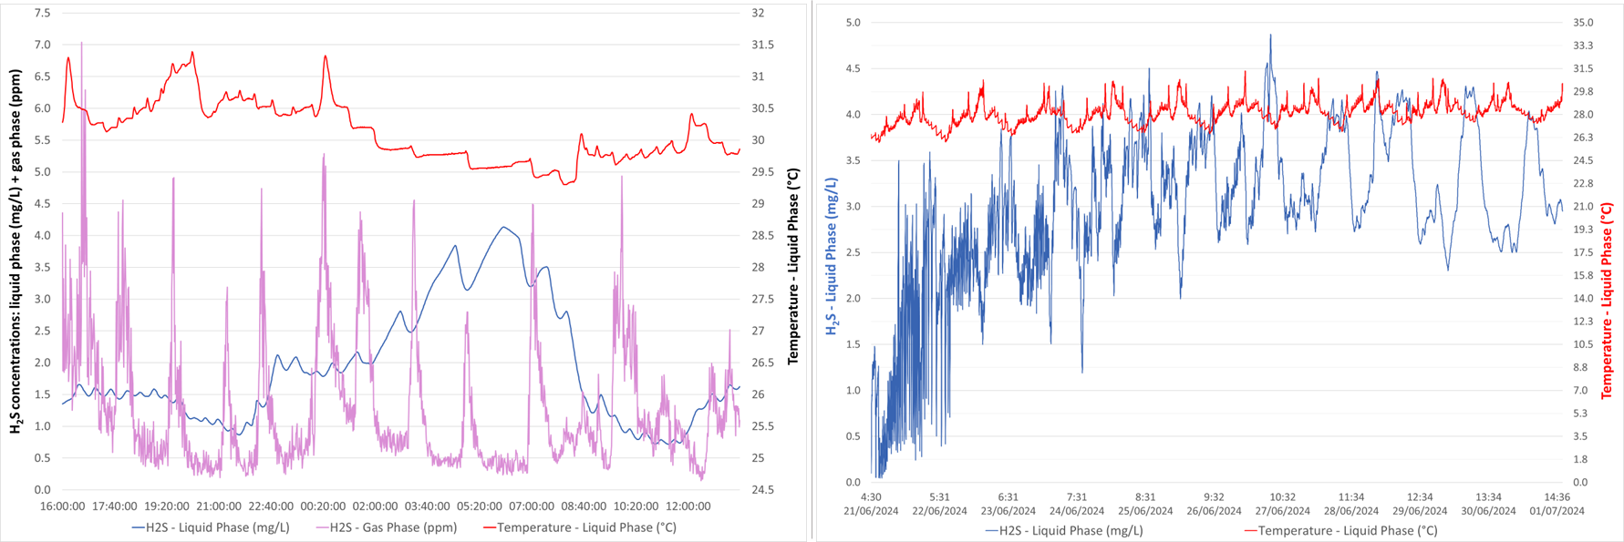
Figure 2: Left: 24-hour parallel measurement of H₂S_{(d)}, H₂S_{(g)} and wastewater temperature in the 2nd campaign. Right: 12-day continuous monitoring of H₂S_{(d)} concentrations and wastewater temperature in the 1st campaign.
4.1. Continuous H₂S_{(d)} measurement results
Table 4 presents the average H₂S_{(d)} concentrations and wastewater temperatures obtained with the Sulfilogger sensor for the 2 campaigns that were carried out, with temperatures increasing by about 2°C between June and August, while average H₂S_{(d)} concentrations halved during that time. Furthermore, the results also show that high H₂S_{(d)} concentration peaks usually occurred at times when H₂S_{(g)} concentrations were relatively lower, and vice versa.
Table 4: Continuous H₂S_{(d)} measurement results
Campaign | Dates | Duration | Avg. H₂S_{(d)} conc. (mg/L) | Std. dev. (mg/L) | Avg. water temp. (°C) | Std. dev. (°C)
1 | 20/06 to 01/07 | 12 days | 2.99 | 0.83 | 28.1 | 0.85
2 | 02/08 to 30/08 | 29 days | 1.49 | 0.80 | 30.3 | 0.48
4.2. Comparison between 24-hour simultaneous H₂S_{(d)} and H₂S_{(g)} measurements
The results of the continuous measurements of H₂S_{(d)}, H₂S_{(g)} and water temperature that were done simultaneously over 24 hours in each the 2 campaigns are shown in Table 5, including average, maximum and minimum values of each parameter. While both the average temperatures and the H₂S_{(d)} concentrations showed a clear increase between the 2 campaigns, inversely, the H₂S_{(g)} concentrations tended to decrease.
Table 5: Results of the simultaneous measurement of H₂S_{(d)} and H₂S_{(g)} concentrations
Parameter | Water temperature (°C) |  | H₂S_{(d)} concentration (mg/L) |  | H₂S_{(g)} concentration (ppm)
Campaign | 1 | 2 | 1 | 2 | 1 | 2
Average value | 27.2 | 30.1 | 1.10 | 1.93 | 3.31 | 1.27
Min. value | 26.0 | 29.3 | 0.04 | 0.72 | 0.15 | 0.15
Max. value | 30.1 | 31.4 | 4.85 | 4.13 | 23.93 | 7.04
Std. deviation | 0.68 | 0.47 | 1.03 | 0.93 | 3.59 | 1.02
While this is in contrast with the longer measurements presented in section 4.1, it must be pointed out that the measurements of the 1st campaign were done at the beginning of June, with lower tourist occupancy, temperature and H₂S_{(d)} values than later in the month. This can be seen in Figure 2 (left), which shows growing H₂S_{(d)} levels. This is the reason why, in this case, the first campaign’s H₂S_{(d)} values were smaller than those of the 2nd campaign.
4.3. Results of the analyses of odour concentration in gas samples and physical-chemical parameters in wastewater samples
A summary of the results of the results of the analyses of odour concentration and physical-chemical parameters carried out in each campaign is shown in Table 6 below.
Table 6: Results of the odour concentration and physical-chemical parameters analyses
Parameter | Units | Campaign 1 (21/06/2024) |  |  |  | Campaign 2 (30/08/2024)
Parameter | Units | S1 | S2 | S3 | Average | S1 | S2 | S3 | Average
Time | -- | 10:00 | 12:40 | 14:30 | -- | 09:30 | 12:15 | 13:40 | --
Temp. | °C | 27.1 | 30.2 | 32.8 | 30.0 | 29.0 | 32.4 | 34.6 | 32.0
pH | upH | 7.2 | 7.0 | 7.1 | 7.1 | 7.0 | 8.5 | 6.7 | 7.4
Conductivity | μS/cm | 1624 | 1213 | 1319 | 1385 | 2030 | 1438 | 1398 | 1622
ORP | mV | -128 | 32 | -192 | -96 | -220 | -232 | -199 | -217
Sulphate | mgSO₄²⁻/L | 55.3 | 26.2 | 34.1 | 38.5 | 52.3 | 15.3 | 10.3 | 26.0
N_{TOT} | mgN/L | 64.9 | 37.3 | 43.0 | 48.4 | 86.0 | 65.1 | 54.0 | 68.4
COD | mgO₂/L | 1123.9 | 1055.4 | 874.8 | 1018.0 | 1176.3 | 898.7 | 708.0 | 927.7
Odor Conc. | ou_{E}/m³ | 5516 |  |  |  | 2742

4.4. Calculation of H₂S_{(d)} values >2mg/L and estimation of HS⁻_{(d)} / H₂S_{(d)} ratios
The % of time that H₂S_{(d)} concentrations were higher than the 2mg/L threshold where, as indicated above, there is a high probability that problems will occur has been calculated for both full-length campaigns. Furthermore, the HS⁻_{(d)} / H₂S_{(d)} ratios have also been estimated based on the pH values (Hvitved-Jacobsen et al. 2013). The results of both calculations are presented in the following table:
Table 7: Calculation of the % of H₂S_{(d)} values above 2mg/L and the HS⁻_{(d)} / H₂S_{(d)} ratios
Campaign | % of H₂S_{(d)} values > 2mg/L | HS⁻_{(d)} / H₂S_{(d)} ratios
1 (20/06 to 01/07) | 96.9 | 1.25
2 (02/08 to 30/08) | 22.5 | 1.51
5. Comments and conclusions
The measurement results show that, relatively speaking, high H₂S_{(d)} concentrations tend to correspond to lower H₂S_{(g)} levels, and vice versa. This inverse relationship between the concentrations in the liquid and gas phases may be due to the fact that, as H₂S_{(d)} is released into the gas phase, its concentration in the wastewater must consequently decrease.
It was also observed that, on average, H₂S_{(d)} concentrations were significantly higher during the first campaign, in June, than in the second campaign, in August (2.99 vs 1.49 mg/L). This may be explained by the increased usage of the sewage network, leading to larger flow rates which cause a significant dilution of the H₂S_{(d)} concentration in the wastewater, as well as a decrease in the amount of H₂S formation related to the shorter retention times of the wastewater in the sanitation system. Moreover, the determined ORP values were also higher in the 2nd campaign, leading to less favourable conditions regarding the formation of H₂S.
Regarding the H₂S_{(g)} measurements in the headspace of the pumping station, it must be pointed out that higher values were obtained in the 1st campaign than in the 2nd one. This agrees with the odour concentration results, which were found to also be higher in the 1st campaign.
The data also shows that H₂S_{(d)} concentrations were higher at night than at daytime, in agreement with the results reported by Sivret et al. 2014, which show similar results that the authors linked to the sanitation network’s daily usage profile, with larger flow rates occurring during the day and, therefore, an increased dilution of the H₂S_{(d)} concentrations, as well as lower nighttime pH values leading to higher H₂S formation rates in the liquid phase, according to Sharma et al. (2013).
It must be pointed out that most of the H₂S_{(d)} values determined during the 1st campaign (96.9%) were higher than the 2mg/L threshold above which, according to Hvitved-Jacobsen et al. (2002), H₂S is likely to cause problems in the sanitation network. In contrast, only 22.5% of the values in the 2nd campaign were found to exceed this threshold. It was also observed that, during episodes of intermittent pumping, H₂S_{(d)} concentration peaks appeared that, tentatively, may be attributed to a re-suspension of the sediments and other solid materials. Additionally, sometimes concentration peaks also appeared at times of accumulation of wipes in the wastewater, similarly to the observations reported by Despot et al. (2021).
Finally, a calculation has been carried out of the theoretical cost associated to a possible dosage of a 40% FeSO₄ aqueous solution in order to ensure that H₂S_{(d)} concentrations remain below 0.5mg/L at all times under the conditions of the 2nd campaign. Taking into account a flow rate of 2000m³/day and an average H₂S_{(d)} concentration of 1.49mg/L, adjusting the reagent dosage to the real H₂S_{(d)} values would result in savings of 60% relative to the costs that would be incurred by constant dosing.
Bibliography
Carrera L., Springer F., Lipeme-Kouyi G., Buffiere P.,2016, A review of sulphide emissions in sewer networks: overall approach and systemic modelling, Water Science & Technology, 73.6, 1231-1242, DOI:10.2166/wst.2015.622.
Despot, D., Fernández M.P., Barjenbruch M., 2021, Online Sensors for Liquid Phase Hydrogen Sulphide Monitoring in Sewer Systems, Water, 13, 1876. https://doi.org/10.3390/w13131876.
Despot D., Reinhold L., Barjenbruch M., 2022, Assessment of limited downstream nitrate dosing for sulphide control in pressure sewers: case study in Germany, Water Practice & Technology Vol 17 No 10, 2031 doi: 10.2166/wpt.2022.106.
Firer D., Friedler E., Lahav O., 2008, Control of sulphide in sewer systems by dosage of iron salts: Comparison between theoretical and experimental results, and practical implications, Science of The Total Environment, Volume 392, Issue 1, 15, Pages 145-156, https://doi.org/10.1016/j.scitotenv.2007.11.008.
Frechen F.-B., Romaker J., Giebel S., 2014, Controlling chemical dosing into sewers for odour and corrosion
Abatement, Chemical Engineering Transactions, 40, 217-222 DOI: 10.3303/CET1440037.
Fytianos G, Tziolas E., Papastegiadis E., Samaras, P., 2020, Least cost analysis for biocorrosion mitigation strategies in concrete sewers, Sustainability, 12(11), 4578, https://doi.org/10.3390/su12114578.
Hvitved-Jacobsen T., Vollersten J, Nielsen A. B., 2013 Sewer Processes. Microbial and Chemical Process Engineering of Sewer Networks, Publisher: CRC Press, ISBN: 978-1-4398-8177-4, DOI:10.1201/b14666.
Hvitved-Jacobsen, T., Vollertsen, J., Yongsiri, C., Nielsen, A. H. & Abdul-Talib, S., 2002, Sewer microbial processes, emissions and impacts. In: Sewer Processes and Networks, Paris, France, IWA.
Hvitved-Jacobsen, T. (2020) ‘Sulfur transformations in sewer networks: effects, prediction and mitigation of impacts’, en Lens, P.N.L. (ed.), Environmental Technologies to Treat Sulfur Pollution: Principles and Engineering. 2nd ed. London: IWA Publishing. doi:10.2166/9781789060966_0099.
INDEXBOX, 2026, European Union Hydrogen Sulphide Scavengers in Sewage Systems- Market Analysis, Forecast, Size, Trends and Insights.
Muyzer G., Stams A., 2008, The ecology and biotechnology of sulphate-reducing bacteria, Nat Rev Microbiol, Jun;6(6):441-54. doi: 10.1038/nrmicro1892.
Oviedo, E. R., Johnson, D., Shipley, H. (2012). Evaluation of hydrogen sulphide concentration and control in a sewer system. Env. Technology, 33(10), 1207–1215. https://doi.org/10.1080/09593330.2011.618932
Sharma K., Ganigue R., Yuan Z., 2013, pH dynamics in sewers and its modelling, Water Research, Volume 47, Issue 16, 15 October 2013, Pages 6086-6096, https://doi.org/10.1016/j.watres.2013.07.027.
Sivret E., Le-Minh N., Wang B., Wang X., Stuetz R., 2014, Impact of sewer emission dynamics on monitoring campaign design, Chemical Engineering Transactions, 40, 43-48 DOI: 10.3303/CET1440008.
Sutherland-Stacey L., Corrie S., Neethling A., Johnson I., Gutierrez O., Dexter R., Yuan Z., Keller J., Hamilton G., 2008, Continuous measurement of dissolved sulphide in sewer systems, Water Sci Technol. 2008;57(3):375-81. doi: 10.2166/wst.2008.132.
Vinck E., Donckels B., Severyns J., Weemaes M., 2017, Dealing with hydrogen sulphide induced problems downstream of sewer rising mains, Water Practice & Technology Vol 12 No 4, 1 doi: 10.2166/wpt.2017.095
Vollertsen J. Nielsen A. B., Jensen H. S., Wium-Andersen T., Hvitved-Jacobsen T., 2008, Corrosion of concrete sewers—The kinetics of hydrogen sulphide oxidation, Science of The Total Environment Volume 394, Issue 1, Pages 162-170, https://doi.org/10.1016/j.scitotenv.2008.01.028.
Watts S.F., 2000, The mass budgets of carbonyl sulphide, dimethyl sulphide, carbon disulfide and hydrogen sulphide, Atmospheric Environment, 34, 761-779, DOI:10.1016/S1352-2310(99)00342-8.

