 CHEMICAL ENGINEERING TRANSACTIONS  VOL. xxx, 2026 | A publication of  
The Italian Association
of Chemical Engineering
Online at www.cetjournal.it

Guest Editors: Laura Capelli, Marzio Invernizzi, Selena Sironi
Copyright © 2026, AIDIC Servizi S.r.l.
ISBN 979-12-81206-xx-x; ISSN 2283-9216

Coupling of Photocatalysis and Adsorption Using a Single Multifunctional Filter for Gas-Phase Toluene Removal
Rania Louali^{a,*}, Amine Aymen Assadi^{b}, Abdelkrim Bouzazaª, Dominique Wolbertª, Lina Lamaa^{c}
ªUniv Rennes, École Nationale Supérieure de Chimie de Rennes, CNRS, ISCR—UMR 6226, F-35708 Rennes, France.
^{b}College of Engineering, Imam Mohammad Ibn Saud Islamic University (IMSIU), Riyadh,11432, Saudi Arabia.
^{c}Brochier Technologies, 90 Rue Fredéric Fays, 69100 Villeurbanne Lyon, France
rania.louali@ensc-rennes.fr

The removal of volatile organic compounds (VOCs) from air streams remains a key challenge in air purification processes. Conventional technologies such as photocatalysis and adsorption are effective but suffer from significant limitations when applied separately. In this study, five commercial activated carbon materials were first evaluated using adsorption isotherm measurements to identify the most efficient adsorbent. The selected activated carbon powder (AC) was then coated on an innovative textile-based filter composed of optical fibers and TiO₂. UVA LEDs were used to irradiate the optical fibers, allowing uniform and efficient illumination of the TiO₂ coating. Two coating configurations were investigated to study the effect of the distribution of activated carbon and TiO₂ on pollutant removal. This approach promotes the synergetic coupling of adsorption and photocatalysis within the same structure. The first configuration comprises a filter with two distinct functional sides. In contrast, the second configuration consists of a filter coated with a homogenous mixture of TiO₂ and AC. In both cases, adsorption was first carried out until saturation, followed by photocatalytic treatment under UVA irradiation. Toluene was used as representative model compound to evaluate the performance of the textile filter. The results showed that the filter configuration significantly affects toluene removal, with up to 70 % degradation achieved when adsorption and photocatalysis were separated on two sides. These findings confirm the potential of integrating both processes in compact air purification devices.
  - Introduction
Due to the presence of volatile organic compounds (VOCs), and other gaseous pollutants that cause respiratory and systemic illnesses, air pollution, especially indoor environments, poses serious dangers to human health (Zhou et al., 2023), including respiratory issues, eye irritation, headaches (Jr et al., 2010).
Toluene, acetone, acetaldehyde, heptane and formaldehyde are always considered as a model air pollutants for the potential international standard testing of air cleaners (DEGALLAIX, 2017).
Indoor air treatment technologies can be divided into two categories: non-destructive processes where pollutants are removed from the air without any chemical destruction. These processes mainly include adsorption, mechanical filtration, and membranes separation. In contrast, destructive methods aim to convert pollutants into harmful products such as photocatalytic oxidation, ozonation, non-thermal plasma and catalytic oxidation. Although these technologies have shown a promising results (Luengas et al., 2015).
Among non-destructive methods, adsorption is widely used for pollutant removal because it operates under mild conditions, is simple to implement and requires limited energy. Activated carbon remains one of the most common adsorbents due to its high specific area, well-developed microporosity, and strong affinity for organic molecules (Yang et al., 2018). However, adsorption also suffers from important limitations, such as absorbent saturation, the need for regeneration, and possible pollutant re-emission under certain operating conditions.
On the other hand, photocatalytic oxidation has emerged as a promising technology for pollutants elimination. TiO₂-based photocatalysts can oxidize VOCs at low concentration under ambient conditions and convert them into CO₂ and H₂O. Nevertheless, the practical application of photocatalysis remains limited by several drawbacks, including rapid electron-hole recombination, limited adsorption capacity toward some pollutants, catalyst deactivation, and the possible formation of partial oxidation by-products (Haghighi and Haghighat, 2024).
To overcome the limitation of these processes used alone for volatile organic compounds (VOC) removal, recent studies have increasingly investigated hybrid systems that combine adsorption and photocatalysis. In such systems, VOCs are first captured and concentrated on an adsorbent surface, and are then degraded by a photocatalyst, typically TiO₂. This combined approach has been widely explored in the literature (Zou et al., 2019).
Liu and his co-workers reported that TiO₂/activated carbon fiber (ACF) composites exhibited enhanced activity under 185 nm irradiation(Liu et al., 2018). This improvement in formaldehyde degradation was attributed to higher generation of hydroxyl radicals from surface hydroxyl groups, together with improved electron transfer through Ti-C interactions. In contrast under 308 nm irradiation, hybrid materials often display lower photocatalytic performance (Biomorgi et al., 2010).
Based on the literature, coupling adsorption and photocatalysis appears to be a promising strategy for improving VOCs removal while overcoming the individual limitation of each process used separately. In this context, the objective of this work was to investigate the performance of an innovative textile-based support. The first part of this study aims to evaluate and compare the performance of five commercial adsorbents. Then the selected activated carbon will be combined with TiO₂ on the textile support and tested under dynamic conditions in a continuous flow-through reactor system. The second part of this work aims to determine the effect of the distribution of activated carbon and TiO₂ on the overall removal performance under dark conditions and under UV irradiation.
  - Material & methods
    - Studied pollutant
The target pollutant in this study is toluene (C₇H₈), a widely used model VOC In gas phase studies. The compound was supplied by Honeywell in liquid form with a purity exceeding 99 %.
    - Adsorbent materials
Five types of commercial activated carbon (AC) with different physical forms were investigated, including two activated carbon textiles manufactured by Jacobi Actitex (Saint Jean de Braye, France): (FC1201), with two different thickness (1 and 2 mm), a non-woven filter material consisting of granular carbon embedded between two fibrous layers, and Dolder foam (thickness 5.5 mm) from Dolder AG (Basel, Switzerland). Additionally, a powdered a named AC Ecosorb from Jacobi Carbon Group (Kalmar, Sweden).
    - Textile support
The textile-based filter, manufactured by Brochier Technologies (Villeurbanne, France), is made of polymer fibers and optical fibers, allowing internal UV light tranmission. These optical fibers have an average diameter of 500 µm (Bourgeois et al., 2012). Both types of fibers were integrated into the textile structure using a binding weave based on the Jacquard weaving process. This support was initially protected a protective silica layer, followed by deposition of TiO₂ P25 supplied by Evonik (Essen, Germany). Activated carbon (AC, Ecosorb) can be deposited in two different ways depending on the textile configuration. In the first configuration (i), one face of the textile was coated with AC, while the opposite face was coated with TiO₂. In the second configuration (ii), both TiO₂ and AC were deposited on each face of the textile, as illustrated in Figure 1.
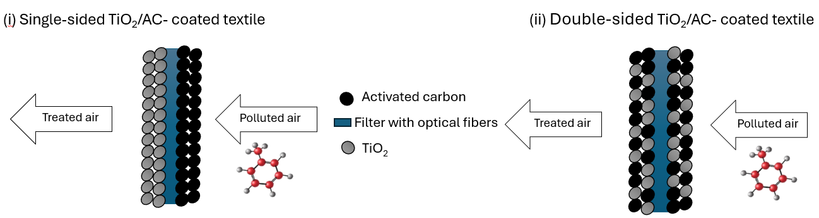
Figure 1: Schematic illustration of the two textiles configuration for gas-toluene removal.
The AC impregnation was carried out using a spray-coating process. A solution containing the AC Ecosorb powder was sprayed on the textile to obtain the desired quantity. Then the impregnated textile was dried in an oven at 70 °C for 10 min. After drying, the excess AC was removed by gentle mechanical tapping the fabric.
    - Adsorption experiments in batch reactor
Batch experiments were first performed to evaluate the adsorption performance of the five activated carbons presented in the Materials section. Adsorption isotherms were established by introducing known concentrations of the target pollutant into sealed flasks containing a known mass of activated carbon and a magnetic stirrer to ensure adequate homogeneity at a constant temperature of 25 °C under normal atmospheric pressure. For each initial concentration, the adsorption kinetics were monitored until equilibrium was reached. The adsorption capacity corresponding to each concentration was then calculated in order to establish the adsorption isotherms.
    - Continuous-flow reactor for adsorption-photocatalysis coupling
The combined adsorption and photocatalysis experiments were carried out in a novel continuous-flow reactor operating in a front-flow configuration, with a cross-sectional area of 0.01 m². The reactor consists of of a module designed to hold the functionalized textile based on optical fiber coated with TiO₂ and activated carbon.
The dry air was supplied by internal network. Its flow rate was regulated by a valve and measured using an Itron Gallus G4 gas meter. The flow rate was fixed at 0.5 m³/h, corresponding to a contact time of 72 ms. The pollutant was injected using a syringe at a concentration of 1.5 mg/m³ and vaporized by means of a heated tap. The resulting air-pollutant mixture was homogenized using a static mixer before entering the reactor. Textile illumination was provided by adjustable UV-LEDs.
    - Analytic tools
The concentration of toluene was measured by gas chromatography (Focus GC) using a flame ionization detector (FID) and an FFAP column (length= 25 m and internal diameter = 0.32 mm). Nitrogen was used as a carrier gas. Direct manual sampling using a 500 µl syringe was used for the analysis.
The adsorption capacity at equilibrium, was calculated according to Eq(1):
 | (1)
  $$q_{e}=\frac{(C_{0}-C_{e})V}{m_{AC}}$$
where C₀ and C_{e} (mg/m³) are the initial and equilibrium pollutant concentrations, respectively, V (m³) is the volume of the vessel, and m (g) is the mass of activated carbon.
The experimental adsorption isotherms were described using two descriptive models. The first, Langmuir model (Langmuir, 1918), assumes that adsorption occurs on a homogeneous surface containing a finite number of identical active sites. Each site can retain one adsorbate molecule, leading to the formation of a monolayer. In addition, the model assumes that all adsorption sites have the same energy and that there is no interaction between adsorbed molecules. The Langmuir equation is expressed as:
 | (2)
  $$q_{e}=\frac{q_{max}K_{L}C_{e}}{1+K_{L}C_{e}}$$
Where $q_{e}$ (g/g) is the adsorption capacity at equilibrium, $q_{max}$ is the maximum monolayer adsorption capacity, K_{L} (m³/mg) is the Langmuir constant related to the affinity of the adsorbent for the adsorbate, and C_{e} (mg/m³) is the equilibrium concentration in the gas phase.
The second model, Freundlich model (Ayawei et al., 2017), is an empirical equation that describes adsorption on heterogeneous surfaces. It assumes that the adsorption sites are not energetically equivalent and that adsorption may occur on multiple layers. The Freundlich model is as follows:
 | (3)
  $$q_{e}=K_{F}C_{e}^{1/n}$$
Where K_{F} is the Freundlich constant related to the adsorption capacity and n is the heterogeneity factor, which provides information on the adsorption intensity. In general, values of 1/n between 0 and 1 indicate favourable adsorption.
  - Results and discussion
    - Adsorption performance of the supports
As described above, batch experiments were conducted to establish the adsorption isotherms (Figure 2), which were fitted using the models mentioned above. The corresponding adsorption parameters from both models are summarized in table 1.
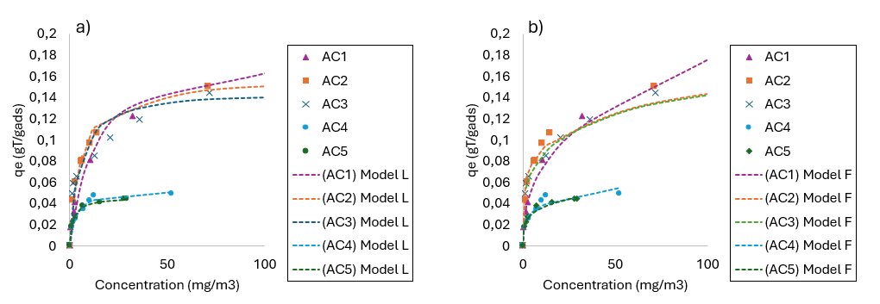

Figure 2: Adsorption isotherm obtained for different adsorbents media at various concentration, fitted with a) Langmuir model and b) Freundlich model.
According to Figure 2, the adsorption capacity followed the order AC1> AC2 >AC3 >AC4 > AC5.
As seen in table 1, both equations accurately describe correctly toluene adsorption on activated carbon. However, regarding isotherm modeling, the Freundlich model provided the best fit for AC1, AC3 and AC5, whereas AC2 and AC4 were better described by the Langmuir model.
Among the five activated carbons AC1, AC2 and AC3 exhibited the highest adsorption capacities, with q_{max} values of 0.184, 0.159 and 0.149 respectively, whereas AC4 and AC5 showed significantly lower value 0,054 and 0,047 gT/g.
AC2 et AC3 appeared to offer the best overall compromise between capacity and affinity, as reflected by relatively high K_{L} values and highest K_{F} value obtained from the models. In contrast, despite their higher K_{L}, AC4 and AC5 have much lower q_{max} values, suggesting a limited number of accessible adsorption sites and therefore a lower adsorption capacity.
Table 1: Adsorption parameters of toluene on different adsorbent materials.
 |  | Langmuir Model |  |  |  |  | Freundlich Model
Support |  | q_{max} (gT/g_{mat}) | K_{L} (m³/mg) | R² (%) | n | 1/n |  | K_{F} | R² (%)
AC1 | Dolder foam | 0.184 | 0.08 | 95.61 | 2.57 | 0.389 |  | 29.35 | 98.48
AC2 | non-woven filter | 0.159 | 0.18 | 97.18 | 4.8 | 0.208 |  | 55.51 | 91.43
AC3 | Ecosorb powder | 0.149 | 0.20 | 89.16 | 4.33 | 0.230 |  | 50.05 | 98.51
AC4 | Actitex 2mm | 0.054 | 0.33 | 92.93 | 4.36 | 0.229 |  | 22.10 | 88.45
AC5 | Actitex 1mm | 0.047 | 0.58 | 92.18 | 4.28 | 0.233 |  | 21.06 | 96.59

    - Continuous reactor for coupling adsorption/photocatalysis
Two textile configurations were investigated and compared on the basis of breakthrough curves obtained under dark condition (adsorption only) and under simultaneous adsorption and UV irradiation (adsorption-photocatalysis coupling). AC Ecosorb was used as adsorbent due to its high adsorption capacity and the ease of its coating.
When comparing the two-textile configuration, it should be noted that activated carbon loading was much higher for the double-face textile (9,7 g/m²) than for the single-sided (3,5 g/m²).
For the single-sided configuration (Figure 3a), the curve obtained under dark conditions showed a 50 % breakthrough (t_{0,5}) at about 4 hours and complete saturation after approximately 6,5 hours.
Under simultaneous adsorption and photocatalysis, t_{0,5} was not reached within the 8,3 hours experimental period, and the outlet concentration has reached a plateau equivalent to C/C₀ ≈ 0,30. This clearly indicates that UV irradiation delayed the breakthrough and improved the overall removal performance of the textile. This behavior is attributed to the contribution of photocatalytic degradation on the TiO₂-coated face, where the pollutant fraction not retained by the activated carbon is subsequently degraded. The difference between two plateaus is due to the catalytic reaction.
For the double-sided configuration (Figure 3b), t_{0,5} increased from 11 hours in adsorption alone to 23 hours under simultaneous adsorption and photocatalysis. In addition, although the dark experiment reached saturation after about 25h, the coupled system still exhibited C/C₀ = 0,72 after 75h, indicating that complete saturation was substantially delayed under irradiation. This result confirms the beneficial effect of coupling adsorption and photocatalysis on the long-term performance of the system.
Even if the activated carbon quantity is higher in the double-sided configuration, under irradiation this configuration did not appear to be the most efficient. Indeed, the single-sided textile achieved a pollutant removal efficiency of about 70 %, whereas the performance of the second configuration decreased to about 33 %. This result suggests that the lower efficiency is related to the way that activated carbon and TiO₂ were deposited on the same surface. In this configuration (Figure 1_{(ii)}), the activated carbon may have partially covered the TiO₂ particles, thereby reducing light penetration and limiting access to photocatalytic sites. By contrast, in the singles sided configuration, the two functions remained separated: the pollutant stream first passed through the activated carbon layer, and the non-adsorbed fraction was than exposed the illuminated TiO₂ side. These results agree with the results reported by (Zhang et al., 2016), who showed that TiO₂@C photocatalysts gave the highest activity only with very thin carbon layers While thicker carbon coating reduced the photocatalytic performance because they limited light use and restricted access to the TiO₂ surface. Derakhshan-Nejad et al., (2020) also confirmed that TiO₂/ZSM-5 under UV improves ethylbenzene breakthrough time and reduces VOCs release.
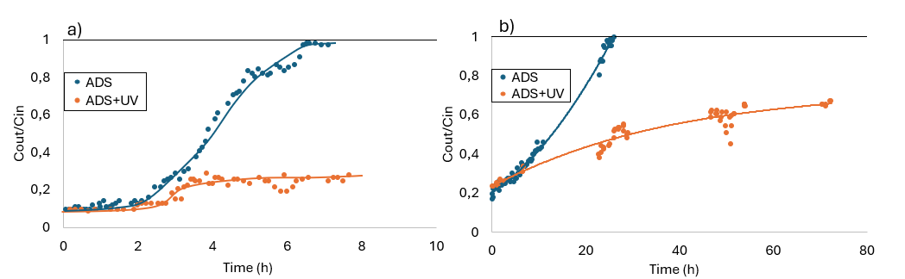
Figure 3: Breakthrough curves of the toluene for (a) the single-sided configuration (m_{AC}= 3.5 g/m²) and (b) the double-sided textile configuration (m_{AC}= 9.7 g/m²), under dark and UV irradiation (Q =0.5 m ³/h, C₀=1.50 mg/m³ and m_{TiO2}= 30 g/m²).
  - Conclusions
This work investigated the coupling of adsorption and photocatalysis for VOCs removal using an innovative optical-fiber textile as a support coated with activated carbon and TiO₂.
Batch adsorption test allowed the selection of the most suitable activated carbon which seems to be carbon powder Ecosorb (AC3).
This activated carbon powder was then selected to combine it with TiO₂ coated on an innovative optical-fiber support with two different configurations, and the device was tested in continuous-front-flow reactor under dark condition and UV irradiation. For the single-face configuration, 50 % breakthrough was observed after 4 hours for adsorption alone and was not reached after 8,3 hours under UV irradiation. The C/C₀ ratio remains constant around 0,35 corresponding to about 71 % removal. For the double-sided configuration, 50 % breakthrough increased from 11 hours to 23 hours under irradiation, but C/C₀ ratio reached 0,72 after 75 h corresponding only about 33 %. Although the double-sided configuration textile increased breakthrough time, mainly due to its higher activated carbon loading, it was less efficient under irradiation in term of removal efficiency. This lower performance may be explained by the fact that activated carbon and TiO₂ were deposited on the same sides, which may have partially masked the TiO₂ layer, reduced light penetration, and limited access to photocatalytic actives sites. Overall, these results confirm the potential of coupling adsorption and photocatalysis in a textile-based filter and highlight the importance of optimizing the spatial distribution of the catalysts Further parameters, including pollutant mixtures, air humidity, and temperature, should be investigated to advance towards an optimized compact reactor design.
Acknowledgements
The authors gratefully acknowledge the financial support of ANR under the project TEXAD (ANR-22-CE04-0009 TEXAD)
Nomenclature

VOCs – Volatile organic compounds
AC – Activated carbon
ADS – Adsorption
C_{e} – Equilibrium concentration, mg/m³
C₀ – Inlet concentration, mg/m³
C – outlet concentration, mg/m³
FID – Flame ionization detection
FFAP– Free fatty acid phase column
GC – Gas Chromatography
K_{L} – The Langmuir constant, m³/mg
K_{F} – The Freundlich constant, -
LEDs – Light-Emitting Diodes
m_{AC} – The mass of activated carbon, g
m_{TiO2} – The mass of titanium dioxide, g/m²
$q_{e}$– The adsorption capacity at equilibrium, gT/g
$q_{max}$ – The maximum monolayer adsorption capacity, gT/g
Q – Flow rate, m³/h
TiO₂ – Titanium dioxide
UVA – Ultraviolet type A
V – The volume, m³

References
Ayawei, N., Ebelegi, A.N., Wankasi, D., 2017. Modelling and Interpretation of Adsorption Isotherms. Journal of Chemistry 2017, 1–11.
Biomorgi, J., Haddou, M., Oliveros, E., Maurette, M.-T., Benoit-Marquié, F., 2010. Coupling of Adsorption on Zeolite and V-UV Irradiation for the Treatment of VOC Containing Air Streams: Effect of TiO₂ on the VOC Degradation Efficiency. Journal of Advanced Oxidation Technologies 13.
Bourgeois, P.-A., Puzenat, E., Peruchon, L., Simonet, F., Chevalier, D., Deflin, E., Brochier, C., Guillard, C., 2012. Characterization of a new photocatalytic textile for formaldehyde removal from indoor air. Applied Catalysis B: Environmental 128, 171–178.
DEGALLAIX, M.-C., 2017. Air cleaning devices: A growing market polluted by confusing communication-certified
performances for air cleaners. Rehva journal 49–51.
Derakhshan-Nejad, A., Rangkooy, H.A., Cheraghi, M., Yengejeh, R.J., 2020. Removal of ethyl benzene vapor pollutant from the air using TiO₂ nanoparticles immobilized on the ZSM-5 zeolite under UVradiation in lab scale. J Environ Health Sci Engineer 18, 201–209.
Haghighi, P., Haghighat, F., 2024. TiO₂-based photocatalytic oxidation process for indoor air VOCs removal: A comprehensive review. Building and Environment 249, 111108.
Jr, G.M., Lienert, J., Jr, J.I.K., 2010. Formaldehyde Exposure and Asthma in Children: A Systematic Review. Environmental Health Perspectives 118.
Langmuir, I., 1918. THE ADSORPTION OF GASES ON PLANE SURFACES OF GLASS, MICA AND PLATINUM. J. Am. Chem. Soc. 40, 1361–1403.
Liu, R.F., Li, W.B., Peng, A.Y., 2018. A facile preparation of TiO₂/ACF with C Ti bond and abundant hydroxyls and its enhanced photocatalytic activity for formaldehyde removal. Applied Surface Science 427, 608–616.
Luengas, A., Barona, A., Hort, C., Gallastegui, G., Platel, V., Elias, A., 2015. A review of indoor air treatment technologies. Rev Environ Sci Biotechnol 14, 499–522.
Yang, X., Yi, H., Tang, X., Zhao, S., Yang, Z., Ma, Y., Feng, T., Cui, X., 2018. Behaviors and kinetics of toluene adsorption‐desorption on activated carbons with varying pore structure. Journal of Environmental Sciences 67, 104–114.
Zhang, J., Vasei, M., Sang, Y., Liu, H., Claverie, J.P., 2016. TiO₂ @Carbon Photocatalysts: The Effect of Carbon Thickness on Catalysis. ACS Appl. Mater. Interfaces 8, 1903–1912.
Zhou, Xihe, Zhou, Xiang, Wang, C., Zhou, H., 2023. Environmental and human health impacts of volatile organic compounds: A perspective review. Chemosphere 313, 137489.
Zou, W., Gao, B., Ok, Y.S., Dong, L., 2019. Integrated adsorption and photocatalytic degradation of volatile organic compounds (VOCs) using carbon-based nanocomposites: A critical review. Chemosphere 218, 845–859.

