 CHEMICAL ENGINEERING TRANSACTIONS  VOL. xxx, 2026 | A publication of  
The Italian Association
of Chemical Engineering
Online at www.cetjournal.it

Guest Editors: Laura Capelli, Marzio Invernizzi, Selena Sironi
Copyright © 2026, AIDIC Servizi S.r.l.
ISBN 979-12-81206-xx-x; ISSN 2283-9216

OSMOTREFF® for real-time monitoring of odour emissions at point sources: case studies on emission trends and abatement performance over time
Federico Cangialosi^{a,*}, Magda Brattoliª, Antonio Fornaro^{b}, Enrico Valtancoli^{b}
ª Tecnologia & Ambiente S.r.l., Via Michele Mummolo 13, Putignano (BA), Italy
^{b} Labservice Analytica S.r.l., Via Emilia 51/c, Anzola Emilia (BO), Italy
federico.cangialosi@icloud.com

The evolution of the regulatory and technical framework concerning odour emissions has increased interest in continuous monitoring systems capable of providing real-time quantitative information at emission sources. In Italy, the technical standard UNI 11761:2023 and the national guidance on odour emissions (Director Decree No. 309/2023) establish a normative framework for deploying Instrumental Odour Monitoring Systems (IOMS), including their application to assess odour abatement efficiency. This paper presents two case studies involving OSMOTREFF®, a continuous monitoring system for odour emissions from point sources that operates upstream and downstream of abatement units, enabling sequential sampling with dynamic dilution and real-time estimation of odour concentration. The deployment workflow is described for an organic waste treatment plant and a wastewater treatment plant, with focus on site-specific calibration and fine-tuning of the predictive models to match facility emission profiles. In both case studies, long-term continuous monitoring enabled the assessment of emission trends and the continuous quantification of abatement efficiency. Data analysis allowed the identification of specific operational phases within the daily production cycle associated with increased emission loads and corresponding variations in abatement performance. The results quantified the dependence of abatement efficiency on process conditions and showed efficiency decrements related to system ageing or saturation. Overall, OSMOTREFF® proved to be an effective tool for process control and abatement performance assessment, supporting maintenance optimization and operational management under variable plant conditions.
  - Introduction
The need for continuous and quantitative odour assessment at emission sources has increased interest in Instrumental Odour Monitoring Systems (IOMS), particularly in waste and wastewater treatment plants. However, although IOMS data are becoming increasingly available for fenceline applications at wastewater and waste treatment plants (Cangialosi et al., 2021; Ratti et al., 2024), their use at stationary conveyed sources remains limited (Prudenza et al., 2023), because continuous duct monitoring must cope with high humidity, condensation, sensor drift, corrosive compounds, temperature instability, and odour loads far higher than those encountered in ambient air. A recent source-oriented approach (Cangialosi and Fornaro, 2024) addressed these constraints through the development of OSMOTREFF®, a system that combines dynamic dilution, automated raw–rinse–clean–rinse cycles, and calibration based on dynamic olfactometry samples collected from the same sampling system. A key distinguishing feature of OSMOTREFF® is the use of dynamic dilution, rather than condensate traps, to control humidity before sensor analysis. This avoids alteration of the sampled air caused by the removal of water-soluble or condensable odorants together with moisture, thereby preserving the representativeness of the odour signal reaching the sensor chamber. The present study goes beyond that initial proof of concept by providing a broader experimental and interpretative framework. With the aim of generating useful information for process engineers and plant managers involved in the design, operation, and control of odour abatement systems, this work presents paired datasets collected upstream and downstream of full-scale abatement units and analyses them to address questions that remain largely unexplored in the literature. The two full-scale case studies discussed here—an organic waste treatment plant and a municipal wastewater treatment plant—were continuously monitored for respectively three and six months in order to characterise the daily fluctuation structure of odour loads, resolve recurrent periodic components associated with plant operating cycles, and quantify load-dependent and time-dependent changes in VOC and odour removal efficiency under real operating conditions.
  - Experimental methods
    - Site descriptions
The first installation is a waste treatment facility dedicated to anaerobic digestion (AD) and composting of urban waste organic fractions. The plant has a nominal capacity of approximately 600 000 t/y and includes mechanical pre-treatment, wet AD, active composting in biocells, and maturation phases. The monitored abatement unit was an activated carbon adsorption column treating a fraction of the exhaust air (nominal flow rate 8,000 Nm³/h) extracted from the biocells during the active composting phase of the digestate. The OSMOTREFF® system was installed on the ductwork immediately upstream and downstream of the activated carbon column, which was installed as a polishing stage to reduce the VOC load of a partial exhaust air stream from aerobic treatment in biocells before the main wet scrubbing and biofiltration line. The second case study was carried out at a municipal WWTP serving a medium-sized urban area. The plant treats both domestic and industrial wastewater (Population Equivalent: 45,000) and includes primary treatment, equalization, activated sludge treatment, and sludge handling. Odorous air is collected from the equalization tank, primary settlers, and sludge thickening units and conveyed to a biotrickling filter. OSMOTREFF® sampling lines were installed on the inlet and outlet ducts of the abatement unit (measured flow rate: 10,000 Nm³ h⁻¹), allowing continuous paired monitoring of the raw and clean streams throughout the three-month campaign.
    - Instruments and data processing
Instruments and training procedure
OSMOTREFF® is a continuous odour monitoring system for humid conveyed emissions. It uses dynamic dilution, rather than condensate traps, to collect the sample to be analyzed without altering its chemical composition. The system sequentially monitors untreated and treated air streams in an automated raw–rinse–clean–rinse cycle, enabling direct evaluation of abatement performance. Sensor data and dynamic olfactometry measurements were jointly used to train a predictive model for the calculation of instrumental odour units (IOU/m³) (Cangialosi and Fornaro, 2024). The model was developed from the VOC, H₂S, and NH₃ sensor responses after a preliminary exploratory analysis of a dataset comprising approximately 30 samples, evenly divided between inlet and outlet air streams. Because significant collinearity was observed among some signals, particularly between H₂S and NH₃, only variables providing statistically independent information were retained for calibration. Odour concentration (IOU/m³) was then modelled by Partial Least Squares Regression (PLS), a suitable approach for relatively small datasets with correlated predictors, and further stabilized through Ridge regularization. The same model structure was applied to both the “raw” and “clean” datasets, while calibration was performed separately to account for their different statistical properties. Model performance was evaluated by internal calibration metrics (R² and RMSE) and by leave-one-out (LOO) validation, particularly appropriate for limited sample sizes.
Peak-to-mean analysis (PTM)
For each day, the VOC and H₂S concentrations measured in the raw stream, together with the corresponding instrumental odour units (IOU), were analysed to determine the daily mean and daily peak values. The resulting peak-to-mean ratio provides a synthetic indicator of the short-term load fluctuations experienced by the abatement unit during operation.
Spectral analysis
Time series of VOC, H₂S, and the corresponding instrumental odour units (IOU) were pre-processed by linear interpolation of missing values and mean centering, and subsequently analysed by Fast Fourier Transform (FFT), a widely used approach for frequency analysis of environmental data (Tchepel and Borrego, 2010). Power spectral density (PSD) was computed to identify statistically significant periodic components (daily, 12-h, weekly, etc.) associated with plant operation. PSD describes the distribution of signal variance across frequencies; therefore, the most relevant cyclic components and the contribution of daily, weekly, or shorter-period fluctuations to the total variance of the VOC, H₂S, and IOU time series could be quantified. In this work, spectral analysis complements PTM analysis: PTM describes the magnitude of short-term fluctuations, whereas PSD indicates whether they arise randomly or reflect recurring variations in inlet load and plant operation.
  - Results and discussions
Table 1 summarizes the univariate statistics of inlet VOC and H₂S concentrations measured at the two plants. For the AD/composting plant (Site A), the monitoring campaign was divided into two phases because the replacement of the activated carbon polishing bed represented a clear operational discontinuity affecting treatment performance. For the WWTP (Site B), by contrast, the campaign was divided into two sub-periods because the data acquisition module was not operational during September.
Table 1: Mean concentration and coefficient of variation (CV) of inlet VOC and H₂S concentrations at Sites A and B, split by monitoring sub-period.
 |  | 1st period |  | 2nd period
 |  | VOC | H₂S | VOC | H₂S
Site A | Mean | 0.93 | 111.90 | 1.03 | 187.1
Site A | CV | 0.31 | 0.66 | 0.7 | 0.71
Site B | Mean | 3.19 | 7 496 | 1.30 | 2 410
Site B | CV | 0.48 | 0.42 | 0.94 | 0.85

    - Peak-to-mean analysis
Site A: Integrated AD and composting plant
Mean inlet VOC concentrations were comparable in the two monitoring periods, although larger fluctuations were observed in the second one. PTM analysis of inlet VOC and instrumental odour units indicated a stable source term, with daily peak-to-mean ratios predominantly between 1.1 and 1.5 in both periods. These low PTM values are consistent with the chemical profile of aerobic curing emissions, typically dominated by highly water-soluble OVOCs such as ethanol, acetone, and 2-butanone, whose volatilisation is mainly driven by continuous aeration, temperature, and moisture gradients rather than by abrupt batch events (Zhang et al., 2019). H₂S concentrations remained low (<0.5 ppm) throughout the campaign, as expected for a partial exhaust air stream from aerobic treatment in biocells. Overall, the PTM results indicate limited short-term variability and suggest that the activated carbon unit was challenged primarily by cumulative loading over time rather than by short-lived shock peaks, thus making bed exhaustion more predictable.
Site B: Wastewater treatment plant
At Site B, the first monitoring period, corresponding to the summer months, showed substantially higher mean inlet concentrations of both VOCs and H₂S than the second period. This difference likely reflects warmer operating conditions, which enhanced volatilisation and favoured H₂S release from covered wastewater units maintained under negative pressure for air capture and conveyance to the abatement system. Previous pilot- and full-scale studies have shown that WWTP biological gas treatment systems may experience highly variable inlet concentrations of VOCs, H₂S (Parzentna-Gabor et al., 2023) and odour (Prudenza et al., 2023). Consistent with this, PTM analysis of the WWTP inlet stream (Figure 1) showed the typical behaviour of an intermittent source. During the first monitoring period, both VOC and H₂S displayed PTM ratios generally below 4, indicating moderate but structured short-term variability. In the second period, VOC PTM values became markedly higher, occasionally exceeding 10, whereas H₂S remained comparatively more constrained, although more variable than in the first period. Instrumental odour units exhibited a similar pattern. These results indicate that the WWTP biotrickling filter was exposed to much larger short-term inlet fluctuations than the AD/composting plant, a condition that may affect odour removal efficiency, especially for the weakly biodegradable or less soluble components of the emission mixture.

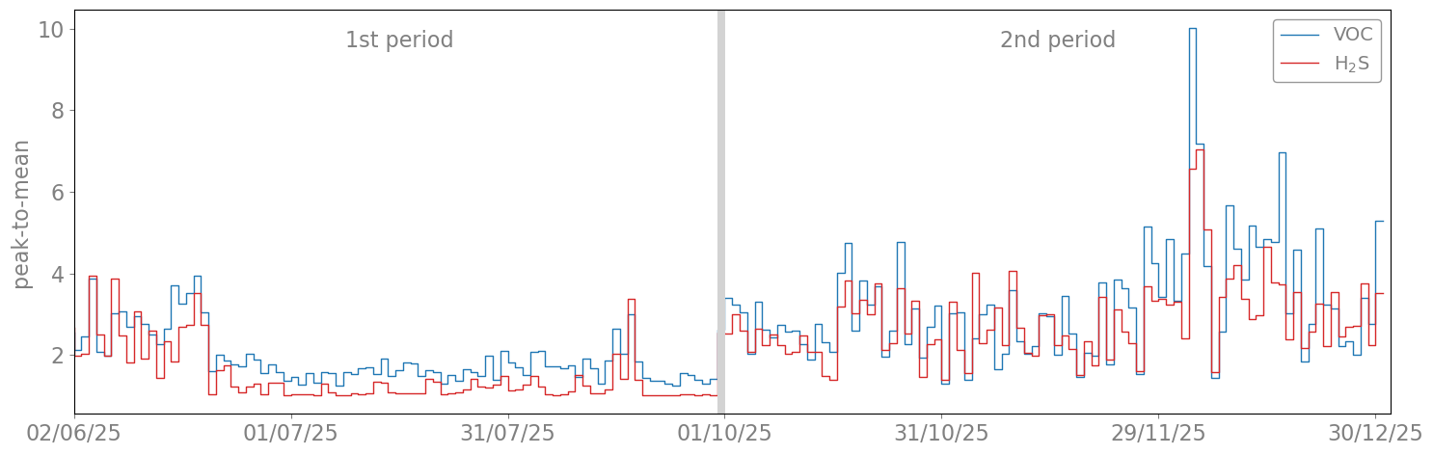
Figure 1: Daily peak-to-mean ratio of inlet VOC and H₂S concentrations for the WWTP.
    - Spectral analysis
Site A: Integrated AD and composting plant
No statistically significant periodic components were identified in the inlet VOC or H₂S signals at the AD/composting plant across either monitoring sub-period. The essentially flat PSD profiles indicate that the variability observed at this site was broadband in nature, rather than dominated by recurrent operational cycles at daily or sub-daily frequencies. The absence of clear periodic harmonics further supports the PTM results, which indicated relatively low short-term variability. The lack of dominant periodic forcing suggests that the performance of the activated carbon unit at this site will depend primarily on cumulative mass loading and multicomponent competitive adsorption, rather than on its capacity to buffer frequent shock loads. Consequently, the filter behaviour can, in principle, be predicted from cumulative loading, the specific sorption capacities of the carbon for the emitted compounds, and the total carbon mass in the bed.
Site B: Wastewater treatment plant
PSD analysis of the WWTP inlet stream showed a dominant peak corresponding to a period of approximately 24 h for VOC, H₂S, and instrumental odour units (Figure 2a–c).

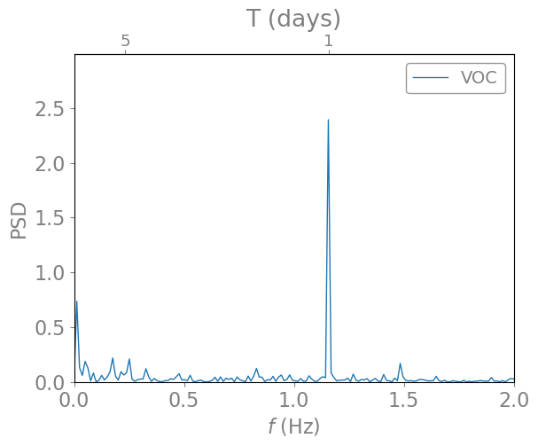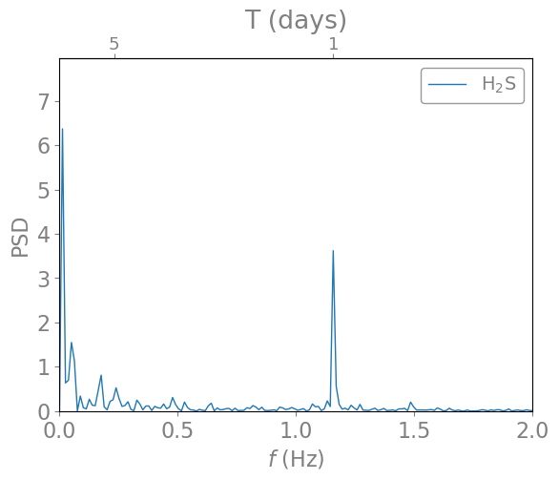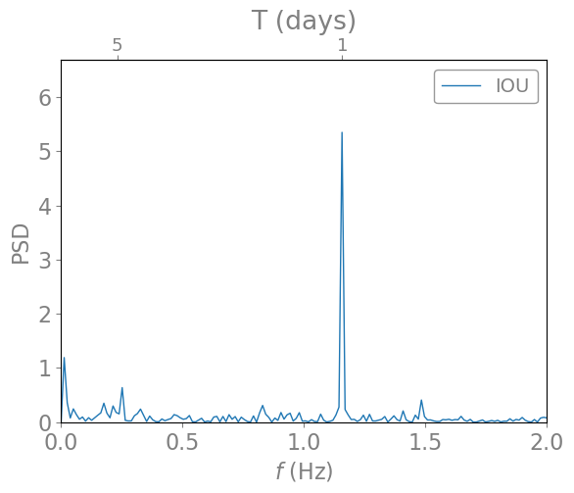
Figure 2a-c: Power Spectral Density of WWTP inlet time series for VOC (2a), H₂S (2b) and Instrumental Odour Unit (2c).
This result is consistent with the daily pattern of municipal wastewater generation, in which recurring human activities produce corresponding hydraulic and organic loading cycles, and hence recurrent odour emissions from equalization, primary treatment, and sludge-related units. The presence of the same fundamental harmonic in all three variables indicates that the load reaching the biotrickling filter was driven by a stable daily pattern. A secondary harmonic observed at around 5 days may also reflect the influence of industrial activities concentrated on weekdays. Overall, the spectral analysis indicates that the odour abatement unit was repeatedly exposed to predictable high-load periods, which may result in elevated short-term outlet concentrations and increase the probability of short-term exceedances of odour emission limits.
    - Removal efficiency
Site A: Integrated AD and composting plant
At the AD/composting plant, the H₂S removal efficiency remained fairly constant over the monitoring period, averaging around 60% and typically ranging from 50% to 70%. Considering the low inlet H₂S concentrations and the intermediate abatement performance—expected for an activated carbon unit not specifically designed for sulfide removal—no significant temporal trend in H₂S removal efficiency was detected. In contrast, VOC removal efficiency exhibited a clear breakthrough pattern (Figure 3).

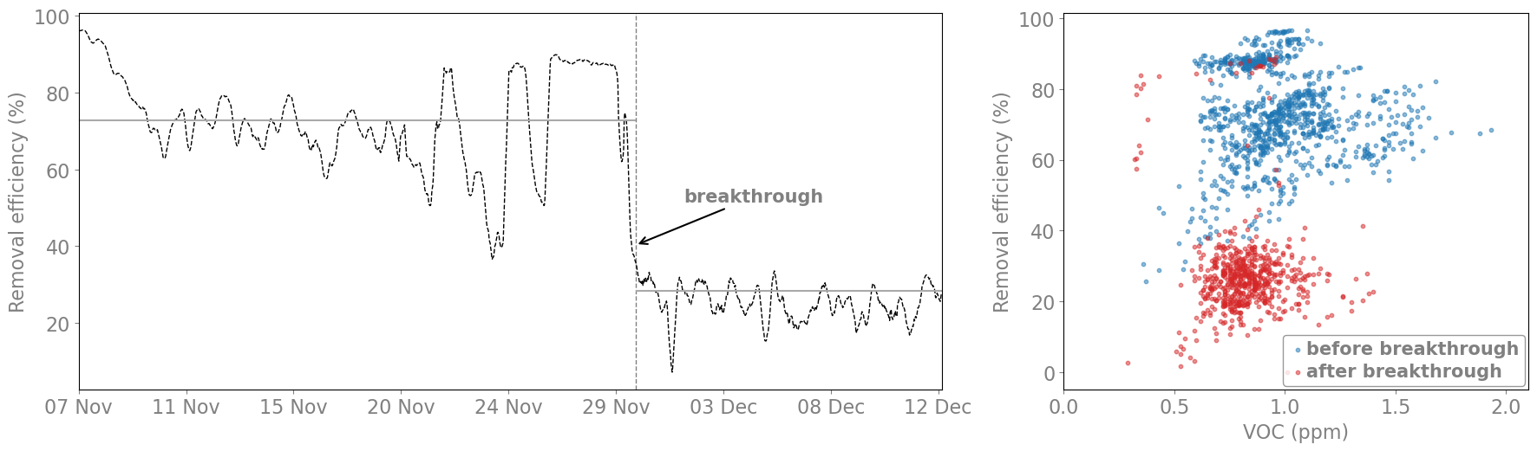
Figure 3a-b: Removal efficiency as a function of operating time (3a) and inlet VOC concentration (3b) (1st monitoring period).
Before breakthrough, the activated carbon bed achieved a mean VOC removal efficiency of about 73%; after breakthrough, this declined to 28%. The scatter plot confirms this shift, with pre-breakthrough data mainly above 60% efficiency and post-breakthrough data mostly below 35%. A similar trend was observed for odour removal efficiency expressed as instrumental odour units (IOU), with mean values of 78% before breakthrough and 39% after breakthrough. The difference between VOC- and IOU-based efficiencies indicates that odour concentration is not determined by VOC concentration alone, but also by other compounds accounted for by the multivariate IOMS model. This behaviour is consistent with progressive saturation of the activated carbon bed, causing a marked decline in adsorption performance after about 22 days of continuous operation. Continuous monitoring with OSMOTREFF® is therefore useful for saturation-based systems such as GAC filters, as it enables early detection of declining performance, prediction of bed exhaustion, and timely replacement before breakthrough.
Site B: Wastewater treatment plant
VOC removal efficiency in the biotrickling filter averaged about 80%, with recurrent daily drops below 60%. Lower efficiencies were observed during morning high-load periods, consistent with the elevated PTM values and the 24 h periodicity identified by spectral analysis. These results indicate limited attenuation of VOC shock loads, likely due to insufficient effective residence time and/or mass-transfer limitations under high-load conditions, especially for the less soluble and less biodegradable compounds in the mixture. At the WWTP, H₂S removal efficiencies remained above 90% over a wide range of inlet concentrations (Figure 4), in agreement with the robust H₂S abatement commonly reported for biotrickling filters treating wastewater off-gases (Parzentna-Gabor et al., 2023).

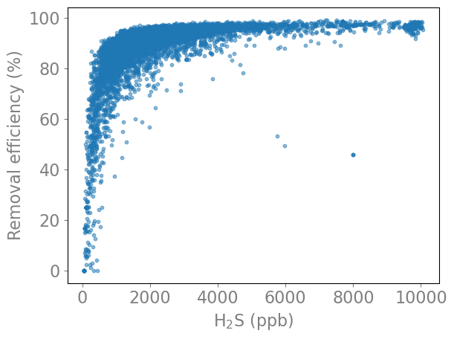
Figure 4: Removal efficiency as a function of inlet H₂S concentration for the WWTP
A more likely limitation to odour removal at this site is not H₂S oxidation, but the less soluble and less biodegradable VOC fractions or volatile sulfur compounds such as dimethyl sulfide (DMS), which are generally removed less efficiently than H₂S in biological systems (González-Cortés et al., 2024; Wu et al., 2018). In terms of instrumental odour units, the lower removal efficiency for VOCs, and possibly also VSCs, caused periodic exceedances of the regulatory odour emission limit of 2000 IOU m⁻³, which was exceeded for 3.5% of the monitored time. If included in dispersion modelling, this variability may increase the predicted odour nuisance at sensitive receptors compared with a constant-emission assumption (Brancher et al., 2021). More broadly, the integration of continuously monitored instrumental odour concentrations at emission points with time-resolved odour dispersion modelling may enable more realistic prediction of population exposure. In future applications, this approach could be extended to near-real-time impact forecasting (Uvezzi et al., 2022), thereby supporting early-warning systems and dynamic plant management.
  - Conclusions
This work presented two full-scale applications of OSMOTREFF® for continuous monitoring of odour emissions at point sources, upstream and downstream of abatement units in an AD/composting plant and in a municipal WWTP. In both cases, the system provided time-resolved information on VOCs, H₂S, and instrumental odour concentration, allowing direct interpretation of inlet load dynamics and treatment performance under real operating conditions. At the AD/composting plant, the inlet emission profile was relatively stable, with low PTM values and no significant periodic components in the PSD analysis. Under these conditions, the GAC unit was mainly affected by cumulative loading, and breakthrough was identified after about 22 days of operation, with VOC removal efficiency decreasing from approximately 73% to 28%. At the WWTP, the inlet load was markedly more variable, with higher PTM values and a dominant 24 h harmonic for VOC, H₂S, and instrumental odour units. The biotrickling filter achieved H₂S removal efficiencies above 90% over a wide concentration range, whereas VOC removal was more variable and showed recurrent efficiency drops during high-load periods, indicating limited attenuation of short-term shock loads. Overall, the results show that OSMOTREFF® provides operational information beyond that obtainable from periodic olfactometric campaigns, including continuous characterization of inlet load dynamics and treatment performance. In addition to supporting process control and predictive maintenance, the instrumental odour data generated by the system may also support future integration with dynamic dispersion modelling for improved assessment of off-site impact and odour nuisance risk.
References

TATISTICAL ELEMENTS OF PREDICTING
THE IMPACT OF A VARIETY OF ODOUR SOURCES
STATISTICAL ELEMENTS OF PREDICTING
THE IMPACT OF A VARIETY OF ODOUR SOURCES
Brancher M., Schauberger G., Piringer M., Franco D., de Melo Lisboa H., 2021, Dispersion modelling of environmental odours using hourly-resolved emission scenarios: Implications for impact assessments. Atmospheric Environment: X,12, 100124.
Cangialosi F., Bruno E., De Santis G., 2021, Application of Machine Learning for Fenceline Monitoring of Odor Classes and Concentrations at a Wastewater Treatment Plant. Sensors 21(14), 4716.
Cangialosi F., Fornaro A., 2024, Advancements in Instrumental Odour Monitoring System from Stationary Emission Sources, Chemical Engineering Transactions 112, 103–108.
González-Cortés J.J., Lamprea-Pineda P.A., Ramírez M., Demeestere K., Van Langenhove H., Walgraeve C., 2024, Biofiltration of gaseous mixtures of dimethyl sulfide, dimethyl disulfide and dimethyl trisulfide: Effect of operational conditions and microbial analysis, Journal of Environmental Management 362, 121320.
Parzentna-Gabor A., Kasperczyk D., Barbusiński K., Rene E.R., Urbaniec K., 2023, Odor and volatile organic compounds biotreatment using compact trickle bed bioreactors (CTBB) in a wastewater treatment plant. Bioresource Technology, 376, 128876.
Prudenza S., Bax C., Capelli L., 2023, Implementation of an electronic nose for real-time identification of odour emission peaks at a wastewater treatment plant, Heliyon, 9, e20437.
Ratti C., Bax C., Lotesoriere B.J., Capelli L., 2024, Real-Time Monitoring of Odour Emissions at the Fenceline of a Waste Treatment Plant by Instrumental Odour Monitoring Systems: Focus on Training Methods, Sensors 24(11), 3506.
Tchepel O., Borrego C., 2010, Frequency analysis of air quality time series for traffic related pollutants, Journal of Environmental Monitoring 12(2), 544–550.
Uvezzi G., Invernizzi M., Sironi S., 2022, Real-time Odour Dispersion Modelling for Industrial Sites Application: State of the Art and Future Perspectives, Chemical Engineering Transactions 95, 133–138.
Wu H., Yan H., Quan Y., Zhao H., Jiang N., Yin C., 2018, Recent progress and perspectives in biotrickling filters for VOCs and odorous gases treatment. Journal of Environmental Management 222, 409–419.
Zhang Y., Zhu Z., Zheng Y., Chen Y., Yin F., Zhang W., Dong H., Xin H., 2019, Characterization of Volatile Organic Compound (VOC) Emissions from Swine Manure Biogas Digestate Storage. Atmosphere 10(7), 411.

