 CHEMICAL ENGINEERING TRANSACTIONS  VOL. xxx, 2026 | A publication of  
The Italian Association
of Chemical Engineering
Online at www.cetjournal.it

Guest Editors: Laura Capelli, Marzio Invernizzi, Selena Sironi
Copyright © 2026, AIDIC Servizi S.r.l.
ISBN 979-12-81206-xx-x; ISSN 2283-9216

Evaluation of Best Available Techniques for Odour Abatement in Refineries: An Italian Assessment
Nicoletta Lotrecchiano^{a,}*, Angelo Pecciª, Nicola Zappimbulsoª, Maria Corteseª, Michele Antonino Ilacquaª, Fabio Ferrantiª
ª Department of Environmental Assessment, Controls and Sustainability Service for Risks and Environmental Sustainability of Technologies, Chemical Substances, Production Cycles and Water Services and for Inspection Activities, ISPRA - Institute for Environmental Protection and Research, Via V. Brancati 48, 00144 Rome, Italy
nicoletta.lotrecchiano@isprambiente.it
Odour emissions represent a significant environmental issue in refinery operations, as they can affect surrounding communities and contribute to negative public perception of industrial activities.
The Integrated Environmental Authorization (IEA) is the regulatory instrument that implements the requirements of the European Integrated Pollution Prevention and Control (IPPC) framework, currently incorporated into Legislative Decree 152/2006 in implementation of the Industrial Emissions Directive (IED) 2010/75/EU.
Within the European regulatory framework, the sector-specific Best Available Techniques (BAT) conclusions for the refining of mineral oil and gas (Decision 2014/738/EU) and cross-sectoral related BATc provide a structured approach for minimizing odour impacts. The BAT Conclusions emphasize the adoption of integrated measures, including Leak Detection and Repair (LDAR) programmes, vapour recovery systems for storage and loading operations, enclosed or covered wastewater treatment units, thermal or catalytic oxidation, biofiltration, and activated carbon adsorption for treating odorous gas streams, etc.
This study provides a comparative evaluation of the odour‑abatement and mitigation systems currently implemented across Italian refinery plants. The objective is to assess the degree to which BAT Conclusions related to odour emissions are effectively operationalized, thereby providing insight into the practical alignment between regulatory requirements and on‑site environmental management practices.
  - Introduction
Odour emissions represent a significant environmental issue in refinery operations, as they can affect surrounding communities and contribute to negative public perception of industrial activities.
The main odour sources in refineries include storage facilities, sewer systems, uncovered dissolved air flotation units, oil/water/solid separation processes, biotreatment units, and flaring. The sewage system and wastewater treatment plants may also contribute to odour nuisance, particularly from open drains and oil separators (Senatore et al., 2021). Special attention should be paid during plant maintenance and cleaning activities, especially during major shutdowns, to prevent the release of odours from drainage systems and/or ponds. Local weather conditions can also affect the potential for odour emissions from a site (Concawe, 2020).
Essentially, these emissions originate from multiple process units - such as storage tanks, wastewater treatment plants, flares and volatile hydrocarbon handling, fugitives from equipment components installed on process plants, pipework and storage – and are often associated with reduced sulphur compounds, such as H₂S and mercaptans, as well as VOCs including aromatic hydrocarbons, and other odour species (Invernizzi et al., 2018).
Effective odour mitigation therefore requires a combination of process optimization, emission control technologies, and continuous monitoring strategies.
Odour nuisance caused by an industrial plant like a refinery may represents a potential risk to the local population, which must be assessed (Pottier et al., 2022) developing an odour policy for a local government ant the plant too (De Bree et al., 2016), in fact most of IEA Decrees is mandatory to have a record of odour reports from the citizens.
  - Materials and Methods
Odour emissions consist of volatile inorganic and organic compounds (VICs and VOCs) originating from both channeled and diffuse/fugitive sources. Within refineries, potential sources of odour include product storage and handling, crude oil, intermediate, and finished product storage tanks, sewer and wastewater systems, open-air DAF (dissolved air flotation) units, oil/water/solid separation processes, wastewater treatment plants (biotreatment units, open drains, oil separators), process units related to processes that handle volatile hydrocarbons, including equipment containing VOCs, sulfur compounds (H₂S, mercaptans), and other odour species, flaring, which can release odours especially during upsets, start-ups, or shutdowns, and leaks from valves, flanges, pumps, connections, compressors. One part of a refinery plant that is a source of odour emissions is the Claus process, in which odour emissions are not intentional but are residual or accidental, and arise mainly from the residual presence of H₂S, hydrogen sulphide – which is the primary cause of the odour – and reduced sulphur compounds.
    - Plants description
In Italy, there are currently 13 refineries subject to the Integrated Environmental Authorization (IEA) under state jurisdiction, distributed across various regions and primarily concentrated in industrial areas and near ports to facilitate the import of crude oil and the export of refined products; Among these are the two biorefineries in Gela and Venice, which represent a significant advancement in the energy and chemical sectors, focused on the production of biofuels, biochemicals, and biomaterials from renewable biomass.
The geographical distribution of the 13 refineries across Italy is shown in Figure 1 that reports also the ISPRA analysis of water stress levels (updated 07/12/2024) and the locations of the 13 Italian refineries and the quantity of raw material processed in 2023 (Blesi et al., 2024).

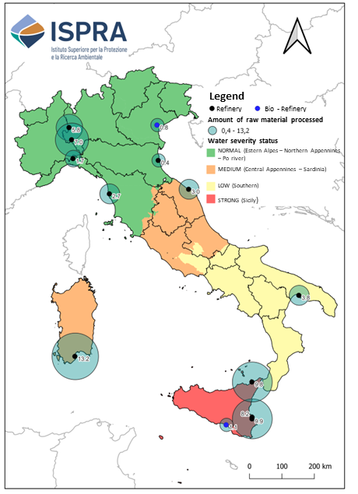
Figure 1. ISPRA analysis of water stress levels (updated 07/12/2024) showing the Italian refineries and bio-refineries locations, and the quantity of raw material processed in 2023.
    - Regulation
The current regulatory framework addresses the issue of odours primarily indirectly, through the regulation of atmospheric emissions, the application of the integrated approach to pollution prevention and control, and the adoption of Best Available Techniques (BAT).
Directive 2010/75/EU on industrial emissions (Industrial Emissions Directive – IED) constitutes the fundamental European reference for large industrial facilities, including oil refineries, by introducing an integrated approach to pollution prevention and control through the application of BATs to limit overall emissions.
Directive 2010/75/EU was amended by the so-called IED 2.0 (Directive 2024/1785/EU), which entered into force in August 2024, recognizing odour emissions as a form of pollution that can have significant effects on the environment and health. Odours must therefore be considered in determining Best Available Techniques (BAT) and during the installation authorization phase.
For the refining sector, the BAT Conclusions adopted by the European Commission - Implementing Decision 2014/738/EU – REF BAT (European Parliament, 2014) are particularly relevant, providing specific guidance on: diffuse and fugitive emissions management, the control of odour sources associated with storage, loading/unloading and treatment units, and environmental monitoring and management systems; the adoption of organizational and technical measures to prevent odour nuisance.
The BAT Conclusions are the reference for defining the permit conditions for refineries subject to the IED and represent the primary instrument for European harmonization regarding industrial odours emissions.
The REF BAT application aims at controlling both diffuse and point-source emissions, including the installation of vapour recovery units at petrol loading and unloading bays (BAT 52), the implementation of Leak Detection and Repair - LDAR- program (BAT 18) (Lotrecchiano et al., 2025), and the achievement of VOC removal efficiencies greater than 98–99% during flaring operations.
In addition to these, other decisions on BATs have been adopted as Implementing Decision (EU) 2016/902, which sets out the conclusions on best available techniques (BATs) for common systems for the treatment and management of wastewater and exhaust gases in the chemical industry - CWW BAT (European Parliament, 2016). This Decision introduced a series of BATs relating to the management of diffuse and fugitive emissions, as well as odour emissions and their management for the purpose of reduction as reported in BAT 6 and 20 that define the implementation of an odour management plan (OMP).
Besides the BAT Conclusions, the Concawe report is intended to help refineries, in any applicable national guidelines, approaching to minimize odours impacts and to address complaints in the event of on-site odour incident. It examines the principal issues associated with odour emissions from refinery operations, including techniques for odour assessment and investigation, the applicable regulatory mechanisms, measures for odour mitigation and control, the essential elements of an Odour Management Plan (OMP), and the establishment of an effective odour complaint management system (Concawe, 2020).
The Ministry of the Environment and Energy Security Decree no. 309 of 28/06/2023, provides a series of measurements to be carried out using a PID portal field detector to evaluate the emission trends of VOCs from vapour recovery units (VRUs). The guidelines also provide an important framework for use in the investigative and decision-making processes of the competent authorities regarding environmental permits and for the future development of regional and state legislation.
In detail, the guidelines address the criteria and methods for applying Article 272-bis of Legislative Decree 152/2006, a provision that generally regulates odour emissions from plants and activities. They are applied directly to establishments covered by Part Five of Legislative Decree 152/2006 (subject to a single environmental authorization - AUA, emissions authorization, or derogation authorization regimes) and indirectly, as a protection criterion to be used in the authorization process, to installations subject to an integrated environmental authorization – IEA (Zalin and Sironi, 2024).
The Technical Document “Odour emissions: reference points and methodological approaches for monitoring”, has been approved by SNPA Council Resolution n. 268/25 (SNPA, 2025) and aims to provide regulatory authorities with comprehensive information to help in selecting appropriate approaches for the prevention, control and assessment of odour emissions. Methodological and technological innovations related to the monitoring and control of odours, as well as updates regarding technical standards in the sector and national and regional legislation that have occurred in recent years, have introduced numerous new elements to the sector itself.
    - Abatement techniques
The REF BAT reports the techniques to be adopted for the limitation of odour emissions that refineries must implement (European Parliament, 2014).
Within the document containing the REF BAT, techniques for reducing odour emissions are identified under BAT 6, 18, 49, and 52.
BAT 6 and 18 concern the techniques to be applied to prevent or reduce diffuse emissions of VOCs within refineries, applying methods for monitoring diffuse and fugitive emissions such as the implementation of the Leak Detection and Repair (LDAR) protocol.
BAT 49 concerns the reduction of diffuse emissions from storage tanks of volatile liquid hydrocarbon compounds. BAT is to use floating roof storage tanks equipped with high efficiency seals or a fixed roof tank connected to a vapour recovery system.
According to BAT 49, floating roof tanks must be equipped with high-efficiency seals, minimizing the leakage of vapours through the tank crown, while for fixed roof tanks, BAT requires that the tanks be connected to a vapour recovery system (VRU), so as to intercept and reduce vapours that would otherwise be released into the atmosphere during filling or level changes.
A Vapour Recovery Unit (VRU) is a system designed to capture and recover hydrocarbon vapours that would otherwise be released into the atmosphere from storage tanks, loading/unloading operations, or other industrial equipment.
Fixed‑roof tanks generally do not release continuous emissions to the atmosphere, as venting events occur primarily during liquid transfer operations. When the tank receives inflows—whether from process units or from other storage vessels—an increase in internal pressure may arise. To prevent structural overpressure, part of the gaseous headspace, consisting of air or inert gas, is vented to the atmosphere. Because this gaseous stream becomes enriched with volatile organic compounds during storage, the resulting release may represent a source of odour emissions. Consequently, the measured odour emission rate can be reasonably correlated with the temporal evolution of the liquid level inside the tanks, as level increases typically correspond to venting episodes.
BAT 52 requires the installation of a vapour recovery technique (VRU or equivalent systems) to reduce NMVOC emissions from the loading of volatile products onto ships. It applies specifically to loading operations in port terminals, refineries, and storage facilities, where significant emissions of hydrocarbon vapours occur due to the movement of gas in the ship's tank during filling, pressure variations in the loading circuits and, the presence of highly volatile products. BAT requires that these vapours be intercepted and treated using recovery systems VRU. Considering that, ninety percent of Italian refineries are located on the coast to facilitate the import of crude oil by sea, the BAT 52 is critical for the refineries.

Odour emission abatement techniques are not limited to those regulated by BAT, but refineries also apply other emission abatement techniques such as covering wastewater treatment tanks or API tanks and alternative techniques such as chemical-physical neutralization referring to section 4.23.9 e 4.24.7 of Refineries BREF 2015 and BAT 21 on Common Wastewater and Gas - CWW.
API tanks (API oil–water separators) are a key component of the refinery wastewater treatment system. They are almost the first stage of treatment and are responsible for separating free oils and suspended solids from the industrial effluent.
During separation, light hydrocarbons (diesel, gasoline, distillates) rise to the surface and form an oily layer.
When these compounds arise and are exposed to air, they evapourate, releasing VOCs, odour hydrocarbons, and volatile sulfur compounds, often responsible for pungent odours. API tanks contain not only hydrocarbons, but also various organic substances. Under conditions of stagnation or low oxygenation, anaerobic degradation occurs, generating hydrogen sulfide, mercaptans, and volatile amines, which are highly odour compounds.
The API tank coverage allows hydrocarbons to be captured in the air above by using an extraction/injection system, sized to ensure compliance with safety regulations and prevent their release into the environment. The VOCs treated generally consist of aromatic and aliphatic hydrocarbons, H₂S, and ammonia.
Odour reduction through chemical-physical neutralization of odour substances uses blends of essential oils. These odour substances are particularly reactive and are not only capable of chemically reacting with malodour molecules, but also of decomposing or transforming them so that they are no longer perceptible as a bad smell. The application is achieved by nebulizing an aqueous mixture into the odour-producing areas using special nozzles located throughout the affected areas.
BAT 21 of EU Decision 2016/902 for common waste water and waste gas treatment/management systems in the chemical sector (CWW), establishing that to prevent or, where that is not practicable, to reduce odour emissions from waste water collection and treatment and from sludge treatment, one or a combination of techniques may be used such as chemical treatments and the optimization of aerobic treatment to destroy or reduce the formation of malodour compounds (e.g., oxidation or precipitation of hydrogen sulphide).
Chemical clarification, flocculation, and flotation treatments in wastewater not only improve water clarity by removing suspended solids (turbidity) but also play a crucial role in odour reduction. By removing colloidal organic matter and suspended bacteria, the primary source of anaerobic decomposition - responsible for foul odours - is reduced.
  - Results and discussion
The following table (Table 1) the current BAT application in the Italian refineries while Figure 2 shows the percentage of BAT implementation in Italian refineries. The calculation took 11 refineries into account; the two bio-refineries are not considered because in their green asset are not considered refineries anymore but are assimilated to chemical plants and so, not under the BAT REF - 2014/738/EU. The two Italian biorefineries have, however, implemented the abatement systems set out in the BAT guidelines for refining, having been converted from traditional refineries.
Some refineries (or chemical plants) send their wastewater to a shared treatment plant located outside their own site, which collects and treats wastewater from several plants. These external treatment plants are subject to regional integrated authorization. Of the Italian refineries considered, three fall into this category.
Table 1: BAT application.
Refinery | § 4.24.7.1  REF BREF  CWW BAT 21  tank/API coverage | CWW BAT 21  chemical-physical treatment | REF  BAT 49  floating roof | REF  BAT 49  fixed roof | REF  BAT 52 | CWW  BAT 6 | CWW  BAT 20 | REF  BAT 18 | § 4.23.7  REF BREF
1 | ○ | ○ | ○ | ⮾ | ○ | ○ | ○ | ○ | ○
2 | ○ | n/a | ○ | ⮾ | ○ | ○ | ○ | ○ | ○
3 | ○ | ○ | ○ | ○ | ○ | ○ | ○ | ○ | ○
4 | ⮾ | ⮾ | ⮾ | ⮾ | ⮾ | ○ | ○ | ○ | ○
5 | ⮾ | ○ | ○ | ○ | ○ | ○ | ○ | ○ | ○
6 | ⮾ | ○ | ○ | ○ | ○ | ○ | ○ | ○ | ○
7 | ○ | ○ | ○ | ○ | ○ | ○ | ○ | ○ | ○
8 | ○ | ○ | ○ | ⮾ | ○ | ○ | ○ | ○ | ○
9 | ○ | ○ | ○ | ○ | ○ | ○ | ○ | ○ | ○
10 | ⮾ | ○ | ○ | ⮾ | n/a | ○ | ○ | ○ | ○
11 | ○ | ⮾ | ○ | ○ | ○ | ○ | ○ | ○ | ○
12 | ○ | ○ | ○ | ⮾ | ○ | ○ | ○ | ○ | ○
13 | ⮾ | ⮾ | ○ | ○ | ○ | ○ | ○ | ○ | ○
Legend: ○ BAT applied, ⮾ BAT not applied, n/a - not applicable

As shown in Figure 2, the BATs relating to the vapour recovery units (VRUs) installation at petrol loading and unloading bays (REF BAT 52), the implementation of an LDAR programme (REF BAT 18), and the removal of >98–99% of VOCs during flare-off operations are applied by all refineries (§ 4.23.7 REF BREF) are applied by all refineries.
Furthermore, the implementation of an odour management plan and the associated monitoring, as proposed by CWW BAT 6 and 20, are also implemented by all refineries.

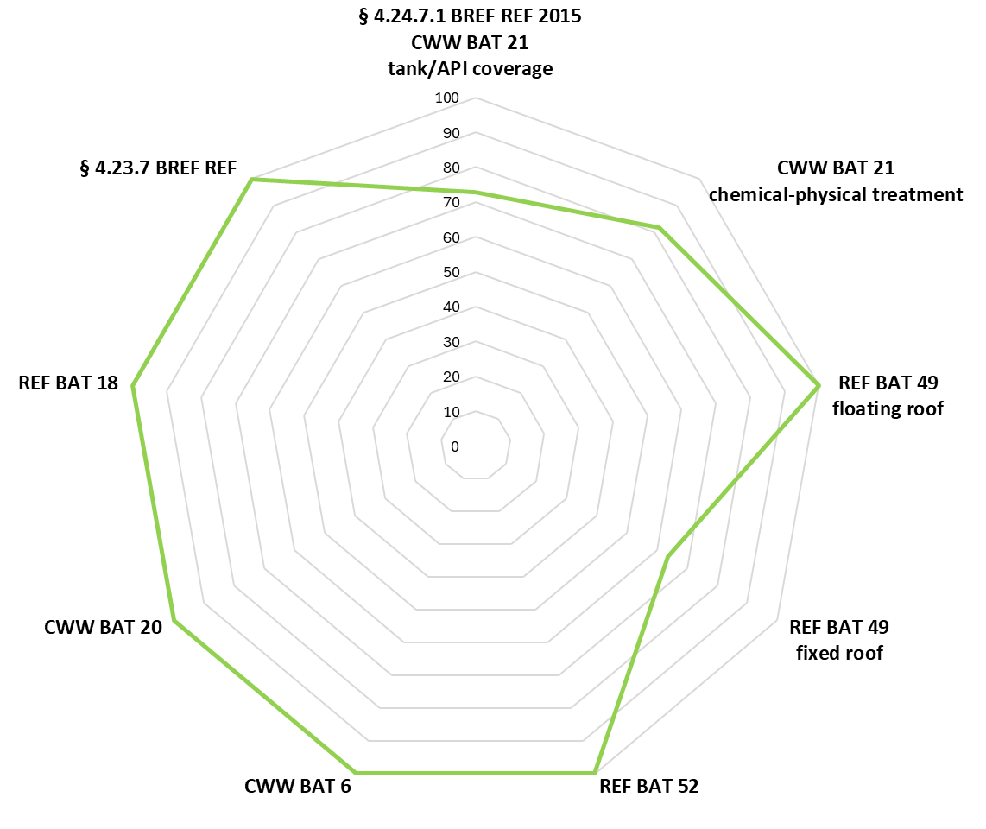
Figure 2. Percentage of BAT application in Italian refineries.
To verify the 95% recovery efficiency required by REF BAT 52, more than 50% of refineries analyse process parameters such as the liquid flow rate, activated carbon bed temperature and minimum pressure at each regeneration cycle. To ensure that the tank pressures of the loading vessels do not exceed the thresholds that allow the relevant pressure safety valves (PSVs) to open, the pressure on the vapour supply lines to the VRU is monitored.
Some Italian refineries do not produce finished petrol products and do not carry out the associated loading and unloading operations so, the REF BAT 52 (VRU at loading bays) does not apply to them; however, they still implement odour emission mitigation systems at their loading bays, such as the installation of mist and activated carbon filter systems for bitumen loading.
Among the BATs, it is noted that the one which is most difficult to implement is REF BAT 49, which relates to the installation of VRUs on tanks fitted with fixed roofs.
  - Conclusions
The assessment of Best Available Techniques (BAT) Conclusions implementation in Italian refineries indicates a high level of alignment with the requirements of the REF BREF. In general, all refineries comply with BATs or are moving towards compliance; they are using systems to mitigate and/or abate odour emissions depending on the various sources present in these complex plants. These results demonstrate the widespread adoption of effective measures for atmospheric emission reduction across the Italian refining sector.
All refineries have implemented odour management plans and associated monitoring activities in accordance with CWW BAT 6 and 20, confirming a systematic approach to odour control that is independent of specific site configurations. This uniform application is essential, given that some refineries discharge wastewater to external, shared treatment facilities, which are operated under integrated regional permits.
About REF BAT 52, over 50% of refineries verify compliance with the required 95% recovery efficiency through continuous or periodic monitoring of the relevant process parameters.
Of the BATs considered, REF BAT 49, which concerns the installation of vapour recovery units on fixed-roof tanks, appears to be the most difficult to implement, likely due to technical, operational and infrastructural constraints. Overall, the results indicate a high level of BAT implementation in Italian refineries, with limited challenges associated with specific techniques that require complex modernization work.
References
Blesi F., Cortese M., Farabegoli G., Giorgioli P., Giuliani C., Spuri S., 2024, Pratiche di Water Reuse nelle raffinerie, Ecoscienza, 2024/03, 48-50, ecoscienza@arpae.it ISSN 2039-0432.
Commission Implementing Decision 2014/738/EU of 9 October 2014 establishing best available techniques (BAT) conclusions for the refining of mineral oil and gas under Directive 2010/75/EU of the European Parliament and of the Council (OJ L 307, 28.10.2014, p. 38).
Concawe, 2020, Odour management guidance for refineries (Report No. 1/20). Concawe. available at https://www.concawe.eu/wp-content/uploads/Rpt_20-1.pdf.
De Bree F., Dingemanse J.D., 2016, Development of an odour policy for a local government, Chemical Engineering Transactions, 54, 1-6 DOI: 10.3303/CET1654001
Directive Decree of the Ministry of the Environment No. 309 of June 28, 2023 – Approval of guidelines for the application of Article 272-bis of Legislative Decree 152/2006 regarding odour emissions from facilities and activities, prepared by the “Emissions Coordination Group”;
Invernizzi M., Ilare J., Capelli L., Sironi S., 2018, Proposal of a method for evaluating odour emissions from refinery storage tanks, Chemical Engineering Transactions, 68, 49-54 DOI: 10.3303/CET1868009.
Pottier B., Artigue V., Tixier J., Olivier S., Chaignaud M., Fanlo J.-L., 2022, Odour Nuisance: a New Methodology to Evaluate and Anticipate the Risk, Chemical Engineering Transactions, 95, 43-48 DOI:10.3303/CET2295008.
Senatore, V.; Zarra, T., Galang, M.G.; Oliva, G., Buonerba, A., Li, C.-W., Belgiorno, V., Naddeo, V., 2021, Full-Scale Odour Abatement Technologies in Wastewater Treatment Plants (WWTPs): A Review. Water, 13, 3503. https://doi.org/10.3390/w13243503.
SNPA Guidelines “Odour Emissions: Reference Elements and Methodological Approaches for Monitoring” referred to in SNPA Council Resolution No. 268/25 of January 23, 2025.
Zalin M. and Sironi S., 2024, New Guidelines in Italy for the Regulation of Odour Emissions, Chemical Engineering Transactions, 112, 13-18 DOI:10.3303/CET24112003.

