 CHEMICAL ENGINEERING TRANSACTIONS  VOL. xxx, 2026 | A publication of  
The Italian Association
of Chemical Engineering
Online at www.cetjournal.it

Guest Editors: Laura Capelli, Marzio Invernizzi, Selena Sironi
Copyright © 2026, AIDIC Servizi S.r.l.
ISBN 979-12-81206-xx-x; ISSN 2283-9216

Operational protocol and acceptance criteria for quality assurance in Instrumental Odour Monitoring Systems (IOMS) under UNI 11761:2023
Magda Brattoli^{a,*}, Federico Cangialosiª, Antonio Fornaro^{b}, Martino Giannuzzi^{b}
ª Tecnologia & Ambiente S.r.l., Via Michele Mummolo 13, Putignano (BA), Italy
^{b} Labservice Analytica S.r.l., Via Emilia 51/c, Anzola Emilia (BO), Italy
m.brattoli@tecnologiaeambientesrl.com
The metrological robustness and long-term stability of Instrumental Odour Monitoring Systems (IOMS) are critical for their reliable application in environmental monitoring and regulatory frameworks. In Italy, the application of IOMS is addressed by the national guidance (Director Decree No. 309/2023) and by the technical standard UNI 11761:2023, which defines verification procedures but does not provide quantitative acceptance criteria for the resulting performance indicators. This study presents an operational quality assurance protocol applied to IOMS installations, developed to bridge the gap between the requirements of the technical standard and practical field implementation. The protocol encompasses validation of the instrumental odour metric (quality assurance level 2) and periodic performance monitoring (quality assurance level 3). Level 2 verification is based on statistical comparison between IOMS outputs and dynamic olfactometry measurements, while Level 3 verification assesses instrumental stability and accuracy over time using span gases at certified concentrations. Based upon long-term operational datasets and experience gained from managing multiple installations subject to regulatory requirements, this paper proposes a methodological approach for IOMS management and introduces quantitative acceptance criteria and decision thresholds to support system validation and the implementation of corrective actions when necessary.
  - Introduction
The use of Instrumental Odour Monitoring Systems (IOMS) in environmental applications is rapidly growing, driven by the increasing demand for continuous monitoring at plant boundaries and by the need for tools that can support regulatory decisions. Compared to conventional odour measurement techniques based on dynamic olfactometry (CEN, 2022), IOMS provide real-time outputs, broader temporal coverage and source discrimination through pattern recognition, but their performance strongly depends on metrological robustness and on the adoption of sound quality assurance procedures (Deshmukh et al., 2015).
At the European level, standardization efforts are ongoing within CEN/TC 264, Working Group 41, but no harmonized standard has been issued yet. Instead in the Italian regulatory framework, the application of IOMS is explicitly addressed in the national guidance on odour emissions (Director Decree No. 309/2023), where these systems are often prescribed as operational tools to monitor odour concentration at the fenceline and to support management actions based on predefined thresholds. This has led regulators, control authorities and plant operators to demand reliable and traceable measurement devices and consequently to the development of a specific technical standard (Cipriano and Capelli, 2019). UNI 11761:2023 publication (UNI, 2023) represents a structured attempt to define metrological requirements and verification procedures for IOMS deployed in real applications. The standard describes performance verification into three levels: Level 1, addressed to manufacturers; Level 2, addressed to end users and based on validation against dynamic olfactometry in the field; Level 3, based on periodic field checks with reference gases.
The main limitation of the current framework is the absence of objective quantitative acceptance criteria for the performance indicators derived by verification procedure. This gap is particularly critical in operational contexts, where IOMS outputs may directly support regulatory decisions or trigger corrective actions.
This paper presents a quality assurance protocol developed according to long-term operational datasets and practical experience gained from managing multiple installations subject to regulatory requirements. This approach is framed from the perspective of end users, who must balance compliance with the standard against what is technically achievable in the practical operation and operational costs associated with verification activities. The focus is on the phases following system training, not covered by the technical standard, and on the definition of quantitative acceptance criteria for Level 2 and Level 3 outcomes.
  - Materials and methods
    - Instrumental apparatus
The quality assurance protocol was developed with specific reference to IOMS deployed for fenceline monitoring across various industrial applications. The instrument used is MSEM 3200 Multi Sensor Environmental Monitor (Sensigent), designed for continuous analysis of ambient air and equipped with a 32-sensor array integrating different measurement principles. The array includes nano-composite array (NCA), metal oxide semiconductor (MOS), electrochemical (EC), photoionization (PID), and infrared/ultraviolet spectrometric detectors. The multi-technology configuration enhances robustness against environmental variability and improves the discrimination between different odour patterns. A site-specific trained algorithm processes the raw signals in real time and provides the output parameters, including instrumental odour concentration and odour classification (ID). An automatic correction cycle, based on temperature, humidity and photoionization measurements, compensates for environmental effects that are particularly relevant for MOS sensors (Ratti et al., 2024). The system is factory-calibrated using n-butanol as span gas, that is the reference compound in dynamic olfactometry (CEN, 2022). The instrument has been qualified by the manufacturer for Level 1 verification under UNI 11761:2023, which defines the metrological performance through tests with reference gases, including the determination of measurement range and detection limit (LR). The main technical specifications are summarised in Table 1.
Table 1: Main technical specifications of the IOMS used in the case study.
Feature | Value
Sensor array | 32 sensors
Measurement range | 80 – 1,800 ou_{E}/m³
Response time | T₉₀ < 15 s (array average)
Span gas | n-butanol
Level 1 compliance | UNI 11761:2023 (manufacturer-qualified)
Output | iou, odour ID, raw sensor signals
    - Level 2 verification
Level 2 verification is based on the comparison between IOMS outputs and odour concentration determined by dynamic olfactometry according to the reference method (CEN, 2022). UNI 11761:2023 assesses system performance using Bland–Altman analysis (Bland and Altman, 1986). To comply with the standard requirement, i.e. to ensure that performance is evaluated under environmental conditions representative of seasonal variability, Level 2 verification is performed every six months for systems operating continuously for more than one year. In field operational conditions, sample presentations are typically carried out without prior knowledge of the actual odour concentration of the samples, and raw sensor signals are not directly inspected during acquisition. Consequently, a data pre-processing procedure was developed prior to Bland–Altman analysis in order to evaluate the quality of the sample presentation and to retain only reliable observations. This step is essential to avoid including low-quality measurement events in the analysis, which could otherwise compromise the robustness and interpretability of the performance assessment. Since raw sensor signals can be affected by noise, drift and memory effects (Gardner and Bartlett, 1999; Capelli et al., 2014; Yan et al., 2015), the data pre-selection procedure was based on a multi-step approach with the aim to detect and quantify these disturbances.

2.2.1 Pre - processing data analysis
The data pre-processing procedure was developed based on the analysis of the IOMS sensor array, with specific reference to the response behaviour of polymer-based sensors, which typically exhibit heterogeneous sensitivity within the array. Accordingly, a stepwise filtering approach was implemented to identify robust and representative observations prior to Bland–Altman analysis.
Active sensor selection. For each sensor and each exposure event, a response amplitude was computed as:
$∆S=B- S_{min}$ (1)
where B is the baseline average over the 120 s preceding the sample presentation and S_{min} is the minimum signal recorded during the exposure, reflecting the downward (negative) response of the sensor. A sensor was classified as active when the following conditions were simultaneously satisfied:
(i) signal-to-noise ratio ΔS/σ_{B} ≥ 3, where σ_{B} is the standard deviation of the baseline signal;
(ii) relative response ΔS/B ≥ 0.10. This threshold was introduced as a pragmatic criterion to exclude small signal variations likely dominated by noise and short-term drift (Padilla, 2010).
Only active sensors contributed to the subsequent indicators.
Carry-over criterion. To account for sensor memory effects, particularly relevant when a high-concentration sample is followed by a lower-concentration one, a carry-over index was defined as:
$Carry over=\frac{|B_{A}- S_{pre, B}|}{{ΔS}_{A}}$ (2)
where B_{A} is the baseline average of the previous event, S_{pre,B} is the signal immediately preceding the current event, and ΔS_{A} is the response amplitude of the previous event. The evaluation was performed on sensors active in both events A and B. A transition was considered acceptable when carry over ≤ 0.25 was satisfied by at least 70% of the sensors in the evaluation pool. Figure 1 illustrates examples of acceptable and non-acceptable carry-over conditions between consecutive sample presentations.

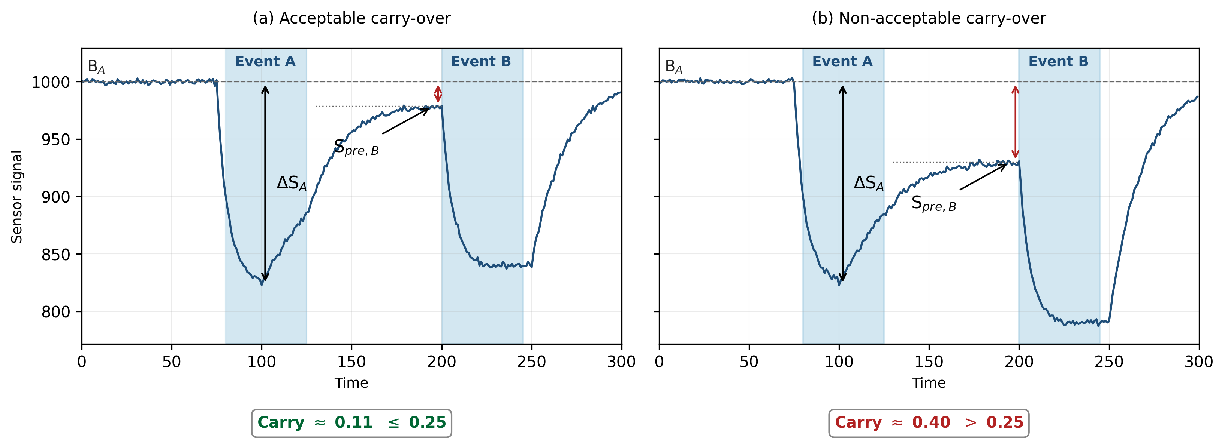
Figure 1: Array-mean sensor responses during two consecutive sample presentations: (a) acceptable carry-over; (b) non-acceptable carry-over.
Replicate consistency. When two replicates of the same sample were available, their consistency was evaluated through the ratio:
$Rs=\frac{max⁡({ΔS}_{s,S1}, {ΔS}_{s,S2})}{min⁡({ΔS}_{s,S1}, {ΔS}_{s,S2})}$ (3)
where ∆S_{s,S1} and ∆S_{s,S2} are the response amplitudes of sensor in the first and second replicate, respectively. A sensor was considered compliant when Rs ≤ 1.5. The use of absolute response amplitudes rather than normalised values was adopted to avoid masking differences between replicates under varying baseline conditions. The sample was classified as consistent when at least 70 % of the common active sensors satisfied the compliance condition. Otherwise, the sample was rejected due to insufficient replicate agreement.
Bypass rule. A bypass condition was introduced to handle cases where the first replicate (S₁) was rejected because of carry-over from a previous presentation. In such cases, the second replicate (S₂) was re-evaluated by computing the carry-over index of the transition from the event that preceded S1 directly to S2.
Parameters and thresholds are summarised in Table 2.
Table 2: Parameters and acceptance thresholds of the Level 2 pre-selection procedure.
Step | Indicator | Definition | Threshold
Sensor response | Response amplitude | ΔS = B − S_{min} | –
Signal quality | Signal-to-noise ratio | ΔS / σ_{B} | ≥ 3
Signal relevance | Relative response | ΔS / B | ≥ 0.10
Memory effect | Carry-over index | |B_{A} − S_{pre,B}| / ΔS_{A} | ≤ 0.25
Sensor agreement | Fraction of compliant active sensors | – | ≥ 70 %
Replicate consistency | Ratio R | max(F) / min(F) | ≤ 1.5
Applicability check. As a final gate, only samples within the IOMS measurement range (80–1,800 ou_{E}/m³) were retained. Out-of-range samples were excluded from further analysis.
Bland-Altman analysis and decision criteria. Validated samples were compared to olfactometry outputs through Bland-Altman analysis (Bland and Altman, 1986), applied in logarithmic scale. The standard does not provide explicit acceptability criteria for this test. According to EN 13725:2022, olfactometry accuracy is defined by a logarithmic bias lower than 0.217 and an intermediate precision corresponding to a factor of 3. Field studies have shown that the agreement between IOMS and dynamic olfactometry typically falls within a factor of 3–4 under real operating conditions (Burgués et al., 2022; Ratti et al., 2024). On this basis, acceptability limits were set at ±0.602 (log units), corresponding to a factor of 4, while the bias criterion was aligned with that of dynamic olfactometry. This choice reflects a conservative approach, acknowledging that the overall agreement achievable by the measurement system is inherently constrained by the uncertainty of the reference method.
As a decision rule, performance was evaluated based on the percentage of compliant observations within the defined acceptability limits to determine whether the verification outcome is acceptable, requires repetition, or requires to plan a new training (Table 3).
Table 3: Classification criteria for Level 2 verification based on Bland-Altman compliance
Compliant observations (%) | Performance classification | Action
≥ 90 % | Acceptable | No action required
70 – 90 % | To be verified | Repeat verification
< 70 % | Not acceptable | Retraining required
    - Level 3 verification
Level 3 verification assesses the stability of the IOMS during field operating conditions and detects drift or performance degradation over time. The procedure is performed periodically (quarterly frequency adopted in this study) using zero gas and n-butanol as span gas, ensuring consistency with dynamic olfactometry (CEN, 2022). Prior to field deployment, the IOMS is trained using n-butanol at a minimum of three concentration levels. During routine Level 3 verification, at least two concentration levels are tested. For each condition, two indicators are calculated: the percentage deviation from the reference concentration (DEV%) (Eq(5)) and the coefficient of variation of the replicates (CV%) (Eq(6)):
$DEV\left(\%\right)=\frac{mean IOMS readings-nominal span gas value}{nominal span gas value}*100$ (5)
$CV\left(\%\right)=\frac{standard deviation of IOMS readings}{mean IOMS reading}*100$ (6)
The acceptance criteria reported in Table 4 were developed in this study based on field experience and long-term operational data, providing practical decision thresholds for Level 3 verification. The outcome is considered positive when at least one of the two indicators is not classified as “not acceptable”, and negative only when both indicators simultaneously exceed the rejection thresholds. The results are tracked over time through a Shewart control chart, enabling early detection of systematic drift.
Table 4: Acceptance criteria for Level 3 verification indicators.
Indicator | Acceptable | To be monitored | Not acceptable
DEV% | ≤ 25 % | 25 – 35 % | > 35 %
CV% | ≤ 20 % | 20 – 30 % | > 30 %
  - Results and discussion
    - Case study: example of application
The operational protocol described in Sections 2.2 e 2.3 was applied to an IOMS installed at the fenceline of a waste treatment facility. Level 2 verification was performed through multi-day sampling sessions, covering different operating conditions. For each sample, two replicates were performed and odour concentration was determined by dynamic olfactometry (CEN, 2022). Level 3 verification was performed at quarterly frequency. Results are presented here as an illustrative case study of the operational framework.
    - Level 2 outcomes
A total of 19 samples were processed through the pre-processing procedure (Section 2.2). The outcome of each step is summarised in Table 5.
Table 5: Level 2 pre-selection outcomes for a real case study
Category | n | %
Initial samples | 19 | 100
Excluded (out of IOMS range) | 1 | 5.3
Rejected (carry-over) | 3 | 15.8
Rejected (replicate inconsistency) | 2 | 10.5
Retained for Bland-Altman analysis | 13 | 68.4

Overall, 68.4 % of the samples were retained after application of the filtering criteria, while 26.3% were excluded due to memory effects or replicate inconsistency. The proportion of rejected samples confirms that raw field data may include a non-negligible fraction of unreliable observations, supporting the need for structured pre-selection criteria prior to statistical validation. The Bland–Altman plot of the retained samples is shown in Figure 2.

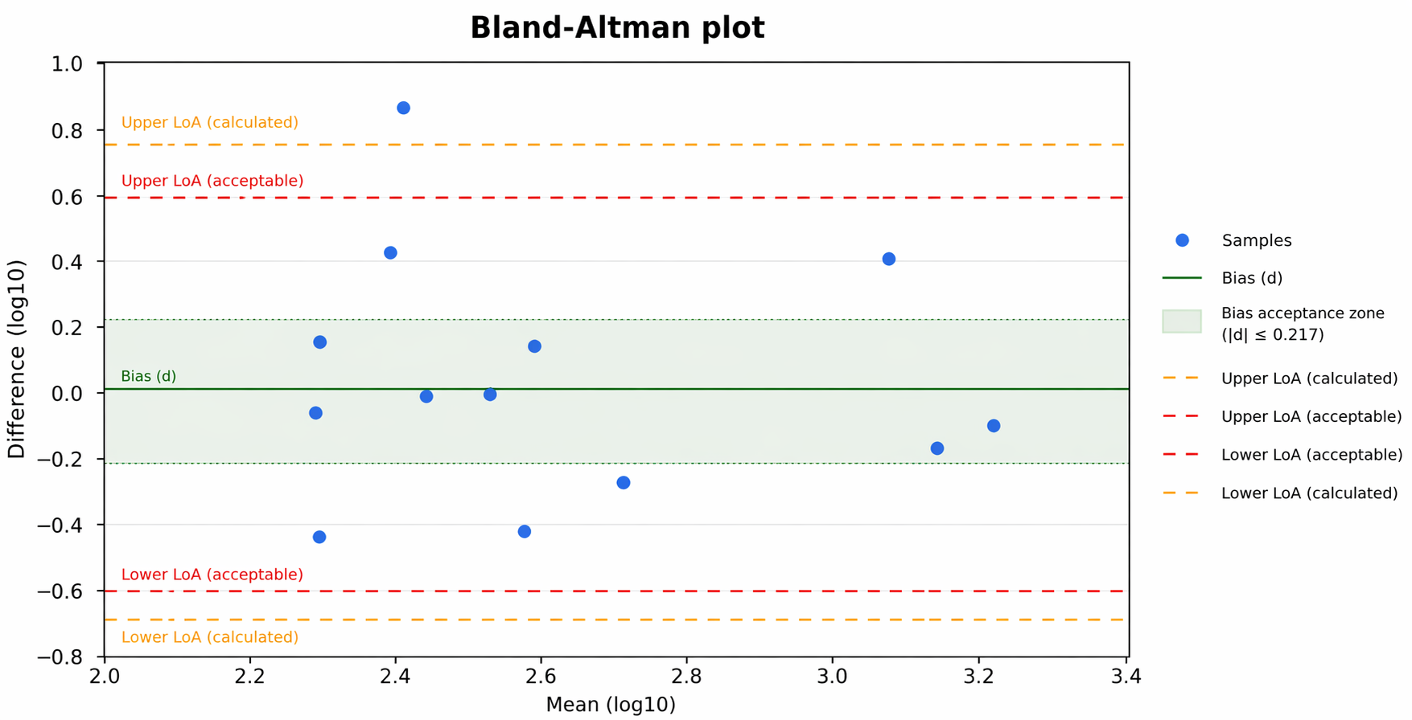
Figure 2: Bland-Altman plot of the 13 retained samples.
Most observations fall within the predefined acceptability limits, indicating a satisfactory agreement between IOMS outputs and dynamic olfactometry measurements while one observation falls outside them. According to the proposed decision criteria, the system performance is therefore classified as acceptable.
    - Level 3 outcomes
In Table 6, DEV% and CV% values are reported for two consecutive Level 3 verifications campaigns. DEV% values range betwen 0.99 % and 4.90 % while CV% values range between 0.05 % and 4.32 %, all well below the acceptability thresholds defined in Table 4. These results indicate a high level of instrumental stability, with no evidence of systematic drift over the three-month interval. The consistently low variability across all concentration levels further confirms the robustness of the system under real operating conditions.
The continuous tracking of these indicators through Shewhart control charts enables early identification of potential deterioration trends, supporting timely implementation of corrective actions before the acceptance limits are exceeded.

Table 6: Level 3 verification results for n-butanol span gas
Date | Dilution | DEV% | CV% | Outcome
30/10/2025 | 1:10 | 4.90 | 0.05 | Acceptable
30/10/2025 | 1:3 | 3.64 | 0.08 | Acceptable
30/10/2025 | Not diluted | 4.23 | 0.23 | Acceptable
22/01/2026 | 1:10 | 4.10 | 0.06 | Acceptable
22/01/2026 | 1:3 | 2.59 | 0.86 | Acceptable
22/01/2026 | Not diluted | 0.99 | 4.32 | Acceptable
  - Conclusions
The Italian technical standard UNI 11761:2023 defines verification procedures for IOMS but does not provide quantitative acceptance criteria for the resulting performance indicators. In this study, an operational quality assurance protocol was developed, covering Level 2 and Level 3 periodic verifications. The protocol was designed to balance metrological robustness with the practical constraints of field operation, ensuring reliable performance assessment while maintaining a feasible and sustainable verification framework.
The protocol includes a structured pre-selection procedure prior to Bland–Altman analysis, based on sequential criteria addressing sensor activity, memory effects (through a carry-over index), replicate consistency and decision thresholds defined according to the proportion of compliant observations in Bland–Altman analysis. In addition, quantitative acceptance criteria are proposed for Level 3 accuracy indicators. The decision-making framework embedded in the proposed protocol was illustrated through the evaluation of a real case study, demonstrating its practical applicability and effectiveness under real operating conditions.
Overall, the protocol interprets the procedural requirements of UNI 11761:2023 into an operational decision tool, is reproducible and auditable, and contributes to the definition of shared quantitative thresholds for the regulatory use of IOMS data.
References
Bland J.M., Altman D.G., 1986, Statistical methods for assessing agreement between two methods of clinical measurement, The Lancet, 327, 307–310.
Burgués J., Doñate S., Esclapez M.D., Saúco L., Marco S., 2022, Characterization of odour emissions in a wastewater treatment plant using a drone-based chemical sensor system, Science of the Total Environment, 846, 157290.
CEN (European Committee for Standardization), 2022, EN 13725 – Stationary source emissions. Determination of odour concentration by dynamic olfactometry and odour emission rate, CEN, Brussels, Belgium.
Cipriano D., Capelli L., 2019, Evolution of electronic noses from research objects to engineered environmental odour monitoring systems: a review of standardization approaches, Biosensors, 9(2), 75.
Deshmukh S., Bandyopadhyay R., Bhattacharyya N., Pandey R.A., Jana A., 2015, Application of electronic nose for industrial odors and gaseous emissions measurement and monitoring – An overview, Talanta, 144, 329–340
Director Decree No. 309, 2023, Italian Ministry of Environment and Energy Security, Guidance for the application of Article 272-bis of Legislative Decree 152/2006 on odour emissions from industrial plants and activities, <https://www.mase.gov.it/portale/indirizzi-per-l-applicazione-dell-articolo-272-bis-del-d-lgs-152-2006-in-materia-di-emissioni-odorigene-di-impianti-e-attivit%C3%A0> accessed 22.04.2026, (in Italian).
Gardner J.W., Bartlett P.N., 1999, Electronic Noses: Principles and Applications, Oxford University Press: New York, NY, USA.
Padilla M., Perera A., Montoliu I., Chaudry A., Persaud K., Marco S., 2010, Drift compensation of gas sensor array data by orthogonal signal correction, Chemometrics and Intelligent Laboratory Systems, 100(1), 28–35.
Ratti C., Bax C., Lotesoriere B.J., Capelli L., 2024, Real-time monitoring of odour emissions at the fenceline of a waste treatment plant by instrumental odour monitoring systems: focus on training methods, Sensors, 24, 3506.
UNI (Ente Italiano di Normazione), 2023, UNI 11761:2023 – Odour emissions. Determination of odour concentration using a continuous monitoring system, (in Italian).
Yan, J., Guo, X., Duan, S., Jia, P., Wang, L., Peng, C., Zhang, S., 2015, Electronic Nose Feature Extraction Methods: A Review, Sensors, 15, 27804-27831.

