 CHEMICAL ENGINEERING TRANSACTIONS  VOL. xxx, 2026 | A publication of  
The Italian Association
of Chemical Engineering
Online at www.cetjournal.it

Guest Editors: Laura Capelli, Marzio Invernizzi, Selena Sironi
Copyright © 2026, AIDIC Servizi S.r.l.
ISBN 979-12-81206-xx-x; ISSN 2283-9216

eNose Technology: Advantages and Operational Benefits in Refinery Applications
Michele Antonino Ilacquaª, Nicoletta Lotrecchiano^{a,}*, Angelo Pecciª, Nicola Zappimbulsoª, Fabio Ferrantiª
ª Department of Environmental Assessment, Controls and Sustainability Service for Risks and Environmental Sustainability of Technologies, Chemical Substances, Production Cycles and Water Services and for Inspection Activities, ISPRA - Institute for Environmental Protection and Research, Via V. Brancati 48, 00144 Rome, Italy
nicoletta.lotrecchiano@isprambiente.it
Odour emissions represent a significant environmental and social challenge for refineries and chemical plants operating under the Industrial Emissions Directive (IED) which often handle volatile organic compounds and many other odorous substances that, even at low concentrations, can lead to nuisance and complaints from surrounding communities. The IED requires installations to apply Best Available Techniques (BAT) to prevent or, where that is not practicable, to reduce emissions, including odours. The BAT Conclusions for the refining and chemical sectors emphasize integrated approaches such as improved process control, optimized storage and handling of raw materials, and the adoption of advanced abatement technologies.
Italy has implemented the provisions of the IED through the Directorial Decree n. 309/2023, which defines the guidelines for odour emissions from plants and activities, giving effect to article 272-bis of D.Lgs. 152/2006. In Annex 5, the decree defines the application fields of Instrumental Odour Monitoring Systems - IOMS (i.e. electronic noses), for which the reference technical standard is UNI EN 11761.
IOMS have recently become widely used as continuous odour monitoring tools; after an appropriate training period, can detect any changes of air composition, including the presence of odorous compounds.
This study analyses electronic Noses - eNoses networks installed in Italian refineries, highlighting how these instruments can detect any real time changes in odorous emissions, activating process control to restore the normal operating conditions.
  - Introduction
Since the full implementation of the European IED Directive, there has been a growing focus on odour emissions, both in terms of regulatory requirements and in response to reports from residents living in the industrial plant neighbourhood. In this context, odour measurement is a key tool for assessing environmental impact, verifying compliance with regulatory requirements and developing mitigation strategies.
The European Decision 2014/738/EU on BAT Conclusions for the refining oil and gas, provide specific guidance on odorous streams monitoring, containment, and treatment. BATs emphasize integrated approaches such as improved process control, optimized storage and handling of raw materials, and the adoption of advanced abatement technologies (European Parliament, 2014).
Recent technological evolution has enabled the development of Instrumental Odour Monitoring Systems – IOMS (eNose) for the continuous monitoring of odour compounds. IOMS (eNoses), are tools that work similarly to the human olfactory system. They can detect the odour fallout (emission) at sensitive receptors located at a certain distance from a production facility. Different commercial IOMS trained to recognize the characteristic odours of complex industrial plants considered on the territory, are particularly useful to determine which source has the greatest impact on a specific receptor. The remote system performs real-time processing of IOMS signal streams. An automated detection agent issues immediate alerts upon identification of deviations in air composition profiles indicative of odour events or gas-related safety hazards.
Settimo and Avino (2024), review the state-of-art of the European legislation for the odour pollution determination and management with a focus on the Italian situation. In Italy, analysing the Integrated Environmental Authorization (IEA), currently, there are only three IOMS networks installed.
This study analyses IOMSs network installed in Italian refineries, highlighting how these real-time monitoring instruments can detect any changes in odorous emissions, activating internal process control to restore the normal operating conditions.
  - Materials and Methods
IOMS - Instrumental Odor Monitoring System – defines any instrument capable of continuously monitoring air quality and producing an odor-related metric. It includes electronic noses – eNoses - as well as monitoring instruments based on different operating principles, such as chemical analyzers and gas chromatography (Capelli et al., 2020).
    - IOMS - Electronic Nose
IOMSs are defined according to the UNI EN 11761:2019 as an automatic instrument capable to detect qualitative information and, in some cases, quantitative information of a gas mixture using odour reference data.
IOMSs (eNoses) instrumentally perform the functions of the human sense of smell. The gas detection system simulates the receptors and responds to a wide range of odorants. The sensor signal processing system compresses the signal, simulating the action of the human olfactory system. Meanwhile, the odour identification and recognition system uses decision support to identify the odour source (PCA - Principal Component Analysis), simulating brain action (Vitali et al., 2018).
IOMS give the possibility of real-time monitoring odour emissions from an industrial plant, acting as an alarm system in the event of exceedances not necessarily related to an accident. The effectiveness of IOMS systems in monitoring odourous emissions has been thoroughly analysed by Naddeo et al. (2016), who compared the performance of a new e-nose prototype with European and Japanese reference methods at a wastewater treatment plant.
Since 2018, IOMS (eNose) network installation is mandatory of the Integrated Environmental Authorization (IEA) specific prescription, to complement the usual yet implemented odour management plan (OMP). The IOMS installation requires several steps that must be followed, including performance verification through laboratory analysis, a training phase during which it must be exposed to the same diluted samples analyzed by dynamic olfactometry, a field-testing phase, and subsequent effective monitoring with continuous analysis of the data obtained.
The IOMSs (eNoses) require a training period to adapt to the context in which they are installed; In this case, both electronic nose networks were trained through a period of field training and by the parent company using pollutant information provided by the refineries. The instruments detect instantaneous deviation from the zero set during the training phase. Following the sensor training period, thresholds are defined for the various concentration levels in accordance with the baseline concentration defined as the 98th percentile of the values measured during a period of continuous operation representative of the production site’s entire operational activity. Three alert levels are then defined, each associated with a different colour: red for values measured during the training period that exceed the 99.9th percentile, orange for values between the 99th and 99.9th percentiles, and yellow for values between the 98th and 99th percentiles.
The yellow threshold corresponds to a perception-based attention level. This threshold represents the first significant deviation from background noise or the instrumental baseline and indicates that the IOMS has begun to simulate human receptors by reacting to an initial concentration of odorants. The BATs suggest that this level signals the need to monitor the phenomenon development, particularly in the presence of diffuse emissions.
The orange threshold corresponds to an alert or pre-alert level. At this level, the signal indicates a sustained and clearly distinguishable presence of VOCs. The signal processing system is detecting an input that requires the activation of the decision support system (PCA) to identify the odour source. It represents a phase in which environmental management procedures should include operational checks to prevent regulatory limits from being exceeded. The red threshold corresponds to an alarm level and triggers an intervention phase. This is the critical threshold indicating a significant emission event (such as the clearly visible impulsive event in Figure 2b). This level represents the exceeding of the acceptability limits defined by the BREF documents for channelled or fugitive emissions. Reaching this threshold usually requires immediate mitigation action to reduce the odour impact and return to compliance parameters.
Information on odour-emitting phenomena can be used to calculate back-trajectories. The back-trajectories calculation for odour emissions is used to define the path from a point where the odour is detected (the receptor) back to possible source areas, using meteorological data and atmospheric dispersion/transport models.
As reported in the SNPA guidelines (SNPA, 2025), using data obtained from eNoses, modelling based on the reconstruction of meteorological fields is able to provide, in real time, the best approximation of the trajectories taken by air masses in the atmosphere, tracing their path backwards from the exact moment and georeferenced location of the reports. Back-trajectories can be particularly significant in areas where there are many industrial activities. Atmospheric back-trajectories can be calculated using a Lagrangian model, in accordance with the approach described by Stein et al. (2015), which is widely used for the analysis of source–receptor relationships (Stein et al., 2015). Deterministic backward air-mass trajectories can be computed also using the MOLOCH non-hydrostatic meteorological model, following the approach described by Trini Castelli et al. (2022).
By correlating citizen reports submitted through a dedicated web app, IOMS measurements, and wind speed, it is possible to clearly determine the eventual refinery’s contribution to olfactory nuisance perceived by citizens (Cangialosi et al., 2022).
    - Odour Measurements
The UNI EN 11761 standard defines the technical and management requirements for IOMS or electronic noses - eNoses. It regulates the measurement and continuous or periodic environmental monitoring, emission, and indoor odours. This standard defines the eNose as an automatic instrument capable of periodically producing information on the odour of a gaseous mixture using reference data obtained from sensorial measurements of odour (by a panel of examiners). As reported in the reference UNI EN standard, IOMS can be installed al the receptors (ambient air) as example to evaluate the odour abatement efficiency of an end of pipe treatment, at the single source generally for the process control to prevent the odour diffusion al receptors after an anomaly, at the plant boundary or for a process control or together with the automatic samplers after the exceeding of a predefined odour threshold and/or in case of citizens’ report even collected by a specific citizen science-based app (Oliva et al., 2024). The UNI EN 11761 standard defines three different types of measurement: odour presence or absence (type A), odour class measurements for the odour qualitative evaluation (type B), and the measurement of odour quantity defining an odour concentration determined according to the UNI EN 13725 standard (type C).
UNI EN 13725 is the European standard for determining odour concentration using dynamic olfactometry and for estimating odour emission rates from fixed sources. It applies to point sources such as chimneys or flues, active area sources, and passive area sources such as API tanks. It is based on that the odour concentration is proportional to the dilution factor required for the odour to no longer be detected by a group of suitably selected and trained human assessors. The measurement result is expressed in European odour units per cubic metre (ouE/m³), where 1 ouE/m³ corresponds, by definition, to the odour detection threshold.
Odour Field Inspection is a monitoring technique that objectively measures the extent and frequency of odour perception across a given area. It involves the odours assessment in ambient air by selected and trained odour assessors, who carry out measurement surveys at specified times, locations and routes, recording the presence and odours quality attributable to the plant considered. The procedure for carrying out odour field inspection is set out in the UNI EN 16841-1 standard, which is based on the German VDI 3940 Part 1 standard.
In addition to dynamic olfactometry, chemical analysis techniques provide essential support for odour monitoring in refineries, as they enable the identification and quantification of the individual compounds responsible for odour emissions. Among these, gas chromatography is widely used and is often combined with mass spectrometry (GC-MS) and Gas Chromatography - Ion Mobility Spectrometer (GC-IMS) (Vera et al. 2016). Continuous analysers are also used for specific compounds, such as H₂S and SO₂, and sampling systems for volatile organic compounds (VOCs).
These methods offer high analytical precision and are widely used for process control and to verify compliance with the emission limits set by the IEA.
The olfactometric and chemical measurements results are often used as input for dispersion models, to estimate the odour impact on the surrounding area. This approach allows the identification of the most exposed areas, evaluate alternative operational scenarios and support decision-making during the permitting phase.
In industrial practice, odour management in refineries is based on an integrated approach, combining direct measurements, continuous monitoring, modelling and environmental management systems.
Among the Italian regulation the Ministry of the Environment Directorial Decree n. 309 of 28/06/2023 (MASE, 2023), in Addendum n. 5 reports useful information on how to correctly implement and use a IOMS network in the industrial field.
    - IOMSs network
The IOMSs network is designed to promptly detect any changes in ambient air composition before they can potentially cause olfactory disturbances outside the plant. Generally, that network is complemented by instruments for measuring meteorological conditions, such as wind direction and intensity, given that they have a significant impact on VOC dispersion.
In the three Italian refineries considered, the networks respectively consist in a certain number of eNoses, and anemometers as described in Table 1, installed 4 meters above the ground on lighting towers or electrical substations, positioned to fully cover the plant perimeter and ensure network redundancy; anemometers are used to measure wind direction and intensity. The analysers positioning is planned considering the meteorological conditions and area topography, considering wind tunnelling effects, and is generally defined to ensure the protection of the main sensitive receptors located along these wind paths.
Table 1: Characteristics of IOMSs networks.
Network | #IOMS | Anemometer | Sensitive Receptor
1 | 19 | 6 | 14
2 | 13 | 2 | -
3 | 2 | 1 | 8

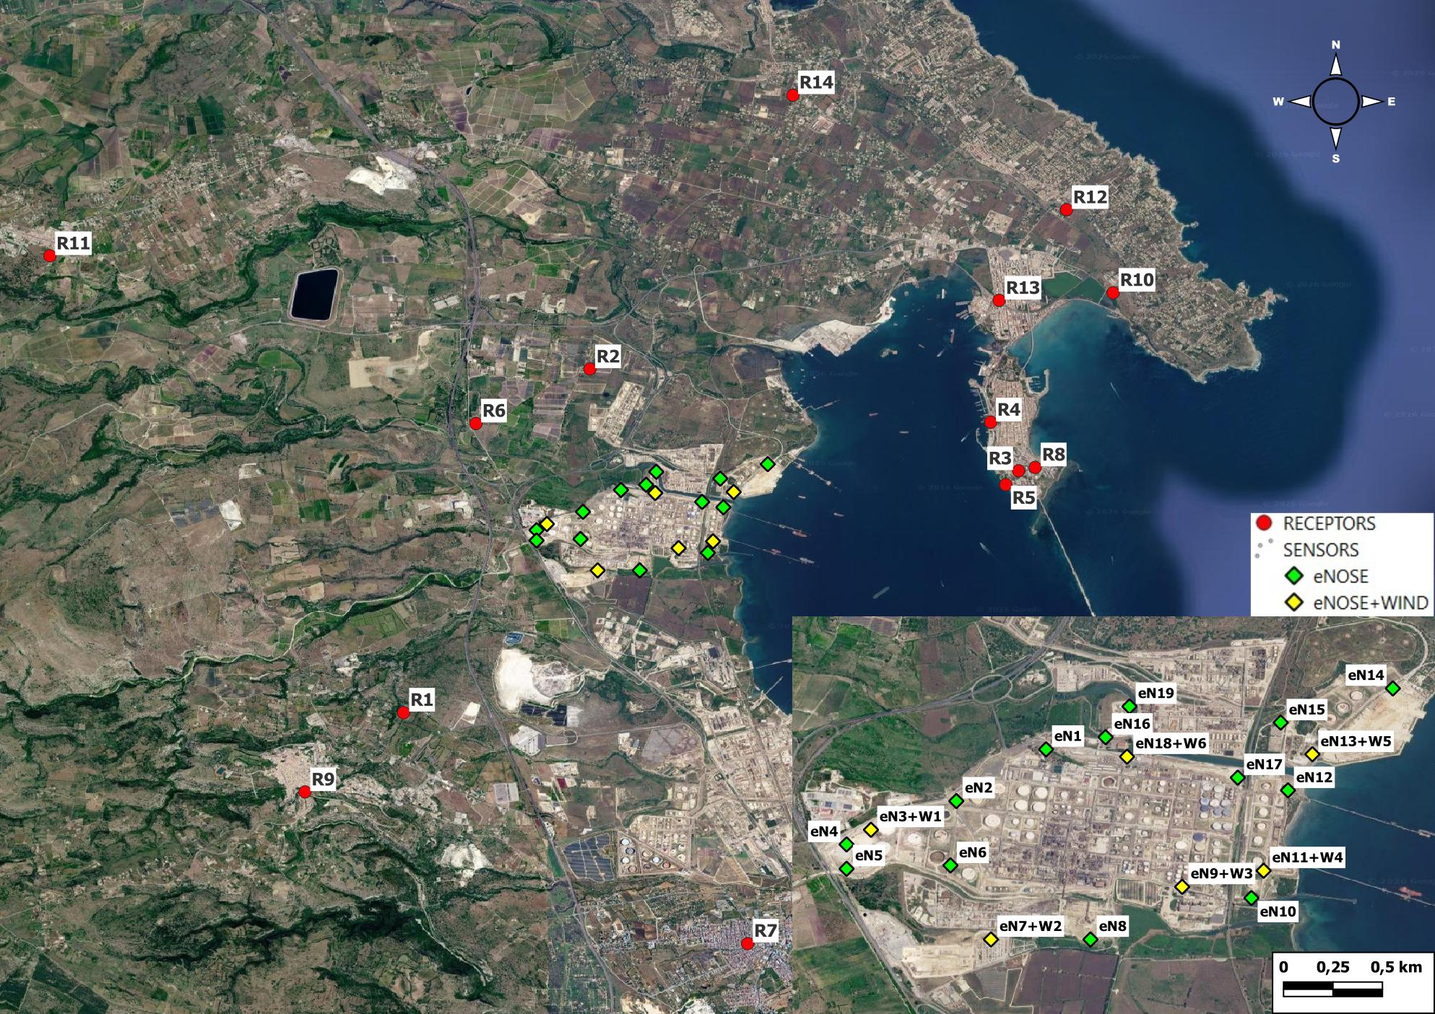
Figure 1: IOMSs network of an Italian refinery including the refinery sensitive receptors. In the bottom-right-hand corner is reported the highlights of the IOMSs positions.
The IOMS (eNose) installed in the network shown in Figure 1 consists of an array of four semiconductor sensors that react differently depending on the reactive molecules present in the ambient air, creating a pattern that correlates the signal to the exposed gas mixture (Bootsma et al., 2014). Oxygen molecules are adsorbed onto the sensing material, capture electrons and increase the electrical resistance. Reducing gas molecules react with the adsorbed oxygen, release electrons and reduce the electrical resistance. The sensor support material acts as a catalyst for the oxidation-reduction reaction. The response of the four sensors varies depending on the air composition, and the device can detect aromatic and sulphur-containing compounds, straight-chain aliphatic hydrocarbons, hydrogen and CO, and methane. The measure is the relative deviation of the actual concentration of all chemically reactive substances present in the air from the background concentration prevailing in the neighbourhood of that eNose. eNose real time data are available on a web-suite that updates automatically with a one-minute refresh rate. The values are conventionally associated with the unit of measurement dB, which does not correspond to physical quantities but define an electric signal.
  - Results and discussion
Figure 2 shows three graphs (a, b, c) representing the time-series of the signal measured every minute by the typical installed IOMSs (eNoses) network and reported in decibels (dB). In the network considered, the thresholds - defined as described in section 2.1 - were set at 10 dB (yellow), 15 dB (orange) and 20 dB (red). The days selected refers to three typical situation that are representative of the IOMS response pattern during the normal refinery operational conditions.
In the three cases considered, an event in which the threshold at the 99.9th percentile (red) is exceeded for more than three minutes is considered significant.

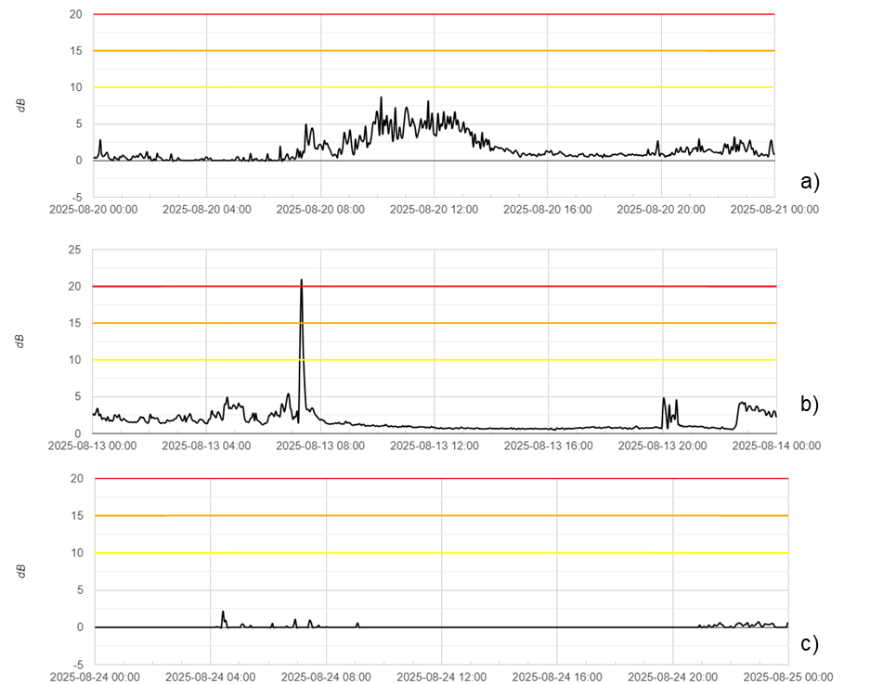
Figure 2. Time-series trend of the eNose signal measured in decibels (dB). Attention level at 10 dB (yellow), pre-alert level at 15 dB (orange) and alarm level at 20 dB (red).
The IOMS signal shown in Figure 2a shows a trend that begins to rise around 8 am, reaching a peak of sustained activity between 10 am and 2 pm. Despite the increase, the signal remains predominantly below the yellow threshold of 10 dB, subsequently stabilising at minimum values in the afternoon and evening. This IOMS is positioned on the refinery perimeter near the crude oil storage tanks. The increase in the measured signal is linked to the crude oil movement following loading from the tanker.
The graph shown in Figure 2b is associated with a IOMSlocated on the sea-facing refinery perimeter, at the loading bay. The signal trend is characterized by a very significant impulsive event; the signal undergoes a sudden peak exceeding the red threshold of 20 dB, then decreases rapidly, and for the rest of the day, the signal fluctuates at low levels below 5 dB, with some small peaks detected around 8 pm. As the eNose red alarm signal lasted for more than 3 minutes, the refinery specific procedures for managing the alert were activated. Each refinery establishes an internal procedure for managing alerts. For example, a checklist may be drawn up to serve as a guideline to assist the operator during an on-site inspection following the eNose activation. After the event reported in Figure 2b, analyzing the refinery operational conditions that were found to be stable and the wind direction detected by the anemometer on the eNose, the peak registered has been associated with an external event, specifically due to the passage of a tanker.
The signal shown in Figure 2c is associated with an eNose located on the seaward refinery perimeter, near a the wastewater treatment plant. It represents the most stable conditions recorded on a day when the refinery was operating at full capacity. The signal remains virtually flat at zero for almost the entire duration of the monitoring, with only very slight fluctuations observed around 4 am and after 8 pm, but these remain well below all alert thresholds.
  - Conclusions
The IOMS is not a gas analyser, but a sensor that detects changes in the composition of the air. The results obtained from the eNoses implementation can be used to define certain operational guidelines, such as the optimisation of the early warning system. The threshold defined as reported in section 2.1 can be an effective operational filter for the case considered. The red threshold acts as a strategic trigger to prevent unnecessary chemical sampling, thereby reducing operational costs whilst ensuring maximum safety. As strategy, upon exceeding the red threshold, the automatic activation of samplers for GC-MS (Gas Chromatography-Mass Spectrometry) analysis could be implemented to comply with BREF requirements regarding the characterisation of unknown odour sources. Measuring odours in refineries presents a complex technical challenge, due to the different type of emission sources and the subjective nature of olfactory perception. No single method, taken on its own, can provide a comprehensive description of the odour phenomenon. Therefore, only an integrated and multidisciplinary approach, combining dynamic olfactometry, chemical analysis, IOMS systems and modelling, and citizen science contribution, allows for an effective assessment and sustainable management of the odour impact of refineries. By aligning operational practices with BAT Conclusions, operators can not only ensure regulatory compliance but also significantly mitigate odour impacts, fostering better relationships with local communities and enhancing overall environmental performance.
References
Bootsma S., Leuwerink T., Bilsen I., 2014, Online air monitoring with enoses at the tata steel plant in the netherlands, Chemical Engineering Transactions, 40, 79-84 DOI: 10.3303/CET1440014.
Cangialosi F., Bruno E., Fornaro A., 2022, Integrating citizen science and instrumental monitoring for the recognition of odor classes nearby a wastewater treatment plant, Ingegneria dell’Ambiente, 9.1, dx.doi.org/10.32024/ida.v9i1.399.
Capelli L., Sironi S., Bax C., 2020, Definition and application of a protocol for electronic nose field performance testing: Example of odor monitoring from a tire storage area, Atmosphere, 11, 426, https://doi.org/10.3390/atmos11040426.
Directive Decree of the Ministry of the Environment No. 309 of June 28, 2023, Approval of guidelines for the application of Article 272-bis of Legislative Decree 152/2006 regarding odour emissions from facilities and activities, prepared by the “Emissions Coordination Group”;
European Parliament, 2014, Commission Implementing Decision 2014/738/EU of 9 October 2014 establishing best available techniques (BAT) conclusions for the refining of mineral oil and gas under Directive 2010/75/EU of the European Parliament and of the Council (OJ L 307, 28.10.2014, p. 38).
Lotrecchiano N., Pecci A., Zappimbulso N., Ilacqua M.A., Ferranti F., 2025, Efficacy of the Leak Detection and
Repair Program in the Italian Industrial Plants, Chemical Engineering Transactions, 116, 823-828, DOI:10.3303/CET25116138.
Naddeo V., Zarra T., Oliva G., Kubo A., Uchida N., Higuchi T., 2016, Odour measurement in wastewater treatment plant by a new prototype of e.nose: correlation and comparison study with reference to both european and japanese approaches, Chemical Engineering Transactions, 54, 85-90, DOI: 10.3303/CET1654015.
Oliva G., Cangialosi F., Grimaldi M., Fasolino I., Belgiorno V., Zarra T, 2024, Urban odour annoyance management: An advanced embedded system for real-time monitoring enhanced by citizen science, Case Studies, Chemical and Environmental Engineering, 9, https://doi.org/10.1016/j.cscee.2024.100712.
Settimo G., Avino P., 2024, State-of-art of the legislation on odour emissions with a focus on the Italian studies, Environmental Pollution, 348, https://doi.org/10.1016/j.envpol.2024.123525.
SNPA, 2025. Odour emissions: reference elements and methodological approaches for monitoring, Italian National System for Environmental Protection.
Stein, A. F., Draxler R. R., Rolph G. D., Stunder B. J. B., Cohen M. D., Ngan F., 2015, NOAA’s HYSPLIT Atmospheric Transport and Dispersion Modeling System, Bulletin of the American Meteorological Society 96, 2059-2077, https://doi.org/10.1175/BAMS-D-14-00110.1.
Trini Castelli S., Tinarelli G., Uboldi F., Malguzzi P., Bonasoni P., 2022, Developments of SPRAY Lagrangian Particle Dispersion Model for Tracing the Origin of Odour Nuisance. In: Mensink, C., Jorba, O. (eds) Air Pollution Modeling and its Application XXVIII. ITM 2021, Springer Proceedings in Complexity, Springer, Cham, https://doi.org/10.1007/978-3-031-12786-1_5.
Vera L., Companioni E., Meacham A., Gygax H., 2016, Real Time Monitoring of VOC and Odours Based on GC-IMS at Wastewater Treatment Plants, Chemical Engineering Transaction, 54, 79-84, DOI: 10.3303/CET1654014.
Vitali S., Bax C., Sironi S., Capelli L., 2018, Investigation of electronic nose sensor drift correction methods and their application to environmental samples, Chemical Engineering Transactions, 68, 289-294, DOI: 10.3303/CET1868049.

