 CHEMICAL ENGINEERING TRANSACTIONS  VOL. xxx, 2026 | A publication of  
The Italian Association
of Chemical Engineering
Online at www.cetjournal.it

Guest Editors: Laura Capelli, Marzio Invernizzi, Selena Sironi
Copyright © 2026, AIDIC Servizi S.r.l.
ISBN 979-12-81206-xx-x; ISSN 2283-9216

Deployment of a semi-autonomous robot to detect ferrous oxide corrosion
Ines Carotti*, Clarissa Stickland, Jash Nataviti, David Hutchins, Duncan Billson, James A. Covington
School of Engineering, University of Warwick, CV4 7AL, Coventry, UK
*ines.carotti@warwick.ac.uk
Corrosion of ferrous metals remains a major challenge in civil and industrial engineering because it can progressively reduce structural integrity before visible damage becomes apparent. Early, non-destructive detection methods are therefore needed to support timely maintenance and reduce the risk of failure. This study investigated whether gas-phase sensing can be used to detect corrosion-related volatile emissions from rusting steel. A bespoke electronic nose (eNose), incorporating a custom gas sensor array, was developed and evaluated alongside Fourier transform infrared spectroscopy (FTIR) using the same corroding samples. The sensor array was trained using headspace collected from non-corroded steel, corroded mild steel, and progressive corrosion samples, and was subsequently deployed within a simulated industrial environment consisting of a 10 m mild-steel pipe. Both the eNose and FTIR differentiated corroded from non-corroded conditions, supporting the feasibility of corrosion detection through gas analysis. Machine-learning models showed strong classification performance, with tree-based models obtaining perfect separation, and logistic regression having a 0.997 accuracy. The sensor array was able to identify corrosion-related signatures under deployment conditions. These findings demonstrate the potential of a compact, low-power eNose as a practical non-destructive tool for early corrosion screening in enclosed industrial environments.
  - Introduction
Steel is one of the most widely used engineering materials in industrial and civil applications because of its strength, versatility, and relatively low cost (Vasagar et al., 2024)). Despite these advantages, steel is susceptible to corrosion, a degradation process that can progressively compromise structural integrity over time (Oh et al., 1998). When corrosion remains undetected, the consequences can be severe. The collapse of the Morandi Bridge in Genoa, Italy, in 2018 has frequently been cited as an example of the risks associated with long-term structural deterioration and inadequate detection of damage (Pianigiani, 2023). These risks highlight the need for reliable methods capable of detecting corrosion at an early stage, before substantial loss of strength occurs. For this reason, non-destructive testing (NDT) techniques have been widely investigated for corrosion monitoring. Existing approaches include ultrasonic inspection, acoustic emission monitoring, visual inspection methods, and predictive modelling of corrosion-prone regions (Agarwala et al., 2000; Corbin & Willson, 2007). Although these methods can be effective, there remains a need for sensing approaches that can detect over a large area and be suitable for use in enclosed or difficult-to-access industrial environments.
One emerging approach is the detection of corrosion-related gases and volatile compounds released from affected materials. In a recent study, researchers at the Fjellander Institute (Norway) and the Animal Detection Consultancy (The Netherlands) trained dogs to detect corrosion under insulation (CUI) from samples obtained from oil and gas facilities. Their double-blind study reported sensitivity and selectivity values of 92% and 93%, respectively. While these results were encouraging, canine remote scent tracing is difficult to interpret as dogs respond to complex odour patterns rather than to identified individual chemical species. Nevertheless, this observation suggests that corrosion may produce a detectable headspace signature that could potentially be recognised using an electronic nose (eNose).
Previous work at the University of Warwick investigated this possibility by analysing headspace emissions from mild steel samples at different stages of corrosion using two eNose platforms (Carotti et al., 2024, 2025). That study showed that corroded and uncorroded samples could be differentiated on the basis of their gas-phase signatures. Building on these findings, the present study describes the development and evaluation of a bespoke gas sensor array configured as an eNose for corrosion detection. The system was designed as a compact and potentially field-deployable platform, with the longer-term aim of integration into a robotic inspection system for use in industrial environments where corrosion poses a significant risk.
  - Material and Methods
2.1 Material preparation
ASTM A36 mild steel samples were prepared for use in this study. The materials comprised three groups: non-corroded mild steel controls, corroded mild steel samples, and mild steel samples undergoing progressive corrosion over a one-week period with Ferric chloride at 40% m/v. The pipe was made out of mild steel sheets rolled into 0.5 m tubes that were then welded. These groups were selected to represent baseline, established corrosion, and developing corrosion conditions. The composition of the ASTM A36 mild steel used in all experiments is given in Table 1.
Table 1: Composition of Mild Steel
Elements | Carbon | Magnesium | Silicon | Copper | Phosphorus | Sulphur | Iron
ASTM A36 Mild Steel | 0.26 | 1.35 | 0.4 | 0.2 | 0.04 | 0.05 | Remainder

2.2 Sensing Devices
A custom sensor array was produced and formed into a compact electronic nose (eNose) for the detection of corrosion-related headspace changes. The array incorporated ten commercially available gas sensors selected to provide broad sensitivity to volatile organic compounds (VOCs) and gases potentially associated with corrosion processes. These are listed in Table 2. Because the specific compounds responsible for corrosion-related odours have not yet been fully established, the sensors were chosen to provide a diverse range of chemical sensitivities rather than to target a single analyte class. The selection also reflected the requirement for a compact, low-power system suitable for eventual deployment in industrial environments.
Table 2: Sensor’s specifications
Sensor | Brand | Target Compounds | Sensor output notation
BME688 | Bosch | VOCs, VSCs, CO, Hydrogen | BME688
ENS160-BGLT | ScioSense | VOCs, Hydrogen, Oxidising gases | ENSVoc, HP0, HP1, HP2, HP3
SGP41-D-R4 | Sensirion | VOCs, NOx | SGPVin, SGPNin
STC31-C-R3 | Sensirion | CO2 | STCCO2
MICS-6814 | Sensortech | VOCs, CO, NO2, H2, Ammonia, Methane | MiCO, MinO2, MinH3
GM-502B | Winsen | VOCs | GMVOC
GM-512B | Winsen | H2S, Alcohol, Acetone | GNH2S
GM-202B | Winsen | Alcohol, Smoke | GMSMO
GM-302B | Winsen | Ethanol | GMETH
GM-802B | Winsen | NH3 | GMWIN

The majority of the selected sensors were based on metal-oxide sensing materials, with the exception being the STC31-C-R3 which operates using thermal conductivity. All sensors were mounted on a 4.0 cm × 9.2 cm pluggable printed circuit board (PCB). In addition to the gas sensor outputs, environmental parameters including temperature, relative humidity, and pressure were also measured. The sensor array was interfaced with a custom 14.5 cm × 4.0 cm control board incorporating an ATSAMD51 microcontroller (Microchip Technology, USA) and a Wi-Fi-enabled ESP32 module (Adafruit, USA) for data communication, as shown in Figure 1a and Figure 1b. Digital sensors were operated through direct I2C communication. Analogue sensors were driven using a voltage-controlled heater arrangement and read through a potential divider circuit comprising the sensor resistance and a fixed resistor. The resulting voltage signals were buffered and measured using an 18-bit ADC (MCP3424, Microchip, USA). The system was powered via USB-C. Three identical sensor systems were constructed to allow parallel experiments in the PTFE bottle training setup and in the mild steel pipe deployment tests shown in Figure 1c and Figure 1d.

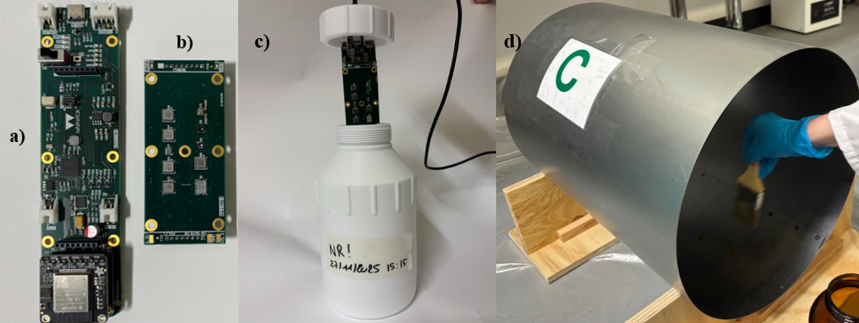
Headspace samples from the same environments were also analysed using an AtmosFIR system (Protea, Middlewich, UK), which served as a comparative reference method based on Fourier transform infrared (FTIR) spectroscopy. The instrument identifies and quantifies gases and vapours by measuring infrared absorbance at specific wavelengths. It was calibrated for the detection of a defined set of target compounds, specifically acetaldehyde, acetone, ammonia, carbon monoxide, carbon dioxide, ethanol, ethylene oxide, hydrogen cyanide, hydrogen sulphide, methane, methanol, methyl mercaptan, nitric oxide, nitrogen dioxide, nitrous oxide, ozone, sulphur dioxide, propane, isoprene, acetic acid, dimethyl sulphide, and trimethylamine.
Figure 1: a) Control board, b) Sensor Array, c) PTFE data collection Setup, d) Corroded pipe section
2.3 Sampling methods
The three identical sensor systems were used across the experiment. One unit monitored rusting mild steel samples, while a second unit was placed in an identical setup containing non-corroded control samples. A third unit was deployed inside the sealed mild steel pipe to assess performance under simulated field conditions. The model was trained on both the data acquired in the pipe and a previous with mild steel corroded in PTFE bottles over time.
Sensor data were normalised using z-score normalisation, and feature extraction was performed using 10 min rolling time windows. The extracted features included mean, median, standard deviation, range, entropy, and slope. Principal Component Analysis (PCA) was used to explore dataset structure and visualise class separation. A Mann-Whitney U test was then applied to identify statistically significant features for feature selection and weighting. Machine-learning classification models were subsequently developed using logistic regression (LR), Random Forest (RF), and eXtreme Gradient Boosting (XGBoost). RF and XGBoost are tree ensembles which model non-linear interactions and typically achieve higher predictive performance on complex data, whereas LR is computationally efficient and interpretable but limited to linear decision boundaries. LR coefficients are weights attributed to features, while tree models produce predictions via aggregation (averaging or weighted summation) across multiple decision trees. The data was split 60/40 for training and testing splits which for this specific dataset split datapoints into 161 datapoints for training and 107 datapoints fir testing.
For FTIR analysis, gas samples were collected from sealed corroded and non-corroded sections of pipe into 3 L Restek Tedlar bags fitted with PTFE/silicone combination valves. The bags were adapted to allow connection to both the MARKES ACTI-VOC pump and the AtmosFIR instrument. Air was drawn into each bag using the MARKES pump with flow rate of 0.17 L min⁻¹, while PTFE tubing was used throughout to minimise contamination and maintain compatibility with corrosive gases.
During analysis, the internal pump of the AtmosFIR drew gas from the sampling bag into a 300 mL measurement cell at a flow rate of 1.5 L min⁻¹. Before each measurement, the cell was purged for 15 s without the sample bag connected to remove residual ambient air. The sample bag was then opened and the cell filled for a further 15 s. Once filled, the inlet and outlet valves were closed to create a sealed static measurement environment within the cell. Each sample was analysed using five 60 s scans, with three replicates collected for each category: acetone, isopropanol, non-corroded mild steel, and corroded mild steel.
  - Results
3.1 Corrosion Rust Assessment Bot Model training
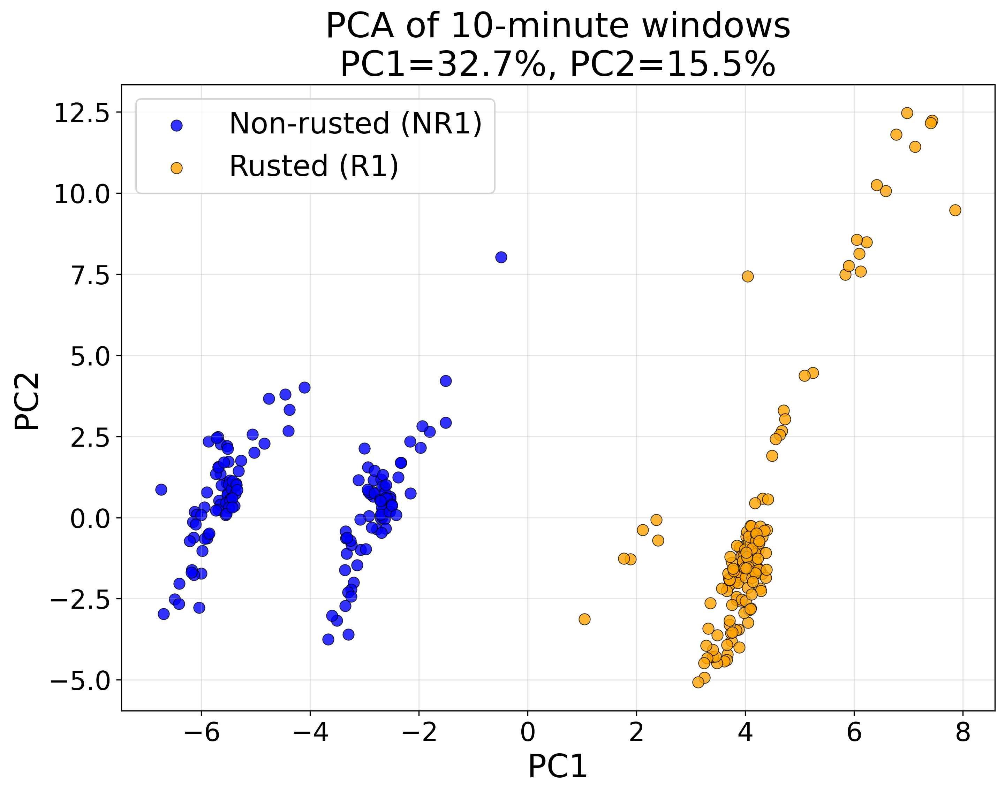
Principal Component Analysis (PCA) was first used to explore the structure of the dataset and to visualise separation between corroded and non-corroded conditions, as shown in Figure 2.
Figure 2: PCA of Pipe rusted VS Non-rusted Setup

The classification performance of the machine-learning models developed for the pipe experiment is summarised in Table 3. Across logistic regression, Random Forest, and XGBoost, strong classification performance was achieved for discrimination between corroded and non-corroded conditions. Logistic regression achieved a test accuracy of 0.997 and a ROC AUC of 0.994, while both Random Forest and XGBoost achieved test accuracy and ROC AUC values of 1.000 on the available dataset. Though the models are overfitting, the models were proofed for data leakage, and it appears that the dataset is trivial to RF and XGBoost even with sensor ablation, early stopping of training and lower tree complexity.
Table 3: Model performances
Model | Accuracy | ROC AUC | TP | FP | TN | FN | Sensitivity | Specificity
LR TRAIN | 1.000 (1.000-1.000) | 1.000 (1.000-1.000) | 36 | 0 | 40 | 0 | 1.000 | 1.000
LR TEST | 0.997 (0.990-1.000) | 0.994 (0.978-1.000) | 151 | 0 | 153 | 1 | 0.993 | 1.000
RF TRAIN | 1.000 (1.000-1.000) | 1.000 (1.000-1.000) | 36 | 0 | 40 | 0 | 1.000 | 1.000
RF TEST | 1.000 (1.000-1.000) | 1.000 (1.000-1.000) | 152 | 0 | 153 | 0 | 1.000 | 1.000
XGB TRAIN | 1.000 (1.000-1.000) | 1.000 (1.000-1.000) | 36 | 0 | 40 | 0 | 1.000 | 1.000
XGB TEST | 1.000 (1.000-1.000) | 1.000 (1.000-1.000) | 152 | 0 | 153 | 0 | 1.000 | 1.000

These results indicate that the extracted sensor features contained sufficient information to distinguish between corroded and non-corroded conditions in the present dataset. The feature-ranking results shown in Figure 3 suggest that multiple sensors contributed to classification performance, indicating that discrimination was based on a combined response pattern across the sensor array rather than on a single sensing element. This is consistent with the expected behaviour of an electronic nose system, in which classification relies on multidimensional response patterns generated by partially selective sensors.
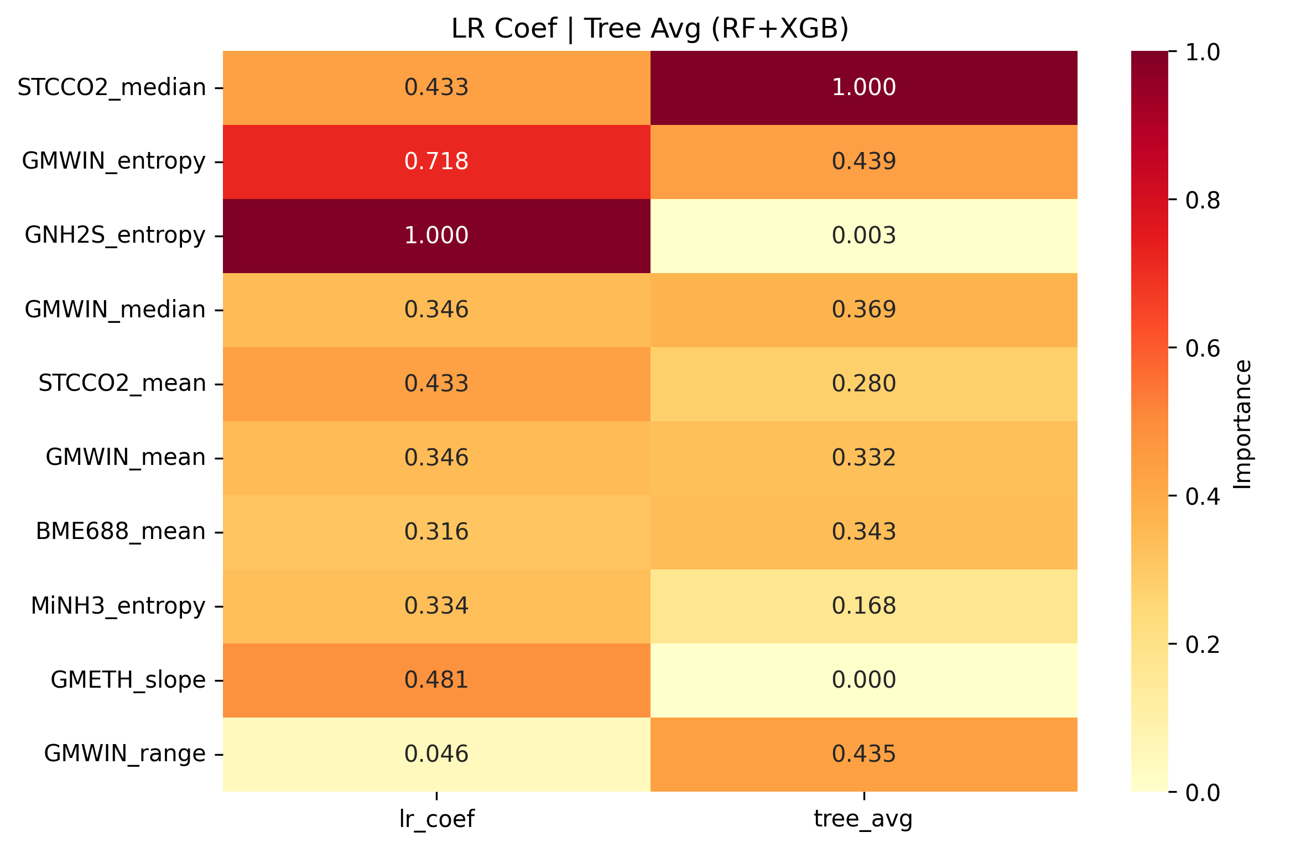
Figure 3: Top 10 features for each model, Logistic Regression, Random Forest, XGBoost
3.2 AtmosFIR Results
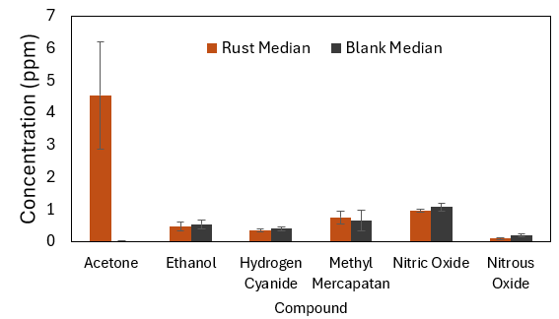
The FTIR system was first evaluated using low concentrations of acetone and ethanol in deionised water in order to verify the performance of the sampling and analytical setup. Following this preliminary verification, headspace samples collected from sealed pipe sections containing either corroded or non-corroded mild steel were analysed. Out of the 16 chemicals the FTIR is trained to detect, the 6 median concentration in ppm of the 6 most discriminant are presented in Figure 4.
Figure 4: Median detected compounds from mild steel pipe corrosion compared to non-corroded pipe

The FTIR measurements showed differences between the headspace of corroded and non-corroded pipe sections, supporting the hypothesis that corrosion is associated with a measurable change in gas composition. These observations are consistent with the sensor-array results and provide independent analytical support for the feasibility of corrosion detection through headspace analysis.
  - Analysis
The results obtained from both the custom sensor array and the FTIR system indicate that corrosion in mild steel is associated with a measurable change in headspace composition. The high classification performance achieved by the machine-learning models suggests that the sensor array was able to capture reproducible differences between corroded and non-corroded environments. In addition, the FTIR measurements provided independent analytical support for the presence of gas-phase differences between these conditions, strengthening the overall interpretation of the study. The feature-ranking analysis showed that discrimination was not dependent on a single sensing element, but rather on the combined response of several sensors within the array. Among the sensors contributing strongly to classification were the GM-202B, GM-302B, and GM-802B devices, which are associated with sensitivity to alcohol-related compounds, ethanol, and ammonia, respectively. Their contribution suggests that corrosion-related headspace may contain a mixture of volatile species rather than a single marker compound. The detection of acetone in the corroded mild steel samples is of particular interest. In the present study, the pipe samples were not cleaned with acetone prior to corrosion, unlike in some earlier experiments. This raises the possibility that the acetone signal may be associated with the corrosion environment itself rather than with sample preparation. However, the origin of this compound cannot be determined conclusively from the current dataset. It may arise from corrosion-related chemical processes, environmental contamination, or potentially microbial activity associated with the corroded surface. Further targeted chemical analysis would therefore be required before assigning a specific source to this observation. An important outcome of this work is the successful progression from controlled bottle experiments to testing within a sealed mild steel pipe. This represents a meaningful step towards practical deployment, as it demonstrates that the sensing approach can operate beyond a simple laboratory headspace configuration.
Despite these promising findings, the present study has several limitations. The number of test conditions remains limited, and the classification results, although highly encouraging, should be interpreted cautiously until validated on a wider range of samples and environmental conditions. Additional work is also required to determine how robust the trained models are to factors such as humidity variation, background contamination, different corrosion stages, and differing steel geometries. Furthermore, while the present work has shown that shorter rolling windows may be feasible, further optimisation will be required before reliable real-time detection can be achieved under practical deployment conditions.
  - Conclusions
This study has demonstrated the potential for detecting mild steel corrosion through headspace analysis using a custom electronic nose system. Both the sensor array and the FTIR reference method differentiated between corroded and non-corroded environments, supporting the hypothesis that corrosion is associated with measurable changes in gas composition. The deployment of the sensor array within a sealed pipe environment further showed that this approach can move beyond controlled laboratory training conditions towards more realistic inspection scenarios. These findings suggest that compact gas sensor arrays may offer a useful non-destructive screening approach for early corrosion detection in enclosed industrial settings. However, further work is required to improve model robustness, validate performance across a broader range of conditions, and reduce sampling times for practical real-time operation.
Acknowledgments
This work was supported by the ESPSRC iCASE: EP/X525030/1, National Nuclear Laboratory- Sellafield Ltd.
References
Agarwala, V. S., Reed, P. L., & Ahmad, S. (2000, March 26). Corrosion Detection and Monitoring—A Review. CORROSION 2000. https://dx.doi.org/
Carotti, I., Billson, D. R., Hutchins, D. A., Liddicott, P., & Covington, J. A. (2025). Detection of Rust Corrosion in Mild Steel and Stainless Steel Through Headspace Analysis by Electronic Noses. IEEE Sensors Journal, 25(12), 22573–22579. https://doi.org/10.1109/JSEN.2025.3562033
Carotti, I., Hutchins, D., Billson, D., & Covington, J. (2024). Non-Invasive Detection of Corrosion Through Odour Emissions: Sniffing Out Rust. 2024 IEEE International Symposium on Olfaction and Electronic Nose (ISOEN), 1–3. https://doi.org/10.1109/ISOEN61239.2024.10556252
Corbin, D., & Willson, E. (2007). New Technology for Real-Time Corrosion Detection.
Pianigiani, G. (2023, October 30). Why MORANDI Bridge Collapsed: Poor Maintenance and Construction Flaws Are Cited in Italy Bridge Collapse | CEPAGRAM. https://cepagram.com/index.php/2021/10/23/morandi-bridge-collapsed-poor-maintenance-construction-flaws-cited-italy-bridge-collapse/
Vasagar, V., Hassan, M. K., Abdullah, A. M., Karre, A. V., Chen, B., Kim, K., Al-Qahtani, N., & Cai, T. (2024). Non-destructive techniques for corrosion detection: A review. Corrosion Engineering, Science and Technology, 59(1), 56–85. https://doi.org/10.1177/1478422X241229621

