 CHEMICAL ENGINEERING TRANSACTIONS  VOL. xxx, 2026 | A publication of  
The Italian Association
of Chemical Engineering
Online at www.cetjournal.it

Guest Editors: Selena Sironi, Laura Capelli
Copyright © 2022, AIDIC Servizi S.r.l.
ISBN 978-88-95608-94-5; ISSN 2283-9216
Refined assessment of odorous emissions from crude oil storage tanks: a case-study
Francesca Tagliaferri*, Marzio Invernizzi
Politecnico di Milano, Department of Chemistry, Materials and Chemical Engineering “Giulio Natta” - Piazza Leonardo da Vinci 32, 20133 Milano, Italy

*Corresponding author: Francesca Tagliaferri, francesca.tagliaferri @polimi.it; +39 02 2399 3149

Odorous emissions are increasingly recognized as a critical environmental issue due to their pronounced influence on public perception and quality of life. Among the various sources, crude oil storage facilities are frequently associated with odour nuisance, while their emission characterization remains inherently complex. External floating-roof storage tanks (EFRT), in particular, are characterized by exclusively diffuse emissions, which limit direct on-site sampling and require the application of indirect methodologies for the estimation of the odour emission flux. Additional complexity arises from the operational variability of these systems, as different crude oils—each exhibiting distinct and highly variable odour characteristics—may be stored within the same tank over the course of a year. Moreover, Volatile Organic Compounds (VOC) losses from storage tanks are commonly estimated using the US EPA AP-42 methodology, which provides annual average emission rates. Such long-term averaged estimates may be poorly representative for odour impact assessments, which are typically based on short-term peak concentrations, and may therefore underestimate the occurrence and intensity of odour annoyance episodes. This study presents a case study referring to a crude oil storage site equipped with EFRTs. The objective is to provide an in-depth characterization of this highly complex emission scenario through refined emission estimation and atmospheric dispersion simulations with the CALPUFF model. Experimental approaches are proposed for the determination of the odour potential of the crude oil mixtures stored in the tanks, explicitly accounting for the temporal variability of stored products. In parallel, a practical methodology for the estimation of VOC wall losses, associated with liquid withdrawal operations, is developed, avoiding long-term averaging assumptions. Overall, the conclusions of this study highlight that the odour potential of the different crude oils is highly heterogeneous, emphasizing the importance of accounting for the quantity of each crude type stored within the tanks. Furthermore, wall losses associated with withdrawal operations are shown to be highly intermittent, characterized by periods of negligible emissions alternated with short-term emission peaks. Finally, the odour impact assessment shows that the comparison between the 98th percentile and the maximum concentrations leads to substantially different impact patterns, mainly driven by the adoption of time-resolved odour emission fluxes.
  - Introduction
Odour emissions from industrial activities represent a distinctive environmental issue whose assessment differs substantially from that of conventional atmospheric pollutants. Unlike many traditional atmospheric pollutants, odours are perceived primarily through human sensory response rather than through toxicological thresholds, which makes their assessment inherently complex. Even relatively low concentrations of certain volatile compounds can trigger nuisance conditions, leading to complaints from residents and growing pressure on regulatory authorities to establish appropriate monitoring and management strategies (Mckittrick et al., 2025; Üstün and Özkal, 2025).
Among the various industrial sectors potentially associated with odour nuisance, crude oil storage facilities represent a particularly complex emission scenario. A first source of complexity lies in the strong variability of the odour potential of crude oils. Depending on their origin and composition, crude oils may contain markedly different concentrations of volatile compounds, including organic sulphur species (e.g., mercaptans and sulphides), which are often responsible for their characteristic odours (Polvara et al., 2025).
EFRTs, which are widely used in crude oil terminals and refineries to reduce evaporative losses, present several specific challenges for emission characterization. Releases can occur even in the absence of active logistics or product transfer operations. In particular, they may arise from the rim seal system between the floating roof and the tank shell, as well as through deck fittings such as access hatches, gauge wells, and roof legs. As a result, these systems are typically associated with diffuse emission sources rather than well-defined point releases. The characterization of diffuse odour emissions is inherently complex, as these sources cannot be investigated through conventional on-site sampling approaches typically applied to confined point sources (Invernizzi Sironi, 2021). While specialized devices such as flux chambers or wind tunnels can be used to derive emission fluxes for certain passive areal sources (Carrera et al., 2025), their application to large industrial structures is often constrained by practical limitations and by the representativeness of localized measurements. In some cases, when direct sampling is not feasible, as for EFRTs, emission rates frequently need to be estimated through indirect methods (Invernizzi et al., 2025; Tagliaferri et al., 2023).
A further challenge concerns the temporal representativeness of commonly used emission estimation methodologies. VOC emissions from storage tanks are commonly estimated using the procedures reported in the US EPA AP-42 guidelines (U.S. EPA, 2024), which are widely adopted in emission inventories and engineering practice. These approaches are typically used for inventory purposes, providing estimates intended to represent overall emissions over extended periods. However, odour impact assessments are generally based on short-term concentration indicators (e.g., high percentiles of hourly concentrations) that are particularly sensitive to transient or peak emission events. In this context, approaches relying on annual-based emission estimates may not always fully capture the temporal variability that can influence the occurrence and intensity of odour nuisance episodes (Tagliaferri et al., 2026).
An additional aspect that contributes to the complexity of emission characterization in crude oil storage facilities relates to the operational management of storage tanks. In many installations, storage tanks are not permanently dedicated to a single crude oil type but may contain different crude blends over time, depending on logistical requirements, supply conditions, or blending operations. Consequently, the composition and odour potential of the stored product may vary throughout the year. This variability implies that the emission potential of a given storage tank cannot always be adequately represented by the properties of a single crude oil. Accounting for the variability in the odour potential of the crude oils associated with a given tank may therefore be important for obtaining a more representative characterization of emissions from crude oil storage facilities, particularly when performing odour impact assessments over extended temporal horizons.
In this context, improving the characterization of odorous emissions from crude oil storage facilities represents an important step toward a more reliable assessment of their potential impacts on surrounding areas.
The present study addresses these challenges through a case study referring to a crude oil storage facility with EFRTs. The main objective is to provide an in-depth characterization of this complex emission scenario by integrating refined emission estimation approaches with atmospheric dispersion simulations. Specific attention is devoted to the experimental characterization of the odour potential of the crude oils handled within the facility and to the development of procedures to account for the variability of stored products in the estimation of emissions. In parallel, a practical approach is applied for the estimation of VOC emissions associated with tank operations, with particular focus on the temporal dynamics of emissions related to withdrawal activities.
  - Materials and methods
    - CALPUFF model setup and simulation configuration
CALPUFF is a non-steady-state atmospheric dispersion model widely recognized for its capability to represent complex and non-uniform environmental conditions (Scire et al., 2000; Tagliaferri et al., 2025). It adopts a Lagrangian framework, simulating pollutant transport by tracking discrete puffs or air parcels as they move through the atmosphere. This approach enables a detailed representation of the interactions between meteorological factors, such as wind fields, temperature inversions, and atmospheric turbulence, and terrain features, including hills, valleys, and built environments.
The simulations were performed over a one-year period, considering a square domain of 4x4 km² that also encompasses residential areas surrounding the production site. The computational domain, centered on the storage facility, was defined with a spatial grid resolution of 100 m.
The meteorological input data used for the CALPUFF simulations consist of three-dimensional hourly prognostic fields generated by the WRF (Weather Research and Forecasting) model, with a spatial resolution of 1 km.

    - Estimation of crude oil tank odour potential
The odour potential of the handled crude oils was quantified through the determination of the Hydrocarbon Odour Emission Capacity (HCOEC), expressed in odour units per unit mass (ou_{E}/kg). HCOEC represents an integrated parameter describing the potential of a hydrocarbon mixture to generate odorous emissions under controlled volatilization conditions. Experimental measurements were carried out using a dedicated laboratory-scale setup specifically designed for hydrocarbon matrices, as described in detail by Invernizzi et al. (2018). Briefly, crude oil samples were subjected to controlled stripping conditions in a laboratory-scale apparatus, in which a carrier gas was passed through the liquid surface under defined conditions to promote the volatilization of odorous compounds. During the test, the mass loss of the liquid phase was continuously monitored to quantify the amount of hydrocarbons transferred to the gas phase. The generated gaseous stream was collected through a series of sampling steps over time, allowing the temporal evolution of odour concentration to be characterized by dynamic olfactometry (CEN, 2022). The overall odour emission was then obtained by integrating the measured odour concentrations over the test duration, and subsequently normalized by the total evaporated mass, yielding the HCOEC expressed in ou_{E}/kg.
The experimental measurement focused on the crude oils most frequently handled at the facility during the year. For crude oils for which direct measurements were not available, the HCOEC value was estimated by analogy with chemically and geographically similar crudes, assuming comparable odour emission behaviour. Based on the HCOEC values obtained for individual crude oils, a subsequent step was to derive representative values at the storage tank level. The estimation of tank-specific HCOEC was approached by considering the variability of crude oils stored over time within each tank. Since storage tanks are not dedicated to a single product but may receive different crude types throughout the year, the use of an HCOEC value referred to a specific crude may not fully reflect actual operating conditions if such variability is neglected. To address this issue, a simple weighted averaging approach was adopted. For each tank, the available HCOEC values of the characterized crude oils were weighted according to their relative contribution to the annual throughput handled by that tank during the year:
${HCOEC}_{x}=\frac{\sum_{i}{{HCOEC}_{i}∙w_{i,x}}}{\sum_{i}{w_{i,x}}}$ $i=crude x=tank$ | (1)
where $w_{i,x}$represents the fractional throughput of crude i in tank x
In this way, the resulting HCOEC value provides a practical representation of the mixture of crude oils handled over time, rather than relying on a single-crude assumption. The consistency of the approach was checked by verifying that the crude oils for which HCOEC data were available accounted for a significant fraction of the total annual throughput of each tank. On average, the characterized crudes represented approximately 80% of the handled volumes, suggesting a reasonable level of representativeness of the estimated tank-specific values.
As shown in Figure 1, the analysed crude oils exhibit a significant variability in HCOEC values. It should be noted that the graphs are presented on a logarithmic scale, which highlights differences spanning up to two orders of magnitude among the individual crude oils. When aggregated at the tank level, this variability is partially smoothed by the throughput-weighted averaging, and the resulting tank-specific HCOEC values do not reach the highest levels observed for the most odorous individual crude oils. Overall, while extreme differences across individual crude oils can span orders of magnitude, the variability among the tanks HCOEC is within a factor of about three.
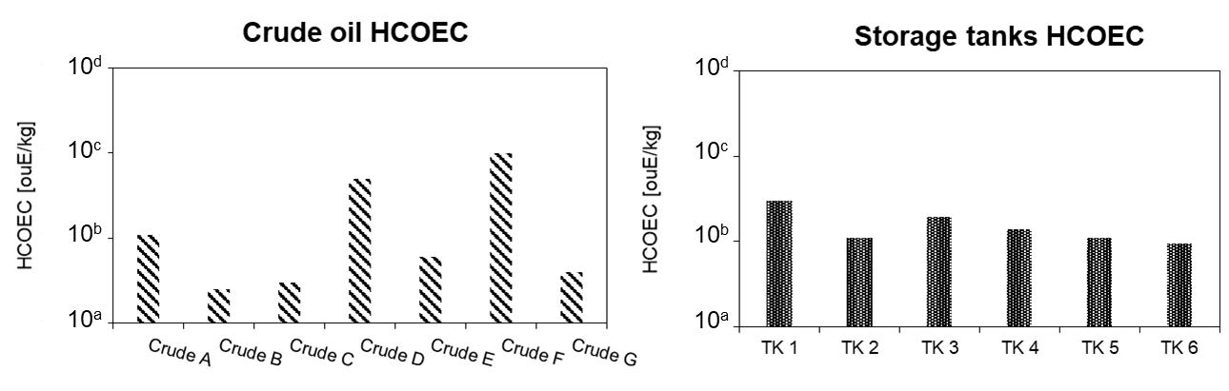
Figure 1: Variability of HCOEC values for individual crude oils (left) and corresponding tank-specific HCOEC values (right) derived through throughput-weighted averaging

    - Estimation of VOC losses from floating-roof tanks
In this study, VOC emissions were estimated using the US EPA AP-42 methodology, which provides empirical correlations to quantify fugitive losses from storage tanks. The total annual mass flux (kg/y) was calculated as the sum of different contributions, including rim seal losses (emissions from the seal between the floating roof and the tank wall), withdrawal losses (associated with liquid level decrease and the evaporation of the liquid film left on the walls), and deck fitting losses (emissions from roof penetrations such as hatches and gauge wells).
To improve the temporal resolution of emissions, a refinement was introduced for withdrawal losses. This contribution was allocated only to the hours in which the tank level was decreasing and weighted according to the actual withdrawal rate, while it was set to zero during filling or idle conditions.
All other emission components, representing standing losses, were instead uniformly distributed over the entire year. This approach allowed the derivation of an hourly-resolved emission profile for each tank.
The resulting time-varying VOC losses (L_{tot}) were then combined with the tank-specific HCOEC values to estimate the corresponding Odour Emission Rate, OER, on an hourly basis.

$$OER = L_{tot}∙HCOEC$$ | (2)
This methodology avoids the use of long-term averaged emissions, which may smooth out short-term variability and underestimate peak emission events potentially responsible for odour nuisance.

    - Emission source parameterization for dispersion modelling
In the dispersion modelling framework, the EFRTs were represented as diffuse emission sources, consistently with the physical nature of the emission mechanisms previously described. Given the absence of well-defined release points and the spatial distribution of emissions across the tank surface and peripheral components, each tank was modelled as an area source within the CALPUFF domain. The emission height was set equal to the tank wall height, while the emitting surface corresponded to the circular plan area of each tank, derived from its diameter. The initial vertical dispersion coefficient (σ_{z0}) was estimated following the AERMOD User’s Guide, by dividing the source height by a factor of 2.15, thereby defining the initial vertical extent of the emitted puff. Each tank was modelled as an independent source with hourly varying OER. The geometric characteristics of the tanks and the corresponding annual OER are reported in Table 1.

Table 1: Tank geometry and associated OER for the EFRTs.
Emission source | D [m] | H [m] | OER [ou_{E}/y]
TK1 | 50 | 16 | 3.62·10¹⁰
TK2 | 50 | 16 | 2.89·10¹⁰
TK3 | 50 | 16 | 3.54·10¹⁰
TK4 | 60 | 16 | 4.81·10¹⁰
TK5 | 50 | 16 | 2.75·10¹⁰
TK6 | 50 | 16 | 2.19·10¹⁰
  - Results
    - Temporal Dynamics of OER: Hourly Variability and Annual Averages
The hourly-resolved OER exhibit a pronounced temporal variability over the simulation period (Figure 2), highlighting the dynamic nature of emissions from EFRTs
While the annual average OER, referred to the total contribution of all six tanks, is approximately 6.3·10³ ou_{E}/s, the distribution of hourly values spans a much wider range, with baseline conditions around 3.7·10³ ou_{E}/s and recurrent peak events reaching up to 9.0·10³–1.0·10⁴ ou_{E}/s. Overall, this corresponds to a variability of about a factor of 2.5 between minimum and maximum hourly values, while peak emissions are approximately 1.7 times higher than the annual mean.
Such variability is primarily associated with the operational dynamics of the tanks, particularly during liquid withdrawal phases, which enhance evaporative losses and lead to short-term emission peaks. The comparison between the scattered hourly values and the annual average clearly shows that a time-averaged approach would smooth out these transient events. As a result, methodologies relying solely on annual emission estimates may be limited to capture the intensity and frequency of peak conditions that are most relevant for odour impact.
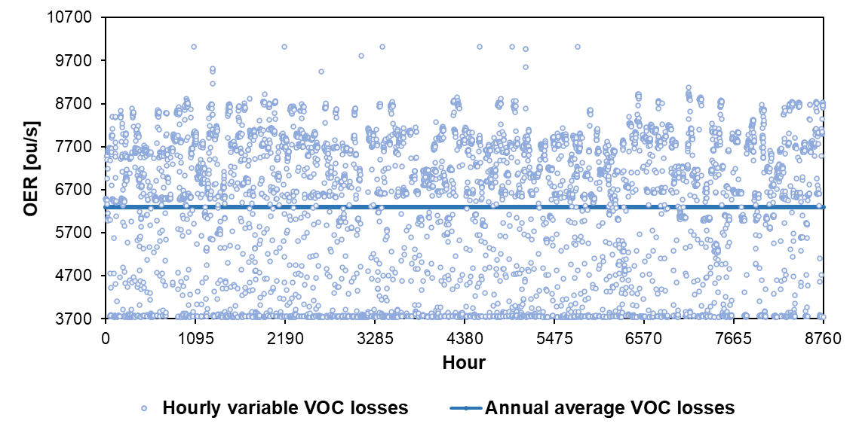
Figure 2: Hourly OER variability over the year for the total emissions from all EFRTs vs annual average.

    - Odour impact assessment
The results of the dispersion modelling were processed in accordance with the Italian regulatory framework (Decreto Direttoriale 28 Giugno 2023, n. 309, 2023), which prescribes the use of the annual 98th percentile of hourly average concentrations (C98) as the reference metric for odour impact. In addition, a peak-to-mean factor equal to 2.3 was applied to account for short-term concentration fluctuations relevant to human odour perception. Figure 3 shows the spatial distribution of odour concentrations obtained from CALPUFF simulations over a 4x4 km² domain, expressed both in terms of C98 and maximum hourly concentrations (Cmax).

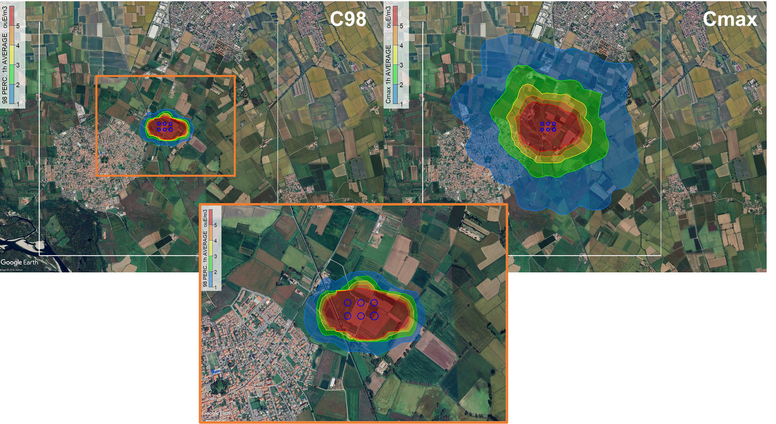
Figure 3: Simulated odour impact maps expressed as annual 98th percentile (C98, left) and maximum hourly concentration (Cmax, right). The lower panel shows a zoomed view of the C98 map near the sources.

The maps highlight a clear impact pattern centred on the tank storage sit, with concentric zones of decreasing concentration extending towards the surrounding areas. The C98 map exhibits a relatively smooth and spatially continuous distribution, with the highest concentration levels prescribed by the Italian regulation confined to the immediate vicinity of the emission sources and a progressive attenuation with distance. In particular, the 1 ou_{E}/m³ isoline reaches a maximum extension of approximately 350 m from the source perimeter, while the 5 ou_{E}/m³ isoline is more contained, extending up to about 200 m. For the Cmax, the spatial extent of the impact is significantly larger: the 1 ou_{E}/m³ isoline extends up to 1.8 km from the sources, whereas the 5 ou_{E}/m³ isoline reaches a maximum distance of about 400 m. Therefore, the Cmax map identifies a wider area potentially exposed to odour impact, as it represents the single most critical hour of the year, driven by temporally variable emissions and meteorological conditions. Therefore, Cmax is more sensitive to short-term emission peaks and atmospheric conditions favouring the highest ground-level concentrations. The substantial discrepancy between C98 and Cmax can be primarily explained by the hourly variability of the OER, with meteorological variability providing an additional contribution. In particular, the time-resolved emission approach makes it possible to represent the discontinuous character of emissions. Under these conditions, the differences between C98 and Cmax become more pronounced, since C98 reflects the most recurrent higher-end impact conditions, whereas Cmax captures the absolute worst hour generated by the combination of emissions and meteorology.
  - Conclusions
This study highlights the complexity of odour emissions from crude oil storage facilities, driven by the diffuse nature of EFRT sources, the variability in crude oil odour potential, and the temporal dynamics of tank operations. The proposed methodology, based on tank-specific HCOEC values and hourly-resolved emission estimates, allows a more refined representation of emission behaviour compared to conventional annual-average approaches. The results demonstrate that odour emissions are highly variable over time, with short-term peaks primarily associated with withdrawal operations. This temporal variability significantly affects dispersion outcomes, as shown by the marked differences between C98 and Cmax indicators: while C98 suggests a localized impact, Cmax identifies a wider potentially affected area due to short-term peak events. The study highlights that a time-resolved approach is crucial for the assessment of odour impacts from crude oil tanks, as it enables the identification of short-term emission peaks that are most likely to drive odour nuisance.
References
Carrera L., Tagliaferri F., Albertini A., Sironi S., Invernizzi M, 2025, A comparative study of wind tunnel and flux chamber for diffuse emission sampling: Experimental evaluation and theoretical approach. Chemosphere, 375. https://doi.org/10.1016/j.chemosphere.2025.144242
CEN, 2022, Air Quality—Determination of Odour Concentration by Dynamic Olfactometry; EN13725:2022.
Decreto Direttoriale 28 Giugno 2023, n. 309, 2023. https://www.reteambiente.it/normativa/51893/decreto-direttoriale-minambiente-28-giugno-2023-n-309/
Invernizzi M., Ilare J., Capelli L., Sironi S., 2018, Proposal of a method for evaluating odour emissions from refinery storage tanks. Chemical Engineering Transactions, 68, 49–54. https://doi.org/10.3303/CET1868009
Invernizzi M., Sironi S., 2021., Odour emission rate estimation methods for hydrocarbon storage tanks. Chemical Engineering Transactions, 85(April), 67–72. https://doi.org/10.3303/CET2185012
Invernizzi M., Tagliaferri F., Manganelli C., Sironi S, 2025, Quantitative estimation of odorous emissions from heterogeneous area sources via thermal imaging drone. Science of the Total Environment, 1000. https://doi.org/10.1016/j.scitotenv.2025.180415
Mckittrick J., Hadgraft N., Fry K. L., Mikkonen A. T., Mavoa S., 2025, Industrial Odour and Psychosocial Wellbeing: A Systematic Review. Environments, 12(10), 364. https://doi.org/10.3390/environments12100364
Polvara E., Legnani V., Invernizzi M., Sironi S., 2025, Olfactometric and Chemical Characterisation of Gaseous Emission from Crude Oils. Molecules, 30(5). https://doi.org/10.3390/molecules30051136
Scire J. S., Strimaitis D. G., Yamartino R. J., 2000, A User’s Guide for the CALPUFF Dispersion Model. Earth Tech. Inc, (January), 521. http://www.src.com/calpuff/download/CALPUFF_UsersGuide.pdf
Tagliaferri F., Invernizzi M., Capra F., Sironi S., 2023, Validation study of WindTrax reverse dispersion model coupled with a sensitivity analysis of model-specific settings. Environmental Research, 222. https://doi.org/10.1016/j.envres.2023.115401
Tagliaferri F., Rota A., Invernizzi M., 2025, Area source emissions: a validation study of CALPUFF and LAPMOD models. Atmospheric Environment: X, 27. https://doi.org/10.1016/j.aeaoa.2025.100348
Tagliaferri F., Sironi S., Invernizzi M., 2026, Assessing VOC Dispersion from Hydrocarbon Storage Tanks: A Case Study on Emission Temporal Resolution. Applied Sciences, 16(4), 1851. https://doi.org/10.3390/app16041851
U.S. EPA., 2024, AP-42: Compilation of Air Emissions Factors. https://www.epa.gov/air-emissions-factors-and-quantification (Fifth).
Üstün M. A., Özkal C. B., 2025, Predicting odor nuisance levels using meteorological data and citizen complaints records: A machine learning approach. Atmospheric Pollution Research. https://doi.org/10.1016/j.apr.2025.102809

