 CHEMICAL ENGINEERING TRANSACTIONS  VOL. xxx, 2026 | A publication of  
The Italian Association
of Chemical Engineering
Online at www.cetjournal.it

Guest Editors: Laura Capelli, Marzio Invernizzi, Selena Sironi
Copyright © 2026, AIDIC Servizi S.r.l.
ISBN 979-12-81206-xx-x; ISSN 2283-9216

Identification, characterization and control of odour emission sources in waste recycling plants located in sensitive environment
Lorenzo Rasoª, Giovanni Agoglia^{b}, Vincenzo Naddeoª, Tiziano Zarraª,
ª Sanitary Environmental Engineering Division (SEED), Department of Civil Engineering University of Salerno – G. Paolo II, 132 - 84084 Fisciano (SA) Italy
^{b} AGECO s.r.l., via Scalo Ferroviario, 95 – 85050 Tito Scalo PZ, Italy
tzarra@unisa.it
Odour emissions from waste treatment activities represent a major environmental concern due to their potential effects on air quality and quality of life in nearby communities. Effective odour management in waste recycling plants requires the identification and characterization of the different emission sources contributing to the overall impact, as well as the assessment of their dispersion in the surrounding environment. In this context, the present study proposes an integrated framework combining source identification, dynamic olfactometry and atmospheric dispersion modelling for odour impact assessment. The research presents the development and application of an integrated framework for the identification, characterization and control of the odour emission sources in waste recycling facilities located in sensitive environments. Field campaigns were carried out at two full-scale plants of different size and configuration, located in the municipality of Tito and Latronico (Basilicata Region, Italy). The first facility operates two treatment lines for multimaterial sorting and solid recovered fuel (SRF) production, while the second consists of a single sorting line combined with external storage areas for end-of-waste materials. Point, areal and volumetric odour sources were identified and characterized through dynamic olfactometry in accordance with UNI EN 13725. Odour dispersion and impact areas were assessed using the CALPUFF modelling chain, applying the acceptability criteria established by the Basilicata Regional Law (L.R. 39/2021) for odour impact assessment. The results highlighted the presence of point, passive areal and volumetric sources, with measured odour concentrations ranging from 61 to 688 OU_{E}/m³. The odour impact assessment demonstrated that both plants comply with the regulatory acceptability criteria, even under worst-case scenario modelling conditions.
  - Introduction
European environmental strategies based on circular economy principles are promoting a progressive transition from disposal-oriented systems toward material recovery and recycling facilities (Sironi et. al. 2010). As a consequence, waste recycling plants (WRPs) are becoming increasingly widespread within modern waste management systems, often located in proximity to urban or industrial areas where the presence of sensitive receptors may lead to potential environmental concerns (Minelgaitė et al. 2019). Among these, odour emissions represent a major environmental and social issue due to their effects on air and life quality in surrounding communities (Zarra et al. 2012). Odour nuisance is frequently associated with waste treatment activities and may significantly affect the acceptance and operation of such facilities (Oliva et al. 2021). Waste recycling plants are characterized by heterogeneous material streams, discontinuous operating conditions and multiple emission mechanisms, where odour releases may originate from conveyed, areal and volumetric sources (Zarra et al., 2009). Under these conditions, plant-scale assessments may be insufficient to correctly identify critical phases and to support effective mitigation actions (Naddeo et al. 2012; Zarra et al., 2010). A source-oriented approach is therefore required to systematically identify, quantify and assess odour emissions under real operating conditions and to evaluate their potential impact on surrounding receptors (Capelli et al. 2013; Fasolino et al., 2016). Despite the increasing diffusion of recycling facilities, only a limited number of studies have investigated odour emissions from such plants within an integrated management perspective. Existing studies generally focus on specific aspects of odour generation or control (Zarra et al., 2016; Font et al., 2011; Jonca et al., 2025), while comprehensive approaches covering the entire chain from source identification to dispersion modelling and impact assessment remain scarce. The study presents and discusses the development and application of an integrated framework for the identification, characterization and control of odour emission sources in real waste recycling facilities located in sensitive environments. The experimental activities combine source identification and classification, in-situ sampling and odour concentration determination by dynamic olfactometry, and atmospheric dispersion modelling for odour impact assessment. The proposed methodology is based on the integration of the DPSIR (Driver–Pressure–State–Impact–Response) framework and the PDCA (Plan–Do–Check–Act) Deming cycle (Dudin et al. 2015), allowing a structured and iterative approach to the analysis and management of odour emissions. The framework is applied to two full-scale waste recycling plants of different size and configuration, located in the industrial area of Tito and Latronico (Basilicata Region, Italy).
The study contributes to improving the understanding of odour emission mechanisms in waste recycling and solid recovered fuel (SRF) production plants, supporting both environmental decision-making and the design of effective mitigation strategies.
  - Materials and methods
    - Integrated methodological assessment framework
Figure 1 illustrates the proposed methodology, based on the integration of the DPSIR (Driver–Pressure–State–Impact–Response) framework and the PDCA (Plan–Do–Check–Act) Deming cycle, along with some operational phases.

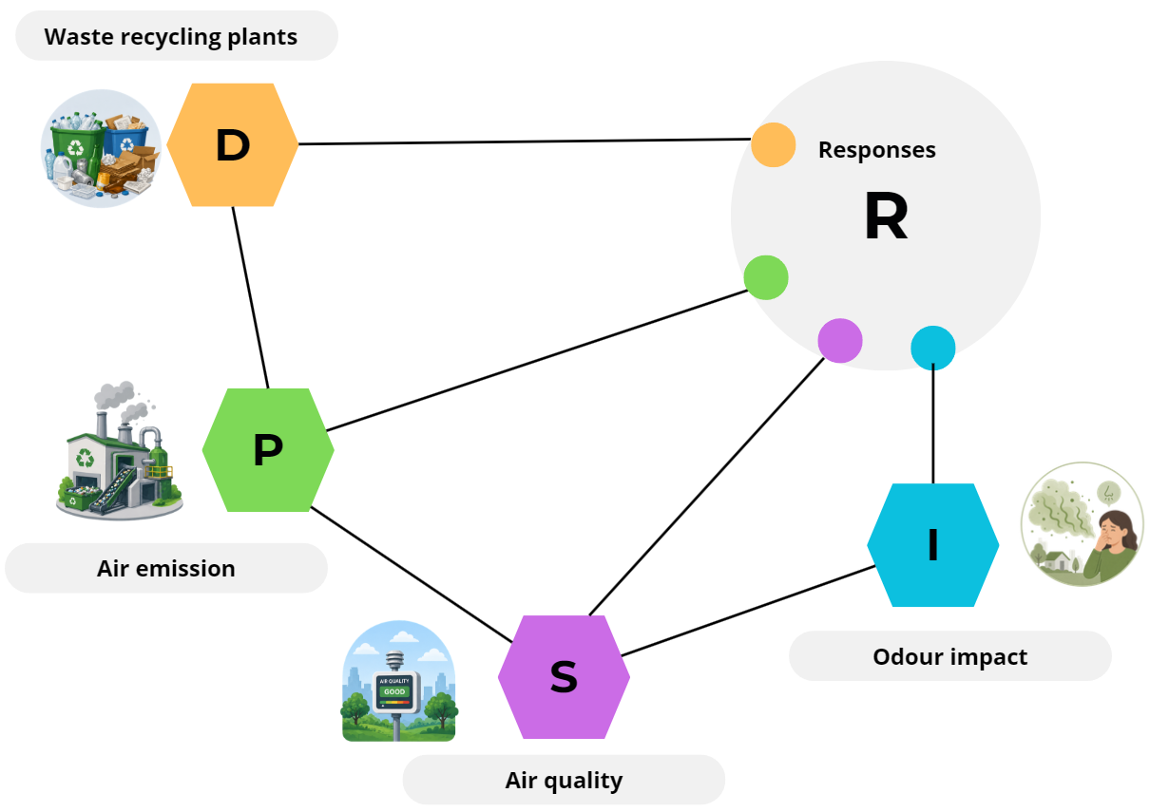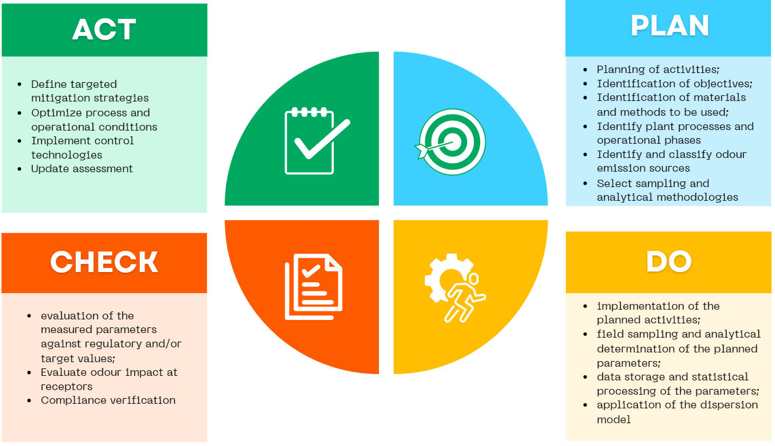
Figure 1: Integrated DPSIR (Driver–Pressure–State–Impact–Response) framework and PDCA (Plan–Do–Check–Act) cycle for odour emissions assessment and management.
The methodology sequentially implements the following main steps:
- Plant analysis, including the investigation of the layout, operational phases and the secondary activities;
- Identification and classification of odour emission sources, according to their typology (point, areal, volumetric; active or passive) and operational condition (real/existing, potential or future);
- Definition of sampling strategies, including the identification of standardized and officially recognized methods for each source type, as well as the number and spatial and temporal distribution of representative sampling locations;
- Field sampling campaigns and laboratory analytical analyses, carried out under representative operating conditions with the support of university laboratories or accredited private laboratories for existing emission sources. For potential and/or future sources, emission data are determined through an in-depth review of the relevant technical and scientific literature, with reference to analogous case studies;
- Assessment of the detected odour emission levels in relation to applicable regulatory limits, guideline values, or reference criteria, where available;
- Application of atmospheric dispersion modelling, including the definition of the modelling approach, the input data (meteorological, topographical, and emission-related), the spatial domain and the simulation parameters, as well as the identification of sensitive receptors and applicable impact criteria;
- Evaluation of odour impact through comparison of model results with applicable regulatory thresholds or impact criteria;
- Identification of mitigation and management measures aimed at reducing odour emissions and associated impacts, including operational, technical, and monitoring actions where appropriate.
The applications focuses on the identification, characterization and impact assessment steps of the framework.
    - Investigated waste recycling plants
The investigated waste recycling plants (WRPs) are two full-scale facilities located in the Basilicata Region (Southern Italy), characterised by mechanical sorting and separation processes for different waste fractions.
In both plants, the main operations are carried out within enclosed buildings maintained under negative pressure, with exhaust air conveyed to dedicated emission stacks. Large openings (doors and gates) are present to allow the entry and exit of vehicles transporting the materials to be treated. The plants also include external storage areas for incoming raw waste and treated materials, consisting of tanks, containers or confined zones on impermeable surfaces, covered to limit exposure to meteorological conditions. The main treated waste fractions include multimaterial streams, plastics, glass, and paper and cardboard, in quantities in accordance with the authorized capacity. Figure 2 shows the layout of the investigated plants, highlighting the buildings where the waste treatment lines are operated (C1.2, C2.2, C1), the buildings hosting the administrative offices (C1.1, C2), and the main external storage areas or units (A).

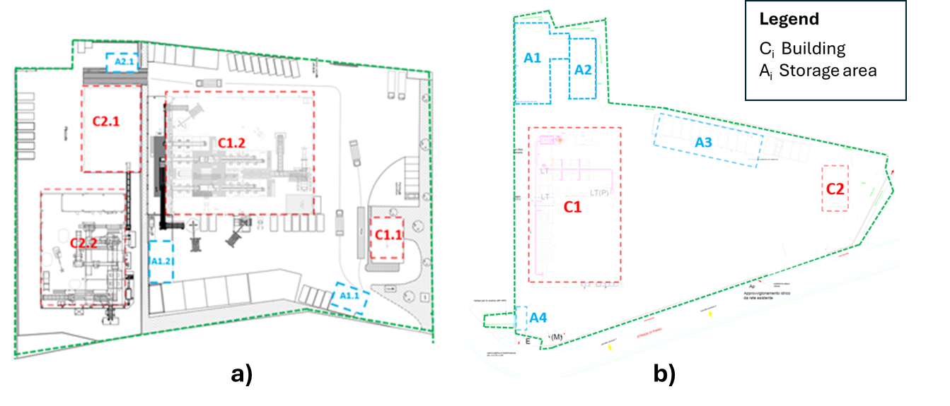
Figure 2: Layout of the investigated waste recycling plants: (a) Tito and (b) Latronico
The Tito plant is characterised by a dual treatment-line configuration and includes, in addition to sorting activities, a specific mechanical treatment line (building C2.2) for the production of solid recovered fuel (SRF) from residual waste. While the Latronico plant presents a simpler configuration and is dedicated exclusively to the treatment of dry fractions from separately collected waste.
    - Odour source identification, classification and characterization
Table 1 summarizes the criteria adopted for the identification of odour sources, together with the corresponding source types and the main recognized references, standards, and guidelines used for their characterization.
Table 1: Odour emission sources identification, classifcation criteria and characterization
Classification criteria | Source type | Reference, standards and guidelines for odour characterization
type | point | - EN 13725:2022  - SNPA Guidelines (2025)  - MASE DD 309/2023  - Zarra et al., 2009  - Belgiorno et al., 2013
type | active areal
type | passive areal
type | volumetric
type | fugitive
operational condition | real
operational condition | potential
operational condition | future potential
origin | direct
origin | indirect

While for the determination of odour concentrations by dynamic olfactometry, in accordance with UNI EN 13725:2022, a TO8 olfactometer (Ecoma GmbH, D) was employed (Zarra et al., 2012a).
    - Dispersion modelling and odour impact assessment
Odour dispersion was assessed using the MMS Calpuff modelling system (Maind srl, Italy), which includes the meteorological pre-processor CALMET, the dispersion model CALPUFF and the post-processing module CALPOST (Scire et al., 2000). The meteorological input dataset, provided by Maind srl (Italy) for 2024, has been utilized within a prognostic model designed for environmental assessment and simulation. This dataset supports high-resolution numerical weather prediction or dispersion modeling applications, ensuring accurate spatial and temporal representation of atmospheric conditions. The modelling domain covers an area of 4 × 4 km² and 2 × 2 km², respectively for Tito and Latronico WRPs, with a spatial resolution of 100 m, allowing a detailed representation of local-scale dispersion processes. A peak to mean ratio of 2,3, according to the MASE DD 309/2023 guidelines was used. The results were evaluated in accordance with the criteria defined by the Regional Law of Basilicata Regione n.39/2021 (Regione Basilicata 2021), which establishes odour acceptability thresholds based on the 98th percentile of hourly peak odour concentrations (OU_{E}/m³) at sensitive receptors. Specifically, the regulation defines different threshold values depending on both the land-use classification of the area in which the receptors are located and the distance from the nearest emission sources. For receptors located in industrial areas, limit values of 2, 3, and 4 OU_{E}/m³ are established for distances respectively greater than 500 m, between 200 and 500 m, and less than 200 m. A total of 64 and 26 receptors were identified and/or validated by the Regional Agency for Environmental Protection of Basilicata (ARPAB) in the surroundings of the Tito and Latronico WRPs, respectively.
  - Results and discussion
    - Odour emission sources identification, classification and characterization
Table 2 summarizes the odour emission sources identified for the two investigated WRPs, their classification, their correspondence with the plant layout reported in Figure 2, and the associated maximum odour concentrations detected from field measurements for the existing sources (S1 – S6), or defined from the analysis of the scientific literature, for the future sources (S7).
Table 2: Classification and characterization of odour emission sources for the Tito and Latronico WRP
ID Source | Source type | Location (Figure 2) |  |  | Maximum  Odour concentration
ID Source | Source type | Tito (a) | Latronico (b) |  | Maximum  Odour concentration
S1 | real, conveyed point | C1.2 - exhaust stack |  | C1- exhaust stacks | 688 OU_{E}/m³
S2 | real potential, volumetric | C1.2- doors |  | C1 - doors | 267 OU_{E}/m³
S3 | real, conveyed point | C2.2 - exhaust stack |  | - | 176 OU_{E}/m³
S4 | real potential, volumetric | C2.2- doors |  | - | 128 OU_{E}/m³
S5 | real, passive areal | A1.1 - glass open bunker |  | A4 - glass closed container | 450 OU_{E}/m³
S6 | real, passive areal | A1.2 - multimaterial storage area |  | A1, A2 - multimaterial storage area | 318 OU_{E}/m³
S7 | future potential, passive areal | A2.1 - organic fraction bunker |  | - | 4380 OU_{E}/m³

Overall, a maximum of seven emission sources were identified. The identified sources include conveyed point sources associated with exhaust stacks, volumetric sources related to industrial building doors used for the passage of transport vehicles for waste unloading and/or for mechanical equipment dedicated to waste handling (front loaders), and passive areal sources linked to external storage units, namely the open concrete bunker for glass, the closed container for glass, the closed concrete bunker for the organic fraction, and the multimaterial storage area.
The highest odour concentration at the Tito plant was detected at the exhaust air stack of the main waste treatment building (C1.2), with a value of 688 OU_{E}/m³, while the lowest concentration was detected at the door openings of building C2.2, with a value of 128 OU_{E}/m³.
    - Odour impact assessment
Figure 3 shows the annual 98th percentile isoconcentration maps of hourly peak odour concentrations for the Tito and Latronico WRPs, obtained according to the methodological framework established by the Basilicata Regional Law L.R. 39/2021.

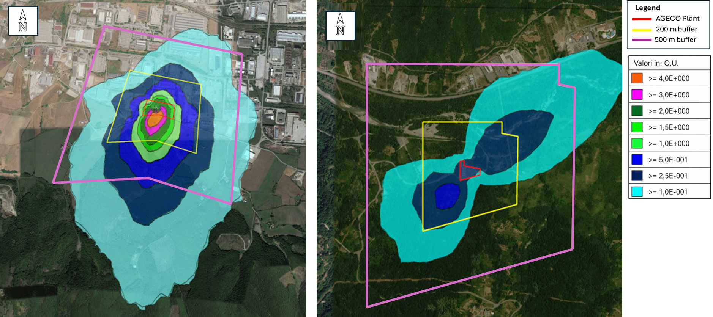
b)
a)
Figure 3: Figure 3. Annual 98th percentile isoconcentration maps of hourly peak odour concentrations for the investigated plants: (a) Tito and (b) Latronico.
The simulated ground-level ( + 1,80 m) odour concentrations demonstrate that, for both facilities, the predicted impacts are widely within the acceptability criteria established by the regional regulation, with no exceedances observed at the investigated receptors or within the surrounding areas. In particular, the highest odour concentrations are mainly confined to the immediate vicinity of the emission sources and progressively decrease with increasing distance from the plants. For both Tito (Figure 3a) and Latronico (Figure 3b), the outer portions of the 200 m and 500 m buffer areas are characterized by low odour concentration levels, confirming the limited spatial extent of the odour plumes and the absence of significant off-site impacts.
At a distance 200 m from the plant boundary, the maximum modelled concentrations are 1,5 OU_{E}/m³ for the Tito plant and below 0,25 OU_{E}/m³ for the Latronico plant, both significantly lower than the regulatory reference limit of 4 OU_{E}/m³. Although the Tito plant exhibits a broader dispersion pattern and higher concentration gradients compared to the Latronico facility, mainly due to the greater number of identified emission sources and the presence of passive areal sources associated with waste storage activities, the simulated concentrations remain fully compatible with the acceptability thresholds defined by L.R. 39/2021. Similarly, the Latronico plant shows a localized and limited odour dispersion pattern, with rapidly decreasing concentrations outside the plant boundary. Overall, the modelling results indicate that neither plant generates significant odour nuisance conditions for the surrounding environment or nearby receptors. Therefore, both facilities can be considered compatible with their current territorial context and receptor distribution, demonstrating negligible environmental impact in terms of odour emissions under the analysed operating conditions.
  - Conclusions
The study presents and discusses an integrated framework for the identification, characterization and assessment of odour emissions from waste recycling plants, combining source-oriented analysis, dynamic olfactometry and atmospheric dispersion modelling. The application to two full-scale facilities highlighted the presence of multiple emission typologies, including conveyed point sources, volumetric sources associated with building openings, and passive areal sources related to waste storage areas such as glass storage tanks and multimaterial storage areas. The measured odour concentrations showed significant variability among the identified sources, with the highest values generally associated with exhaust stacks of the treatment buildings, while lower concentrations were observed for diffuse and volumetric emissions. The dispersion modelling results, expressed as the annual 98th percentile of hourly peak concentrations, indicate that odour impacts remain confined to the areas immediately surrounding the plants and fully comply with the regulatory acceptability criteria, even under worst-case scenario conditions. These findings confirm the negligible odour impact of both facilities on the surrounding environment and nearby receptors.
Overall, the proposed approach provides a robust and systematic framework for the identification and characterization of odour emission sources and for the assessment of their environmental impact. The methodology therefore represents an effective decision-making support tool for the integrated management and control of odour-generating facilities, particularly waste recovery and recycling plants. Furthermore, the framework can support the development of targeted odour mitigation and management strategies, contributing to the prevention and reduction of potential impacts in environmentally sensitive areas.
References
Belgiorno, V., Naddeo, V., Zarra, T., 2013. Odour Impact Assessment Handbook. https://doi.org/10.1002/9781118481264.
Capelli, L., Sironi, S., Del Rosso, R., Guillot, L., 2013. Measuring Odours in the Environment vs. Dispersion Modelling: A Review. Atm. Environment 79: 731–43. https://doi.org/10.1016/j.atmosenv.2013.07.029.
Dudin, M., Frolova E., Gryzunova, N., Shuvalova.E., 2015. The Deming Cycle (PDCA) Concept as an Efficient Tool for Continuous Quality Improvement in the Agribusiness. SSRN Scholarly Paper No. 2587597. Social Science Research Network. https://papers.ssrn.com/abstract=2587597.
EN 13725, 2003. Air quality and determination of odour concentration by dynamic olfactometry.
Fasolino, I., Grimaldi, M., Zarra, T., Naddeo, V., 2016. Odour control strategies for a sustainable nuisances action plan. Global NEST Journal 18, 734–741. https://doi.org/10.30955/gnj.002109
Font, X., Artola, A., & Sánchez, A., 2011. Detection, Composition and Treatment of Volatile Organic Compounds from Waste Treatment Plants. Sensors, 11(4), 4043-4059. https://doi.org/10.3390/s110404043
Jonca,J., Bezyk, Y., Miller, U., Wróbel, M., Arsen, A., Szrek, J., Muraszkowski, A., Włóka, A., Janicka, A., Sówka, I. 2025. Holistic approach to odour impact assessment on the basis of three waste management plants. Waste Management, 208, 115156. https://doi.org/10.1016/j.wasman.2025.115156
Ministero dell’Ambiente e della Sicurezza Energetica (MASE), 2023. DD n. 309 del 28/06/2023 “Indirizzi per l'applicazione dell'articolo 272-bis in materia di emissioni odorigene di impianti e attività”.
Minelgaitė, A., Liobikienė, G., 2019. Waste problem in European Union and its influence on waste management behaviours. Science of The Total Environment 667: 86–93. https://doi.org/10.1016/j.scitotenv.2019.02.313.
Naddeo, V., Zarra, T., Giuliani, S., Belgiorno, V., 2012. Odour Impact Assessment in Industrial Areas. Chemical Engineering Transactions, 30, pp. 85–90. https://doi.org/10.3303/CET1230015
Oliva, G., Zarra, T., Pittoni, G., Senatore, V., Galang, M.G., Castellani, M., Belgiorno, V., Naddeo, V., 2021. Next-generation of instrumental odour monitoring system (IOMS) for the gaseous emissions control in complex industrial plants. Chemosphere 271, 129768. https://doi.org/10.1016/j.chemosphere.2021.129768
Regione Basilicata, Legge Regionale 23 settembre 2021, n. 39. Norme per la prevenzione e la limitazione delle emissioni odorigene. Bollettino Ufficiale n. 74 (Speciale) del 24 settembre 2021.
Scire, J. S., Strimaitis, D. G., & Yamartino, R. J. , 2000. A user’s guide for the CALPUFF dispersion model. Earth Tech, Inc, 521, 1-521.
Sironi, S., Capelli, L., Céntola, P., Del Rosso, R., Pierucci, S., 2010. Odour Impact Assessment by Means of Dynamic Olfactometry, Dispersion Modelling and Social Participation. Atmospheric Environment 44 (3): 354–60. https://doi.org/10.1016/j.atmosenv.2009.10.029.
Zarra, T., Giuliani, S., Naddeo, V., Belgiorno, V., 2012. Control of odour emission in wastewater treatment plants by direct and undirect measurement of odour emission capacity. Water Science and Technology 66(8), 1627–1633. https://doi.org/10.2166/wst.2012.362
Zarra, T., Reiser, M., Naddeo, V., Belgiorno, V., Kranert, M. 2012. A Comparative and Critical Evaluation of Different Sampling Materials in the Measurement of Odour Concentration by Dynamic Olfactometry. Chemical Engineering Transactions 30: 307–12. https://doi.org/10.3303/CET1230052.
Zarra, T., Naddeo, V., Belgiorno, V., 2009. A novel tool for estimating the odour emissions of composting plants in air pollution management. Global Nest Journal, 11(4), 477–486. https://doi.org/10.30955/gnj.000484
Zarra, T., Naddeo, V., Giuliani, S., Belgiorno, V., 2010. Optimization of field inspection method for odour impact assessment. Chemical Engineering Transactions, 23, pp. 93–98. https://doi.org/10.3303/CET1123016
Zarra, T., Naddeo, V., Oliva, G., Belgiorno, V., 2016. Odour emissions characterization for impact prediction in anaerobic-aerobic integrated treatment plants of municipal solid waste. Chemical Engineering Transactions, 54, pp. 91–96. https://doi.org/10.3303/CET1654016

