 CHEMICAL ENGINEERING TRANSACTIONS  VOL. xxx, 2026 | A publication of  
The Italian Association
of Chemical Engineering
Online at www.cetjournal.it

Guest Editors: Laura Capelli, Marzio Invernizzi, Selena Sironi
Copyright © 2026, AIDIC Servizi S.r.l.
ISBN 979-12-81206-xx-x; ISSN 2283-9216

Waste-to-Energy Nexus Approach for Odour Abatement and CO2 Biofixation in Environmental Engineering Plants
Lorenzo Rasoª, Letizia Levaª, Aniello Marinielloª, Giuseppina Olivaª, Vincenzo Belgiornoª, Vincenzo Naddeoª, Tiziano Zarraª,
ª Sanitary Environmental Engineering Division (SEED), Department of Civil Engineering University of Salerno – G. Paolo II, 132 - 84084 Fisciano (SA) Italy
lraso@unisa.it
Odour emissions from environmental engineering plants represent a significant environmental and social issue, requiring sustainable mitigation strategies. The research presents and discusses the development and experimental validation of an advanced integrated biotechnological system for the treatment of real odour emissions, combining a Moving Bed Biofilm Reactor (MBBR) with a downstream algal photobioreactor (aPBR). The proposed platform enables simultaneous odour abatement and carbon valorisation through microbial degradation and CO₂ biofixation, within a waste-to-energy nexus framework integrating emission control and resource recovery. Experimental validation was performed under controlled laboratory batch conditions using real odour emissions collected from a full-scale wastewater treatment plant (WWTP) located in the municipality of Salerno (Campania Region, Italy). System performance was assessed by determining odour concentration (OUE m⁻³) abatement, removal efficiencies of target compounds, and CO₂ biofixation rates. The results showed odour removal efficiencies of up to 95%, with nearly complete removal (~100%) of the target compound methyl mercaptan. The algal photobioreactor achieved CO₂ biofixation efficiencies of up to 86% while producing algal biomass with a lipid content of approximately 22%, supporting its potential for energy recovery. The study highlights the potential of integrated biotechnological solutions to simultaneously address odour control, climate change mitigation, and resource recovery, contributing to the development of next-generation sustainable emission management strategies.
  - Introduction
Odour emissions from environmental engineering facilities, such as wastewater treatment plants (WWTPs), represent a significant environmental and societal issue due to their adverse effects on the quality of life of exposed populations(Belgiorno et al. 2012; Sironi et al. 2010) . Even at concentrations well below toxicological thresholds, odorous compounds can induce nuisance, discomfort, and persistent complaints, often leading to conflicts between plant operators and surrounding exposed communities (Oliva et al. 2023). Consequently, odour pollution is increasingly recognised as a relevant environmental pressure requiring structured monitoring, regulation, and mitigation strategies (Naddeo et al. 2012; Capelli et al. 2020).
In WWTPs, odour emissions are mainly associated with the biodegradation of organic matter under anaerobic or anoxic conditions, where microbial metabolism promotes the formation of volatile and malodorous compounds (Lewkowska et al. 2016). Among these, reduced sulphur compounds, such as hydrogen sulphide (H₂S) and mercaptans, are among the dominant contributors to odour nuisance, alongside ammonia and volatile fatty acids (Zarra et al. 2012). The most critical emission sources are typically identified in preliminary treatment units and sludge handling processes, where high organic loads, extended retention times, and enhanced volatilisation favour the release of odorous substances (Zarra et al. 2008). These emission patterns are strongly influenced by plant configuration, hydraulic and operational conditions, and wastewater characteristics, resulting in high temporal and spatial variability. The treatment of odour emissions remains challenging due to their complex composition and fluctuating nature (Fasolino et al. 2016) . Conventional abatement technologies, including scrubbers, adsorption systems, and biofilters, are widely used and can achieve high removal efficiencies under optimised operating conditions (Senatore et al. 2021). Among these, biological processes are particularly attractive due to their lower environmental footprint, cost-effectiveness, and capability to degrade a broad spectrum of pollutants ( Zarra, et al. 2012; G. Oliva et al. 2021). Nevertheless, these technologies are typically designed for pollutant removal only and do not inherently promote resource recovery. In this context, increasing attention has been directed towards integrated treatment approaches aligned with circular economy principles and climate change mitigation objectives (European Commission, 2020). Microalgae-based systems have emerged as a promising solution, as they enable CO2 biofixation through photosynthetic activity while generating biomass that can be valorised for bioenergy or bioproducts (Oliva et al. 2023; Senatore et al. 2021). The integration of microalgal processes with biological gas treatment technologies offers the potential to couple emission abatement with carbon capture and resource recovery within a waste-to-energy framework. Despite these advancements, studies addressing the combined application of biological odour removal and microalgal CO₂ valorisation under real emission conditions remain limited. The research presents and experimentally validates an innovative integrated biotechnological system for the treatment of odour emissions, combining a Moving Bed Biofilm Reactor (MBBR) with a downstream algal photobioreactor (aPBR). Experimental assessment of the system was carried out under controlled laboratory batch conditions, employing real odorous streams sourced from a full-scale wastewater treatment facility in Salerno (Campania, Italy). The research highlights the effectiveness of developing integrated biotechnological approaches aimed at simultaneously addressing multiple environmental challenges, including odour mitigation, greenhouse gas reduction, and resource recovery, thereby representing a promising pathway towards next-generation sustainable and circular emission management frameworks.
  - Material and Methods
    - Advanced integrated biotechnological system
Figure 1 schematically illustrates the advanced integrated biotechnological platform, including its main components and process flow lines. The system integrates a Moving Bed Biofilm Reactor (MBBR, R1) with a downstream algal photobioreactor (aPBR, R2). In the first reactor (R1), odorous compounds are biologically degraded via heterotrophic metabolism, whereas in the second reactor (R2), the CO₂ present in the inlet stream and produced during biological oxidation is biofixed through autotrophic algal growth.

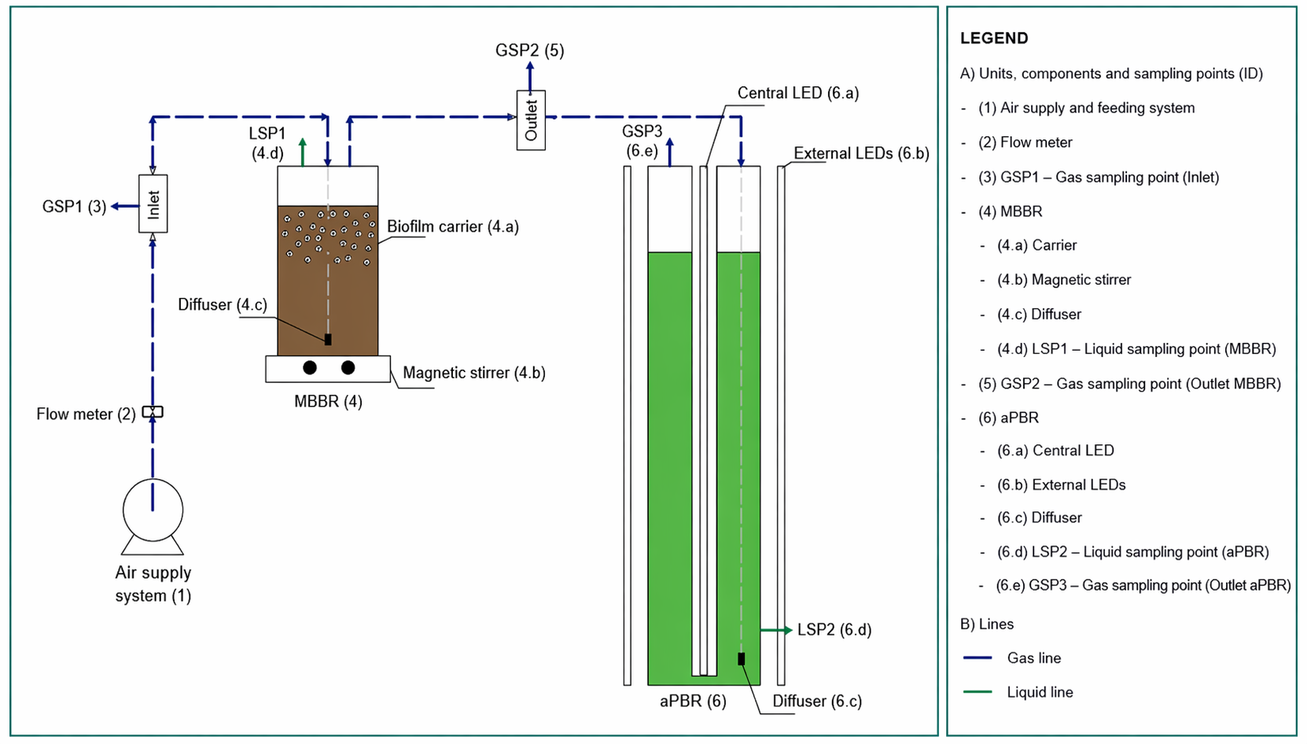
Figure 1: Advanced integrated biotechnological system
The layout of the system includes a gas supply line, in which the influent gas stream is regulated by a flowmeter and maintained at a constant flow rate of 0.5 L/min. The gas is monitored through a first sampling port (GSP1) located upstream of the MBBR. The MBBR, constructed of Pyrex glass with a working volume of 10 L, represents the biological treatment unit of the system. The reactor contains activated sludge and plastic carriers, which provide support for the development of heterotrophic biofilm. Mixing is achieved by a magnetic stirrer, while the gas is introduced at the bottom through a diffuser to enhance gas–liquid mass transfer and promote effective contact with the biomass. Downstream of the MBBR, a second gas sampling port (GSP2) is installed to monitor the characteristics of the treated gas stream prior to its transfer to the algal photobioreactor. The aPBR, constructed of Plexiglass with an operating volume of 26 L, contains a suspension of Chlorella vulgaris cultivated in a nutrient medium. Illumination is supplied by both internal and external LED systems, while aeration and mixing are provided via a bottom diffuser. The gas stream exiting the photobioreactor is finally sampled at the outlet through a third sampling port (GSP3).
    - Experimental plan and program
To assess the performance of the integrated system under representative operating conditions, real odour emissions were collected and analysed. The sampling activities were conducted at a full-scale wastewater treatment plant located in Salerno (Campania, Italy). Two representative emission sources were selected: P1, corresponding to the screening unit in the wastewater line, and P2, associated with the sludge thickening unit in the sludge line. For each odour source, gaseous samples were collected using a vacuum sampling system (ECOMA GmBH, D) equipped with Nalophan® bags, with a total volume of 49 L per campaign. A total of five campaigns were performed on a weekly basis. The collected samples were characterized before, during, and after treatment in terms of odour concentration and selected target compounds, to evaluate the system’s abatement performance. Each experimental treatment was carried out with a feeding time of 1.5 hours. Synthetic dairy wastewater (DWW) served as the culture medium to support both bacterial and algal activity. The algal photobioreactor operated under controlled illumination (5000 lux) with a light/dark cycle of 12/12 hours. Table 1 summarizes the investigated parameters, analytical methods, monitoring frequency, and the corresponding sampling phases (before, “B”; during, “D”; and after, “A” treatment), as well as the matrix type (gas or liquid).
Table 1: Investigated parameters, analytical methods, monitoring frequency and phases for each treatment run.
Matrix | Parameter | Frequency/phase | Instrument or Method
Liquid | T (°C), pH, DO (mg/L) | 3 times/B,D,A | Multiparameter probe (HI9829, Hanna Instruments)
Liquid | TSS (g/L) | 3 times/ B,D,A | APHA 2540 D
Liquid | Chlorophyll (mg/L) | 1 time/D | Spectrophotometer (PerkinElmer Lambda 25), Standard Methods 10200 H
Liquid | Lipids (g) | End of tests/A | Rotary evaporator (R-300), Specify extraction protocol
Gas | CH₃SH, CO2 (ppm) | 9 times/ B,D,A | MultiRAE (Recom srl)
Gas | Odour concentration (ouE/m³) | 2 time/ B, A | Olfactometer (TO8 Ecoma GmBH),  EN 13725:2022
    - Performance indicators
System performance was evaluated through a set of indicators related to the removal of target gaseous compounds, odour abatement, CO₂ biofixation, and biomass production.
The removal efficiency of target gaseous compounds was calculated according to Equation (1):
$$RE_{gas}(\%)=\frac{C_{in}-C_{out}}{C_{in}}⋅100$$ | (1)
where $C_{in}$and $C_{out}$ are the inlet and outlet concentrations of the target compounds, respectively.
The odour removal efficiency was determined according to Equation (2):
$$RE_{odour}(\%)=\frac{OU_{in}-OU_{out}}{OU_{in}}⋅100$$ | (2)
where $OU_{in}$and $OU_{out}$represent the odour concentrations at the inlet and outlet of the system, respectively, expressed in OU_{E}/m³.
The CO₂ biofixation efficiency in the photobioreactor was calculated according to Equation (3):
$$η_{CO_{2}}(\%)=\frac{C_{in}-C_{out}}{C_{in}}⋅100$$ | (3)
where $C_{in}$and $C_{out}$refer to the CO₂ concentrations measured at the inlet and outlet of the photobioreactor, respectively.
Biomass production was evaluated in terms of volumetric productivity, calculated according to Equation (4):
$$P=\frac{X_{t}-X_{t0}}{t-t_{0}}$$ | (4)
where $X_{t}$and $X_{t0}$are the biomass concentrations at time $t$and initial time $t_{0}$, respectively.
  - Results and discussion
    - Physico-chemical characterization
Figure 2 shows the average values of temperature (T), pH, dissolved oxygen (DO), and total suspended solids (TSS), calculated over the five experimental campaigns for both reactors (MBBR and aPBR), considering the two investigated odour emission sources (P1 and P2) across the three phases of the treatment process (before, “B”, inlet; during, “D”; after, “A”, outlet).
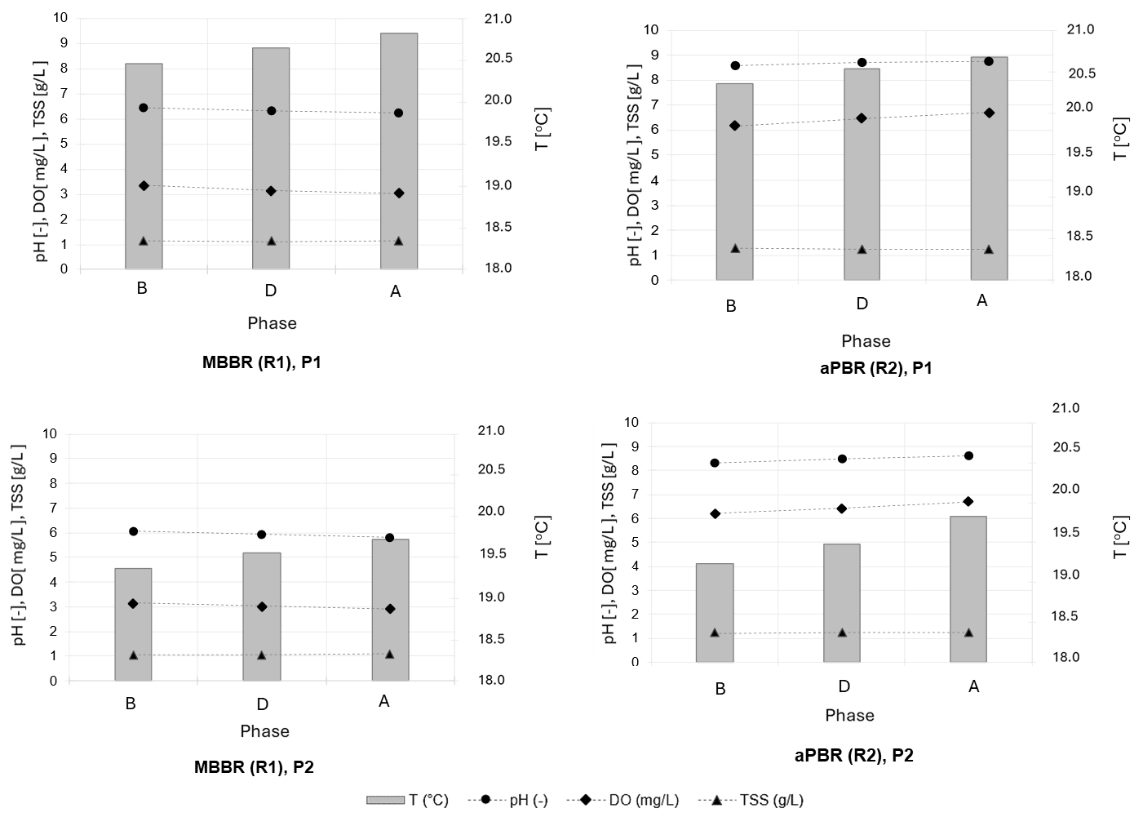
Figure 2: Average physico-chemical parameters measured in the MBBR (R1) and aPBR (R2) for P1 and P2 emission sources during the three phases of the treatment process (B, D, A).
Results highlight how in the MBBR (R1), pH remained close to neutrality, while dissolved oxygen slightly decreased due to consumption by heterotrophic biomass during aerobic degradation. TSS values remained stable, confirming the maintenance of active biomass.
In the aPBR (R2), higher pH and DO values were observed, with a slight increase over time, consistent with algal photosynthetic activity, which promotes CO2 uptake and oxygen production. TSS values also remained stable, indicating effective biomass retention. Similar behaviour was observed for both P1 and P2. Slightly lower pH and DO values were recorded in the MBBR for P2, likely due to the different emission characteristics, while the aPBR showed recovery of optimal conditions.
    - System performances evaluation
Complete removal of the target compound (CH₃SH) was achieved under all tested conditions for both investigated emission sources (P1 and P2). Despite the significantly higher inlet concentration observed for P2 (4.16 ppm) compared to P1 (0.17 ppm), the system maintained full removal efficiency, confirming the robustness of the biological stage towards variable sulphur loads. The observed removal can be attributed to the activity of heterotrophic sulphur-oxidizing microorganisms attached to the biofilm carriers, whereas CO₂ reduction in the aPBR was promoted by photosynthetic carbon fixation performed by Chlorella vulgaris (Senatore et al., 2021). Table 2 reports the average CO₂ concentrations measured at the inlet (Cin) and the outlet (Cout1) of the MBBR (R1), and at the outlet (Cout2) of the algal photobioreactor (R2), together with the corresponding biofixation efficiencies (RE) for the investigated odour emission sources (P1, P2) over the entire monitoring period.
Table 2. CO2 concentrations and biofixation efficiencies for the investigated odour emission sources.
Sampling point | C in (CO2)  [ppm] | C out1 (CO2)  [ppm] | C out2 (CO₂)  [ppm] | RE  [%]
P1 | 266 | 1531 | 278 | 86
P2 | 380 | 1373,3 | 273,3 | 80

For both investigated odour emission sources, CO₂ concentrations increased across the MBBR (from 266 to 1531 ppm for P1 and from 380 to 1373 ppm for P2) due to biological oxidation and were subsequently reduced in the aPBR to 278 ppm (P1) and 273.3 ppm (P2). Biofixation efficiencies reached 86% and 80% for P1 and P2, respectively, confirming the effective role of the algal stage under variable inlet conditions and performances comparable to or exceeding those of standalone photobioreactors. These odour removal efficiencies are comparable to those reported for conventional biological treatment technologies such as biofilters and biotrickling filters (Zarra et al., 2012; Fasolino et al., 2016), while additionally enabling CO₂ biofixation and biomass production. Figure 3 shows the odour removal efficiency (RE) evaluated at the outlet of the system, together with the measured inlet (Cod IN) and outlet (Cod OUT) odour concentrations for P1 (left) and P2 (right) in the five experimental campaigns.

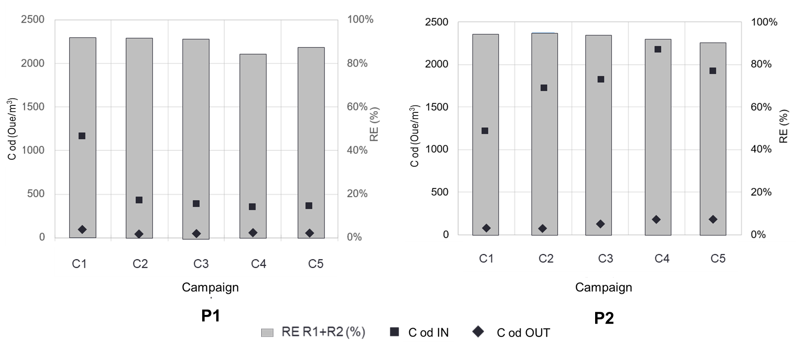
Figure 3: Odour removal efficiency evaluated at the outlet of the system, together with average inlet and outlet odour concentrations for P1 (left) and P2 (right).
The results showed a significant reduction in odour concentration under all tested conditions. For P1, the average value decreased from 533.4 to 57.2 OU_{E} /m³, corresponding to a removal efficiency of 92%, while for P2 it decreased from 1773.4 to 130.8 OU_{E} /m³, with a removal efficiency of 95%. In all experimental runs, outlet odour concentrations were consistently well below 300 OU_{E} /m³; value adopted in the literature as a reference threshold for emissions from biological treatment systems to minimize potential odour impact and ensure compliance with typical regulatory and permitting requirements (Zarra et al. 2012).
    - Algal biomass characterization
Figure 4 shows the temporal evolution of total suspended solids (TSS) and chlorophyll concentration in the algal photobioreactor for the two investigated emission sources.

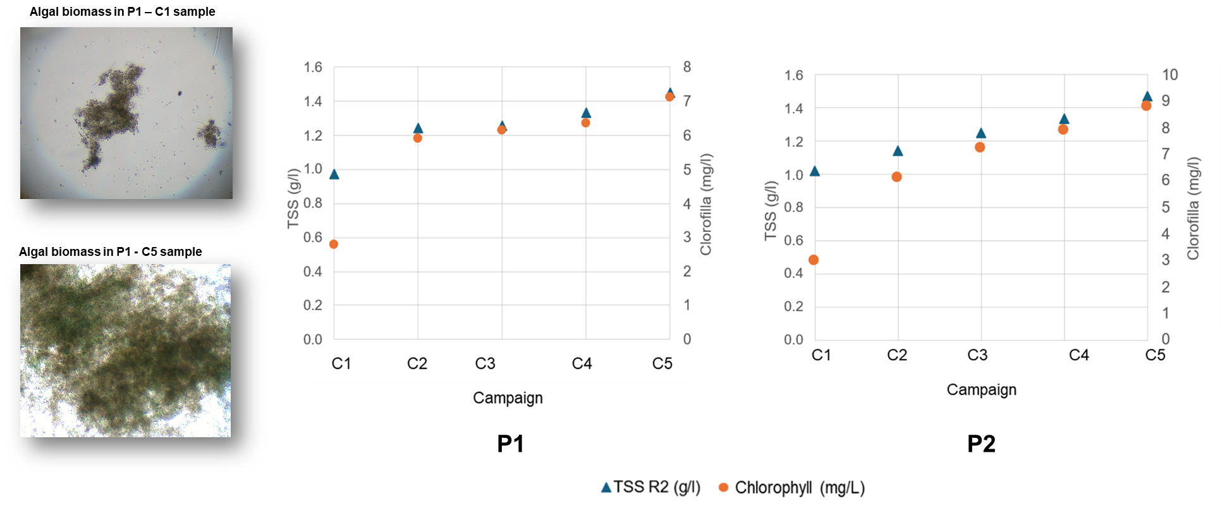
Figure4: Temporal evolution of TSS and chlorophyll concentration in the aPBR for P1 (left) and P2 (right), including representative microscopic images of algal biomass.
TSS concentrations showed a progressive increase over time in both configurations. In P1, biomass increased from 1.0 to 1.45 g/l, corresponding to an overall growth of 45%. Similarly, P2 exhibited a comparable trend, with TSS rising from 1.0 to 1.5 g/l, equivalent to a 50% increase. The average growth rate was slightly higher in P2, suggesting enhanced biomass accumulation, likely due to greater nutrient availability. Lipid content ranged between 18% and 22%, confirming the system’s potential for downstream energy valorization
  - Conclusion
The research investigates an integrated MBBR–aPBR system for the treatment of real odour emissions. The results demonstrated complete removal of sulphur compounds, odour abatement efficiencies of 92–95% (with outlet concentrations consistently below 300 ouE m⁻³), and CO₂ biofixation efficiencies of up to 80%. Furthermore, the production of algal biomass with a lipid content ranging from 18% to 22% highlights the potential for energy valorisation and supports the integration of emission control and resource recovery within a circular economy framework. Although a detailed techno-economic assessment was beyond the scope of this study, the proposed configuration shows promising potential for future full-scale implementation in WWTPs by coupling odour treatment, carbon capture and biomass production. Overall, the integrated system represents a sustainable alternative to conventional end-of-pipe technologies, simultaneously addressing odour mitigation, greenhouse gas reduction and resource recovery within a waste-to-energy nexus perspective.
References
Belgiorno, Vincenzo, Vincenzo Naddeo, e Tiziano Zarra. 2013. Odour Impact Assessment Handbook. https://doi.org/10.1002/9781118481264.
Capelli, Laura, Rosa Arias, Jose Uribe, e Selena Sironi. 2020. «OVERVIEW OF ODOUR MEASUREMENT METHODS: THE ODOUR OBSERVATORY AS AN INFORMATIVE TOOL FOR CITIZEN SCIENCE BASED APPROACHES TO ODOUR MANAGEMENT». Detritus, fasc. 12 (settembre): 169. https://doi.org/10.31025/2611-4135/2020.14003.
Fasolino, I., M. Grimaldi, T. Zarra, e V. Naddeo. 2016. «Odour control strategies for a sustainable nuisances action plan». Global NEST Journal 18 (4): 734–41. https://doi.org/10.30955/gnj.002109.
Lewkowska, Paulina, Bartłomiej Cieślik, Tomasz Dymerski, Piotr Konieczka, e Jacek Namieśnik. 2016. «Characteristics of odors emitted from municipal wastewater treatment plant and methods for their identification and deodorization techniques». Environmental Research 151 (novembre): 573–86. https://doi.org/10.1016/j.envres.2016.08.030.
Naddeo, Vincenzo, Tiziano Zarra, Stefano Giuliani, e Vincenzo Belgiorno. 2012. «Odour Impact Assessment in Industrial Areas». Chemical Engineering Transactions 30 (settembre): 85–90. https://doi.org/10.3303/CET1230015.
Oliva, G., M. G. Galang, T. Zarra, V. Belgiorno, e V. Naddeo. 2023. «Advanced Technologies for a Smart and Integrated Control of Odour Emissions from Wastewater Treatment Plant». In Current Developments in Biotechnology and Bioengineering. Elsevier. https://doi.org/10.1016/B978-0-323-99920-5.00004-4.
Oliva, G., T. Zarra, G. Pittoni, et al. 2021. «Next-generation of instrumental odour monitoring system (IOMS) for the gaseous emissions control in complex industrial plants». Chemosphere 271 (maggio): 129768. https://doi.org/10.1016/j.chemosphere.2021.129768.
Senatore, Vincenzo, Tiziano Zarra, R. Pahunang, et al. 2021. «Sustainable Odour and Greenhouse Gas Emissions Control in Wastewater Treatment Plant by Advanced Biotechnology-based System». Chemical Engineering Transactions 85 (aprile): 25–30. https://doi.org/10.3303/CET2185005.
Sironi, Selena, Laura Capelli, Paolo Céntola, Renato Del Rosso, e Sauro Pierucci. 2010. «Odour Impact Assessment by Means of Dynamic Olfactometry, Dispersion Modelling and Social Participation». Atmospheric Environment 44 (3): 354–60. https://doi.org/10.1016/j.atmosenv.2009.10.029.
Zarra, Naddeo, e Belgiorno. 2008. «A novel tool for estimating the odour emissions of composting plants in air pollution management». Global NEST Journal 11 (4): 477–86. https://doi.org/10.30955/gnj.000484.
Zarra, T., S. Giuliani, V. Naddeo, e V. Belgiorno. 2012. «Control of odour emission in wastewater treatment plants by direct and undirected measurement of odour emission capacity». Water Science and Technology 66 (8): 1627–33. https://doi.org/10.2166/wst.2012.362.
Zarra, T., M. Reiser, V. Naddeo, V. Belgiorno, e M. Kranert. 2012. «A Comparative and Critical Evaluation of Different Sampling Materials in the Measurement of Odour Concentration by Dynamic Olfactometry». Chemical Engineering Transactions 30 (settembre): 307–12. https://doi.org/10.3303/CET1230052.
Zarra, Tiziano, Mark Gino K. Galang, Giuseppina Oliva, e Vincenzo Belgiorno. 2022. «Smart instrumental Odour Monitoring Station for the efficient odour emission management and control in wastewater treatment plants». Chemosphere 309 (dicembre): 136665. https://doi.org/10.1016/j.chemosphere.2022.136665.

