

CHEMICAL ENGINEERING

TRANSACTIONS

VOL.

xxx
,

202
6

A publication of

The Italian Association

of Chemical Engineering

Online at www.cetjournal.it

Guest Editors:

Laura
C
apelli, Marzio Invernizzi
,

Selena Sironi

Copyright © 202
6
, AIDIC Servizi S.r.l.

ISBN

97
9
-
12
-
81206
-
xx
-
x
;

ISSN

2283
-
9216

Development Of A Low-Cost Portable Sensors Toolbox For Methane Emissions Quantification In Landfills
Lorenzo Bertin^{a,*}, Matteo Mentasti^{b}, Fabrizio Pittorino^{b}, Veronica Villaª , Emanuele Zanni^{b}, Dario Vernola^{b}, Maria Arditoª, Gabriele Viscardi^{b}, Yuri Ponzani^{c}, Andrea Massara^{d}, Manuel Roveri^{b}, Raffaele Dellaca’^{b}, Laura Capelliª
ªPolitecnico di Milano, Department of Chemistry, Materials and Chemical Engineering “Giulio Natta”, Piazza Leonardo da Vinci 32, Milan, Italy
^{b}Politecnico di Milano, Department of Electronics, Information, and Bioengineering, Via Giuseppe Ponzio 34, 20133 Milan,
Italy
^{c} Recycle2Trade Ltd, Sussex Innovation Centre, Science Park Square, Brighton BN1 9SB, UK ^{d}Integraciones Digitales Gold SL (Indigo), Barcelona, Spain
Lorenzo.Bertin@polimi.it
This work focuses on the development of a portable toolbox for the quantification of methane emissions in landfills, with the aim of making environmental monitoring more widespread and accessible. Methane, a potent greenhouse gas, is a significant contributor to climate change, and landfills are one of the main sources of methane emissions. Conventional monitoring techniques, such as flow chambers and FID detectors, are reliable but have limitations in terms of cost, representativeness, and operational flexibility. Alternatively, the use of low-cost sensors based on MOX and NDIR technologies represents a promising solution. The European ESCAPE (Environmental Sites CH₄ Assessment Platform Europe) project addresses this issue by developing portable tools equipped with low-cost sensors for detecting and quantifying methane emissions in landfills. The work focused on the realization of a toolbox integrating low-cost sensors for methane emission monitoring. The toolbox was calibrated through an experimental phase that included laboratory tests and field survey. The selected sensors were analyzed to assess their sensitivity to different methane concentrations, the effect of humidity, interference with other gases, and signal repeatability. Laboratory tests were conducted using a gas mixing bench capable of generating calibrated mixtures of methane, air, and other gases under controlled humidity conditions. Subsequently, the sensors were used in the field at a MSW landfill to test their performance in real environmental conditions. A machine learning model was also developed for the quantification of methane emissions, used to improve real time monitoring accuracy and optimize the identification of emission sources.
This approach provides an economical solution for landfill monitoring, offering a faster and easier technical alternative that can be used alongside existing methods. The developed toolbox supports emission management and control activities, effectively contributing to emission reduction strategies and environmental sustainability.
- Introduction
In recent years, attention to environmental issues and climate change has grown significantly, leading to an improvement of greenhouse gas emission mitigation policies. Landfill management has assumed an increasingly central role in this context, as landfills remain one of the main anthropogenic sources of greenhouse gas emissions. Among these, methane (CH₄) is particularly significant: its global warming potential is approximately 28 times higher than that of carbon dioxide (CO₂) and its atmospheric lifetime exceeds a decade (Huang et al., 2022, Vaverkova, 2019).
Methane is generated within waste through the anaerobic decomposition of organic matter, leading to the formation of biogas composed mainly of CH₄ and CO₂. Under ideal conditions, this gas is captured and treated through extraction and combustion or energy recovery systems, but a significant portion inevitably escapes into the atmosphere in the form of fugitive emissions.
In addition to contributing to global warming, the accumulation of CH₄ can create potentially explosive or flammable atmospheres, posing risks to workers and facilities.
The monitoring techniques currently available are mainly based on high-precision instruments such as Flame Ionisation Detectors (FID), which provide reliable measurements but are costly, complex, and difficult to operate in the field (Mønster et al., 2019, Lotesoriere et al., 2023). Among the most widely used direct methods, flux chambers allow gas flows to be measured through specific areas of the landfill surface, but they are timeconsuming and often provide data that is not representative of the overall emission behaviour of the site. Advanced techniques, such as Differential Absorption LiDAR (DIAL) and Optical Gas Imaging (OGI), offer greater accuracy and the possibility of covering larger areas, but are costly, complex to operate, and highly dependent on environmental conditions (Mønster et al., 2019). Alongside these experimental methodologies, predictive models are also used, such as the EPA’s LandGEM or IPCC models, which estimate emissions based on the characteristics of the waste and the landfill, but are unable to detect localised leaks or anomalies (Aghdam et al., 2019).
These limitations highlight the need to develop simpler, portable and economical solutions allowing direct, widespread and reliable monitoring of landfill emissions. In recent years, interest has therefore shifted towards low-cost sensors, which, despite their lower individual performance, allow for the realisation of portable, modular and replicable systems suitable for extensive and frequent monitoring (van den Bossche et al., 2017, Domènech-Gil et al., 2023).
This is the context for the ESCAPE (Environmental Sites CH₄ Assessment Platform Europe, project, funded under the Eureka Eurostars programme (project no. 2204)) project, dedicated to the development of innovative tools for quantifying methane emissions from landfills and brownfield sites (Villa et al., 2024).
This paper presents the development, optimisation, and first field testing of the ESCAPE Sensor Toolbox, a low-cost portable device integrating commercial MOX and NDIR sensors into a single modular unit. The main phases of the work include: the selection and characterisation of sensors through preliminary laboratory tests, the development of a portable toolbox integrating hardware and software components for data acquisition and visualisation, laboratory calibration using dedicated gas mixing system and field testing at a landfill site to compare results with a reference instrument and evaluate real-world performance.
- Development of the portable sensor toolbox

Toolbox hardware
Building on the technology scouting and preliminary screening activities described by Villa et al. (2024), experimental tests were carried out using two successive prototypes to inform the final sensor selection. The selected analogue MOX sensors are the TGS2611-C00 and the TGS2611-E00 (Figaro), both specifically designed for methane (Dey et al., 2018). The two models differ in that the E-00 version integrates an activated carbon filter directly into the sensor housing, which helps to reduce the interference of non-target compounds and to limit the influence of humidity on the response, whereas the C-00 version operates without such filtering. The SGP40 (Sensirion) is a digital MOX sensor with integrated temperature and humidity compensation, while the MH-441D (Winsen) NDIR sensor for CH₄ is used as an internal selective reference for high-concentration events, given its detection threshold above 1000 ppm.
The ESCAPE toolbox consists of a measuring chamber, through which a continuous air flow passes, allowing real-time sampling and analysis. The chamber houses one Figaro TGS2611-C00 and one Figaro TGS2611-E00 sensor, one Sensirion SGP40, one Sensirion SHT40 for monitoring temperature and relative humidity, and the MH-441D NDIR sensor, used as a reference for higher CH₄ concentrations. The simultaneous use of the filtered (E-00) and unfiltered (C-00) versions of the TGS2611 within the same chamber makes it possible to directly assess the effect of the integrated activated carbon filter on the sensor response under identical sampling conditions. The multi-sensor configuration also allows the complementarity between the different measurement principles to be exploited, resulting in a more robust response to environmental variations.
The air flow through the chamber is generated by a micro-diaphragm pump. The system is regulated by a flow damper, calibrated to maintain a constant number of hourly air exchanges within the chamber, ensuring stable measurement conditions and a consistent sensor response over time. Overall operation is managed by an ESP32 microcontroller, which acquires signals at a frequency of 1 Hz and transmits them via Bluetooth Low Energy to an external device, such as a smartphone or computer, for real-time data visualisation and recording. Power is supplied by two power banks, which guarantee several hours of operating autonomy and make the system completely independent of external power sources
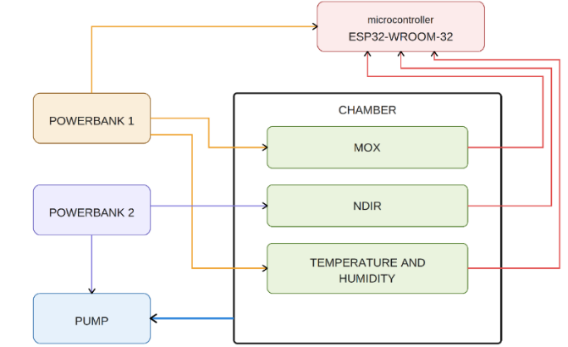
Figure 1. Functional diagram of the first version of Toolbox

Mobile app
A mobile application dedicated to the ESCAPE project was developed to support data acquisition during walkover campaigns, providing real-time visualisation of toolbox signals, GPS-tagged storage of measurements. The application communicates with the toolbox via Bluetooth Low Energy (BLE), acquiring MOX, NDIR, and thermo-hygrometric sensor values at 1 Hz together with GPS coordinates and timestamps, and storing them in JSON format compatible with the ESCAPE cloud platform. The system operates in offline mode, synchronising automatically once connectivity is restored. The interface is organised into three screens dedicated to the map, numerical readings, and real-time signal graphs from the chamber.

Laboratory calibration
Laboratory calibration was a fundamental step in assessing the behaviour of the sensors integrated into the toolbox, with the aim of evaluating their sensitivity, selectivity, repeatability, and the influence of humidity and other compounds on their response under controlled and reproducible conditions. Tests were performed on a dedicated test bench equipped with high-precision mass flow controllers (MFCs) (Alicat Scientific, Inc., Tucson, AZ, USA) enabling the generation of calibrated gas mixtures at known concentrations and humidity level (Helwig et al., 2014). Three types of tests were carried out. Air-only humidity tests were conducted by varying relative humidity from 10% to 80% RH in the absence of target gas, to quantify the influence of hygrometric changes on sensor response. Methane concentration tests were performed at controlled concentrations ranging from 1 ppm to 1000 ppm, both in step-up mode and as absolute steps, to evaluate the sensitivity, linearity, and repeatability of each sensor. Combined methane-interferent tests were carried out by introducing CO₂, ethanol, and acetone into the gas mixture alongside methane, at proportions representative of landfill gas, to assess the cross-sensitivity of the sensors to non-target gases. All tests were conducted repeatedly at different relative humidity.

Results of the lab calibration tests
Figure 2 shows the responses of the TGS2611-C00 (left) and TGS2611-E00 (right) sensors during one of the methane exposure tests. Both sensors show clear responses at all concentrations tested, with increasing signal amplitude as a function of the CH₄ concentration analysed. In each panel, the blue line represents the sensor's response while the orange line is the methane concentration set during the test. As expected, the TGS2611-C00 sensor shows faster response and recovery dynamics compared to the TGS2611-E00. It is worth highlighting that in laboratory conditions sensors responses are clearly visible already at 5 ppm of methane.
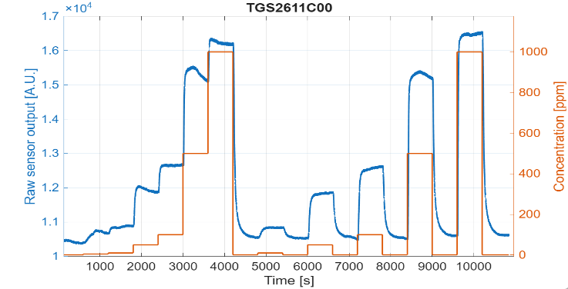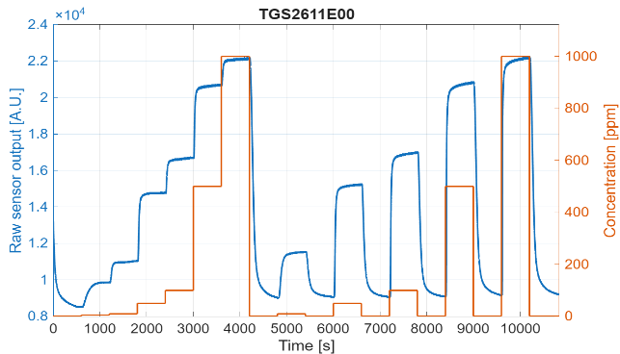
Figure 2: Response of the sensors TGS2611-C00 (on the left) and TGS2611-E00 (on the right) sensor to a methane test, the blue curves represent the sensor responses, while the orange curves show the target CH₄ concentration.
Figure 3 shows four tests performed at the same methane concentrations but at different relative humidity levels (20%, 40%, 60%, and 80%), comparing the response of the TGS2611-C00 (a) and TGS2611-E00 (b) sensors. The C-00 sensor, which does not integrate any internal filter, shows a clearly increasing baseline as humidity rises, highlighting the direct influence of hygrometric conditions on the response of the unfiltered MOX sensor. The E-00 sensor, equipped with an integrated activated carbon filter, shows an attenuated but still visible dependence of the baseline on humidity: the spacing between the curves at different RH levels is considerably reduced compared to the C-00, confirming that the internal filter partially mitigates the effect of water vapour on the signal without fully suppressing it.
a)
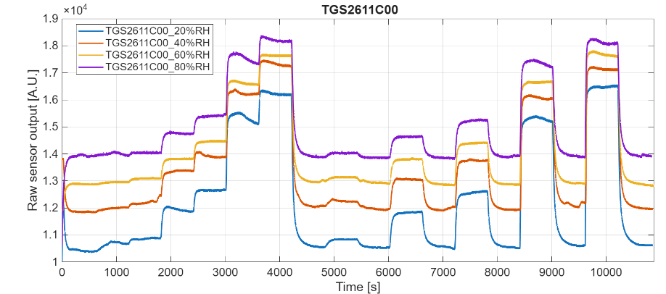
b)
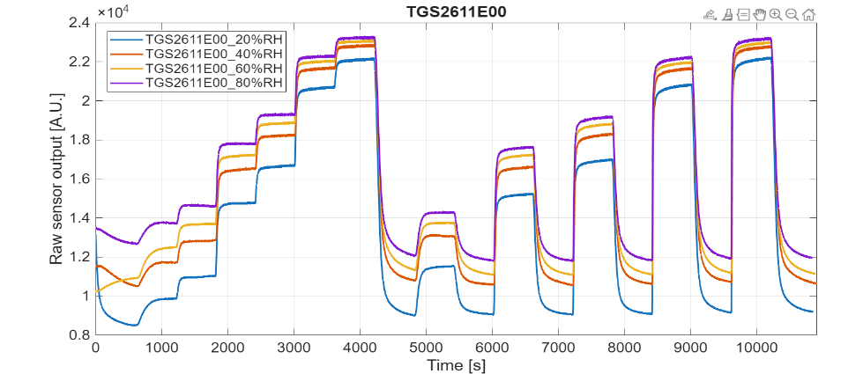
Figure 3 a-b. Comparison between tests performed at the same CH₄ concentrations under different humidity levels (20%, 40%, 60%, 80%). a) response of sensor TGS2611-C00 1; b): response of sensor TGS2611-E00
The comparison shown in Figure 4 refers to a combined test evaluating selectivity in the presence of a volatile organic compound (acetone): the TGS2611-E00 sensor, equipped with an integrated activated carbon filter, responds exclusively to changes in methane concentration, while the TGS2611-C00 sensor, which does not integrate any internal filter, shows a stepped pattern corresponding to variations in acetone concentration.

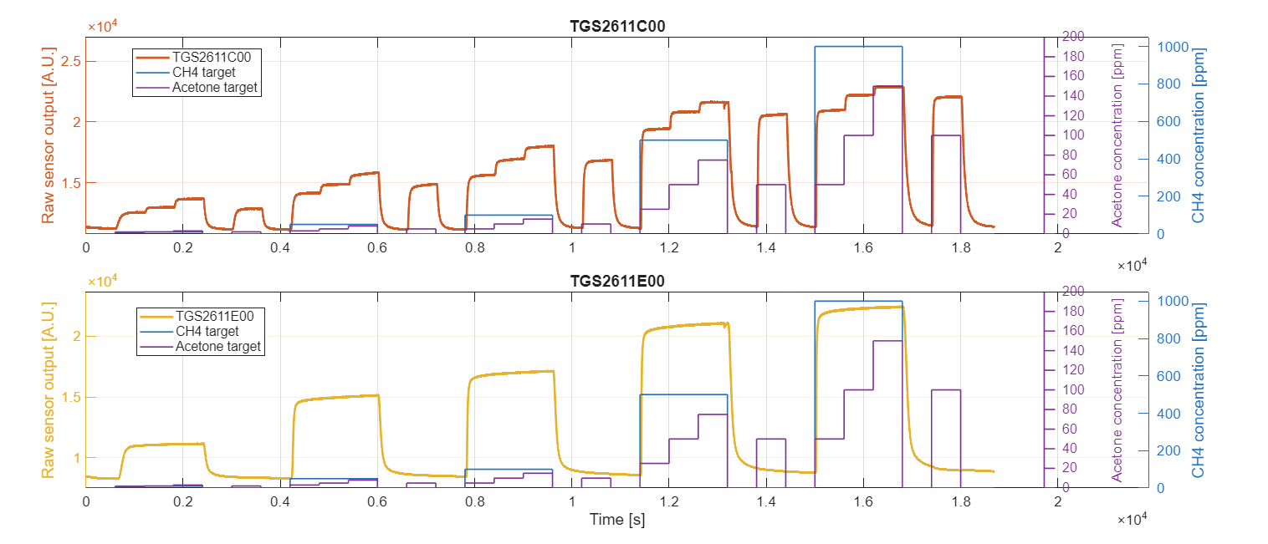
Figure 4. Response to a methane-acetone test with acetone concentration from blue line 1 ppm up to 150 ppm

Field test at the landfill site
The toolbox was tested in the field at an active landfill in Northern Italy (November 2025) to verify its functionality under real operating conditions and evaluate its ability to detect methane concentration variations along a walkover route. A portable FID (Flame Ionisation Detector) (Gas-Tec, Crowcon Detection Instruments Ltd, Abingdon, UK), which represents the reference instrument most widely used for CH₄ surface scanning surveys (Mønster et al., 2019), was carried simultaneously by the same operator, with the two instruments’ sampling inlets positioned in close proximity to each other in order to minimise any spatial or temporal offset between the two measurements. Figures 5 show the responses of the two TGS2611 sensors compared with the FID measurement.
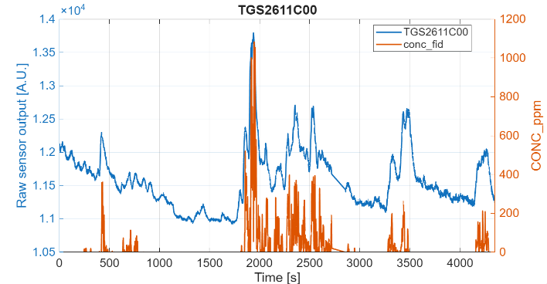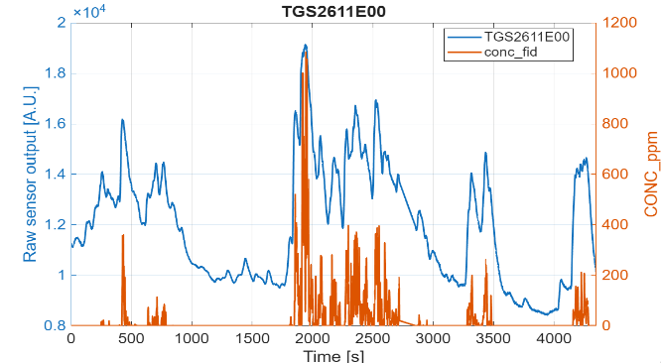
Figure 5. Sensor responses (blue line) compared with FID measurements (orange line) obtained during the field survey
Both sensors show qualitative consistency with the FID trend, correctly tracking the main concentration peaks.

Estimation of CH₄ Concentration using a Machine Learning Model
In parallel with the development of the toolbox, a machine learning model was implemented to estimate methane concentration from the signals acquired by toolbox. The chosen model, the Hist Gradient Boosting Regressor, was selected for its robustness in noisy datasets and its ability to capture the transient behaviour typical of MOX sensors (Ke et al., 2017). The model was trained on a mixed set of methane and interferent tests, while validation on separate files avoided temporal leakage. Figures 6 illustrate examples of the comparison between real and predicted concentrations during a methane-only test (left) and an interferent test (right) , respectively.
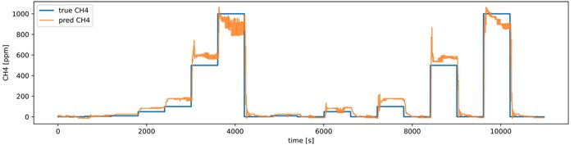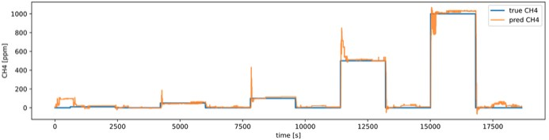
Figure 6. Comparison between real concentration and the value predicted by the model during a methane-only test (on the left) and an interferent test (on the right)
As a preliminary evaluation beyond laboratory conditions, the model was applied to the last 1500 samples of the field walkover, using the FID measurements as a reference. As shown in Figure 7, the model correctly identifies the main emission peaks, confirming a promising ability to generalise to real field data despite being trained exclusively on laboratory measurements.
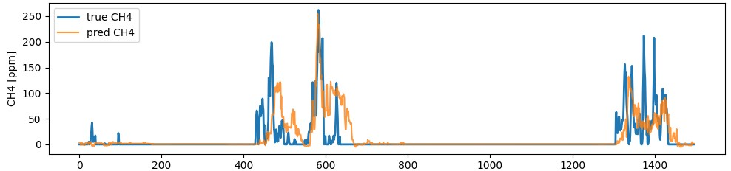
Figure 7. Comparison between true CH₄ concentration measured by the FID (blue line) and values predicted by the machine learning model (orange line)

Conclusion
The research and development activities carried out up to now made it possible to design, build, calibrate and preliminarily test a portable toolbox for monitoring landfill methane emissions, based on low-cost sensors and a modular configuration designed for simple, reliable and repeatable use.
Laboratory calibration confirmed good correlation between sensor resistance variations and CH₄ concentration, as well as the repeatability of the sensor response. In particular, the simultaneous integration of the TGS2611-C00 and TGS2611-E00 sensors within the same measuring chamber proved to be a key design choice, as it allows the complementary characteristics of the two versions of the same MOX sensor to be exploited within a single device. The C-00 version, which does not integrate any internal filter, is characterised by faster response and recovery dynamics, making it particularly effective in promptly detecting emissive hotspots during walkover surveys, where rapid concentration variations must be captured as the operator moves across the landfill surface. Its high reactivity makes it suitable for the identification and spatial localisation of fugitive emission sources, even when these are transient or highly localised. The E-00 version, on the other hand, although characterised by slower dynamics due to the integrated activated carbon filter, is considerably less influenced by environmental parameters such as humidity and is virtually insensitive to non-target gaseous compounds typically found in landfill air, such as volatile organic compounds. This makes the E-00 signal markedly more stable and selective, providing a reliable reference against which the C-00 response can be interpreted and, in perspective, corrected for environmental and cross-sensitivity effects.
The combined use of the two sensors therefore delivers a measurement system that is simultaneously reactive and robust, capable of balancing rapid detection with signal stability, and represents a promising low-cost alternative to more complex and expensive monitoring instruments. The field validation phase demonstrated full system functionality and good qualitative consistency with FID measurements, confirming the operational reliability of the toolbox under real environmental conditions. A preliminary machine learning model, trained on laboratory data and tested on field walkover data, further demonstrated the potential of the multi-sensor approach for quantitative CH₄ estimation.
Future developments shall include the expansion of the experimental dataset through new field campaigns under different environmental and seasonal conditions, the design of miniaturised versions suitable for integration into backpacks or robotic platforms, the production of additional toolbox units to assess the feasibility of serial manufacturing in terms of reproducibility and consistency of the sensor response across different devices, and the further validation and optimisation of machine learning models to improve concentration estimation accuracy and operational robustness.

References
Aghdam E.F., Scheutz C., Kjeldsen P., 2019, Impact of meteorological parameters on extracted landfill gas composition and flow, Waste Management, 87, 905–914.
Domènech-Gil G., Duc N.T., Wikner J.J., Eriksson J., Påledal S.N., Puglisi D., Bastviken D., 2023, Electronic nose for improved environmental methane monitoring, Environmental Science & Technology, 58, 1, 352– 361.
Dey A., 2018, Semiconductor metal oxide gas sensors: A review, Materials Science and Engineering B, 229, 206–217.
Helwig N., Schüler M., Bur C., Schütze A., Sauerwald T., 2014, Gas mixing apparatus for automated gas sensor characterization, Measurement Science and Technology, 25, 5.
Huang D., Du Y., Xu Q., Ko J.H., 2022, Quantification and control of gaseous emissions from solid waste landfill surfaces, Journal of Environmental Management, 302, 114001.
IPCC, 2013, Climate Change 2013: The Physical Science Basis. Contribution of Working Group I to the Fifth Assessment Report of the Intergovernmental Panel on Climate Change, Cambridge University Press, Cambridge.
Lotesoriere B.J., Invernizzi M., Panzitta A., Uvezzi G., Sozzi R., Sironi S., Capelli L., 2023, Micrometeorological methods for the indirect estimation of odorous emissions, Critical Reviews in Analytical Chemistry, 53, 7, 1531–1560.
Mønster J., Kjeldsen P., Scheutz C., 2019, Methodologies for measuring fugitive methane emissions from landfills – A review, Waste Management, 87, 835–859.
van den Bossche M., Rose N.T., De Wekker S.F.J., 2017, Potential of a low-cost gas sensor for atmospheric methane monitoring, Sensors and Actuators B: Chemical, 238, 501–509.
Vaverkova M.D., 2019, Landfill impacts on the environment – review, Geosciences, 9, 10, 431.
Villa V., Vernola D., Robbiani S., Lotesoriere B.J., Ratti C., Viscardi G., Roveri M., Dellacà R., Ponzani Y., Capelli L., 2024, The ESCAPE Project: Sensor Selection for the Development of a Portable System for Landfill Surface Emission Monitoring, Chemical Engineering Transactions, 112, 145–150.
Ke, G., Meng, Q., Finley, T., Wang, T., Chen, W., Ma, W., et al. (2017). Lightgbm: A highly efficient gradient boosting decision tree. Advances in neural information processing systems, 30.

