 CHEMICAL ENGINEERING TRANSACTIONS  VOL. xxx, 2026 | A publication of  
The Italian Association
of Chemical Engineering
Online at www.cetjournal.it

Guest Editors: Laura Capelli, Marzio Invernizzi, Selena Sironi
Copyright © 2026, AIDIC Servizi S.r.l.
ISBN 979-12-81206-xx-x; ISSN 2283-9216

Implementation of building downwash in the LAPMOD atmospheric dispersion model
Roberto Bellasio*, Roberto Bianconi
Enviroware srl, Via Dante Alighieri 142, Concorezzo (MB), Italy
rbellasio@enviroware.com
Since odour pollution is typically a short-range problem, it is important to simulate as precisely as possible the fate of the pollutant close to the release points. This means that specific effects such as stack orientation, presence of rain cap, and building downwash must be considered. Aim of this paper is to describe the implementation of a building downwash algorithm into the Lagrangian particle model LAPMOD. A literature review that guided to the choice of a specific algorithm is initially briefly described. Then the implementation of the building downwash algorithm into the model is described. The results of the sensitivity analysis carried out with and without the building, with the source at different distances, show that the model behaves as expected, predicting high concentrations close to the building. A comparison with the results of CALPUFF, implementing the PRIME algorithm for building downwash, for a simple situation shows that this model predicts very high concentrations with respect to LAPMOD. Also, CALPUFF predicts constant concentrations over the building and at short downwind distances from it.
  - Introduction
Odor pollution causes nuisance and adverse effects on human health (Mckittrick et al., 2025). For this reason the odour complaints received by regulatory agencies are continuously increasing.
Odour pollution is typically a short-range problem; it is therefore important to simulate as precisely as possible the fate of the pollutant close to the release points. Buildings and any structure opaque to the wind alter the atmospheric flow, then, if pollutant masses move within that altered flow region, the atmospheric dispersion of the pollutant can be very different from that without obstacles. Plumes moving into the altered flow region may be rapidly brought to the ground causing high concentration levels. Therefore, this effect, known as building downwash, must be simulated by odour dispersion models.
A literature review has been performed to understand pros and cons of the different methods available for implementing building downwash. The empirical relations obtained from wind tunnel experiments and implemented in the PRIME2 algorithm have been selected (Petersen and Guerra, 2018). The PRIME2 equations have been preferred to the PRIME (Schulman et al., 2000) equations because the latter may cause overpredictions for certain building configurations.
The results of new wind tunnel studies were used by Petersen and Guerra (2018) to prepare a database of wind speed and turbulence intensity measurements downwind of various rectangular and streamlined (e.g., tanks) structures. A set of equations was then derived to estimate velocity deficit and turbulence intensity enhancement in the building wake.
Building downwash as implemented in LAPMOD (Enviroware, 2026) does not act only on particles in plume rise phase, but on all the particles moving in the buildings’ wake, including those emitted by non-point sources. This development requested a huge effort in coding, debugging, testing and validating the new version of LAPMOD. The results of the sensitivity analysis show that LAPMOD correctly predicts the concentration increase downwind of an isolated building.
  - Choice of the building downwash scheme
A literature review has been conducted to decide what building downwash algorithm implement into LAPMOD. The choice was essentially between PRIME (Schulman et al., 2000) and PRIME2 (Petersen and Guerra, 2018). The primary differences between these two schemes involve significant updates to the physical formulations of building wake development and plume interactions, which lead to better model performance in predicting air quality concentrations. PRIME2 was developed to correct theoretical flaws in the original PRIME algorithm, which is currently the regulatory default in AERMOD (US-EPA, 2024).
The main differences between PRIME and PRIME2 are summarised here:
- Vertical turbulence and velocity decay: In the original PRIME model, turbulence enhancement and velocity deficits are assumed to be constant from the ground up to the height of the wake (Schulman et al., 2000). PRIME2 improves this by having enhanced turbulence and velocity deficits rapidly decay back to ambient levels above the top of the building, which is consistent with recent wind tunnel and CFD observations (Petersen et al., 2022).
- Structure types: PRIME assumes all structures are solid rectangular blocks. PRIME2 introduces equations specifically for streamlined structures, such as natural draft cooling towers (NDCT) and tanks, which exhibit smaller wakes and lower velocity deficits than rectangular solids (Petersen and Guerra, 2018).
- Lateral vs. vertical turbulence: In PRIME, lateral and vertical turbulence intensities in the wake are nearly identical. PRIME2 recognizes that lateral turbulence intensity increase is generally less than vertical intensity increase.
- Roughness dependency: PRIME2 equations account for approach roughness, showing that turbulence intensity increase in the wake decreases as surface roughness increases. While the original PRIME equations technically include roughness, they lacked observational support and did not agree as well with wind tunnel data.
For these theoretical reasons and for the better performances shown by PRIME2 implemented in AERMOD with respect to PRIME (Petersen et al., 2022), the algorithms described in (Petersen and Guerra, 2018) have been coded in LAPMOD. It is noticed that it is not correct to state that LAPMOD implements PRIME2 because this scheme is a modification of the plume rise algorithm PRIME (Schulman et al., 2000), while the plume rise algorithms of LAPMOD are those described by Janicke and Janicke (2001) and Webster and Thomson (2002).
  - Implementation of building downwash in LAPMOD
When the atmospheric flow encounters an obstacle (a building or any other structure opaque to the wind), two regions are determined downwind of it (Schulman et al., 2000). The cavity, or near wake, is the region bounded above the roof by the separation streamline originating at the upwind roof edge, and bounded downwind of the building by the reattachment streamline. Laterally, the cavity is bounded by the streamlines separating from the corners. The region beyond the cavity where the flow is still perturbed by the presence of the obstacle is called far wake. Sometimes cavity and far wake are considered together and simply named as wake. However, the two regions are characterized by different properties. The cavity is a region of airflow that is often characterized by turbulent or recirculating air and low velocity compared to the free-stream wind. This occurs when the flow around a building creates a low-pressure zone behind or near the structure, which can result in a kind of "pocket" of swirling air. The far wake is larger and extends farther downwind than the cavity, the flow velocity is lower compared to the free-stream wind and the turbulence increases, but with larger scale turbulent mixing with respect to the cavity.
Empirical relations have been defined to calculate the vertical and lateral extents of cavity and far wake (Schulman et al., 2000). Considering a building of height (H), projected building width across the flow (W), and projected building length along the flow (L), the length scale R is defined as (Wilson, 1979):
$$R= B_{S}^{\frac{2}{3}} B_{L}^{\frac{1}{3}}$$ | (1)
where B_{S} = min(H,W) and B_{L} = max(H,W). The length scale is a fundamental variable, for example for determining if the rooftop cavity reattaches to the building or not, and to estimate the termination of the far wake. Indeed, the far wake extends to a maximum distance of 15R from the downwind face of the building. According to the PRIME theory (Schulman et al., 2000), this distance is considered the point where turbulence intensity generally returns to ambient levels, though a cap is applied to prevent unreasonably long decay distances in very stable conditions. On the other hand, according to the PRIME2 theory (Petersen and Guerra, 2018), turbulence returns to the ambient level at distances depending on the type of obstacle: For rectangular obstacles the normalised downwind distance is x/H=16, while for streamlined obstacles it is x/H=2.1. However, many factors influence the termination distance of the building downwash effect, for example, areas with relatively high surface roughness cause the building-induced turbulence to decay more rapidly, then shortening the wake length.
LAPMOD has been modified to read the geometrical properties of the structures, including streamlined ones, as tanks or NDCT (natural draft cooling towers). Then, the regions defining cavities and far wakes have been calculated. When a computational particle is within these regions, the velocity deficit and turbulence intensity enhancement are calculated as described in Petersen and Guerra (2018) depending on the downwind distance of the particle from the building.
There are some peculiarities with the implementation of the Petersen and Guerra (2018) downwash algorithm in LAPMOD. The downwash algorithm acts on all the particles traveling in the building wake, not only to those in the plume rise phase. This is reasonable because a building alters the atmospheric flow for all the particles, not only for those in plume rise phase. As a consequence of the previous point, the building downwash acts on particles emitted by any type of source (e.g., area, volume), not necessarily point sources. Finally, there is no need to use BPIP/BPIPPRM (US-EPA, 1995) for preparing the variables needed by the building downwash algorithm (building geometry is directly read by LAPMOD).
  - Sensitivity analysis
Sensitivity analysis tests have been carried out to verify if LAPMOD behaves as expected from a theoretical point of view. In a first test, a single building has been considered and a stack has been placed at different positions, upwind and downwind with respect to the building. Simulations have been done considering different stack heights, and also removing the building to evaluate the GLCs without building downwash.
Figure 1 shows the four different positions of the stack with respect to the building; they are placed at X=-1m (E1), X=21 m (E2), X=50 m (E3) and X=75m (E4). The building size is W×L×H=20×20×10 (each size in meters).
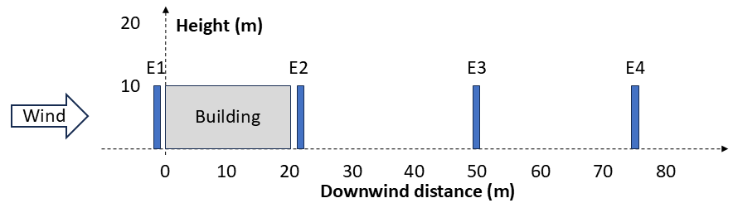
Figure 1: Schematic representation of the four positions of the stack with respect to the building.
Considering a wind perpendicular to the building, the resulting cavity (blue) and wake (red) are represented in Figure 2. The upper part (Figure 2a) is a view from side that shows the height of the perturbed volume, while the lower part (Figure 2b) is a view from top that shows the enlargement of the perturbated volume (only a half of it, the other half is symmetrical). The length scale R is 12.6 m, and the cavity reattaches to the building top, as shown in Figure 2a. The recirculation cavity length is 19.8 m. The building wake terminates at 189 m from the downwind face of the building.
Figure 3 shows the normalized concentration (i.e., concentration divided by the emission rate) at different distances due to the emissions of the stack at the four positions. Concentrations have been calculated both considering the presence and absence of the building. The wind speed is 3.1 m/s, the stack height is 10 m, the stack diameter is 0.4 m, the emission temperature is 30°C and the emission velocity is 3 m/s. When the stack is very close to the building, upwind (Figure 3a) or downwind (Figure 3b) of it, the maximum concentration predicted with the building downwash effect (orange line) is higher – more than double – with respect to the concentration due to the same emissions without the building (blue line). Moreover, the peak concentration is predicted very close to the source. On the contrary, when the source is within the wake but far from the building - and from the cavity – the peak concentration predicted with the building downwash effect is still predicted before than the maximum concentration of the case without building downwash, but the value of the maximum concentration is similar (Figure 3c and Figure 3d). It is also observed that the downwind distance between the peak concentration with and without building downwash decreases as the distance between the stack and the building increases. This happens because the velocity deficit and turbulence intensity enhancement decrease moving away from the building within the wake.
A comparison has been carried out between the results of LAPMOD and CALPUFF (Scire et al., 2000). Figure 4 shows the normalized concentration predicted by LAPMOD (Figure 4a) and CALPUFF (Figure 4b) – which uses PRIME - for source E1 in three different scenarios: without a building, with a building of size (m) W×L×H=20×20×10 (B1), and with a building of size (m) W×L×H=40×20×10 (B2). The wind is orthogonal to W with a speed of 1.8 m/s. Even without any buildings, the concentrations are different: the maximum predicted by CALPUFF is about 37% higher than the one predicted by LAPMOD, and is 5 m closer to the source.
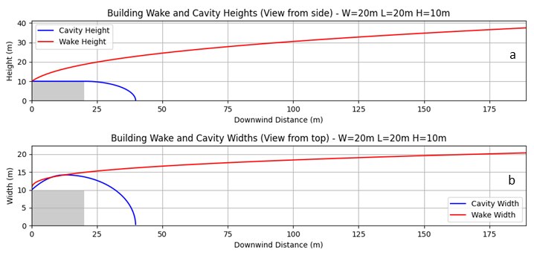
Figure 2: Cavity and wake generated by a building with W=20m, L=20m, H=10m.
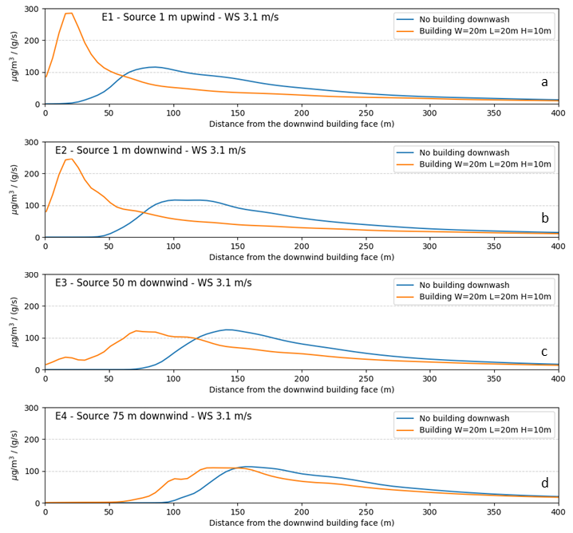
Figure 3: Normalized concentration trend for the four stack positions, with and without the building.
When building downwash is considered, the differences are more pronounced. When building B1 is considered, the maximum concentration predicted by CALPUFF is more than double the one predicted by LAPMOD. It is also noted that CALPUFF predicts constant concentrations within the wake region close to the building, due to the PRIME's assumption that the plume mass is recirculated and vertically mixed within the near-wake cavity. Indeed, PRIME assumes that a fraction of the plume mass is captured within the near wake (recirculation cavity) and fully mixed through its height and a representative width scale (Schulman et al., 2000), resulting in a constant concentration value within this volume. The mass captured in this region is treated as a uniform volume that is eventually re-emitted to the far wake as a ground-level source. This simplifies the complex, non-uniform concentrations observed in real-world wind tunnel tests into a single average value for the near-wake area.
While this assumption leads to a constant concentration profile over or immediately behind the building in the model, recent research has identified this as a theoretical flaw. Wind tunnel observations show that, in reality, concentrations within the cavity are not uniform and that turbulence enhancement decays rapidly above the building height rather than staying constant up to the wake boundary (Petersen and Guerra, 2018).
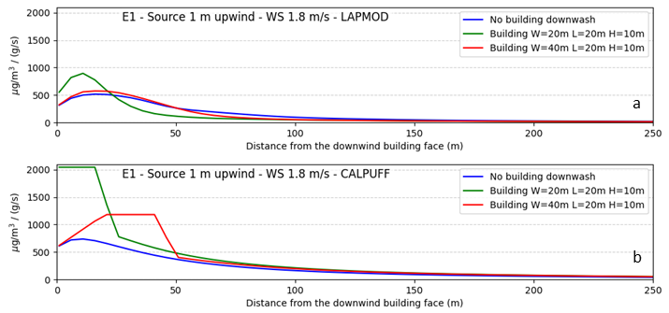
Figure 4: Normalized concentration trend of CALPUFF and LAPMOD for an upwind stack and two different buildings.
  - Validation
The next step will be the validation of LAPMOD against experimental data collected in situations where the building downwash effect plays a role. Some useful datasets, already used by other researchers (Petersen et al., 2022) with the same aim have been identified:
- Alaska North Slope Database (Guenther et al., 1989). It consists of 44 hours of buoyant SF₆ releases from a 39-meter high turbine stack. It includes on-site meteorological data collected during daylight hours over a snow-covered tundra surface.
- Bowline Point Power Plant Database (Schulman and Hanna, 1986). It covers the full year 1981 of hourly data for a moderately buoyant source. Two monitors located at about 400 m and 850 m downwind from the building are mainly affected by downwash.
- Balko, Oklahoma Natural Gas Compressor Station Database (Panek et al., 2020). It spans 13 months of monitoring (Dec 2015 through Dec 2016) of NO_{X} recorded at four locations, along with hourly on-site meteorological data. Other pollutants are also measured, but they are not useful for building downwash validation.
  - Conclusions
This paper describes the implementation of the building downwash scheme described by Petersen and Guerra (2018) in the Lagrangian particle model LAPMOD. The implementation of the new algorithms in the open source Lagrangian particle model LAPMOD has been challenging. It requested functions for reading the geometrical properties of rectangular and streamlined structures, functions for calculating the lateral and vertical extension of cavities and wakes and to determine if a specific particle is inside or outside them, and functions for calculating the velocity deficit and turbulence enhancement for particles affected by building downwash. The results of the sensitivity analysis performed to evaluate the correct implementation of the algorithms show reasonable results, with high concentrations downwind to the building that decrease as the source is moved away from the building. Comparisons with CALPUFF show that this model predicts concentrations higher than LAPMOD in the building wake. Moreover, due to the PRIME algorithm, the CALPUFF concentration within the cavity is constant. Thus, this new scheme by Petersen and Guerra (2018) seems to be more realistic than the PRIME scheme described by Schulman et al (2000) and adopted by AERMOD and CALPUFF. The next step to understand and perhaps improve the building downwash algorithm in LAPMOD will be its validation against experimental data.
References
Enviroware, 2026, The LAPMOD system < https://www.enviroware.com/lapmod/> accessed 07.04.2026.
Janicke U., Janicke L., 2001, A three-dimensional plume rise model for dry and wet plumes. Atmospheric Environment, Vol. 35, N. 5, 887-890. https://doi.org/10.1016/S1352-2310(00)00372-1
Guenther A., Lamb B., Allwine E., 1989, Building wake dispersion at an Arctic industrial site: Field tracer observations and plume model evaluations. Atmospheric Environment 24A:2329–47. https://doi.org/10.1016/0960-1686(90)90326-I
Mckittrick J., Hadgraft N., Fry K.L., Mikkonen A.T., Mavoa S., 2025, Industrial Odour and Psychosocial Wellbeing: A Systematic Review. Environments, 12(10), 364. https://doi.org/10.3390/environments12100364
Panek J.A., McCarthy J.M., Huth A.Z., Nowak C., 2020, PRCI ambient NO₂ AERMOD performance assessment and model improvement project: Modeled to observed comparison. J. Air Waste Manage. Assoc. 70 (5):504–21. https://doi.org/10.1080/10962247.2020.1743382.
Petersen R.L., Guerra S.A., Bova A.S., 2017, Critical review of the building downwash algorithms in AERMOD. Journal of the Air & Waste Management Association, 67(8), 826–835. https://doi.org/10.1080/10962247.2017.1279088
Petersen R.L., Guerra S.A., 2018, PRIME2: Development and evaluation of improved building downwash algorithms for rectangular and streamlined structures. Journal of Wind Engineering and Industrial Aerodynamics, 173, 67–78. https://doi.org/10.1016/j.jweia.2017.11.027
Petersen R.L., Paumier J.O., Guerra S.A., 2022, Development, evaluation, and implementation of building downwash and plume rise enhancements in AERMOD. Journal of the Air & Waste Management Association, 72(12), 1423–1441. https://doi.org/10.1080/10962247.2022.2120563
Schulman L.L., Hanna S.R., 1986, Evaluation of downwash modifications to the industrial source complex model. J. Air Pollut. Control Assoc. 36 (3):258–64. https://doi.org/10.1080/00022470.1986.10466066
Schulman L.L., Strimaitis D.G., Scire J.S., 2000, Development and Evaluation of the PRIME Plume Rise and Building Downwash Model. Journal of the Air & Waste Management Association, 50(3), 378–390. https://doi.org/10.1080/10473289.2000.10464017
Scire J.S., Strimaitis D.G., Yamartino R.J., 2000, A User’s Guide for the CALPUFF Dispersion Model (Version 5); Earth Tech. Inc.: Concord, MA, USA.
US-EPA, 1995, User’s guide to the building profile input program, EPA-454/R-93-008, Revised February 1995. <https://gaftp.epa.gov/Air/aqmg/SCRAM/models/related/bpip/bpipd.pdf> accessed 03.04.2026.
US-EPA, 2024, AERMOD implementation guide, EPA-454/B-24-009, November 2024. <https://gaftp.epa.gov/Air/aqmg/SCRAM/models/preferred/aermod/aermod_implementation_guide.pdf> accessed 07.04.2026.
Webster H.N., Thomson D.J., 2002, Validation of a Lagrangian model plume rise scheme using the Kincaid data set. Atmospheric Environment, Vol. 36, N. 32, pp. 5031-5042. https://doi.org/10.1016/S1352-2310(02)00559-9
Wilson D.J., 1979, Flow patterns over flat-roofed buildings and application to exhaust stack design. ASHRAE Transactions 85(2):284–295

