 CHEMICAL ENGINEERING TRANSACTIONS  VOL. xxx, 2026 | A publication of  
The Italian Association
of Chemical Engineering
Online at www.cetjournal.it

Guest Editors: Laura Capelli, Marzio Invernizzi, Selena Sironi
Copyright © 2026, AIDIC Servizi S.r.l.
ISBN 979-12-81206-xx-x; ISSN 2283-9216

Challenge of monitoring sulphur compounds at low concentration: experimental application of a UV detector
Elisa Polvaraª, Francesca Brogliaª, Marzio Invernizzi^{a,}*, Selena Sironiª
ª Department of Chemistry, Materials and Chemical Engineering “Giulio Natta”, Politecnico di Milano, Milano, Italy
marzio.invernizzi@polimi.it
Volatile sulphur compounds (VOSCs) and hydrogen sulphide are key contributors to odour emissions and represent a significant challenge for accurate odour monitoring due to their low odour thresholds and the potential analytical interferences. This study evaluates the performance of HORIBA APSA-370 designed for the detection of sulphur species thanks to two conversion units for specific detection and quantification of H₂S and Total Reduced Sulphur (TRS). From the obtained results, the instrument demonstrated good selectivity and reliability for SO₂ measurements in the simpler configuration (detector UV for SO₂), with no significant interference observed from tested sulphur-containing and aromatic compounds. In contrast, the internal H₂S conversion unit showed limited selectivity, with substantial signal interference from other sulphur species even if present at low concentrations, limiting its applicability for specific H₂S quantification. The TRS conversion unit, however, provided robust and accurate oxidation of sulphur compounds across a concentration range of 5–1000 ppb, yielding consistent results for both simple and complex sample matrices. These findings highlight the limitations associated with selective H₂S monitoring in the presence of mixed VOSCs, while showing promising perspectives for broader sulphur compound analysis in odour-related applications.
  - Introduction
Odorous emissions constitute a relevant environmental issue in numerous industrial activities. Between the molecules responsible of odour harassment, volatile organic sulphur compounds (VOSCs) and hydrogen sulphide (H₂S) are widely recognized as key contributors to odour annoyance due to their extremely low odour thresholds (ppb range) and their ubiquitous presence in industrial emissions (Czarnota et al., 2023; Gostelow et al., 2001; Ma et al., 2024). Consequently, their effective and reliable monitoring is a central requirement in odour assessment and management strategies (Polvara et al., 2024). Despite their well-known potential, the analytical detection and quantification of these compounds is inherently complex, owing to a convergence of analytical, physicochemical, and environmental challenges (Pandey et al., 2012).Three principal obstacles recur: the trace-level concentrations at which these compounds are relevant for odour perception; the limited selectivity of commonly employed sensing technologies; and the wide range of chemical and physical interferences affecting measurement reliability under real-world conditions. These challenges are particularly acute in the context of continuous ambient monitoring, which is increasingly recognised as a necessary tool for effective odour management. Focusing on the specificity of detection of H₂S, most widely used field-deployable instruments - electrochemical sensors - operate via redox reactions at an electrode surface, generating a current proportional to the concentration of the target gas. However, this principle of operation renders them susceptible to cross-sensitivity: this effect occurs when other gases also react with the electrode surface and produce a current that interferes with the target gas signal, with the degree of interference dependent on electrode material, operating temperature, humidity, and sensor age (Huszal et al., 2021; Khan et al., 2019). Gas chromatography coupled with sulphur-selective detectors offers the high specificity and sensitivity needed to resolve individual VOSCs, but is costly, complex and require specialised personnel and rigorous periodic calibrations. All these aspects make this approach impractical for continuous field monitoring (Pandey and Kim, 2009). A possible solution, which has not yet been widely adopted in the context of odour emissions, is the implementation of UV fluorescence instruments coupled with specific catalysers. This technology represents a potentially valuable alternative for the continuous monitoring of H₂S and sulphur compounds, combining high sensitivity with a selective detection principle. For these reasons, these instruments have been employed in previous odour monitoring campaigns for H₂S measurement (Constantin et al., 2025; Oliva et al., 2024; Traven et al., 2024). However, their performance, especially in relation to interference effects in complex odorous matrices, remains an area of ongoing investigation. For these reasons, the present study aims to evaluate the applicability of the UV fluorescence instrument (Horiba APSA-370 with internal H2S Converter and TRS Converter) for monitoring sulphur compounds at low concentration, assessing the system’s performance in terms of low-level detection (LDL) capability, repeatability, and H2S selectivity in the presence of sulphur compounds and other potential interferents.
  - Materials and methods
    - APSA-370 + internal H2S Converter + TRS Converter
The APSA 370 (Horiba, Japan) is an UV fluorescent analyser to measure the sulphur dioxide (SO₂) in ambient air. During the measurement, the gas sample is irradiated by a UV (Xe) lamp, which causes the SO₂ molecules to vibrate; the UV light emitted as the molecules relax is proportional to the concentration of SO₂ in the sample. Due to the potential interference of aromatic hydrocarbons, the instrument is equipped with a HC cutter to reduce these interferences. The SO₂ concentration range is 0-0.5 ppm, with a possible extension range 0-10 ppm. The declared lowest detection limit (LDL) is 0.5 ppb. For measuring VOSCs and H₂S, the instrument is equipped with two different converters. The H₂S converter unit is equipped with two different catalysers - the first one removes SO_{X} from the sample and a second converts H₂S into SO₂. The oxidation temperature is equal to 300 °C and the declared efficiency is ≥ 95%. For measuring the VOSCs, a TRS (Total Reduced Sulphur) unit is installed upstream of the UV detector. It can oxidise sulphur compounds to SO₂ by utilising the effect of temperature in an oxidising environment (i.e. atmospheric oxygen) downstream of a scrubber unit that removes environmental SO₂. The oxidation temperature of TRS unit is 950 °C and its declared efficiency is ≥ 90%.
    - Samples preparation
Both standard gasses and real samples have been employed to verify the instrument performance. All experiments were performed by directly analysing gas samples collected in NalophanTM bags. Firstly, test with calibration gases were performed. At this stage, the molecules used in the tests were selected to testing their affinity with the detector and the potential interferences with the detector and the catalysers/cutters. The investigated molecules are: H₂S, methanethiol (MeSH), dimethyl sulphide (DMS), dimethyl trisulphide (DMTS), tetrahydrothiophene (THT), benzene, toluene. In addition, mix of these gases were prepared: toluene + H₂S, toluene + MeSH, H₂S + MeSH. Certified gas mixtures (SIAD S.p.A. and SAPIO S.r.l., Italy) were employed as primary standards. To obtain target concentrations within the instrument’s working range, a laboratory dilutor (EPD sample pre-dilution device, Olfasense GmbH, Germany) was used during bag filling before subsequent analysis. Analyses were carried out by directly connecting the analyser inlet for the measurement of SO2, H2S, and TRS concentrations. Real samples from MSW plant - collected according to EN 13725:2022 - were analysed to evaluate the instrument’s performance with complex real-world mixtures. The samples’ sulphur content was independently determined by GC-PFPD analysis (Massimi et al., 2024) and compared with the APSA response. To conduct the tests, the samples, collected at the emission sources, were diluted by factors of 10 and 100 using laboratory dilutor to match the APSA 370 operative range.
  - Results
    - Determination of SO₂: study of the potential interferences of APSA 370
In its preliminary configuration, APSA 370 can quantify the concentration of SO₂ reached the UV detector, crossing the HC cutter. Figure 1 shows the SO₂ concentration measured during the analysis of the different standard gases (single compounds and mixtures). Observing the data, the measured SO₂ concentration is generally negligible (≤LDL, with an estimated interference equal to 0.1%) for all the tested compounds/mix, except for DMS at 10 ppm and toluene at 170 and 17 ppm. Indeed, a significant interference response is seen in these latter cases, as reported in Figure 1A (green points). However, these values lie more than one order of magnitude above the upper limit of the manufacturer-declared linearity range, indicating that they fall outside the instrument’s reliable quantitative regime.
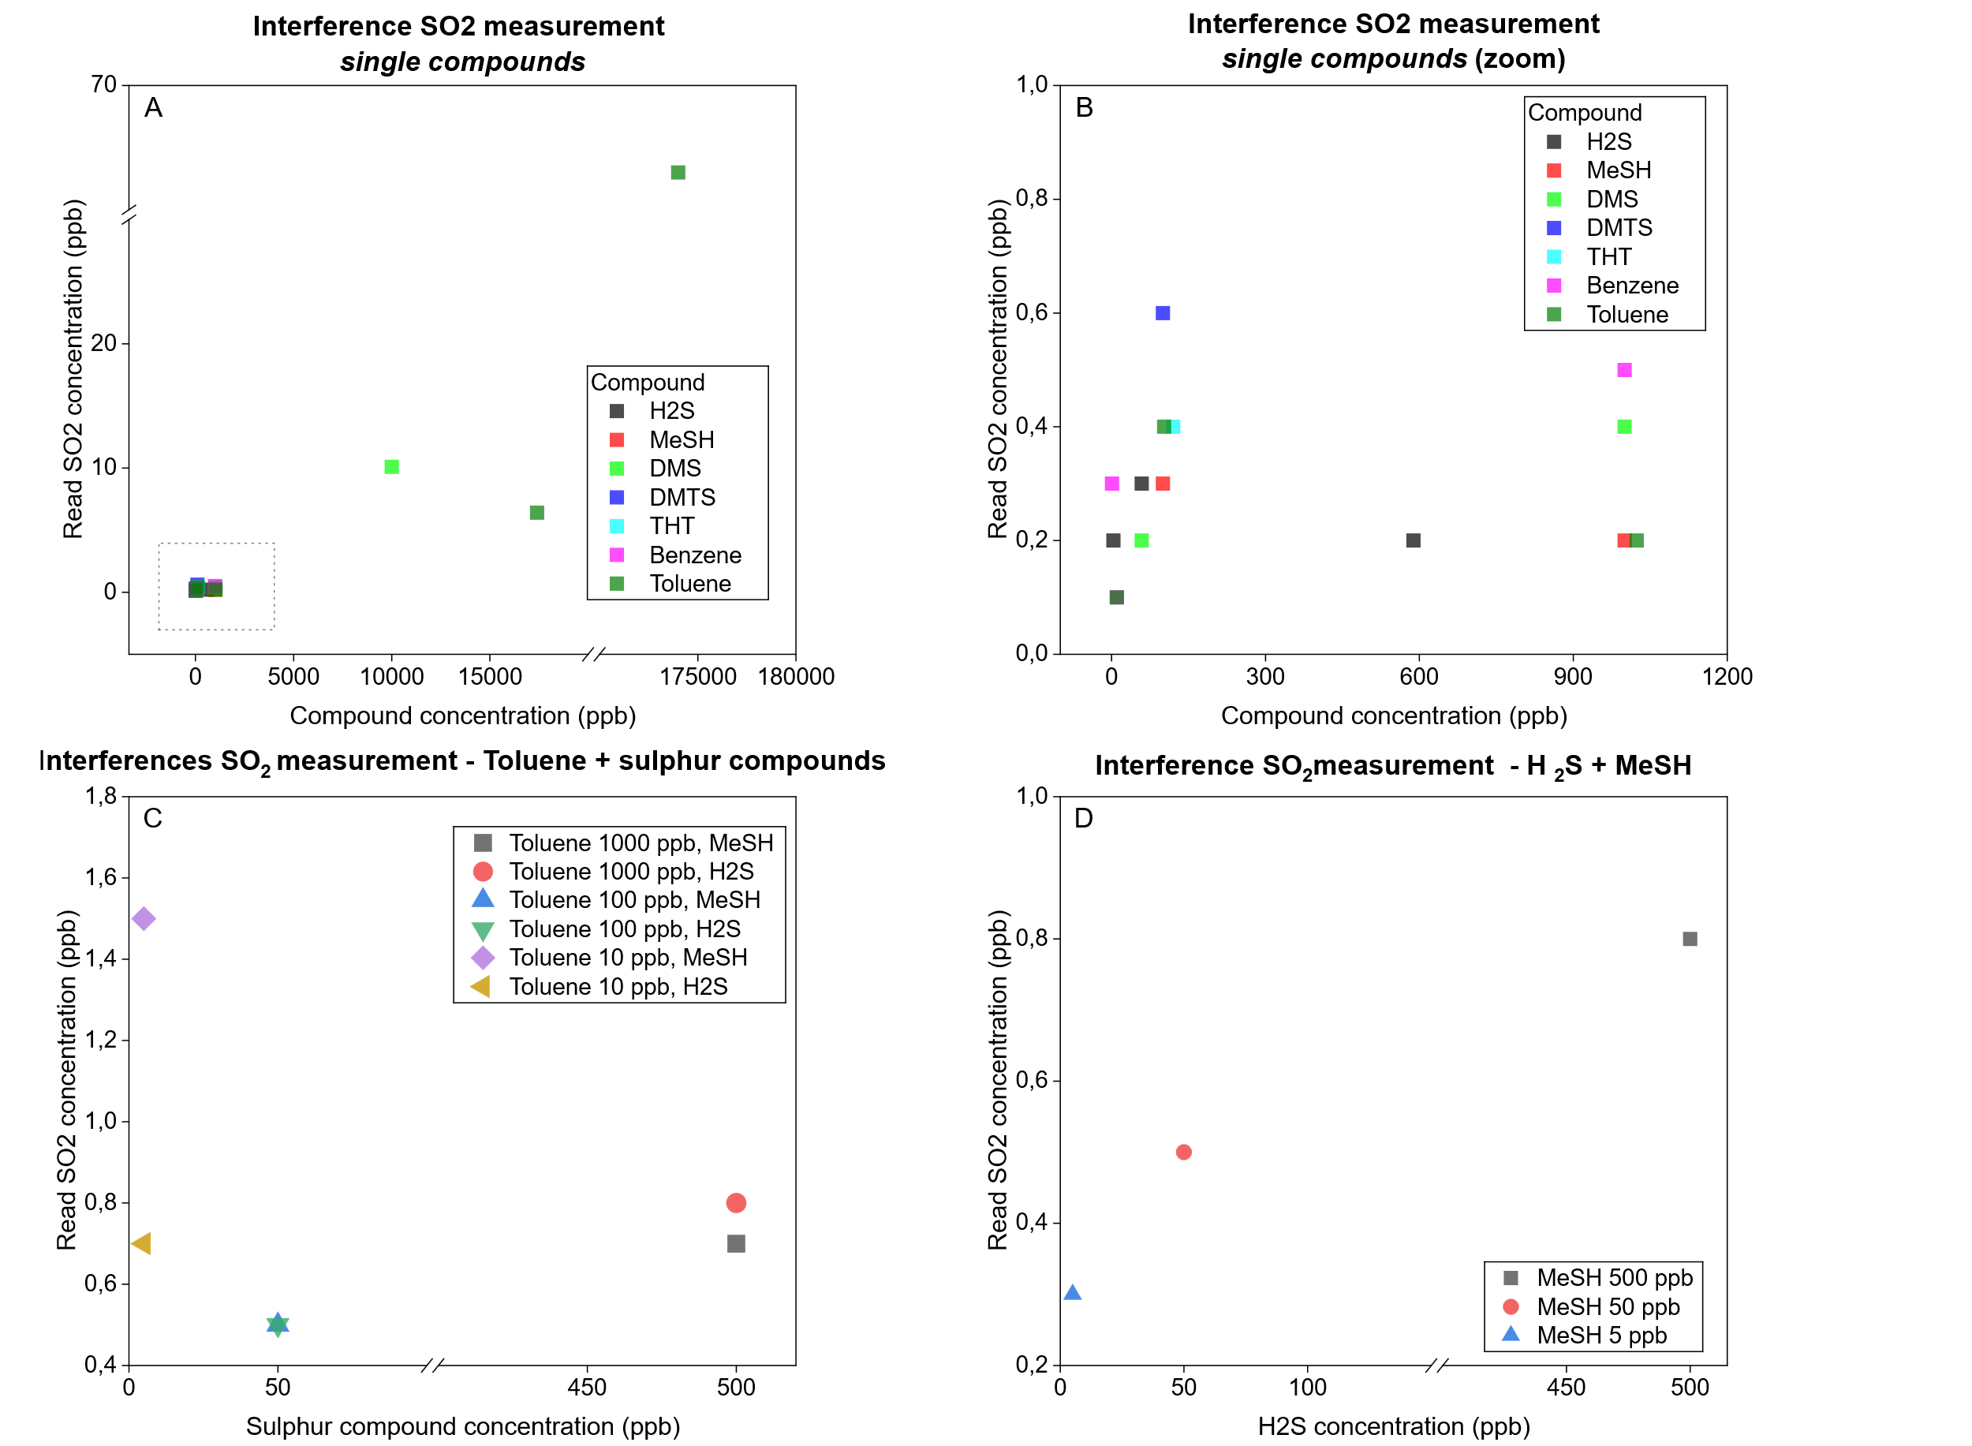
Figure 1: SO₂ concentration measured using APSA 370 for interference check: (A) and (B) individual compounds; (C) mix toluene and sulphur compound (H₂S or MeSH); (D) mix sulphur compounds (H₂S + MeSH)
    - Determination of H₂S: study of the potential interferences of H₂S converter unit
By coupling the APSA 370 with the H₂S converter unit, it could be possible to quantify specifically H₂S present in ambient air. The comparative analysis is reported for H₂S interferences study in Figure 2. A significant discrepancy can be observed between the data obtained and the findings of the SO₂ analysis, in particular in terms of interferences. Discussing the quantification of H₂S, the converter can be considered accurate (error <5%) if only H₂S is present. However, if the sample contains other reduced sulphur compounds, either on their own or mixed with H₂S, significant interference is observed in the instrument’s reading. This could indicate that the cutter is not completely selective for H₂S. Significant interference was observed for MeSH, which is generally detected with H₂S (with an oxidation efficiency greater than 70%). In the case of DMTS, a higher concentration of H₂S is detected than the nominal concentration, confirming that for every S atom, a new oxidized SO₂ molecule is generated. Discussing the hydrocarbon interferences, once more, a substantial interference is discernible at elevated concentrations of toluene (170 and 17 ppm). However, these interferences largely exceed the linearity range specified by the manufacturer. Another significant observation pertains to the negative interference in H₂S reading caused by the presence of hydrocarbons (toluene) in the mixture. As illustrated in Figure 2C, H₂S in the mixture is detected at a lower concentration than expected, with a conversion efficiency of approximately 75%, contrasting with the observations made for H₂S alone.
    - Determination of VSOCs: study of the potential interferences of TRS converter unit
By coupling the APSA 370 with the TRS converter unit, it is possible to quantify reduced species of Sulphur, expressed as Total Reduced Sulphur, present in ambient air. The performance analysis of this configuration is reported in Figure 3. The TRS concentrations for the different sulphur species are obtained by converted the concentration (in ppb) of the single species in concentration of SO₂ derived from the oxidation process. This value was compared to the SO₂ read by the instrument.

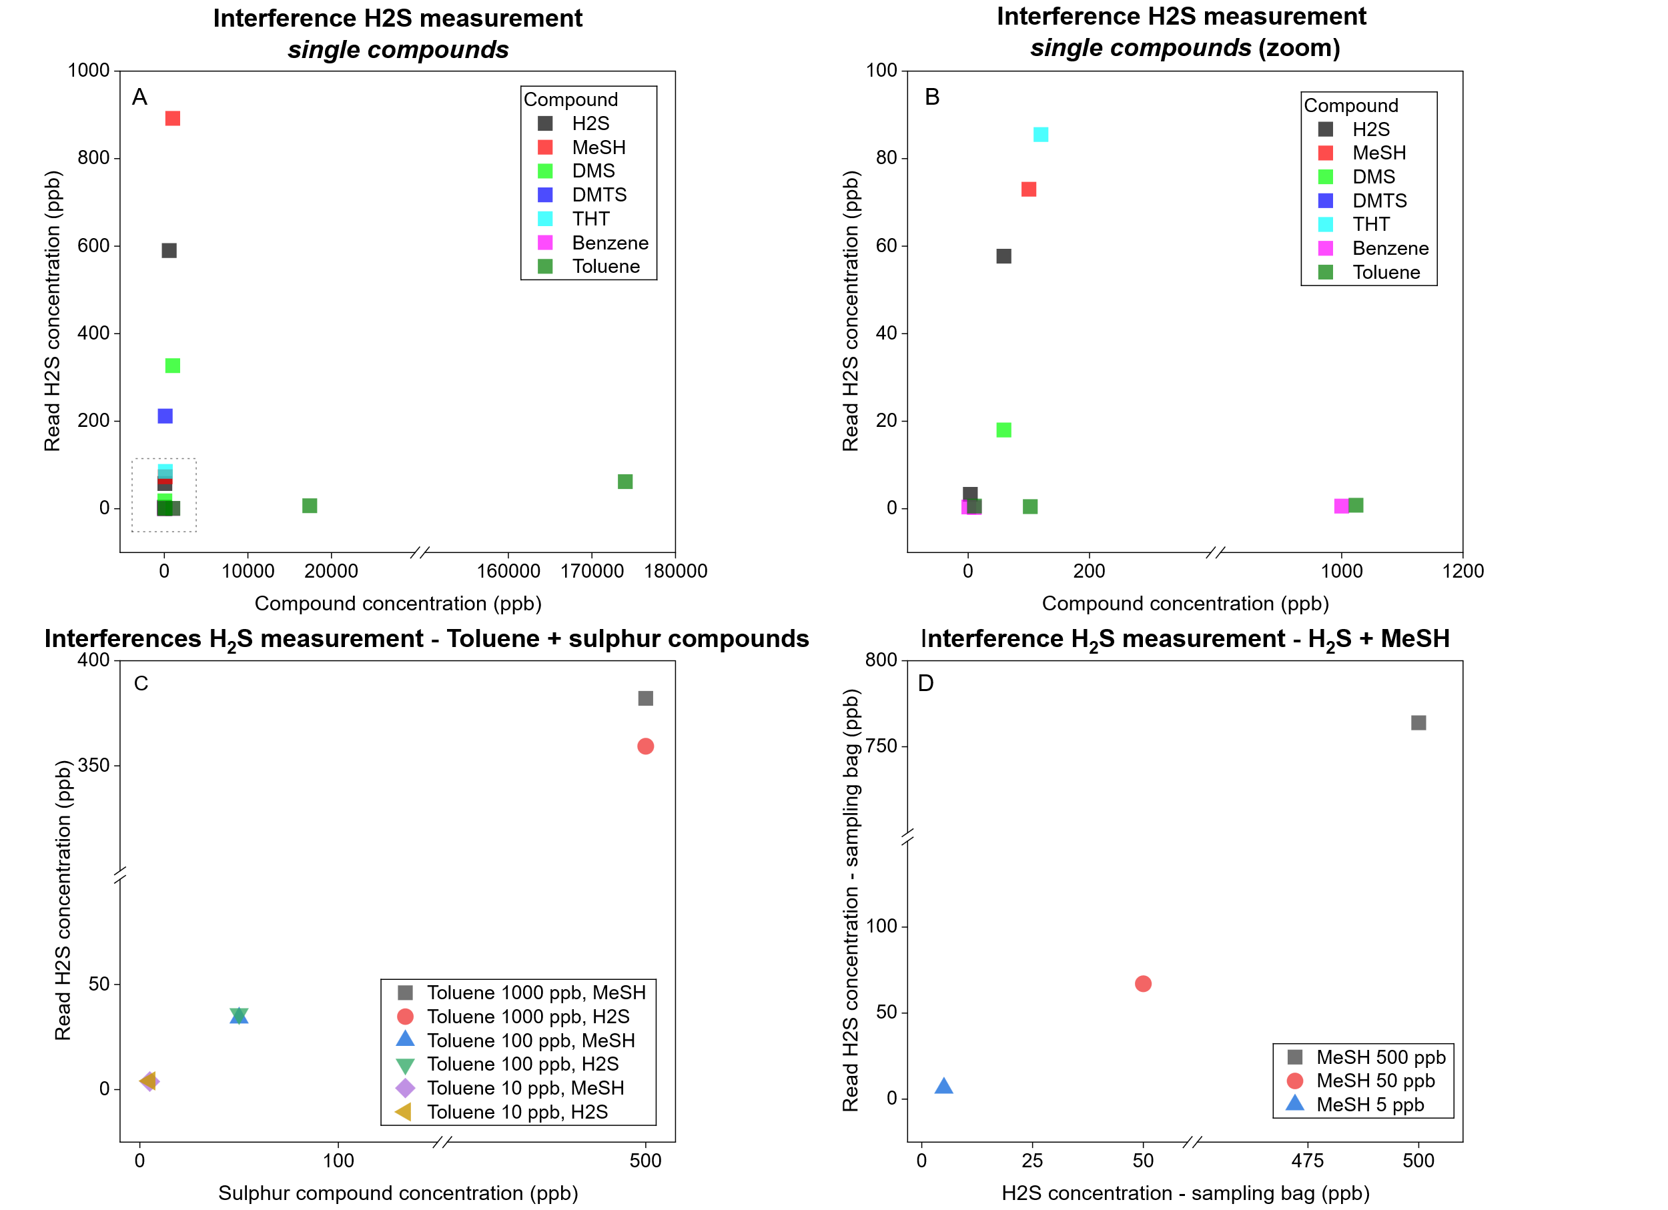
Figure 2: H2S concentration measured using APSA 370 + H₂S converter unit: (A) (B) individual compounds; (C) mix toluene and sulphur compound (H2S or MeSH); (D) mix sulphur compounds (H2S + MeSH)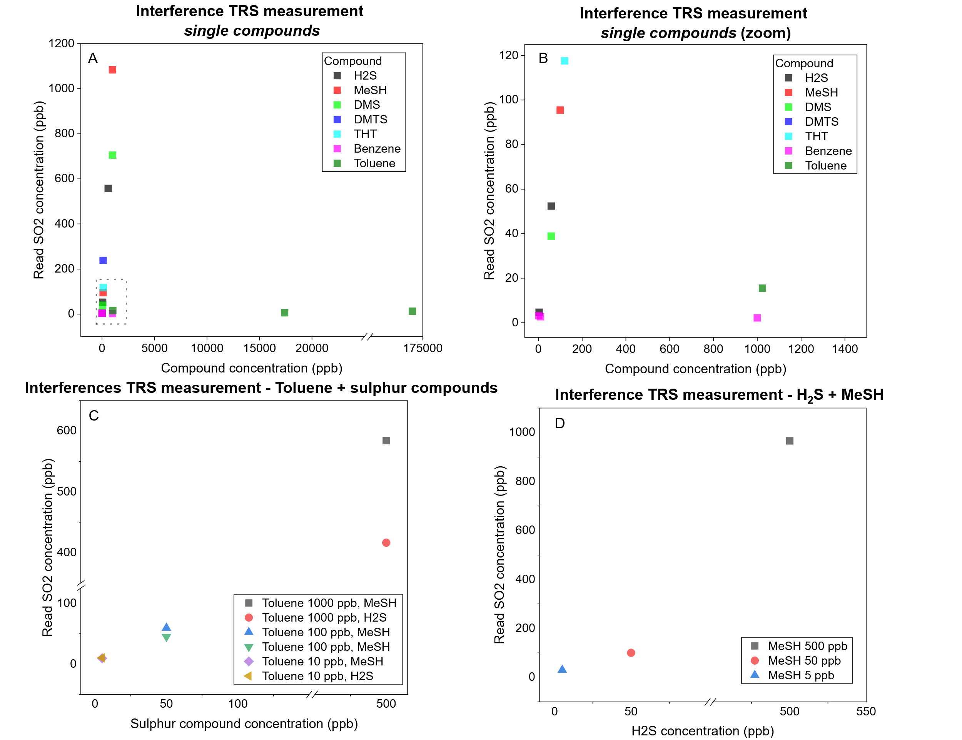
Figure 3: TRS concentration measured using APSA 370 + TRS converter unit: (A) (B) individual compounds; (C) mix toluene and sulphur compound (H2S or MeSH); (D) mix sulphur compounds (H2S + MeSH)
The results for TRS measurements indicate an overall efficient oxidation process, with a maximum estimated error of approximately 25% observed at concentrations close to the lower detection limit (LDL). Aromatic hydrocarbons don’t introduce significant interference, even at elevated concentrations, confirming the selectivity of the instrument configuration under these experimental conditions. However, mixed samples (aromatic hydrocarbon + sulphur compounds) at limited concentration levels (~10 ppm) systematically lead to an overestimation of the measured values, suggesting the presence of interaction effects in this regime. Overall, the APSA + TRS configuration demonstrates high robustness and accuracy across the tested conditions, with the notable exception of low sulphur-concentration mixtures, where caution is required in data interpretation.
    - Application of APSA 370 + TRS converter unit to real odorous samples
Based on the results obtained, an investigation was carried out into the applicability and robustness of the APSA 370 + TRS configuration for the analysis of real odour samples. The results of this experimentation and the comparison with the VOSCs obtained by GC-PFPD analysis were reported below. Two dilutions of the samples were performed (1:10 and 1:100) to verify the operating range.
Table 1: TRS analysis of real odorous samples
Sample | SO₂ from GC-PFPD  (ppb) | SO₂ from TRS Horiba  (ppb)
OUT biofilter | 278 | 268
OUT biofilter – 1:10 | 25 | 20
OUT biofilter- 1:100 | 3.4 | 5.3
IN biofilter | 36 | 27
IN biofilter – 1:10 | 3.3 | 5.6
IN biofilter – 1:100 | 0.8 | 5.5
OUT scrubber | 124 | 160
OUT scrubber – 1:10 | 10 | 18
OUT scrubber – 1:100 | 2.3 | 6.4

Discussing the results obtained for real odorous samples, it is possible to observe that the TRS conversion of VOSCs present in complex mixtures in concentrations greater than 10 ppb is effective and comparable with the GC-PFPD analysis. Concentration lower than 5 ppb, an overestimation of TRS values occurs, probably due to concentrations close to those of LDL.
  - Conclusions
The present study investigates the applicability of the instrument APSA-370 equipped with internal H₂S converter and TRS converter into environmental odour context.
The results obtained in this study demonstrate that the instrument provides reliable performance for SO₂ monitoring. In particular, the tested concentrations of sulfur-containing and/or aromatic compounds did not produce significant interference, confirming the detection selectivity of the system toward SO₂ under the investigated conditions.
In contrast, the internal H₂S conversion unit exhibited not-ideal selectivity, and consequently, limited reliability. The analytical response was strongly affected by the presence of other sulfur-containing species, even at low concentration levels. Therefore, caution should be exercised when using this analytical approach for the specific monitoring of H₂S, owing to the potentially substantial interference from other reduced sulphur compounds.
Moreover, the TRS conversion unit showed robust and accurate performance in the oxidation of sulfur compounds over a concentration range of 5-1000 ppb. Consistent results were obtained for both single- and binary-component samples, as well as for real samples characterized by more complex matrices.
These findings support the applicability of the APSA 370 equipped with a TRS unit for the reliable quantification of Total Reduced Sulphur compounds under diverse analytical conditions and suggest the potential use of this instrument configuration for odour monitoring, given its satisfactory performance in terms of interference control and limits of detection.
Acknowledgments
The authors gratefully acknowledge STA S.r.l. for providing access to the instrument used in this study.

References
Constantin, C., Modrogan, C., Dancila, A.M., Gavrila, G.O., Calinescu, S.M., Cirstea, A., Danciulescu, V., Tanase, G., Vasile, G.G., 2025. Dispersion Modeling of Odor Emissions from Area Sources in a Municipal Wastewater Treatment Plant. Atmosphere 2025, Vol. 16, Page 577 16, 577. https://doi.org/10.3390/ATMOS16050577
Czarnota, J., Masłoń, A., Pajura, R., 2023. Wastewater Treatment Plants as a Source of Malodorous Substances Hazardous to Health, Including a Case Study from Poland. Int. J. Environ. Res. Public Health 20, 5379. https://doi.org/10.3390/IJERPH20075379
Gostelow, P., Parsons, S.A., Stuetz, R.M., 2001. Odour measurements for sewage treatment works. Water Res. 35, 579–597. https://doi.org/10.1016/S0043-1354(00)00313-4
Huszal, A ;, Jaworski, J, Huszal, Anna, Jaworski, Jacek, 2021. Studies on the Impact of Hydrogen on the Results of THT Measurement Devices. Energies 2022, Vol. 15, Page 221 15, 221. https://doi.org/10.3390/EN15010221
Khan, M.A.H., Rao, M. V., Li, Q., 2019. Recent Advances in Electrochemical Sensors for Detecting Toxic Gases: NO2, SO2 and H2S. Sensors 2019, Vol. 19, Page 905 19, 905. https://doi.org/10.3390/S19040905
Ma, L., Zhao, R., Li, J., Yang, Q., Liu, Y., 2024. Release characteristics and risk assessment of volatile sulfur compounds in a municipal wastewater treatment plant with odor collection device. J. Environ. Manage. 354, 120321. https://doi.org/10.1016/J.JENVMAN.2024.120321
Massimi, N., Polvara, E., Invernizzi, M., Sironi, S., 2024. VOSCs Analysis through TD-GC-MS/FID/PFPD: Tools to Enhance Detectivity and Selectivity in Real Samples. https://doi.org/10.3303/CET24112016
Oliva, G., Cangialosi, F., Grimaldi, M., Fasolino, I., Belgiorno, V., Naddeo, V., Zarra, T., 2024. Urban odour annoyance management: An advanced embedded system for real-time monitoring enhanced by citizen science. Case Studies in Chemical and Environmental Engineering 9, 100712. https://doi.org/10.1016/J.CSCEE.2024.100712
Pandey, S.K., Kim, K.H., 2009. A review of methods for the determination of reduced sulfur compounds (RSCS) in air. Environ. Sci. Technol. 43, 3020–3029. https://doi.org/10.1021/ES803272F/SUPPL_FILE/ES803272F_SI_001.PDF
Pandey, S.K., Kim, K.H., Tang, K.T., 2012. A review of sensor-based methods for monitoring hydrogen sulfide. TrAC Trends in Analytical Chemistry 32, 87–99. https://doi.org/10.1016/J.TRAC.2011.08.008
Polvara, E., Invernizzi, M., Sironi, S., 2024. Characterization of the odorous fluxes. Advances in Chemical Engineering 63, 17–57. https://doi.org/10.1016/BS.ACHE.2024.08.001
Traven, L., Linšak, Ž., Crvelin, G., 2024. Mitigating landfill gas emissions: the effectiveness of HDPE covers in reducing atmospheric concentrations of H₂S, NH₃, and PM₁₀. Arh Hig Rada Toksikol 75, 259–269. https://doi.org/10.2478/aiht-2024-75-3912

