 CHEMICAL ENGINEERING TRANSACTIONS  VOL. xxx, 2026 | A publication of  
The Italian Association
of Chemical Engineering
Online at www.cetjournal.it

Guest Editors: Laura Capelli, Marzio Invernizzi, Selena Sironi
Copyright © 2026, AIDIC Servizi S.r.l.
ISBN 979-12-81206-xx-x; ISSN 2283-9216

Occupational Exposure Risk in Olfactometry: Contribution of Compounds with High Odour Thresholds
Elisa Polvaraª, Andrea Spinazzè^{b}, Marzio Invernizzi^{a,*}, Selena Sironiª
ªDepartment of Chemistry, Materials and Chemical Engineering “Giulio Natta”, Politecnico di Milano, Milano, Italy
^{b}Department of Science and High Technology DiSAT, Università degli Studi dell’Insubria, Como, Italy
* marzio.invernizzi@polimi.it
Combustion stack emissions are generally of limited odour relevance, as they typically show low odour concentrations (Cod), but may contain compounds whose odour perception occurs at concentrations close to or above occupational exposure reference values. During dynamic olfactometry, these samples may therefore require low dilution factors, leading to increased exposure concentrations for panellists. This study assesses potential occupational exposure concerns associated with combustion stack samples in dynamic olfactometry. The approach was based on the chemical analysis of real emission samples to quantify combustion-related compounds, the preliminary estimation of the Hazard Index (HI), the definition of a sample-specific minimum dilution value (MDV) not to be exceeded during olfactometric analysis, and the comparison between measured C_{od} and MDV. Based on the obtained results, it is possible to affirm that a non-negligible proportion of the investigated samples showed critical or near-critical conditions with respect to MDV, indicating that this class of matrices may present relevant operational constraints during dynamic olfactometry despite its limited odour relevance. Therefore, particular attention needs to be paid to combustion stack samples to protect panellists’ health. A targeted procedure based on preliminary compound screening, risk estimation, and prior definition of MDV is proposed to support safe testing conditions and effective protection of panellists’ health.
  - Introduction
Odour emissions are generally associated with the presence of volatile organic compounds (VOCs) and other inorganic volatile odorants (H₂S or NH₃). In Europe, odour quantification is standardized by EN 13725:2022, 2022, and is primarily based on dynamic olfactometry, which remains the reference method for determining odour concentration (C_{od}) (Brinkmann et al., 2018). Because the method is based on direct human perception, occupational health is an intrinsic part of the measurement process rather than a secondary issue, as highlighted in EN 13725:2022, 2022. The occupational exposure pattern of olfactometric examiners is unusual from an industrial hygiene perspective. Exposure is intermittent and short in duration: panel sessions are limited to avoid nose fatigue, individual presentations last only a few seconds, and assessors are not expected to perform unrestricted daily testing. However, the inhaled gas is sampled directly at the emission source and is not attenuated by atmospheric dispersion before analysis. In addition, the usual control and protection strategies are difficult to apply in their conventional form, because sample modification, isolation, and respiratory protection are largely incompatible with the analytical objective. This explains why this topic requires ongoing attention and can be explored in greater depth from scientific, methodological and practical standpoints, particularly with regard to the execution of olfactometric analyses.
Considering all these aspects, recent studies have investigated this issue in detail. These works have shown that, in typical real-case scenarios involving olfactometric samples, no substantial occupational criticalities emerge for examiners. This behaviour can be reasonably attributed to the fact that, for odorous compounds, the olfactory threshold is typically much lower than the occupational exposure limits established to protect workers’ health. The recent studies, based either on specific categories of sources/industries or entire working activities and applying probabilistic approaches, highlighted that panellists’ exposure risk can be considered, even under conservative assumptions, negligible (Davoli et al., 2012, 2016; Polvara, Ashari, et al., 2021; Polvara, Capelli and Sironi, 2021; Spinazzè et al., 2022; Polvara et al., 2024). Taken together, these findings suggest that, for generic odorous emissions containing VOCs, the human nose can act as an effective first-line self-protection system during olfactometric analyses.
Within this general framework, the positive context and the results presented in the literature do not resolve the entire problem. Indeed, critical points may arise for emissions with limited concentrations of readily odorous VOCs and inorganic volatile odorants. Combustion stack emissions are representative of this condition, since thermal oxidation generally reduces the concentration of readily odorous organic compounds in the emitted gas. Specifically in monitoring and regulatory control programmes, point-source emissions, such as combustion stack emissions, are frequently included in olfactometric assessment activities. While these sources are often of limited interest from a strictly odour-related standpoint, due to both the composition of the emitted gas stream (absence or very low levels of VOCs) and the structural/geometric design of the emission point, they may still deserve careful attention in terms of occupational exposure risk for examiners involved in the measurements. From a chemical standpoint, gas generated under excess-air combustion conditions is mainly composed of major inorganic products such as CO₂, H₂O, N₂ and O₂, with variable concentrations of SO₂, NO_{x} and CO. In many cases, readily perceivable VOC odorants are not the dominant fraction of the mixture, resulting in lower odour concentrations. Under these conditions, olfactometric analyses may require examiners to reach low dilution levels, corresponding to exposure to relatively high concentrations of the chemical constituents in the sample. This aspect becomes clearer when comparing occupational exposure limits (OELs) and odour thresholds (OTs) for typical combustion-related compounds (Table 1).
Table 1: Odour threshold (OTs) and occupational exposure limits (OELs) for selected combustion-related compounds.
Compound | OTs from Nagata, 2003  [ppm] | EU-OELs  [ppm] | OELs type
SO₂ | 0.87 | 1 | STEL – 15 min
NO | NA | 2 | TWA – 8 h
NO₂ | 0.12 | 1 | STEL – 15 min
CO | NA | 100 | STEL – 15 min

For SO₂ and NO₂, the OT (0.87 and 0.12 ppm) are close to or lower than the occupational exposure limit for short exposure defined by the European Union (EU OEL-15 min= 1 ppm). By contrast, for NO and CO no odour thresholds are generally defined, because CO is odourless and for NO the perceivable warning odour is mainly associated with the higher oxides rather than with NO itself. However, their occupational exposure limits are 2 ppm (EU OEL-8 h) and 100 (EU OEL-15 min), respectively. Therefore, even when such emissions are not especially relevant from an odour nuisance perspective, they may still require specific consideration in occupational risk assessment because the absence or weakness of odorous warning properties may reduce the protective function normally associated with olfactometric testing.
Accordingly, the present study focuses on these critical samples containing oxidation products, to investigate whether specific occupational concerns may arise for olfactometric examiners, to clarify whether these sources may represent a real critical issue during olfactometric testing, and to define operational criteria for conducting their analysis under safe conditions.
  - Materials and methods
    - Samples analysis and calculation of Minimum Dilution Value (MDV)
According to the aims of the study, 86 samples from combustion stacks from different industrial categories were considered. These samples were collected and analysed during one year of activity at the Laboratorio Olfattometrico - PoliMI. Samples were collected at the emission sources in NalophanTM bags, in accordance with EN 13725:2022 (EN 13725:2022, 2022) and transported to the laboratory. Before olfactometric analysis, the samples were analysed for combustion-related compounds using an electrochemical and NDIR analyser (Optima 7, MRU, Germany) to measure CO, NO, NO₂ and SO₂. Based on these data and adopting the methodological approach already presented in the literature (Polvara, Spinazzè, et al., 2021), the minimum dilution value (MDV) was calculated by considering non-carcinogenic risk, through the calculation of the Hazard Index (HI) of the sample from the sum of the Hazard Quotient (HQ) of the four individual compounds considered. The HQ was calculated by dividing the measured concentration of each compound by its occupational exposure limit. In this study, for CO, NO₂ and SO₂, the 15-min occupational exposure limit established at the EU level was used (OEL-STEL), in accordance with the mentioned literature approach. For NO, no OEL-STEL is defined by Europe and, according to previous methodological approach, the EU 8-hour occupational exposure limit (OEL-TWA) was applied (Polvara, Spinazzè, et al., 2021).
The carcinogenic risk has not been assessed for these samples, as the compounds analysed are not classified as carcinogenic or potentially carcinogenic, according to the definition supplied in Part 3 of Annex VI to Regulation (EC) No 1272/2008.
To adopt a precautionary approach, MDV was operationally assigned as the nearest olfactometer dilution step higher than the HI-based value calculated for the sample. This choice reflects the discrete stepwise dilution sequence of the instrument and further reinforces the conservative nature of the approach, since the selected MDV always corresponds to the first dilution level ensuring a margin of safety with respect to the theoretical value obtained. Immediately afterwards, dynamic olfactometry was carried out to determine the odour concentration (C_{od}) within 30 hours of sampling, according to EN 13725:2022. When the measured C_{od} was lower than or equal to the MDV, the olfactometric analysis was discontinued and the resulting C_{od} was defined ≤ MDV for the sample.
    - Acceptability criteria
According to the obtained results, samples were classified on the basis of the ratio between the measured odour concentration (C_{od}) and the minimum dilution value (MDV). Specifically, samples were considered “non-acceptable” when C_{od} ≤ MDV, “borderline” when MDV < C_{od} ≤ 4·MDV, and “acceptable” when C_{od} > 4·MDV.
The introduction of the borderline class was intended to reflect both the factor-of-two stepwise dilution sequence of the olfactometer and the variability associated with C_{od} determination and allows the quantification of samples that may require specific attention.
  - Results
    - Samples concentration
First, a preliminary evaluation of the concentrations obtained for the 86 samples considered can be performed. Table 2 reports the minimum and the maximum values measured for the samples (C_{od}, combustion products concentrations and the calculated MDV).
Table 2: Minimum and maximum values for the combustion stacks samples analysed
Parameters | Min value | Max value
C_{od} [ou_{E}/m³] | 58 | 2’500
SO₂ [ppm] | 0.1 | 450
NO [ppm] | 0.2 | 757
NO₂ [ppm] | 0.9 | 270
CO [ppm] | 0.1 | 970
MDV | 4.4 | 1’120

The results show that the MDV values calculated for the samples exhibit a range that is comparable to the measured C_{od} values. This condition clearly indicates a reduced safety margin during dynamic olfactometry analyses. In addition, considering the combustion products’ concentration, it is possible to observe that the maximum concentrations observed for the four compounds (measured before olfactometric analysis) are significantly elevated, reaching up to two orders of magnitude higher than the corresponding OELs (Table 1). Again, a comparison of the concentration ranges detected in the samples with their odour thresholds (OTs, reported in Table 1) reveals that the OTs are comparable with the minimum values detected in the samples analysed. Therefore, once again, it appears clear that, given the compound concentrations detected, it is not possible for the nose to detect the odour of these samples before they reach the OELs. This evidence highlights the necessity to investigate this category of samples and define an MDV before conducting olfactometric analysis.
    - Occupational exposure assessment – real-case dataset
Discussing the entire real-case dataset of combustion stack samples, Table 3 reports the distribution of the samples according to three different acceptability criteria. Most of the samples (84%) fall within the “acceptable” region (green points), indicating that, under testing conditions, the C_{od} is higher than the corresponding MDV and no immediate safety constraint is expected. However, a non-negligible portion of samples lies in critical conditions: 10% are classified as “non-acceptable”, where olfactometric analysis had to be interrupted to avoid reaching hazardous concentrations (C_{od} ≤ MDV). An additional 6% fall within a conservative “borderline” region (C_{od} ≤ 4 ∙ MDV). Despite the overall prevalence of acceptable conditions, the presence of 16% of samples in critical or near-critical regions is significant in the context of routine olfactometric analyses. These results demonstrate that exceedance of MDV is not an isolated occurrence but a frequent condition within this class of samples.
Table 3: Dataset of combustion stack samples
Criteria | N° samples | Percentage [%]
Acceptable – C_{od} > 4 ∙ MDV | 72 | 84
Borderline – MDV < C_{od} ≤ 4 ∙ MDV | 5 | 6
Non-acceptable – C_{od} ≤ MDV | 9 | 10

The relationship between C_{od} and MDV for the investigated samples is shown in Figure 1. Data points are colour-coded according to the predefined acceptability criteria (“acceptable”, “borderline”, “non-acceptable”). The red points indicate samples for which the analysis was halted to ensure the MDV limit was not exceeded and C_{od} was defined as equal to MDV (for this reason the red points have the same x and y coordinates), following, for this graph, an upper bound approach.

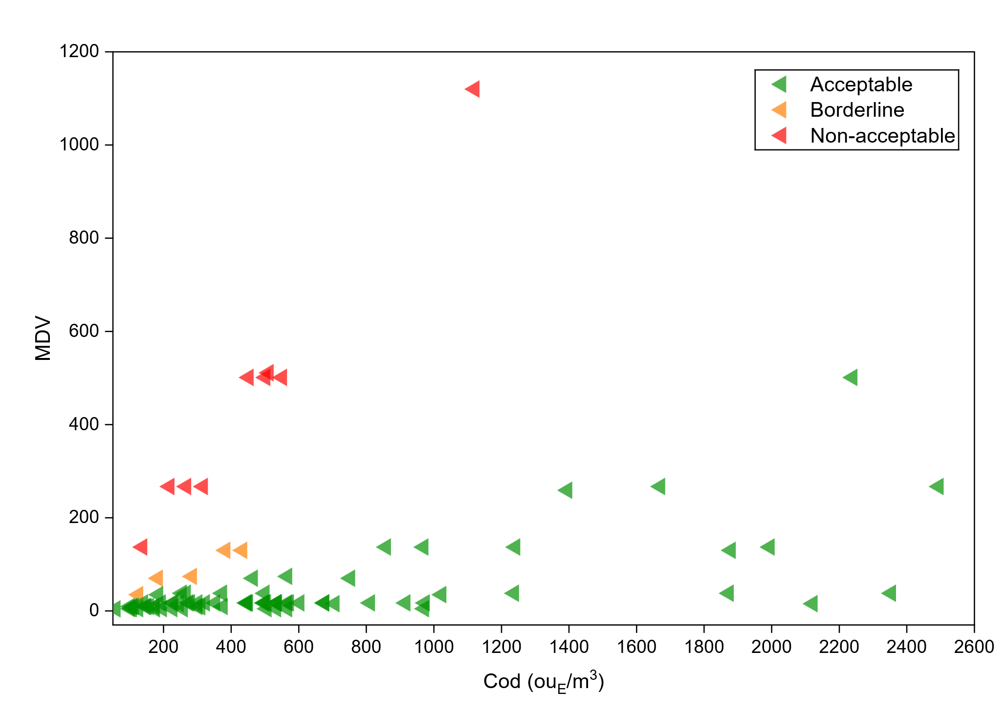
Figure 1: Comparison of C_{od} and MDV for the samples
In addition, Figure 1 shows clearly that several critical and borderline cases are observed for samples characterized by relatively low C_{od} values (≤ 500 ou_{E}/m³), confirming that for this class of samples an evaluation of the occupational risk and a definition of a MDV is extremely important to protect panellists’ health.
Considering the oxidised compounds measured and detected in the samples, several observations can be made. A comparison of the OELs for the four compounds reveals that the exposure concentration for CO is two orders of magnitude higher (100 ppm). This aspect mitigates concerns regarding the potential implications of CO for occupational safety and health in this context. Therefore, sulphur dioxide and NO_{X} represent the most critical compounds in this scenario. Focusing on the samples of concern (red and yellow points in Figure 1), for these, it is possible to specify the content of SO₂, NO₂ and NO. In critical samples, the compound with the highest HQ was SO₂, followed by NO, as reported in Figure 2. This finding indicates that these compounds appear to be the most relevant ones for the assessment of the risk associated with these types of samples.
Interpreted in light of the scientific literature, these findings complement those of previous studies, based on probabilistic approaches, in which the risk associated with olfactometric analyses was found to be statistically negligible. Probabilistic occupational risk assessment in dynamic olfactometry showed that, at the overall laboratory scale and under several conservative assumptions, the estimated risk remained below the adopted acceptability criteria, thus supporting the conclusion of a generally negligible exposure scenario (Polvara et al., 2024). However, that study was designed to describe the overall probability of unacceptable exposure across a broad range of analytical conditions, rather than to identify operational criticalities associated with specific sample categories.
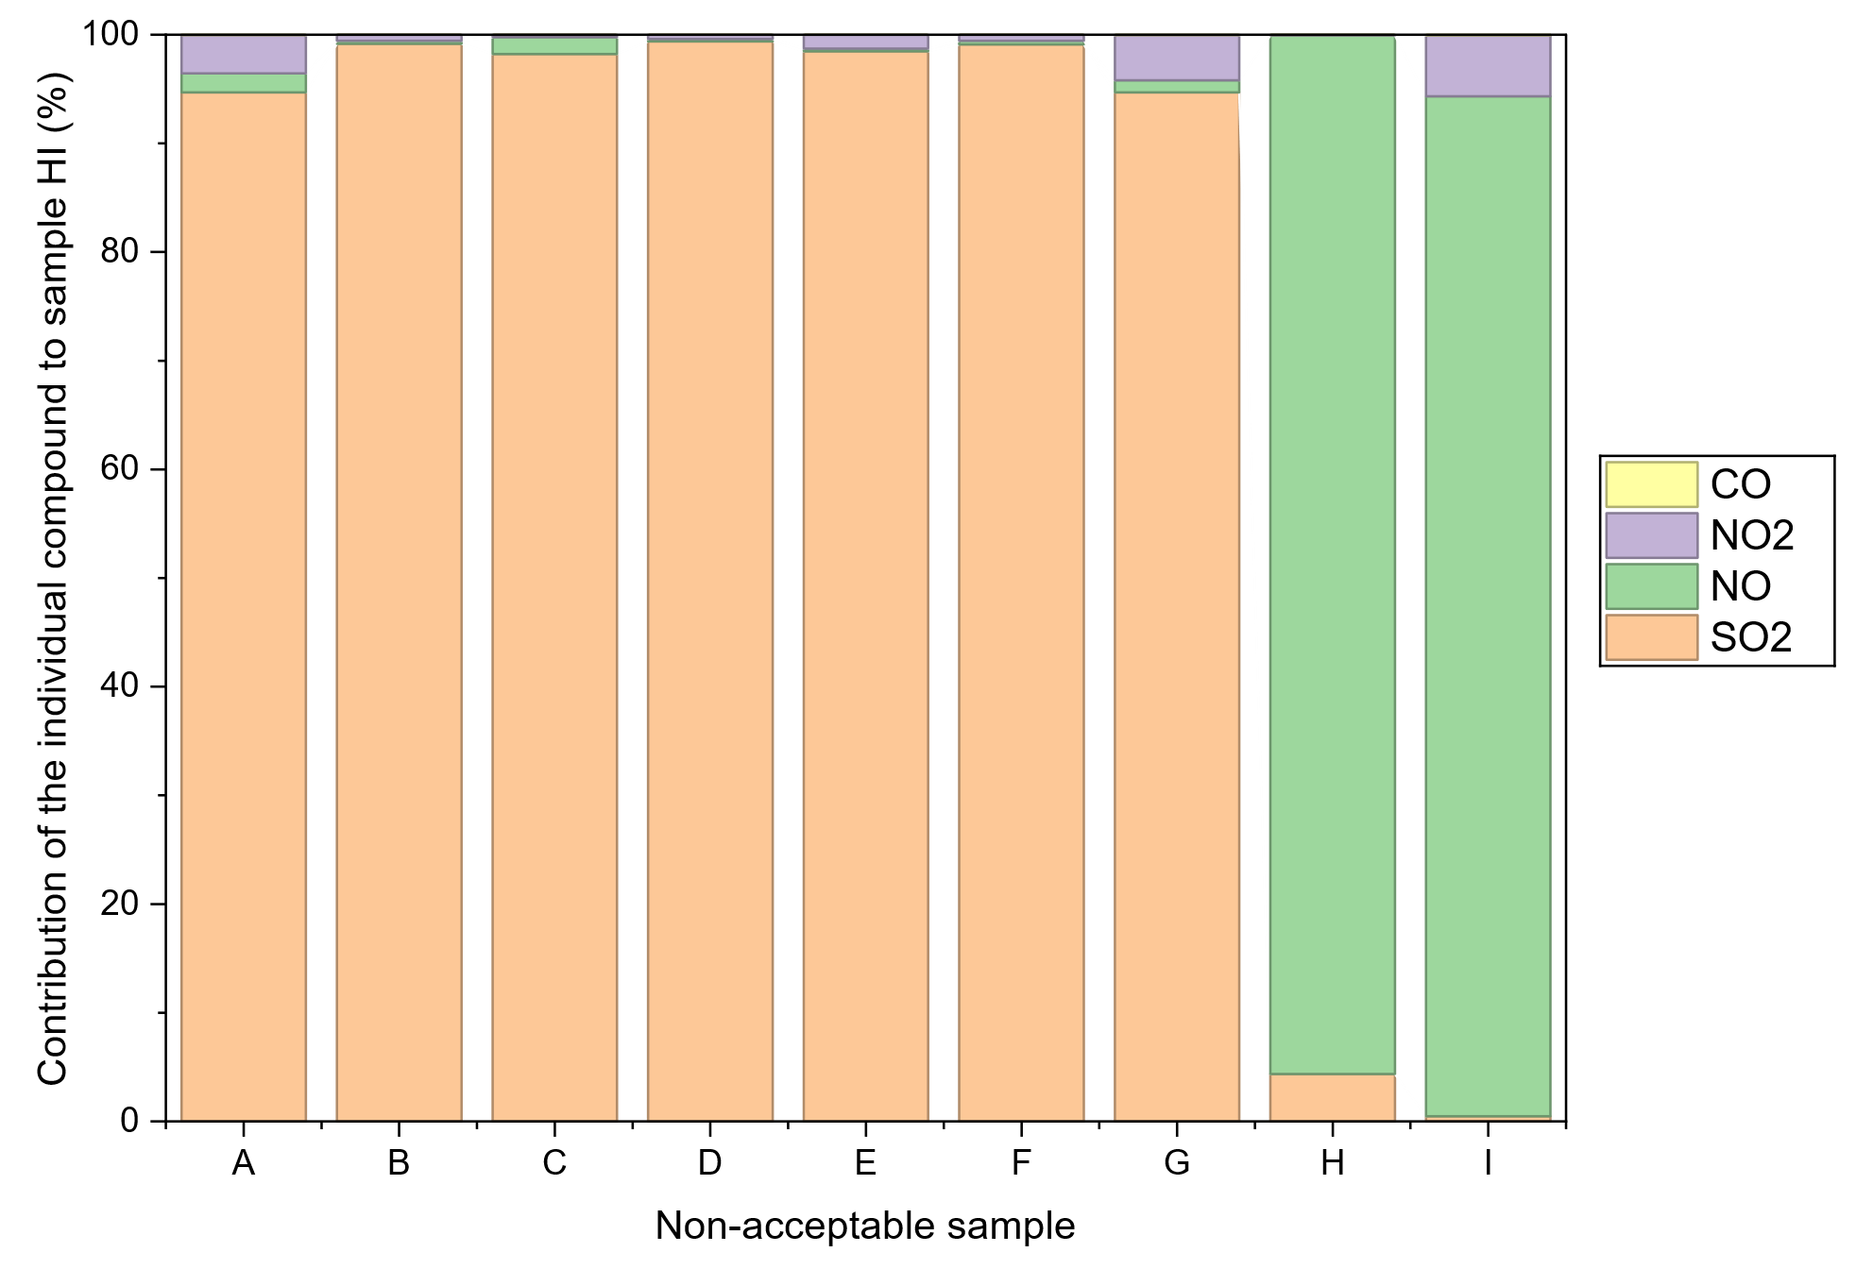
Figure 2: Relative contribution (%) of individual compounds to HI in non-acceptable samples
By focusing specifically on combustion stack samples, the present results show that matrices characterized by limited VOC contributions and low odour concentrations may nevertheless pose non-negligible operational constraints during olfactometric analysis. Overall, the C_{od}-MDV distribution indicates that this sample class requires specific attention during olfactometric testing, despite its generally limited relevance from an odour impact perspective. It should also be emphasized that the occupational risk assessment approach adopted for olfactometric examiners exposed to stack emission samples is methodologically conservative, as it is based on precautionary assumptions regarding exposure duration and operating conditions during olfactometric analysis (Polvara, Spinazzè, et al., 2021; Polvara et al., 2024). In particular, it is important to reiterate that the use of occupational exposure limits defined for 8 hours (OEL-TWA) or 15 minutes (OEL-STEL) is inherently precautionary, because these limits are defined for exposure periods longer than the actual inhalation time (few seconds) experienced by the olfactometric examiners during each evaluation. Therefore, even in the most critical cases identified for this sample class, the estimated risk values should be interpreted as prudential estimates of potential exposure rather than as a direct representation of the real short-term exposure experienced during testing.
    - Proposed operative approach
According to the present results, estimating an MDV before olfactometric analysis appears essential for this class of samples, namely emissions from combustion units. Accordingly, a specific operational workflow should be defined for these samples. As a first step, the compounds present in the sample should be preliminarily quantified before dynamic olfactometry is performed. For this purpose, rapid screening instruments, such as electrochemical sensors and NDIR analysers for combustion gases, may be sufficient. At this stage, an expedited assessment approach is adequate for this sample category, and simple sensor-based devices may be preferable to more complex analytical instrumentation (e.g. gas chromatography), provided that they generate sufficient information for a preliminary assessment of compounds relevant to occupational exposure.
Subsequently, based on the measured concentrations, non-carcinogenic risk should be estimated according to the methodology adopted in previous studies, by calculating the Hazard Index (HI) for the sample (Polvara, Spinazzè, et al., 2021). The panel leader should then assign the appropriate MDV to be adopted as an operational limit during the olfactometric test, based on the HI estimate, and then interrupt the test once the MDV is reached. In such cases, the odour concentration should be reported as less than or equal to the corresponding MDV. Overall, this procedure represents a practical, methodologically sound, and conservative approach for conducting olfactometric analyses while protecting panellists’ health and focusing analytical effort on the samples most likely to present critical conditions, as shown by the present study. At the same time, it allows the analyses to be completed within the time constraints established by the standard (EN 13725:2022, 2022), including completion within 30 hours after sampling, while providing targeted and effective protection against exposure to concentrations approaching occupational exposure limits.
  - Conclusions
The present study investigated the occupational exposure concerns for olfactometric examiners during the analysis of combustion stack samples. Although these samples are generally considered of limited relevance in terms of odour impact, because of their low content of readily odorous VOCs, they may reach low dilution steps during olfactometric analysis, corresponding to higher concentrations at the presentation stage. Consequently, panellists may be exposed to potentially hazardous compounds during testing. Based on 86 combustion stack samples from different industrial sources analysed by the Laboratorio Olfattometrico – PoliMI over one year, most samples were classified within acceptable conditions. However, a non-negligible fraction (16%) fell within critical (Cod ≤ MDV) or near-critical conditions (MDV < C_{od} ≤ 4 ∙MDV). These findings indicate that MDV exceedance or near-exceedance is not an occasional event for these matrices, but a recurrent condition of practical relevance. Therefore, despite their limited odour impact, combustion stack samples represent a critical category from an occupational hygiene perspective and may require specific precautions before olfactometric analysis. Beyond the general safety provisions included in EN 13725:2022, the proposed methodology provides a sample-specific and quantitative approach to define protective testing conditions before olfactometric analysis. Its main advancement consists in linking preliminary compound quantification by rapid screening methods, Hazard Index estimation and MDV definition, thereby converting chemical composition data into an operational dilution limit. In this framework, the panel leader can evaluate the estimated exposure concern before testing and assign the MDV as the minimum allowable dilution level for sample presentation. The use of MDV as a stopping criterion allows olfactometric measurements to remain aligned with the standard procedure while reducing unnecessary exposure of panellists. Overall, preliminary MDV-based assessment represents a proportionate risk management tool for combustion stack samples and provides an operational complement to EN 13725:2022 for cases in which low odour concentration may coexist with relevant occupational hygiene concerns.
References
Brinkmann, T., Both, R., Maria Scalet, B., Roudier, S. and Delgado Sancho, L. (2018) “JRC Reference Report on Monitoring of Emissions to Air and Water from IED Installations - Industrial Emissions Directive 2010/75/EU (Integrated Pollution Prevention and Control).” Available at: https://doi.org/10.2760/344197.
Davoli, E., Zuccato, E., Bianchi, G., Il Grande, M., Bonati, S., Rossi, A.N., Porporato, C., Pereno, M. and Soldati, S. (2016) “Dynamic olfactometry and sample toxicity. a case study for a MSW incinerator odour assessment project,” Chemical Engineering Transactions, 54, pp. 13–18. Available at: https://doi.org/10.3303/CET1654003.
Davoli, E., Zuccato, E., Bianchi, G., Palmiotto, M., Il Grande, M., Bonati, S. and Rossi, A.N. (2012) “Dynamic Olfactometry and Potential Sample Toxicity. Guidelines for a Safe Occupational Health Approach,” Chemical Engineering Transactions, 30, pp. 7–12. Available at: https://doi.org/10.3303/CET1230002.
EN 13725:2022 (2022) Stationary source emissions - Determination of odour concentration by dynamic olfactometry and odour emission rate. Available at: https://doi.org/10.31030/3290685.
Nagata, Y. (2003) “Measurement of Odor Threshold by Triangle Odor Bag Method,” Odor Measurement Review, pp. 118–127.
Polvara, E., Ashari, B.E., Capelli, L. and Sironi, S. (2021) “Evaluation of occupational exposure risk for employees working in dynamic olfactometry: Focus on non-carcinogenic effects correlated with exposure to landfill emissions,” Atmosphere, 12(10), p. 1325. Available at: https://doi.org/10.3390/atmos12101325.
Polvara, E., Capelli, L.M.T. and Sironi, S. (2021) “Non-carcinogenic occupational exposure risk related to foundry emissions: focus on the workers involved in olfactometric assessments,” Journal of Environmental Science and Health - Part A, 56(6), pp. 646–659. Available at: https://doi.org/10.1080/10934529.2021.1913927.
Polvara, E., Spinazzè, A., Invernizzi, M., Cattaneo, A., Cavallo, D.M. and Sironi, S. (2024) “Probabilistic Approach for Assessing the Occupational Risk of Olfactometric Examiners: Methodology Description and Application to Real Exposure Scenario,” Toxics 2024, Vol. 12, Page 784, 12(11), p. 784. Available at: https://doi.org/10.3390/TOXICS12110784.
Polvara, E., Spinazzè, A., Invernizzi, M., Cattaneo, A., Sironi, S. and Cavallo, D.M. (2021) “Toxicological assessment method for evaluating the occupational risk of dynamic olfactometry assessors,” Regulatory Toxicology and Pharmacology, 125(May), p. 105003. Available at: https://doi.org/10.1016/j.yrtph.2021.105003.
Spinazzè, A., Polvara, E., Cattaneo, A., Invernizzi, M., Cavallo, D.M. and Sironi, S. (2022) “Dynamic Olfactometry and Oil Refinery Odour Samples: Application of a New Method for Occupational Risk Assessment,” Toxics 2022, Vol. 10, Page 202, 10(5), p. 202. Available at: https://doi.org/10.3390/TOXICS10050202.

