 CHEMICAL ENGINEERING TRANSACTIONS  VOL. xxx, 2026 | A publication of  
The Italian Association
of Chemical Engineering
Online at www.cetjournal.it

Guest Editors: Laura Capelli, Marzio Invernizzi, Selena Sironi
Copyright © 2026, AIDIC Servizi S.r.l.
ISBN 979-12-81206-xx-x; ISSN 2283-9216

Multi-stage Wet Scrubbing for Industrial Odor and VOCs Abatement: Design Features and Full-Scale Case Studies
Davide Cassinari, Riccardo Snidar*, Jacopo Parolin, Luca Arcobasso
Tecnoimpianti Water Treatment S.r.l., Via Salvo D’Acquisto 16/B, 20060 Pozzuolo Martesana (Milan), Italy
*rsnidar@tecnoimp.com
Industrial emissions are technically demanding because of their chemical complexity, containing components that may differ by several orders of magnitude in water solubility, reactivity and odor threshold. This paper describes the engineering role of wet scrubbing in odor and Volatile Organic Compounds (VOCs) abatement, with specific emphasis on multi-stage wet scrubbers developed and applied by Tecnoimpianti Water Treatment S.r.l. (TWT). Wet scrubbing is discussed as a gas-liquid mass-transfer and chemical-conversion process in which each stage can be designed for specific pollutant families through pH control, oxidation, packing selection, recirculation strategy, demisting and automation. Three field case studies are then presented. These cases show that multi-stage wet scrubbing is a robust and flexible best-available-technique-compatible option for soluble and reactive odorants, particularly when embedded in an integrated treatment train for hydrophobic VOCs and variable industrial matrices.

Keywords: odor emissions; VOCs; wet scrubber; packed tower; multi-stage deodorization; industrial air treatment
  - Introduction
Odor emissions from industrial activities are a distinctive form of air-pollution because they are perceived through a sensory response rather than only through the mass concentration of a single compound. Wastewater treatment plants, waste-treatment facilities, rendering plants, chemical and pharmaceutical processes, plastic processing, foundries, livestock activities and other industrial installations may release complex mixtures that become relevant even at very low concentrations. Odor pollution is now widely recognized as an environmental issue that requires dedicated measurement methods and cannot be adequately managed through conventional chemical monitoring alone (Bax et al., 2020).
The engineering problem is therefore to convert a subjective perception into reproducible parameters that can support design, performance verification, impact assessment and communication with regulators and communities. Dynamic olfactometry, chemical analysis, instrumental odor monitoring systems, field inspection and dispersion modeling each provide different information. None is sufficient in isolation for all purposes: olfactometry quantifies the sensory response of a gas sample, chemical analysis identifies compounds and process causes and dispersion modeling links source emissions to receptor exposure (Bax et al., 2020).
The importance of source characterization is especially evident for area sources and wastewater-related emissions. Odor emission factors can be used to estimate emissions from wastewater treatment plant units, but different process units can have very different odor-emission behavior (Capelli et al., 2009). Consequently, the selection and design of abatement systems must begin with a source-by-source assessment rather than with a generic technology choice.
Wet scrubbing is one of the main technologies available for odor and soluble gas control. European BAT documents for wastewater and waste-gas management recognize wet abatement, adsorption, biological treatment and thermal oxidation as techniques that may be used individually or in combination according to pollutant properties and process context (Brinkmann et al., 2016). The practical question is therefore not whether a scrubber is universally effective, but when and how a scrubber should be engineered to address a specific odor matrix. TWT field experience indicates that high odor removal can be achieved when wet scrubbing is designed as a staged, chemically controlled and monitored process rather than as a simple humidification or air-washing unit.
  - Wet scrubbers for odor and VOC control
This chapter deals with the working principles of wet scrubbers, their design and the advantages of multi-stage scrubbers.
    - Process principles and domain of applicability
Wet scrubbing purifies a gas stream by transferring one or more pollutants from the gas phase to a liquid phase. In industrial odor control, the gas stream is usually air, the target substances are gaseous or vapor-phase odorants and VOCs and the washing liquid is generally water or an aqueous solution containing acid, alkaline, oxidizing or other process-specific reagents. The mechanism may be physical absorption, chemical absorption or a combination of both. Physical absorption is governed by gas-liquid equilibrium, interfacial area, mass-transfer coefficients, gas residence time and liquid-to-gas ratio, while chemical absorption increases the driving force by converting absorbed substances into less volatile or less odorous forms (Cassinari et al., 2024).
Only substances that are sufficiently soluble in the selected washing liquid or that react fast enough after entering the liquid phase can be efficiently removed by wet scrubbing. Hydrophobic and poorly reactive VOCs may pass through a scrubber with limited removal and may require adsorption on activated carbon, biological treatment, condensation, thermal oxidation or other complementary technologies. For this reason, odor abatement should not be specified only as a target percentage. It should consider what compounds generate the odor, their solubility, reactivity and odor thresholds.
The non-linearity between chemical concentration and odor concentration is central. Odorants can have extremely different detection thresholds. A low mass concentration of an extremely odorous sulfur compound can dominate the perceived odor, whereas a much higher concentration of a less odorous solvent may have a smaller sensory impact. Consequently, design and performance assessment must combine chemical and olfactometric information (Bax et al., 2020).
    - Scrubber configurations and design variables
Wet scrubbers for gas treatment include spray towers, tray scrubbers, floating-bed scrubbers, and packed-bed scrubbers. Packed-bed towers are widely used for gas absorption because the packing distributes the liquid over a large, wetted surface area and promotes gas-liquid contact (US EPA). TWT’s odor-control applications mainly use vertical countercurrent towers or, where height restrictions require it, horizontal crossflow arrangements. In general, vertical countercurrent packed towers provide higher mass-transfer efficiency for a given footprint because the cleanest liquid contacts the cleanest gas near the outlet, preserving the concentration driving force.
The design of a wet scrubber is multi-variable optimization (Table 2). Gas velocity affects pressure drop, flooding margin, droplet entrainment and contact time. Packing type affects interfacial area, fouling tendency, hydraulic capacity and maintenance. Liquid recirculation rate and make-up/blowdown strategy control mass transfer and salt or by-product accumulation. Reagent selection and control logic determine whether target compounds are neutralized, oxidized or simply transferred to the liquid. Nozzles type, number and position influence liquid distribution, while demisters prevent carryover of droplets that could damage downstream equipment, corrode ducts or saturate activated carbon. The control instrumentation is finally an essential element for the proper management of the process (Cassinari et al., 2024).
The gas-to-liquid transfer problem is complicated by field constraints. A correct design must account for inlet concentrations, expected outlet limits, temperature, humidity, emission variability, process intermittency, ATEX classification, available water quality, wastewater management, acoustic zoning, sampling ports, construction access, working-at-height requirements, seismic classification and interference with plant operations.
    - Why multi-stage wet scrubbing improves odor control
Single-stage wet scrubbing can be adequate for simple streams dominated by one soluble or highly reactive compound. However, odor emissions from industrial and municipal facilities like wastewater sludge handling, hospital-waste treatment and thermoplastic processing are generally different. They may contain reduced sulfur compounds, ammonia and amines, organic acids, aldehydes, ketones, chlorinated or aromatic VOCs, humid vapors, particulate matter and process-specific intermediates. One recirculating liquid chemistry cannot be optimized for all these families simultaneously.
A multi-stage scrubber divides the gas-treatment process into sequential functional zones. A first stage may remove particulate matter, condensable material or a high fraction of soluble load while protecting downstream packing. A dedicated acid stage can target alkaline compounds such as ammonia and amines. A basic or oxidative stage can target acidic or reduced sulfur compounds such as hydrogen sulfide and mercaptans. A neutral water wash or final polishing stage can remove residual reagents and reduce carryover. Independent recirculation loops allow each stage to operate at its own pH, oxidation-reduction potential, blowdown rate, and reagent strategy.
This architecture has three practical advantages. First, it increases robustness under variable inlet composition because stage-specific settings can be adjusted without redesigning the entire plant. Second, it improves efficiency per unit footprint by maintaining favorable mass-transfer and reaction conditions along the tower sequence. Third, it reduces operational risk: fouling, reagent depletion or an excursion in one stage can be detected and corrected before downstream units are compromised. When hydrophobic VOCs or poorly soluble odorants are present, multi-stage scrubbing can be combined with activated carbon or other polishing systems. The combined line should be designed as an integrated treatment train, because a wet stage can also condition the gas for downstream adsorption by removing moisture-soluble or corrosive components, while excessive droplet carryover would have the opposite effect.
A flow diagram of a multi-stage wet scrubber can be seen in Figure 1.
Table 2. Principal engineering variables in multi-stage wet-scrubber design
Variable group | Examples | Effect on performance and operability
Gas-side parameters | Flow rate, temperature, humidity, velocity, pressure drop, emission variability | They define residence time, hydraulic loading, mass-transfer driving force, fan selection and operating envelope.
Liquid-side parameters | Recirculation rate, make-up/blowdown, pH, ORP, conductivity, reagent dosing | They control absorption capacity, reaction kinetics, reagent consumption, by-product accumulation and wastewater load.
Mass-transfer internals | Packing type, packing height, nozzles, liquid distribution, demister | They determine contact area, droplet carryover, fouling risk and maintenance frequency.
Staging architecture | Number of stages, independent sumps, stage order, polishing stage | They allow different chemistries for different compounds and prevent counterproductive reagent mixing.
Control and monitoring | SCADA, pH/ORP probes, differential pressure, flow meters, alarms, remote monitoring | They maintain performance under variable loads and support preventive maintenance.

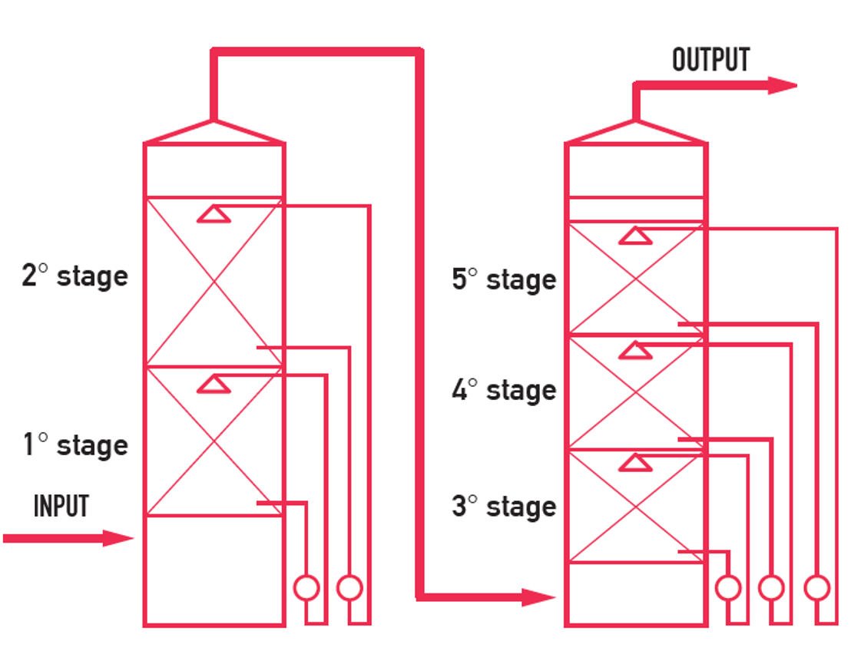
Figure 1: Flow diagram of a multi-stage wet scrubber
  - Case studies from TWT field experience
The following case studies are field applications by TWT. They cover three different matrices (Table 3):
- municipal and industrial wastewater treatment,
- hospital-waste thermal treatment and refuse-derived-fuel/SSF production,
- thermoplastic-compound production.
Table 3. Overview of the three field case studies
Sector and source | Main issue | TWT treatment concept
Municipal and industrial wastewater treatment; sludge oxidation, primary and digested sludge tanks, thickening, thermal sludge treatment | High odor load; earlier horizontal scrubber ineffective; need odor and chemical control near urban receptors | Five washing/deodorization stages in two vertical wet towers, with activated-carbon polishing for residual substances
Hospital-waste physical/thermal treatment and SSF production | Light solids, fibers, microplastics, paper/cardboard fluff and water condensation caused severe fouling and frequent cleaning | Ad hoc solid-particle pretreatment followed by five-stage wet treatment; downstream activated carbon retained as safety/polishing unit
Thermoplastic-compound production | VOCs, light particles, intense odor, humid vapors, partial water insolubility, residential proximity, and acoustic constraints | Modular activated-carbon filter followed by five-stage wet scrubbing with acid, basic and oxidative dosing flexibility; silencers and stack relocation

    - Wastewater treatment plant
The first case study regards one of the largest wastewater-treatment facilities in Lombardy, located north of Milan (Italy). The site treats wastewater from 26 municipalities and hundreds of production facilities, has a nominal capacity of 600,000 population equivalent and operates continuously. The odor-control problem was associated with sludge and thermal-treatment areas, including sludge oxidation tanks, primary-sludge collection tanks, anaerobically stabilized digested-sludge collection tanks, mechanically thickened sludge tanks, post-combustion sludge heat-treatment units and hydrolyzed-sludge tanks.
An earlier horizontal scrubber was reported to be ineffective for the odor load. TWT replaced it with an Advanced Multistage Deodorization System (AMDS) consisting of five washing and deodorization stages in two vertical wet towers operating in series. The solution was designed to fit within the footprint of the demolished horizontal scrubber. The first tower contains two chemical washing stages, while the second tower contains three stages, including a final neutral water wash. Each stage uses random packings to promote contact between the upward gas stream and the recirculating liquid and each tower includes droplet separation at the outlet. The treated gas can be sent to an activated-carbon filter for final polishing.
The reported performance demonstrates the importance of integrated treatment (Table 4). Scrubbing alone reduced the main soluble and reactive compounds substantially, but residual odor and VOCs required activated carbon because part of the matrix was not sufficiently water-soluble or reactive in the washing solutions. Downstream activated carbon polishing, all reported emission limits were met in the case-study dossier, with odor below 300 ou_{E}/m³ and non-methane VOCs around 3 mg/Nm³.
Table 4: Reported performance for scrubber and activated-carbon polishing
Parameter | Inlet | Oulet scrubber | Outlet activated carbon
Odor concentration | 4,200 ou_{E}/m³ | 650 ou_{E}/m³ | 250 ou_{E}/m³
Hydrogen sulfide | 10 ppm | <0.5 ppm | <0.5 ppm
Mercaptans | <10 ppm | <0.5 ppm | <0.5 ppm
Non-methane VOCs | <100 ppm | <30 ppm | <3 ppm
Ammonia | 20 ppm | <0.5 ppm | <0.5 ppm

    - Hospital-waste thermal-treatment and SSF-production plant
At a company located in the province of Foggia (Italy) that treats hospital waste by physical and thermal processes, the pre-existing configuration used two scrubbers operating in parallel, each originally treating approximately 8,000 m³/h. The critical issue was not only odor and dust compliance but also fouling. The extracted air contained very light solid particles, including fluff, non-woven fabric, glove fragments, volatile microplastics and paper/cardboard fibers. In the presence of condensed water vapor, these materials rapidly fouled the two scrubbers, requiring internal cleaning every two to three weeks.
TWT’s design study included chemical characterization of the air stream, fluid-dynamic analysis of the suction systems, and evaluation of alternative technologies. The final concept connected the two inlet lines, used dampers to partition inflow, introduced ad hoc pretreatment for removal and segregation of solid particles and sent the pretreated stream to a five-stage wet system. The stages wash the air sequentially with progressively cleaner aqueous solution, while allowing independent management of treatment conditions according to the compounds present. The existing activated-carbon plant downstream was retained primarily as a safety function, especially during maintenance of the wet-treatment system.
The field objective was therefore dual: increase abatement efficiency and increase the maintenance interval. Post-installation chemical and olfactometric analyses reported significant efficiency and the average yield as approximately 90% (Table 5). The analytical campaign of October 10, 2023 illustrates the order of magnitude of removal: total organic carbon measured by FID decreased from 180 mg/Nm³ upstream to 18 mg/Nm³ downstream, particulate matter decreased from 9.5 to 1.3 mg/Nm³ and ammonia decreased from 1.2 to below 0.5 mg/Nm³. These data support the design choice of combining particulate pretreatment with staged wet scrubbing rather than relying on a conventional single wet device.
Table 5. Analytical campaign results, October 10th, 2023.
Parameter | Inlet (mg/Nm³) | Outlet (mg/Nm³) | Reduction
Total Organic Carbon | 180 | 18.0 | 90%
Total particulate matter | 9.5 | 1.3 | 86%
Ammonia | 1.2 | < 0.5 | > 58%
Ethanol | 356 | 31 | 91%
Isopropyl alcohol | 39 | 3.4 | 91%
Acetaldehyde | 14 | 1.8 | 87%

    - Thermoplastic-compound production plant
At a company located in the province of Milan (Italy) that produces colored and natural thermoplastic compounds in granule form, the original odor-control system consisted of two scrubbers in series treating approximately 40,000 m³/h. The plant is close to residential receptors, so odor reduction had to be considered together with noise control and operating continuity. The extracted air contained VOCs, light solid particles, high odor concentration and humid vapors. Because the mixture was variable and partly insoluble in water, the pre-existing system could not reliably meet the desired odor and chemical performance.
TWT’s revamping began with upstream/downstream chemical and odor analysis and a noise assessment. The existing system was dismantled and replaced by a modular activated-carbon filter followed by a five-stage wet scrubber. The activated-carbon filter was responsible for reducing VOCs and was subdivided into four sections so that one module could be maintained while the system remained in operation. The downstream wet scrubber then provided five sequential washes, with the possibility of acid, basic and oxidative dosing in four of the five stages depending on the compounds present. Ancillary measures included moving the stack after modeling and applying silencers to the pumps, fan, stack and other emission points.
Available olfactometric data show the improvement in the wet-scrubbing section (Table 6). In August 2023, with the previous scrubber, odor decreased from 2,400 to 1,800 ou_{E}/m³, corresponding to about 25% reduction. In October 2024, the new scrubber showed about 70% odor reduction. Because the activated carbon is located upstream, the VOC concentrations measured at the scrubber inlet in 2024 were already relatively low; the wet stages therefore functioned primarily as odor and residual-soluble-pollutant control downstream VOC adsorption.

Table 6. Odor monitoring before and after the new treatment configuration
Campaign and configuration | Scrubber inlet odor (ou_{E}/m³) | Scrubber outlet odor (ou_{E}/m³) | Reduction
August 2023, previous scrubber | 2,400 | 1,800 | 25%
October 2024, new system - wet scrubber section | 2,300 | 650 | 72%

  - Conclusions
- Industrial odor abatement requires compound-specific engineering because of the complexity of the matrix. Total VOC concentration alone is insufficient for predicting sensory impact or scrubber efficiency.
- Wet scrubbing is effective when target odorants are soluble or chemically reactive in the washing liquid. Multi-stage wet scrubbing improves the process by assigning different chemical and hydraulic functions to different stages, maintaining cleaner downstream washing solutions and enabling stage-by-stage control.
- Field data from the wastewater treatment plant show that a five-stage wet system followed by activated carbon can reduce a high wastewater-treatment odor load to below 300 ou_{E}/m³ and achieve strong removal of H₂S, mercaptans, ammonia and VOCs.
- Field data from the hospital-waste thermal-treatment plant show that a five-stage wet treatment system with solid-particle pretreatment can reduce both pollutant concentrations and maintenance burden in a hospital-waste thermal-treatment application, with approximately 90% average abatement.
- Field data from the thermoplastic-compound production plant show that, for that process, integration of activated carbon and multi-stage wet scrubbing is more appropriate than wet scrubbing alone. The new scrubber section achieved about 70% odor reduction and improved substantially over the previous scrubber.
- The strongest design conclusion is that odor-control systems should be conceived as integrated and maintainable treatment trains. A multi-stage wet scrubber is an excellent core technology for many odor and soluble-VOC applications, but it must be tailored to the pollutant matrix, local regulatory limits, site constraints, and the long-term maintenance strategy.

  - References
Bax, C., Sironi S., Capelli L., 2020, How Can Odors Be Measured? An Overview of Methods and Their Applications, Atmosphere, 11(1), 92.
Brinkmann T., Giner Santonja G., Yükseler H., Roudier S., Delgado Sancho L., 2016, Best Available Techniques (BAT) Reference Document for Common Waste Water and Waste Gas Treatment/Management Systems in the Chemical Sector, Publications Office of the European Union, Luxembourg.
Capelli L., Sironi S., Del Rosso R., Centola P., 2009, Predicting odour emissions from wastewater treatment plants by means of odour emission factors, Water Research, 43(7), 1977-1985.
Cassinari D., Parolin J., Arcobasso L., 2024, Wet Scrubbing, Chapter In: Invernizzi M. (Ed.), Odorous Emission Control: Monitoring and Abatement, Advances in Chemical Engineering, 63, Elsevier, London, UK, 85 – 126.
Sironi S., Capelli L., Centola P., Del Rosso R., Pierucci S., 2010, Odour impact assessment by means of dynamic olfactometry, dispersion modelling and social participation, Atmospheric Environment, 44(3), 354-360.
U.S. Environmental Protection Agency. Monitoring by Control Technique - Wet Scrubber for Gaseous Control. <www.epa.gov/air-emissions-monitoring-knowledge-base/monitoring-control-technique-wet-scrubber-gaseous-control> accessed 28.05.2026.

