 CHEMICAL ENGINEERING TRANSACTIONS  VOL. xxx, 2026 | A publication of  
The Italian Association
of Chemical Engineering
Online at www.cetjournal.it

Guest Editors: Laura Capelli, Marzio Invernizzi, Selena Sironi
Copyright © 2026, AIDIC Servizi S.r.l.
ISBN 979-12-81206-xx-x; ISSN 2283-9216

A comprehensive approach to modeling odor emissions from anaerobic ponds including biogas bubbling and surface volatilization
Maria J. Allievi^{a*}, Ademir Prata ^{b,} Leonardo Hoinaski^{c}, Paulo B. Filho^{c}
ªEnvironmental Institute of Santa Catarina (IMA), Florianópolis, SC, Brazil
^{b}São Paulo State University (UNESP), Institute of Geosciences and Exact Sciences, Rio Claro, SP, Brazil
^{c}Federal University of Santa Catarina (UFSC), Dep. of Sanitary and Environmental Engineering, Florianópolis, SC, Brazil
mjallievi@gmail.com
Anaerobic ponds are widely used in Wastewater Treatment Plants (WWTP), yet their odor impact remains a significant challenge. In these systems, biogas bubbling is recognized as a important source of emissions of hydrogen sulfide (H₂S) and other compounds, while volatilization is normally neglected as an emission pathway. However, this assumption has not been put to test and there is no a priori reason for volatilization not to be accounted. In this study, mathematical models were combined to simulate the emission of odorants via both pathways, ebullition of biogas bubbles and volatilization directly from the surface, integrating meteorological variables and temporal dynamics to support a more realistic assessment of the processes involved. A detailed comparison revealed that, biogas bubbling is heavily dependent on internal biochemical dynamics, whereas surface volatilization is more sensitive to atmospheric conditions such as wind speed. Furthermore, dispersion modeling indicated that emissions from surface volatilization often dominate the spatial extent of the odor impact plume. These findings emphasize the necessity of incorporating both pathways into environmental assessments to ensure a comprehensive understanding of stabilization ponds under varying environmental conditions.
  - Introduction
WWTP emit complex gas mixtures that can affect nearby communities, particularly due to odorous compounds detectable at very low concentrations (Zarra et al., 2008). The composition of these emissions depends on wastewater characteristics, treatment processes, and operational conditions. Anaerobic ponds are widely used in small and medium-sized communities, especially in warm climates, due to their simplicity and high loading capacity, but odor emissions remain a significant concern (Coggins et al., 2019).
These pond systems behave mostly as passive liquid surfaces, where odors mainly arise from anaerobic degradation of organic matter, producing compounds such as H₂S, a toxic and highly odorous gas that plays a central role in odor pollution (Bazemo et al., 2021). Emission processes are typically described by volatilization (turbulent diffusion directly from the surface) and ebullition (through biogas bubbles), both influenced by environmental conditions such as wind speed and temperature.
Despite advances, few studies have explicitly linked emissions from anaerobic ponds to population exposure, reinforcing the need to integrate emission and dispersion modeling (Brancher et al., 2020). Paing et al. (2003) proposed a model based on biogas ebullition and demonstrated a relationship between emissions and ambient H₂S concentrations, highlighting the role of meteorological conditions and the usefulness of dispersion modeling for defining setback distances. However, the study assumed negligible surface volatilization, focusing solely on bubbling as the dominant emission pathway.
Given the implications of this assumption for impact assessment and mitigation strategies, this study evaluates H₂S emissions from an anaerobic pond, focusing on the relative contributions of volatilization and ebullition. The volatilization approach incorporates recent advances, including the effect of the internal boundary layer associated with surface roughness (Prata et al., 2021). Emission estimates are then integrated with dispersion modeling to assess their influence on impacted areas.
  - Material and methods
    - Emission source
The odor source was a hypothetical anaerobic pond, represented as a rectangular area source based on Paing et al. (2003). The liquid-phase H₂S concentration was assumed equal to that indicated by those authors based on temperature, pH, and sulfide data. The main source characteristics are given in Table 1.
Table 1: Characteristics of the anaerobic pond (emission source) based on Paing et al. (2003)
Parameter | Description | Unit
Length  Width  Depth  Influent flow rate  Retention time  Assumed liquid phase temperature | 61.0  26.4  3.1  1,087.0  4.6  17.3 | m  m  m  m³.d⁻¹  d  ºC
H₂S concentration in the liquid phase | 9.5 | mgS.L⁻¹
    - Meteorological data
Meteorological data were incorporated into the volatilization and dispersion models using a one-year data set of hourly records, suitable for estimating direction-dependent separation distances (Brancher et al., 2021). Data from 2010 were obtained from Florianópolis International Airport (SBFL) (−27.6703, −48.5489; 26 m a.s.l.) and assumed representative of the hypothetical source. The region has a humid subtropical climate (Cfa), influenced by seasonal variability and frontal systems (Kottek et al., 2006). In 2010, winds were predominantly from the NNE, with contributions from NNW, SE, and SW. The annual average wind speed was 3.3 m.s⁻¹, with a maximum of 12.9 m.s⁻¹.
    - Odorant
Paing et al. (2003) focused on H₂S, identified as a majour odorous compound in anaerobic ponds, with a concentration of 2,400 mg m⁻³ in the biogas. For emission estimates, annual average pond parameters reported by the authors were used (Table 1).

    - Estimation of odor emission rates (OER)
    - Surface volatilization model
Friction velocity and wind-induced wave development are the primary physical factors influencing mass transfer over passive liquid surfaces. Experimental results from wind-wave tunnel studies confirm the strong relationship between friction velocity (u*) and the liquid-side and gas-side mass transfer coefficients (k_{L} and k_{G}) (Prata et al., 2018). The study by Prata et al. (2021) highlights the importance of considering the Internal Boundary Layer (IBL) over the water surface, which develops due to the transition in surface roughness from land to water. As wind measurements in WWTP are typically conducted over land, incorporating IBL development improves the physical representativeness of emission estimates. Neglecting these effects may lead to inaccuracies, particularly in analyses involving temporal variability and odor impact frequency (Prata et al., 2021).
To estimate emissions, a three-step approach was adopted, as shown in the schematic flowchart in Figure 1. Figure 1a presents the parameterisation for the fetch-averaged friction velocity following Prata et al. (2021). The surface volatilization model is shown in Figure 1b, where the liquid-side mass transfer coefficient (k_{L}) is estimated from empirical correlations as a function of fetch (Prata et al., 2018). Although the original gas-side coefficient (k_{G}) formulation by Brutsaert (1975) assumes a fully developed internal boundary layer (IBL), adaptations by Prata et al. (2018) account for its growth over liquid surfaces. For highly volatile compounds such as H₂S, mass transfer is predominantly controlled by k_{L}, with minor contribution from k_{G} (Prata et al., 2018), so K_{L}≈k_{L}. The emission flux is calculated as shown in Figure 1c. The upwind roughness length was taken as 0.1 m, representing pasture land, which is a typical surroundings for pond systems.

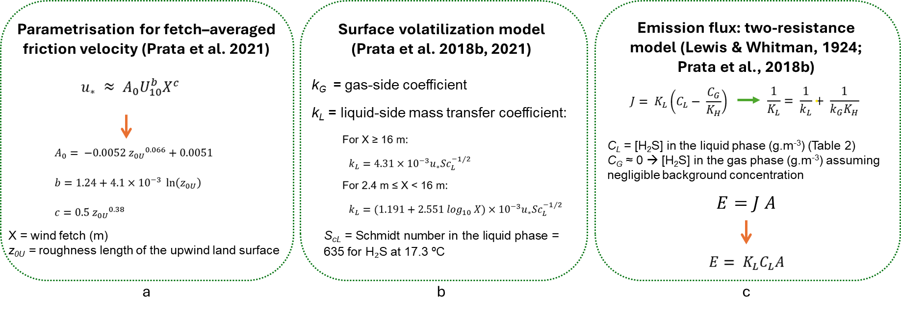
Figure 1: Schematic representation of the Prata et al. (2018, 2021) model for H₂S emission. (a) Fetch-averaged friction velocity (u*); (b) Mass transfer coefficients, with k_{L} as a function of fetch (X) and k_{G} accounting for boundary layer development; (c) Emission flux calculated using the two-resistance model, dominated by k_{L} for H₂S.
    - Biogas ebullition model
The ebullition model of Paing et al. (2003) was adopted, as shown in the schematics in Figure 2. In this approach, the H₂S emission rate is estimated from the H₂S concentration in biogas [H₂S]_{biogas} and the biogas emission rate E_{biogas}. Further details are provided by Paing et al. (2003).

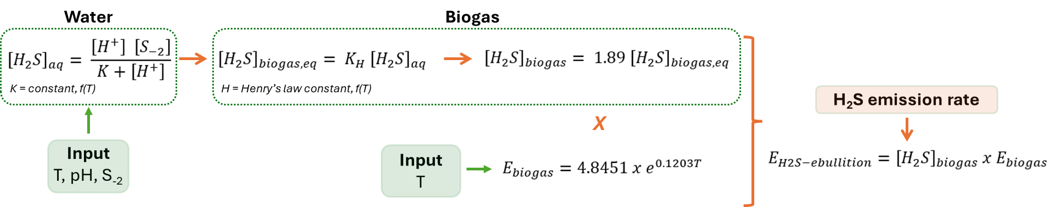
Figure 2: Ebullition model of Paing et al. (2003), where [H₂S]_{aq}, [S₋₂] and [H₂S](_{biogas,eq}) in mgS.L⁻¹; [H₂S]_{biogas} in mgS.m⁻³; E_{biogas} in L.m⁻².d⁻¹; and E_{H2S-ebullition} in mgS.m⁻².d⁻¹.
    - Dispersion modeling
The AERMOD modeling system was employed for dispersion calculations in this study (US EPA, 2024). The model domain was defined as a 10 × 10 km area centered on the source, with a 100 m grid resolution (10,000 receptors) and receptors placed at 1.5 m height. Hourly odor concentrations were calculated over this grid for a total period of one year. Sensitivity analyses confirmed the adequacy of the chosen resolution. Flat terrain with pasture land use and a uniform roughness length of 0.1 m was assumed. Downwash effects for area sources were not considered, and simulations were performed using AERMOD and AERMET (version 19191).
    - Simulation of odorant impact and emission scenarios
The analysis adopted the German Odor Impact Criterion (OIC), with 90% compliance, a threshold of 0.25 ou_{E}.m³ (peak), a peak-to-mean factor of 4, and 10% exceedance limit. Exceedance was taken to indicate significant odor impact and the need for separation zones.
Impact maps and separation areas were generated using iso-concentration contours (Kriging) and calculated via Green’s Theorem (Brancher et al., 2021), based on emission scenarios from the selected models (Table 2). The surface volatilization scenario was time-resolved (8,760 hourly emissions), while ebullition assumed constant emissions based on Paing et al.’s (2003) model. Emissions were normalized by the Odor Threshold Limit (OTL), using 5.71×10⁻¹ µg.m⁻³ for H₂S (Nagata, 2003), to obtain Odor Activity Values, which were adopted as proxy for the odor concentration due to the single effect of H₂S.

Table 2: Characteristics of the model emissions evaluated.
Scenarios | Emission pathway | Wind velocity | Odor emission rate
BE | Biogas ebullition only | Non-applicable | Constant
SV | Surface volatilization only | Hourly variation | Hourly variation
VE | Both scenarios combined (BE and SV) | Hourly variation | Hourly variation
    - Assessing different temperatures in the liquid phase
As temperature strongly influences biogas ebullition, a Monte Carlo sensitivity analysis was performed to assess its effect on emission pathways. A total of 1,000 random combinations of temperature and aqueous H₂S concentrations, within the ranges reported by Paing et al. (2003), were used to estimate emissions for both ebullition and surface volatilization under the same meteorological conditions (Section 2.2). This approach enabled evaluation of variability in emission estimates.
  - Results and Discussions
    - Odor emission rates
Figure 3 presents the time series of OAV.s⁻¹.m⁻², used as a proxy for odor emission rates (ou_{e}.s⁻¹.m⁻²), for the BE, SV, and VE scenarios. Due to differences in magnitude, the vertical axis is shown on a logarithmic scale.
A clear difference in emission magnitude was observed between pathways. Emission rates estimated by SV were consistently higher than those associated with biogas ebullition (BE) throughout the entire period. Consequently, the VE scenario closely follows the SV results, indicating that surface volatilization is the dominant pathway controlling H₂S emissions in the hypothetical anaerobic pond analysed. This demonstrates that volatilization cannot be neglected in odor impact assessments or sulfur mass balances in anaerobic ponds.
These findings are consistent with previous studies indicating that volatilization and stripping are key mechanisms governing atmospheric emissions of H₂S (Beghi et al., 2012). While biogas bubbling contributes to emissions, the dominance of surface volatilization suggests that models considering only ebullition may substantially underestimate total emissions. Furthermore, the magnitude of volatilization emissions provides a plausible explanation for the sulfur mass balance discrepancy reported by Paing et al. (2003), where a significant fraction of sulfur could not be accounted for by measured pathways. The results suggest that neglecting surface volatilization may lead to underestimation of atmospheric H₂S emissions and misrepresentation of sulfur fluxes in anaerobic ponds.

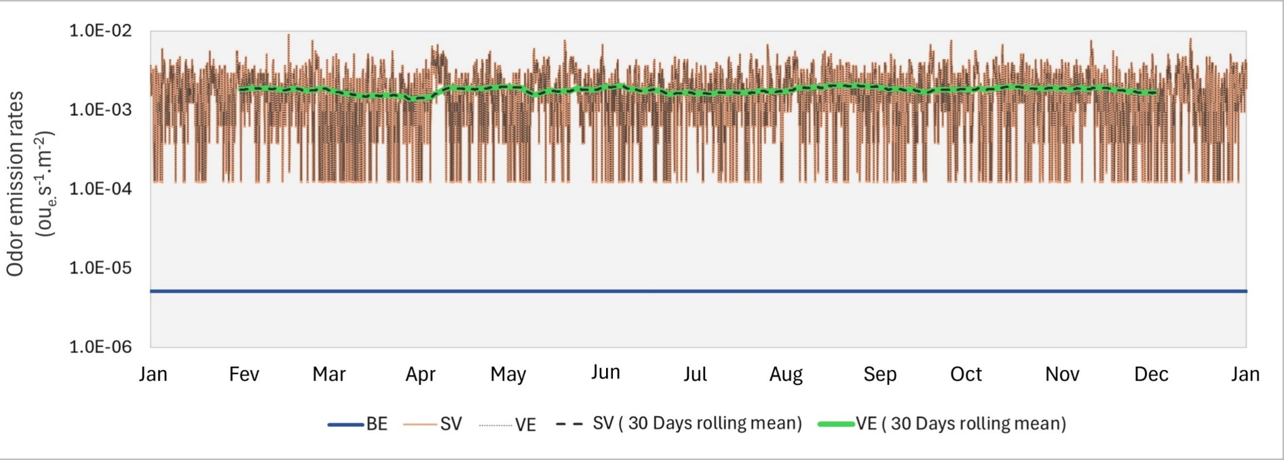
Figure 3: Temporal dynamics of simulated odor emissions. Odor emission rates, expressed in ou_{e}.s⁻¹.m⁻², calculated hourly for the scenarios BE, SV and VE. To highlight general patterns, 30-days rolling means for SV and VE scenarios are also plotted.
    - Separation distances
Emission rates from the BE, SV, and VE scenarios were used in AERMOD to estimate separation distances, with impact areas defined by contour lines exceeding the adopted OIC threshold (Figure 4).
Substantial differences were observed between scenarios. The BE scenario produced much smaller impact areas, while SV closely matched VE, indicating that surface volatilization dominates H₂S emissions in terms of odor impact. This highlights the importance of including volatilization in dispersion-based assessments.
Despite adopting the relatively permissive German OIC, the SV and VE scenarios resulted in extensive impact areas. This reflects the high emission rates and suggests that nearby populations may experience significant odor nuisance, reinforcing the need for appropriate land-use planning.
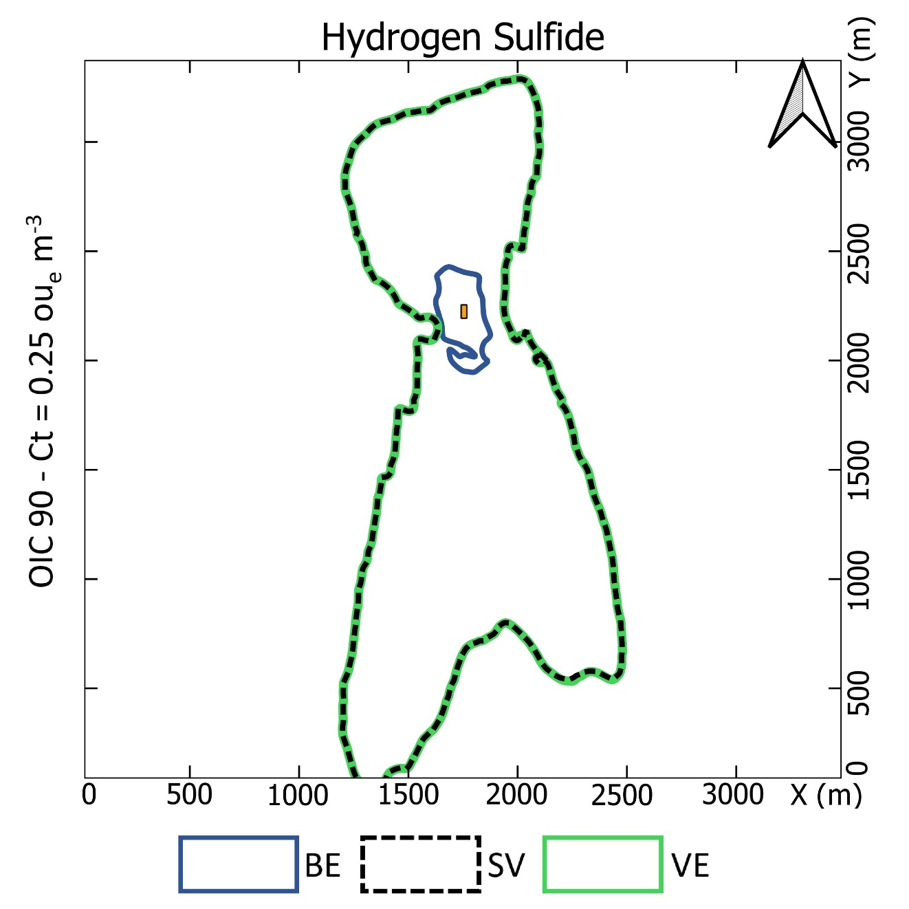
Figure 4: Separation distances estimated for each scenario as contour lines, enclosing the area of exceedance of the OIC (section 2.6).
    - Monte Carlo simulation
The Monte Carlo analysis (Figure 5) showed that H₂S emissions via surface volatilization are significantly higher than those from biogas ebullition. While ebullition results exhibited lower variability, with values concentrated around the mean, surface volatilization presented higher mean emissions and greater dispersion, reflecting its dependence on meteorological conditions, particularly wind speed.
Quartile analysis confirmed that volatilization yields higher emissions across most of the distribution, whereas ebullition displayed greater skewness and heavier tails. Statistical tests indicated a highly significant difference between pathways, demonstrating that the observed differences are systematic rather than due to random variation.
These results highlight the distinct sensitivities of the two mechanisms. While biogas ebullition is primarily controlled by physicochemical conditions such as temperature and pH, surface volatilization is strongly influenced by atmospheric dynamics, including wind speed and surface roughness, which affect turbulence at the air–water interface. Additional simulations under higher temperature conditions indicated that, although ebullition emissions increase, they remain substantially lower than those associated with surface volatilization.

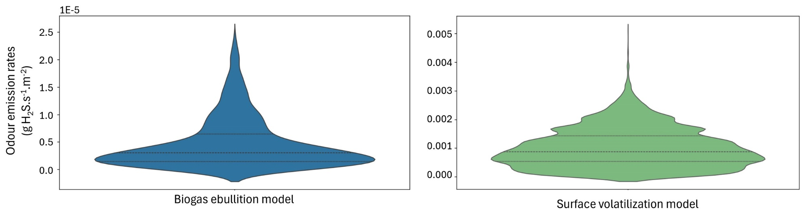
Figure 5: Odor emission rates (g H₂S.s⁻¹.m⁻²) for biogas ebullition, based on Monte Carlo simulations, and for surface volatilization. The violin plots illustrate the variability in emission rates for the models evaluated. Note the use of different scales in the emission rate axis.
  - Conclusions
This study demonstrates the critical importance of accounting for surface volatilization when assessing odor emissions from anaerobic ponds in wastewater treatment plants. Surface volatilization was identified as the dominant pathway controlling H₂S emissions and associated odor impacts, consistently exceeding emissions from biogas ebullition across all scenarios analysed.
The results also highlight the distinct controlling mechanisms of each pathway, with volatilization strongly influenced by meteorological conditions and ebullition governed by physicochemical processes. These differences reinforce the need to integrate multiple emission pathways in modeling approaches.
An emission modeling framework combining both volatilization and biogas ebullition is therefore recommended to provide more realistic inputs for dispersion modeling and odor impact assessment. Such an approach is essential for improving environmental management, supporting land-use planning, and minimizing odor nuisance in communities surrounding wastewater treatment facilities.
Future research should focus on refining emission models and evaluating their applicability under different operational and climatic conditions.
Funding and Acknowledgements
This study was supported by the Environmental Institute of Santa Catarina (IMA-SC), the state agency responsible for environmental licensing, monitoring, and regulation in Santa Catarina, Brazil, in line with its mission to promote environmental protection and sustainable resource management.
The authors acknowledge IMA-SC for supporting the integration of scientific research and environmental regulation. Given the widespread use of anaerobic stabilization ponds in the region and the relevance of associated odour emissions, this study contributes to improving regulatory approaches for wastewater treatment systems and odour impact assessment.
A. Prata was a Visiting Fellow at the UNSW School of Civil and Environmental Engineering, UNSW Sydney, and the ARC Training Centre for the Transformation of Australia’s Biosolids Resources.
References
Bazemo, U., Gardner, E., Romero, A., Hauduc, H., Al-Omari, A., Takacs, I., Murthy, S., Torrents, A., De Clippeleir, H., 2021. Investigating the dynamics of volatile sulfur compound emission from primary systems at a water resource recovery facility. Water Environment Research, 93, 316–327. https://doi.org/10.1002/wer.1417
Beghi, S.P., Santos, J.M., Reis, N.C., De Sá, L.M., Goulart, E.V., De Abreu Costa, E., 2012. Impact assessment of odours emitted by a wastewater treatment plant. Water Science Technology, 66, 2223–2228. https://doi.org/10.2166/wst.2012.409
Brancher, M., Hoinaski, L., Piringer, M., Prata, A.A., Schauberger, G. 2021. Dispersion modelling of environmental odours using hourly-resolved emission scenarios: Implications for impact assessments. Atmospheric Environment: X, 12, 100124. https://doi.org/10.1016/j.aeaoa.2021.100124
Brancher, M., Knauder, W., Piringer, M., Schauberger, G. 2020. Temporal variability in odour emissions: To what extent this matters for the assessment of annoyance using dispersion modelling. Atmospheric Environment: X, 5, 100054. https://doi.org/10.1016/j.aeaoa.2019.100054
Brutsaert, W. 1975. A theory for local evaporation (or heat transfer) from rough and smooth surfaces at ground level. Water Resources Research, 11, 543–550. https://doi.org/10.1029/WR011i004p00543
Coggins, L.X., Crosbie, N.D., Ghadouani, A. 2019. The small, the big, and the beautiful: Emerging challenges and opportunities for waste stabilization ponds in Australia. WIREs Water 6, 1–18. https://doi.org/10.1002/wat2.1383
Kottek, M., Grieser, J., Beck, C., Rudolf, B., Rubel, F. 2006. World map of the Köppen-Geiger climate classification updated. Meteorologische Zeitschrift 15, 259–263. https://doi.org/10.1127/0941-2948/2006/0130
Lewis, W.K., Whitman, W.G. 1924. Principles of Gas Absorption. Industrial & Engineering Chemistry, 16, 1215–1220. https://doi.org/10.1021/ie50180a002
Nagata, Y. 2003. Measurement of Odor Threshold by Triangle Odor Bag Method. Odor measurement review. Japan Environmental Sanitation Center, Tokyo, Japan.
Paing, J., Picot, B., Sambuco, J.P. 2003. Emission of H2S and mass balance of sulfur in anaerobic ponds. Water Science Technology, 48, 227–234. https://doi.org/10.2166/wst.2003.0125
Picot, B., Paing, J., Toffoletto, L., Sambuco, J.P., Costa, R.H.R. 2001. Odor control of an anaerobic lagoon with a biological cover: Floating peat beds. Water Science Technology, 44, 309–316. https://doi.org/10.2166/wst.2001.0562
Prata, A.A., Santos, J.M., Timchenko, V., Stuetz, R.M. 2021. Modelling atmospheric emissions from wastewater treatment plants: Implications of land-to-water roughness change. Science of Total Environment, 792, 148–330. https://doi.org/10.1016/j.scitotenv.2021.148330
Prata, A.A., Santos, J.M., Timchenko, V., Stuetz, R.M. 2018. A critical review on liquid-gas mass transfer models for estimating gaseous emissions from passive liquid surfaces in wastewater treatment plants. Water Research, 130, 388–406. https://doi.org/10.1016/j.watres.2017.12.001
US EPA, 2024. User’s Guide for the AMS/EPA Regulatory Model (AERMOD). Environmental Protection Agency, Research Triangle Park, North Carolina, US.
Zarra, T., Naddeo, V., Belgiorno, V., Reiser, M., Kranert, M. 2008. Odour monitoring of small wastewater treatment plant located in sensitive environment. Water Science Technology, 58, 89–94. https://doi.org/10.2166/wst.2008.330

