 CHEMICAL ENGINEERING TRANSACTIONS  VOL. xxx, 2026 | A publication of  
The Italian Association
of Chemical Engineering
Online at www.cetjournal.it

Guest Editors: Laura Capelli, Marzio Invernizzi, Selena Sironi
Copyright © 2026, AIDIC Servizi S.r.l.
ISBN 979-12-81206-xx-x; ISSN 2283-9216

Application of olfactometry to assist odour regulation in Abu Dhabi
Mansour A. Alkatheeri*ª, Nigel Gibson^{b}, Sounak Ghosh^{c}, Asma A. Alhanaeeª, Mariam AlMemariª, Nasser S. AlNuaimiª, Rashed M. Ekaabiª, Meera Alyafei^{c}
ªEnvironment Agency – Abu Dhabi, Al Mamoura Building, Muroor Road UAE
^{b}Ricardo, Harwell Campus, Didcot Oxfordshire, UK
^{c}Envirozone L.L.C. Abu Dhabi Industrial City, Abu Dhabi, UAE

mansour.alkatheeri@ead.gov.ae
This paper details an investigation using olfactometry to support odour regulation in Abu Dhabi. The investigation measured odour emissions from a cattle farm and found that odour release rates are much higher in the Emirate compared to similar facilities in Europe. Air pollutant dispersion modelling was carried out to further understand the extent of the potential impact on receptors near the farm. The modelling found that the adopted odour benchmark of 3 ou_{E}/m³ as a 98th%ile would be exceeded at nearby properties and showed the need for emission reduction to minimize impact of unpleasant odour. The study also shows how the findings can assist in land use planning close to single farms or multiple farms so that odour does not infringe on the quality of life of the new inhabitants.
Key words: odour measurement, olfactometry, odour benchmarks, odour modelling, mitigation.
  - Introduction
Odour can be a significant contributor to air quality and pollution concerns. Offensive odours may have adverse effects on people’s lives and well-being, which can result in conflicts between those experiencing the odour and those who release them. The Environment Agency Abu Dhabi (EAD) has been tasked to develop an odour management system as part of the Emirate's commitment to monitor and improve the levels of ambient odours, to keep pace with the continuous expansion of the urban areas, the increase of the population density in the residential areas and the surrounding infrastructure and human activities (UAE, 2021).

Currently EAD has used hydrogen sulphide (H₂S) sensors to monitor potential odours released from the significant oil and gas sector in the region. These measurements are then compared to the World Health Organization’s annoyance threshold (WHO, 1991) to establish whether levels of ambient odours are at acceptable levels. However, during a recent comprehensive review of agricultural, industrial, sewage and waste facilities in the Emirate, EAD found that although H₂S could contribute to ambient odour in some circumstances (wastewater treatment and landfills), there was a wide range of activities that emitted other odorous chemicals. In many situations, the emitted odorants are present in very low concentrations in the dispersing plume, hence these can be challenging to measure using chemical methods. Furthermore, where emissions do contain mixtures of chemicals the odour threshold cannot be predicted based on the thresholds of the individual odorants in the mixture. Therefore, the use of human noses through olfactometry is the most reliable way to measure odour concentrations.

EAD have decided to consider alternative methods to the current sensor-based approach and have identified that various papers have reviewed the range of odour assessment criteria in use. The papers (M Brancher et al (2017), C Conti et al (2020), A Bokowa et al (2021) summarize the range of odour benchmarks that rely on thresholds based on odour concentration that are used across numerous jurisdictions. The reviews showed that the odour benchmarks varied:
- In the threshold that set to protect against unreasonable annoyance, ranging from 0.5 to 10 ou.m⁻³ depending on the likely offensiveness of the emission. EAD chose to adopt a sliding scale to reflect the most, moderate and the less offensive odour sources.
- In the average time applied, ranging from 3 minutes to 1 hour. EAD chose to adopt a 1 hour average to avoid additional uncertainty associated with shorter averaging times.
- In the model statistic that is applied, ranging from a 97th percentile to 99.5th percentile. EAD chose to adopt a 98th percentile as this is most widely applied statistic.
- In the peak to mean factor that is applied, ranging from 1 to 7.8. EAD recognized that many factors influence this factor (e.g. release height, atmospheric stability etc.) and chose not to apply a peak to mean factor.
In summary, EAD has chosen to consider deploying an odour benchmarking system that allows thresholds to be linked to the potential unpleasantness or offensiveness of the odour likely to be emitted from an installation. The odour benchmarking selected was:

- 1.5 ou_{E}m⁻³ as a 98th%ile of 1-hour averages for highly offensive operations such as sewage treatment, landfill, oil and gas operation treating sour gas/oil,
- 3.0 ou_{E}m⁻³ as a 98th%ile of 1-hour averages for moderately offensive operations such as intensive farming, food processing, surface coating etc.
- 6.0 ou_{E}m⁻³ as a 98th%ile of 1-hour averages for least offensive operations such as coffee roasting, fragrance manufacture, bread baking.
  - Application of the odour management system to the dairy sector
EAD recognize that in order to understand and manage odour from a sector it is necessary to determine the scale of odour emission that needs to be regulated. EAD considered various options for scaling odour emissions, for the dairy sector these include:
- using the hydrogen sulphide and VOC emission estimate methodology set out in the USEPA AP42 Chapter 9 covering livestock and poultry feed operations. This took account of various housing systems serving the dairy sector and considered factors linked to the scaling of pollutant emissions in terms of hydrogen sulphide and VOC. The factors considered were animal number, ambient temperature, wind speed and ambient relative humidity.
The hydrogen sulphide emission estimate for a mechanically ventilated shed with surface scraping to remove slurry is given as Ln(H2S) =6.287004+ 0.86173 * animal number + 0.012786 Ambient Temperature. In the Abu Dhabi context the average ambient temperature is about 35°C, rising to about 50°C in the summer. This gives a hydrogen sulphide emission contribution of 70.6 µg H₂S.s⁻¹.cow⁻¹ for the average temperature, rising to 85.5 µg H₂S.s⁻¹.cow⁻¹ for the higher summer temperature. By applying an hydrogen sulphide odour threshold of 0.7µg.ou⁻¹, the hydrogen sulphide based odour emission estimate would be about 101 ou.s⁻¹. cow⁻¹ and 122 ou.s⁻¹. cow⁻¹ for average and summer temperatures.
The VOC emission estimate for a mechanically ventilated shed is set at 187.8 µg VOC.s⁻¹.cow⁻¹. Using an odour threshold estimate of 5.0µg.ou⁻¹, the odour emission contribution would be about 37.5 ou.s⁻¹. cow⁻¹. No
It is unclear whether the odour emission rate estimate provided by the use of the USEPA AP42 approach took account of odorants.
- using published olfactometry measurement to estimate emission from dairy farming. For this purpose EAD relied on odour emission factors for several different bedding arrangements (see Table 1.) based on measurement from Poland and United States.
The odour emission rate estimate derived using olfactometry would have taken all odorants present into account,
For the purpose of initial sector impact evaluation, EAD chose to assess the impact of the dairy sector on the basis of 100 ous⁻¹cow⁻¹. The evaluation work was then underpinned by site-specific olfactometry assessment described here was to verify, or otherwise, the odour emission factor for a cow on a large dairy farm in the Abu Dhabi setting.
Table 1: Odour emission data for animal housing on dairy
Odour source | Odour emission factor (ou_{E}s⁻¹cow⁻¹) | Country | Reference
Deep litter | 49.5 – 168.4 | USA | Mosquera et al 2006)
Cubicles  Deep litter  Shallow litter | 22.6 – 387.1  28.9 – 396.6  6.8 – 97.7 | Poland | Mielcarek and Rzeźnik (2014).

The total odour emission (ou_{E}s⁻¹) from a specific dairy facility can then be estimated as product of the number of cows and the odour emission factor. The drawback in using published odour emission data is that the data measured on farms in Europe or North America, may not reflect the emissions associated with climate, the production system and management practices used in Abu Dhabi. In Abu Dhabi:
- The average temperature is around 35°C, but summer temperatures can reach 50°C increasing microbial activity and odour volatilization.
- Evaporative cooling and roof fans are widely used to avoid heat stress; the excess moisture added to bedding will increase microbial activity.
- Slurry is scrapped from the dunning row and bedding area up to three times a day. Depending on the production system the scrapped slurry may be spread across the paddock area.
These local practices may exacerbate odour generation and emission.

  - DAIRY FARM LAYOUT
For this study, EAD secured access to a 6,000-cow dairy farm, which supplies milk to its own dairy processing facility, which is either for bottled or further processed to produce yoghurt and cheese products. The farm was visited in September 2024, reflecting conditions during a summer period.

The farm is situated in rural land alongside a large number of smaller farms. Residential dwellings in this area are considered to reflect the general population linked to a major conurbation.

To manage cow welfare; control feeding; and manage cow access to the milking parlor three times a day, the farm housed cows in groups of 120 within a zone. Each zone comprises areas for placing rations along the central roadway through the building, a concrete road where cows access their rations, a sand covered bedding area served by fine water sprays and roof fans for cooling purposes and an external paddock.

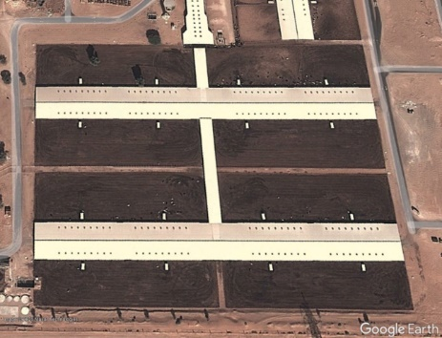 | 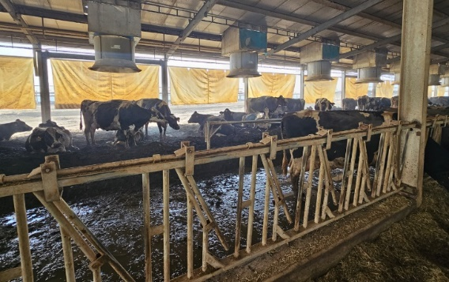
Figure 1: A typical dairy feedlot with housing in eight zones and internal of an animal house showing the bedding area with roof cooling fans, feeding row and internal roadway
The odour emissions from this type of dairy facility are primarily linked to placement of fresh feed, slurry on concrete road surfaces and bedding, and waste that accumulates on and within the sand across the paddock. A large dairy farm will also have an effluent treatment plant [ETP] to deal with wastewater and a storage area where sand contaminated with dried slurry is stored awaiting treatment or disposal. These contributions need to be evaluated in order to establish an odour emission factor which is representative of these activities in Abu-Dhabi.

  - METHODOLOGY USED TO DETERMINE ODOUR FLUX
Odour assessment and analysis methods used in this study were all carried out based on the requirements of BSEN 13725 (2022), covering: sampling, sample collection and olfactometry analysis. The overall assessment methodology followed the approach recommended in the UK and Ireland (Irish EPA 2019).

Most emission sources within the dairy facility are linked to the accumulation of slurry or dirty sand on the ground. To obtain a representative sample from the surface where there is no air flow a Lindvall hood was employed. The Lindvall hood is connected to an air blower to provide ‘sweep’ air, a carbon filter used to ensure that the sweep air is odour free, and ducting to connect blower, filter and hood together. The hood is designed so that ‘sweep’ air can pass over the surface as the air moves from inlet to outlet. A Lindvall hood factor is obtained from the hood dimension and is the product of the height of the hood (160mm), the width of the flow path (160mm) and the area covered by the hood (960mm x 960mm). For the hood shown, the factor was 0.028 (dimensionless). To allow the surface emission rate to be calculated the velocity of the air leaving the hood was measured at 0.5ms⁻¹. The air as it leaves the Lindvall hood is collected in a Nalophan sample bag by evacuating the sampling drum.

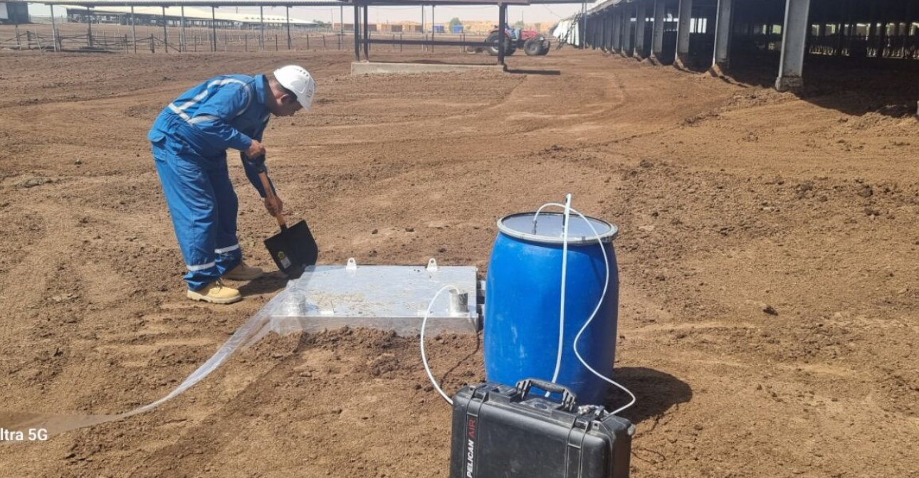 | 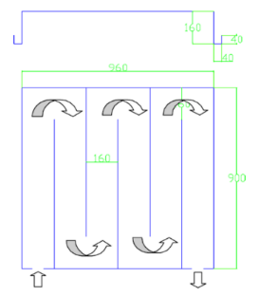
Figure 2: Image of Lindvall hood sampling system being place within a paddock area and a schematic image showing the dimensions of the Lindvall hood

Air samples were collected from a number of different emission types representing the main sources of odour on site. The odour samples were transported to an olfactometry lab that had been set up to allow the olfactometry analysis to meet the requirements of BSEN 13725. The aim of the olfactometry analysis is to determine the odour concentration. The odour concentration of an odorous gas sample is determined by presenting a panel of assessors with the odour sample, varying the concentration by diluting with odourless air, in order to determine the dilution factor to reach the point where 50% of the odour panel can and cannot detect the odour in the sample. That dilution factor is the odour concentration (expressed in ou_{E}m⁻³). As part of setting up the olfactometry lab it was necessary to select a panel of assessors based on their acuity.
Figure 3: Sampling drum arrangement used to collect the odour sample

The panel selection comprised of:

Panel selection assessment - 10 people participated in the selection assessment. The selection process involved determining the individual threshold values for n-butanol for each delegate several occasions.
Identify those participants whose olfactory response complied with the BSEN requirement:
- The antilog of the standard deviation of individual threshold estimates (ITE) calculated from the logarithms (log10) of the ITE, expressed in mass concentration units of the reference odorant gas, has to be less than 2.3.
Figure 4: Olfactometry panel in operation
- The geometric mean of the ITE of a known substance, expressed in mass concentration units of the reference odorant gas, shall fall between 0.5 times and 2 times 40ppb within the range 20ppb – 80 ppb.
Performance checks with butanol were carried out during each panel session to ensure continued compliance.

  - ODOUR FLUX AND ODOUR EMISSION RATE ESTIMATES
The olfactometry analysis provided a measure of the dilution to detection threshold. This dilution factor is the odour concentration. Table 2 presents the odour concentration determined for each odour sample collected using the Lindvall hood. Table 2 also defines the hood factor and the velocity of the sweep air passing through the Lindvall hood used. The odour flux is product of the odour concentration, the hood factor and the air velocity. It is recognised that practical aspects of the sampling (e.g. the state and nature of the surface where the Lindvall hood was applied) and olfactometry analysis (e.g. panel selection, dilution accuracy etc.) will introduce some uncertainty into the process.

The odour emission derived from the sampling exercise is linked to the area associated with:
- a house zone, and the 120 cows housed in that zone; and
- site wide facilities such as effluent treatment that serves the entire 6000 cows on site.

The individual contributions to the total odour emission rate presented in Table 2 have been normalized based on a housing zone. The sum of the odour emission estimates was 53,942 ou_{E}s⁻¹ per zone or 449.5 ou_{E}s⁻¹cow⁻¹. This emission factor was estimated during the summer when local conditions are likely to exacerbate odour generation and emission. The site-specific emission factor, expressed as ou_{E}s⁻¹cow⁻¹, was approximately 4.5 times higher than had originally been considered by EAD and exceeded USEPA AP42 odour emission estimate and the highest estimated based on the published Polish and US dairy odour emission data (see Table 1).

Table 3. Odour emission data measured at various emission sources on dairy
Sample location | Odour conc.  (ou_{E}m⁻³) | hood  (unitless) | Air velocity through hood (ms⁻¹) | Odour flux (ou_{E}m⁻²s⁻¹) | Area allocated to housing zone (m²) | Total odour emission rate (ou_{E}s⁻¹)
Feed lane | 3018 | 0.027 | 0.5 | 41 | 78 | 3198
Dunning row | 1842 | 0.027 | 0.5 | 25 | 320 | 8000
Bedding area | 499 | 0.027 | 0.5 | 7 | 320 | 2240
Paddock area | 742 | 0.027 | 0.5 | 10 | 3972 | 39720
Manure stockpile | 1877 | 0.027 | 0.5 | 26 | 24 | 624
ETP - aerated tank | 927 | 0.027 | 0.5 | 13 | 12 | 156
ETP – reception pad | 214 | 0.027 | 0.5 | 3 | 1 | 3
ETP - primary settlement | 499 | 0.027 | 0.5 | 7 | 0.2 | 1.4
ETP - final settlement | 36 | 0.027 | 0.5 | 0.5 | 0.2 | 0.1

  - ODOUR IMPACT ASSESSMENT
The estimated emission factor was used as the basis of an odour dispersion modelling exercise. This was carried out:
- using the USEPA AERMOD dispersion model over a study area in a 10km-by-10km grid centered on the host farm;
- using five years meteorological data measured at Abu Dhabi International Airport;
- assuming the topography was flat; and
- to calculate the 98th percentile of hourly average (for consistency with the recommended odour benchmark scheme).

The dispersion modelling results were presented as composite map (see Figure 5) based on the maximum concentration from the five years meteorological data to represent the worst-case scenario. In addition to the impact of the host farm, the dispersion model was run using the site-specific emission factor applied to all the other dairy operations in the area.

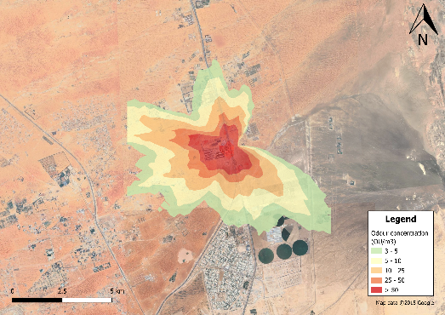 | 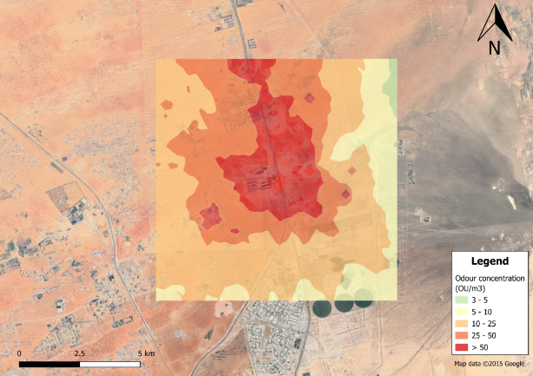
Figure 5: Estimated impact of the individual farm (left) and the total impact of all farms on odour (right)
The odour impact for the host farm shows that several nearby residential receptors fall within contours that exceed 3 ou_{E}m⁻³ as a 98th%ile, indicating that nearby receptors may be exposed to noticeable and unpleasant levels of farm type odour. From a regulatory point of view the impact assessment shows that improvement to control emission is required to reduce impact to comply with the odour benchmark.

The results of the ‘in combination’ farm impact assessment show that agricultural odour is likely to be noticeable over a wide area at level in excess of the odour benchmark. On the regional scale this means that those living in the region are likely to experience a noticeable odour which could be classed as an annoyance. From a regulatory point of view the regional odour map is important in land use planning either to regulate the development of agricultural concerns or to advise on where land can be developed for commercial or residential purposes, especially where the development may bring new people into the area.

  - CONCLUSIONS FROM THE STUDY
In order to establish the scale of impact from the dairy sector in the Emirate, EAD have considered a number of approaches, including the use of USEPA pollutant emission factors and published olfactometry-based odour studies. These have been compared to site-based olfactometry measurements at a farm in Abu Dhabi.

The study demonstrates how useful an olfactometry-based assessment can be and has shown that the unit emission from the dairy farm exceeded the emission estimates derived using the USEPA AP42 methodology and the highest olfactometry-based emission factors reported in studies in Europe and the United States. The Emirate based emission estimate was found during the summer operating period. It is foreseen that emissions following rain events or during winter periods could give different results and should be investigated. The study has assumed that the unit emissions apply to all farm sizes, however it is likely that waste management on smaller farming concerns is likely to be less effective, again this needs to be investigated.

The host farm is likely to have a significant impact on odours on its own and ‘in-combination’ with other farms leading to annoyance and dissatisfaction across the receiving population.

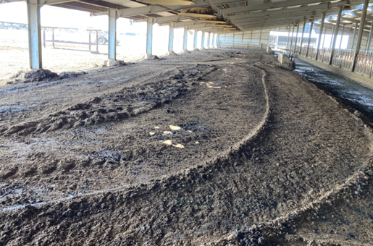
The study has shown that odour is linked to practices used to deal with slurry arisings. The results suggest that the largest impact is tied to the paddock and will be caused by the spreading of slurry from the dunning row and bedding area resulting in the sand on the paddock becoming increasingly contaminated. Review of current practices identified that a ‘common sense’ management approach could be incorporated to improve emission control from the animal house. This approach would require slurry to be completely removed from the dunning row and bedding area, reducing the need to spread wet slurry on the paddock area. This in turn would result in less contaminated sand in the paddock reducing the need to manage dirty sand. Management of dirty sand on the paddock could involve treatment with lime which will reduce hydrogen sulphide type odour but will increase the emission of ammonia and amines.
Figure 6: Al Ain farm bedding area

The slurry scraped from the dunning row can be treated e.g. in an anaerobic digestor. The contaminated sand in the bedding area can be washed, the clean sand can be reused, and dirty water can be treated, e.g. in an anaerobic digestor.

Adoption of this type of strategy would reduce the rate at which contaminated sand builds up around the animal house. Other potential options could be to wash remove residual slurry on the dunning row. The slurry laden wastewater would then pass to the on-site ETP for treatment. Removing slurry from around the animal houses should reduce the amount of material that can decompose to produce ammonia and hydrogen sulphide, either of which could be used as an on-site marker monitoring the performance of slurry removal. Improved management of raw materials (feed) and waste on site will contribute to the overall odour reduction. Odour arising from the storage, mixing, application of feed and removal of residues, particularly during the hot summer months, adds to the total odour emission from the site. Odour emissions can be reduced by improved fresh feed management, storage of feed out of the sun, and handle feed and mixed feed so that it does not become warmed (i.e. by the exposure to the sun or by the onset of the action of composting).

Overall, the study has shown that emissions from this sector in the Emirate are likely to make a strong contribution to agricultural odours in the area which will adversely affect the existing population. Care needs to be taken with any future development as this is unlikely to be tolerated by people populating new developments. Any development may need to go hand in hand with improved odour management on the farms.
REFERENCES
Bokowa, A.; Diaz, C.; Koziel, J.A.; McGinley, M.; Barclay, J.; Schauberger, G.; Guillot, J.-M.; Sneath,
R.; Capelli, L.; Zorich, V, 2021: Summary and Evaluation of the Odour Regulations Worldwide. Atmosphere 12, 206.
Brancher, M.; Griffiths, D.; and Franco, D, 2017:A review of odour impact criteria in selected countries around the world Chemosphere 168 .
BSEN 13725, 2022: Stationary source emissions - Determination of odour concentration by dynamic olfactometry and odour emission rate.
Clean Air Strategic Alliance ‘Good Practices Guide For Odour Management In Alberta (2015)
Conti, C., Guarino, M., and Bacenetti, J., 2020: Measurements techniques and models to assess odor annoyance: A review. Environment International 134 .
Irish Environmental Protection Agency ‘Odour Emissions Guidance Note (Air Guidance Note AG9) (2019)
Mosquera j., Hol j. M. G., Monteny G. J. Gaseous emissions from a deep litter farming system for dairy cattle. International Congress Series 1293, 291, 2006.
Mielcarek, P. and Rzeźnik, W, 2015: Odor Emission Factors from Livestock Production Pol. J. Environ. Stud. 24, 1, 27-35, 2014.
United States Environmental Protection Agency draft_ap-42 section-9.4._Livestock and poultry feed operations (2024).
The United Arab Emirates General Environmental Policy, 2021.
WHO, 1991: Air Quality Guidelines For Europe, 2nd edition

