 CHEMICAL ENGINEERING TRANSACTIONS  VOL. xxx, 2026 | A publication of  
The Italian Association
of Chemical Engineering
Online at www.cetjournal.it

Guest Editors: Laura Capelli, Marzio Invernizzi, Selena Sironi
Copyright © 2026, AIDIC Servizi S.r.l.
ISBN 979-12-81206-xx-x; ISSN 2283-9216

Development of a portable multi-detector for indoor air quality monitoring in schools: preliminary results about formaldehyde measurements
Hamza Jebeniani^{a,b,*}, André Canosa^{b}, Amina Meslemª, Gisèle El Dib^{b}
ªUniversité de Rennes, Laboratoire de Génie Civil et Génie Mécanique (LGCGM), Rennes, France
^{b}Université de Rennes, Institut de Physique de Rennes (IPR), Rennes, France
hamza.jebeniani@univ-rennes.fr
Indoor air quality (IAQ) in schools is a major public-health concern, as pupils and staff spend extended periods in classrooms where air renewal, occupancy, and material emissions interact. A portable multi-detector was developed to monitor key indoor pollutants, namely carbon dioxide, particulate matter, total volatile organic compounds, and formaldehyde, using compact low-cost sensors integrated into an embedded acquisition system.
The paper focuses on the description of the multi-detector and presents measurements obtained during a six-week campaign conducted in fourteen classrooms across five elementary schools under real operating conditions, with particular attention to formaldehyde data.
Results show significant spatial and temporal variability of formaldehyde concentrations between classrooms, with median values ranging from 2 to 28 ppb. All measured concentrations remain below the WHO and ANSES short-term guideline (80 ppb), while only five classrooms exhibit median values below the French long-term guideline of 8 ppb. These findings highlight the relevance of multi-parameter monitoring for assessing exposure to indoor pollutants in school environments.
  - Introduction
Inadequate indoor air quality in schools affects health, comfort and learning conditions because pupils and teachers remain exposed for several hours each day. Sadrizadeh et al. (2022) reviewed classroom worldwide studies and showed that school environments frequently combine insufficient ventilation with exposure to particulate matter, carbon dioxide and gaseous pollutants.
Continuous measurements performed directly in classrooms are therefore essential to correlate pollutant levels with occupancy, ventilation behavior and indoor emission sources, and eventually apply appropriate mitigation actions. This context supports a monitoring strategy that does not rely solely on carbon dioxide as a ventilation indicator but also on a variety of pollutants and environmental parameters to provide a more comprehensive understanding of indoor air quality dynamics.
Among indoor pollutants, formaldehyde, a colorless, corrosive, flammable gas with a pungent and suffocating odor, deserves particular attention due to its health effects, including respiratory irritation and potential long-term risks such as carcinogenicity (WHO, 2010). Consequently, a substantial body of literature addresses formaldehyde monitoring in indoor environments (Trocquet, 2023). For instance, Salthammer et al. (2010) identified formaldehyde as a major indoor pollutant emitted from wood-based products, furnishings, and coatings. In school settings, Tang et al. (2009) showed that concentrations are typically higher in newer buildings and during warmer periods, highlighting the role of material emissions and environmental conditions. Poulhet et al. (2014) further demonstrated that multiple emission sources can coexist within a single classroom, with a significant contribution from construction and furnishing materials. Then, while carbon dioxide remains relevant for tracking occupancy and air renewal, formaldehyde monitoring is required since it has specific emission sources that can persist independently of occupancy levels.
Regulatory guidelines have been established to limit exposure to formaldehyde in indoor environments. The World Health Organization (WHO) recommends a guideline value of 100 µg/m³ (approximately 80 ppb) for short-term exposure (i.e. over 30-minute periods at lifelong exposure), similarly to the French national agency ANSES. For a 2-hour exposure, ANSES recommends a maximum value of 50 µg/m³ (Trocquet, 2023), and the French government has established an annual average threshold of 10 µg/m³ (approximately 8 ppb) in public buildings, including schools (Decree n° 2011-1727, 2011). Although medium- or long-term exposure can be monitored using standard techniques such as passive samplers, continuous monitoring with high temporal resolution becomes essential to better understand short-term pollutant dynamics in classroom environments.
The development of compact and low-cost sensors now enables the design of portable multi-parameter systems capable of tracking several pollutants simultaneously. Accordingly, the objective of this work is to develop and deploy a fast-response portable multi-detector in school environments. The following sections describe the developed device and present formaldehyde measurements obtained during a recent campaign conducted in several elementary schools in western France.
  - Materials and methods
    - System overview
The developed prototype consists in a portable multi-detector designed for indoor air quality monitoring in school environments. It integrates sensors for carbon dioxide, particulate matter, total volatile organic compounds, and formaldehyde, combined with an embedded communication and acquisition system.
In addition to pollutant-specific sensors, environmental parameters such as temperature, relative humidity, light intensity, and acoustic levels are monitored to provide contextual information for interpreting pollutant dynamics. These parameters are known to influence both emission processes and sensor response, particularly formaldehyde, whose emissions are strongly affected by temperature and humidity conditions (Liang et al., 2016).
The sensing elements are integrated on a custom-designed printed circuit board (PCB) and interfaced with an embedded microcontroller (Arduino ESP32) responsible for data acquisition and transmission. The sensors provide electrical signals that are converted into physical quantities such as gas concentrations, temperature, and relative humidity. This configuration ensures consistent and directly interpretable measurements across the monitored environments. The developed prototype is shown in Figure 1.a.
    - Sensors
Table 1 presents the sensors selected for the prototype, along with their target parameters, measurement technologies, and main characteristics. The selected devices are supported by previous studies, confirming their suitability for indoor air quality monitoring applications (McGarry et al., 2025; Zusman et al., 2020; Hong et al., 2023; Pei et al., 2023; Báthory et al,2022).
In addition to the sensors listed in Table 1, a commercial Aranet4 Home device was used as a reference for carbon dioxide measurements, providing an independent benchmark to assess the performance of the integrated CO₂ sensor.
Table 1: Sensors selected for the portable multi-detector and their main characteristics
Sensor | Target | Technology | Nominal range | Interface | Accuracy
Sunrise  PMS7003  SGP40  SFA30  BH1750  PCB Artist | CO₂  Particles  TVOC  H₂CO  Brightness  Sound | NDIR  Mie scattering  MOX  Electrochemical  Photodiode  MEMS microphone | 400–10⁴ ppm  0.3–10 µm  0–60 ppm  0–5 ppm  1–65,000 lx  30–120 dB | I²C  UART  I²C  I²C  I²C  Analog | ±30 ppm ±3%  75%  ±15%  ±10%  ±20%  ±3 dB
    - Other components
Table 2 summarizes the main electronic components used for system integration, data acquisition, and communication within the portable multi-detector.
The electronic system is implemented on a custom-designed printed circuit board developed using KiCad software. The PCB was fabricated and assembled in our laboratory workshop, where all components listed in Table 2 were soldered and integrated into a compact architecture. This approach ensures reliable electrical connections and facilitates the deployment of the device in real classroom environments.
The embedded system is programmed using the Arduino development environment, which is also used for the configuration and testing of the ESP32 microcontroller. This platform enables the implementation of data acquisition routines, sensor communication protocols, and data transmission functions.
Table 2: Main electronic components used for the multi-detector system
Component | Technology / Type | Interface | Role in system
Arduino µcontroller  W5500 Ethernet  MB102 Power supply  µSD Data storage  RTC Timer  PCB | Dual-core MCU  Ethernet controller  5 V / 3.3 V  Removable disk 1GB  Real-time clock  Printed circuit board | UART–SPI–I²C  SPI  -  SPI  I²C  - | Data processing and communication  Data transmission  System powering  Local data backup and redundancy  Timestamping of measurements  Electrical integration of all components
    - Data acquisition & transmission
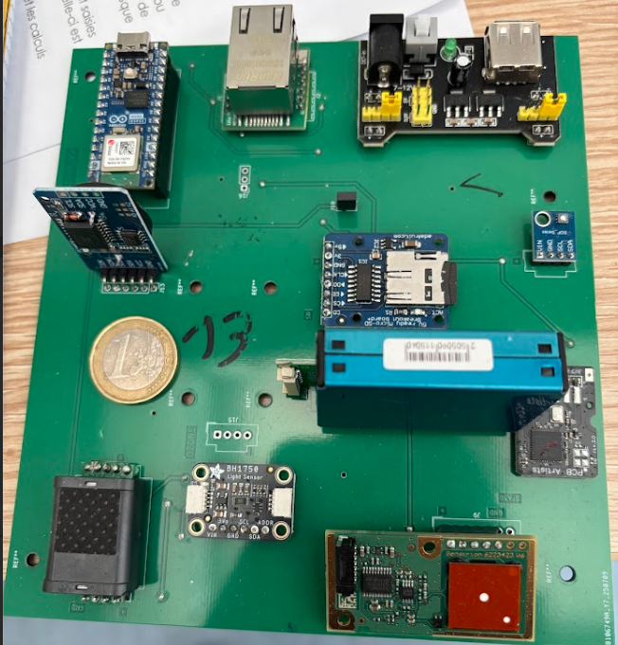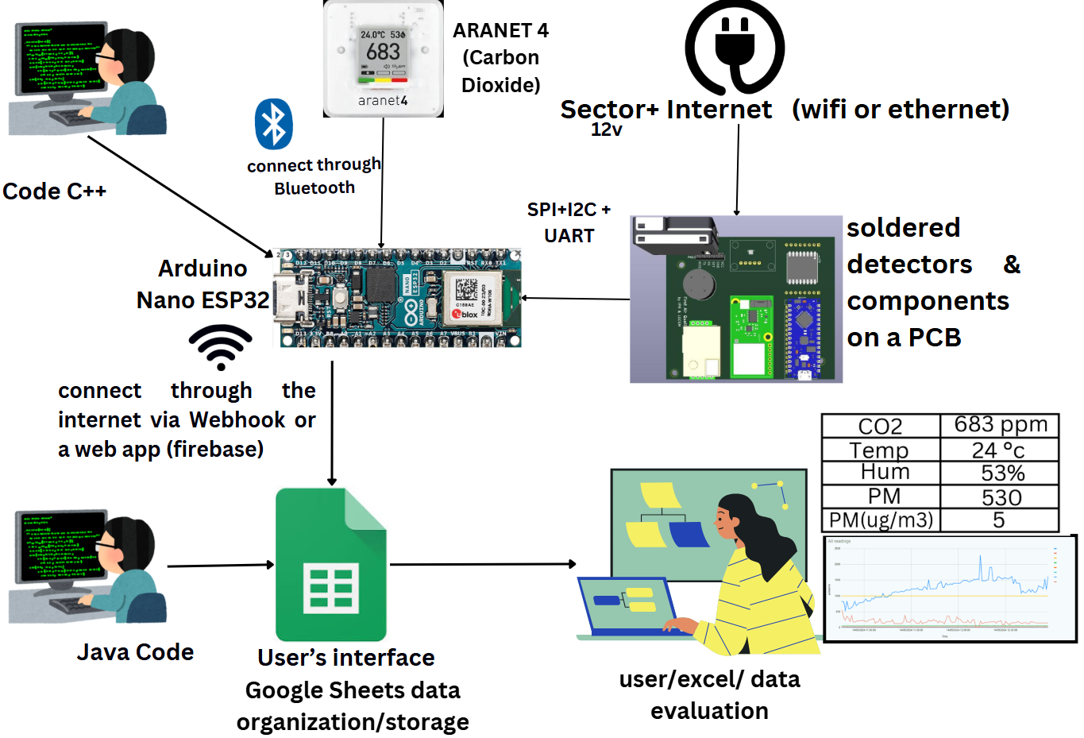
Figure 1.a: Portable multi-detector prototype (COFRA V2.0) integrating gas sensors, environmental sensors and communication modules on a custom-designed PCB. | Figure 1.b: Data acquisition and transmission architecture of the multi-detector system, including sensor interfacing, embedded processing, wireless communication, and cloud-based data storage.

Measurements are collected at a temporal resolution of one sample per minute, with the loop delay controlled by the Arduino microcontroller, enabling the detection of short-term variations and transient pollutant peaks. The embedded ESP32 microcontroller collects data from the wired sensors via I2C and UART communication protocols and can also interface with external devices such as the Aranet4 Home through Bluetooth connectivity. This configuration allows for comparison of carbon dioxide measurements obtained from the Senseair Sunrise sensor with those provided by the Aranet4 Home reference device. The system is programmed in C++ using the Arduino development environment. Several libraries are required to ensure communication with the sensors and external services, including WiFi.h, Ethernet.h, Wire.h, SPI.h and other dedicated sensor libraries.
The acquired data are formatted as structured HTTP requests (e.g. JSON format) and transmitted using a webhook-based communication system towards a cloud platform. In this configuration, the ESP32 sends data via Wi-Fi or Ethernet to a Google Sheets interface acting as a central data storage and organization tool. Alternative transmission approach based on an API-driven platform “Firebase” and keeping Google Sheets as a final receiving point was also tested. However, this approach introduced synchronization issues between successive requests, leading sometimes both to data losses and/or duplicated data entries. In contrast, the webhook-based transmission provided a more stable and consistent data flow, making it better suited for continuous acquisition at minute resolution in this application.
Google Sheets is configured to receive incoming data through webhooks and APIs and is programmed using triggers and Google Apps Script (JavaScript-based functions) to automate data organization, formatting and storage. It is also used to retrieve and integrate data from other commercial sensor platforms deployed during the measurement campaign through their respective web applications and APIs. This platform can therefore act both as a central storage system and as an intermediate processing layer, enabling the generation of alerts and the transmission of information to external services such as email notifications or monitoring applications.
This architecture enables flexible data management, interoperability between heterogeneous sensing systems and real-time data accessibility, while providing a user interface for visualization and post-processing using spreadsheet tools or dedicated data analysis environments.
    - Deployment conditions and measurement overview
The multi-detector system was deployed in several elementary school environments during a measurement campaign conducted between 2 February and 24 March 2026, corresponding to six consecutive weeks of monitoring. Measurements were carried out in fourteen classrooms from five schools located in the Ille-et-Vilaine department (Brittany, France), under real operating conditions. Each multi-detector, based on an Arduino platform, was installed in a single classroom and operated autonomously with a measurement frequency of one minute. Data from each device was transmitted independently using dedicated webhook addresses, allowing real-time collection and storage of measurements in separate data streams associated with each classroom.
To support data interpretation, contextual information was collected in collaboration with teachers through a daily reporting form. This included occupancy periods, air renewal actions (e.g., by window opening), teaching activities, and other relevant events such as cleaning periods. The combination of high-resolution measurements and contextual data provides a detailed description of indoor air quality conditions and enables the identification of short-term variations and differences between classrooms over time.
  - Results and Discussion
    - Global formaldehyde distribution
Figure 3 presents the distribution of formaldehyde concentrations across the monitored classrooms during occupied periods only. These periods correspond to teaching hours (8:00–12:00 and 13:00–15:3), excluding weekends, holidays, and Wednesdays when no classes are held, ensuring that the analysis reflects actual occupancy conditions. The results show marked variability between classrooms, with median concentrations ranging from 2 to 28 ppb. all measured concentrations remain below the WHO and ANSES short-term guideline (80 ppb), while only five classrooms out of fourteen exhibit median values below the French long-term guideline of 8 ppb.
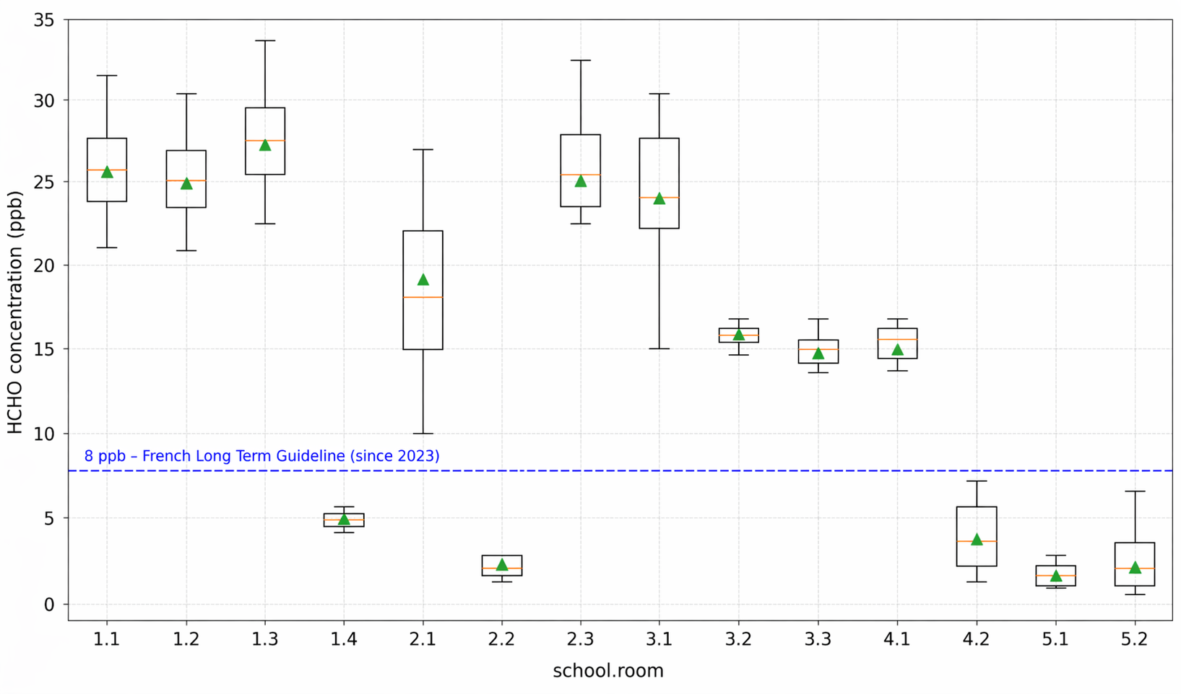Figure 3: Distribution of formaldehyde concentrations across monitored classrooms in occupied periods; ----: French Long-Term Guideline since 2023; Box: interquartile range 25th–75th percentiles; :median; : mean; : 5th and 95th percentiles.

    - Temporal evolution of formaldehyde concentrations
The temporal evolution of formaldehyde concentrations measured in one school, where four classrooms were instrumented, is presented in Figure 4. In contrast to Figure 3, this representation includes the full measurement period (24 h/day), encompassing both occupied and unoccupied periods, including nights, weekends, and holidays.
The time series reveal distinct behaviors between classrooms. One classroom maintains consistently higher concentration levels, typically between 20 and 35 ppb, with frequent peaks exceeding 40 ppb, while another remains at much lower levels, often below 10 ppb and occasionally approaching near-zero values during extended unoccupied periods, particularly at night and during weekends. The other classrooms exhibit intermediate behaviors with moderate variability.
Periodic decreases in concentrations are observed across all classrooms during unoccupied periods. These variations likely reflect a combination of factors, including changes in occupancy, air renewal conditions, and environmental parameters. In contrast, higher concentrations are observed at other times, although their occurrence cannot be attributed to a single factor. Overall, the temporal profiles confirm the variability observed in Figure 3, where classrooms with higher median concentrations also exhibit sustained elevated levels over time.
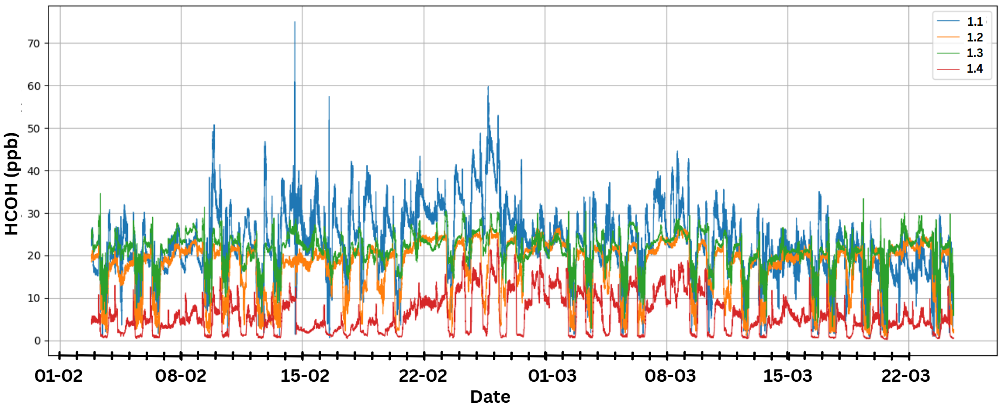
Figure 4: Minute-resolution formaldehyde concentrations in four classrooms of one school (Feb.-Mar 2026)
    - Correlation analysis
The correlations between formaldehyde and other measured parameters were calculated for the occupied periods only using a homemade Python code, based on the Pearson correlation coefficient (Pearson, 1896). Table 4 presents the results for one representative classroom per school. Similar trends are observed across the selected classrooms. Relative humidity shows the highest correlations, reaching r = 0.85, while temperature and tVOCs exhibit none to strong correlations (up to r = 0.65). In contrast, moderate correlations are found with CO₂ (r ≤ 0.45), and negligible values are observed for PM₁₀ and sound levels. These results highlight that formaldehyde variations are mainly associated with environmental conditions, although the strength of these relationships varies between classrooms.
Table 4: Pearson correlation coefficients between formaldehyde (HCHO) and environmental parameters for representative classrooms during occupied periods
Parameter | 1.1 | 2.3 | 3.1 | 4.1 | 5.1 | Interpretation
CO₂  Temperature  tVOCs  Relative Humidity  PM₁₀  Sound (dB)  Luminosity | 0.45  0.25  0.65  0.35  0.05  0.02  0.10 | 0.35  0.45  0.55  0.60  0.00  0.05  0.15 | 0.40  0.50  0.35  0.65  0.00  0.10  0.20 | 0.30  0.20  0.10  0.70  0.00  0.00  0.00 | 0.35  0.65  0.00  0.85  0.05  0.20  0.10 | Moderate  Moderate to strong  None to strong  Moderate to very strong  Negligible  None to weak  None to weak
  - Conclusion
This study presented the development and deployment of a portable multi-detector system for monitoring indoor air quality in school environments, with a focus on formaldehyde measurements. The six-week campaign conducted in fourteen classrooms across five schools provided high-resolution data under real operating conditions, enabling the characterization of pollutant dynamics in occupied environments.
The results highlight significant spatial and temporal variability of formaldehyde concentrations between classrooms, with distinct behaviors observed depending on room characteristics, air renewal practices, and usage conditions. While all measured concentrations remained below the WHO short-term guideline, a majority of classrooms exhibited median values above the French long-term reference value, underlining the relevance of continuous monitoring in such environments.
Correlation analysis indicates that formaldehyde measurements are associated with several environmental parameters, particularly temperature and relative humidity, while weaker relationships are observed with carbon dioxide, particulate matter, and acoustic levels. These observations suggest that both emission processes and environmental conditions contribute to the variability of the measured signal. The relative importance of these factors may differ between classrooms depending on characteristics such as ventilation practices, occupancy patterns, and material-related emission sources.
Overall, this work demonstrates the relevance of multi-parameter monitoring for investigating indoor air quality in schools and provides a practical approach for collecting high-resolution data using portable and low-cost instrumentation. The observed variability between classrooms, together with the differences in correlation strengths across parameters, indicates that formaldehyde concentrations are influenced by several interacting factors rather than by a single dominant variable. Future work will therefore focus on improving sensor characterization under controlled conditions and refining data analysis methods to better distinguish between environmental influences, emission-related variations, and measurement effects in educational buildings.
Acknowledgements
This work was supported by Rennes Regional Education Authority
  - References
Báthory, C., Dobó, Z., Garami, A., Palotás, Á., & Tóth, P. (2022). Low-cost monitoring of atmospheric PM—development and testing. Journal of Environmental Management, 304, 114158.
Decree n° 2011-1727 (2011). French indoor air quality guideline values for formaldehyde and benzene. Journal Officiel de la République Française (JORF), p. 20529, texte n° 4.
Hong, G.H., Le, T.C., Lin, G.Y., 2023. Long-term field calibration of low-cost metal oxide VOC sensor: Meteorological and interference gas effects. Atmospheric Environment, 310, 119955.
Liang, E., Lv, M., Yang, X. (2016). The combined effects of temperature and humidity on initial emittable formaldehyde concentration of a medium-density fiberboard. Building and Environment, 98, 80–88.
McGarry, P., Noakes, C.J., Sleigh, P.A., 2025. Addressing actual and community expectations on CO₂ monitoring in ventilated spaces. Indoor Environments, 3, 100030.
Pearson, K., 1896. Mathematical contributions to the theory of evolution. III. Regression, heredity and panmixia. Philosophical Transactions of the Royal Society of London, 187, pp. 253–318.
Pei, Z., Balitskiy, M., Thalman, R., Kelly, K.E., 2023. Laboratory performance evaluation of a low-cost electrochemical formaldehyde sensor. Sensors, 23, 7444.
Poulhet, G., Dusanter, S., Crunaire, S., Locoge, N., Gauduin, J., Thomas, S., Kaluzny, P., Coddeville, P., Galloo, J.C., 2014. Investigation of formaldehyde sources in French schools using a passive flux sampler. Building and Environment, 71, pp. 111–120.
Sadrizadeh, S., Yao, R., Yuan, F., Awbi, H., Bahnfleth, W., Bi, Y., Cao, G., Croitoru, C., de Dear, R., Haghighat, F., Kumar, P., Malayeri, M., Nasiri, F., Ruud, M., Sadeghian, P., Wargocki, P., Xiong, J., Yu, W., Li, B., 2022. Indoor air quality and health in schools: A critical review for developing the roadmap for the future school environment. Journal of Building Engineering, 57, 104908.
Salthammer, T., Mentese, S., Marutzky, R., 2010. Formaldehyde in the indoor environment. Chemical Reviews, 110, pp. 2536–2572.
Tang, X., Bai, Y., Duong, A., Smith, M.T., Li, L., Zhang, L. (2009). Formaldehyde in China: Production, consumption, exposure levels, and health effects. Environment International, 35(8), 1210–1224.
Trocquet, C., Lara-Ibeas, I., Becker, A., Schulz, A., Bernhardt, P., Person, V., Cormerais, B., Englaro, S., Le Calvé, S., 2023. Continuous real-time monitoring of formaldehyde over 5 weeks in two French primary schools: identification of the relevant time resolution and the most appropriate ventilation scenario. Air Quality, Atmosphere & Health, 16(6), 1091–1115.
World Health Organization (WHO), 2010. WHO Guidelines for Indoor Air Quality: Selected Pollutants. WHO Regional Office for Europe, Copenhagen, Denmark.
Zusman, M., Schumacher, C.S., Gassett, A.J., Spalt, E.W., Austin, E., Larson, T.V., Carvlin, G., Seto, E., Kaufman, J.D., Sheppard, L., 2020. Calibration of low-cost particulate matter sensors: Model development for a multi-city epidemiological study. Environment International, 134, 105329.

