 CHEMICAL ENGINEERING TRANSACTIONS  VOL. xxx, 2024 | A publication of  
The Italian Association
of Chemical Engineering
Online at www.cetjournal.it

Guest Editors: Selena Sironi, Laura Capelli
Copyright © 2024, AIDIC Servizi S.r.l.
ISBN 979-12-81206-13-7; ISSN 2283-9216

Evaluation of the Shelf Life of Fresh Fish Using an Electronic Nose
Ramiro Sánchez.ª, María Alejo.ª, Patricia Escribano.ª ,Patricia Arroyo.^{b}, Félix Meléndez.^{b}, Jesús Lozano.*^{b}

ª Center for Scientific and Technological Research of Extremadura (CICYTEX), 06007 Badajoz, Spain;
^{b} Industrial Engineering School, University of Extremadura, 06006 Badajoz, Spain;
*corresponding.author: jesuslozano@unex.es;

Keywords: fresh fish, electronic nose, shelf life, quality assessment.

The fishing industry faces significant challenges in supply chain management and fish quality assurance. Freshness, a crucial quality attribute, decreases over storage time. Traditional freshness control methods like sensory analysis, chromatography, or microbiological analyses, while effective, are slow and costly. Hence, the need for a tool like the electronic nose (E-nose) emerges, capable of predicting fish freshness by evaluating its odor using economical, quick, and portable equipment. This study aimed to classify the river fish Tinca tinca (tench) according to its freshness state and correlate its olfactory pattern with the presence of aerobic mesophilic microorganisms in the samples. The proliferation of aerobic mesophiles accelerates the sensory olfactory degradation of fish and is an indicator of quality. The E-nose used is a prototype developed by the University of Extremadura (UEx) with a matrix of 5 metal oxide semiconductor (MOS) gas sensors. Data were analyzed using Principal Component Analysis (PCA), where the first two components explained 93.4 % of the total variance, and Partial Least Squares Discriminant Analysis (PLSDA) was successful in classifying 95 % of the samples. Lastly, a Partial Least Squares (PLS) model was employed to relate the actual number of aerobic mesophilic bacteria to those predicted by the E-nose, achieving a determination coefficient of R²_{Pred} = 0.990. E-nose technology emerges as a promising alternative for enhancing the precision and efficiency in assessing fresh fish quality.
  - Introduction
In the fishing industry, ensuring quality is essential for protecting health and satisfying consumers. Tench is a freshwater fish, and interest in its cultivation has significantly increased due to its potential in aquaculture, taste, and high nutritional value. Tench production has grown in Europe, and studies on its intensive breeding have increased (Al Fatle et al., 2022). Fish freshness, a key quality indicator, is compromised by microbial activity (Li et al., 2019), which can cause unfavorable sensory changes like bad odors and tastes. The detection of aerobic mesophilic bacteria is a fish quality indicator, as their presence indicates contamination and deterioration, reflecting hygiene conditions during processing and storage, and therefore, the fish's freshness and shelf life (Peris and Escuder-Gilabert, 2009).

Given the limitations of traditional analysis techniques for assessing fish freshness, emerging technologies like electronic noses (E-nose) offer a promising solution. Over the last two decades, a substantial number of studies have been conducted focusing on the application of E-nose technology to assess the freshness and stability of stored fish products. These studies have examined a series of volatile compounds such as sulfur and nitrogen compounds, which are released as a result of microbial activity and biochemical processes throughout the preservation period (Grassi et al., 2019). E-noses mimic the human sense of smell and allow for the identification of changes in the chemical composition of foods quickly and non-invasively (Wu et al., 2023). Integrating electronic noses with chemometric analysis to evaluate fish freshness based on olfactory profiles and the evaluation of bacterial load represents a significant advance. These methods provide a detailed perspective on quality, enabling precise discrimination between different states of fish freshness and correlating these data with levels of aerobic mesophilic bacteria (Grassi et al., 2019).

This work focuses on the electronic nose's ability to differentiate between various degrees of tench fish freshness and associate these results with the presence of aerobic mesophilic bacteria, proposing a rapid and efficient method to improve quality control in the fishing industry. This study not only enhances the effectiveness of quality monitoring but also contributes to food safety by mitigating the risk of foodborne diseases and ensuring higher quality products for consumers.
  - Materials and Methods
    - Experimental Design
The study was conducted with river tench samples acquired from a local market and refrigerated at a temperature of 2°C. Five samples were randomly selected for analysis, conducting aerobic mesophilic counts and E-nose measurements on days 0 (purchase day), 4, 12, and 18 post-purchase to encompass a representative range of the fish's shelf life.
    - Microbiological Analysis
The plate count method, as referenced in UNI EN ISO 4833-1: 2013, was used to determine the load of aerobic mesophiles. 10 g of fresh fish samples were homogenized in a peptone saline solution and serially diluted. 1 mL of each dilution was inoculated onto Petri dishes with standard count agar and incubated at 30 °C for 72 h. Colony counts were expressed in logarithms of colony-forming units per gram (log CFU/g).
    - Electronic Nose
The E-nose device used is a prototype developed by the University of Extremadura (UEx) that communicates via Bluetooth with a mobile app. It is a compact, low-energy consumption portable device incorporating 5 metal oxide semiconductor (MOS) gas sensors from different manufacturers, providing broad selectivity. These sensors' distinctive feature is their ability to integrate both analog and digital electronic components on a hotplate with the detectors, all within a single integrated circuit. Additionally, the device is equipped with sensors for measuring other environmental parameters like temperature, relative humidity, and atmospheric pressure. Specific details of the sensors used are presented in Table 1.
Table 1: Sensors included in the electronic nose prototype.
Sensor | Manufacturer | Type | Signals
BME680 | Bosch Sensortech Gmbh, Germany | Metal-Oxide (MOS) | Temperature, Relative Humidity, Pressure, Resistance value(Ω)
SGP30 | Sensirion AG, Switzerland | MOS | CO2, TVOCs 1, H2 (raw signal 2), Ethanol (raw signal)
ZMOD4410 | Renesas Electronic Corporation, Japan | MOS | Ethanol (raw signal), Resistance value(Ω), CO2, TVOCs, IAQ 3
CCS811 | ScioSense B.V., The Netherlands | MOS | CO2, TVOCs, Resistance value
iAQ-Core | ScioSense, Eindhoven, The Netherlands | MOS | CO₂ (ppm), TVOCs (ppb), Resistance value (Ω)

- Total Volatile Organic Compounds.
- Signal derived from the sensor resistance.
- Air Quality Index.

The device measures 118 x 82 x 22.5 mm operates on a +3.7 VDC rechargeable lithium battery and uses Bluetooth for communication with a mobile app dedicated to its control and configuration. It also includes a pump and a solenoid valve for extracting the headspace from the samples. A block diagram of the device's electronic board is shown in Fig. 1.

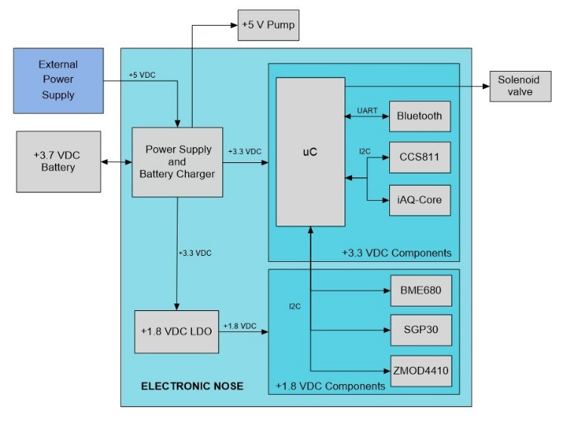
Figure 1. Block diagram of the electronic board of the prototype
The measurement process with this device occurs in two stages: a 60-second desorption phase where sensors are only in contact with ambient air, serving as a reference and cleaning signal, followed by a 60-second adsorption or sampling phase where sensors interact with the sample's headspace. The solenoid valve, managed by the microcontroller, alternates between these two inputs of sample and air. Analyses were performed on 5 fish fillets. A 5 g sample was placed in a container with a lid that has one air inlet and another for aspirating the sample's headspace through the E-nose pump. The sample was placed in a thermostatic water bath at 25 ºC as illustrated in Fig. 2.
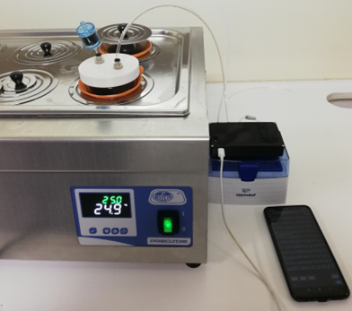
Figure 2. Measurements of the olfactory pattern of fish with E-nose
    - Laboratory test
To test the discrimination capability for gases indicative of fish spoilage due to microbial attack, such as ammonia gas, a laboratory test was conducted. The test consisted of preparing a solution of distilled water and another of 0.02 % ammonia. Ten samples were taken from each solution, and six measurements were made for each sample. Subsequently, the observations from the water and ammonia were plotted on a PCA graph.
2.5 Statistical Analysis
The data collected by the E-nose were subjected to Principal Component Analysis (PCA) to reduce data dimensionality and explore possible sample groupings according to their freshness. Additionally, Partial Least Squares Discriminant Analysis (PLSDA) was performed to classify samples based on storage days. For correlating freshness with microbial load, a Partial Least Squares (PLS) model was used. All statistical analyses were conducted using Matlab R2023a Software version 9.14.0.2206163 (The Mathworks Inc., Natick, MA, USA) with the PLS_Toolbox 9.1 (Eigenvector Research Inc., Wenatchee, WA, USA).
  - Results and Discussion
    - Microbiological Results
The microbiological analysis (Table 2) revealed a significant increase in the load of aerobic mesophiles over the storage period.

Table 2: Aerobic mesophilic values during storage
 | Day Zero | Day 4 | Day 12 | Day 18
Aerobic Mesophiles (log UFC/g) | 3.60 | 3.30 | 7.00 | 9.44

Initially, on day zero, the bacterial load was 3.60 log CFU/g, slightly decreasing to 3.30 log CFU/g by day 4, which could be attributed to sampling variability. However, by day 12, the load increased to 7.00 log CFU/g, and by day 18, it reached 9.44 log CFU/g, indicating significant bacterial proliferation and a reduction in fish freshness.
    - Electronic Nose Results
PCA analysis of the data obtained by the electronic nose showed clear discrimination between samples from different storage days. In Figure 3, the principal components PC1 and PC2 explained 77.21% and 16.17% of the total variance, respectively, demonstrating a good separation between fresh samples and those stored for longer periods.

Figure 3. Grouping of observations with E-nose performed on different storage days
PLSDA provided precise classification of samples according to storage days, with a correct prediction percentage of 95 % (Table 3). To construct the classes in the PLSDA model, fish samples were collected at four different time points: Day 0 (fresh), Day 4, Day 12 and Day 18. Each time point was considered a different class. The E-nose data were preprocessed using standard normalization techniques and PLSDA was used to classify samples based on storage days. To evaluate the accuracy of the model, internal cross-validation was performed using the "leave-one-out" technique. This high success rate indicates the effectiveness of the electronic nose in conjunction with chemometric analysis in classifying fish based on its freshness.
Table 3: Classification Prediction by PLSDA Model
 | Real Class
Predicted | Day Zero | Day 4 | Day 12 | Day 18
Day Zero | 4 | 0 | 0 | 0
Day 4 | 1 | 5 | 0 | 0
Day 12 | 0 | 0 | 5 | 0
Day 18 | 0 | 0 | 0 | 5
Finally, the results of the PLS prediction model are depicted in Figure 4. This graph shows the relationship between the actual microbial load values of aerobic mesophiles and those predicted by the electronic nose for samples at different storage times.
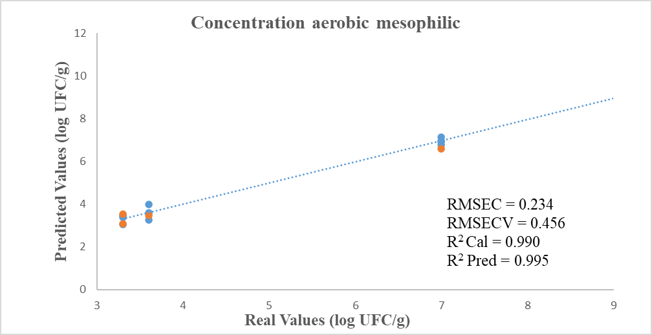
Figure 4. PLS Graph of Correlation between Actual and E-nose Predicted Values of Aerobic Mesophiles

The orange dots represent validation data, and the blue dots are calibration data. The overall trend indicated by the data is that the electronic nose is capable of accurately predicting the microbial load in samples based on data collected at different storage times. The high R² value in both data sets (calibration and validation) and the low values of RMSEC and RMSECV suggest that the electronic nose could be an effective tool for monitoring the microbial load of aerobic mesophiles in these samples.
The findings of this study affirm the hypothesis that the electronic nose, in conjunction with chemometric analysis tools, offers an effective and efficient alternative for fish quality control. The correlation between microbial load and olfactory profiles detected by the electronic nose highlights the significance of these microorganisms in determining fish freshness. These results align with recent scientific literature, such as Al-Hooti et al. (2024), which explored the efficacy and reliability of an E-nose in detecting microbial decomposition in fresh sardines, comparing its readings with total bacterial count and other indicators under varying storage conditions. Furthermore, the success of an electronic nose is closely linked to proper sensor selection and data analysis system design. Recent studies in the field of electronic noses have emphasized the importance of feature selection and sensor array optimization for optimal device performance (Borowik et al., 2020). In this study, the selection of MOS sensors and the use of PCA, PLSDA, and PLS were shown to be suitable for the task, but ongoing optimization of these components is crucial for enhancing accuracy and the technology's applicability in different contexts.

3.3 Laboratory Test Results

The PCA graph depicted in Figure 5 demonstrates two distinct data sets, one representing water and the other a 0.02 % ammonia solution.
Figure 5. Graph of discrimination between distilled water and 0.02% ammonia solution
The pronounced separation of ammonia, a marker for fish freshness, even at such low concentration, highlights the sensors' efficiency in discriminating these sample types. A Neural Network Analysis (ANN) classification model was applied (Table 4), yielding a 100 % success rate in identifying the samples.

Table 4: Classification Prediction by ANN Model
 | Real Class
Predicted | Water | Ammonia
Water | 60 | 0
Ammonia | 0 | 60

  - Conclusions
This study demonstrated the E-nose's capability, along with chemometric analyses, to effectively classify fish freshness based on its olfactory profile and correlate these results with the load of aerobic mesophilic bacteria. The findings suggest that the electronic nose can serve as a valuable tool for quality control in the fishing industry, offering a rapid, accurate, and non-destructive alternative to conventional methods based on microbiological analysis. The established correlation between the olfactory profiles detected by the electronic nose and the microbial load highlights the relevance of this technological approach for assessing fish freshness and, consequently, its quality. This study should be completed with an increase in the number of samples analysed to establish more robust models and confirm their potential use. This work paves the way for future research to further optimize sensor selection and analysis algorithms, expanding the electronic nose's applicability to a wider range of food products and storage conditions. It is also imperative to continue exploring the integration of these technologies into real-time monitoring systems, thus enhancing the food industry's ability to ensure the safety and quality of its products. In conclusion, the electronic nose represents a significant advancement in fish quality control, facilitating more informed and rapid decisions that can improve supply chain management and meet consumer demands for high-quality products.
Acknowledgments
The authors would like to thank the Scientific and Technological Research Center of Extremadura (Spain) for providing their facilities and materials for the conduct of the tests. Additionally, gratitude is extended to the Research Group on Perception and Intelligent Systems of the University of Extremadura (GR21045) for their support in carrying out this work.
References
Al Fatle, F. A., Meleg, E. E., Sallai, Z., Szabó, G., Várkonyi, E., Urbányi, B., ... & Lehoczky, I., 2022, Genetic Structure and Diversity of Native Tench (Tinca tinca L. 1758) Populations in Hungary—Establishment of Basic Knowledge Base for a Breeding Program. Diversity, 14(5), 336.
Al-Hooti, H. S., Al-Bulushi, I. M., Al-Attabi, Z. H., Rahman, M. S., Al-Subhi, L. K., & Al-Habsi, N. A., 2024, Efficiency of Electronic Nose in Detecting the Microbial Spoilage of Fresh Sardines (Sardinella longiceps). Foods, 13(3), 428.
Borowik, P., Adamowicz, L., Tarakowski, R., Siwek, K., & Grzywacz, T., 2020, Odor detection using an e-nose with a reduced sensor array. Sensors, 20(12), 3542.
Grassi, S., Benedetti, S., Opizzio, M., di Nardo, E., & Buratti, S., 2019, Meat and fish freshness assessment by a portable and simplified electronic nose system (Mastersense). Sensors, 19(14), 3225.
ISO 4833-2: Microbiology of the Food Chain-Horizontal Method for the Enumeration of Microorganisms: Part 1: Colony Count at 30 C by the Pour Plate Technique, 2013, Available online: https://www.iso.org/standard/53728.html (accessed on 09.09.2024).
Li, P., Ren, Z., Shao, K., Tan, H., & Niu, Z., 2019, Research on distinguishing fish meal quality using different characteristic parameters based on electronic nose technology. Sensors, 19(9), 2146.
Peris, M., & Escuder-Gilabert, L., 2009, A 21st century technique for food control: electronic noses. PubMed. Recuperado de https://pubmed.ncbi.nlm.nih.gov/
Wu, K., Debliquy, M., & Zhang, C., 2023, Metal–oxide–semiconductor resistive gas sensors for fish freshness detection. Comprehensive Reviews in Food Science and Food Safety, 22(2), 913-945.

