 CHEMICAL ENGINEERING TRANSACTIONS  VOL. 95, 2022 | A publication of  
The Italian Association
of Chemical Engineering
Online at www.cetjournal.it

Guest Editors: Selena Sironi, Laura Capelli
Copyright © 2022, AIDIC Servizi S.r.l.
ISBN 978-88-95608-94-5; ISSN 2283-9216

E&T&C Certification, New Protocol to Rate Engagement, Transparency and Communication in Industrial Activities. When the Odour Unit is not Enough.
Carlos Diazª, Cyntia Izquierdo^{a,}*, Ainhoa Antón^{a,}
ªOlores.org. C/Uribitarte 6, planta baja. 48001, Bilbao, Bizkaia (Spain)
carlosdiaz@olores.org
These instructions comply with the rules set by AIDIC for the publication of the papers in a volume in the series: Chemical Engineering Transactions.
Instructions:
- Use this template directly to write and format your paper
- Select the appropriate CET formatting style (see square brackets in this template for style names) for your text by looking in the “Home” tab in the “Styles” box, e.g. use [Style: CET Body text] for the body
- Replace this section with your Abstract and do not write the word Abstract at the beginning.
The length of the Abstract cannot be more than half page.
- In the author list, please use an * (asterisk) to mark the corresponding author. In the case of a single author, the asterisk is not required
- In case of all authors of the paper having the same affiliation, superscript letters should be omitted
- Please use just one (main) affiliation for each author, others should be in the Acknowledgments section
- The email of the corresponding author should be provided on a separate line after the affiliations
- For publication in CET, the corresponding author must agree to copyright transfer to AIDIC
  - Abstract
There is a need for a framework to mainstream citizen engagement, increase transparency and boost communication channels in the case of existence of repeated episodes of odour impact. When there is an odour conflict, most crisis communication experts would agree that Engagement, Transparency and Communication (E&T&C) are key to maintaining or regaining the neighbours’ trust. A recent case that demonstrates the negative outcomes of failing to be transparent and communicative is the emissions scandal at Volkswagen.

In order to promote a change in the paradigm of traditional industrial opaque thinking, we have created the first E&T&C Certification. This certification was designed to assess performance of industrial plants with regards to their relationship with communities nearby, making it the first certification of its kind.

A project's performance is checked either by the plant or through "full third-party" audits conducted by an independent auditor. This fully independent project certification process cannot be found anywhere else in the world. The auditor remains neutral and objective and may not, under any circumstances, advise or train the certification applicant. Such complete transparency guarantees independence and impartiality for the applicant. The final aim is to measure and score the degree of E&T&C of a plant.
  - Introduction
There is a need for a framework to mainstream citizen engagement, increase transparency and boost communication channels in the case of existence of repeated episodes of odour impact. Citizen science play a critical role in advocating and helping to make industrial facilities more transparent, accountable, and effective, and contributing to innovative solutions to the complex challenge of odour impact.

Plant managers tend to hide or minimize the impact of their activities, letting the time go by or trying to withhold information. For example, a widespread practice is staying silent when there has been an incident in the plant that may have originated an odour release to the atmosphere.

That is the exact opposite of a ‘good practice’ in odour management. This action might produce good results in the short term, but in the long run, citizens living near one of this opaque plants will be more prone to complaints and the conflict will get worst.

For a plant, to get to the point where citizens trust them enough to believe in a long term odour abatement plan, there is a need for engagement, transparency and communication.

Each of the actions that a plant takes to deal with an odour impact should be documented. The Odour Management Plan (OMP) is a good starting point. However, OMP have certain limitations, being the main ones that:

- They are neither public, nor co-designed with the help of the neighbouring communities.
- They usually respond to a public administration requirement, and they are done with no citizen participation.
- Normally due to the short administrative time allowed to reply to the administration, that is not possible inside an OMP as, for example, an engagement strategy+co-design process will take several months, before it is fully implemented.

That is why there is a need for a certification to show that a plant is taking (or will take) the right actions in order to correct a situation of odour impact.

Odour units are very useful, but unfortunately they are not a measurement of odour annoyance. Dose-response studies performed in the past (Miedema et. al. 2000, Sucker et. al. 2001), have tried to close this gap, but most of these studies are very old, and cannot be a reference for every single case. There are criteria set for odour impact in different regulations (Bokowa et. al. 2021), but there might be always situations in which those criteria, normally set in percentiles of odour units, are not enough.

Engagement, Transparency and Communication are not numbers yet, like the odour unit is. The only way to measure these three key parameters is through a certification process that rate how good a plant is in dealing with these important topics. That is, there is a need to put numbers to the strategies of Engagement, Transparency and Communication taken by a plant. Not all plants are the same in this regard.

The aim of this paper is thus to present a methodology to rate Engagement, Transparency and Communication (E&T&C) through a Certification process for industrial plants.
  - Methodology
There E&T&C certification is designed for the plant manager, as an easy tool to account Engagement, Transparency and Communication. In this case, E&T&C performance can be carried out by the plant itself or by an external person appointed for that task.

In order to get the final score, there is a four-step process to verify the information given in the form, depending on the complexity of the information required. The four levels of complexity are.

• Direct information
• Letter of assurance
• Technical report (third party or not)
• On-site check

For some items, only a direct information is needed. For example, to the question of: Do you have a publicly available register of complaints? The options offered are ‘yes’ or ‘no’. In the case that ‘yes’ is selected, an option is provided in which the respondent must write a link to the website or a phone number. If that information is not provided, the points for this question will not be accounted for.

For other items, a direct information is not enough and in this case a letter of assurance must be provided. Again, if that letter is not uploaded, the points will not be taken into account in the final score. An example is, when the plant is asked about: Do you have an OMP published and available? The options again in this case are ‘yes’ or ‘no’. In the case of selecting the option ‘yes” a direct information must be provided with the link to download the OMP. In the case of selecting ‘no’, three more options are offered: ‘I do have an OMP, but it is not public’; ‘I don’t have an OMP’ or ‘I do not have an OMP but I plan to have one’. In this third option a letter of assurance must be provided with a compromise to carry out the OMP, in order to account for these points.

In other cases a letter of assurance is not enough and a report carried out by the plant or a third party is needed. To the question, have you carried out any evaluation of the odour emission of your plant? The answer could be ‘yes’ or ‘no’. In the case of answering ‘yes” an option will be given to upload the report.

Last, there are some cases in which a plant E&T&C performance must be checked through "full third-party" audits conducted by an independent auditor on site. This fully independent project certification process, consists of both a desk review and field visit and provides independent confirmation that the plant and its impacts are in being in line with the E&T&C Certification.

Progress is assessed in the E&T&C Certification using 30 independent indicators, 10 for each of the three chapters, but in general, the approach to certify E&T&C is guided by five principles: 1) it is results-focused; 2) it involves engaging throughout the time of the project; 3) it seeks to strengthen plant communication programs; 4) it is context-specific; and 5) it is gradual.

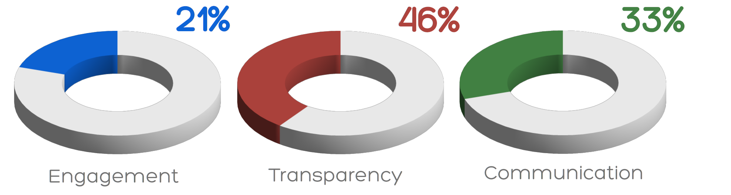
Figure 1: Example of Performance E&T&C score of a plant
This final E&T&C Certification consist of a number and a colour that score the state of the plant in each of the three topics taking into account thirty different indicators (10 for each part). The final E&T&C Certification score is shown as a percentage of the total.

Another key point of this certification is that the whole evaluation report is public and available to everyone, provided that the corresponding indicator is ticked as ‘public’.
  - Discussion
This Certification process is built on stocktaking and lessons learned from different projects in the past. A key lesson for example is the importance of geographical context, government ownership, and clear objectives for citizen engagement.

Engagement, Transparency and Communication require different approaches depending on the final aim of each task. There is no space in this paper, nor it is the aim here to describe the full 30 indicators. As an example, here four examples of indicators are presented:

• Encouragement (Engagement)
• Compensation (Engagement)
• Expectation (Transparency)
• Friendship (Communication)

    - Encouragement
Encouraging the community around to leave odour observations online, available to everyone shows neighbouring communities that the plant is listening to them and interested in their needs. Community observations can also help the plant manager to uncover areas in which the plant can do better, improving their ability to meet the neighbours’ concerns.

Complaints should be visible and offer constructive, relevant information. In order for the complaints to be constructive, there is a need to be involved with the neighbouring communities through networking or regular meetings, to profile the way odour observations should be carried out.

The more complaints and feedback an industrial facility has on its site, the better. This information will be key for a plant manager, to take the right constructive approaches and to allocate the correct resources to deal with the odour impact.

On the other hand, it is necessary to understand that an industrial activity will never please everyone. That is simply the reality of any industrial facility in the real world. That said, it is not a good practice to delete published complaints or any other negative feedback that comes to the plant. Keeping those complaints and responding to them, in fact helps boost a plant’s credibility.

Plant managers should use these opportunities to show that they care about their communities, by responding to complainants. A register of complaints with nothing but positive comments will likely make citizens assume that the plant manager is filtering out complaints or that the industrial facility is planting fake complaints.
    - Compensation
Plant managers should be aware that odour impact comes at a cost to the citizens, being the two main monetary consequences 1) The decrease in the property value affected by odour impact and 2) The economic impact on public health. In fact, the cost of odour control can be several orders of magnitude lower that the cost of the odour impact itself (Diaz C. 2019).

To maintain trust and build a long-term loyalty to the LTOAP, plant managers might choose to incentivize the communities around all along the process. Offering perks and other programs to compensate odour impact is a useful strategy, provided it is made with caution.

Care should be taken for this incentive to be translated to the widest and broadest amount of citizens. For example, getting t-shirts and other sport equipment for the kids sport clubs might be a good idea, but buying a sofa for the office of the mayor of a town does not reach the same amount of people.

In extreme cases, there might be a need to compensate the citizens affected during the process of implementing the LTOAP. For example, the corporation Waste Management, Inc, owner of the landfill of Tullytown in USA has been paying 6000 dollars every year for each of the 640 residents affected by odour impact, through the council of Tullytown (Rosengren C.2017; Diaz C. 2016).
    - Expectation
Taking shortcuts or overpromising, will result in a lost of trust of the community around a plant. Citizens prefer a realistic long term plan, rather than a short-term, deceptive program.

Being honest about what a plant can do and cannot do, and making sure that the plant at the very least, will meet the community expectations in the long term is key. This will establish trust between the plant and the citizens around and will create a strong foundation for avoiding future conflicts over time.

Installing odour abatement methods not suitable, or not dimensioned for the needs of a project, will result in lack of trust in the long term. Allocating economic resources to low-cost odour abatement means not suitable for a task will produce that any further odour abatement measure proposed by the plant will be taken with distrust by the communities. Long Term Odour Abatement Plans (LTOAP) instead, will be better accepted provided that there is a prove of the solution of the problem and a schedule for that plan.
    - Friendship
Friendships, like most relationships, take time and are built on trust and respect. The relationship with the communities around a plant shouldn’t be much different. Treating citizens in the same way than friends is a good policy in the road towards a successful communication strategy.

By treating citizens as if they are friends, a plant can establish a strong foundation of trust with the neighbouring communities that will give them a reason to stay loyal and focused on the LTOAP. Once reached this point, short-term incidents and/or accidents, will be better understood by the citizens. One bad interaction can taint the future actions of an industrial plant for many years.

Citizen friendship on a day-to-day basis simply means being available for them on all channels, listening to their wants and needs and taking criticism with grace. This will show the communities around how much a plant care about them and value their lives.

After evaluating each of the 30 indicators (10 for each part), the final E&T&C Certification is calculated. The final score consists of a number and a colour that grade the state of the plant in each of the three topics taking into account these indicators. The final E&T&C Certification score is shown as a percentage of the total.

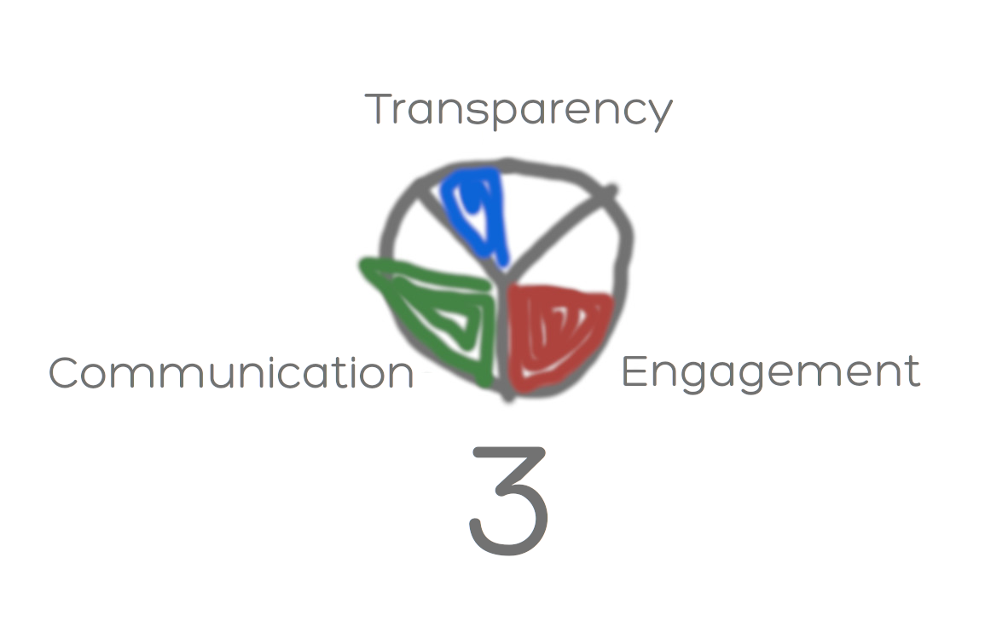
Figure 2: Example of E&T&C score for a plant
A certification process in which these, and other indicators, are examined and form part of a final score is needed, in order to rate how good a plant is at interacting with neighbouring communities.

  - Conclusion
In this paper we present an innovative approach with the aim of scoring Engagement, Transparency and Communication (E&T&C) of a plant.

In order to get the final score, there is a four-step process to verify the information given in the form, depending on the complexity of the information required, based on direct links, letters of assurance, technical reports and on-site checks.

This final E&T&C Certification have a number and a colour that score the state of the plant in each of the three topics taking into account 30 different indicators. In this paper, four examples of indicators are presented and discussed.

Another important point of this certification is that the whole evaluation report is public and available to everyone, provided that the corresponding indicator is ticked as ‘public’.

A full E&T&C Certification scheme is being prepared on the website entnc.com and expected to be ready by the conference.

References
Bokowa A., Diaz C., Koziel J.A., McGinley M., Barclay J., Schauberger G., Guillot J.‐M., Sneath R., Capelli L., Zorich V., Izquierdo C., Bilsen I., Romain A.-C., del Carmen Cabeza M., Liu D., Both R., Van Belois H., Higuchi T., Wahe L. (2021). Summary and Overview of the Odour Regulations Worldwide. Atmosphere, 12, 206. https://doi.org/10.3390/atmos12020206
Diaz Carlos. Olores.org, 2019. The cost of the odour impact in Russellville, Arkansas, USA. <https://www.olores.org/en/content/685-the-cost-of-the-odour-impact-in-russellville-arkansas-usa> accessed 10.07.2022.
Diaz Carlos Olores.org 2016. A landfill in US reached a $2M settlement in a lawsuit about odours. <energy.gov/sites/prod/files/2016/09/f33/CHP-Steam%20Turbine.pdf> accessed 10.07.2022.
https://www.olores.org/en/news-recent/odour-regulations/528-a-landfill-in-us-reached-a-2m-settlement-in-a-lawsuit-about-odors
Miedema, H.M.E., Walpot, J.I., Vos, H., Steunenberg, C.F., 2000. Exposure-annoyance relationships for odour from industrial sources. Atmos. Environ. 34, 2927e2936.
Rosengren Cole. 2017. Wastedive. Pennsylvania borough struggles with post-landfill life as host fees begin to dry up. <https://www.wastedive.com/news/pennsylvania-borough-struggles-with-post-landfill-life-as-host-fees-begin-t/448539/> accessed 10.07.2022.
Sucker et al. Adverse effects of environmental odours: Reviewing studies on annoyance responses and symptom reporting. Water. Sci. Technol, (2001)

