|  |  |
| --- | --- |
| cetlogo ***CHEMICAL ENGINEERING TRANSACTIONS***  ***VOL. 82, 2020*** | A publication of  aidiclogo_grande |
| The Italian Association  of Chemical Engineering  Online at www.cetjournal.it |
| Guest Editors: Selena Sironi, Laura Capelli  Copyright © 2020, AIDIC Servizi S.r.l. **ISBN** 978-88-95608-80-8; **ISSN** 2283-9216 | |

Risk of odorous gas emissions from wastewater treatment systems related to global warming effects

Fida MAALEMa\*, Christophe GERYb, Fabien SIINOa, Madani DIALLOa, Isabelle CROSNIERa, Léa,COCHARDb, PIET Hélènec

a SIAAP, Route Centrale des Noyers, MAISONS-LAFFITTE (78), France - Fida.MAALEM@siaap.fr

b EGIS, Air/Odor department, SAINT QUENTIN EN YVELINES (78), France - christophe.gery@egis-group.com

c EGIS, Air/Odor department, AIX-EN-PROVENCE (13), France - helene.piet@egis-group.com

Emissions of odorous gases resulting from the biological activity of wastewater is a known and documented phenomenon whose effects can be as detrimental to nearby residents as to network and WWTP managers. In addition, we have been experiencing global warming for several years, which has caused and continues to cause an increase in average temperatures on the earth's surface as well as a modification of other meteorological factors. Thus, it appears crucial for wastewater system managers to understand the evolutions caused by climate change to anticipate and reduce future impacts on their facilities.

In this context, the SIAAP (Syndicat interdépartemental pour l'assainissement de l'agglomération parisienne) has drawn up an inventory of the factors promoting the production of odorous gasses (in particular H2S) through a literature review. These factors were compared with data from the SIAAP measurement network for the period 2000-2022 and future evolution scenarios to determine if the global warming effects could lead to a deterioration in the odorous impact of wastewater collection and treatment facilities. The study shows that the effects of climate change seem to have contributed, from a probabilistic point of view to the creation of an additional risk of major H2S peak production on SIAAP WWTP and networks, almost exclusively related to the increase in temperature.

1. **Introduction**

SIAAP is a public institution in charge of collecting, transporting, and treating wastewater of more than 9 million inhabitants from Paris and its neighboring cities. This institution is responsible for the operation of more than 440 km of networks and 6 wastewater treatment plants, including the Seine Aval plant (SAV), one of the largest in the world with an average feed rate of approximately 1.2 million m3/day.

For many years, SIAAP has had to deal with the risk of gas emissions from bacterial activity in the wastewater networks and treatment plants. These gasses are essentially CH4, H2S, RSH, and VOCs. Their emissions can have consequences at several levels, in terms of personnel safety, equipment protection, and odorous impacts on the environment.

Today, the effects of climate change are locally measurable and SIAAP wishes to evaluate the impacts of this change on the emission risk of its sites, to adapt the treatment solutions accordingly. The purpose of this article is to present the work carried out by the SIAAP teams, in collaboration with the EGIS consultancy firm, on the evaluation of the effects of climate change regarding the emissions of sulfur compounds in the SIAAP wastewater networks and treatment plants.

1. **Materials and Methods** 
   1. **Overview of odor problem and control in wastewater collection system and WWTP**

The environmental factors relating to hydrogen sulfide generation fall into three basic areas of scientific study: chemical, physical, and biological action. Among the main factors influencing H2S formation, the scientific literature highlights:

* A dissolved oxygen concentration of less than 0.1 to 1 ppm generally enhances sulfate reduction (Pomeroy, 1974).
* The rate of metabolic reactions in the sewer biofilm, and thus the rate of sulfide generation, is affected by changes in sewage pH (Gutierrez et al., 2009). The quantitative relationship between the different sulfide species (H2S/HS-/S2-) is controlled by the pH of the wastewater. At pH 6, 90% of the sulfide will be present as H2S, and the higher the H2S concentration is, the greater the tendency for it to volatilize. Conversely, at pH 10, 100% of the sulfide will be present as S2-.
* H2S concentration increases with increasing sewer temperature (Zuo et al., 2019). Sulfide formation increases by 7% per degree, up to 40°C. Conversely, below a minimum temperature, the sulfides would hardly appear anymore. It would seem that this relationship is not linear (Fayoux, 1988).
* The flow rate of sewage in the pipeline — velocity less than 1 m/s (meter per second) will allow inorganic grit to accumulate at the bottom leading to sulfide buildup.
* High retention time within the collection system fosters H2S formation.

These studies show the effects of various wastewater quality and flow parameters affecting H2S generation and emission.

* 1. **SIAAP’s previous work about the relationship between H2S emissions and environmental factors (SAN indicator study)**

Between 2013 and 2018, the SIAAP conducted a study, called the "SAN indicator study", The study aimed to create an H2S emissivity risk indicator based on SIAAP’s measurement network that could be used to adjust the chemicals injection into wastewater which mainly uses calcium nitrates to reduce sulfides production.

To do it, this study determined the relationship between H2S major peak emission (>5 ppm) and available, reliable, and easily measurable parameters alike: air/ water temperature, rainfall volumes, and water flow velocity. The 5 ppm H2S level was chosen as an infrequent condition reflecting a high emissivity of the network compared to the measurement history and the operators' feelings about odors. The measurement point was localized at the entrance of the SIAAP’s main station called Seine Aval (SAV). Based on a 6-year data set (2011-2017), this work succeeded in establishing an indicator and permit to determine the probability of an H2S major peak occurrence depending on the intensity level of each of the parameters. The strongest correlations were with the air temperature (R² = 0,98), the water temperature (0,98), cumulative rainfall over 4 hours (0,67), and the number of dry days before the rain (0,67).

Thus, these four parameters have been identified as good indicators to evaluate the evolution above the time of the H2S major peak emission risk.

* 1. **SIAAP current work**

The aims of this new work are: 1) to describe the 2000-2021 meteorological and functioning trends that could be affected by climate change (air temperature, wastewater temperature at the entrance of the station, cumulative rainfall, number of dry days) 2) to determine if the observed trends could lead to an increase of H2S major peak emission risk using the correlation established on the previous work 3) to characterize if possible the future trends with the projections of Paris Climate Agency (APC) 2020 report.

For this study, we relied on the data collected 2000-2021 records by the measurement sensors positioned at the wastewater inlet on the SAV site (wastewater temperature parameter) as well as the meteorological records of the on-site station (air temperature). To complete our data, data from the national meteorological station network (Meteo-France station, Velizy-Villacoublay) have also been exploited (rainfall and number of dry days).

1. **Results**
   1. **Effect of air and water temperatures changes**
      1. **Impact of the air and water temperature evolutions**

In the SAN indicator study, we highlighted the relationship between the risk of a major H2S peak (> 5 ppm) at the plant entrance as a function of air and wastewater temperature. The result is shown in Figure 1.

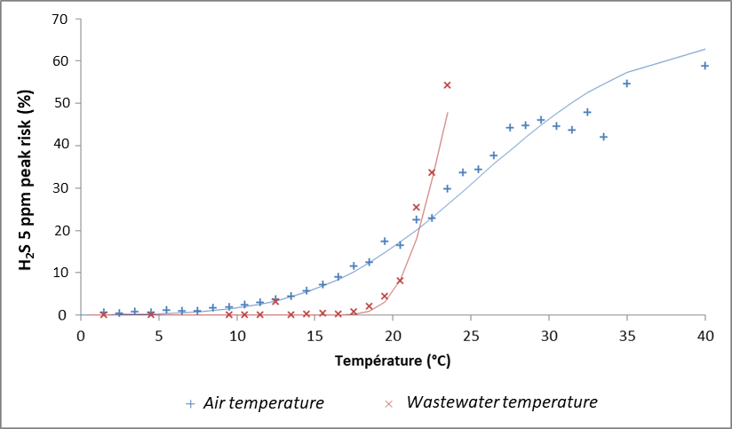

*Figure 1: Risk of a 5 ppm H2S peak at SAV depending on air and water temperature*

This graph indicates that, for an air temperature above 20°C, the risk of emitting a 5 ppm H2S peak is greater than 15%, and this probability increases linearly until the temperature of 35°C where the risk reaches 60%. Regarding the water temperature, exceeding the value of 20°C would lead to a significant increase in the risk of H2S production, since from 20 to 24°C the risk is increased by 5.

Thus, the increase in the number of annual hours exceeding the threshold temperature of 20°C (air and water) linked to climate change needs to be investigated.

* + 1. **Air temperatures evolution**

As shown in Figure 2, the evolution of the annual average temperature reflects a slow increase despite a greater variability of values over the period 2000-2021. In 21 years, we saw an increase in the average temperature of about 1°C, which is relatively in line with national observations.

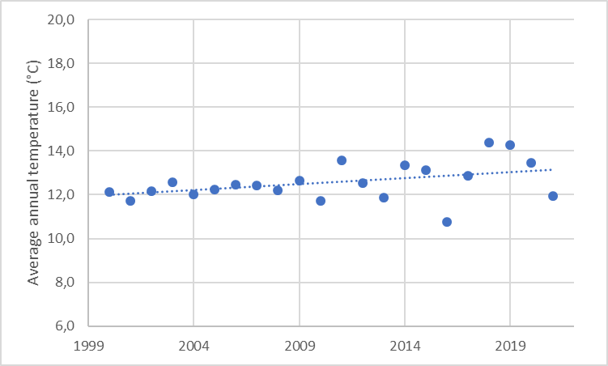

*Figure 2: Changes in average annual temperatures on measures by the SIAAP meteorological station (Achères 2000-2021)*

According to Météo-France data modeling described in the Paris Climate Agency (APC) 2020 report, short and medium-term projections estimate an average rise of about 2.5°C in 2030 and 2.7°C in 2050 compared to the 1885 level. Long-term projections are more uncertain and depend greatly on our ability to limit greenhouse gas emissions. Thus, these projections foresee a continuation of this measured upward trend for the years to come. Furthermore, the analysis of threshold temperature exceedances tells us:

* That the exceedance of the 20°C temperature is subject to an increase of the order of 600h/year between 2000 and 2020, i.e. an increase of 30% ;
* That the 25°C and 30°C temperature exceedances are subject to too much variability from year to year to conclude an increase.

According to the Paris Climate Agency (APC) 2020 report, this trend is expected to continue. For example, the number of days with temperatures above 25°C is expected to increase from 54.8 to 60.2 days between 2010 and 2030, a continuation of the current trend.

Consequently, the increase in the number of annual hours exceeding the threshold temperature of 20°C over the period 2000-2021 tends to produce a more favorable situation for the emission of H2S peaks. While it is certain that these peaks are not the only cause of odor nuisance, they nevertheless participate in the phenomenon of odor production and behave as an indicator of the biological activity of the networks.

The current and future rise in air temperatures leads us to project a worsening of the odor situation from the point of view of this phenomenon.

* + 1. **Wastewater temperatures evolution**

Figure 3 shows the same analysis performed by the SIAAP. We measured the evolution of the temperature of the liquid effluents entering the Seine Aval plant over the period 2000-2021.

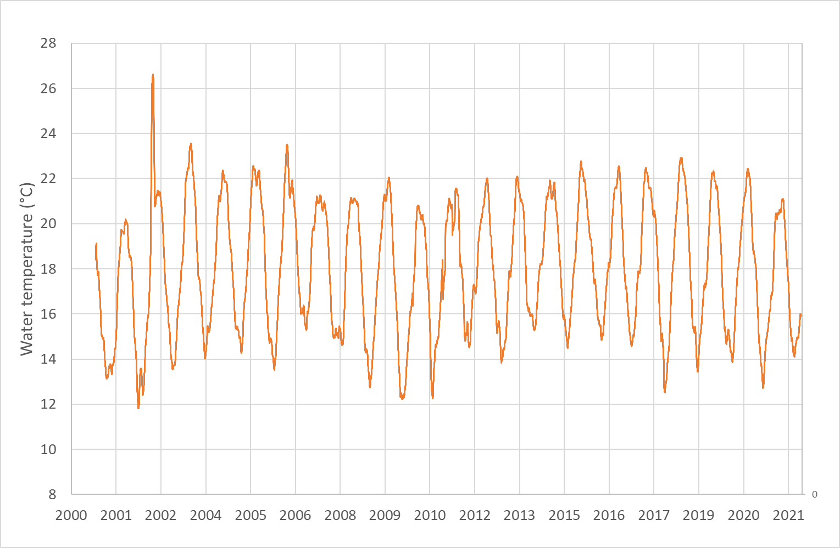

*Figure 3: Evolution of the average temperature of wastewater at the entrance of SAV between 2000 and 2021*

The average annual temperature of the wastewater at the entrance of SAV is relatively stable over time. However, variations in the amplitude can be observed from one year to the next, particularly for minimum temperatures. We also observe that summer heat waves like 2003 and 2018 lead to maximum temperature peaks above 22°C. However, we do not measure a net increase in the number of hours per year affected by wastewater temperatures exceeding 20°C over the period 2000-2021 except for the specific case of major heat waves. It’s likely that no degradation of the odor situation is expected about the warming of the wastewater.

It is interesting to note that the increase in wastewater temperature has been observed in at least one other French WWTP operator, from the city of Marseille. The research conducted by this operator tends to show an increase in average effluent temperatures of around +3°C between 2001 and 2017 (Laplace et al., 2018).

The difference observed between the trends of SIAAP and the other operator shows that it is not possible to conclude that there is a national trend but that the evolution of wastewater temperature is also influenced by other factors such as the network configuration.

Influence of drought periods.

* 1. **Influence of drought periods**
     1. **Impact of drought periods increase**

In the SAN indicator study, we highlighted the relationship between the risk of a major H2S peak at the plant entrance as a function of drought periods. As shown in Figure 4, this study showed that there is a relationship between the two phenomena. It appears that the increase in the risk of major H2S spikes is small, given that an additional dry day contributes to an increase in the risk of about 0.2%. To see a significant effect, an important evolution of drought periods would be needed, as an increase of 50 days for a risk increase of 10%.

*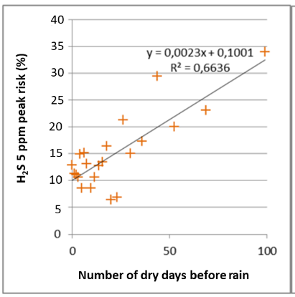*

*Figure 4: Risk of a 5 ppm H2S peak at SAV depending on the number of dry days before rain*

* + 1. **Drought periods evolution**

To complete SAV's data, we analyzed the evolution of drought periods between 2000 and 2021 for the Météo-France station of Vélizy-Villacoublay, the most representative station for which we had enough historical data. Figure 5 describes the annual evolution of the number of periods concerned by a lack of precipitation greater than 1mm.

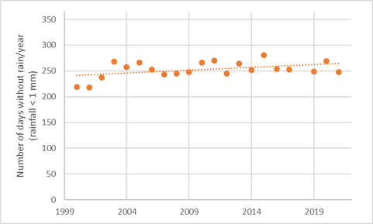

*Figure 5: Evolution of the number of days without rain between 2000 and 2021 - Vélizy-Villacoublay meteorological station*

Local observations show an average increase in the number of days without rain between 2000 and 2021. This change is on the order of one additional day per year. Météo-France data modeling describes a continuation of the increase in the number of days without rain at least until 2030. Thus, no major change in the odor situation is expected based solely on the increase in dry periods.

* 1. **Influence of rainfall volumes and wastewater flow**

The reductions in incoming wastewater flow caused by a decrease in rainfall volume are likely to generate two phenomena: 1) an increase in the organic load of the effluent, and 2) a reduction in the flow velocity within the pipes and WWTP.

The literature review (and the network operator feedback) shows consensus about the negative influence of both factors. Therefore, the evolution of rainfall volumes and wastewater flow is studied. Regarding the SIAAP facilities, there is a clear downward trend with 1) the loss of about 800,000 m3/d between the years 2000 and 2021 of the total volume of water treated by the SIAAP; 2) an increase in the average Chemical Oxygen Demand (COD). However, data shows that this trend is accompanied by an increase in the volume of rain off waters (+ 30,000,000 m3/ y) and the share of contribution to rain off over wastewaters (+ 4 %). This trend could be partly explained by an increase in soil artificialisation.

According to Météo-France data modeling described in the Paris Climate Agency (APC) 2020 report, short and medium-term projections predict relative stability of the annual cumulative rainfall in 2030 (633 mm) and a rise for a long-term perspective (679 mm in 2050, 721 mm in 2085). Although rainfall volume will probably continue to grow in the future, it's hard to evaluate the effect on the wastewater flow.

* 1. **Other influencing factors to explore**

Other factors influencing the olfactory situation of the site have been studied but need more research to be exploitable. We can for example mention the impact of:

* the rainfall intensification over a short period. In the SAN indicator study, we highlighted an interesting relationship between the risk of a major H2S peak at the plant entrance and a function of rainfall water level. According to local network operators, despite this average increase in water volumes, important rainfall over a short period is a phenomenon that is occurring more and more frequently. These events, if they follow a long period without rain seem to maximize the emission risk ;
* the marked and lasting evolution of prevailing wind speeds and directions. These factors do not directly influence the production of odorous gasses but contribute, through the quality of its dispersion, to the emergence of impact (or impact reduction) on residents.

These points are possibilities that can be explored in our future works.

1. **Conclusions**

The review of the literature allowed us to establish a list of influencing factors that promote the production or the dispersion of odorous gasses from sewer systems and treatment plants. We have selected among these factors those for which we could suspect a possible evolution in connection with global warming.

Based on SIAAP and public data, this work showed that the SAV plant and its associated network are concerned by:

* An increase in the average air temperature of about +1°C over the period 2000-2021 that should continue in the coming decades, as well as the more frequent occurrence of warm days (>25°C). Based on a previous SIAAP study (SAN indicator), we established that this past and future trend is expected to contribute to the increase in odorous gas emissions.
* An increase of drought periods of about +1 day/ year over the period 2000-2021 that should continue at least until 2030. However, this study shows that this factor has a small impact on the H2S and odorous gasses emission.
* An annual rainfall accumulation which is not likely to increase the emissive risk since the share and volume of rainwater of SIAAP treated water is increasing between 2000 and 2020 by 30 million cubic meters/ year and for a share of +4% and represents in 2020, 105 million cubic meter/ year. However, additional work needs to be done on the rainfall intensification over a short period.

In conclusion, the study shows that the effects of climate change seem to have contributed, from a probabilistic point of view to the creation of an additional risk of major H2S peak production on SIAAP WWTP and networks, almost exclusively related to the increase of temperature. If the probabilistic approach used does not allow us at this time to precisely quantify the impact of the phenomena involved, it opens the way to complete this analysis and to consider: 1) the innovative odor reduction methods that can be implemented or redesigned (product injection, air treatment, ventilation); 2) to include in this approach a reflection on the contribution to GHG emissions associated with these methods.

**References**

Pomeroy R. D., 1974, Process design manual for sulfide control in sanitary sewerage systems, US Environmental Protection Agency, Technology Transfer, USA.

Gutierrez, O., Park, D., Sharma, K.R., Yuan, Z., 2009, Effects of long-term pH elevation on the sulphate-reducing and methanogenic activities of anaerobic sewer biofilms, Water Res. 2009, 43, 2549–2557.

Zuo, Z., Chang, J., Lu, Z, Wang, M., Lin, Y., Zheng, M., Zhu, D.Z., Yu, T., Huang, X., Liu, Y., Hydrogen sulfide generation and emission in urban sanitary sewer in China: What factor plays the critical role, Environ. Sci. Water Res., Technol. 2019, 5, 839–848.

Fayoux C., 1988, Networks corrosion by hydrogen sulfide (in French), Sicteub experiment, TSM,-1, january.

Laplace, D., Hesse, N., & Mertz, J.M., 2018. Marseille's sewage system in front of climate changes (in French). TSM, Urban Engineering Rural Engineering, 12, 41-50.