CHEMICAL ENGINEERING TRANSACTIONS  VOL. 95, 2022 | A publication of
The Italian Association
of Chemical Engineering
Online at www.cetjournal.it

Guest Editors: Selena Sironi, Laura Capelli
Copyright © 2022, AIDIC Servizi S.r.l.
ISBN 978-88-95608-94-5; ISSN 2283-9216

Development of on-line and field dual TD-GC-FID/MS for automatic and continuous VOCs monitoring in ambient air
Fanny Bachelier^{a,b}, Franck Amiet^{b}, Véronique Daëleª, Damien Bazin^{b*}
ªICARE – UPR 3021 – CNRS, 1C, av. De la recherche scientifique CS50060 – 45071 Orléans, France
^{b}Chromatotec, 15 rue d’Artiguelongue, 33240 Saint-Antoine, France
damien.bazin@chromatotec.com
Odorous compounds, such as carbonyl substances, play a major role in ambient air pollution. Monitoring these VOCs is important because some of them have adverse effects on human health and the environment or are, at least, responsible for unpleasant smells. Due to the large number of molecules potentially analyzed, it is difficult to separate and quantify precisely all compounds using a chromatograph equipped with a non-specific detector. The goal of this study is to perform automatic and continuous identification and quantification of odorous VOCs using two different Thermal-Desorption Gas Chromatographs equipped with two Flame Ionization Detectors (FID) and one Mass Spectrometer (MS). Each system is designed with its specific analytical conditions, one for monitoring light compounds and the other for heavier compounds. The coupling of two different TD-GC-FIDs to a Quadrupole MS, allows the automatic identification of coeluted compounds by MS and the quantification of the non-coeluted ones by FID.
An algorithm has been developed in the software to select the more accurate result between this dual detection. To achieve this automatic reprocessing, the implementation of validation parameters was developed for each identified compound, while remaining adaptable and verifiable if necessary. This fully automatic system allows non-specialist operators to access expertise level results.
  - Introduction
Volatile Organic Compounds (VOCs) are key components of ambient air and are emitted in the atmosphere from anthropogenic (solvent, industry, transport) and biogenic sources (Barletta et al., 2005; Gu et al., 2019). The amount of these substances in outdoor air is between 50 and 300 (Hong et al., 2019) and some of them have adverse effects on human health (Abraham et al., 2016; Bari et al., 2018). At a significant level of concentrations, their presence has been associated to poor air quality and odorous nuisances (Zhu et al., 2016; Nie et al., 2019). Due to the short duration of odorous occurrences, the use of air sensors can be very helpful because they are able to provide near-real time VOCs monitoring (Spinelle et al., 2017). However, some of these molecules have a low odor detection threshold which requires the use of sensitive systems capable of analyzing a wide range of concentrations from ppt to ppm levels (Gallelo et al., 2019). Moreover, as odorous compounds are often generated from industrial processes, the specific quantification of molecule is difficult due to the large number of potential interferences. Usually, laboratory gas chromatographs are used to perform identification and quantification of molecules in complex mixtures. Nevertheless, these devices require trained operators and do not allow continuous monitoring (off-line sampling). To improve the accessibility of results and to avoid the risk of losing sample information during transport, there is a need for easy-to-use continuous on-site monitoring systems.
In this study, the performances and limitations of a dual thermo-desorption gas chromatograph equipped with flame ionization detector and mass spectrometer for the characterization of odorous VOCs in ambient air will be presented. The second objective is to develop validation parameters for each compound in order to implement them in the software to automatically select the more accurate result of this dual detection FID versus MS and to provide validated results to the user.
  - Material and methods
    - Auto-TD-GC-FID/MS for C₂C₆ Monitoring
An automatic gas chromatograph (airmoVOC C2-C6, Chromatotec, France) equipped with a flame ionization detector (FID) and mass spectrometer has been used for the monitoring of non-polar molecules containing from 2 to 6 carbon atoms. For each analysis, 107 mL of ambient air was drawn into the system with a flow rate of 12 mL.min⁻¹ (air sample is integrated over 10 min). The air sample passed first through a dryer (airmoDry, Chromatotec, France) to remove the humidity and then hydrocarbons were pre-concentrated at -10 °C on a trap filled with a mixture of Carboxen and Carbopack. The pre-concentrated air sample was thermally desorbed at 220 °C for 4 minutes and directly injected in a 25 m Al₂O₃/Na₂SO₄ column (PLOT column, 0.53 mm ID, 10.0 µm dF) located inside the heated oven of the GC. Within the first minute of the analytical procedure, the oven temperature rose from 36 °C to 38 °C. Afterwards a constant heating rate of 15 °C.min⁻¹ was applied and the temperature reached 202 °C. Then the temperature is kept at 202 °C for 630 s before cooling. C₂–C₆ hydrocarbons were detected by FID and the detection limit has been determined to be 0.065 µg.m⁻³ for N-butane.
    - Auto-TD-GC-FID/MS for C₆C₁₂ monitoring
For the monitoring of molecules containing from 6 to 12 carbon atoms an automatic gas chromatograph (airmoVOC C6-C12, Chromatotec, France) equipped with FID and mass spectrometer has been used. For each analysis, 440 mL of ambient air was drawn into the system with a flow rate of 20 mL.min⁻¹ (air sample is integrated over 20 min). The compounds were pre-concentrated at room temperature on a trap filled with a Carbopack mixture. The pre-concentrated air sample was thermally desorbed at 380 °C for 4 minutes and directly injected in a 60 m MXT 1 column (0.28 mm ID, 1.0 µm dF) located inside the heated oven of the GC. During the first 7 minutes of the analytical procedure, the oven temperature rose from 36 °C to 50 °C. Afterwards a constant heating rate of 10 °C.min⁻¹ was applied for 3 minutes followed by a heating rate of 15 °C.min⁻¹ for 8 minutes. The temperature reached 200 °C by the heating time. Then the temperature is kept at 200 °C for 240 s before cooling. C₆–C₁₂ compounds were detected by a FID and the detection limit has been determined to be 0.045 µg.m⁻³ for Benzene.
    - Mass spectrometer for C₂C₁₂ monitoring
Low-resolution mass spectra (MS) were recorded in the electron impact mode (EI, 70 eV) with a single quadrupole mass spectrometer (DET QMS, Chromatotec, France). The system is equipped with a heated multiplexing system for two streams (200 °C) and two heated transfer lines (200 °C). The measured intensities were computed using VistaMS software and concentration calculations were performed using high intensity on selected ion for each species. The determination of validated results was performed with VistaMS. The tuning of the mass spectrometer was performed using Perfluorotributylamine (PFTBA) from Sigma-Aldrich. All electronic parameters were saved and used for the whole time of the experiment.
    - Gas supply
Air generators (Airmopure, Chromatotec, France) and Hydrogen generators 99.9999 % with dew point below
-15 °C (Hydroxychrom, Chromatotec, France) were used for the flames of FIDs, valve actuations of the auto-TD-GC-FIDs and drying of samples for C₂ to C₆ analysis. The VOCs content of gas generated by both generators was verified experimentally using auto-TD-GC-FID and Non-Methanic Hydrocarbon Concentration (NMTHC) for both analysers was below 0.1 µg.m⁻³.
    - Calibration setup
Quality controls of the instruments were performed using NIST certified cylinders. TO15 (64 compounds) and PAMS 58 (Takachiho, Japan) were used for the calibration of instruments and response factor calculations.
For the calibration of VOCs, certified gas mixtures of TO15 and PAMS compounds were used at different concentrations in the range 0.5 – 10 ppb_{v}. The concentration of each compound in the cylinder is 100 ppb_{v}
± 10%. To perform the dilution of the cylinder with zero air, 2 mass flow controllers (MFC) were used. The flow range of the Cylinder MFC was 0-10 mL.min⁻¹ and the flow range of Dilution MFC was 0-1 L.min⁻¹. The sample flow rate was 30 mL.min⁻¹. Calibration curves were performed with 6 different concentrations with 10 replicates for the first calibration point and 6 replicates for the others. Precision and accuracy were evaluated at 4 ppb_{v}.

  - Results and discussion
The aim of this study was to characterize odorous VOCs in ambient air, using an on-line system including 2 automatic TD-GC-FID coupled to a mass spectrometer, and to develop validation parameters to optimize automatic reprocessing.
    - C2C6 measurement
Light non-polar odorous VOCs containing 2 to 6 carbons were analyzed using the first on-line auto-TDGC-FID/MS equipped with an Al₂O₃/Na₂SO₄ PLOT column. The system can analyze all light compounds from PAMS 58 cylinder and some of the molecules included in the TO15 cylinder such as Freons, Chlorinated compounds and Carbon disulphide. Nevertheless, light OVOCs such as Methanol, Formaldehyde and Acetaldehyde cannot be analyzed with this system because they cannot be eluted from Al₂O₃/Na₂SO₄ PLOT column.
    - C6C12 measurement and performance studies
The second on-line auto-TDGC-FID-MS equipped with an MXT-1 column is designed to analyze molecules containing 6 to 12 carbons and was used for the measurement of odorous VOCs.
The TO15 gas mixture contains mostly Oxygenated and Halogenated compounds, while PAMS cylinder contains Alkanes & Aromatic Hydrocarbons.
The FID chromatograms of TO15 and PAMS standard mixtures at 4ppb are showed in Fig. 1a and Fig. 1b respectively. The VOCs detected were identified with their retention times. To confirm identifications, mass spectrometry detection and NIST database were used.
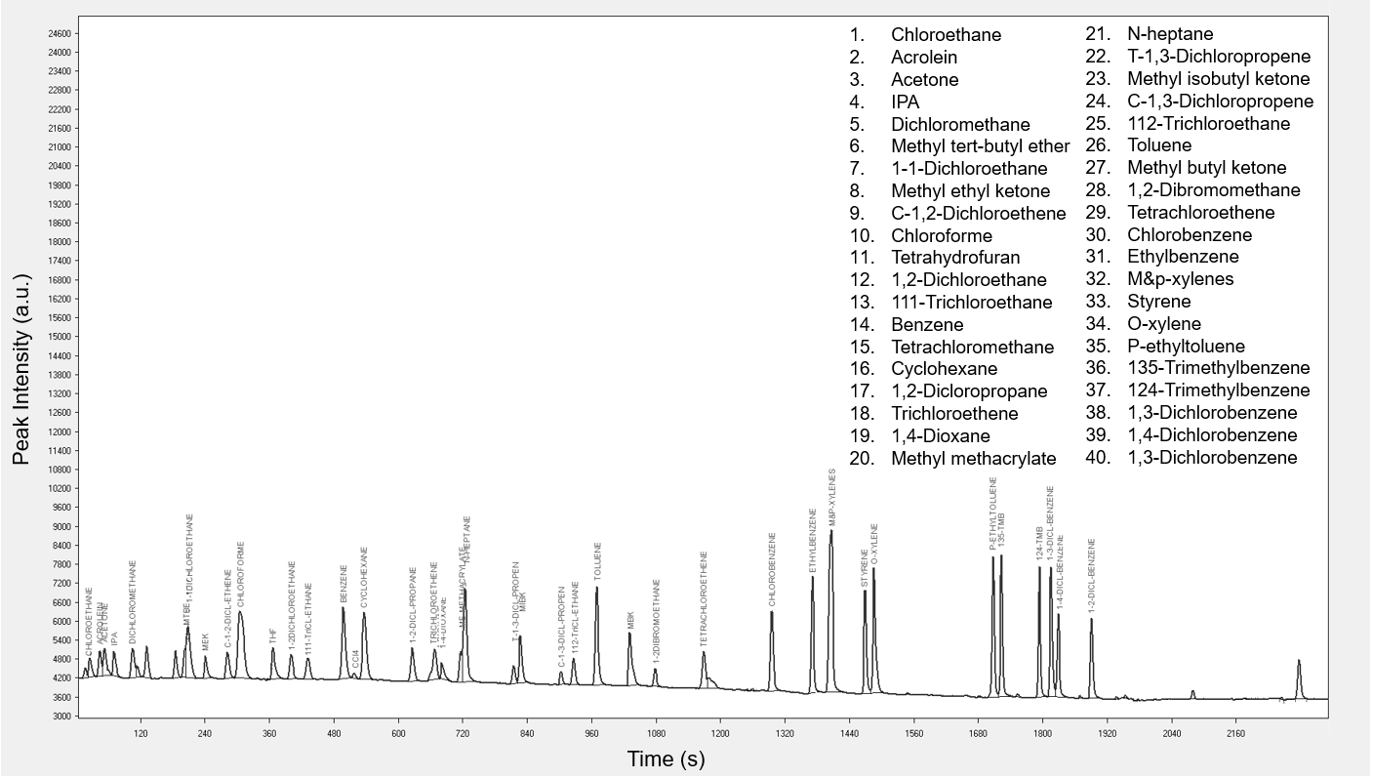 | 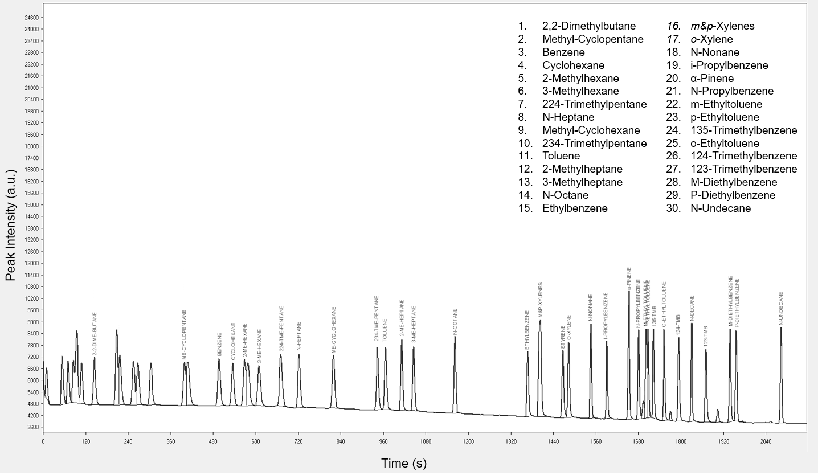
Figure 1a: FID chromatogram of a 4 ppb TO15 standard mix | Figure 1b: FID chromatogram of a 4 ppb PAMS standard mix
It is noticeable that coelutions occur between some VOCs contained in the cylinders; e.g. in TO15 mix, MTBE, Vinyl acetate and 1.1-Dichloroethane are co-eluted, Ethyl acetate is co-eluted with Chloroform and Methyl methacrylate with N-heptane. Fortunately, we can avoid these coelutions with MS detection by selecting the specific ion for each compound.

Methyl methacrylate has a fruity odor and an odor threshold of approximatively 340 ppb (EPA, 1992), Chloroform smell is sweet and ether-like and its odor threshold is around 3800 ppb (Nagata, 2003). Although, these molecules have different organoleptic characteristics, they are coeluted. Thus, the probability to make identification mistakes by olfactometry are significative. The use of a system equipped with a mass spectrometer is then required.

The performances studies were evaluated for 4 families of VOCs detected in ambient air: Alkanes, Aromatic hydrocarbons, Oxygenated Volatile Organic Compounds (OVOCs) and Halogenated compounds.
Only were reported in Table 1, the results of the performance studies of OVOCs.

Table 1: Determination coefficients, detection limits and accuracies of 1 family of VOCs (OVOCs) using FID and MS detections
 | VOCs |  | FID Detection |  |  |  | MS Detection
 |  | Odor threshold (ppb_{v}) | Determination coefficient (R²) | LOD (ppb_{v}) | Accuracy at 4 ppb_{v} (%) |  | Determination coefficient (R²) | LOD (ppb_{v}) | Accuracy at 4 ppb_{v} (%)
 | Acrolein | 1800 | 0.9992 | 0.093 | 2.62 |  | 0.9990 | 0.277 | 1.67
 | Acetone | 100000 | 0.9960 | 0.065 | 8.27 |  | 0.9995 | 0.253 | 2.22
 | Isopropyl alcohol | - | 0.9829 | 0.130 | 13.6 |  | 0.9871 | 0.404 | 7.87
 | Methyl tert-butyl ether | - | Coeluted | - | - |  | 0.9995 | 0.216 | 2.09
 | Vinyl acetate | 400 | Coeluted | - | - |  | 0,9992 | 0,431 | 0,73
 | Methyl ethyl ketone | 5400 | 0.9960 | 0.124 | 14.2 |  | 0.9899 | 0.068 | 19.8
 | Ethyl acetate | 10000 | Coeluted | - | - |  | 0.9882 | 2.092 | 21.4
 | THF | - | 0.9999 | 0.140 | 3.00 |  | 0.9989 | 0.087 | 5.85
 | 1,4-Dioxane | 75000 | 0.9896 | 0.146 | 28.7 |  | 0.9978 | 0.285 | 14.9
 | Methyl methacrylate | 340 | Coeluted | 0.124 | 15.3 |  | 0.9984 | 0.273 | 5.92
 | Methyl isobutyl ketone | 270 | 0.9986 | 0.325 | 7.36 |  | 0.9979 | 0.760 | 2.34
 | Methyl butyl ketone | 24 | 0.9970 | 0.296 | 18.2 |  | 0.9988 | 0.159 | 2.47

Calibration curves for each VOCs were performed with six different concentrations of the standard mixture. The range of concentrations is 0.5 to 10 ppb. The linearity of calibration curves was determined with determination coefficient (R²) for FID and MS detection. The determination coefficients varied between 0.9750 (Tetrachloroethene) and 0.9999 (1-2-Dichlorobenzene) for FID and 0.9871 (IPA) and 0.9998 (1.4-Dichlorobenzene) for MS, showing linear calibration curves for most of the compounds
The limits of detection (LOD) of the systems were calculated according to the Chinese standard norm for ambient air measurement (HJ 1010-2018, 2019). Thus, the LODs were determined with the standard deviation of 10 replicates of the standard gas at 0.5 ppb. The detection limits ranged from 0.017 ppb (Cyclohexane) to 0.618 ppb (CCl₄) and 0.068 ppb (MEK) to 2.110 ppb (Ethyl acetate) for FID and MS respectively. The detection limits are overall higher with MS detection.
The precision and accuracy were calculated at 4 ppb according to the Chinese standard method. The majority of the compounds had low relative standard deviations, but the non-gaussian peak shape of some compounds could be responsible of accuracies over 10 %, especially for the oxygenated ones (Table 1). In comparison, Benzene accuracies are 1.06 % and 4.70 % for FID and MS respectively.

    - Development of automatic reprocessing and validated data
Although the LOD and repeatability are overall better for FID than MS, FID detection could not provide analysis of the co-eluted compounds. However, by selecting a specific ion for each species, MS detection allows accurate quantification of these substances.

Therefore, in order to make a selection among FID and MS detections, an algorithm has been developed in the VistaMS software to select the most suitable result between this dual detection and to provide validated results. To achieve this automatic reprocessing, the implementation of validation parameters was developed for each identified compound. The algorithm is presented in Eq(1). The validation parameters correspond to
CST_C_GAP and PCENT_C_GAP and were optimized for each VOCs.

CST_C_GAP: If $\left|\left[FID\right]-\left[MS\right]\right| <CST_C_GAP$  Then FID value selected  Otherwise MS value  Or  PCENT_C_GAP: If $\frac{\left[FID\right]-\left[MS\right]}{[MS]} ×100 <PCENT_C_GAP$  Then FID value selected  Otherwise MS value | (1)

After implementation of validation parameters, the percentages of result given by FID and MS detections depending on VOCs families were evaluated and are showed in fig. 2. As Alkanes have very good responses in FID and no significant interferences, results given by the FID are prefered. On the other hand, most of OVOCs and halogenated compounds are coeluted on this GC system. Fortunately, these substances have very specific m/z ions, that allows MS detector to detect and quantify them. As shown in fig. 2, MS detection is thus favorized for these families of VOCs.

Figure 2: Percentage of results given by FID or MS detection depending on the VOCs families
To verify if the algorithm is efficient to deliver reliable results, the accuracies at 4 ppb for FID, MS and validated data were compared for every identified compound and are represented in fig. 3.
The Relative Standard Deviations that reached 100 % correspond to the coeluted compounds not detected by the FID.
Fig. 3 show that after the implementation of the validation parameters, the results with better accuracies are mostly selected. Therefore, by selecting MS or FID result, the RSD percentages of the validated data range from 0.07 % to 21.4 % demonstrating very good overall accuracy.

Figure 3: FID, MS and validated data accuracies at 4 ppb of every identified compounds
  - Conclusions
In this work, the performances and limitations of detection of VOCs in ambient air by dual thermo-desorption gas chromatograph equipped with flame ionisation detector and mass spectrometer were described. Using TO15 and PAMS standard gas mixtures, more than 70 VOCs were identified and accurately quantified on the C6C12 system with FID and MS detection. To select the best result between this dual detection, validation parameters have been optimized for each identified compound and gave accurate concentrations at 4 ppb.
Acknowledgments
This work was carried out as part of a thesis with a CIFRE agreement from the National Association for Technical Research (ANRT)
References
Abraham M. H., Gola J. M.R., Cometto-Muñiz J. E., (2016), An assessment of air quality reflecting the chemosensory irritation impact of mixtures of volatile organic compounds, Environment International 86, 84 – 91.
Bari Md. A., Kindzierski W. B., (2018), Ambient volatile organic compounds (VOCs) in Calgary, Alberta: Sources and screening health risk assessment, Science of the Total Environment 631 – 632, 627 – 640.
Barletta B., Meinardi S., Sherwood Rowland F., Chan C.Y., Wang X., Zou S., Chan L. Y., Blake D. R., (2005), Volatile organic compounds in 43 Chinese cities, Atmospheric Environment 39, 5979 – 5990.
EPA, (1992), Reference guide to odor thresholds for hazardous air pollutants listed in the clean air act amendments of 1990 [R]. Washington, DC.
Gallego E., Folch J., Teixdor P., Roca F. J., Perales J. F., (2019), Outdoor air monitoring: Performance evaluation of a gas sensor to assess episodic nuisance/odorous events using active multi-sorbent bed tube sampling coupled to TD-GC/MS analysis, Science of the Total Environment 694, 133752.
Gu Y., Li Q., Wei D., Gao L., Tan L., Su G., Liu G., Liu W., Li C., Wang Q., (2019), Emission characteristics of 99 NMVOCs in different seasonal days and the relationship with air quality parameters in Beijing, China, Ecotoxicology and Environmental Safety 169, 797 – 806.
HJ 1010-2018, (2019), Specifications and Test Procedures for Ambient Air Quality Continuous Monitoring System with Gas Chromatography for Volatile Organic Compounds.
Hong Z., Li M., Wang H., Xu L., Hong Y., Chen J., Chen J., Zhang H., Wu X., Hu B., Li M., (2019), Characteristics of atmospheric volatile organic compounds (VOCs) at a mountainous forest site and two urban sites in the southeast of China, Science of the Total Environment 657, 1491 – 1500.
Nagata Y., (2003), Measurement of odor threshold by triangle odor bag method, Tokyo Japan, Japan Ministry of the Environment.
Nie E., Zheng G., Gao D., Chen T., Yang J., Wang Y., Wang X., (2019), Emission characteristics of VOCs and potential ozone formation from a full-scale sewage sludge composting plant, Science of the Total Environment 659, 664 – 672.
Spinelle L., Gerboles M., Kok G., Persijn S., Sauerwald T., (2017), Review of Portable and Low-Cost Sensors for the Ambient Air Monitoring of Benzene and Other Volatile Organic Compounds, Sensors 17, 1520.
Zhu Y.L., Zheng G.D., Gao D., Chen T.B., Wu F.K., Niu M.J., Zou K.H., (2016), Odor composition analysis and odor indicator selection during sewage sludge composting, Journal of the air & waste management association 66, 930 – 940.

