|  |  |
| --- | --- |
| cetlogo ***CHEMICAL ENGINEERING TRANSACTIONS***  ***VOL. 95, 2022*** | A publication of  aidiclogo_grande |
| The Italian Association  of Chemical Engineering  Online at www.cetjournal.it |
| Guest Editors: Selena Sironi, Laura Capelli  Copyright © 2022, AIDIC Servizi S.r.l. **ISBN** 978-88-95608-94-5; **ISSN** 2283-9216 | |

A simple and practical methodology for monitoring the peak concentration of odorous gases in air

Giampietro Casasantaa, Roberto Sozzid, Sandro Finardic, Alessandro Di Giosab, Laura Bennatib, Antonio Amorosob, Stefano Listranib. S. Argentinia

a National Research Council of Italy, Institute of Atmospheric Sciences and Climate (CNR-ISAC), 00133 Rome, Italy (g.casasanta@isac.cnr.it)

bARPA Lazio, 00187 Rome, Italy

cARIANET, 20159 Milan, Italy

dIndependent Scientific Consultant, 20126 Milan

Odour nuisance impacting residents' life comfort is the result of the presence in air of numerous species, mainly gaseous, negatively interacting with the human olfactory system. It is well known that odour nuisance does not depend on the mean gas concentrations over long averaging times (of the order of one hour), but on their turbulent fluctuations, that can be some orders of magnitude greater than hourly averaged values. Currently, the direct measure of intensity and frequency concentration peaks can be carried out only for a few species and requires high-cost instruments, representing a serious challenge for Environmental Protection Agencies responsible for public health and environmental protection. This paper describes the intermediate-cost methodology developed by ARPA Lazio, the environmental agency responsible for the Italian administrative region which includes Rome, to monitor and assess the presence of odorous gases. It is based on mobile vehicles equipped with intermediate-cost analyzers for some of the main odorous gases, successfully deployed in more than fifteen field campaigns carried out all over the region in the last five years. As an example, results from one of the campaigns are also reported briefly. Such an effort is mainly motivated by the need to fulfil institutional duties, but it also supports the possibility of building a network of affordable instruments capable of routinely monitor odour nuisance impact over relatively large regions.

* 1. Introduction

Odorous gases are emitted into the Planetary Boundary Layer (PBL), the lowest part of the atmosphere close to Earth’s surface that is always in a turbulent state; as a consequence, their concentrations at a fixed point in space is characterized by large and rapid fluctuations in time, depending on the local level of turbulence. Thus, within the PBL it is not uncommon for instantaneous concentrations to be one order of magnitude higher than their mean value. Air quality studies are generally focused on mean concentrations of a number of atmospheric components such as, e.g., NO2, SO2, CO, O3, VOCs, PM10 and PM2.5, as the dose accumulated over the years by the human body with breathing significantly increases the probability of the onset of serious diseases (Cesaroni et al., 2013; Ancona et al., 2015). In this context, cumulative values over time matter far more than concentration temporal variabilities, but this is not the case of odour nuisance, for which the olfactory system is able to make an almost instantaneous qualitative-quantitative analysis (Nicell, 2009) triggering a negative sensation whenever the concentration of an odorous substance reaches a threshold value. In this case, it is the instantaneous concentration (and especially its peak) instead of the mean concentration that should be considered.

Most of the sensors currently available to measure odorous gases are expensive and complex closed-path gas analyzers with non-ideal dynamic characteristics, i.e., not fully capable of detecting the continuous behaviour of odorous gases, including their peaks of concentrations. For some odorous gases, namely H2S and NH3, automatic analyzers with technical characteristics like those used in air pollution monitoring are available, while for other species (reduced sulphur compounds, VOCs) automatic gas chromatographs/PIDs capable of providing average concentrations are often used. This second class of instruments is generally less expensive and easier both to operate and maintain. As a matter of fact, instruments to routinely monitor the concentration of odorous gases such as H2S and NH3 have good accuracy but low dynamics, resulting in a distorted and out-of-phase representation of the acquired signal. Therefore, from the measured signal it is only possible to obtain with good accuracy the mean concentration, without all the statistical information required to estimate the peak concentration - often defined as an appropriate percentile of the concentration itself (e.g., 90th or 99th). In addition, instruments for detecting sulphur compounds and VOCs are usually limited to hourly averaged values.

In the last five years, the increasing in both frequency and magnitude of odour events pushed ARPA Lazio (the regional environmental agency of Lazio region) to develop a technique capable of detecting the presence of the main odorous gases and their hourly peaks. Such a technique was assessed in more than fifteen one-month experimental campaigns, carried out in different part of the regional administrative territory with a mobile laboratory equipped with H2S and NH3 low dynamics analyzers, as well as an automatic gas chromatograph capable of providing the hourly mean concentrations of several odorous substances.

In this work, we present both the theoretical basis of the developed technique and its application in a recent monitoring campaign carried out to detect odorous substances near Rome, including the determination of the Odour Intensity (OI) synthetic index proposed by Wu et al. (2016), which allows to evaluate the potential hourly olfactory nuisance perceived (or perceptible) at the monitoring site.

* 1. Theoretical framework

The operational method developed by ARPA Lazio is based on several statistical and fluid dynamic considerations briefly outlined as follows.

* + 1. Definition of peak concentration and its determination

The instantaneous concentration *c*(*t*) of a gas in the PBL can be considered as a stationary stochastic process whose statistical properties are completely defined by a probability density function (*PDF*) that has to be determined experimentally (see, e.g., Cassiani et al., 2020 for a review), and is well described by a Gamma distribution (Nironi et al. 2015). Let $C$ be the mean concentration, σ the standard deviation and $i_{c}=σ/C$ the concentration intensity. The *PDF* governing the stochastic process (instantaneous concentration) is the one-parameter Gamma distribution (Nironi et al. 2015):

|  |  |
| --- | --- |
| $$p\left(χ\right)=\frac{k^{k}}{Γ\left(k\right)}χ^{k-1}exp\left(-k\right),$$ | (1) |

with $χ=c/C$, ${k=i}_{c}^{-2}$, and $Γ\left(k\right)$ the Euler Gamma function. Eq. (1) is fully determined when either $i_{c}$ or *C* and its associated standard deviation σ are known. As pointed out by Nironi et al. (2015), eq. (1) also supports the conjecture on the existence of a universal *PDF* for instantaneous concentrations that can be modelled by a family of one-parameter Gamma distributions, as previously suggested in Villermaux and Duplant (2003), Duplant and Villermaux (2008), Yee and Skvortsov (2011), and Efthimiou et al. (2016).

The peak concentration *C*p, defined as a specific percentile of the instantaneous concentrations measured within one hour (Schauberger et al., 2012), can be determined by inverting the cumulative distribution of eq. (1), providing that both the mean and the variance are known. Determining the peak concentration immediately leads to the peak-to-mean ratio, .

* + 1. The sensor as a low-pass filter

The peak concentration *C*p can only be estimated if both *C* and σ are known. Unfortunately, most intermediate-cost gas analyzers are not really capable of measuring *c(t)*, because of their non-ideal dynamic characteristic; as a result, the signal produced by the analyser turns out to be just a filtered and phase-shifted version of *c(t)*. Observing that typical analyzers behave like low-pass filter, and using spectral turbulence together with linear system theory arguments, in neutral situations Horst (1997) obtained the following relation linking the variance $σ^{2}$ with the measured sample variance $σ_{c}^{2}$:

|  |  |
| --- | --- |
| $$\frac{σ^{2}}{σ_{c}^{2}}=1+\left(2π∙n_{m}τ∙\frac{U}{z}\right)=Cor,$$ | (2) |

where *n*m = 0.062. *Cor* increases linearly with τ and the average wind speed *U* but decreases with the measurement height *z*.

*Figure 1: Google Earth map of Colonna and its surroundings. The wind rose generated from all the observed data is centred at the measurement site (41.830677N, 12.754868E).*

* + 1. Equivalence of passive scalars

Fluid dynamics provides equations to describe space and time evolution of *C* and $σ^{2}$ as a function of molecular diffusivity as well as location and modality of emission, so that, in principle, different odorous gases should behave differently. Nonetheless, following the considerations of Tennekes and Lumley (1989) and Chatwin and Sullivan (1990), it can be assumed that atmospheric turbulent effects outweigh molecular forces. In particular, according to Ferrero et al. (2020), at a fixed location from the source the concentration intensity $i_{c}$ is the same for all gases, regardless of the specific value of both *C* and $σ$. Also, the same conclusion applies to $R_{p}$ as well, because it depends only on $i_{c}$ through eq. (1).

In addition, considering that at about 1-2 km from the source the typical time of flight of an emitted odorous gas is about an order of magnitude greater than the typical Lagrangian integral time scale *T*L, it is safe to assume that the effect due to dry deposition and chemical reactivity are negligible. Such a relatively long time of flight turns out to be useful also in case of close multiple sources, that for most practical applications can be considered as one (Sawford, 1985).

* 1. Materials and Methods
     1. Instruments

The monitoring campaigns were conducted by ARPA Lazio using a mobile vehicle equipped with a meteorological station, air quality analyzers compliant with current standards (EN 2008/50/CE) and analyzers to continuously monitor the main odorous gases, i.e., with intermediate-cost instruments like those normally used for air quality monitoring. More specifically, the mobile observatory includes low-dynamics H2S (Teledyne API T10, ) and NH3 analyzers (Teledyne API T201, $τ_{NH3}=113.5 s$), both measuring instantaneous concentrations every 5 s, as well as a gas chromatograph equipped with an electrochemical detector combined with a PID (Chromatotech Vigi E-NOSE), capable of measuring the 20-minute mean concentrations of several odorous gases, namely DES, DMS, DMDS, MES, TBM, THT, 2-Butyl mercaptan, Ethyl mercaptan, Isobutyl mercaptan, Isopropyl mercaptan, Methyl mercaptan, n-Butyl mercaptan, n-Propyl mercaptan and VOCs - Sulphur detector has a limit of detection (LOD) less than 1 ppb, and the hourly concentration of each sulphur compounds is calculated as the arithmetic mean of three chromatographic run, without considering the LOD.

* + 1. Operational method

Following the theoretical framework introduced in Sec. 2, the step-by-step procedure adopted to retrieve peak concentrations is as follows.

* Retrieve hourly mean concentrations of all measured gases, as well as H2S or NH3 sample standard deviations.
* Obtain for H2S and NH3, with estimated from eq. (2).
* Estimate the peak-to-mean ratio $R_{99}={C_{99}}/C$, where the peak concentration is defined as the 99th percentile of the concentrations measured within 1 hour.
* Calculate the peak concentration for H2S, NH3 and all the gases for which only the average concentration is available, by assuming the *R*99 calculated from the previous step as a constant.
  1. Summary of the results of the ARPA Lazio campaign in Colonna (RM)

The technique described above was already used in several experimental campaign. As an example, this section describes the results of the ARPA Lazio campaign carried out during the period from 4 June to 23 July 2020 in Colonna (Rome, Colli Albani district), where the potential source of odour nuisance is an industrial area located at about 2 km SE of the city centre, whose activities include the production of bituminous conglomerate. In addition, a motorway close to the area (from W to SE) represents an important source of VOCs and NH3 emissions. As reported in Figure 1, that shows both the ARPA Lazio mobile laboratory position and the wind rose during the entire period, the experimental site was downwind of the potential sources for most of the time.

The mean values of the hourly concentrations of all the 16 measured gases are reported in Table 1, along with their maximum and standard deviation values. H2S and NH3 measurements show mean and standard deviation values of the same order of magnitude, with maximum values about one order of magnitude greater. Such a behaviour reflects the diurnal evolution of the PBL height, which determine the maximum volume available for gas dispersion. Also, as expected they have the same concentration intensity, $i_{c}=0.82$. Conversely, other odorous gases maxima are about two orders of magnitude higher than their hourly values, suggesting the presence of intense sources located in the industrial area and detected only when the mobile laboratory was downwind of it. This conclusion is further supported by both the hourly mean and the peak concentration time series of H2S and NH3 compared to that of a typical odorous gas such as DES (Figure 2). While H2S and NH3 concentrations are continuous in time because of the presence of diffuse sources, DES concentration is highly intermittent, suggesting that all emissions are concentrated in a single area.

Table 1: Mean of the hourly concentrations of all the 16 measured gases, along with their maximum and standard deviation values.

|  |  |  |  |  |
| --- | --- | --- | --- | --- |
|  |  | Max | Mean | Std |
| H2S | μg/m3 | 5.46 | 0.90 | 0.74 |
| DMDS | ppb | 1.87 | 0.00 | 0.06 |
| METHYL-SH | ppb | 3.40 | 0.02 | 0.16 |
| ETHYL-SH | ppb | 2.57 | 0.01 | 0.11 |
| DMS | ppb | 1.87 | 0.00 | 0.07 |
| ISO-PRO-SH | ppb | 2.47 | 0.02 | 0.14 |
| TMB | ppb | 2.97 | 0.02 | 0.17 |
| N-PROP-SH | ppb | 8.20 | 0.03 | 0.30 |
| MES | ppb | 1.47 | 0.01 | 0.07 |
| 2-BUTYL-SH | ppb | 6.98 | 0.03 | 0.27 |
| THT | ppb | 5.04 | 0.02 | 0.21 |
| DES | ppb | 18.84 | 0.11 | 0.86 |
| N-BUTYL-SH | ppb | 6.41 | 0.02 | 0.22 |
| ISO-BUT-SH | ppb | 3.52 | 0.02 | 0.17 |
| VOC-EQDMS | ppb | 127.28 | 37.09 | 26.10 |
| NH3 | μg/m3 | 4.08 | 0.94 | 0.77 |

Peak concentrations reported in Figure 2 are calculated with the operational method illustrated in Sec. 3.2, using 0.2 Hz raw H2S data to obtain $i_{c}=σ/C$. To consider the dynamic characteristics of the H2S analyzer, the standard deviation $σ$ was determined by applying the spectral correction described in Sec. 2.2. As shown in Figure 2, the spectral correction leads to peak concentration values significantly higher than those obtained by using the sample variance as measured by the instrument (Figure 2 concentration-axis scale is logarithmic).

ARPA Lazio is institutionally required to provide the population and the competent authorities with a summary of the olfactory situation recorded during the campaign, even if there are no regional prescriptions about it. For this purpose, following Wu et al. (2016), the potential hourly olfactory nuisance perceived at the monitoring site was evaluated through the Odor Intensity (OI), which is a synthetic index capable of accounting for the contemporary presence of different odorous gases. Firstly, for each odorous gases the OAVp value defined as

|  |
| --- |
|  |
|  |
|  |

Figure 2: Time series of hourly mean and peak concentration values of H2S, NH3 and DES with and without the spectral correction (Sec. 2.2)

the ratio between its peak concentration and the relative odour threshold (Nagata 2003) was calculated. Then SOAVp, defined as the sum of all the OAVp, is calculated, and Odor Intensity is finally obtained for each hour of the campaign using the relationship (Wu et al., 2016) $OI=log\left(SOAVp\right)+0.5$. Figure 3 shows the OI rose calculated over the entire observation period, which combines wind direction with OI data to give a graphical representation of the odour emission origin. As expected, higher OI values correspond to wind coming from SE, where the industrial area is located.

*Figure 3: OI values and wind direction.*

* 1. Conclusions

The operational method developed by ARPA Lazio is based on well-known fluid-dynamic properties and on the assumption, well supported by experimental evidence, of a universal PDF for the instantaneous concentration of a generic gas. It allows the determination of H2S and NH3 peak concentrations by intermediate-cost gas analyzers with non-ideal dynamic characteristics, and of any other gas provided that its hourly concentration is measured at the same time and in the same place. The use of intermediate-cost instruments supports the possibility of building dense networks of affordable gas analyzers for monitoring odour nuisance systematically and continuously over large regions.

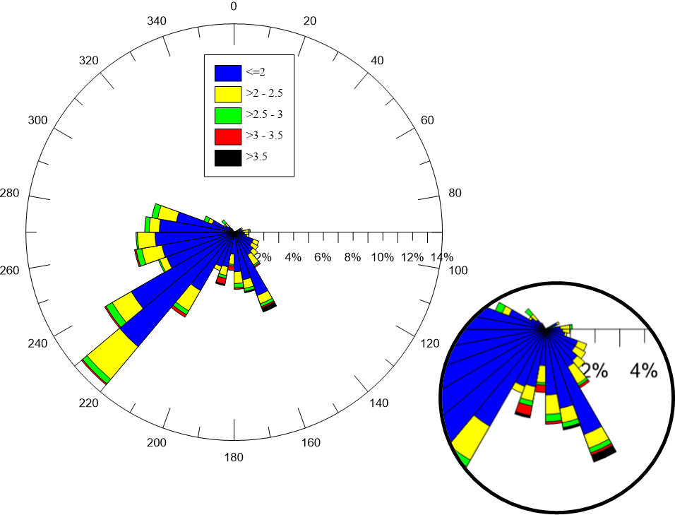

References

Ancona C., Badaloni C., Mataloni F., Bolignano A., Bucci S., Cesaroni G., Sozzi R., Davoli M., Forastiere F., 2015, Mortality and morbidity in a population exposed to multiple sources of air pollution: A retrospective cohort study using air dispersion models, Environmental Research, 137, 467–474.

Cassiani M., Bertagni M., Marro M., Salizzoni P., 2020, Concentration fluctuations from localized atmospheric releases, Boundary-Layer Meteorology, 177, 461–510.

Cesaroni G., Badaloni C., Gariazzo C., Stafoggia M., Sozzi R., Davoli M., Forastiere F., 2013, Long-Term Exposure to Urban Air Pollution and Mortality in a Cohort of More than a Million Adults in Rome,Environmental Health Perspectives,121,324-331.

Chatwin P. C., Sullivan P., 1990, A simple and unifying physical interpretation of scalar fluctuation measurements from many turbulent shear flows, Journal of Fluid Mechanics, 212, 533-556.

Duplant J., Villermaux E., 2008, Mixing by random stirring in confined mixtures,Journal of Fluid Mechanics 617, 51-86.

Efthimiou G. C., Andronopoulos S., Tolias I., Venetsanos A., 2016, Prediction of upper tail of concentration distributions of a continuous point source release in urban environments*,* Environmental Fluid Mechanics, 16, 1-23.

Ferrero E., Manor A., Mortarini L. and Oett D., 2020, Concentration fluctuations and odor dispersion in Lagrangian models, Atmosphere, 11, 27.

Horst T.W., 1997, A simple formula for attenuation of eddy fluxes measured with first-order-response scalar sensors, Boundary-Layer Meteorology, 82, 219-233.

Nagata Y., 2003, Measurements of odor threshold by triangle odor bag method*,* Chapter In: Odor measurements review, 118, pp. 118-127.

Nicell J.A., 2009, Assessment and regulation of odour impacts*,* Atmospheric Environment, 43, 196-206.

Nironi C., Salizzoni P., Marro M., Mejean P., Grosjean N.,. Soulhac L., 2015, Dispersion of a passive scalar fluctuating plume in a turbulent boundary layer. Part I: velocity and concentration measurements, Boundary-Layer Meteorology,156, 415-446.

Schauberger G., Piringer M., Schmitzer R., Kampa M., Sowa A., Koch R., Eckhof W., Grimm E., Kypke J., Hartung E., 2012, Concept to assess the human perception of odour by estimating short-time peak concentrations from one-hour mean values, Reply to a comment by Janicke et al., Atmospheric Environment 54, 624-628.

Sawford B.L., 1985, Lagrangian statistical simulation of concentration mean and fluctuation fields, Journal of Applied Meteorology and Climatology, 24,1152-1166.

Tennekes H., Lumley J. L.,1972, A first course in the turbulence*,* MIT Press, Cambridge (MA).

Villermaux E., Duplant J., 2003. Mixing as an aggregation process*,* Physical Review Letters, 91, 184, 501.

Wu C., Liu J., Zhao P., Piringer M., Schauberger G., 2016, Conversion of the chemical concentration of odorous mixtures into odour concentration and odour intensity: a comparison of methods, Atmospheric Environment, 127, 283-292.

Yee E., Skvortsov A., 2011, Scalar fluctuations from a point source in a turbulent boundary layer, Physical Review E, 84, 036306.