 CHEMICAL ENGINEERING TRANSACTIONS  VOL. 95, 2022 | A publication of  
The Italian Association
of Chemical Engineering
Online at www.cetjournal.it

Guest Editors: Selena Sironi, Laura Capelli
Copyright © 2022, AIDIC Servizi S.r.l.
ISBN 978-88-95608-94-5; ISSN 2283-9216

Concept of questionnaire surveys in an urban agglomeration as an essential element of identifying the sources of odour nuisance
Marta Wiśniewska*, Andrzej Kulig
Warsaw University of Technology, Faculty of Building Services, Hydro and Environmental Engineering, 20 Nowowiejska Street, 00-653 Warsaw
*Marta.Wisniewska@pw.edu.pl
  - Introduction
Urban environmental comfort is linked to the development of acoustic, thermal, lighting, optical and olfactory factors (Wojnarowska et al., 2020). Odour nuisance is one of the most common environmental causes of complaints from residents. The development and extension of the boundaries of urban agglomerations usually bring residential development closer to industrial and municipal installations. Both increasing numbers of pollutants originate from municipal facilities such as landfills, recycling factories or wastewater treatment plants, and industrial plants including oil refineries, manufactories, breweries, distilleries, and others have a significant impact on the introduction of chemical compounds from various groups to the atmosphere (Capelli et al., 2013; Chen et al., 2006; Davoli et al., 2003; De Santis et al., 2004). Air pollutants can harm living organisms and the environment. Some of these can have carcinogenic properties, which can be very dangerous to human life, especially at high concentrations. Air pollutants should direct particular attention to all substances responsible for unpleasant aroma in air – odours (Fang et al., 2012; Sówka et al., 2011; Ying et al., 2013). Despite numerous studies to detect odours and reduce emissions, there is still no definitive method to assess the impact of odours on humans and the population's response (Capelli et al., 2011; Hayes et al., 2014). A nuisance of odours can have a significant adverse effect on the well-being of residents, understood as a state of satisfaction or physiological well-being resulting from the harmony between man and the environment, i.e. between the physiological and ecological conditions of man.
Survey studies play an essential role in the initial identifying measurement points in analysing odour effects in urban agglomerations (Kulig et al., 2022). Based on the analysis of residents' complaints, the researchers could specify the areas of research that were subsequently reviewed. Odour nuisance cases also refer to situations in which residents declare discrepancies between the odours they perceive. An example of a method of inventorying sources of odour nuisance in the analysed area is surveyed, such as the computer-assisted telephone interview – CATI (Kulig et al., 2010). Such studies allow obtaining reliable information, among other things, on the odour nuisance experienced by residents. Another critical point is the measures taken by the city administration to minimise odour nuisance.
The paper presents the concept of a questionnaire survey of urban residents as well as competent institutions and organisations, the purpose of which is to identify the sources of odour nuisance and assess the extent of the problem. These studies and analysis will be undertaken in a city with a significant industrial share, located in central Poland (Masovian Voivodeship).
  - Materials and Methods
    - Information about the research area
In the frame of this work, a concept for surveys in urban agglomerations in Poland was developed. The aim of the studies is to determine the causes of odour nuisance (type of source, location of origin) and to assess the extent of the problem and the perceived fragrance intensity and odour nuisance intensity of the olfactory situation of the respondents. It is the first and very important step before field measurement series thanks to which the odour nuisance sources will be characterised. The selected agglomeration under Polish conditions is a medium-sized city with complex urban infrastructure and different types of potentially odorous objects. The metropolitan area, the town of Płock,is administratively subdivided into 23 settlements (21 housing estates and two uninhabited industrial estates). The city has a population of 117,573 (as of December 2021) and an area of 88.0 km². The population density was 1,336 people per square kilometre. The area of debt rescheduling and other institutions, urban and industrial sites that offer potential sources of odours. Figure 1 shows the location of the study area.
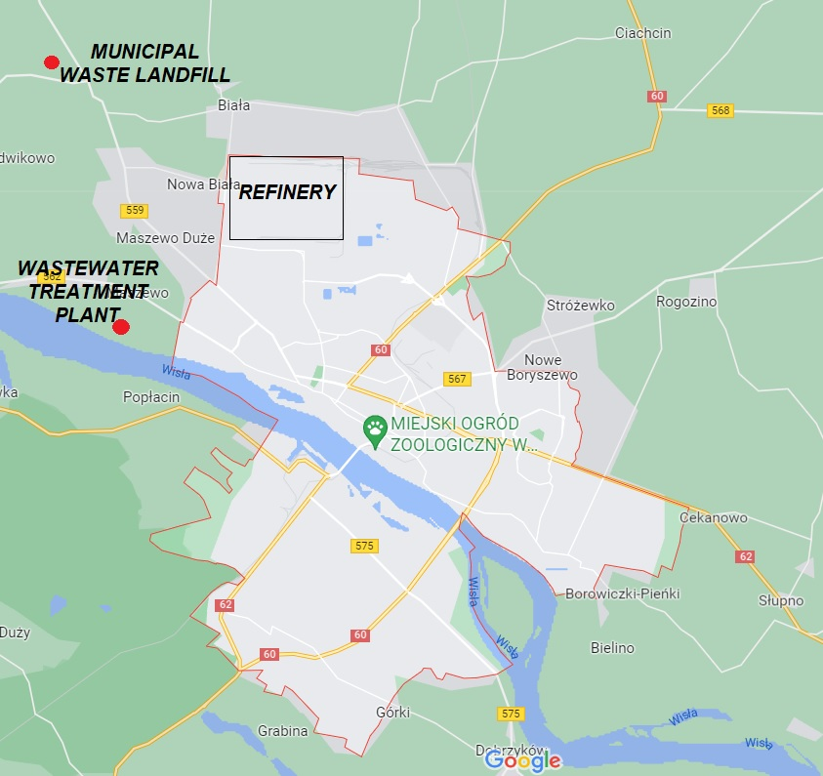
Figure 1: The urban agglomeration area as the subject of the planned research programme with the primary odour nuisance sources (own elaboration based on https://www.google.pl/maps).
Figure 1 shows the group of the main odour nuisance sources presented in the northwest of the urban agglomeration area studied. It is important from the viewpoint of the odour source characteristics. Figure 2 shows the wind rose for Płock area.
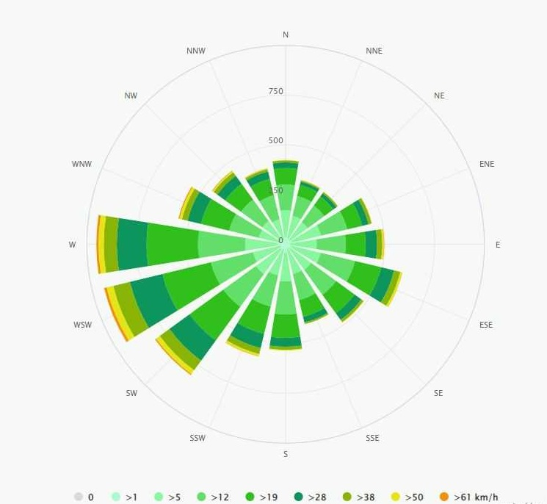
Figure 2: The wind rose for Płock area (https://www.meteoblue.com/).
The presented in figure 2 wind rose is developed based on 30-year hourly simulations of weather models. It shows the domination of west and south-west wind directions in the analysed area.
    - Development of the concept of survey research
The concept of survey research was developed based on a literature review on the subject of work and the team’s own research experience. Figure 3 shows five steps of the process.
4
3
5
2
1
Figure 2: Scheme of the concept of survey research.
The first step of the concept includes the reconnaissance of the potential sources of odour nuisance, in particular municipal and industrial facilities. After familiarizing ourselves with the structure of the urban agglomeration studied, a survey will be carried out aimed at the inhabitants of the agglomeration and neighbouring towns (step 2). The final version of the survey will be sent to the respondents via the Google Forms app, which does not require registration to complete the survey and ensures complete anonymity of respondents. To increase the number of recipients, the request to make the survey available on their website is addressed to the Municipal Administration, the Sanitary Epidemiological Station, the Voivodeship Environmental Protection Inspectorate and other institutions and organisations (step 3). After the respondents' answers have been received, an analysis of the results will be carried out, which should reveal how residents perceive the odour nuisance in a certain imagination, at what times of day they perceive it, in what direction they feel, and what they describe as the cause of the nuisance (step 4). The final stage of research will include olfactometric field studies by Nasal Ranger® (St. Croix Sensory Inc. of Lake Elmo, Minnesota) based, inter alia, on the results of the surveys (step 5) and chemical determinations using portable volatile organic compound detector with chromatograph function X-PID 9500 by Dräger® (Lübeck Germany). Thanks to these devices it will be possible to get a response how much odour can be determine in measuring points and what kinds and how much compounds can cause this odour.

    - Identification of odour nuisance in urban agglomeration
The causes of odour nuisance can be divided into industry, services and agriculture, depending on the urban area. Based on guidelines and various studies (Capelli et al., 2013; Chen et al., 2006; Davoli et al., 2003; De Santis et al., 2004; The draft of Polish act on counteracting odour nuisance, 2008) as the cause of the nuisance, such sources are listed as it is presented in figure 4. These are the potential odour sources, which have to be considered in analysed agglomeration.

Figure 4: Scheme of the potential odour sources in urban agglomeration.
These sources form the basis for identifying potential odour causes in the urban area studied and its vicinity - neighbouring villages. Their position on the map can be helpful when implementing surveys.
    - Survey studying
One of the essential elements of the survey approach is developing an appropriate set of questions for identification. Table 1 shows several questions which were developed as part of the survey design based on the project of Ordinance of the Environment Minister (2004) in Poland. The survey consists of ten questions: eight closed questions (multiple choice) and two open questions (for which it is necessary enter the answer). The problem related to the perception of odour nuisance: type of odour, the intensity and frequency of perception, time of day and/or night during which it is perceived and odour nuisance location. Correctly carried out surveys are helpful, among other things, in the development of a methodology for the investigation of the fragrance effect. The result of these works is developing a method for investigating the direct effects of odours to formulate an odour management program to minimise odour nuisance in urban areas (Succer et al., 2008; VDI 3940 B.3; VDI 3940 B.4).
  - Surveys
The surveys are carried out using the Google FORMS application. A link is generated for the surveys sent to the inhabitants of Płock and the neighbouring villages. The questionnaires is distributed to different institutions with separate links to the surveys to obtain answers from as many respondents as possible. This summarises the research results that are necessary for the statistical analysis of the results obtained. The results of the survey will form the basis for the initial identification of odour sources in the agglomeration area under investigation. Their validation will be carried out by field olfactometry and portable VOC detector with chromatography function.

Table 1: Concept of a questionnaire for odour nuisance surveys
No. | Question | Answer 1 | Answer 2 | Answer 3 | Answer 4 | Answer 5 | Answer 6 | Answer 7 | Answer 8
1. | Do you have an odour nuisance in Płock or its surroundings? | YES | NO | - | - | - | - | - | -
2. | In which area of Płock or the surrounding village do you feel an odour nuisance? Enter the street name in Płock or the name of the neighbouring villages. | Open answer
3. | At what time of day/night do you feel the odour nuisance? You can tick more than one answer. | 12:00 am-3:00 am | 3:00 am-6:00 am | 6:00 am-9:00 am | 9:00-12:00 pm | 12:00 pm-3:00 pm | 3:00 pm-6:00 pm | 6:00 pm-9:00 pm | 9:00 pm-12:00 am
4. | How to estimate the intensity of the perceived fragrance? | I do not feel the odour | Very weak | Weak | Clearly | Strong | Very strong | Extremely strong | -
5. | How do you assess the hedonic quality of the perceived fragrance? | Unpleasant | Indifferent | Pleasant | - | - | - | - | -
6. | How do you estimate the intensity of the odour nuisance? | No odour | No nuisance | Small nuisance | Nuisance | Large nuisance | Extreme nuisance | - | -
7. | Can you determine what is causing your odour nuisance? | Open answer
8. | In which wind direction do you most often experience an odour nuisance? | N | NE | E | SE | S | SW | W | NW
9. | How often do you experience odour nuisance in Płock or near Płock? | Never | At least one a month | At least once a week | At least once a day | Almost constantly | - | - | -
10. | Have you ever complained about an odour nuisance? | NO | YES, WHOM? | - | - | - | - | - | -

- Not applicable

  - Conclusions
This work aimed to develop a survey concept, which is the first part of the research to create a methodology for identifying and characterising sources of odour nuisance in urban areas. The development of a 5-step concept, based on a literature review and own scientific experience, is very helpful in identifying and characterizing odour sources in urban areas. Thanks to the questionnaire surveys submitted, it is possible to determine the times of day and night when the disorder occurs, the frequency of odour nuisance occurrence and the intensity of its perception. The presented concept constitute from the basis for more comprehensive investigations to identify and characterize odour causes in urban agglomerations using direct (in-situ) measurement methods.
Acknowledgments
This research was partly funded by National Science Centre, Poland, grant no. 2021/41/N/ST10/00777. For Open Access, the author has applied a CC-BY public copyright licence to any Author Accepted Manuscript (AAM) version arising from this submission.
Authors acknowledge the Dräger Polska Ltd. for the technical support provided.
References
Capelli L, Sironi S, Del Rosso R, Centola P, Rossi A, Austeri C., 2011, Olfactometric approach for the evaluation of citizens' exposure to industrial emissions in the city of Terni, Italy. Science of the Total Environment, 409(3):595–603.
Capelli L., Sironi S., Del Rosso R., Guillot J.M., 2013, Measuring odours in the environment vs dispersion modelling: A review. Atmospheric Environment, 79, 731.
Chen C.L., Shu C.M., Fang H.Y., 2006, Location and Characterisation of Emission Sources for Airborne Volatile Organic Compounds Inside a Refinery in Taiwan, Environmental Monitoring and Assessment, 120, 487.
Davoli E., Gangai M.L., Morselli L., Tonelli D., 2003, Characterisation of odorants emissions from landfills by SPME and GC/MS, Chemosphere, 51, 357.
De Santis F., Fino A., Menichelli S., Vazzana C., Allegrini I., 2004, Monitoring the air quality around an oil refinery through diffusive sampling, Analytical and Bioanalytical Chemistry, 378, 782.
Fang, J.J.; Yang, N.; Cen, DY; Shao, L.M. & He, PJ, 2012, Odor compounds from different sources of landfill: Characterisation and source identification, Waste Management, 32, 1401–1410.
Hayes J.E., Stevenson R.J., Stuetz R.M., 2014, The impact of malodour on communities: A review of assessment techniques, Science of the Total Environment 500–501, 395–407.
Kulig A., Lelicińska-Serafin K., Sinicyn G., 2010, Impact of Technological Solutions and Operating Procedures on Odour Nuisance of Municipal Solid Waste Landfills in Poland, Chemical Engineering Transactions 23, 249-254.
Kulig A., Szyłak-Szydłowski M., Wiśniewska M., 2022, Application of Field Olfactometry to Monitor the Odour Impact of a Municipal Sewage System, Energies 15, 4015.
Ordinance of the Environment Minister of 2004 on air quality standards for odours and methods for assessing the air quality of odours (project).
Sówka, I., Skrętowicz, M., Szklarczyk, M., Zwoździak, J., 2011, Evaluation of nuisance of odour from food industry, Environment Protection Engineering, 37,5–12.
Sucker, K., Both, R., Bischoff, M., Guski, R., Winneke, G., 2008, Odor frequency and odor annoyance. Part I: assessment of frequency, intensity and hedonic tone of environmental odors in the field, Int. Arch. Occup. Environ. Health 81, 671-682.
The draft act of 2008 on counteracting odour nuisance (Poland).
VDI 3940 B.3, Measurement of odour in ambient air by field inspections – Determination of odour intensity and hedonic odour tone, Verein Deutscher Ingenieure, Berlin, Beuth Verlag, 2010.
VDI 3940 B.4, Determination of the hedonic odour tone – Polarity profiles, Verein Deutscher Ingenieure, Berlin, Beuth Verlag, 2010.
Wojnarowska M., Plichta G., Sagan A., Plichta J., Stobiecka J., Sołtysik M., 2020, Odour nuisance and urban residents' quality of life: A case study in Kraków's in Plaszow district, Urban Climate 34, 100704.
Ying D., Chuanyu C., Bin H., Yueen X., Xuejuan Z., Yingxu C., Weixiang W., 2012, Characterisation and control of odorous gases at a landfill site: a case study in Hangzhou, China Waste Management, 32, 317.

