Odour monitoring with eNoses on the Tata Steel plant in the Netherlands’

Stef Lommena, Filippo Zuliania, Theo Leuwerinka, and Simon Bootsmab*
a Tata Steel Strip Products Mainland Europe, PO Box 10000, 1970 CA IJmuiden, The Netherlands
b Comon Invent, PO Box 39, NL2600 AA, Delft, The Netherlands
* bootsma@comon-invent.com

Introduction

Tata Steel Nederland is a fully integrated steel plant in IJmuiden. The steel plant is situated at the shore of the North Sea, about 30 kilometers northwest of Amsterdam, in the Province of North Holland. The steel plant is located in a densely populated area and must comply with strict environmental regulations. Emissions from Tata Steel may lead to complaints about odour, dust, and noise from citizens in the residential areas.

In 2010 Tata Steel IJmuiden started a research project to explore the opportunities of online eNose. First, a field trial aiming at the detection of passing plumes and a thorough investigation of the odour emission from the most dominant odour emission sources were performed. This which was performed according to the European standard EN13725. During the sampling and in the laboratory testing the eNose signals were analysed against the olfactometric tests. Thereafter, the eNose network was expanded to include both the steel plant premises as well as the surrounding communities, with the aim to track and trace odorous emissions that may lead to odour nuisance by comparing the eNose fingerprints of the complaints with a reference set derived from the odour emission sources of the steel plant.

Although the testing of the reference set of fingerprints demonstrated positive matching with those derived from the citizens’ complaints, only about 50% of the complaints fingerprints could be successfully matched. This paper details how to improve the accuracy of matching by using classification models. Kriging is then used to estimate the value of the odour nuisance both on the steel plant site and the nearby communities. This methodology is applied in real-time on the eNose readings and is currently in use by Tata Steel Nederland and the Province North Holland – represented by their EPA Omgevingsdienst Noordzeekanaalgebied. This provides valuable information to track and trace the odour complaints of the citizens.

- eNose setup
1.1 eNose sensors. Electronic noses (eNose) are compact sensors capable of detecting variations in the gas concentration in ambient air. The eNose used for this project is constituted by an array of four semiconductor gas sensors. The operating principle of this device is that the surface charge of the activated semiconductor layer depends on the total concentration of reactive molecules adsorbed on it. The basic semiconductor layer of all four sensors is the same, although dopant materials are added in each one of the layers. This results in different electrical characteristics of the four sensors when exposed to the same gas.

The eNoses are connected to a remote computer system via a wireless data communications link. The interpreting software first detects if the air composition is anomalous and, if so, it compares the pattern of the actual eNose readings with a database of reference eNose patterns. The patterns are called fingerprints of the eNose and correspond to the exposed gas. They are determined during training sessions by recording the eNose readings during exposition to known gases. The fingerprints of some relevant TATA Steel plant sources have been previously described [1] and will not be repeated here.

1.2 eNose sensitivity. A change in the reactive gas concentration results in a measurable change of the sensor signal as for:
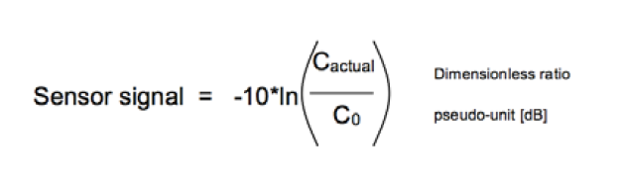
Fig. 1 shows a comparison between the odour concentration determined by dynamic olfactometry (ouE/m3) and eNose readings (pseudo-unit dB) for air samples taken at the stack of the TATA Steel sinter plant [1]. The eNoses were exposed to a dosed dilution of the sample air in a concentration from of 0.1 to 10.2 ouE/m3, corresponding to eNose readings ranging from 0.1 and 1.5 pseudo-unit dB.

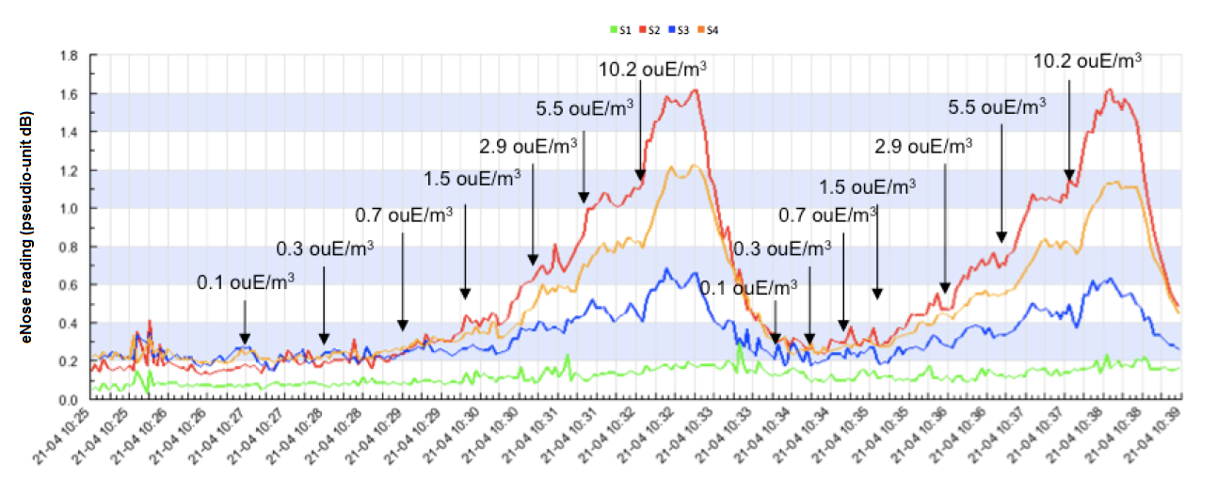
Fig. 1: comparison between dynamic olfactometry and eNose readings for the TATA steel sinter plant odour.

Although from the comparison above it can be argued that eNose can match the sensitivity of the human nose for the sinter plant odour, this unfortunately does not apply in all cases. Some odours, for example, are annoying at such low concentrations that cannot be detected by the eNose sensors.

1.3 eNose network. The eNose network installed on the Tata Steel site of Ijmuiden, in the neighbouring communities and along the North Sea Canal is composed of more than 70 eNoses in total (see Fig. 2).

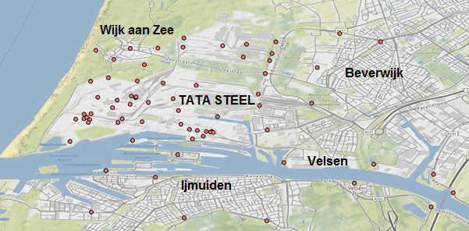
Fig. 2: eNoses locations (red spots) on Tata Steel Ijmuiden site and surrounding areas.

The eNoses data is daily ingested into the Tata Steel data lake and used for complaints analysis by both Tata Steel and Comon Invent. Each time an anomaly is detected by the eNose network an alert is triggered by the remote system, connecting the anomaly with the odour type of the best fitting reference fingerprint.

- Odour complaints sources
Events of odour annoyance in residential areas around the TATA Steel plant in IJmuiden were considered. For this purpose a dataset containing the complaints of annoyed citizens between Jan 1, 2016 and Dec 31, 2020 was made. This includes GPS-coordinates, timestamp, wind direction and eNoses readings both onsite the TATA Steel plant and in the nearby communities for each recorded complaint. Fig. 3 shows the complaints distribution by neighboring community of the TATA Steel plant in the reference period. The majority of the odour complaints originates from the community of Wijk aan Zee, where a relatively dense network of eNoses is installed. For these reasons, the complaints for odour nuisance from the community of Wijk aan Zee will constitute the basis of the analysis of this paper.

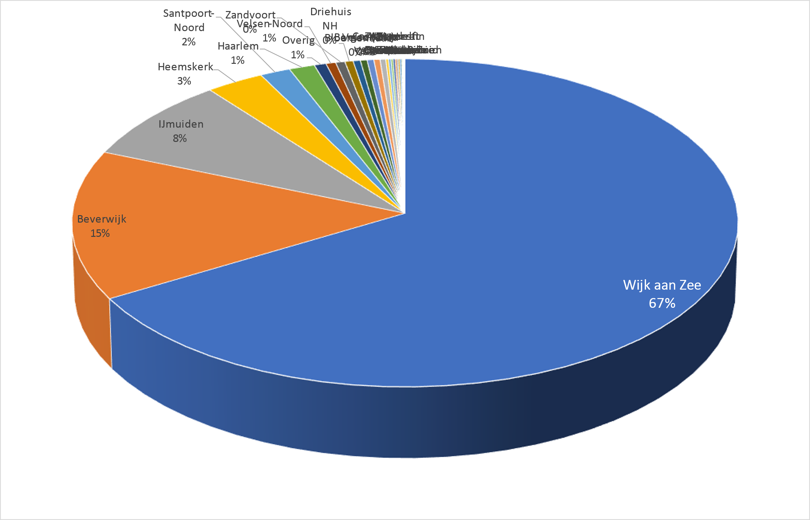
Fig. 3: share of odour complaints by neighborhood on the TATA Steel plan in Ijmuiden in the reference period.

Previous studies [1] showed the eNoses potential to detect the spread of the TATA Steel odours in the surrounding environment. The testing of the set of reference fingerprints provided by the laboratory testing demonstrated positive matching with complaints of annoyed citizens where readings of nearby eNose were present. As first estimate, 11 different events with a total 63 complaints from the complaints database were analyzed. A positive match was found for six events, whilst in four cases the match was not evident and in one event no match was found. This corresponds to an accuracy rate of about 50% of positively matched complaints by direct comparison of the related eNoses fingerprints with the reference set.

To increase the accuracy of matching of odour complaints events, classification methods are here employed. These do not resort to any reference set of odour sources. The complaint events considered here do coincide with large deflection of the eNoses signals mainly described by two of the four eNose sensors readings (see Fig. 4).
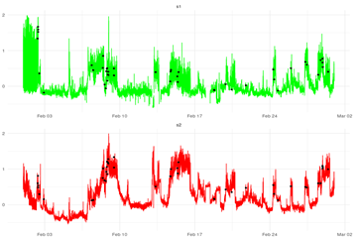
Fig. 4: eNoses signals of s1 (green) and s2 (red) channels. Complaints are shown at the related timestamps (black dots).
Thus, they can be clustered into 2 major distinct profiles. Cluster 1 is a combination of almost equal s1 and s2 contributions, whilst cluster 2 shows a dominating s2 profile (see Fig. 5).

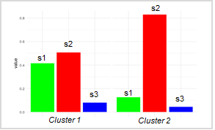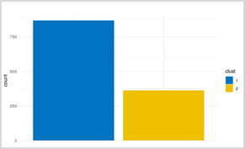
Fig. 5: Cluster 1 and 2 fingerprints (left) and complaints distribution (right).

For each cluster a logistic regression [3] is used to predict whether odour complaints are likely to occur or not. The logistic regression performance returns more than 80% of complaints correctly classified (see Fig. 6). The calculated AUC is 0.87 and 0.89 for cluster 1 and 2, respectively. The target variables of the two clusters show a difference in the s1 and s2 ratio, suggesting a similar difference in the composition and source of the detected reactive gases.

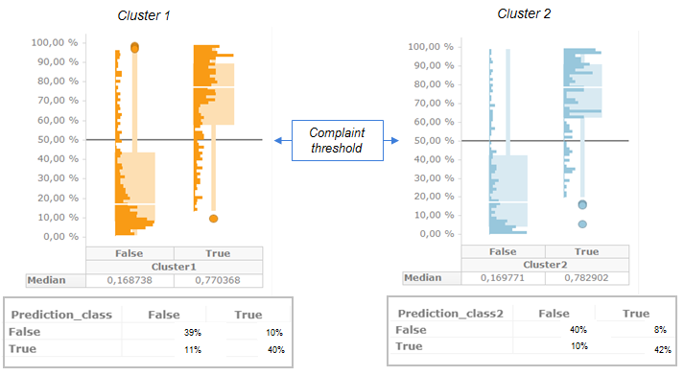
Fig. 6: model performance for odour complaints cluster 1 (left) and 2 (right).

The likely sources of the odour nuisance can in fact be identified by the wind direction distribution of the two clusters, with the two peaks being separated by ca. 23 degrees. This indicates a spatial separation between the sources or the odour nuisances corresponding to the different clusters (see Fig. 7).

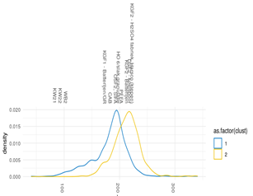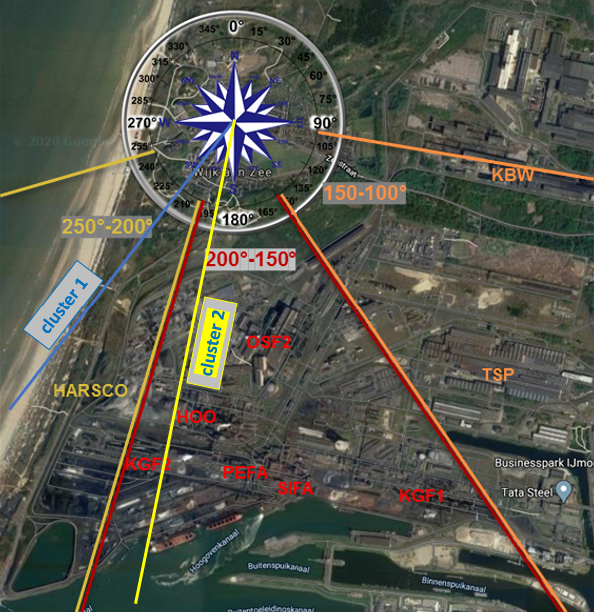
Fig.7: clusters 1 and 2 wind direction distribution (left) and peak wind directions with respect to TATA Steel plant installations (right).

- The odour radar
The eNoses network generates about 4000 observation / hour. The clustered logistic regression model described in the previous sections has a low computation cost and can be used to predict in real-time the odour nuisance for every location in the Ijmuiden region around the TATA Steel plant from the eNoses readings. A gaussian process regression (kriging) [4, 5] is used to spatially interpolate the eNose data accounting for the complaints clusters and any anisotropy due to wind effects. An example of the model fit to the points forming the empirical semivariogram based on the eNoses network described in this paper is shown in Fig. 8.
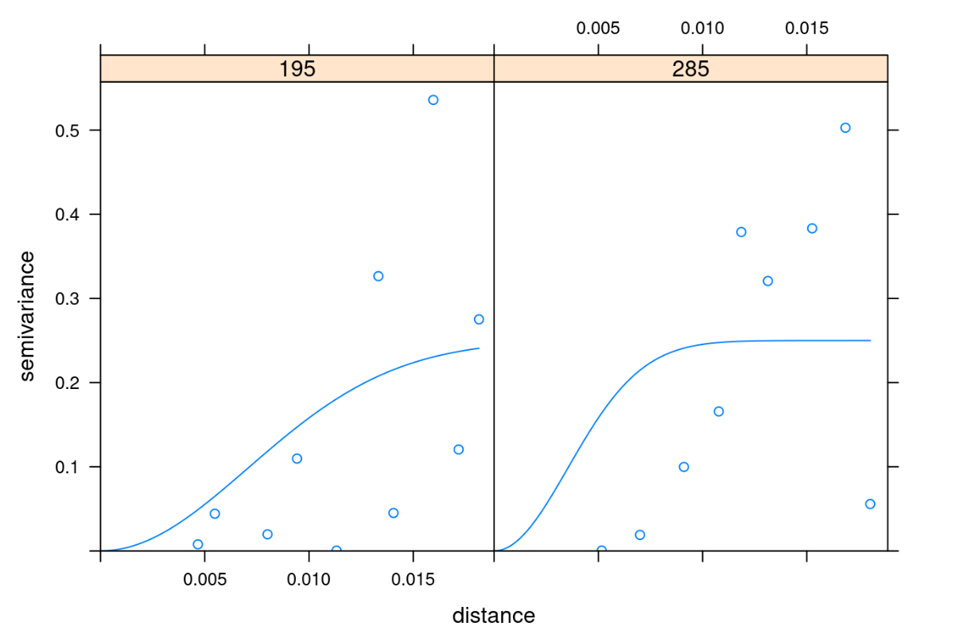
Fig. 8: empirical semivariogram sample (example for selected wind directions).

This constitutes the framework of the odour radar web-app currently employed in Tata Steel and Omgevingsdienst for real-time monitoring of odour complaints in the area around the steel plant (see Fig. 9).

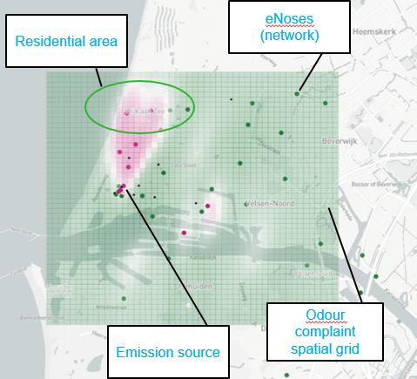
Fig. 9: odour radar web-app (example snapshot).

Conclusions

The results of this pilot conducted on the Tata Steel in Ijmuiden show that tracking the spread of odour nuisance in the neighborhoods can be achieved by means of an appropriate eNoses network spanning through both the industrial site area and the nearby communities. The sensors data are then processed by advanced analytics models.

More than 80% of the complaints can in fact be recast in terms of eNoses data and classification models. These models are applied in real-time on the eNoses network readings, providing valuable predictions of the odour hinderance even before complaints are filed.

References

[1] Bootsma S., Leuwerink T., Bilsen I. (2014) Online Air Monitoring with eNoses at the TATA Steel Plant in the Netherland, Chemical Engineering Transactions, 40, pp. 79-84, DOI: 10.3303/CET1440014.

[2] VITO NV, Flemish Institute for Technological Research, Boeretang 200, 2400 Mol, Belgium

[3] McCullagh P., Nelder J.A. (1983). Generalized Linear Models. London: Chapman and Hall.

[4] Cameron K., Hunter P. (2002) Using Spatial Models and Kriging Techniques to Optimize Long-Term Ground-Water Monitoring Networks: A Case Study, Environmetrics, 13, pp. 629-59.

[5] Deutsch C.V., Journel A.G. (1998). GSLIB: Geostatistical Software Library and User’s Guide. New York: Oxford University Press.

