 CHEMICAL ENGINEERING TRANSACTIONS  VOL. 95, 2022 | A publication of  
The Italian Association
of Chemical Engineering
Online at www.cetjournal.it

Guest Editors: Selena Sironi, Laura Capelli
Copyright © 2022, AIDIC Servizi S.r.l.
ISBN 978-88-95608-94-5; ISSN 2283-9216

Odour impact assessment: a combined approach based on the emitting source and the receptor site analysis in a case study of a waste treatment plant in the municipality of Celico (Italy)
Simona Pascariello, Francesco Filippelli, Roberto Zambianchi, Francesco Favaretto, Maurizio Benzo*
Osmotech, Lifeanalytics group, Via Fratelli Cuzio 42, 27100 Pavia
maurizio.benzo@lifeanalytics.it
Odour nuisance can be arduous to objectify, above all if the sources and the territories are complex. Dispersion modelling is the technique of choice for the odour impact assessment but may have some limitations and needs validation of the results. In this study, citizens of municipalities adjacent to a landfill located in Celico (CS) in the Calabria Region (Italy) complained of odour nuisance attributable to the plant. To objectify the source of the odour and to determine the size of the impact, an integrated approach was designed combining traditional methods of assessment (prediction model) with the study of odour at receptors level, or rather in residential areas potentially impacted, through the installation of remote-activated sampling systems and the analysis of citizen complaints. Combining different methods is the key to strengthening knowledge and engaging communities, allowing to collect a lot of data while empowering citizens in science and odour pollution. A good congruence between the different methodologies was observed and model results were confirmed. The chemical composition of ambient air and observations reported by people stressed the importance of Volatile Fatty Acids (VFAs) in odour events.
  - Introduction
Concern about odour pollution is constantly increasing in the last few years, due to both continuous and rapid urbanization and growing awareness among citizens. To manage this issue, it is necessary to objectify odours and their impact on people exposed. Nowadays, most odour regulations all over the world, including the Italian one, are defined based on the application of dispersion modelling (Capelli et al., 2013). This approach allows predicting odour impact starting from the characterization of odour emissions at the source. The resulting maps of odour dispersion are compared with the acceptability limits of odour annoyance fixed by regulations, to be respected at receptors.
Independently from the model used, model validation is fundamental to define model reliability but currently, reports on studies for validation of odour dispersion models are limited in literature (Capelli et al., 2013). Furthermore, although these methodologies nowadays constitute a routine method in environmental odour management to calculate an odour impact, this odour assessment is not always useful for evaluating the day-to-day operation of an odour emitting industry (Díaz et al., 2016). Related to this matter is the fact that odour measurements and assessments remain challenging, especially in the case of complex sources. So, under some circumstances, complaints arise despite facilities complying with odour guidelines and regulations (Brancher et al., 2021).
A direct impact evaluation conducted at the receptors level constitutes an efficient approach to overcome these limitations, thanks to supplying information complementary to traditional methodologies. For example, the installation of remote odour sampling systems near receptors is particularly useful when emissions and perceptions are not continuous, in cases of short exposition time and low frequency (Romain and Fays, 2020). In addition, as in many other scientific fields, it is possible to obtain a lot of significant information through community engagement processes, addressed to people who know the territory issues. Involving citizens in the processes of identifying odour problems, collecting data, interpreting the results and designing actions can significantly improve the way in which odour pollution is tackled, reducing the costs of measuring odours while empowering the communities (Arias et al., 2018).
In this work, commissioned from Calabria Region, a combined approach of different odour impact assessment techniques was adopted to objectify the odour annoyances complained by citizens and ascribable to a landfill located in the municipality of Celico (CS).
Landfills are among the most significant sources of odour emissions, mainly coming from fresh waste disposal, leachate collection and storage and gas of anaerobic decomposition phase (Polvara et al., 2021). Regarding emission chemical composition, it consists of volatile compounds such as nitrogenous compounds, oxygenated compounds, aromatics, halogenated compounds, sulphur compounds, and terpenes (Wu et al., 2018).
  - Description and history of the site
The plant under study is a landfill for non-hazardous waste located in the municipality of Celico (CS). The plant is adjacent to the valley situated between the municipalities of Rovito and Celico, from which a great number of odour complaints have arisen from citizens. The landfill consists of three functional areas: the waste disposal area, a biostabilization/composting area, connected with the area of biofilter, the odour abatement system.
  - Materials and Methods
The proposed methodology includes the study of odour impact through the Lagrangian dispersion modelling system Calpuff. All samplings at the plant and olfactometric measurements were carried out in compliance with the regulations UNI EN 13725. For the impact assessment at receptor level, remote sampling systems Odorprep® were used. The chemical characterization was carried out according to the TO-15 (U.S. EPA, 1999) method for GC-MS. The odour observations from the citizens were collected through TOM (Total Odour Management) software developed with Purenviro. The users can indicate anonymously with a smartphone or PC the presence of malodor by providing its type and intensity in addition to the location where it is perceived. Before the start of the survey, two public meetings were organized to engage the communities, informing, and training them about the odour monitoring campaign in progress. The data collected have been verified based on meteorological conditions before the analysis.
  - Results
The first phase of emission sources characterization was carried out in November 2018 followed by the elaboration of the dispersion model. From November 2018 to January 2019 a preliminary survey was conducted, while remote odour sampling systems were installed from March to September 2019.
    - Odour impact assessment by model
To characterize odour emissions from the plant, a measurement campaign was carried out in November 2018. Five different sources of odour were identified and considered relevant (Cod > 80 ou_{E}/m³), according to the guidelines of the Lombardy Region (Regione Lombardia, 2012): one active areal source (biofilter) and four passive areal sources consisting of different areas of the landfill: the working face of the cell (fresh and compacted waste) and the old and recent temporarily covered landfill surfaces.
Table 1 shows the measures for each emission source. To estimate the emission rate for the area of fresh and compact waste were used two different values of odour concentration, depending on the time of the day: the first one is associated to the diurnal time (8 a.m.- 4 p.m.), when the waste is processed, the second one to the remaining hours, when the waste is assimilated as an area of recent cover. Altogether, the working face of the cell and the area of recent cover account for 83% of the total annual odour emission rate of the plant.
Table 1. Summary of odour emission source characteristics (monitoring campaign November 2018)
Odour emission source |  | C_{od}  (ou_{E}/m³) | Area  (m²) | OER  (ou_{E}/y) | OER  (%)
Biofilter |  | 3,102 | 624 | 1.99·10⁸ | 8
Area of recent cover of waste |  | 17,000 | 1,800 | 1.07·10⁹ | 41
Area of old cover of waste |  | 3,800 | 2,000 | 2.66·10⁸ | 10
Working face of cell | Fresh waste | 2,850-17,000 | 176 | 1.23·10⁸ | 5
 | Compacted waste | 1,450-17,000 | 1624 | 9.81·10⁸ | 37

The results of the odour impact assessment on the neighbouring territories, performed with the dispersion model, show that the odour emission of the waste treatment plant reaches an extension of about 2.5 km from the plants fencelines, affecting the residential areas of Celico and Rovito municipalities, both within the isopleth of 1 ou_{E}/m³. Rovito is reached also by the isopleth of 5 ou_{E}/m³, and this evidence represents an unacceptable impact on the population, according to the available acceptance criteria for odour impact (Provincia Autonoma di Trento, 2016). For Celico, odour events interest mostly evening and nocturnal hours, characterized by the thermal inversion phenomenon and the resulting atmospheric stability. The impact on Rovito is favoured by the low wind coming from east and north-east descending the valley mostly during nocturnal hours.
    - Odour impact assessment at receptors level
Remote odour sampling systems were installed from March to September 2019 both in Celico and Rovito. The choice of the locations was made based on the results of the predicting model and of a preliminary survey conducted from November 2018 to January 2019. The systems were programmed to be activated following notifications from citizens. In addition, the systems sample under specific weather conditions (these samples are indicated as “programmed”).
During the monitoring period, the number of valid complaints amounted to 70, corresponding to 62% of the total complaints received. As expected, the largest number of observations came from Rovito (80%), with a peak of complaints in June, and a higher incidence on Fridays and Saturdays (Figure 1). Regarding hourly distribution, almost all odour warnings (91%), happened during the evening, between 7 and 11 p.m. These data seem to confirm the results of the model, describing a stronger odour impact in the evening and night hours. However, it should be considered that the data collected may be affected by sampling bias as the temporal frequencies of complaints can be influenced by the citizens’ habits: for example, the tendency to spend more time at home in the evening and on weekend.

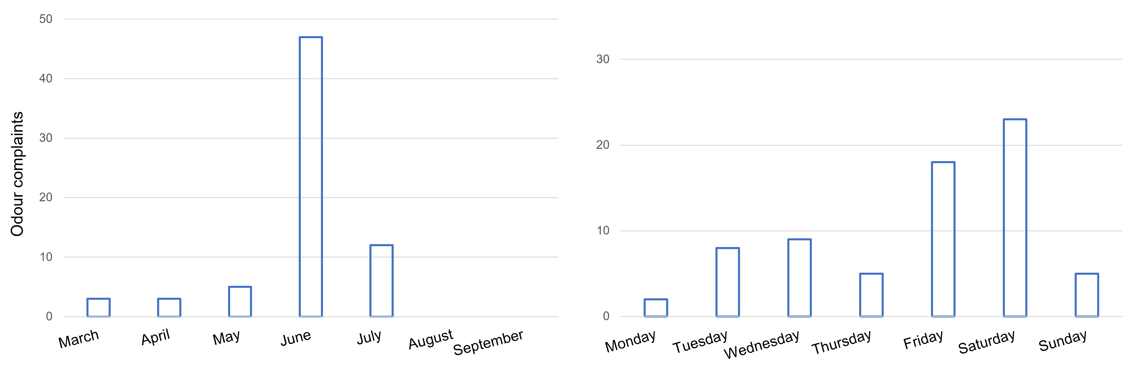
Figure 1. Monthly and weekly distribution of odour complaints during the monitoring period.
The odour complaints activated Odorprep® 12 times and, in addition, 8 programmed samples were collected. Starting from the chemical characterization of odour sources in the waste treatment plant, some markers were chosen. They derive from the decomposition of the waste’s organic matter and belong to the classes of Volatile Fatty Acids - VFAs (butyric acid, iso-caproic acid, propionic acid, valeric acid), ketones (6-methyl-5-hepten-2-one, acetone, methylethylketone) and terpenes (α-pinene and limonene).
During odour events reported from citizens, higher average concentrations, and detection frequency of all tracers of the plant occurred, except for methylethylketone. The differences between programmed samples and those collected after citizen complaints are registered above all for the class of VFAs: the average concentration increased from 0.002 to 0.007 mg/m³ and detection frequency from 21% to 72%.
The most significant difference is observed for butyric acid with an increase in detection frequency from 13% to 83%. Based on these observations the events registered by the citizens are attributable to the plant under investigation. Moreover, VFAs seem to be an important factor in the episodes of odour nuisance, and this is coherent with odour descriptors “sour” and “putrid” provided by the citizen and attributable to chemicals belonging to this class.
Odour sensation is caused by often unpredictable interaction of several molecules but, to determine the most relevant substances (key odorants) in the odour annoyance reported by citizens, a correlation analysis was performed between the number of complaints and the concentration of each tracer of the plant. For butyric acid, a good correlation between the number of complaints and the chemical concentration is found, with a correlation coefficient of 0,75 (Figure 2).

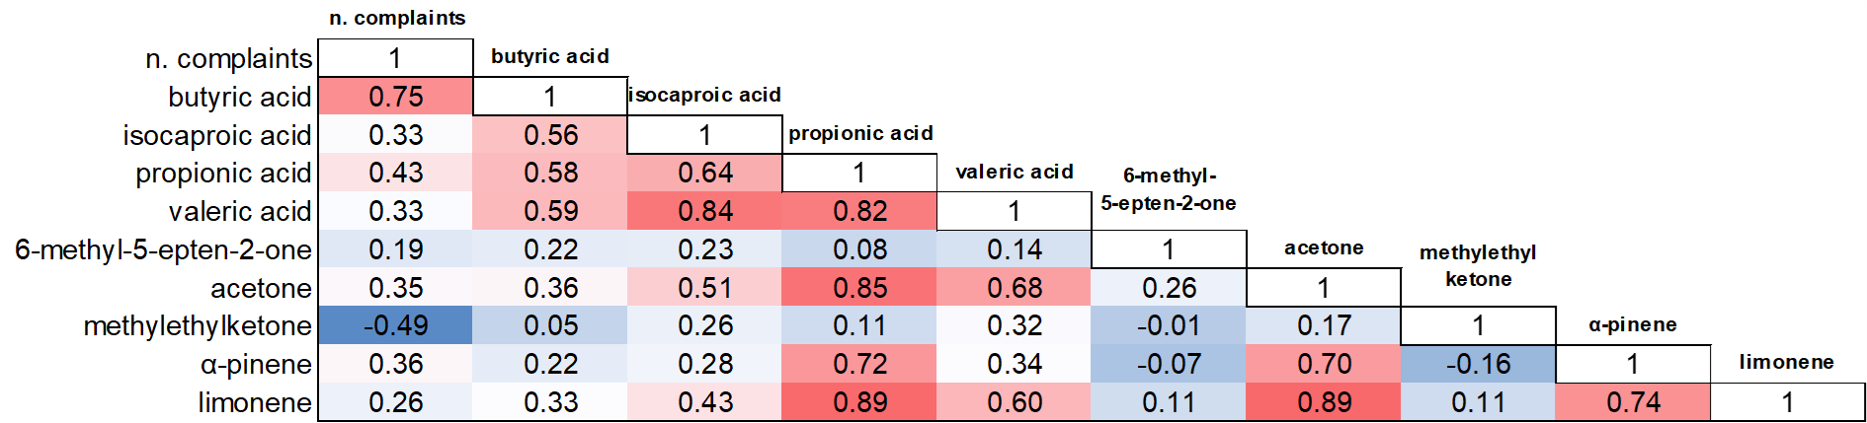
Figure 2. Spearman correlation matrix between chemical markers concentration (mg/m³) and number of complaints.
This compound is formed during organic matter fermentation of waste as an intermediate by-product from amino acids and sugars and it has a low Odour Threshold (OT) of 0.0007 mg/m³ (Nagata, 2003). In Figure 3 it is possible to observe the number of odour complaints in the months of monitoring with Odorprep® and the percentage of butyric acid compared to the chemical tracers selected.

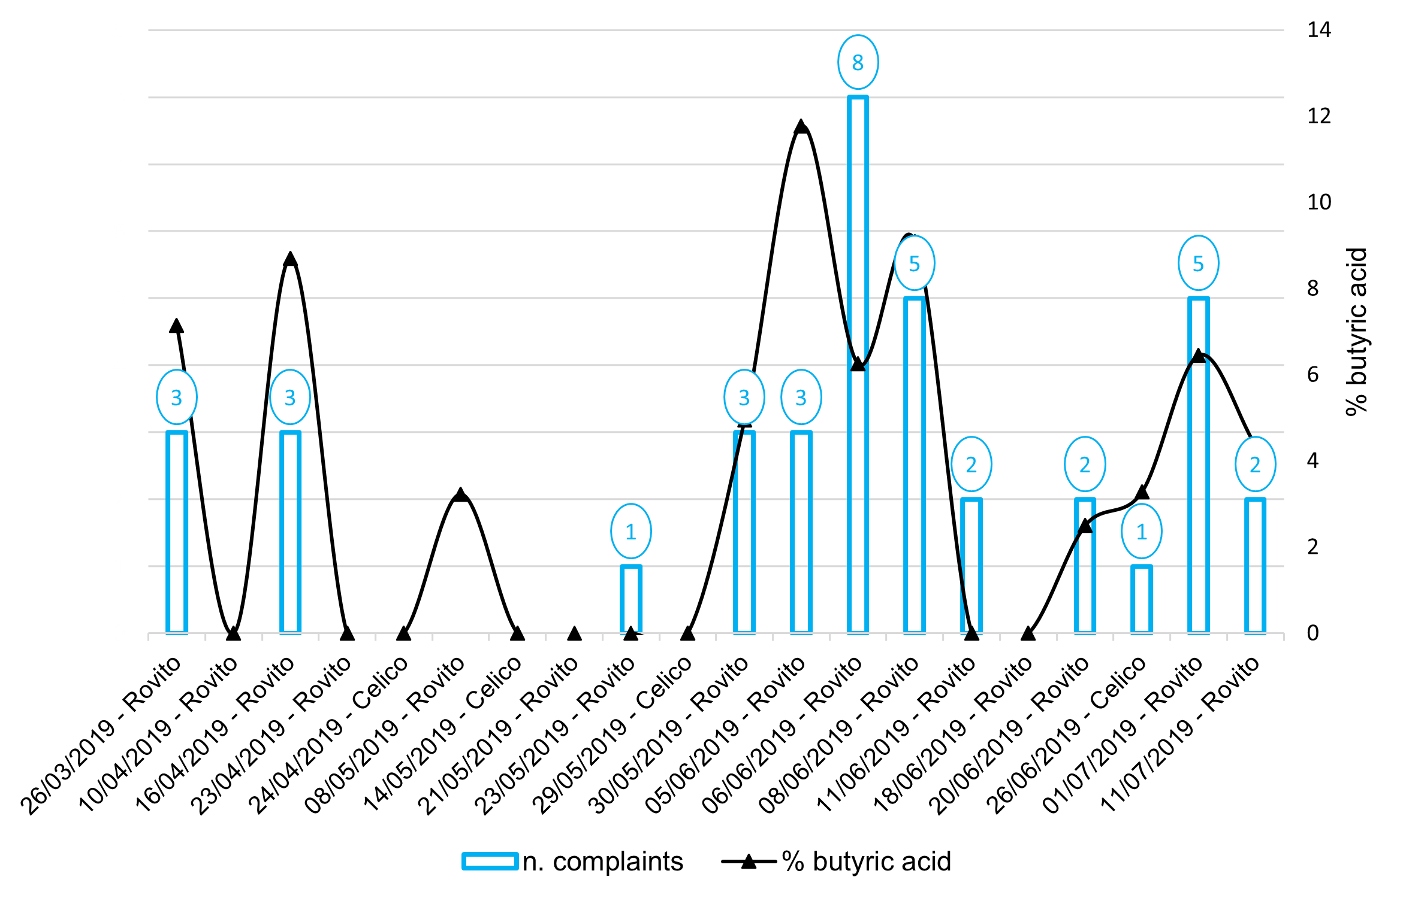
Figure 3. Number of odour complaints and percentage of butyric acid concentration compared to the chemical markers selected, during monitoring campaign with remote sampler Odorprep®.
Regarding the odour sources of the plant, higher concentrations of VFAs and butyric acid were found for the recent cover (respectively 1.707 and 1.489 mg/m³), followed by the old cover (0.143 and 0.112 mg/m³) and fresh waste (0.071 and 0.056 mg/m³) and finally by biofilter (average value of 0.027 and 0.009 mg/m³).
    - Odour impact assessment: a comparison between different assessment methods
Considering the complexity in defining and quantifying odour and its impact, a good congruence is observed between the results obtained from different methods of evaluation.
The results of the model find a good response in the analysis of receptors, and this confirms their validity. Analysis of complaints confirms the highest odour impact in evening hours, suggesting that the weather conditions are a driving factor behind the exacerbation of the odour nuisance. This confirms the importance to include the odour pollution assessment already in the early stages of the designing of a plant. Moreover, the number of complaints, in addition to the higher chemicals markers concentrations registered, except for methylethylketone, confirm Rovito as the most affected municipality. It was also possible to compare the location of complaints with emission plume, extracting model results on specific time scales and correspondence of 77.3% was found: in Figure 4 an example for June 8th.

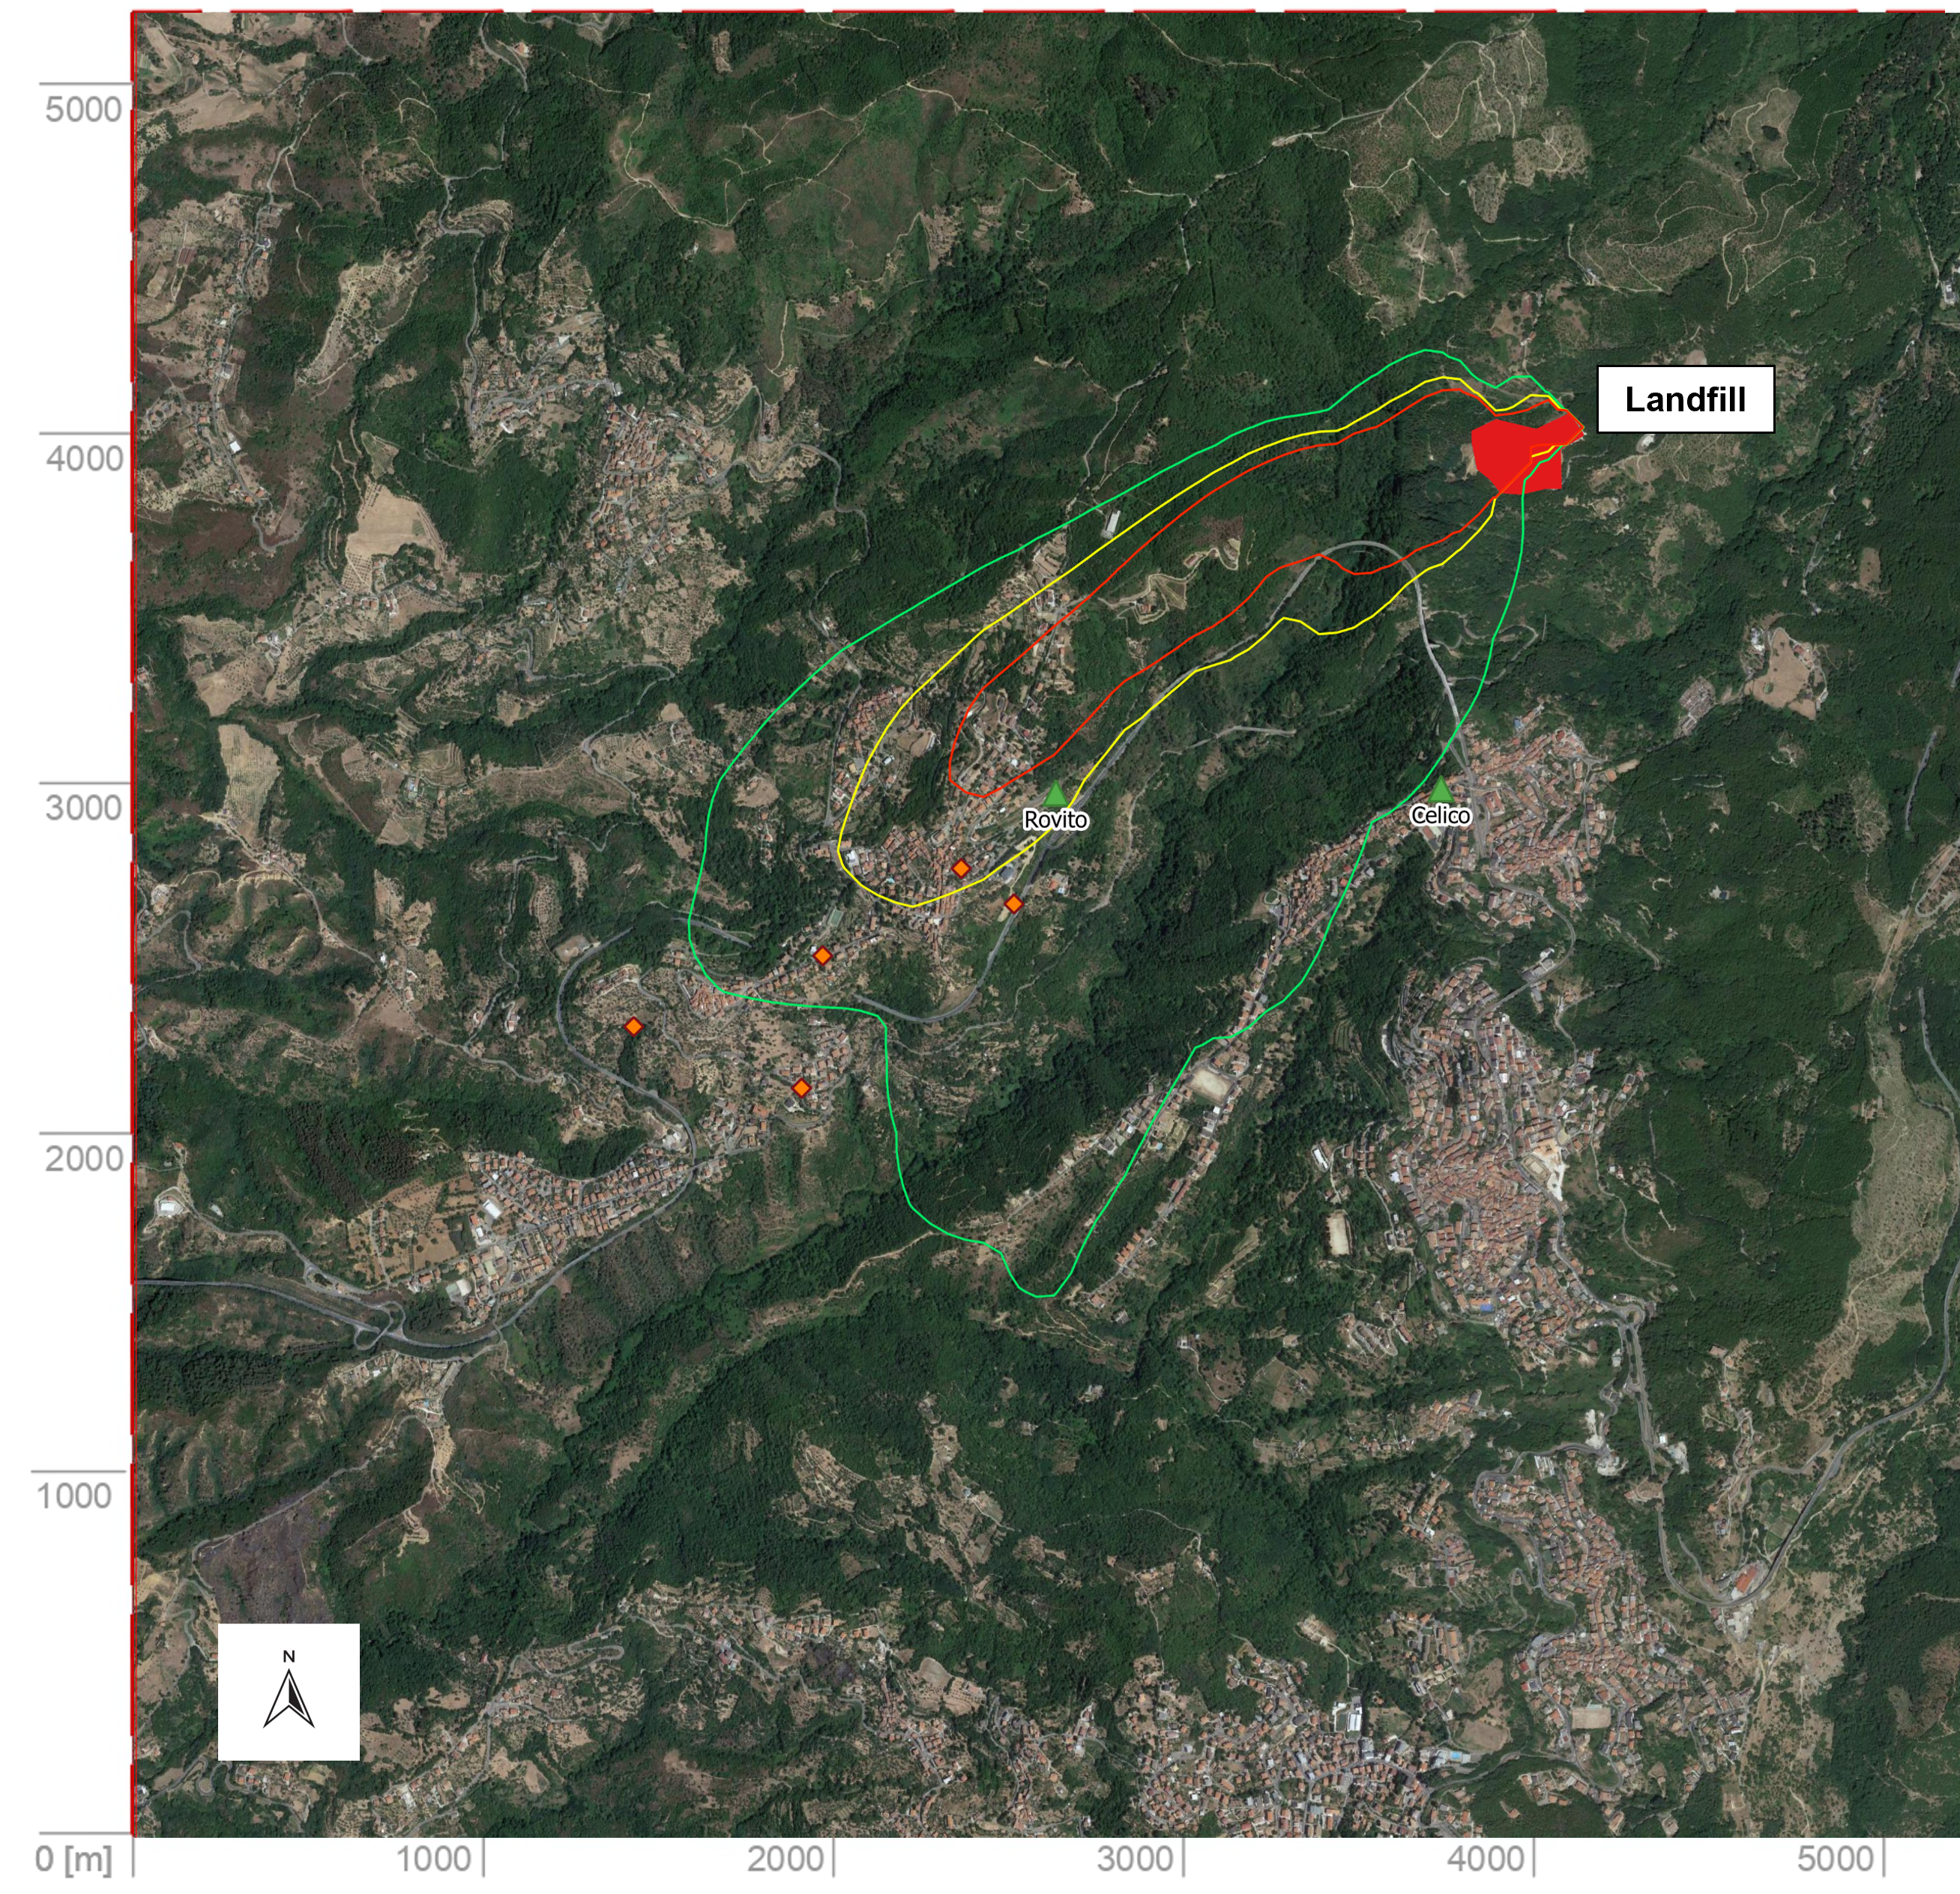
Figure 4. Comparison between isopleths of maximum hourly odour concentration (green = 1 ou_{E}/m³; yellow = 3 ou_{E}/m³ and red = 5 ou_{E}/m³) and the places of citizen complaints (orange dots) on June 8th.
Analysis of the chemical composition of air samples makes it possible to objectify the complaints of citizens and attribute them to the waste treatment plant. The importance of VFAs and above all butyric acid in reported odour episodes provides valuable information on odour sources: in particular, the recent cover area is the most critical in terms of concentration of these compounds, while the concentration in the biofilter outlet is negligible. This evidence is entirely consistent with the emission ranking elaborated by the dispersion model, which identify the area of recent cover of waste as the main source of odour and the biofilter as secondary, despite the biofilter outlet showing an odour concentration higher than the level reported by sector guidelines (DM 29/01/2007), which indicate a theoretical value < 300 ou_{E}/m³.
  - Conclusions
Odour impact assessment often constitutes a complex analysis that must consider many variables and issues, including the subjectivity of odour perception and the complexity of some emissions, hard to characterize. For this reason, in this work a combined approach was used to objectify odour annoyance caused by a landfill. The method has included dispersion modelling, remote sampling systems and citizen science for better understanding the odour issues and designing solutions. The advantages of a combined approach lie in the integration of different and complementary sources of data, that strengthen the knowledge in open collaboration between science and other knowledge actors, according to open science practice promoted by recent European research programs.
A good congruence of the results was observed between different methods, and it was possible to validate and enrich the information provided by the traditional methods of assessment. Between simulated immissions and observations reported by citizens, a correspondence of 77.3% was found. Citizen engagement made it possible to obtain a large amount of data, and this combined with the use of remote sampling systems, allowed to know and objectify instantaneous and real odour impact on territories. Analysis of chemical tracers confirms the landfill as the source of odour annoyance. A good relation was found between complaints and the presence of VFAs, especially for butyric acid (Spearman correlation coefficient of 0,75), ascribable mainly to the areas of the recent cover of waste. Rovito is the most impacted municipality according to the dispersion model, to the average concentration of almost all the tracers and the number of complaints registered (80%). Analysis of complaints confirms that the evening hours are the most critical (91% of observations) due to unfavourable weather conditions.
Future developments might include the use of electronic noses at receptors or plant fencelines, for continuous odour monitoring, and the adoption of an extended, standardized and common methodology of community engagement, to generate scientifically valid and actionable data through citizen science interventions that can improve people’s lives (Arias et al., 2018).
Acknowledgments
This work was carried out within the "Olfactometric monitoring service and odour dispersion evaluation at the waste treatment and disposal plant owned by MI.GA. S.r.l. and located in the locality of San Nicola, in Celico municipality", commissioned to Osmotech S.r.l. in 2018 by the Environment and Territory Department of Calabria Region.
References

Arias R., Capelli L., Díaz C, 2018, A new methodology based on citizen science to improve environmental odour management. Chemical Engineering Transactions, 68, 7–12.
Brancher M., Hoinaski L., Piringer M., Prata A. A., Schauberger G., 2021, Dispersion modelling of environmental odours using hourly-resolved emission scenarios: Implications for impact assessments. Atmospheric Environment: X, 100124.
Capelli L., Sironi S., Del Rosso R., Guillot J. M., 2013, Measuring odours in the environment vs. dispersion modelling: A review. Atmospheric Environment, 79, 731–743.
Díaz C. N., Zamora C. I., Fernández D. C., Graña J. M. V., Rodríguez López Á., 2016, Comparison of predicted versus real odour impacts in a rendering plant with PrOlor. Chemical Engineering Transactions, 54, 199–204.
Decreto 29 gennaio 2007, Emanazione di linee guida per l’individuazione e l’utilizzazione delle migliori tecniche disponibili in materia di gestione dei rifiuti, per le attività elencate nell’allegato I del decreto legislativo 18 febbraio 2005, n. 59, Ministero dell’ambiente e della tutela del territorio e del mare.
Nagata Y., 2003, Measurement of Odor Threshold by Triangle Odor Bag Method, Odor Measurement Review, 118–127.
Polvara E., Capelli L., Arias R., Schleenstein G., Hernández M., Burbano J., 2021, Review on odour pollution and its relationship with chemical compounds and health issues, D-NOSES, H2020-SwafS-23-2017-789315.
Provincia Autonoma di Trento, 2016, Deliberazione n. 1087 del 24 giugno 2016 – Linee Guida sugli odori, 2–3.
Regione Lombardia, 2012, D.G.R. 15 febbraio 2012 – n. IX/3018, Determinazioni generali in merito alla caratterizzazione delle emissioni gassose in atmosfera derivanti da attività a forte impatto odorigeno, Bollettino Ufficiale 20 febbraio 2012.
Romain A.C., Fays S., 2020, Odour sampling system with remote triggering: feedback from a Belgian experience, NOSE 2020 lecture abstract.
U.S. Environmental Protection Agency, 1999, Compendium method TO-15 determination of Volatile Organic Compounds (VOCs) in air collected in specially-prepared canisters and analyzed by Gas Chromatography /Mass Spectrometry (GC/MS), Compendium of methods for the determination of Toxic Organic Compounds in ambient air, 15-63.
Wu C., Liu S., Shu M., Qu C., Liu J., Piringer M., Schauberger, G., 2018, Seasonal variations in odorous compounds emission from a municipal solid waste disposal plant. Chemical Engineering Transactions, 68, 85–90.

