CHEMICAL ENGINEERING TRANSACTIONS  VOL. 95, 2022 | A publication of
The Italian Association
of Chemical Engineering
Online at www.cetjournal.it

Guest Editors: Selena Sironi, Laura Capelli
Copyright © 2022, AIDIC Servizi S.r.l.
ISBN 978-88-95608-94-5; ISSN 2283-9216

Electronic Nose for real-time monitoring of odour emissions at a Wastewater Treatment Plant
Stefano Prudenza, Alessandra Panzitta, Carmen Bax*, Laura Capelli
Politecnico di Milano, Departement of Chemistry, Materials and Chemical Engineering, Piazza Leonardo da Vinci, 32, 20133 Milano, Italy.
*carmen.bax@polimi.it
This paper describes the procedure adopted for implementing a monitoring system based on an electronic nose (EN) to continuously monitor odour emissions from a wastewater treatment plant (WWTP), with the purpose of identifying odour peaks related to the incoming wastewaters. The paper focuses on the methodology related to the instrument training, the implementation of a suitable model to classify the odour peaks, and then the validation procedure. In the specific case, the EN was installed at the arrival tank of the plant, which is characterized by anomalously intense odours and high variability of the incoming wastewater, with the purpose of identifying the origin of the odour peaks. To do this, the EN was equipped with automatic sampling systems to collect both the liquid effluent and gaseous samples at the arrival tank for further olfactometric and chemical characterizations. The paper limits its focus on the illustration of the EN training to identify the anomalous odour peaks related to unpredictable changes in the incoming wastewater, and the validation of the implemented model based on principal component analysis and support vector machine. Results achieved show that the EN can be effectively used for process control: the alarm set on EN signals proved effective in detecting alterations of the incoming effluent potentially responsible for odour events in the surroundings of the plant, thereby allowing plant managers prompt intervention to limit odour impacts.
  - Introduction
Electronic Nose (EN) can serve as useful tool for monitoring plant emissions at their fenceline or receptors in the surroundings, since they are capable to provide a real-time qualitative and quantitative characterization of odours in ambient air. An emerging application of this technology is emission monitoring aimed at process control (Collins and Moy 1995, Martı́, Busto et al. 2005, Majchrzak, Wojnowski et al. 2018) . Indeed, the continuous characterization of odorous emission can be useful to verify that the plant is working under regular operating conditions, and for the real-time identification of malfunctioning and/or anomalies that could cause odours nuisance nearby the plant. This paper proposes the use of an EN for the continuous monitoring of odorous emissions from a WasteWater Treatment Plant (WWTP). The WWTP under investigation receives both civil and industrial wastewaters from over 40 industries of different types (e.g., chemical, tanneries, paper mill, printing, food, car washes etc.). Civil wastewaters account for about 60-70% of the total incoming flowrate (i.e., ca. 22’000 m³/day), while industrial wastewaters account for the remaining 30-40%. Due to the frequent reports of odour nuisance from the citizens living in the proximity of the plant, in agreement with the regional guidelines on odour emission management, several olfactometric campaigns were carried out at the WWTP emission sources with the purpose of determining odour concentrations and odour emission rates. This preliminary work allowed identifying the sources with the highest odour emissions and evaluating the odour impact associated to the plant in the surrounding territories. As expected, based on experimental evidences collected so far, the arrival tank turned out to be the most problematic source of the plant. One peculiarity of this plant is the considerable variability of the odour concentration values measured at the arrival tank, which ranges from 2’000 to 120’000 ou_{E}/m³. This variability is not related to the meteorological conditions, but is more likely linked to the arrival of a particularly odorous and discontinuous discharge originating those malodorous events. However, the origin of this particularly odorous discharge has not yet been identified. Since these particular odorous conditions occur in an unpredictable manner, it was decided to implement a monitoring system capable to provide a real-time measurement of the odours at the arrival tank and to detect anomalous conditions. Once the occurrence of an odour peak is detected, the system shall automatically activate a sampler to withdraw both air and liquid samples to be analysed by dynamic olfactometry and GC-MS for the identification of the chemical substances related to the odorous wastewater discharge causing the odour peaks. The chemical speciation of the substances contained in the liquid and in its headspace, compared with the respective olfactory threshold values, is used to identify the chemicals most responsible for the odour emissions. This paper focuses on the experimental procedure involved for the training of an EN for the implementation of such monitoring system and the evaluation of its performance. More in detail, the EN, equipped with an automatic gas sampling system, has been installed at the arrival tank of the WWTP. The training lasted about 1 month and involved the analysis of samples collected at the arrival tank under different meteorological and operating conditions of the plant. EN signals relevant to the training period were combined with the odour concentration values measured by dynamic olfactometry and with reports of presence/absence of odour by the citizens living nearby, to implement classification models aimed at identifying a Normal Operating Region (NOR) (Leung and Romagnoli 2002), representative of moderate presence of odour on the arrival tank not causing nuisance in surrounding territories. This paper also reports the results of the model validation. In this phase, gas samples have been randomly collected at the plant in order to verify the peformance of the model developed.
  - Material and methods
Electronic nose and sampling system
The EN used in this project is the WT1 outdoor monitoring system commercialized by Rubix. This instrument is characterized by a fast response time, returning the sensors’ signal every 10 seconds, and is therefore suitable for real-time monitoring purposes. It is equipped with 4 metal oxide sensors (MOS), characterized by a high sensitivity to Volatile Organic Compounds (VOC), 3 electrochemical sensors of for the detection of hydrogen sulphide (H₂S), formaldehyde (CH₂O) and ammonia (NH₃), and a photoionization detector (PID) calibrated in isobutylene for VOC. The MOS sensors return as response the value of the sensor resistance in Ohms, while the electrochemical sensors and the PID provide the concentration of the compounds in ppm. The instrument comprises also sensors for measuring the temperature and relative humidity of the external environment.
Together with the EN, also a gas automatic sampler has been installed at the arrival tank of the WWTP. It consists of an airtight suitcase of 25 liters produced by Scentroid (VC20) equipped with a membrane vacuum pump and Nalophan bags for sample collection. The sampler can be activated manually or automatically by the EN when the set alarm threshold is exceeded.
Training of the Electronic Nose
In this study, the training phase lasted for about 30 days during which the EN was installed inside the shed of the arrival tank to acquire data representative of the odour conditions at the plant inlet. Due to the extreme environmental conditions inside the arrival tank shed (high relative humidity and high levels of hydrogen sulphide), in order to avoid excessive sensors’ deterioration, a dilution system was applied at the inlet of the EN. The system consists of an Y joint attached to the inlet of the nose, to which 2 Teflon tubes were connected, one taking the air from the inside of the shed and one from the ambient outside. Exploiting the sucking capability of the WT1 and by tailoring the Teflon tube length a 1:1 dilution of the flow coming from the arrival tank with ambient air has been reached.
The training phase consisted in the implementation of a model able to correlate the EN sensors’ responses with the level of the odour concentration on the arrival tank. The training was aimed at the definition of a “reference” condition on the arrival tank of the WWTP representative of moderate odour concentration, unlikely to cause nuisance to the citizens living nearby the plant. For this purpose, the training phase involved the collection of gas samples inside the arrival tank shed and their characterization by dynamic olfactometry. In particular, 18 samples were collected on 10 different days under different meteorological and operating conditions of the plant (e.g., different incoming wastewater flowrate, active or inactive recirculation of sludges) in order to include in the training dataset the variability of the source. Once the data were collected, a specific procedure, illustrated in Figure 1, has been developed for their elaboration.

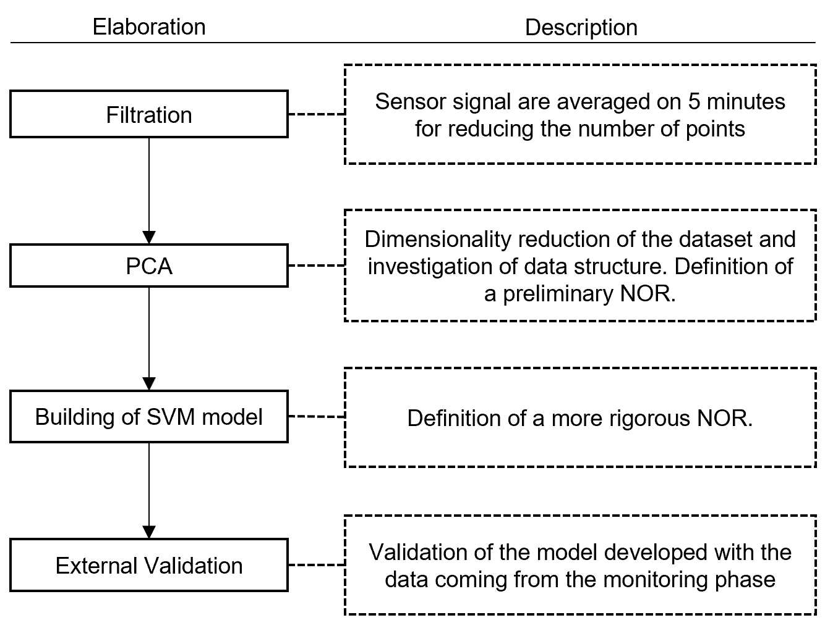
The sensors response is initially averaged on 5 minutes, to reduce the dataset dimensionality, and ease data elaboration and interpretation. It has been verified that this operation does not cause loss of useful information for the differentiation of the odour level operated by subsequent processing. Then, a principal component analysis (PCA) (Abdi and Williams 2010) was applied to further reduce the data dimensions, allowing for a better visualization and investigation of their structure. By looking at the PCA scores distribution and combining the information about the odour concentration detected on the arrival tank and citizen reports, a preliminary “reference” region on the score plot has been drawn. Finally, in order to define a more rigorous NOR representative of moderate odour conditions at the inlet of the plant, the PCA scores were used as inputs of Support Vector Machine (SVM) algorithm (Sun 2014), in order to obtain an optimal decision boundary according to data distribution and the information relevant to the odour concentration.
Figure 1. Block diagram of the data elaboration for the development and validation of the model.
Validation
Once the alarm model was developed and implemented on the EN, the validation and monitoring phase started. The data registered by the EN in this phase follows the same data processing pathway implemented for the training. The sensors response is averaged over 5 minutes and then the data are projected onto the PCA model developed on training data. Then, the PCA score obtained on monitoring data were used as inputs for the SVM algorithm to determine if they fall inside or outside the defined NOR. In case of projection outside the NOR boundaries, the EN reports an alarm and activates the automatic samplers for collecting gaseous and liquid samples to be further analysed by dynamic olfactometry, with the purpose of evaluating if their odour concentration was consistent with the alarm exceedance.
In order to validate the model, validation samples were collected both in case of alarm threshold exceedance and under normal conditions. A total of 10 validation samples was considered.
  - Results
Training
3.1.1 Preliminary considerations
The dataset obtained at the end of the training phase consists of 246570 observations from which 6 features each have been extracted (i.e., the signals of 2 MOS, 3 electrochemical sensors and 1 PID sensor). Here only 2 out of the 4 MOS sensors have been considered (i.e. one more sensitive to amine compounds and one more sensitive to aldehydic compounds), since the other were more subjected to the variation of relative humidity and temperature registered on the arrival tanks and did not provide useful information. These data have been processed by PCA, and the results are reported in Figure 2. For this case study, 2 principal components, describing 72.7% of the dataset variance, have been considered. More in detail, Figure 2 A reports the PCA score plot, where the projection of the data into the new reference system is reported. The plot also reports the odour concentration in ou_{E}/m³ of the samples taken from the arrival tank assessed by dynamic olfactometry. Based on visual investigation of the PCA score plot, the PC1 direction expresses a clear correlation with the odour concentration of samples: decreasing PC1 values correspond to increasing odour concentration.
Figure 2 B reports the PCA loading plot, which provides information about the correlation among variables and their contribution to the dispersion of points in the PCA score plot. From its visual investigation it can be deduced that the left region of the plot accounts for odorous conditions at the WWTP. In particular, the high values of electrochemical sensors, corresponding to an increase of the detected concentration of H₂S, NH₃, CH₂O and VOC, contribute to the positioning of observations in the left portion of the PCA score. Conversely, the MOS sensors’ loadings point in the opposite direction. Therefore, in the left portion of the plot, low resistance values are expected, in line with the MOS n-type behaviour when exposed to gas (i.e., their electrical resistance decreases).
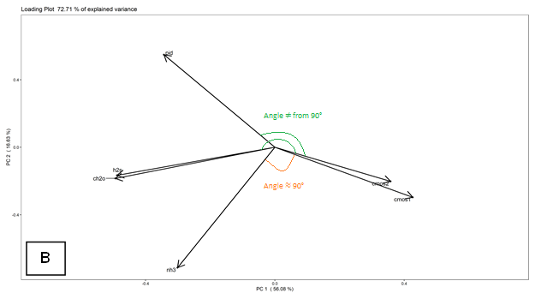
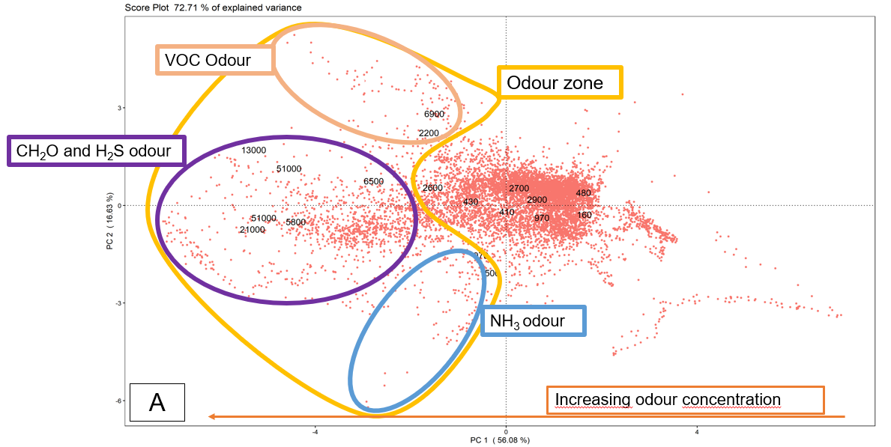
Figure 2. Scores (A) and Loadings (B) plot of the PCA on the training data. The numbers displayed in the score plot indicates the odour concentration of the gas samples taken from the arrival tank.

Moreover, the loading plot also enables determining correlations between the sensors’ signals. In this case, the MOS sensors are mainly correlated with the H₂S, CH₂O and PID sensors since the angle between them is narrower than 90°, the one indicative of no correlation. Conversely, there is a negligible correlation with the NH3 sensor, because their angle is close to 90°. This is probably due to the lower levels of ammonia registered on the arrival tank, varying among 0.3 and 1.5 ppm. Combining the points distribution on the score plot and the information coming from the loading plot, and looking at the scores distribution on the PC2, three main regions of odours can be identified: one in the top-left part, one in the middle-left and one in the bottom-left part of the score plot. These 3 regions are relevant to different odour conditions at the arrival tank, associated to high levels of VOC, H₂S/CH₂O and NH₃ respectively. It is clear that this doesn’t mean that the presence of odours is only attributable to these compounds, but this information gives an estimation of the class of molecules most responsible for the specific odour peak.

3.1.2 Development of the model
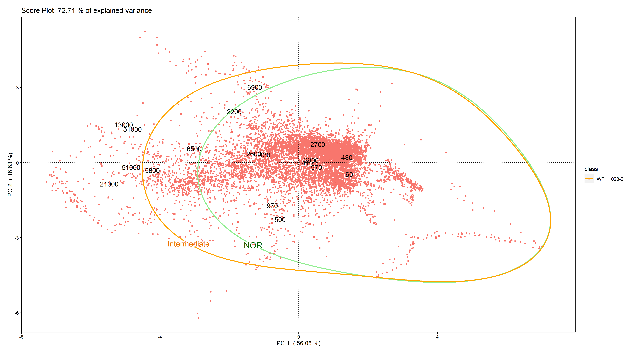
Based on the scores distribution, the information obtained from the loading plot, the results of the olfactometric analysis and the citizen reports, a preliminary NOR, representative of moderate odour concentrations on the arrival tank, has been defined on the score plot. The citizen reports have been collected through the app Odorcollect and have been used for comparing the odour concentration at the arrival tank of the plant provided by the IOMS and the possible nuisance perceived by the citizen living nearby. In this way it has been possible to identify a score plot “region” representative of such condition that causes nuisance in the citizens. For the definition of this preliminary NOR only the points that satisfied the following conditions have been selectd: PC1>0 ˄ ∀ PC2, -2.5<PC1<0 ˄ -3<PC2<2. Once selected, they have been used to train a one-classification SVM model (Schölkopf, Platt et al. 2001), in order to determine a more accurate confidence region though radial kernel. This algorithm defines in an unsupervised manner a hyperplane/function around the data used to train it, that enables their circumscription. The algorithm will classify the new data in a binary way, as belonging to the circumscribed region defined by the hyperplane or not. It is important to underline how, for this one-classification SVM, the choice of correct reference data is a key step that can have a great impact on the subsequent results. In this case, the use of different indicators for the identification of the reference condition on the arrival tank, such as EN signals, dynamic olfactometry results and citizen reports, provide a stronger base for the NOR definition. Support vectors define the margins of the hyperplanes, that can vary in shape and dimensions, depending on the input parameters provided by the user on the base of considerations on the data distribution and requirements on the classification. In particular, two parameters are required: the “nu” parameter that controls the sensitivity of the support vectors and should be tuned to the approximate ratio of outliers in the data, and the “gamma” parameter that defines the shape of the radial kernel. For this case study, the “nu” and “gamma” parameters were set at 0.0001 and 0.03, respectively. With the practical purpose of introducing also an intermediate alarm region, representative of anomalous conditions that cannot be assimilated to the NOR region, but not so troubling in terms of odour concentration, a second area has been identified. This region is defined by PCA scores satisfying the following requirements: PC1>0 ˄ ∀ PC2, -4<PC1<0 ˄ -4<PC2<3. On this data the SVM has been implemented to define the boundaries of the intermediate region, using as input parameters nu=0.0001 and gamma=0.03. The confidence regions obtained are reported in Figure 3.
Figure 3. PCA score plot illustrating NOR and intermediate alarm region obtained with one-class SVM.

From the results obtained it is possible to observe that the NOR defined includes samples with odour concentrations between 160 ou_{E}/m³ (with confidence interval (C.I.) 70 - 290 ou_{E}/m³) and 2900 ou_{E}/m³ (C.I. 1300 - 5300 ou_{E}/m³). The intermediate region comprises samples with odour concentrations between 5800 ou_{E}/m³ (C.I. 2500 - 11000 ou_{E}/m³) and 6900 ou_{E}/m³ (C.I. 3000-13000 ou_{E}/m³) approximately, while samples with higher concentrations fall into the alarm zone.

Validation and monitoring
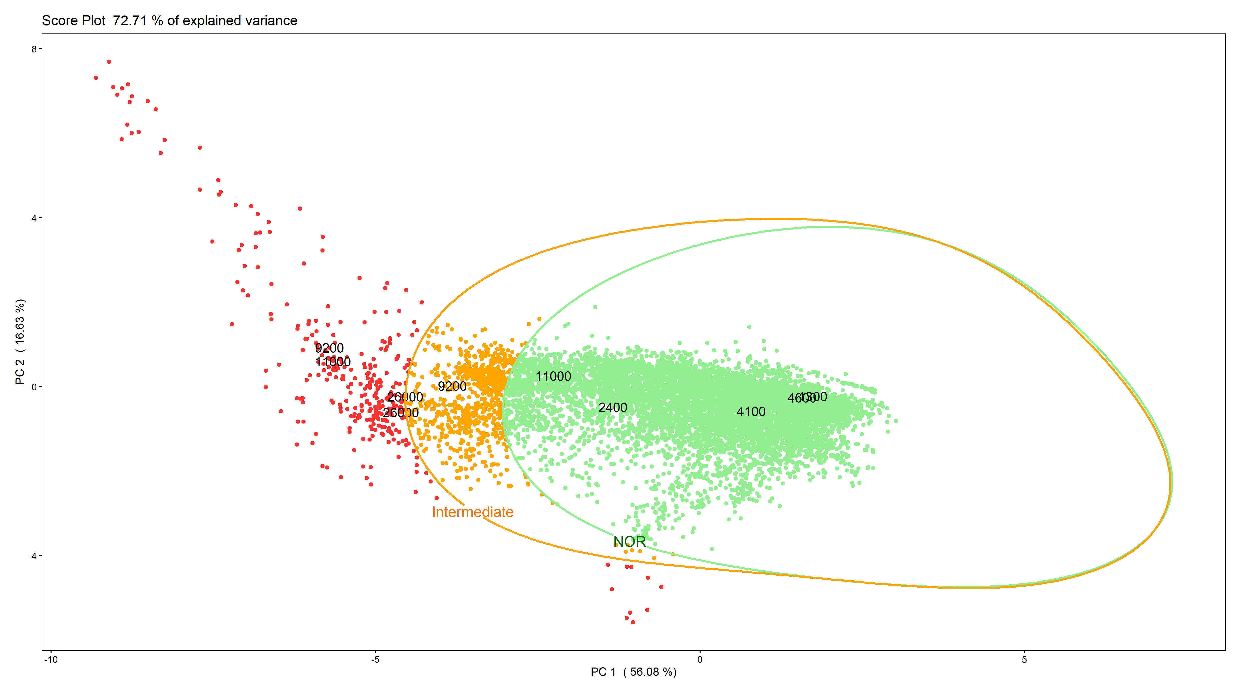
During the monitoring phase, the data are continuously acquired by the EN and processed by the models developed on the training data. With the purpose of evaluating the capability of the EN to detect the presence of anomalous odour conditions, a validation was carried out. For such purpose, 10 independent samples, taken on 5 different days and representative of both reference and anomalous odour conditions at the arrival tank, were collected. They were analysed with dynamic olfactometry in order to determine their odour concentration and verify the correct prediction of the developed model compared to the EN predictions.
Figure 4. The PCA score plot with the NOR and intermediate region obtained with the One class SVM on external validation data.
Figure 4 illustrates the graphical results of this validation phase. As can be noted, all the 4 samples with odour concentration below 4’900 ou_{E}/m³ fall correctly within the NOR region, leading to a 100% recall for this class. The 2 samples with a concentration of 9’200 ou_{E}/m³ fall outside the NOR: one into the intermediate (i.e., orange region in Figure 4) and the other one into the alarm region (i.e., red region in Figure 4), leading to a recall of 50%. On the contrary, among the 4 samples with odour concentration higher than 11’000 ou_{E}/m³, 3 correctly fall into the alarm region, while 1 falls inside of the NOR, bringing the recall of such class equal to 75%. Globally, the implemented model achieves a balanced accuracy of 75% (CI_{95%} 55 – 99 %). Thus, the model proved to be suitable for the discrimination between conditions representative of normal functioning of the plant characterized by odorous emissions not causing odour events in the surroundings and anomalous odour peaks. Moreover, the alarm defined turned out to be effective in signalling the exceedance of the critical odour concentration and activating automatic sampling systems with the purpose of identifying the causes of the odour event detected. Misclassifications recorded could be associated to the wide confidence interval of dynamic olfactometry, making that odour concentrations of 11’000 and 9’200 ou_{E}/m³ are substantially very similar. It is also worthy to highlight that this paper presents a preliminary model developed not for accurately quantifying the odour concentration, which is the objective of future developments of the work currently ongoing, but to provide an estimate of the odour level at the arrival tank to be used for activating automatic sampling of gas and liquid for further analysis.

  - Conclusions
This paper describes the EN monitoring of odorous emissions from the arrival tank of a WWTP. The EN was trained to signal the detection of anomalous malodours by implementing specific multivariate model, based on PCA and one classification SVM algorithms, combining EN signals with odour concentration of gas collected on the arrival tank and the citizens’ reports about the presence or absence of odours nearby the plant. Results achieved prove that the EN is capable to reveal in real-time the deviation from normal operating conditions, and provide information about the potential causes of the malfunction. This allowed the activation of gas and liquid samplers when the anomalous condition occurred to collect the samples in a targeted way and better investigate the causes of the problem. This information should be useful for the identification of the substances responsible of odour peaks and consequently to develop a specific tailored abatement system, thus optimizing the costs and benefits compared to more generic solutions.
Future goals to be achieved within this project concern the implementation of a more precise quantification model based on regression to estimate the odour concentration. Moreover, future works should focus on the validation over time of the model to spot the sensors drifting and intervene to compensate it with an appropriate drift correction model aimed at extending the model validity.
References
Abdi, H. and L. J. Williams (2010). "Principal component analysis." WIREs Computational Statistics 2(4): 433-459.

Collins, M. A. and L. Moy (1995). The Electronic Nose for Process Control. Neural Networks: Artificial Intelligence and Industrial Applications, London, Springer London.

Leung, D. and J. A. Romagnoli (2002). Chapter 6.4 - Fault Diagnosis Methodologies for Process Operation. Computer Aided Chemical Engineering. B. Braunschweig and R. Gani, Elsevier. 11: 535-556.

Majchrzak, T., W. Wojnowski, T. Dymerski, J. Gębicki and J. Namieśnik (2018). "Electronic noses in classification and quality control of edible oils: A review." Food Chemistry 246: 192-201.

Martı́, M. P., O. Busto, J. Guasch and R. Boqué (2005). "Electronic noses in the quality control of alcoholic beverages." TrAC Trends in Analytical Chemistry 24(1): 57-66.

Schölkopf, B., J. C. Platt, J. Shawe-Taylor, A. J. Smola and R. C. Williamson (2001). "Estimating the support of a high-dimensional distribution." Neural computation 13(7): 1443-1471.

Sun, M. (2014). Support Vector Machine Models for Classification. Encyclopedia of Business Analytics and Optimization. J. Wang. Hershey, PA, USA, IGI Global: 2395-2409.

