CHEMICAL ENGINEERING TRANSACTIONS  VOL. 95, 2022 | A publication of
The Italian Association
of Chemical Engineering
Online at www.cetjournal.it

Guest Editors: Selena Sironi, Laura Capelli
Copyright © 2022, AIDIC Servizi S.r.l.
ISBN 978-88-95608-94-5; ISSN 2283-9216

A method to evaluate odour impacts in the case of highly variable emission scenarios: a case study in a foundry
Beatrice J. Lotesoriere*, Alessandra Panzitta, Laura Capelli
Politecnico di Milano, Departement of Chemistry, Materials and Chemical Engineering, Piazza Leonardo da Vinci, 32, 20133 Milano, Italy.
*beatricejulia.lotesoriere@polimi.it

Odour impact assessment can be a very complex issue for plants characterized by variable emissions associated to different operating conditions occurring with unpredictable frequencies. An example of this type of plants are foundries which, in general, are equipped to treat, transform and process a variety of raw materials in order to reach the required prerequisites of their final products (i.e., alloys). Thus, depending on the raw materials entering the plant, it could be necessary to change very often, even several times a day, the operating conditions of the plant, leading to a continuous variation of their emissions. In this context, the present work aims to describe a methodology to characterize such complex and variable emission scenario from an olfactory point of view. This case-study focuses on the evaluation of the odour impact assessment of a non-ferrous metal smelting and alloying plant whose odorous emissions demonstrated to strongly differ from each other depending on the processing phase and type of raw materials used. Firstly, several olfactometric campaigns were carried out in different seasons and considering different operating conditions. By analysing the odour concentration values by means of a one-way ANOVA test, two “macro-classes” of operating conditions characterized by statistically different odour emissions were identified: “Low” odour condition and “High” odour condition. Then, a randomized dispersion model was developed to simulate the variability of emissions of the plant through a statistical approach implementing a specific MATLAB® function to randomly distribute the occurrence of the higher-emission conditions over the year. Finally, 6 different scenarios have been simulated by CALPUFF and the results obtained have been compared and evaluated, proving the importance of investigating the model sensitivity towards the choice of the hours in which the higher-emissions conditions occur.

  - Introduction
The interest in odour pollution is continuously growing among local authorities and communities, leading to an extensive research aimed at the development and definition of methodologies for odour impact assessment (Sironi et al., 2010; Piringer et al., 2021). Moreover, the sensitivity among the population to the issue of the olfactory nuisance is growing because of the increasing presence of malodours in residential areas ever closer to the industrial areas (Lotesoriere et al., 2020; Magalhães et al., 2022).
In this context, one challenge is related to the impact assessment from complex sources. Complex sources include highly variable emissions, for which a precise characterization of the hourly emission rate is hardly achieved. One type of industrial plant characterized by highly variable emissions includes foundries, which are particularly problematic from the point of view of the odour impacts. Historically, the primary source of air pollution from foundries was the melting process and its associated particulate emissions. However, during the years, chemical products started to be employed in melting process to improve the yield of the process and the quality of the alloys produced as final product (Morag-Levine, 2009). This led to an increase of odour emissions associated to the different operating conditions of foundries. The variability of the emissions in foundries is related to the variety of operations that are carried out, dealing with the selection and the pre-treatment of the raw materials, the melting process, and the processing of the waste produced during the melting processes. Moreover, the working conditions of the plant continuously change according to the physical and chemical characteristics of the raw materials delivered to the plant requiring specific transformations.
This work is part of an extensive investigation aimed to characterize the different odour emissions of a non-ferrous metal smelting and alloying plant, with a special focus to the melting processes. Indeed, the odour emissions of the plant proved to strongly differ from each other depending on the processing phase and type of raw materials used. The main goal of this paper is to present the methodology developed to characterize the odour impact of the foundry under investigation in the attempt of including the extreme variability of its emissions. Specifically, the study carried out aimed to quantify the emissions - both conveyed and diffused - relating to the different phases of the foundry process, in order to obtain a picture as realistic as possible of the odour emissions of the plant, appropriately considering the frequency of the different processes. Thus, based on the results of the olfactometric campaigns, two “macro-classes” were identified applying a statistical test. Moreover, for the purpose of assessing the sensitivity of the odour impact of the plant to the temporal distribution of its variable emissions, a randomized model was developed, as will be better discussed in the following sections.
  - Materials and methods
    - Description of the plant
The foundry involved in this study is a non-ferrous metal smelting and alloying plant, which processes second-use aluminum for the purpose of producing aluminum ingots and nuts for reuse and sale. Its production is about 800 tons per day of aluminum products operating on a continuous cycle.
The plant includes different working areas consisting of a pre-treatment line preparing raw materials to be properly processed in smelting furnaces and a smelting area, being the core of all the plant, producing the aluminum ingots and some by-products to be sold on the market (Figure 1).

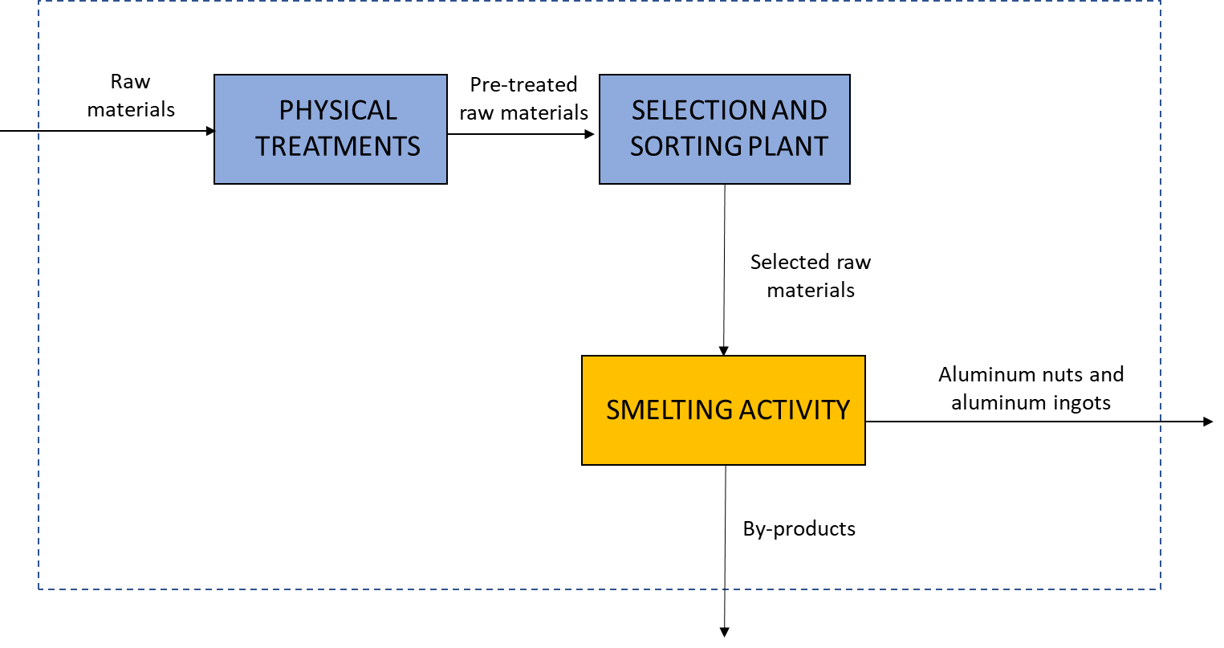
Figure 1. Scheme of the main activities carried out in the plant: pre-treatment line (blue boxes) and smelting line (yellow box)

Raw materials are mainly aluminum scrap delivered in different forms (ready-made product, pre-treated or internal recycled material) and processed, being crushed and sorted to reduce and standardize their size before undergoing the smelting process and treated at high temperature to remove organic pollutants from raw materials before being melted. The pre-treated and selected raw material is sent to the smelting area where corrective materials, such as calcium eliminator (i.e., MgCl₂) and PAF (i.e., Potassium-Aluminum-Fluoride), are sometimes added to raw materials to aid the smelting process and limit the decrease in aluminum content in the alloy. Indeed, the smelting area includes 5 smelting lines involving 7 main furnaces. Their emissions are conveyed to two stacks.

    - Identification of the odour emission sources
For the purpose of identifying the most critical sources from the point of view of the odour emissions, the first step of the work consisted in an olfactometric characterization (according to EN 13725:2003) of all odour sources of the plant, including the pyrolytic area, the storage area where slag heaps were stored, and the smelting area. Both conveyed and diffuse emissions were considered, by means a simultaneous sampling at the outlet of the stacks and in ambient air near the openings of the furnaces involved in the investigated process.
Table 1 lists the different operating conditions of the plant under examination. It is worth highlighting the presence of a condition defined as “normal”, whereby all furnaces were melting raw materials and no further materials were loaded into the furnaces. In order to include the variability of the odour emissions of the plant according to the different seasons, several olfactometric campaigns were carried out in different months of the years (i.e., July, September, November, February and May).
Table 1. Description of the emission sources and the operating conditions considered for the olfactometric characterization of the plant according to EN 13725:2003
AREA OF THE PLANT | TYPE OF PROCESSING
Pyrolytic Area | - Pyrolytic furnace loaded only with aluminium cans  - Pyrolytic furnace loaded with aluminium cans and lathing material
Storage Area | - Slag heaps  - Aluminium oxide piles
Smelting Area | - “Normal” operating conditions  - Rotating furnaces loaded with different raw materials  - Rotating furnaces loaded with PAF  - Dock and holding furnaces loaded with different raw materials  - Dock and holding furnaces loaded with PAF  - Dock and holding furnaces loaded with calcium eliminator  - Slagging process

    - Definition of macro-classes for odour emissions
Based on experimental evidence, the possibility of sorting the different smelter operations was explored. The two investigated "macro-classes" are characterized respectively by a "lower" concentration, labeled as “Low” (which is the macro-class corresponding to "normal" and assimilable conditions), and a "higher" concentration, labeled as “High” (which is the macro-class corresponding to those operations that lead to a statistically significant increase in the emitted odour concentration). In order to identify the operating conditions of the plant belonging to the “Low” class and the “High” class, different macro-classes, each of them including from time-to-time different working conditions of the plant, were investigated. A one-way ANOVA test on the logarithmic odour concentration values representatives of the operating conditions of the foundry was applied (Brown and Forsythe, 1974). The Analysis of Variance (ANOVA) is a statistical model used to analyze the differences among group means and their associated variability, among and between groups, resulting in the probability, expressed in terms of p-value, that the distribution of the two groups is statistically different. A Shapiro-Wilk test to verify the normality of data and a Levene test to verify the data homoscedasticity were implemented before applying ANOVA test. The violation of the homoscedasticity hypothesis was considered in the evaluation.
An ANOVA test was carried out for each pair of “macro-classes” and, comparing the p-values obtained, it was possible to define the operating conditions that grouped in two “macro-classes” allowed the most significant differentiation in terms of distribution of odour concentrations. The one that resulted to have a higher statistical difference between the concentration values of the “Low” odour condition and the “High” odour condition was the one which obtained the lowest p-value.
    - Randomized dispersion modelling
The identification of two macro-classes corresponding to the different odour emission scenarios of the plant (i.e., “Low” and “High”) and their randomization across the daily hours enabled to characterize the odour impact of the foundry, accounting for the variability of the emissions not only in terms of odour concentrations, but also in terms of their occurrence during the day. Indeed, the odour impact of the foundry was evaluated developing a randomized dispersion model, meaning that for each randomization a dispersion model was developed resulting in the corresponding 98th percentile map of the odour impact (Onofrio et al., 2020).
CALPUFF was used as dispersion model, and 3 discrete receptors were included within the simulation domain, corresponding to the closest sensitive receptors. As will be discussed in Section 3.1, the storage area and the pyrolytic plant were not implemented in the dispersion modelling because their emissions resulted to be negligible, thus only the smelting furnaces and their stacks were considered in the odour impact assessment study as emission sources. The stacks conveying the emissions from the furnaces were implemented as point sources, while the smelting furnaces were implemented in the dispersion modelling as volume sources, assuming that emissions from the furnaces occur by natural convection generated due to the temperature difference between the inside of the furnace and the outside (room temperature) (EN 15242:2007).
Assuming log-normal distributions for odour concentrations, the expected values of each distribution (i.e., different macro-classes) were calculated considering the mean value of each distribution µ and its standard deviation σ:
$$e^{μ+\frac{1}{2}σ^{2}}$$ | (1)
Regarding the diffuse emissions from the smelting furnaces, no macro-classes were identified, and they were considered to be present continuously, 24 hours a day, 365 days a year, conservatively assuming that there is always at least one furnace open.
Regarding the point emissions, it was assumed that operations corresponding to the highest odour concentration condition occur approximately for 50% of the time. However, associating specific daily hours to a specific scenario of the plant odour emissions is a quite challenging task. Since the distribution of the “High” and “Low” odour conditions of the plant over the year could affect the final odour impact of the plant, 6 different randomizations were considered, and on their basis 6 different simulations for the odour impact assessment of the foundry were carried out. For this purpose, a specific MATLAB® function based on a Crude Montecarlo (Kroese et al., 2011) method was implemented. It randomly produced different odour concentration values based on the expected values of the two macro-classes and the confidence interval of dynamic olfactometry and distributed over the year a set of 4380 values (corresponding to 50% of the hours of the year) corresponding to the higher odour concentration condition ("High"), and an equal number associated with the lower odour concentration condition ("Low").
  - Results
    - Input data for the randomized dispersion modelling
During the olfactometric campaigns, 64 odour samples were collected and analysed by dynamic olfactometry. Based on their results, the most impacting emission sources were identified.
The emissions related to the storage area and to the pyrolytic area resulted to be negligible because the odour concentrations obtained were below 80 ou_{E}/m³, which is the limit value below which an odour source can be considered as negligible (DGR February 15, 2012 - no. IX/3018). Thus, the emissions related to the different operating conditions of the smelting process were the only ones implemented in the dispersion model.
Regarding the diffuse emissions, no significant difference between their odour concentration values characterizing the different operating conditions was noticed. For this reason, for diffuse emissions no macro-classes were identified. The expected value of the odour concentrations distribution of the diffuse emissions was calculated obtaining a value of about 2’000 ou_{E}/m³. On the other hand, considering point emissions, the different operating conditions were characterized by highly variable odour concentrations. The boxplots reported in Figure 3 suggested that, despite the variability in odour concentrations, two different “macro-classes”, representatives of two different odour conditions of the plant, could be identified.

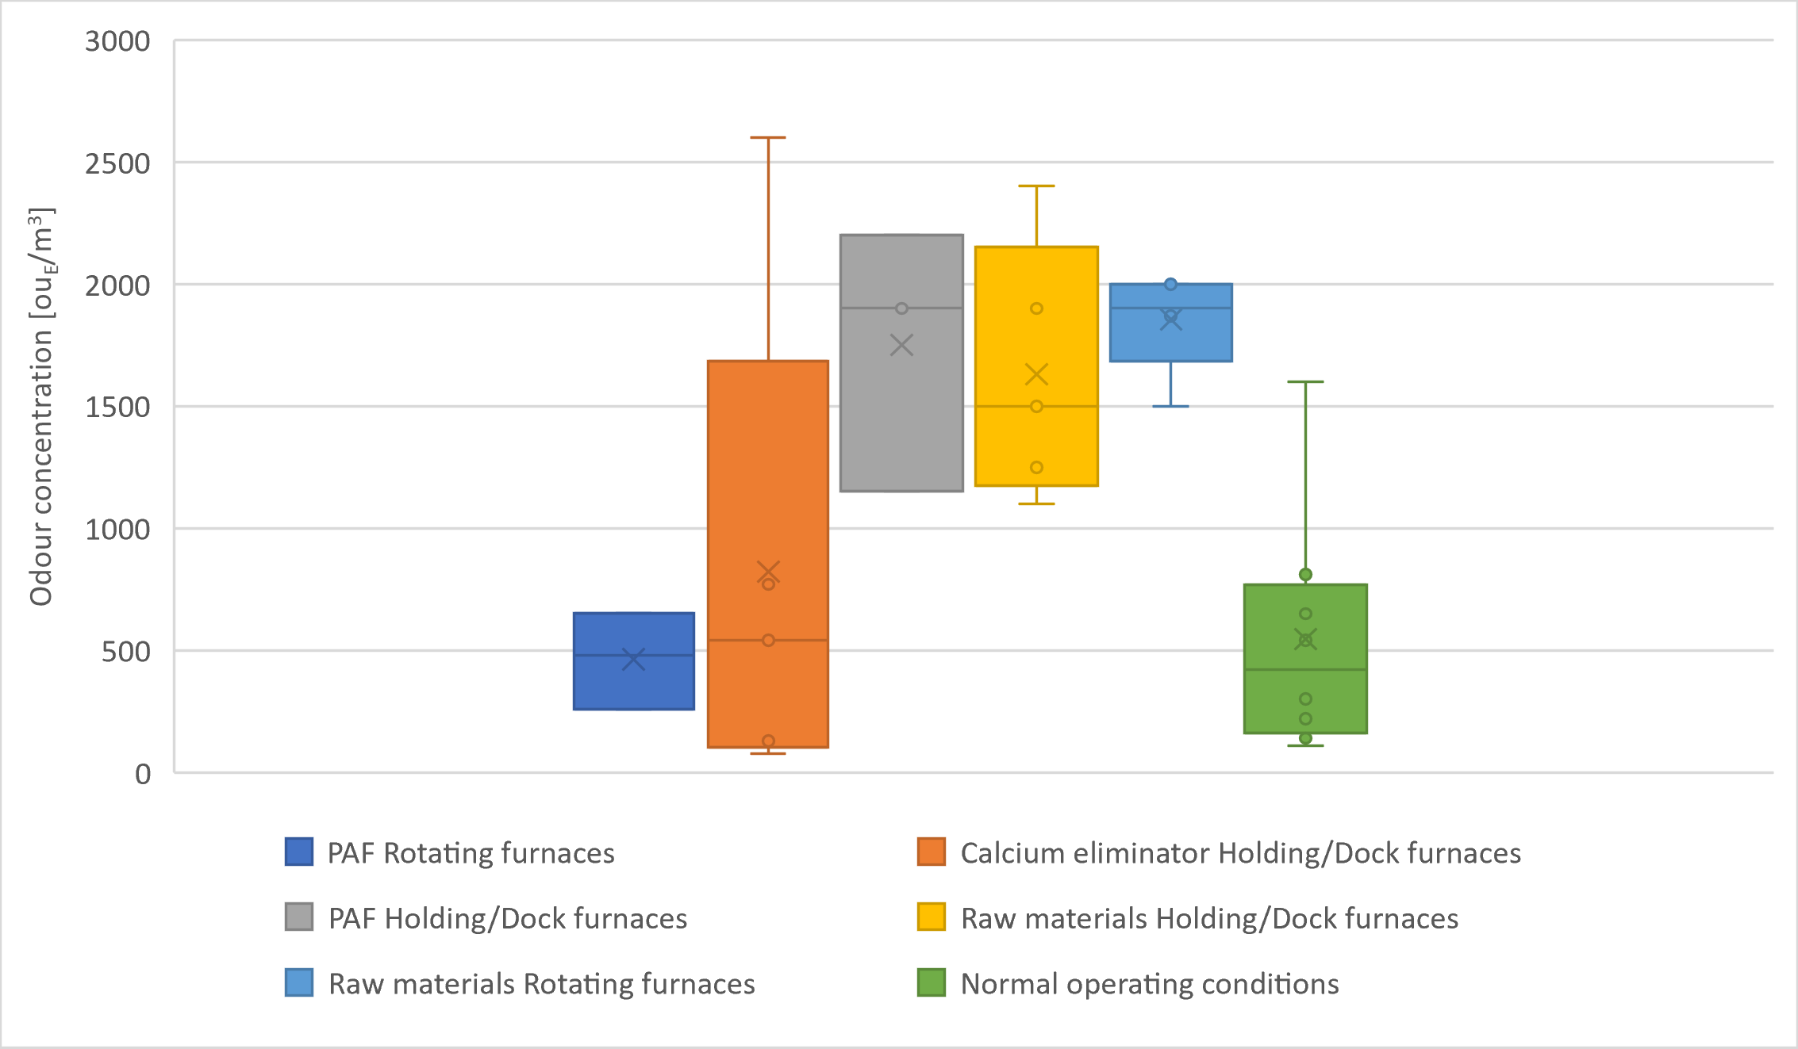
Figure 3. Box plots of odour concentration ranges of point emissions associated to different operating conditions
In order to validate the identification of the two “macro-classes”, one-way ANOVA tests on different possible pairs of “macro-classes”, differing in the grouping of the different working conditions, were performed. This way, the two “macro-classes” being most statistically different were identified based on the p-values. These two classes are characterized by different levels of odour emissions, which have been implemented in the model by considering the expected value of each odour concentration distributions, evaluated using Eq(1):
- class “Low” characterized by "lower" odour emissions, i.e., with an expected odour concentration value of 650 ou_{E}/m³, which includes "normal" conditions (i.e., no loading), PAF loading in rotary furnaces, and calcium eliminator loading in dock and holding furnaces.
- class “High” characterized by higher odorous emissions, i.e., with an expected odour concentration value of 1'800 ou_{E}/m³, which includes scrap loading operations in the different types of furnaces (rotary and holding/dock), and PAF loading in holding/dock furnaces.
    - Sensitivity analysis
At the end, the resulting 98th percentile impact maps corresponding to the 6 different dispersion models were investigated and compared. As an example, Figure 4 reports two odour impact maps.
The odour impact of the plant does not vary significantly as the temporal distribution of the two different odour conditions of the foundry varies over the year. This is even more evident when looking at the 98th percentile point values of concentration evaluated on the 3 discrete receptors, shown in Table 2. The variation concentration changes are on the order of 1% over all the receptors considered.

a) | 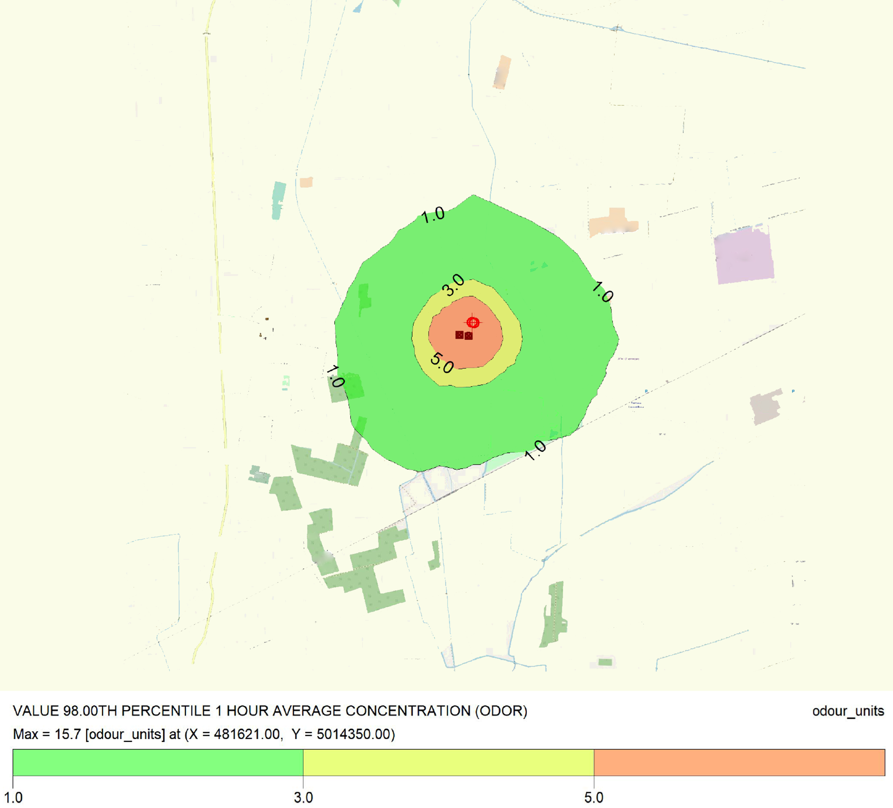  b)
Figure 4. 98th percentile impact maps corresponding to two different randomizations of the dispersion model
Table 2. 98th percentile odour concentration values evaluated on the 3 discrete receptors for the different randomizations
Receptor | Cod,98 – RAND1 [ou_{E}/m³] | Cod,98 – RAND2 [ou_{E}/m³] | Cod,98 – RAND3 [ou_{E}/m³] | Cod,98 – RAND4 [ou_{E}/m³] | Cod,98 – RAND5 [ou_{E}/m³] | Cod,98 – RAND6 [ou_{E}/m³]
R_1 | 2.85 | 2.85 | 2.84 | 2.84 | 2.84 | 2.85
R_2 | 1.41 | 1.41 | 1.40 | 1.40 | 1.41 | 1.41
R_3 | 1.20 | 1.19 | 1.17 | 1.19 | 1.20 | 1.19

This behavior can be explained by looking at the map representing the impact related to diffuse emissions only (Figure 5.a), compared with the map related to the impact of point emissions only (Figure 5.b showing, by way of example, the one related to randomization 1). It is clear that the largest contribution to the overall emissions of the plant is attributable to diffuse emissions from the furnaces.

a) | b)
Figure 5. 98th percentile impact maps considering only diffuse emissions (a) and only point emissions (b)
In conclusion, the randomized dispersion modelling enabled to consider the unpredictable occurrence of higher odour emissions from the smelting process. However, in this specific case, the odour impact of the plant turned out to be mostly related to diffuse emissions, and thus it is not much affected by the distribution of the different levels of concentrations at the stacks. The isoplethe corresponding to an odour concentration of 5 ou_{E}/m³ remains mostly enclosed within the plant fenceline, while the 98t^{h} percentile odour concentrations assessed at the receptors representing the first residences near the plant slightly above 1 ou_{E}/m³, which corresponds by definition to the odour threshold concentration.

  - Conclusions
This work aims to present a methodology to deal with highly variable emissions in the evaluation of the odour impact of an industrial plant. Specifically, this study focused on the characterization of odour emissions of a foundry. It enabled to quantify the odour emissions related to the different phases of the foundry process in order to obtain a snapshot as representative as possible of the odour impact of the plant. For this purpose, a randomized dispersion model was developed considering the frequency of the different processes and the temporal variability of the emissions themselves. This approach allowed to demonstrate that, in this case, the odour impact of the plant is mostly related to the diffuse emissions from the furnaces, and thus the variability of stack emissions does not play a significant role in the overall odour impact.
References
Brown M. B., and Forsythe A. B., 1974, The Anova and Multiple Comparisons for Data with Heterogeneous Variances, Biometrics, 30(4), 719–724.
Kroese Dirk P., Taimre Thomas, and Botev Zdravko I., 2011, Handbook of Monte Carlo Methods, Hoboken, NJ, John Wiley & Sons, USA.
Lotesoriere B.J., Giacomello A.D., Bax C. and Capelli L., 2021, The Italian Pilot Study of the D-noses Project: an Integrated Approach Involving Citizen Science and Olfactometry to Identify Odour Sources in the Area of Castellanza (VA), Chemical Engineering Transactions, 85, 145-150.
Magalhães J., Guasch B., Arias R., Giardullo P., Elorza A., Navalhas I., Marín-González E., Mazzonetto M., and Luís C., 2022, A methodological approach to co-design citizen science communication strategies directed to quadruple-helix stakeholders, Journal of Science Communication, 21(4).
Morag-Levine N., 2009, Chasing the Wind: Regulating Air Pollution in the Common Law State, Princeton University Press, Princeton, USA, 143-178.
Onofrio M., Spataro R. and Botta S., 2020, A review on the use of air dispersion models for odour assessment, International Journal of Environment and Pollution, 67(1), 1-21.
Piringer M., Knauder W., Baumann-Stanzer K., Anders I., Andre K. and Schauberger G., 2021, Odour Impact Assessment in a Changing Climate, Atmosphere, 12(9), 1149.
Sironi S., Capelli L., Céntola P., Del Rosso, R., Pierucci S., 2010, Odour impact assessment by means of dynamic olfactometry, dispersion modelling and social participation, Atmospheric Environment, 44(3), 354-360.

