CHEMICAL ENGINEERING TRANSACTIONS  VOL. 95, 2022 | A publication of
The Italian Association
of Chemical Engineering
Online at www.cetjournal.it

Guest Editors: Selena Sironi, Laura Capelli
Copyright © 2022, AIDIC Servizi S.r.l.
ISBN 978-88-95608-94-5; ISSN 2283-9216

Analysis of Odorous VOCs using TD-GC-MS/FID/PFPD: Development and Applications to Real Samples
Elisa Polvara^{a,*}, Daniele Morosini^{b}, Marzio Invernizziª, Selena Sironiª
ª Politecnico di Milano, Department of Chemistry, Materials and Chemical Engineering “Giulio Natta”, Piazza Leonardo da Vinci 32, 20133 Milano, Italy
^{b} SRA Instruments S.p.A., Via alla Castellana, 3, 20063, Cernusco sul Naviglio (MI), Italy
elisa.polvara@polimi.it

This work aims to present the applicability of a gas chromatograph equipped with three detectors for the analysis of odorous mixtures. An Agilent gas chromatograph (mod. 8890), equipped with a mass spectrometer (Agilent 5977B MSD), a Flame Ionization Detector (FID, Agilent) and a Pulsed Flame Photometric Detector (PFPD, OI Analytical mod. 5833) was adopted, obtaining simultaneous acquisition with MS, FID and PFPD detectors. The splitting of the sample into the three detectors was carried out at the end of the chromatographic column, by a capillary flow technology splitter (Agilent Splitter CFT). By using this system, it is, therefore, possible to achieve the specific detection and quantification of organic compounds by FID analysis, sulphur compounds by PFPD and the identification of the compounds by MS analysis, via comparison with mass spectra. Based on the preliminary outcomes obtained,the application of this system in the analysis of odour samples enabled the determination of specific classes, even in traces: by this, the subsequent identification of these compounds during a single chromatographic run is possible. This combination provides significant time and costs savings in the calibration and analysis of chromatographic data.
  - Introduction
Chemical analysis of odorous samples is a complex task due to the recurrent huge heterogeneity of the present molecules. Moreover, generally speaking, chemical analysis of odorous gas mixture is usually untargeted: the scope is properly the identification of the molecules responsible for the odour. To identify and quantify the species present in odorous emissions, the most diffuse analytical technique is gas chromatography coupled with mass spectrometry (GC-MS). Due to the necessity to understand the chemical nature of odorous mixture, MS is generally used in total ion current (TIC) mode. Despite the potential of this technique (i.e. the identification of unknown molecules in complex mixtures), it shows some critical aspects, in particular, correlated with the quantification and detection of specific compounds. Focusing on quantification, the chemical composition is generally unknown and the molecules present in odorous emission can be potentially extremely numerous (Murphy et al., 2012). In addition, in the scenario of odour studies, detection of a single specie is uncommon, because the interest is the characterisation of the whole mixture. Therefore, a specific calibration curve for every single compound may not be easily obtainable and the quantification with a specific standard for each compound greatly increases the costs of the analysis (D’Agostino et al., 2014). In addition, a calibration curve for all the pollutants potentially present in odorous emissions is impractical, due to the availability of standards for all compounds (Raffo et al., 2018). For these reasons, a semi-quantification of molecules is commonly adopted, by using the calibration curve of a single compound for the quantification of a family or group of chemicals(Kamarulzaman et al., 2019; Rice et al., 2018; Spinazzè et al., 2022). However, using MS, the signal produced by a molecule is strictly connected to its structure and the ionization efficiencies vary for compounds (Bicchi et al., 2008; Cicchetti et al., 2008). In addition, MS quantification is affected by source conditions and the detector response may not be constant (Biedermann et al., 2017). Therefore, due to these critical aspects, using a semi-quantification may lead to a non-negligible error (Niemi et al., 2019). In addition, focusing on the detection of compounds, mass spectrometer, used in TIC mode, is a non-specific detector. However, discussing the analysis of specific classes of compounds, for example sulphur compounds, MS may not be as effective and may have worse performance (in terms of linearity, LOD and selectivity) compared to other detectors (Hegazi & Andersson, 2007; Yu et al., 2022). For all these reasons, in the case of untargeted analysis of odour samples, consisting of different and unknown compounds, GC-MS alone may not be sufficient for the complete chemical characterisation of odour emissions. The obtainment of the wide characterisation can require the use of specific detectors, combined with gas chromatography (GC), to detect and quantify promptly all the chemicals potentially present in odorous emissions. Therefore, to overcome these criticalities, a combination of different analytical techniques can be adopted. To resolve these critical aspects (the necessity to adopt a semi-quantification of pollutants in untargeted analysis and the quantification problems associated with MS detector), the use of detectors based on element response and comparatively simpler than MS would be a better choice for quantification of single compounds. In particular, for the quantification of organic compounds, FID detector appears the ideal solution for more robust quantification of carbon compounds, often present in odorous mixtures. Indeed, FID provides, for similar hydrocarbons, a response correlated with the number of carbon atoms (De Saint Laumer et al., 2010). In addition, it is linear over a wide dynamic range and highly sensitive (Walters et al., 2018). The combination of MS and FID to obtain qualitative information (using MS) and quantitative information (by FID) is already widespread practice (Justino de Araújo et al., 2020; Pacchiarotta et al., 2010; Yuan et al., 2021). However, to the best of our knowledge, the combination of a third detector (PFPD), equipped on the same GC, has not yet been widely used, particularly in the field of odour emissions. The implementation of a detector specific for sulphur compounds can be a useful solution, due to the potential olfactory impact of these compounds. Indeed, the use of this additional detector allows not only the detection, but also the specific quantification of sulphur compounds. PFPD provides an equal molar response to sulphur, regardless of the molecular structure and it is highly sensitive (Del Río et al., 2011). Therefore, by FID and PFPD signals, it is possible to quantify the molecules present in samples by using the response factor of the single compound (Dijkmans et al., 2015). This semi-quantification, while preserving the advantages of time and cost savings, can lead to a minor quantification error. Therefore, this study aims to evaluate the applicability to the odours’ analysis of a gas chromatograph equipped with three detectors in parallel (MS, Flame Ionization Detector (FID) and Pulsed Flame Photometric Detector (PFPD)). In particular, this study aims to investigate the possibility of applying this type of instrumentation to obtain the wide characterization of odorous gas samples, considering the critical aspects observed during the untargeted measurement of this kind of analysis.
  - Materials and methods
    - Samples collection
Samples were collected at a wastewater treatment plant (WWTP), which treats local residential wastewater. As a preliminary study, three samples were collected from the same sampling point and analysed on the same day. Gaseous emissions were collected at the stack conveying the air exhaust from a scrubber, which treats department air from different processing areas,. According to EN 13725:2022, gaseous emissions were sampled using NalophanTM bags (6 L) equipped with a TeflonTM inlet tube. These materials are odourless and are commonly used in dynamic olfactometry and using these materials allows chemical and olfactometric analysis to be performed in the same time. These materials are also non-reusabletherefore do not require determine the container’s background. Air samples were collected using a vacuum pump to collect the gas directly into the sampling bag, due to the depression, to prevent contaminations. After the sampling, the bags were directly analysed by GC analysis.
    - Chemical instrumentation and analysis
The analysis of odorous samples was conducted by a gas chromatograph (Agilent, mod. 8890), equipped with a single quadrupole mass selective detector (Agilent 5977B MSD), a Flame Ionization Detector (FID, Agilent) and a Pulsed Flame Photometric Detector (PFPD, OI Analytical mod. OI 5833). A diagram of the system is reported in Figure 1. This combination was adopted to obtain the specific detection and quantification of organic compounds by FID analysis, sulphur compounds by PFPD and the identification of the compounds, by MS analysis, by comparing the generated spectra with library ones. The air samples were collected directly from the Nalophan™ sampling bags, using a calibrated pump (Markes, Air Server-xr) and sent to thermal desorption (Markes, Unity-xr). After the sampling, the gas was sent to a cryofocusing trap maintained at −27 °C. After that, the cold trap was heated from −27 °C to 300 °C. After this step, the compounds were transferred by hot transfer line (200 °C) into the capillary column (DB-Sulfur SCD, 60 m×0.320 mm×4.20 μm, Agilent J&W, Folsom, CA, USA). After the chromatographic run, the gas flow is split into equal portions between the three detectors at the end of the chromatographic column by a capillary flow technology splitter (Agilent Splitter CFT). Therefore, a simultaneous acquisition with MS (operated in TIC mode), FID and PFPD detectors was conducted and three different and overlapping chromatograms are registered during a single chromatographic run. Discussing the detectors’ setting, mass spectral data were acquired over a mass range of 40–350 u and a solvent delay of 3.5 min. was set to remove the CO₂ signal due to the sample matrix, the temperature was equal to 150 °C for FID and 100 °C for PFPD. The identification of the compounds was conducted by comparing the spectra obtained by GC-MS analyses with the NIST20 database (NIST/EPA/NIH Mass Spectral Library, Version 2.4 Mar 25 2020). Figure 1 shows the instrumentation adopted for the analyses.
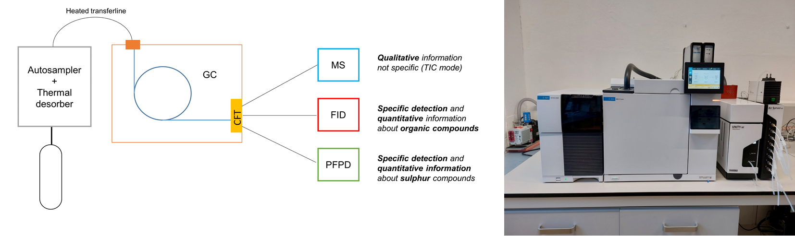
Figure 1: TD-GC-MS/FID/PFPD (diagram and analytical instrumentation used)
  - Results and discussion
From the GC-MS chromatogram (TIC mode) obtained for the analysed samples, only two chromatographic signals (Retention Time, RT= 5.6 and 6.7 min.) were detected in the untargeted analysis, as shown in Figure 2. From the comparison of mass spectra of these picks with the NIST library, the two peaks were identified as Acetone (RT= 5.6 min.) and Dimethyl sulphide (RT= 6.7 min). In the GC-MS chromatogram, no signal significantly different from the background noise (intensity of background signal: 2*10⁴ count) was therefore detected. Similar to the signal obtained by GC-MS, the chromatogram obtained by GC-FID (Figure 3) is also characterised by two detectable peaks. These two signals correspond to the two signals detected in the chromatogram shown in Figure 2. On the other hand, from the chromatogram obtained by GC-PFPD, a specific detector for sulphur compounds, it can be observed different chromatographic signals, at intensities significantly different from the background. From the chromatogram shown (Figure 4), it is possible to detect five chromatographic signals. The identification of the sulphur compounds observed in the PFPD chromatogram can be conducted by searching, at the specific RT observed, the signal of sulphur compounds in the GC-MS signal. Indeed, having determined the presence of sulphur compounds in the sample, the use of PFPD makes it easier to selectively search specific areas of the GC-MS chromatogram for the mass spectrum useful for the identification of sulphur compounds. The qualification was conducted by research qualifier ion (Table 1). This instrumental configuration can be also particularly useful in the case of coelution of two compounds, one of which contains sulphur: indeed, if a coelution with a hydrocarbon compound occurs, it is possible to detect the presence of a second compound below a single GC-MS peak. Table 1 shows the compounds identified by applying this particular instrumental configuration to the samples analysed.
Table 1: Compounds identified in the samples analysed using GC-MS/FID/PFPD
RT [min] | Name | CAS | Formula | Analysis |  | Qualifier ion [m/z]
3.2 | Carbonyl sulphide | 463-58-1 | COS | Detection: PFPD; identification: MS |  | 60
4.5 | Methyl mercaptan | 74-93-1 | CH₄S | Detection: PFPD; identification: MS |  | 47
5.7 | Acetone | 67-64-1 | C₃H₆O | Detection: FID and MS; identification: MS
6.7 | Dimethyl sulphide  (DMS) | 75-18-3 | C₂H₆S | Detection: FID, MS and PFPD;  identification: MS
7.4 | Carbon Disulphide | 75-15-0 | CS₂ | Detection: PFPD; identification: MS |  | 76
14.1 | Dimethyl disulphide (DMDS) | 624-92-0 | C₂H₆S₂ | Detection: PFPD; identification: MS |  | 94

Figure 5 shows the extracted ion chromatogram (EIC) obtained from the search for the qualifying ion of the compounds. From the reported results, it is possible to affirm that the analytical system adopted to analyse these samples allows to obtain useful qualitative information for the characterisation of odour mixtures, minimising the analysis time required. Indeed, by using specific detectors (FID and PFPD) it is possible to selectively detect classes of compounds. These are then identified not only by comparing the RT with standards but, much more easily, are immediately identified by comparing the mass spectra with the NIST library.
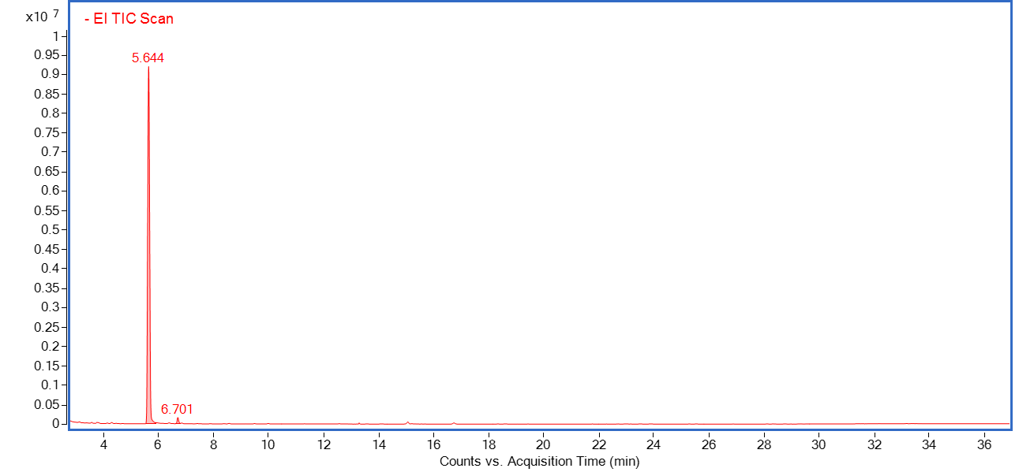
Figure 2: MS chromatogram of analysed sample, obtained using TIC mode
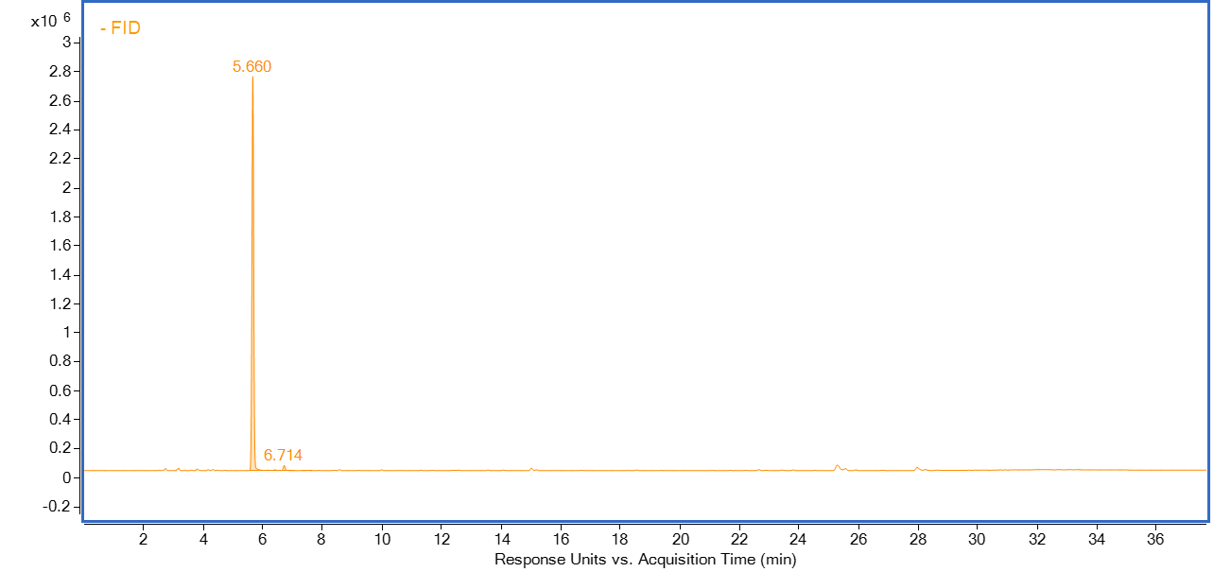
Figure 3: FID chromatogram of analysed sample – detection of organic compounds
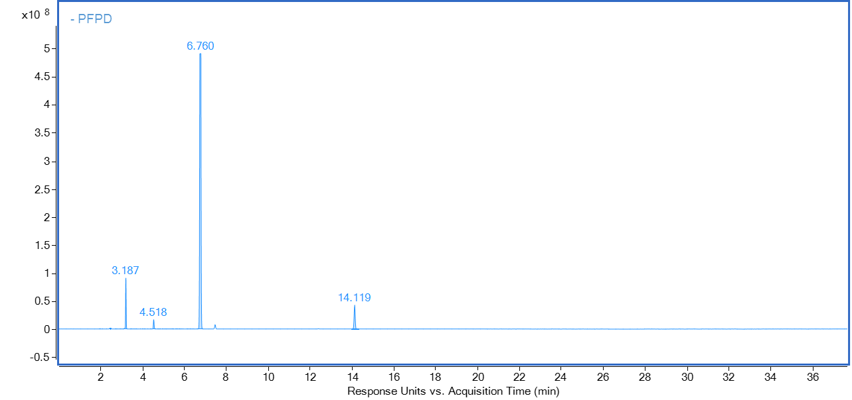
Figure 4: PFPD chromatogram of analysed sample – detection of sulphur compounds
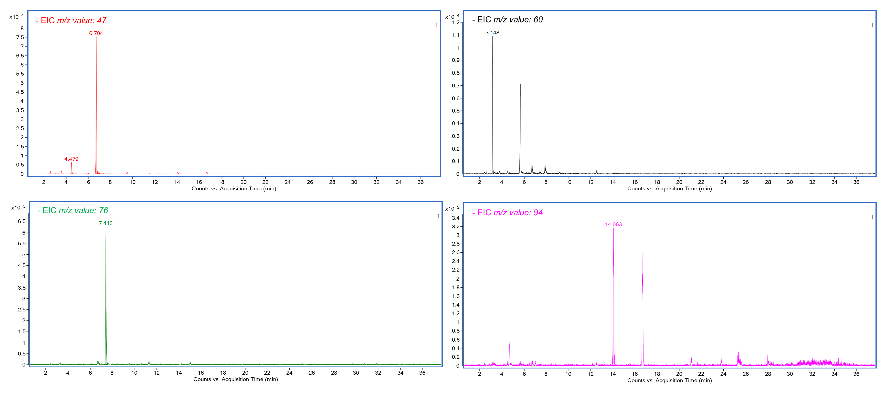
Figure 5: EIC chromatogram of selected qualification ions for VOCs detected in GC-PFPD chromatogram
The quantification of compounds was conducted by calibrating FID and PFPD, in terms of mg/m³ of, respectively, Carbon and Sulphur. The compounds’ concentration was obtained by transformation of mg_{C}/m³ or mg_{S}/m³. In Table 2 the concentrations of observed compounds, expressed in mg/m³, are reported: for every compound, its odour activity value (OAV) was established.
Table 2: Compounds concentration obtained by FID and PFPD calibration (OT reference: (Nagata, 2003))
Name |  | OT  [mg/m³] | C  [mg/m³] | OAV
Carbonyl sulphide |  | 1.4E-01 | 0.03 | 0.21
Methyl mercaptan |  | 1.4E-04 | 0.01 | 71
Acetone |  | 1.0E+02 | 15 | 0.15
Dimethyl sulphide (DMS) |  | 7.6E-03 | 0.11 | 14
Carbon Disulphide |  | 6.5E-01 | 0.003 | 0.005
Dimethyl disulphide (DMDS) |  | 8.5E-03 | 0.02 | 2.35

The obtained OAVs highlight that sulphur compounds detected in PFPD chromatogram have a non-negligible odour impact (i.e. higher OA). Therefore, from the results obtained, it is possible to affirm that the analytical instrumentation adopted allows describing better the chemical characteristic of odorous emissions. Therefore, a wide chemical description of odorous emission can be reached.
Discussing the observed concentration of compounds, despite the separation of flow in three different detectors, the concentration reached using specific detectors, such as PFPD and FID, could be very low (around 0.002 mg/m³ of compound). In addition, it is necessary to highlight that, discussing odorous samples, according to EN 13725:2022, the samples have to be collected directly to the emissions' sources, where the highest concentrations of the pollutants can be found.
  - Conclusions
The accurate analysis of odorous samples still represents a challenge from a technical point of view. Indeed, due to the complexity of the matrix, a polyvalent analytical approach is required to obtain, more efficiently, the most complete chemical characterisation. The combination of several detectors is one of the most useful tools to maximise the amount of information that can be obtained in the shortest analysis time. The application of the TD-GC-MS/FID/PFPD system to samples collected at a WWPT showed its potential: using it, it was possible to selectively detect compounds of particular interest from an odour point of view. These compounds would have hardly been detected in a generic untargeted MS analysis. This undoubtedly reduces the processing time of the chromatographic data, simplifies the identification of this class of compounds and provides more robust results. Moreover, discussing the quantification of the detected compounds, the use of detectors such as FID and PFPD reduces the costs associated with calibrations, while being less expensive than semi-quantification with MS. Therefore, the combination of these three detectors simultaneously provides different information, useful for the complete chemical characterisation of complex mixtures, such as odours, saving a lot of time and thus increasing the efficiency of the analysis. It is important to note that this study is a first attempt to evaluate the applicability of GC-MS/FID/PFPD instrumentation in the analysis of odorous samples, in order to obtain a most complete characterization of compounds present in odour emissions.
References
Bicchi, C., Liberto, E., Matteodo, M., Sgorbini, B., Mondello, L., Zellner, B. d. A., Costa, R., Rubiolo, P., 2008, Quantitative analysis of essential oils: A complex task, Flavour and Fragrance Journal, 23(6), 382–391.
Biedermann, M., McCombie, G., Grob, K., Kappenstein, O., Hutzler, C., Pfaff, K., Luch, A., 2017, FID or MS for mineral oil analysis?, Journal Fur Verbraucherschutz Und Lebensmittelsicherheit, 12(4), 363–365.
Cicchetti, E., Merle, P., Chaintreau, A., 2008, Quantitation in gas chromatography: Usual practices and performances of a response factor database, Flavour and Fragrance Journal, 23(6), 450–459.
D’Agostino, M. F., Sanz, J., Martínez-Castro, I., Giuffrè, A. M., Sicari, V., Soria, A. C., 2014, Statistical analysis for improving data precision in the SPME GC–MS analysis of blackberry (Rubus ulmifolius Schott) volatiles, Talanta, 125, 248–256.
De Saint Laumer, J. Y., Cicchetti, E., Merle, P., Egger, J., Chaintreau, A., 2010, Quantification in gas chromatography: Prediction of flame ionization detector response factors from combustion enthalpies and molecular structures, Analytical Chemistry, 82(15), 6457–6462.
Del Río, D., Rey, M., Sedran, U., De La Puente, G., 2011, Combined PFPD–FID assessment of sulfur in liquid fuels, Fuel Processing Technology, 92(12), 2278–2284.
Dijkmans, T., Djokic, M. R., Van Geem, K. M., Marin, G. B., 2015, Comprehensive compositional analysis of sulfur and nitrogen containing compounds in shale oil using GC x GC - FID/SCD/NCD/TOF-MS, Fuel, 140, 398–406.
EN 13725:2022, Stationary source emissions - Determination of odour concentration by dynamic olfactometry and odour.
Hegazi, A. H., Andersson, J. T., 2007, Limitations to GC-MS determination of sulfur-containing polycyclic aromatic compounds in geochemical, petroleum, and environmental investigations, Energy and Fuels, 21(6), 3375–3384.
Justino de Araújo, A. C., Freitas, P. R., Rodrigues dos Santos Barbosa, C., Muniz, D. F., Rocha, J. E., Albuquerque da Silva, A. C., Datiane de Morais Oliveira-Tintino, C., Ribeiro-Filho, J., Everson da Silva, L., Confortin, C., Amaral, W. do, Deschamps, C., Barbosa-Filho, J. M., Ramos de Lima, N. T., Tintino, S. R., Melo Coutinho, H. D., 2020, GC-MS-FID characterization and antibacterial activity of the Mikania cordifolia essential oil and limonene against MDR strains, Food and Chemical Toxicology, 136.
Kamarulzaman, N. H., Le-minh, N., Fisher, R. M., Stuetz, R. M., 2019, Science of the Total Environment Quanti fi cation of VOCs and the development of odour wheels for rubber processing, Science of The Total Environment, 657, 154–168.
Murphy, K. R., Wenig, P., Parcsi, G., Skov, T., Stuetz, R. M., 2012, Characterizing odorous emissions using new software for identifying peaks in chemometric models of gas chromatography-mass spectrometry datasets, Chemometrics and Intelligent Laboratory Systems, 118, 41–50.
Nagata, Y., 2003, Measurement of Odor Threshold by Triangle Odor Bag Method, Odor Measurement Review, 118–127.
Niemi, C., Lage, S., Gentili, F. G., 2019, Comparisons of analysis of fatty acid methyl ester (FAME) of microalgae by chromatographic techniques, Algal Research, 39, 101449.
Pacchiarotta, T., Nevedomskaya, E., Carrasco-Pancorbo, A., Deelder, A. M., Mayboroda, O. A., 2010,Evaluation of GC-APCI/MS and GC-FID As a Complementary Platform.
Raffo, A., Masci, M., Moneta, E., Nicoli, S., Sánchez del Pulgar, J., Paoletti, F., 2018, Characterization of volatiles and identification of odor-active compounds of rocket leaves, Food Chemistry, 240, 1161–1170.
Rice, S., Lutt, N., Koziel, J. A., Dharmadhikari, M., & Fennell, A., 2018, Determination of Selected Aromas in Marquette and Frontenac Wine Using Headspace-SPME Coupled with GC-MS and Simultaneous Olfactometry, Separations 2018, Vol. 5, Page 20, 5(1), 20.
Spinazzè, A., Polvara, E., Cattaneo, A., Invernizzi, M., Cavallo, D. M., Sironi, S., 2022, Dynamic Olfactometry and Oil Refinery Odour Samples: Application of a New Method for Occupational Risk Assessment, Toxics 2022, Vol. 10, Page 202, 10(5), 202.
Walters, C. C., Wang, F. C., Higgins, M. B., Madincea, M. E., 2018, Universal biomarker analysis using GC×GC with dual FID and ToF-MS (EI/FI) detection, Organic Geochemistry, 115, 57–66.
Yu, P., Yang, Y., Sun, J., Jia, X., Zheng, C., Zhou, Q., Huang, F., 2022, Identification of volatile sulfur-containing compounds and the precursor of dimethyl sulfide in cold-pressed rapeseed oil by GC–SCD and UPLC–MS/MS, Food Chemistry, 367.
Yuan, S., Li, H., Liu, Z., Wang, Y., Wang, L., Zhang, X., Liu, G., 2021, Measurement of non-hindered and hindered phenolic species in aviation fuels via tandem-SPE with comprehensive GC × GC–MS/FID, Fuel, 287, 119561.

