|  |  |
| --- | --- |
| cetlogo CHEMICAL ENGINEERING TRANSACTIONS  ***VOL. 95, 2022*** | A publication of  aidiclogo_grande |
| The Italian Association  of Chemical Engineering  Online at www.cetjournal.it |
| Guest Editors: Selena Sironi, Laura Capelli  Copyright © 2022, AIDIC Servizi S.r.l. **ISBN** 978-88-95608-94-5; **ISSN** 2283-9216 | |

Emissions of nanoparticles from local stationary heat sources that burn wood in the Czech countryside

Marek Nechvátala,b,\*, Karel Kloudaa,b, Hana Kubátovác, Petra Roupcováa,b

aVSB- Technical University of Ostrava, Lumirova 630/17, Ostrava, Czech republic, EU

bOccupational Safety Research Institute, Prague, Czech Republic, EU

cState Office for Nuclear Safety, Senovazne namesti 9, Prague, Czech Republic, EU

nechvatal@vubp-praha.cz

We encounter smoke relatively regularly in our lives. Smoke consists of gaseous, liquid and solid components that are formed by combustion / oxidation of fuel. The chemical composition of smoke depends not only on the fuel used, but on a number of other parameters (operation, technology, atmospheric influences). So the chemical composition of smoke is variable and cannot be easily characterized.

In addition to unconsumed air, wood, CO2, methane, volatile organic compounds, trace elements and ultrafine particles are released into the atmosphere when wood is burned. Measurements for a given type of combustion technology with a specific type of fuel are published on this topic. The procedure of our measurement of the concentration of nanoparticles (10-700 nm) in wood smoke and their mean diameters can be called "terrain". The aim of these measurements in real situations was to find and describe the sources of increased nanoparticle concentration.

Substantial quantitative information on the occurrence of nanoparticles during wood burning in various types of heaters was obtained in the field in real climatic conditions, typical for the winter period in Central Europe, when it is most heated in households. Wood burning in households in predominantly agricultural areas of the Czech Republic can thus be considered the main source of outdoor air pollution, but it can also have a significant effect on the deterioration of indoor air quality. At the same time, it can be assumed that the negative impact of nanoparticles on human health in areas polluted by wood smoke is weaker than the impact elsewhere - in industrial, more polluted areas.

Keywords: Nanosafety; Air pollution; Smoke; Environment.

* 1. Introduction

The use of wood stoves has increased significantly in recent years (Aguilar, 2015), raising concerns about the health effects of wood smoke (Burki, 2018). Smoke consists of gaseous, liquid and solid components that are formed by the combustion / oxidation of fuel. The chemical composition of smoke depends not only on the fuel used, but on a number of other parameters (operation, technology, chimney configuration, atmospheric influences) (Trojanowski and Fthenakis, 2019). So the chemical composition of smoke is variable and cannot be easily characterized.

Wood smoke is known to contain compounds such as carbon monoxide, methane, nitrogen oxides, sulfur oxides, aldehydes, polycyclic aromatic hydrocarbons, Na, Mg, Al, Si, S, Cl, K, Ca, Ti, V, Cr, Mn, Fe, Ni, Cu, Zn, Br in the form of particles of different sizes (Olsen et al., 2020). Nanoparticles are the smallest and most easily penetrate into the inner human environment. Some compounds found in wood smoke such as benzo [a] pyrene and formaldehyde are human carcinogens (Pierson et al., 1989). Wood smoke samples taken from the exterior and interior show toxic, carcinogenic and mutagenic activity in biological tests (Naeher et al., 2007).

Current emission regulations do not take into account the number of nanoparticles or the type produced by burning wood in households, although most published studies show that a significant proportion of the particles produced during combustion are in the nano-size range (Trojanowski and Fthenakis, 2019). Due to the potential health effects of wood smoke nanoparticles, exposure to this source of air pollution should be minimal.

* 1. Material and methods

The Testo DiSC mini 133 device was used for all measurements - measuring range 10-700 nm. The diffusion size classifier (DiSCmini) is a relatively simple and robust instrument that can measure with a high time resolution of 1s. The device is based on charging and current detection, there is no working fluid as in CPC.

Measurements of nanoparticle emissions by local stationary heat sources burning wood were performed outside in the village of Jiřičky in the cadastral area of Košetice, Pelhřimov district, Vysočina region in five different places and in one case inside a house in the same village (Figure 1, 2, 3).

The evaluation of risks associated with the action of nanoparticles was performed according to a certified methodology for the provision of personal protective equipment in an environment with a risk of nanoparticles (Senčík et al., 2016). A path using direct observation and recording of the intensity of the smell of wood smoke was chosen to assess the odor load (Czech Standard ČSN 83 5031, 1998). The degree of wood smoke odor was evaluated according to Czech Standard 83 5030 (Czech Standard ČSN 83 5030, 1998). Then the recruitment of volunteer evaluators - "sniffers" - was started. The basic requirement for participation in the assessment of air odors was adulthood (min. 18 years of age), good health with a good sense of smell (according to one's own assessment) and non-smoking. All of them were professionally trained and acquainted with the methodology of monitoring the smell of wood smoke in the locality in accordance with the requirements of the ČSN 83 5030 standard. Each volunteer evaluator received a form where they recorded their olfactory perceptions using a six-point scoring 0 (no odor)–5 (unbearable odor), depending on the intensity of the odor.

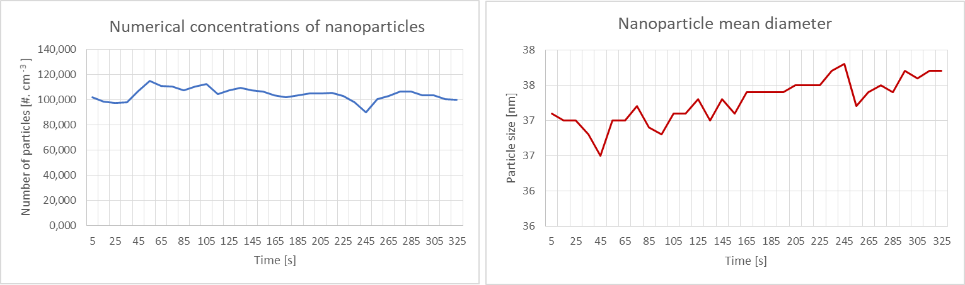

Figure 1: Nanoparticle emission measurement in the indoor environment, on the ground floor, 5 February 2022.

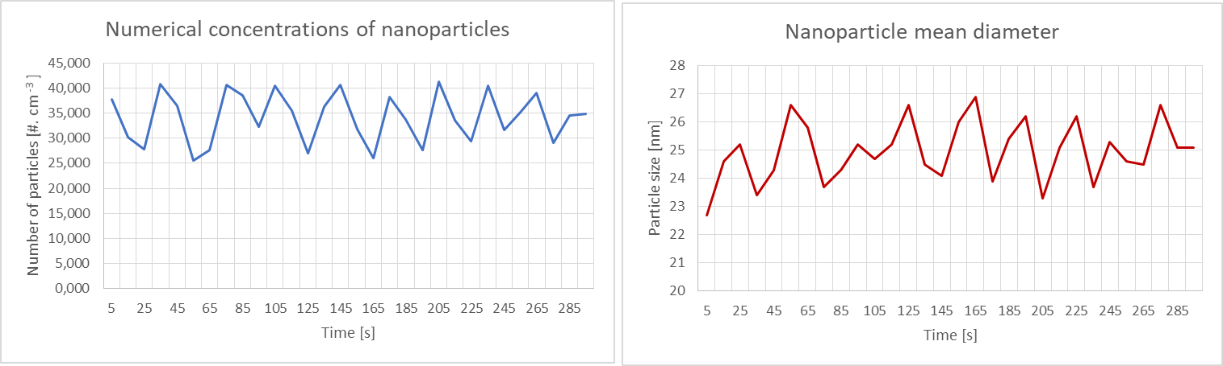

Figure 2: Nanoparticle emission measurement in the indoor environment, in the boiler room of the house, 5 February 2022.

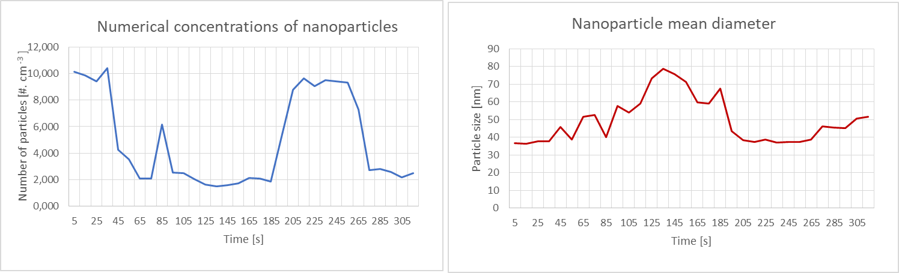

Figure 3: Nanoparticle emission measurement in the indoor environment, in the attic of the house, 5 February 2022.

* 1. Results

The expected exposure time when moving in this environment (village exterior, free space) is up to 1 hour / day, resp. up to 7 hours per week (category 1). Because wood smoke contains nanoparticles with toxic and carcinogenic effects on human health, its emissions are classified in the worst hazard group (V). Based on the determination of the exposure time and classification into hazard groups, we evaluated the risks associated with the action of nanoparticles. The risk has a value of 3. This means that a negative impact on human health by nanoparticles can be expected. The risk of potential negative health effects associated with the action of nanoparticles can be perceived as unacceptable, Table 1. It is always recommended to use respiratory protection at work.

Table 1: Nanoparticle emission measurement in the outdoor environment - assessment of risks (AVG – average, CW – cordwood, H – humidity, HW – hardwood, KS – kitchen stove, RH – relative humidity, SFB – solid fuel boiler, SP – stationary phase, SW – softwood, VE – village exterior)

|  |  |  |  |  |  |  |  |  |  |
| --- | --- | --- | --- | --- | --- | --- | --- | --- | --- |
| Chimney | Heater | Fuel | Place | Combustion process | Exposure time category | Danger group | Assessment risks associated with the action of nanoparticles | Number of particles [#. cm-3] (AVG) | Particle size [nm] (AVG) |
| A – 10.5 m, 300 mm x 300 mm | Sideros Desirée 860, 7.5 – 10.5 kW (KS) | HW, CW, 11 – 17 % H | VE, 3 °C, 50 % RH, 3 m. s-1, 954 hPa | SP | 1 | V | 3 | 9,458 | 51 |
| B – 8 m, Ø 140 mm | MBS-3-ECO-12022161, 6.5 kW (KS) | SW, CW,  6 – 15 % H | VE, 3 °C, 50 % RH, 3 m. s-1, 958 hPa | SP | 1 | V | 3 | 20,826 | 51 |
| C – 7.6 m, Ø 160 mm | Dakon DOR 32, 9 – 32 kW (SFB) | SW, CW, 6 – 15 % H | VE, 3 °C, 50 % RH, 3 m. s-1,  952 hPa | SP | 1 | V | 3 | 5,526 | 83 |
| D – 7.5 m, Ø 200 mm | ATMOS 32 S, 35 kW (SFB) | SW, CW, 6 – 15 % H | VE, 3 °C, 72 % RH, 7 m. s-1, 949 hPa | SP | 1 | V | 3 | 4,876 | 53 |
| E – 8 m, Ø  150 mm | MORAVIA VSP-9100.438, 6 kW (KS) | HW, CW, 10 % H | VE, 3 °C, 72 % RH, 9 m. s-1, 949 hPa | SP | 1 | V | 3 | 4,907 | 54 |
| F – 7 m, Ø 140 mm | Nameless, 6 kW (KS) | SW, CW, 6 – 15 % H | VE, 3.7 °C, 77 % RH, 9 m. s-1, 945 hPa | SP | 1 | V | 3 | 2,428 | 53 |

The expected exposure time when moving in this environment (ground floor, attic) is over 6 hours per day, resp. over 42 hours per week (category 4). Because wood smoke contains nanoparticles with toxic and carcinogenic effects on human health, its emissions are classified in the worst hazard group (V).

Based on the determination of the exposure time and classification into hazard groups, we evaluated the risks associated with the action of nanoparticles. The risk has a value of 3. This means that a negative impact on human health by nanoparticles can be expected. The risk of potential negative health effects associated with the action of nanoparticles can be perceived as unacceptable, Table 2. It is always recommended to use respiratory protection at work.

Table 2: Nanoparticle emission measurement in the indoor environment - assessment of risks (AVG – average, BC – brown coal, CW – cordwood, H – humidity, HW – hardwood, KS – kitchen stove, SFB – solid boiler, SP – stationary phase, SW – softwood)

|  |  |  |  |  |  |  |  |  |  |
| --- | --- | --- | --- | --- | --- | --- | --- | --- | --- |
| Heater | Fuel | Place | Combustion process | Sensory test | Exposure time category | Danger group | Assessment risks associated with the action of nanoparticles | Number of particles [#. cm-3] (AVG) | Particle size [nm] (AVG) |
| Sideros Desirée 860 (KS) | HW, CW, 11 – 17 % H | Ground floor | SP | 1 – smell of smoke just detectable | 4 | V | 3 | 104,500 | 37 |
| Sideros Desirée 860 on the ground floor (KS) | HW, CW, 11 – 17 % H | Attic | SP | 0 – no perceptible smell of smoke | 4 | V | 3 | 4,958 | 49 |
| Ecoscroll Alfa (SFB, full automatic) | BC | Boiler room | SP | 0 – no perceptible smell of smoke | 1 | V | 2 | 34,124 | 25 |

The expected exposure time when moving in this environment (boiler room) is up to 1 hour / day, resp. up to 7 hours per week (category 1). Because wood smoke contains nanoparticles with toxic and carcinogenic effects on human health, its emissions are classified in the worst hazard group (V).Based on the determination of the exposure time and classification into hazard groups, we evaluated the risks associated with the action of nanoparticles. The risk has a value of 2. This means that a negative impact on human health by nanoparticles cannot be ruled out. The risk of potential negative health effects associated with the action of nanoparticles can be perceived as conditionally acceptable, Table 2. It is recommended to use respiratory protection at work.

Table 3: Nanoparticle emission measurement in the outdoor environment (AVG – average, CW – cordwood, H – humidity, HW – hardwood, KS – kitchen stove, RH – relative humidity, SFB – solid fuel boiler, SP – stationary phase, SW – softwood, VE – village exterior)

|  |  |  |  |  |  |  |  |  |  |  |
| --- | --- | --- | --- | --- | --- | --- | --- | --- | --- | --- |
| Chimney | Static chimney draft [Pa] | Heater | Fuel | Place | Combustion process | Number of particles [#. cm-3] (AVG) | Particle size [nm] (AVG) | Sensory test of smoke at the foot of the house | Smoke sensory test 10 steps from the house | Smoke color according to Ringelmann scale |
| A – 10.5 m, 300 mm x 300 mm | 54 | Sideros Desirée 860, 7.5 – 10.5 kW (KS) | HW, CW, 11 – 17 % H | VE, 3 °C, 50 % RH, 3 m. s-1, 954 hPa | SP | 9,485 | 51 | 1 – smell of smoke just detectable | 2 – faint smell of smoke | 1 |
| B – 8 m, Ø 140 mm | 41 | MBS-3-ECO-12022161, 6.5 kW (KS) | SW, CW,  6 – 15 % H | VE, 3 °C, 50 % RH, 3 m. s-1, 958 hPa | SP | 20,826 | 51 | 2 – faint smell of smoke | 3 – distinct smoke odor | 2 |
| C – 7.6 m, Ø 160 mm | 39 | Dakon DOR 32, 9 – 32 kW (SFB) | SW, CW, 6 – 15 % H | VE, 3 °C, 50 % RH, 3 m. s-1,  952 hPa | SP | 5,526 | 83 | 2 – faint smell of smoke | 3 – distinct smoke odor | 0 |
| D – 7.5 m, Ø 200 mm | 39 | ATMOS 32 S, 35 kW (SFB) | SW, CW, 6 – 15 % H | VE, 3 °C, 72 % RH, 7 m. s-1, 949 hPa | SP | 4,876 | 53 | 1 – smell of smoke just detectable | 0 - no perceptible smell of smoke | 0 |
| E – 8 m, Ø  150 mm | 40 | MORAVIA VSP-9100.438, 6 kW (KS) | HW, CW, 10 % H | VE, 3 °C, 72 % RH, 9 m. s-1, 949 hPa | SP | 4,907 | 54 | 1 – smell of smoke just detectable | 2 – faint smell of smoke | 2 |
| F – 7 m, Ø 140 mm | 36 | Nameless, 6 kW (KS) | SW, CW, 6 – 15 % H | VE, 3.7 °C, 77 % RH, 9 m. s-1, 945 hPa | SP | 2,428 | 53 | 1 – smell of smoke just detectable | 1 – smell of smoke just detectable | 0 |

Parameters of chimneys, heaters, fuels, color of wood smoke and evaluation of its smell, Table 3.

* 1. Discussion

A certain disadvantage is that the measurement concerns only the area of nanoparticles, therefore the risk assessment also concerns only this area. Other pollutants in the form of aerosols, dispersed larger solids or gases of various concentrations will often be present in the air at a particular location (Olsen et al., 2020).

Measurements have shown that inside a house near a local heat source (ground floor, Figure 1) the concentration of nanoparticles can be much higher than outside the house or on another floor (attic, Figure 2). This can be caused by many factors - incorrect operation, heater failure, etc.

Where the risk is 2 or 3, measures should be taken to minimize the negative impact of nanoparticles on human health. This can be done through technical and organizational measures. Alternatively, by means of individual measures, or with the help of personal protective equipment, here respiratory protective equipment.

Risk minimization should always be considered in the case of nanoparticle hazards, which are listed in the certified methodology for the provision of personal protective equipment in an environment with a risk of nanoparticles (Senčík et al., 2016). In these cases, it is always recommended to use respiratory protective equipment.

Based on data from the literature (Brochot et al., 2012, Dolez, 2015), the efficiency before the action of nanoparticles can be considered relatively high.

Where a risk is identified as 3, it is nevertheless recommended that the effectiveness of the assigned respiratory protective equipment be tested on an individual basis (Brochot et al., 2012, Dolez, 2015). Individual testing should take place directly at the workplace. We didn't do that.

Respiratory protective devices available on the Czech and European markets can be considered suitable for use and for protection against nanoparticles. In the case of extreme exposure to nanoparticles, it is recommended to give priority to the protection of employees by technical means, resp. using collective protection.

In the case where the risk is identified as 3 or 2, and when it is associated with the action of nanoparticles, it is appropriate to address other possibilities of nanoparticles penetrating the body and consider, for example, appropriate eye protection (Senčík et al., 2016).

* 1. Conclusions

The concentration of nanoparticles in wood smoke from local furnaces is relatively high, because the risk assessment reaches medium and high values.

To minimize risks, it is best to implement technical and organizational measures. Alternatively, mitigate them through individual measures.

Acknowledgments

This result was financially supported by the institutional support for the long-term conceptual development of the research organization for the years 2018-2022 and is part of the research task Measurement and evaluation of the working atmosphere in the nanotechnology industry, solved by the Occupational Safety Research Institute in 2022.

References

Aguilar F., 2015, Wood energy in developed economies: an overlooked renewable, Resources (Washington), 188, 20-27.

Brochot C., Michielsen N., Chazelet S., Thomas D., 2012, Measurement of protection factor of respiratory protective devices toward nanoparticles, Annals of occupational Hygiene, 56,5, 595-605.

Burki T.K., 2018, Hygge but harmful? Wood-burning stoves under scrutiny, The Lancet Respiratory Medicine, 6,12, 901.

Czech Standard ČSN 83 5031, 1998, Determination of odorous substances in the outdoor air by field survey, Czech Standards Institute, Prague, CZ. (in Czech)

Czech Standard ČSN 83 5030, 1998, Effects and assessment of odors - determination of nuisance by interviewing a panel sample of the population, Czech Standards Institute, Prague, CZ. (in Czech)

Dolez P.I., 2015, Progress in personal protective equipment for nanomaterials, Nanoengineering, 607-635.

Naeher L.P., Brauer M., Lipsett M., Zelikoff J.T., Simpson C.D., Koenig J.Q., Smith K.R., 2007, Woodsmoke health effects: a review, Inhalation toxicology, 19,1, 67-106.

Olsen Y., Nøjgaard J.K., Olesen H.R., Brandt J., Sigsgaard T., Pryor S.C., Hertel O., 2020, Emissions and source allocation of carbonaceous air pollutants from wood stoves in developed countries: A review, Atmospheric Pollution Research, 1,12, 234-251.

Pierson W.E., Koenig J.Q., Bardana Jr E.J., 1989, Potential adverse health effects of wood smoke, Western Journal of Medicine, 151,3, 339.

Senčík J., Nechvátal M., Klouda K., Škréta K., Böswartová J., Frišhansová L., 2016, Certified methodology for providing personal protective equipment in an environment with a risk of nanoparticles, Occupational Safety Research Institute, Prague, CZ. (in Czech)

Trojanowski R., Fthenakis V., 2019, Nanoparticle emissions from residential wood combustion: A critical literature review, characterization, and recommendations, Renewable and Sustainable Energy Reviews, 103, 515-528.