|  |  |
| --- | --- |
| cetlogo ***CHEMICAL ENGINEERING TRANSACTIONS***  ***VOL. 95, 2022*** | A publication of  aidiclogo_grande |
| The Italian Association  of Chemical Engineering  Online at www.cetjournal.it |
| Guest Editors: Selena Sironi, Laura Capelli  Copyright © 2022, AIDIC Servizi S.r.l. **ISBN** 978-88-95608-94-5; **ISSN** 2283-9216 | |

Realisation of a multi-sensor system for real-time monitoring of odour emissions at a waste treatment plant

Alessandra Panzitta, Carmen Bax\*, Beatrice J. Lotesoriere, Christian Ratti, Laura Capelli

Politecnico di Milano, Department of Chemistry, Materials and Chemical engineering “Giulio Natta”, piazza Leonardo da Vinci 32, Milan 20133, Italy;

carmen.bax@polimi.it

Currently, there is a growing interest in the development of Instrumental Odour Monitoring Systems (IOMS) for the real-time monitoring of odour emissions. They can be used at sensitive receptors for assessing the odour impact of the plant, or at plant fenceline or emission sources for process control purposes. The present work describes a research project, currently ongoing, concerning the realisation of an innovative IOMS network for the real-time measurement of odour concentration at the fenceline of a plant for the treatment of organic waste. More in detail, the IOMS, after a specific training phase, provides an output correlated to the odour concentration measured by dynamic olfactometry. As final goal, this project aims to define specific thresholds for the odour concentration at the plant fenceline, capable to effectively provide information about the probability of occurrence of odour episodes at sensitive receptors located in the surroundings of the plant. The research has been structured in five phases: 1) Parametric modelling study, aimed at correlating the odour concentration at the plant fenceline and the potential impact on the nearest sensitive receptors. 2) IOMS training for the specific application 3) IOMS performance verification in the field 4) Real-time monitoring of ambient air at the fenceline. 5) Definition of variable “alarm” thresholds for the odour concentration on the basis of meteorological data. Results achieved until now concerning the performance verification of the instrument in the field proved, with an accuracy of 82% (CI95% 68-94), the capability of the IOMS to detect and recognize odours from the plant. The preliminary evaluation of the quantification performance highlighted that the IOMS can provide an estimation of the odour concentration within the confidence interval by dynamic olfactometry.

* 1. Introduction

In recent years, there has been a rising interest in applying electronic noses (e-noses), or more generically Instrumental Odour Monitoring Systems (IOMS), for monitoring odour emissions (Capelli *et al*., 2014; Deshmukh *et al*., 2015; Laor *et al*., 2014). Indeed, e-noses are being developed for the estimation of plant odour impact at sensitive receptors, or for continuous monitoring of plant operation at its fenceline (Cangialosi et al., 2018) or at the emission source. Currently, in Italy, the prescription within environmental permits of the permanent installation of IOMS at the plant fenceline for the real-time monitoring of the odour emissions is becoming more and more frequent (Cangialosi et al., 2018). This application is extremely relevant because the continuous analysis of odours close to the emissions allows the real-time identification of anomalous events, offering useful indications for the management of the plant and the minimization of odour impact on the receptors (Bax et al., 2021b). In this context, this paper describes a research project concerning the development of an innovative IOMS network for real-time monitoring of odour concentration at the fenceline of a waste treatment plant (WTP) producing biomethane and quality compost.

The overall project is structured in five phases: 1) Preliminary activities concerned the identification of the optimal installation points for the two instruments at the plant fenceline, through a parametric modelling study, aimed at correlating the odour concentration at the plant fenceline and the potential impact on the nearest sensitive receptors; 2) The IOMS were subjected to a training phase, involving the analysis of odour samples representative of the WTP odour sources and the implementation of specific quantification and classification models to be further used for the real-time analysis of the ambient air; 3) The reliability of the implemented model was assessed by testing in the field; 4) The IOMS have been installed at the plant fenceline for the continuous assessment of the odour concentration; 5) IOMS outputs relevant to the monitoring phase are evaluated in combination with meteorological conditions and odour observations made by human “sentinels” occurring during the monitoring phase, with the purpose of defining suitable alarm thresholds for the real-time detection of odorous conditions potentially responsible for odour events in the vicinity of the plant.

This paper, after a brief description of the plant under investigation, describes the first phases of the project (1-3), focusing on the experimental protocol involved for defining suitable monitoring sites at the plant fenceline, training the IOMS and verifying their performance by means of specific field performance tests.

* 1. The waste treatment plant

The WTP under investigation converts the organic fraction of municipal wastes (OFMSW) into biomethane and high-quality compost. More in detail, after the separation of plastics and the de-blasting treatment, the OFMSW is mixed with water and undergoes anaerobic digestion. The gaseous product of the digestion is subsequently refined to biomethane in an upgrading section, while the solid phase of digestate is transferred to an aerobic composting section to produce high-quality compost. Odour emissions from the plant can be generated from the biofilter unit treating exhausted air extracted from the buildings storing compost and organic waste and biogas leaks from bio-pulpers and digester.

* 1. Materials and methods
     1. Phase 1: Parametric dispersion model

The first phase of the work focused on the selection of the monitoring sites of the IOMS on the basis of the results of a parametric dispersion modelling study of the odorous emissions from the plant. The parametric modelling aimed at correlating the odour concentration at the plant fenceline with the potential odour impact on the nearest sensitive receptors. The first step for the implementation of the model consisted in the identification of the main odour sources of the plant, i.e. the bio-pulpers, digesters, biofilter and the building dedicated to the de-sandblasting. The simulation is performed on a whole year with a spatial domain of 2000 m x 2000 m. Six sensitive receptors, represented by neighbourhoods located in the proximity of the plant, were included in the simulation. As a first result, the most impacted sensitive receptors were identified. Secondly, the hourly maps resulting from the simulation (i.e., the dispersion plume) were analysed by considering different meteorological conditions in terms of wind direction and stability classes. The points at which IOMS should be placed for the monitoring phase were selected as the ones included in the emissive plumes reaching most frequently the receptors of interest. Indeed, the detection of high odour concentrations levels at such points could most likely result in odour events at the sensitive receptors.

* + 1. Phase 2: E-nose training

**IOMS involved in the study**

For this study, we used two WT1 outdoor electronic noses commercialized by Ellona. For the specific application, the WT1 sensor arrays are equipped with 4 MOS sensors characterized by a high sensitivity to volatile compounds, 2 electrochemical sensors sensible to hydrogen sulphide (H2S) and ammonia (NH3), and a photoionization detector (PID) calibrated in isobutylene for detection of volatile organic compound (VOC).

With the purpose of combining IOMS outputs with meteorological conditions, a weather station (Vantage Pro 2), marketed by Davis Instruments, has been also installed at the plant. The station provides real-time information about wind speed, wind direction, solar radiation, temperature, humidity, pressure and precipitation, which can be viewed and download via Ellona’s web interface for further processing.

**Data acquisition**

The training consists in the creation of a reference dataset (i.e., the Training Set – TS), including the characteristic “patterns” of the odours that the instrument will be exposed to during the monitoring phase, which the IOMS will refer for the characterization of the ambient air at the plant fenceline (Bax et al., 2020a). Representative samples were collected from the main odour sources of the plant according to rules of olfactometric sampling: the storage building of the OFMSW (Figure 1a) and the one of plastics separated from the organic waste, the de-sandblasting section, the biofilter (Figure 1b) and the biogas produced from anaerobic digestion (Figure 1c).

|  |  |  |
| --- | --- | --- |
| a) | b) | c) |

Figure 1: Olfactometric sampling of the plant main odour sources: a) OFMSW, b) biofilter, c) biogas.

Before presenting the samples to the IOMS for the construction of the Training Set (TS), these were characterized by dynamic olfactometry according to EN 13725:2022. The olfactometry allowed assessing their odour concentration and evaluating the dilution factors to be applied to samples in order to prepare odour samples representative of odour events potentially occurring during the monitoring phase, whose concentrations are obviously lower than the ones at emission sources due to atmospheric dilution (Li Voti et al., 2018). The olfactometry campaigns were carried out on different days, with the purpose of including in the TS the intrinsic variability of the plant odour sources. During the training, also non-odorous ambient air samples were collected at the monitoring site, when no odour could be perceivable by operators, and were analysed to represent the condition of odour absence. Thus, the TS consists of six classes: “Air”, “Biogas”, “Biofilter”, “Organic waste”, “Plastic and Compost” and “De-sandblasting”.

**Data processing**

The data acquired by the instruments were processed aiming to implement first a classification model and subsequently a quantification model. The scheme of the data processing of this study is depicted in Figure 2 and consists of 5 steps: data pre-treatment, feature extraction, feature selection, implementation of classification model using Support Vector Machine (SVM) radial algorithm and quantification model using Partial Least Square (PLS) algorithm.

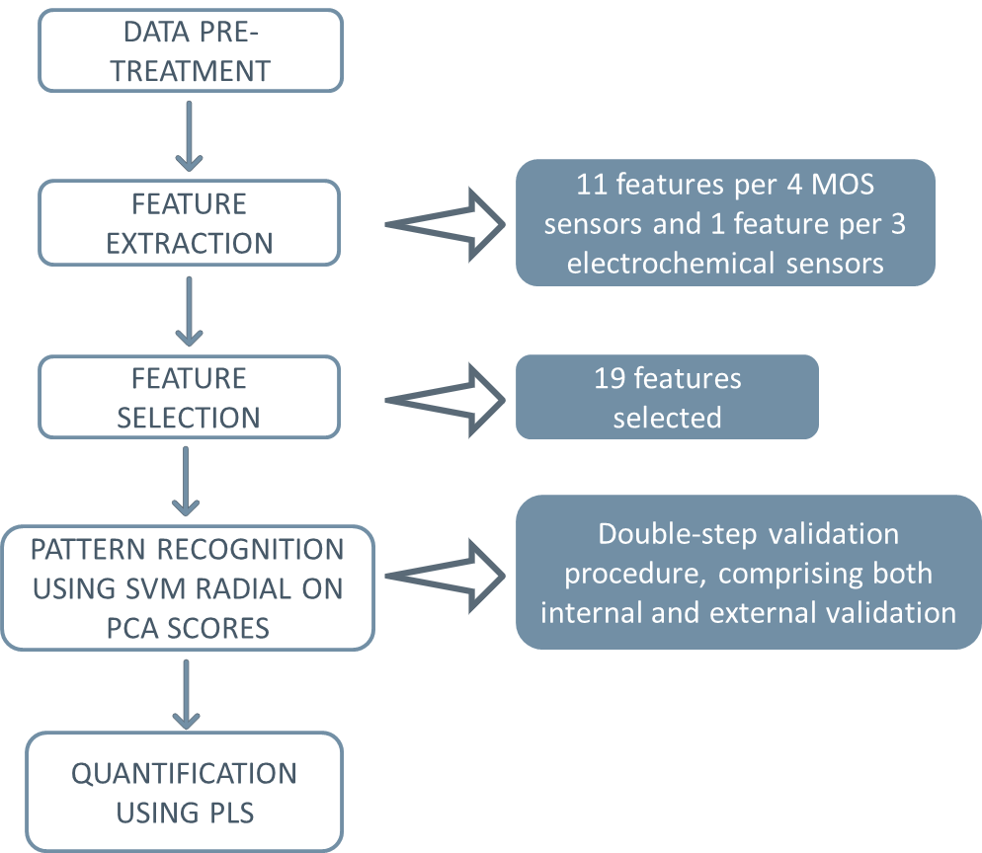

Figure 2: Work flow of data processing procedure developed within this study.

* + 1. Phase 3: Monitoring evaluation and alarm thresholds definition

The last step of the work, which is still on-going, concerns the analysis of monitoring data about the quality and the odour concentration of the ambient air provided by the IOMS aimed at defining variable “alarm” thresholds on the basis of meteorological conditions. Indeed, as reported by Bax et al. 2021, the same odour concentrations at the plant fenceline could result in very different odour conditions at the receptors depending on wind speed, wind direction and atmospheric dispersion capability. To do this, monitoring data acquired by the instruments are combined with the meteorological conditions measured by the weather station and with odour observations made by human “sentinels”.

* 1. Results
     1. Phase 1: Installation site selection

The installation points selected on the basis of the modelling results are located respectively at the western corner of the plant (i.e., F1) and at the eastern one (i.e., F17). Indeed, these points are those mainly downwind the plant and are located along the line of the prevailing wind direction, intended as the direction toward which the wind predominantly blows. The Figure 3 compares two hourly maps of the emissive plume associated to plant odour emissions related to stable and unstable meteorological conditions. The results of this first part of the study highlight how the impact on sensitive receptors is strictly related to atmospheric stability.

|  |  |
| --- | --- |
| a) | b) |

Figure 3: Hourly maps of the emissive plume related to stable (a) and unstable (b) atmospheric conditions.

* + 1. Phase 2: Electronic nose training

**Olfactometric results**

Table 1 summarizes the details of the odour samples used to train the IOMS. It reports the number of samples collected at each emission source, the measured odour concentrations and the odour concentration range of the diluted samples prepared and analysed for the IOMS training.

|  |  |  |  |
| --- | --- | --- | --- |
|  | N° Samples collected | Odour concentration measured by dynamic olfactometry [ouE/m3] | Odour concentration range of diluted samples [ouE/m3] |
| Biogas | 8 | 390’000 - 740’000 - 810’000 - 860’000 - 880’000 - 1’600’000 - 2’100’000 - 2’200’000 | 22 - 860 |
| Biofilter | 9 | 290 - 410 - 460 - 610 - 680 - 1’000 - 1’600 - 2’000 - 2’400 | 18 - 590 |
| Organic waste | 6 | 1’400 - 1’700 - 2’900 - 4’600 - 15’000 - 26’000 | 27 - 560 |
| De-sandblasting | 4 | 910 - 2’700 - 2’900 - 12’000 | 18 - 270 |
| Plastic and Compost | 5 | 810 - 1’600 - 1’800 - 2’200 - 2’400 | 22 - 610 |

Table 1: Details of training samples.

**Preliminary consideration**

First, PCA was applied to the TS to explore the structure of the data and obtain preliminary information about the IOMS discrimination capability between the different classes. Outliers were identified and removed from the TS. As shown in Figure 4, the PCA score plot highlights similar odour fingerprints for the classes ‘Plastic and Compost’, ‘De-sandblasting’ and ‘Organic waste’ samples. Thus, such samples were considered as a single odour class called ‘Sheds’ for tuning the pattern recognition model. This similarity is justified by the fact that the storage building for the organic waste fraction is contiguous with that for plastics and compost, and the de-sandblasting department receives organic waste after initial pre-treatment and addition of water.

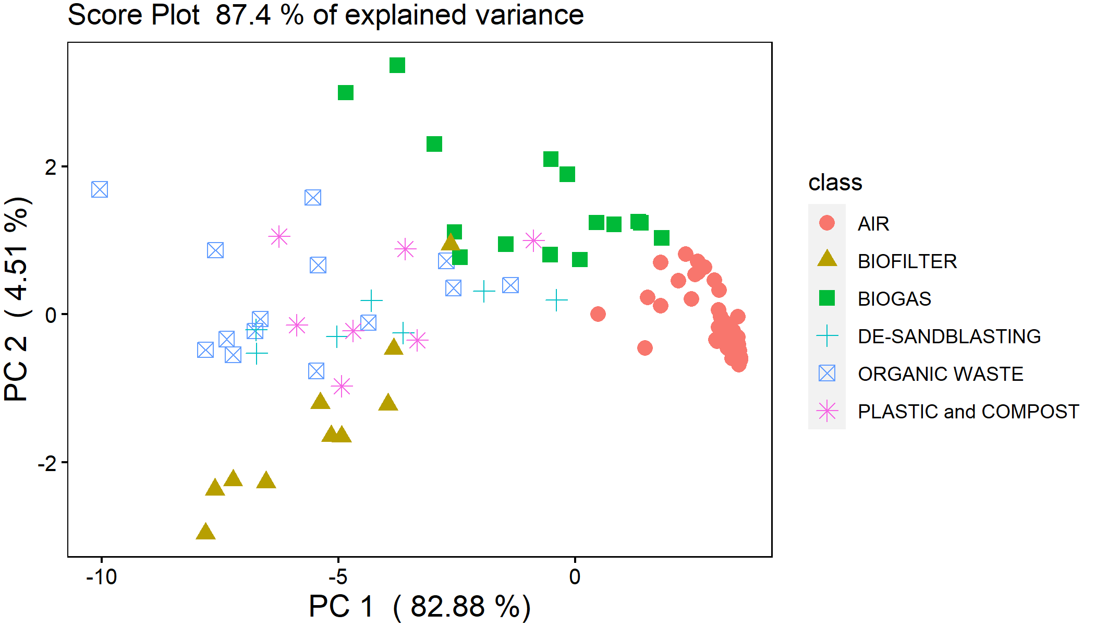

Figure 4: Principal Component Analysis (PCA) score plot relevant to the Training Set.

**Classification model**

PCA scores were used as input parameters for a classification model based on the SVM radial algorithm. 10-Fold CV was used to optimize the pattern recognition model and define its tuning parameters. An accuracy close to 95% was achieved on 10-fold cross validation. Then, the trained IOMS were subjected to specific field tests, involving the analysis of 37 independent samples, to validate their classification capability. Accuracies and recalls relevant to the classification performance are summarized in Table 2.

Because of maintenance activities on the biofilter, samples representative of this odour class could not be included in this first session of field testing. Therefore, the IOMS capability of recognizing such odour fingerprints will be tested in the next future.

|  |  |  |  |  |  |  |
| --- | --- | --- | --- | --- | --- | --- |
|  |  | PREDICTION | | | | CLASSIFICATION PERFORMANCE |
|  |  | Air | Biogas | Sheds | AI | 82% (CI95% 68-94) |
| REFERENCE | Air | 13 | 0 | 0 | Rair | 100% |
| Biogas | 0 | 9 | 4 | RBiogas | 82% |
| Sheds | 0 | 2 | 9 | RSheds | 69% |

Table 2: Confusion Matrix for the evaluation of the e-nose capability odour classification.

**Quantification model**

A PLS regression model for each of the main odour sources of the plant (i.e., “Biogas”, “Biofilter” and “Organic waste”) was developed to estimate the odour concentration at the fenceline. The odour concentration of the training set each odour class ranges from 42 to 560 ouE/m3. The PLS models were validated by cross validation testing. The number of PLS components minimizing the root mean square error (RMSEP) was selected as optimal for tuning the PLS models (Mevik et al., 2007). Figure 5 shows the comparison between the odour concentrations predicted by the PLS models versus the concentration measured by dynamic olfactometry respectively for “Sheds”, “Biogas” and “Biofilter” samples.Plots in Figure 5points out a very good predictive capability for “Sheds” and “Biogas” odour classes (i.e., a RMSEP in line with olfactometry confidence interval was recorded). A higher dispersion was obtained for “Biofilter” samples, most probably associated to the malfunctioning of the abatement system, causing an alteration of the samples composition. Specific tests for assessing the quantification capability by Bland-Altman approach is currently ongoing.

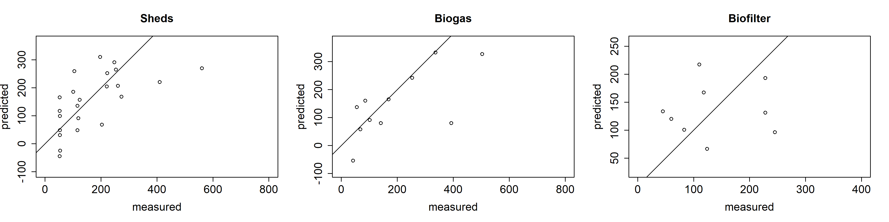

Figure 5: Predicted VS measured odour concentration for classes “Sheds”, “Biogas” and “Biofilter”

* 1. Conclusions

This paper presents the preliminary results achieved within a research project, currently ongoing, aimed at the realisation of an IOMS network for real-time monitoring of the odour concentration at the fenceline of a WTP plant. Preliminary results achieved prove the capability of the IOMS trained for the specific application of detecting, classifying and accurately quantifying odour events at the plant fenceline. Future developments of the project concern the definition of “alarm” thresholds for the odour concentration at the plant fenceline capable to effectively provide information about the occurrence of odour events at sensitive receptors located in the surrounding of the plant. Such thresholds will be implemented by combing IOMS predictions with meteorological data and observations of human ‘sentinels’, aiming at making the IOMS an effective monitoring tool for the management of the plant.

References

Bax, C.; Lotesoriere, B. J.; Capelli, L. Real-time Monitoring of Odour Concentration at a Landfill Fenceline: Performance Verification in the Field. Chemical Engineering Transactions, v. 85, p. 19-24, 2021b.

Bax, C.; Sironi, S.; Capelli, L. Definition and Application of a Protocol for Electronic Nose Field Performance Testing: Example of Odor Monitoring from a Tire Storage Area. Atmosphere, v. 11, n. 4, p. 426, 2020a.

Bax, C; Lotesoriere, B. J.; Capelli, L. Implementation of a “smart” multi-sensor system with variable thresholds for the continuous monitoring of odour emissions from a landfill. Sardinia Symposium 2021.

Cangialosi, F.; Intini, G.; Colucci, D. On line monitoring of odour nuisance at a sanitary landfill for non-hazardous waste. Chemical Engineering Transactions, v. 68, p. 127-132, 2018.

Capelli, L.; Sironi, S.; Del Rosso, R. Electronic Noses for Environmental Monitoring Applications. Sensors, v.14, n. 11, p. 19979-20007, 2014.

Deshmukh, S.; Bandyopadhyay, R.; Bhattacharyya, N.; Pandey, R.A.; Jana, A. Application of electronic nose for industrial odors and gaseous emissions measurement and monitoring – An overview. Talanta, v. 144, p. 329-340, 2015.

Laor, Y.; Parker, D.; Page, T. Measurement, prediction, and monitoring of odors in the environment: A critical review. Reviews in Chemical Engineering, v. 30, p. 139-166, 2014.

Li Voti, M.; Bax, C.; Marzocchi, M.; Sironi, S.; Capelli, L. Testing procedure for performance evaluation of electronic noses for environmental odour monitoring. Chemical Engineering Transactions, v. 68, p. 277-282, 2018.

Mevik, B.H.; Wehrens, R. The pls package: Principal Component and Partial Least Squares Regression in R. Journal of statistical software 2007, 18(2).