|  |  |
| --- | --- |
| cetlogo ***CHEMICAL ENGINEERING TRANSACTIONS***  ***VOL.*** | A publication of  aidiclogo_grande |
| The Italian Association  of Chemical Engineering  Online at www.cetjournal.it |
| Guest Editors:  Copyright © AIDIC Servizi S.r.l. **ISBN** 978-88-95608-xx-x **ISSN** 2283-9216 | |

Challenges in characterization of odour emissions from wood chip storage

Francesca Tagliaferri, Filippo Panzeri, Marzio Invernizzi\*, Selena Sironi

Politecnico di Milano, Department of Chemistry, Materials and Chemical Engineering “Giulio Natta”, Piazza Leonardo da

Vinci 32, 20133 Milano, Italy

marzio.invernizzi@polimi.it

Woody biomass energy is increasingly widespread due to its renewable nature. Before processing, biomass is typically stored in wood heaps located outdoor. A prolonged storage may lead to gaseous emission due to the physicochemical and biological degradations within the biomass. This experimental work focuses on the characterization of odorous emission from wood chips storage, since similar studies are not available in literature. To this purpose, some field measurements have been conducted on wood heaps stored in an Italian thermal power plant to evaluate if they represent a possible significant source of odour and to identify some potential parameters (i.e. storage time, wood matrix, presence of smoke) that may affect the odour release from wood storage. This study reveals the heterogeneity of the heap surface. Infact, while “dry zones” appears not particularly significant in terms of odour emission, “smoking zones” are characterised by odour concentrations values two orders of magnitude higher (and up to 200,000 ouE/m3). The presence of smoking areas seems to be strictly connected to the storage time, since in heaps stored from more than 100 - 150 days smoking regions only occur in localized areas and in less enhanced way. Therefore, storage time appears as a significant parameter which affects the odour emissions. On the contrary, the type of wood matrix seems not a crucial variable: no remarkable differences have been identified among heaps with different wood origin.

* 1. Introduction

Biomass energy represents a valid resource for the environment, and it continues to be the main source of renewable energy in the Europe (European Commission, 2019).

In Italy, there are 2,753 thermal power plants working with biomass, producing 19,563 GWh, that corresponds to 6 % of total Italian energy requirement. Almost half of the energy produced by these thermal plants comes from solid biomass, that can be waste or woody biomass such as vegetal carbon, wood pellet and chips (GSE, 2021). In Europe, solid biomass sector touched 100 MTOE (Million Tonnes of Oil Equivalent) in 2017 and underwent a 64 % increase from 2010 to 2020 (EurObserv’ER, 2018).

In last decades, woody biomass power plants are gaining importance because of two main reasons. Firstly, the theoretical impact on environment is zero because biomass combustion releases a quantity of carbon dioxide equal to that absorbed during lifetime of the tree the biomass comes from. The second reason is the possibility to easily convert some kinds of process or manufacturing plants in biomass power plants. In 2006, most of Italian sugar production plants, due to European Market reform, stopped their activity and were partially converted into biomass thermal plants.

Despite its already wide usage, woody biomass has a potential that has not been exploited yet. For instance, if Italy would have used woody biomass with the same proportion that Europe uses it, ten percent of total Italian energy requirement would be fulfilled, leading to 8,000,000 ton/y of carbon dioxide emission saving (GSE, 2021).

The need for woody fuels storage is in line with the increasing demand for bioenergy (He et al., 2020). However, the prolonged storage of wood heaps prior to utilization may cause some problems. The physicochemical and biological degradations of the biomass during storage lead to emissions that may have impact on the surrounding environment considering that heaps are usually placed outdoor (Alakoski et al., 2016; Eriksson & Gustavsson, 2010).

In the literature, some studies are available regarding gaseous emissions from wood heaps made up of pelletized wood (Alakoski et al., 2016). What is a partially unexplored field is the study of odorous emissions from wood storage, especially regarding wood chips.

There are many different processes, chemical or biological, that can occur during the storage of lignocellulosic biomass. Chemical reactions involve auto-oxidation of fatty acids, leading to aldehydes, ketones, and carboxylic acids (Bulian, 2021) and mainly occur in the first ten days of storage.

Another type of chemical reaction is auto-ignition, meaning combustion of woody biomass without the presence of ignition. This phenomenon is strongly undesired in biomass thermal plants because of safety reasons and the consequent calorific value loss (Whittaker et al., 2014).

Biological processes are organic degradation reactions due to bacterial activity both in the presence or in absence of oxygen (Holighaus et al., 2017).

Aerobic degradations occur in two phases, the first due to mesophilic bacteria, leading to a temperature increase up to 40 °C. The second phase is the thermophilic phase, starting from 40 °C and ending at about 70 °C (Sommer & Møller, 2000), when temperature is high enough to inhibit any bacterial activity. Mesophilic bacteria should end their activity in timespan between 2 and 7 days, whereas the consequent thermophilic phase starts approximately 7 days after the storage up to 2 months (Anerud et al., 2020). Auto-ignition of ligninocellulosic materials is influenced by temperature: specifically, the probability of occurrence becomes considerable when temperature increases (Ferrero et al., 2009).The sequence and timing of chemical and biological processes is complex and, to the best knowledge of the authors, not described in detail in literature. Despite that, it is possible to assert that biological reactions can act as starter and enhancer of chemical reactions, e.g. auto-ignition due to temperature increase (Alakoski et al., 2016).

Given the lack of studies in the scientific literature, this paper focuses on the odorous emission from wood chips storage. To this purpose, a brief experimental campaign has been conducted on wood heaps stored in a real-case thermal power, plant in order to collect some field results regarding odour emission from this kind of source and to investigate some potential parameters (i.e. storage time, wood matrix, condition of the pile) that may affect the odour release from wood storage.

* 1. Materials and methods

The wood heaps storage consists of different wood heaps, with a typical height of 5 m, made up of lignocellulosic chips coming mainly from forest and poplar wood. Heaps can be heterogeneous each other in terms of void fraction, storage time, chip characteristic dimension and humidity content.

Sampling was conducted using a flux chamber system (Figure 1) with a diameter of 0.4 m, into which a known quantity (200 sL/h, i.e. standard litre per hour) of neutral air was blown in. The air flow was flushed through the flux chamber device by means of a mass-flow meter. To promote the mixing of air flow, a portable fan was located within the flux chamber during the sampling. A PTFE tube was used to connect the hood with a Nalophan® bag (12 litres of capacity).

In particular, the use of flux chamber is suggested by the literature for the odour sampling on landfill surfaces (Capelli et al., 2014; Tagliaferri et al., 2020).

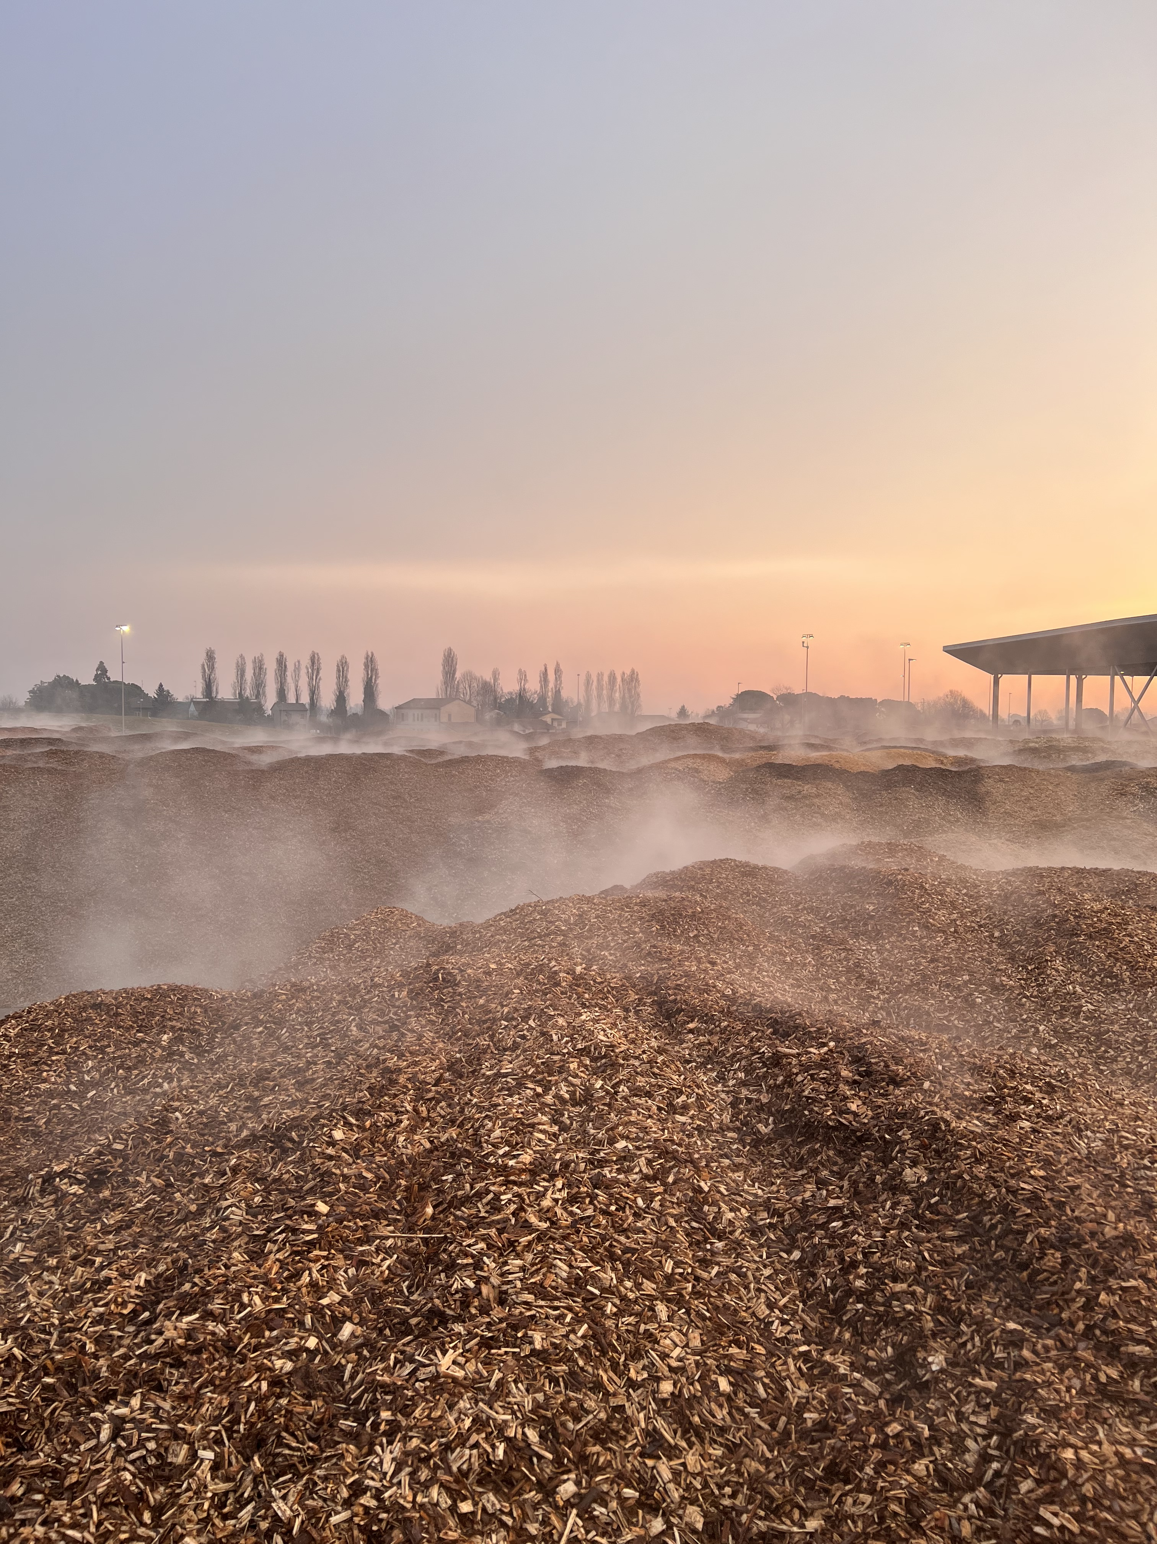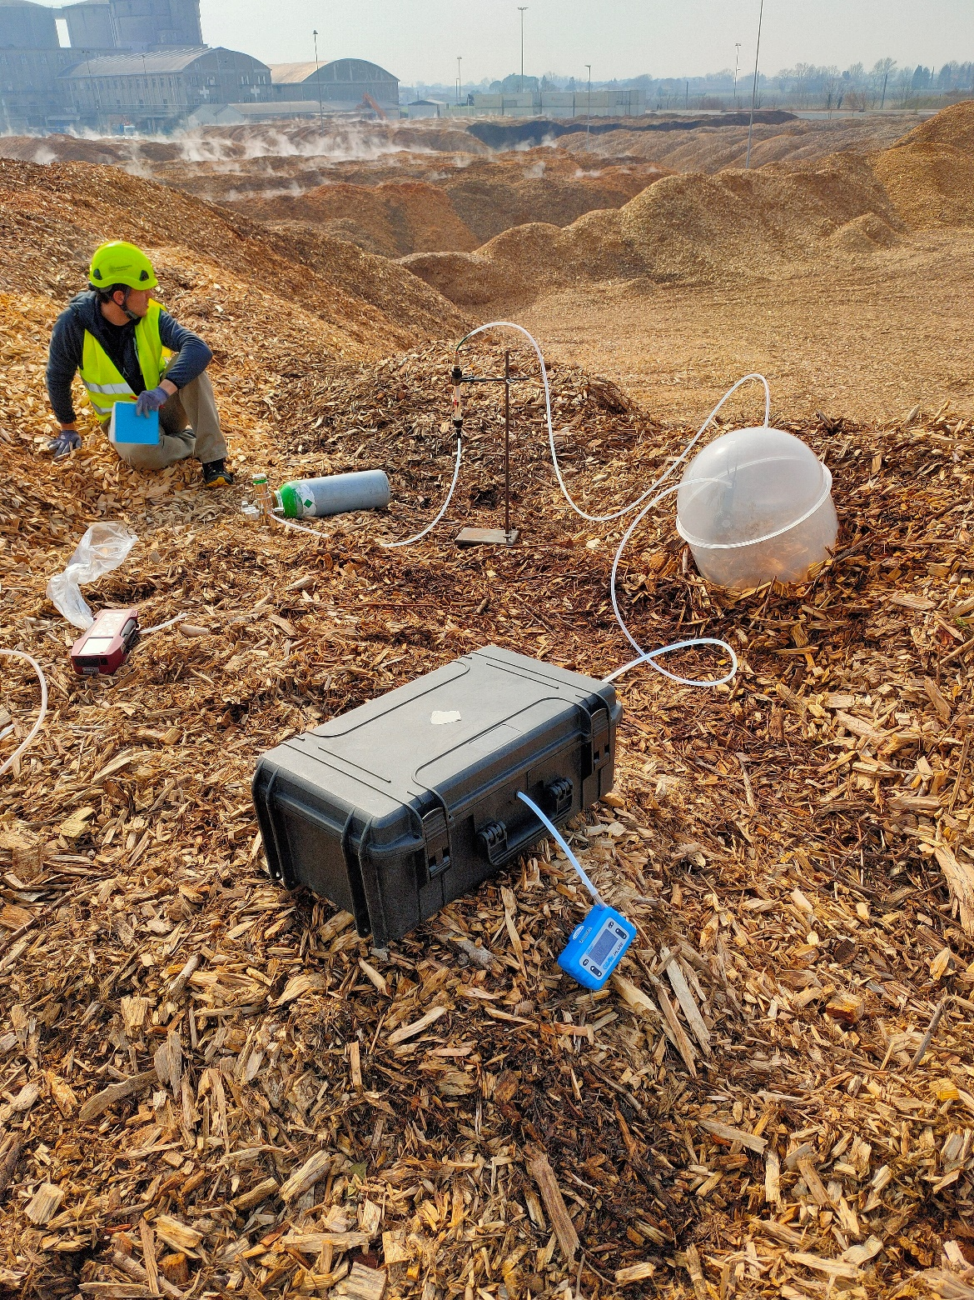

*Figure 1. Experimental set-up adopted for the sampling (left) and detail of a wood chips heap (right)*

The emitting surfaces of wood chips, as well as landfill surfaces, are peculiar sources, since they cannot be classified as active area sources, i.e. with an outward flow greater than 30 m3/h/ m2 (CEN, 2022). However, wood chips are not properly passive area sources, due to the presence of a possible flow, though very low, promoted by biological processes within the heap.

Gaseous samples were then analysed in laboratory within 30 hours by using dynamic olfactometry(CEN, 2022). Moreover, given the heterogeneity of heap surface, it is advisable to collect more than one sample per heap. In this regard, since no technical standard suggests a suitable number of samples, operators made some assessments directly in the field, based on the specific features of the heaps surface, so as to fully characterise the variability of the emitting source (as discussed in the next paragraph) and therefore obtain representative results.

The correct position of the flux chamber is a crucial aspect too. As a matter of fact, the so called “chimney effect” should be considered. As a consequence of this effect, gaseous molecules follow preferential paths through the heaps causing the emission mostly in the highest parts of the heaps (Whittaker et al., 2017). Therefore, the sampling device was located on the top of the wood heap.

Two sampling campaigns have been conducted, the first in October and the second in March. For each sample, odour concentration and specific odour emission rate (SOER) have been computed:

|  |  |
| --- | --- |
|  | (1) |

Where cod is the measured odor concentration (ouE/m3), Qair the air flow rate inside the hood (m3/s) and Abase the base area of the sampling hood (m2).

* 1. Results

The first main result, regarding the heterogeneity of the heap surface, has been collected visually (and then confirmed by numerical results). Indeed, on a same heap it has been possible to recognize different zones. The first can be referred as “smoking zone” due to presence of clearly visible smoke emitted from the chips and typically with a surface that appears wet. The second characterised by the absence of visible smoke with a completely dry surface and therefore classified as “dry zone”. Heaps seem to have a different distribution of smoking areas. Some heaps are composed mainly by smoking regions, whereas in others smoking regions are strictly localized or absent. The main reason for this is probably the different age of the heap, i.e. storage time. Heaps stored from more than 100 - 150 days do not present any smoking region at all, or in some cases they are only in localized areas and in less enhanced way.

The most important outcome is that high odour concentrations seem to be strongly correlated to the presence of smoking regions. As a result, it is supposed that the storage time is a key factor for gaseous emissions and in particular for odour emissions.

On the other hand, the other investigated variable (i.e. type of wood matrix), appears not significant: no remarkable differences have been identified between heaps with different wood origin.

In the following table (Table 1), odour concentration, wood origin, storage time and SOER are reported for each sample collected in the first campaign (October) and in the second campaign (March).

*Table 1. Olfactometric campaigns: odour concentration, wood origin and storage time*

|  |  |  |  |  |  |  |  |  |  |
| --- | --- | --- | --- | --- | --- | --- | --- | --- | --- |
| Campaign | Sample | | Odour concentration  [ouE/m3] | | Wood origin | |  | Storage time  [days] | SOER  [ouE/m2/s] |
| 1  1  1  1  1  1  1  1  1  2  2  2  2  2  2  2  2  2  2  2  2  2 | Heap E – Dry  Heap E – Dry  Heap E – Smoking  Heap G – Dry  Heap D – Dry  Heap D – Smoking  Heap C – Dry  Heap C – Smoking  Heap H – Smoking  Heap B – Dry  Heap B – Smoking  Heap F – Dry  Heap F – Smoking  Heap E – Dry  Heap E – Smoking  Heap E – Smoking  Heap A – Dry  Heap A – Smoking  Heap A – Dry  Heap A – Smoking  Heap D – Smoking  Heap D – Dry | | 300  130  350,000  64  91  1,100  54  1,000  860  38  110  40  540  300  650  37,000  220  13,000  1,800  28,000  9,800  3,100 | | Forest  Forest  Forest  Forest  Forest  Forest  Forest  Forest  Orchard  Forest  Forest  Forest  Forest  Forest  Forest  Forest  Poplar  Poplar  Forest – oxidized\*  Forest – oxidized\*  Forest  Forest | |  | 70  70  70  90  70  70  45  45  50  210  210  150  120  80  30  30  15  15  45  45  7  0 | 0.13  0.06  155  0.03  0.04  0.49  0.02  0.44  0.38  0.02  0.05  0.02  0.24  0.13  0.29  16.4  0.10  5.75  0.80  12.4  4.33  1.37 |
|  | |  | |  | |  |  |  |  |

\* a portion of heap 1 burned down two months before the second campaign

From odour concentration values reported in Table 1, it is possible to notice the remarkable odour concentration difference between smoking and dry regions, even considering the same heap. The same difference is detected by considering SOER values. As mentioned before, it is not the same for wood origin, which seems not to be a relevant parameter for odour concentration.

For what concerns the effect of heaps age, it is possible to notice that on heaps stored by 150 days or more the odour concentration is low. Hence, for better understanding this point, Figure 2 reports the trend of odour concentration in function of the storage time for dry regions (left) and smoking regions (right).

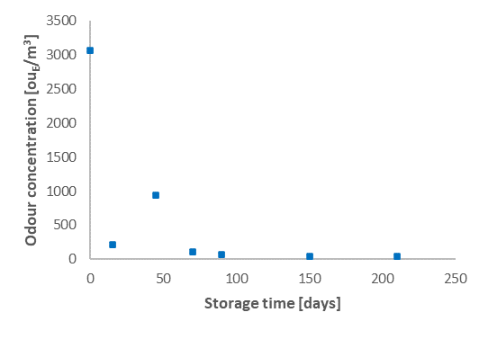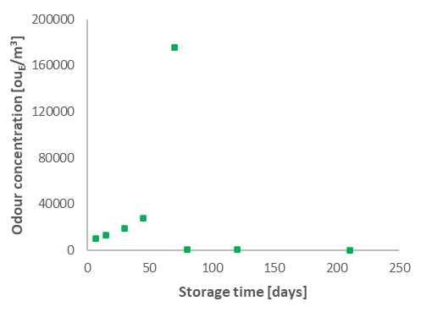

*Figure 2. Odour concentration [ouE/m3] vs storage time [days] for dry regions (left) and smoking regions (right)*

Comparing the two graphs above, it is easy to notice the difference in terms of order of magnitude of odour concentration values detected for dry and smoking regions. The latter have odour concentrations approximately two orders of magnitude greater than dry areas. Indeed, excluding the heaps with storage time above 80/90 days for which, as discussed later, odour concentrations are usually negligible, for dry regions the concentration falls within the range 100 ouE/m3 – 3,000 ouE/m3. Conversely, in case of smoking regions, measured odour concentration increases up to 10,000 ouE/m3– 200,000 ouE/m3.

In addition, it is interesting to observe the trend of the odour concentration in function of time. Dry regions have a maximum when considering the sample obtained from chips immediately taken off the delivery truck (heap D – dry, second campaign). The high odour concentration value observed in the first days is probably the effect of monoterpenes release (Bulian & Fragassa, 2016). Monoterpenes are light and volatile components of wood resin, often responsible for odourous emission, and their release may occur in the first days because of a physical phenomenon related to their volatility that does not involve any chemical process.

On the other hand, for smoking regions no sample with low storage age (i.e. below 7 days) is available because of the characteristic time of chemical and biological processes which appear responsible for the presence of smoke.

Apart from the first few days, both smoking and dry regions odour concentration seems to have a trend not monotone with storage time, showing a maximum between 30 and 75 days.

This timing fits well the studies reported in the literature and discussed in the Introduction. As a matter of fact, this maximum, detected after 45 days for dry regions and 70 days smoking regions, can be explained by considering the timespan (between 7 days and 2 months) in which aerobic thermophilic bacteria end their activity leading temperature to its maximum value of about 70 °C. Consequently, high temperatures promote significant odour emissions. When heaps overcome approximately 80/90 days of storage, odour concentrations are significantly lower (i.e. below 1,000 ouE/m3 for smoking areas and below 100 ouE/m3 for dry areas) consistently with the reduced chemical and biological activity within the heap which, according to the literature, is significantly limited after two months.

* 1. Conclusions

The phenomenology that occurs inside the heaps of wood chips is complex and its understanding is not trivial. This is because a variety of chemical and biological processes occur and the literature available is not comprehensive since it is mainly focused on characterisation of wood pellets.

Wood chip heaps are very often not only heterogeneous from each other, but even a single heap is heterogeneous on its surface. This complexity results in the presence of “smoking region”, due to presence of clearly visible smoke emitted from the chips and typically with a wet surface, and “dry region”, characterised by the absence of visible smoke with a completely dry surface. Experimental data on odour concentration show a significant difference between smoking and dry regions of about two orders of magnitude. Smoking regions also overcome 100,000 ouE/m3, hence it is better to pay particular attention to these regions not only for reasons of odorous emission, but also as possible areas where biological and chemical reactions can occur. This discrepancy, in terms of odour emission, between dry and smoking areas, highlights the importance of collect a sufficient number of samples to properly characterise the emitting surface. In addition, since a single odour concentration is not usually representative of the entire source, it is advisable not to estimate an average Odour Emission Rate (OER) but to distinguish between the different regions. A future perspective would be the development of a method the estimation of the Odour Emission Rate coming from a whole heterogeneous pile. The quantification of OER is the starting point to assess odour impact on citizens. However, the estimation of this parameter requires the definition of the emitting surface which, in case of smoking area, is not trivial to estimate. Anyway, this study represents a preliminary evaluation to highlight the heterogeneity that can be observed over a wood heap in terms of odour concentration. It is important to stress that the individual concentration values may be affected by the specific hood adopted for the sampling but a general trend (i.e. smoking vs dry regions) is clearly observed.

Another interesting outcome concerns the influence of the storage time as a significant parameter which affects the odour emissions. In this regard, odour concentration trend vs time fits quite well the sequence of biological and chemical processes reported in literature. This close relation between reaction sequence and odour emission can be exploited to better understand the detailed phenomenology occurring in the heaps.

Given the complexity and the heterogeneity of this kind of source, it would be good to obtain further experimental results to better characterise the influence of storage time on odour concentration and to eventually identify a possible correlation between these two variables. In addition, future development should be focused on the measurement and the study of other chemical and physical parameters, such as temperature and humidity of the wood heaps or chemical composition of the gaseous emissions. This way, it would be possible to identify the main parameters affecting the odour emission from wood chips.

References

Alakoski, E., Jämsén, M., Agar, D., Tampio, E., & Wihersaari, M. (2016). From wood pellets to wood chips, risks of degradation and emissions from the storage of woody biomass - A short review. *Renewable and Sustainable Energy Reviews*, *54*, 376–383. https://doi.org/10.1016/j.rser.2015.10.021

Anerud, E., Larsson, G., & Eliasson, L. (2020). Storage of wood chips: Effect of chip size on storage properties. *Croatian Journal of Forest Engineering*, *41*(2), 277–286. https://doi.org/10.5552/crojfe.2020.663

Bulian, F. (2021). *Le emissioni di sostanze organiche volatili dal legno e dai suoi derivati*. 1–4.

Bulian, F., & Fragassa, C. (2016). *VOC Emissions From Wood Products and Furniture : a Survey About Legislation , Standards and Measures Referred to Different Materials VOC Emissions From Wood Products and Furniture : a Survey About Legislation , Standards and Measures Referred to Different*. *August*. https://doi.org/10.5937/fmet1604358B

Capelli, L., Sironi, S., Del Rosso, R., & Magnano, E. (2014). Evaluation of landfill surface emissions. *Chemical Engineering Transactions*, *40*(Special Issue), 187–192. https://doi.org/10.3303/CET1440032

CEN. (2022). *Stationary source emissions - Determination of odour concentration by dynamic olfactometry and odour*.

Eriksson, L., & Gustavsson, L. (2010). Comparative analysis of wood chips and bundles - Costs, carbon dioxide emissions, dry-matter losses and allergic reactions. *Biomass and Bioenergy*, *34*(1), 82–90. https://doi.org/10.1016/j.biombioe.2009.10.002

EurObserv’ER. (2018). *Biofuels Barometer*. *2017*(September 2018), 1–14.

European Commission, J. R. C. (2019). *Brief on biomass for energy in the European Union*. Publications Office. https://data.europa.eu/doi/10.2760/546943

Ferrero, F., Lohrer, C., Schmidt, B. M., Noll, M., & Malow, M. (2009). A mathematical model to predict the heating-up of large-scale wood piles. *Journal of Loss Prevention in the Process Industries*, *22*(4), 439–448. https://doi.org/10.1016/j.jlp.2009.02.009

GSE, R. S. (2021). Energia da fonti rinnovabili in italia - Rapporto Statistico. In *GSE*.

He, X., Lau, A. K., & Sokhansanj, S. (2020). Effect of Moisture on Gas Emissions from Stored. *Energies*.

Holighaus, G., Versuchsanstalt, N. F., & Thakeow, P. (2017). Wood production, wood technology, and biotechnological impacts. *Wood Production, Wood Technology, and Biotechnological Impacts*, *July*. https://doi.org/10.17875/gup2007-262

Sommer, S. G., & Møller, H. B. (2000). Emission of greenhouse gases during composting of deep litter from pig production - Effect of straw content. *Journal of Agricultural Science*, *134*(3), 327–335. https://doi.org/10.1017/S0021859699007625

Tagliaferri, F., Invernizzi, M., Sironi, S., & Capelli, L. (2020). Influence of modelling choices on the results of landfill odour dispersion. *Detritus*, *12*, 92–99. https://doi.org/10.31025/2611-4135/2020.13998

Whittaker, C., Yates, N. E., Powers, S. J., Donovan, N., Misselbrook, T., & Shield, I. (2017). Testing the Use of Static Chamber Boxes to Monitor Greenhouse Gas Emissions from Wood Chip Storage Heaps. *Bioenergy Research*, *10*(2), 353–362. https://doi.org/10.1007/s12155-016-9800-9

Whittaker, C., Yates, N., & Shield, I. (2014). *Streamlining the supply chain: greenhouse gas emissions and dry matter losses. Rothamsted Research: Role in Supergen*. *November*.