|  |  |
| --- | --- |
| cetlogo ***CHEMICAL ENGINEERING TRANSACTIONS***  ***VOL. 95, 2022*** | A publication of  aidiclogo_grande |
| The Italian Association  of Chemical Engineering  Online at www.cetjournal.it |
| Guest Editors: Selena Sironi, Laura Capelli  Copyright © 2022, AIDIC Servizi S.r.l. **ISBN** 978-88-95608-94-5; **ISSN** 2283-9216 | |

Applicability of Instrumental Odour Monitoring Systems in the Light of Scientific, Legal, and Commercial Restrictions

Wolfhard Reimringer\*, Caroline Schultealbert, Thorsten Conrad

3S – Sensors, Signal Processing, Systems GmbH, Saar-Lor-Lux-Str. 11, 66115 Saarbrücken, Germany

wolfhard.reimringer@3s-ing.de

Low-cost sensor elements are available for many components that are relevant for outdoor air quality. Sophisticated operation methods for those sensors have been evolving for many years, adding information dimensionality to mixture analysis and, along with physical sensor arrays, enabling data analysis techniques for the use in odour assessment (Reimann et. al., 2014). Looking at the odour threshold of known odorants, however, it becomes obvious that relevant concentrations may lie well below the detection limits of technical solutions. Thus, the promise of a versatile, out-of-the box “electronic nose” cannot be maintained and has led to much dissonance in the past.

Recent developments scrutinize the shortcomings of “electronic noses” and suggest validation methods to demonstrate and validate the relevance and value of the generated information. In CEN/TC 264/WG 41, a black-box approach has been discussed along with a validation procedure based on EN 13725, that makes the complying sensor device an “instrumental odour monitoring system” (IOMS). This general concept leaves the IOMS design in full responsibility of the manufacturer. A thorough validation procedure is therefore necessary, yet the cost of its implementation is likely to overrule the low-cost quality of the sensor.

Similar issues arise from the discussion in CEN/TC 264/WG 42, where quality requirements for specific outdoor air pollutants have been laid out along with test specifications – here, at least, the target gases are known, and a once validated system could be universally applicable. For odour monitoring, this is strongly dependent on individual application situations.

The proposed solution is a modular, scalable approach that can be easily adapted to an individual application, including hardware configuration, data analysis and meta data support (e.g., olfactometry data). From recent and current example projects, various applications are demonstrated, ranging from uncalibrated anomaly detection using multiple environmental parameters to instrumental odour monitoring applications at emission and impact sites, employing olfactometry and grid inspection reference. In result, this shows a possible adoption of economic solutions to real-world problems while maintaining an inherent expandability even within the duration of a project.

* 1. Introduction

In this work, the general motivation of having a reliable way for technical odour measurement is laid out along with current standardisation work and accompanying research. Over the last years, a number of devices have been designed for continuous odour assessment. In the past, many applications of “electronic noses” led to erroneous results (Boeker, 2014) which shall be overcome by better quality assurance in current standardisation and new technical developments. Field tests show that alignment between standardisation discussion and real-world application is necessary to obtain feasible results.

* 1. Standardisation in odour measurement
     1. Olfactory reference methods

The most important standards in the odour measurement field are EN 13725 and EN 16841. In EN 13725, the odour concentration of an odour sample is evaluated with a human panel by searching for a dilution that is just perceptible. This dilution factor corresponds to the odour concentration in odour units per cubic meter (ouE/m³). Because of the necessary bag sampling and dilution steps, only odours ⪆50 ouE/m³ can be practically quantified, which is suitable for emission sources, not for impact sites, and only spot measurements can be made. For emission sources, the results can be used for dispersion calculations relating to the impact area.

EN 16841 describes field inspection methods. In Germany, the grid inspection method (EN16841-1) is used, where a fixed array of locations is pseudo-randomly assessed over a significant period (half year, one year) in order to achieve representative information on odour frequency in the impact area. Despite the effort and statistics, no continuous information can be given, and sparse events can go unnoticed.

* + 1. Legal requirements in Germany

As the human sensory methods mentioned above have been in use for several decades, even before the current European standards evolved, they are explicitly and exclusively referenced in Annex 7 “Detection and assessment of odour immissions” of the revised TA Luft (2021). The TA Luft is an “administrative rule” for Germany and as such legally binding for all authorities and approval processes in the field of environmental odours. It is further used as a guideline for officials in Austria and has model character beyond these countries. The exclusive usage of human sensory methods effects that for all legally relevant situations, sensor systems may not be applied as a substitute, regardless of their actual performance. Thus, current standardisation work (cf. section 3.2) must set the foundation for future addition of technical methods.

* 1. IOMS calibration for training and validation
     1. General methods

In general, calibration refers to a comparison between a given measurand and the output of a measurement system. Practical applications are adjustment (e.g., factory calibration or re-calibration) or validation purposes (determination of correctness). With gas sensor systems, this is more complicated than with mechanical measurement equipment: Initial variation and deterioration of sensor elements are inevitable and reaction mechanisms in complex gas matrices are challenging to sort into target sensitivity and suppression of interferents.  
Depending on the sensor setup, different chains of measurement ensue which have to be integrally assessed (Reimringer et. al., 2014). This generally results in a multi-stage calibration process where adjustments are made on some elements and correction parameters are calculated for others. Reference values for electrical parameters can be easily provided via specialised equipment, single target gases can be applied via calibrated mixtures in gas bottles or synthesized. Preparation of realistic background matrices is more complicated as sensors (especially broadband sensors used in odour measurement) are susceptible to many non-odorous components occurring in real application contexts. Even more demanding is the application of target compositions which can neither be easily synthesized in the lab nor transported without loss or alteration, which is always the case for real-world odours. For those, in-situ calibration becomes a necessity, moving the challenge from preparation to plannability and reference measurement.

In practice, in-situ work should be only carried out with systems that have already been pre-qualified by initial setup, test, and factory calibration, e.g., with a synthetic proxy mixture to ensure full functionality and basic comparability. This also seems a sensible predisposition for the application of complex learning algorithms from the artificial intelligence spectrum which typically cannot be thoroughly validated by classical approaches.

* + 1. CEN work on IOMS validation

One important result of former standardisation group CEN/TC 264/WG 41 is the establishment of a general idea on what a sensor system should be like to provide odour relevant measurements. Hence, the term “IOMS” or “Instrumental Odour Monitoring System” was coined to differentiate such systems from unspecific “electronic noses” which raise unrealistic expectations. The proposed standard suggests to formally define a validatable manufacturer’s claim and outlines how this is done for absence/presence, classification, and quantification of a specific set of odours under study.

Specifically, source samples are taken and diluted in the field with ambient air to simulate IOMS reactions instead of waiting for natural occurrences of the odour under study. A minimum number of 9 pairs of samples should be prepared and applied to the IOMS, each having one diluted source sample at relevant odour concentrations and one background sample without target odours. The samples have to be representative of source and background dynamics. For validation, the result is compared with the manufacturer’s performance claim. The standard shall explicitly not prescribe how the IOMS is enabled (trained) for the application, this is the sole responsibility of the respective manufacturer.

The work item has been recently resumed and the newly formed WG41 is planning to continue on the results and finalize the work from the last period.

* + 1. Application of CEN validation method for training

In order to align the specific training process to the demands of the proposed validation method, a minimum training set should follow the same steps. However, for quantification purposes, a single source – background pair cannot be sufficient. Instead, a dilution series is made following the concept of Fig. 1: Firstly, a source sample is taken according to the procedure in EN 13725 and the odour concentration is determined. In parallel, background air is sampled in the area of the IOMS installation and checked for absence of the odour under study by direct evaluation. The background sample is separated into *n* different sample bags and a defined amount of the source sample is injected in *n-1* of those so that the resulting dilution has a known, pre-defined odour concentration. The presence of the odour under study is checked by direct evaluation. The *n*th bag contains only the background and is used as a zero reference. All *n* sample bags are then applied to the IOMS being calibrated, so that a series of annotated measurements is generated for training. In order to obtain a sufficient data set, the whole process has to be repeated multiple times, ideally for a representative selection of source and background situations.

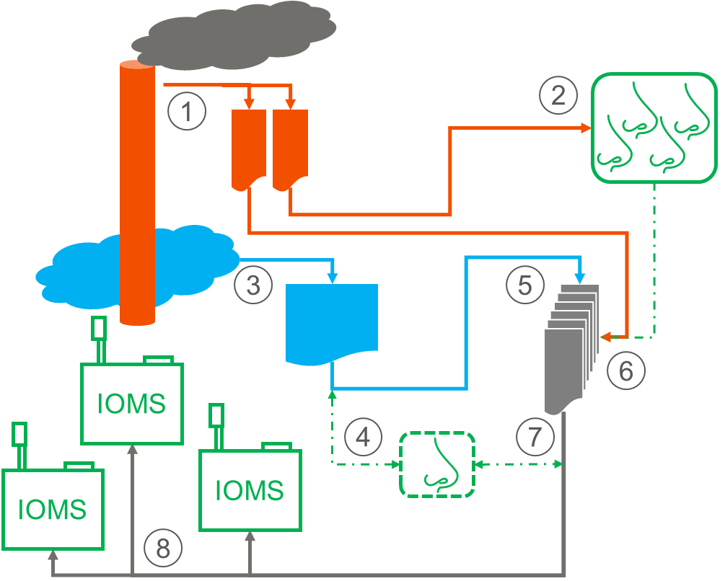

Figure 1: Sample series preparation process. 1 - source sampling, 2 – dynamic olfactometry, 3 – background sampling, 4 – direct evaluation, 5 – separation, 6 – injection, 7 – direct evaluation, 8 – application

* 1. Results from lab and field experiments

The sensor systems used in lab and field tests were built around a set of metal oxide semiconductor sensors with temperature cyclic operation and corresponding evaluation algorithms. Pumped sampling and diffusion access devices have been tested according to the variants in sections 5.2 and 5.3. Locations varied between source site and residential neighbourhood.

* + 1. Viability tests with real samples in the lab

Working with real samples from a wastewater plant, a prototype system has been assessed in the lab. A highly dynamic dilution unit was used to prepare defined concentrations online, compatible to dynamic olfactometry. It has been found that the sensors’ sensitivity was sufficient to detect and quantify odours from 5 ouE/m³ for various sources. Source attribution was possible from 50 ouE/m³.

* + 1. Odour training using extended field inspection

Following lab qualification from the section above, a small network of sensor systems was deployed on the wastewater plant. For training and validation, information from a EN 16841-1 was used. However, at the sensor sites, additional data were recorded: For each 10 s interval, the odour intensity was registered for a semi-quantitative dataset. For this, a good synchronisation between human and sensors perception is crucial; this has been achieved by integration of an optical synchronisation signal on the sensor system.

The evaluation algorithm was trained to classify the current situation in one of three intensity groups: Neutral, significant, and strong. After initial training in summer, the model could be improved by including reference data from late fall and winter. Validation data was randomly separated from the reference data set, training data was optimized using wind data. Fig. 2 shows the resulting confusion matrix for the classifier.

* + 1. Odour training using diluted source samples

The concept from section 3.3 was first evaluated on a wastewater plant and in an urban impact area. Three training campaigns were organised to provide all IOMS (4 +8) with 8 dilution series per campaign (0, 5, 10, 25, 50, 100, 200 ouE/m³). However, systematic problems arose, especially a strong offset between the usual ambient air and the background of the prepared odour samples (cf. Fig. 3), rendering a specific assessment hardly possible.

As the application method and the IOMS devices could be ruled out as a possible cause for this offset, something probably went wrong during sample preparation and/or background air sampling. In a follow-up project, the same concept has been applied. Here, the offset problem did not occur (cf. Fig. 4). Thus, the general principle seems to work out and some hidden challenges will need to be addressed in the sample preparation process. A live monitoring of the background sampling and separation with sensors could be helpful to detect anomalies aside from odours before injecting the costly source sample.

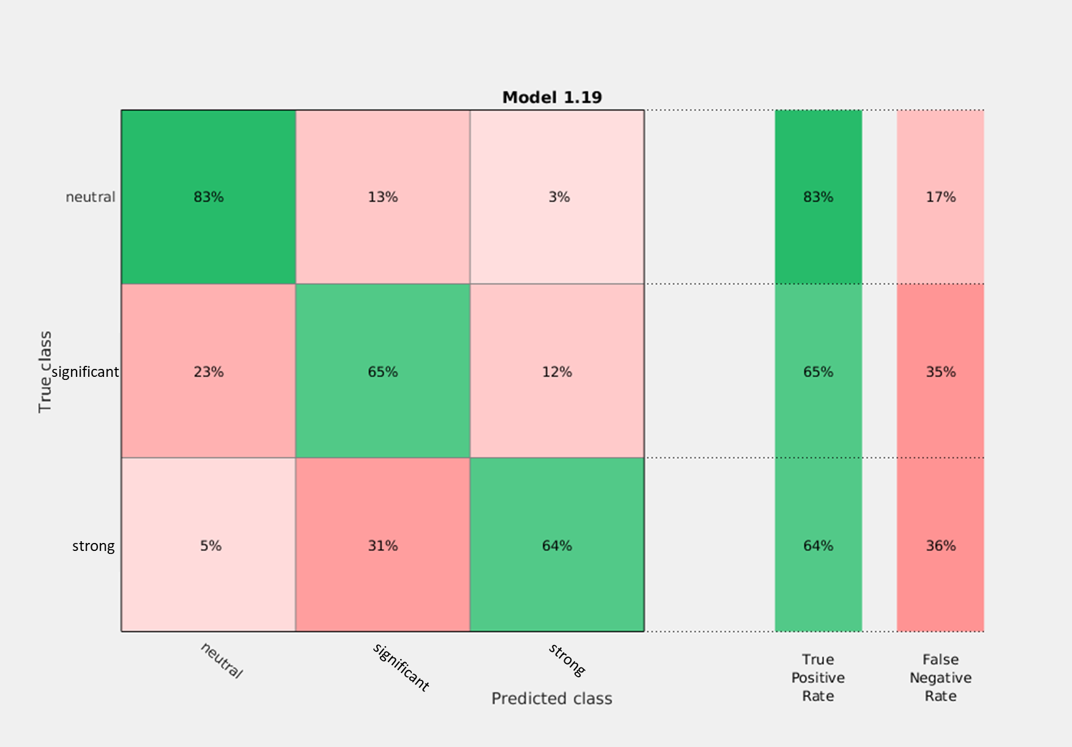

Figure 2: Confusion matrix for odour classification according to paragraph 4.2, within 10 s intervals the odour intensity was classified as neutral, significant, and strong by human reference.

* 1. Commercial aspects and realisation options
     1. Cost for human sensory information

A campaign as mentioned in section 4.3 is only feasible if there is a nearby olfactometry lab for timely assessment of the samples. Employing a mobile olfactometry lab with full staff is very expensive; for all three campaigns in the said project, costs amounted beyond 75.000 €. Extended grid inspection (cf. section 4.2) can be applied in the course of an existing inspection campaign to dampen costs (around 50.000 € per year) or organisational methods have to be found to involve available staff from the respective plant (e.g., interactive odour reports through a digital app).

* + 1. Full size IOMS applications

A fully featured sensor system as shown in Fig. 5 fulfils all requirements for field measurements at the source or in the impact area, along with integrated field calibration options and modular expandability. The pumped sampling path enables sample air pre-treatment methods like condensation, dehumidification or dust filtering which are necessary for measurements at emissions sources, process atmospheres and other problematic contexts. Such, the technology can be adapted and optimized, justifying significant organisational and financial effort for specific training and reference measurements.

* + 1. Sensor nodes for odour monitoring networks

Depending on the application, an anomaly screening of the gas phase can be sufficient, e.g., when an unspecific event is considered for disposition of specialised measuring vans or maintenance personnel. In such applications, it is favourable to deploy a close-meshed network of cost-efficient measurement nodes for high spatial resolution. Cost reduction can be achieved by omitting complex fluidics and pumped sampling stream (cf. Fig. 5, right).

* + 1. Automated sample collection

In the case of sparse events or unclear source attribution, automated sample collection can be useful for clarification: Odour sampling bags, GC screening bags or adsorption tubes can be sampled on demand, triggered either manually or by the sensor system. The trapped sample can then be lab analysed to derive further information.

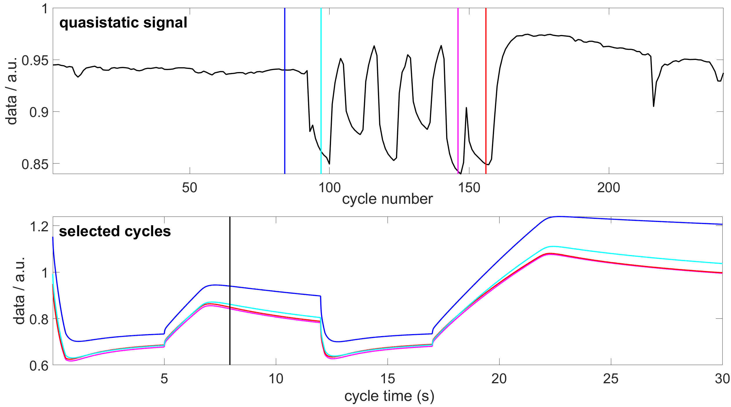

Figure 3: Training data set with strong offset between bagged background (cyan, pink, and red) and ambient (blue).

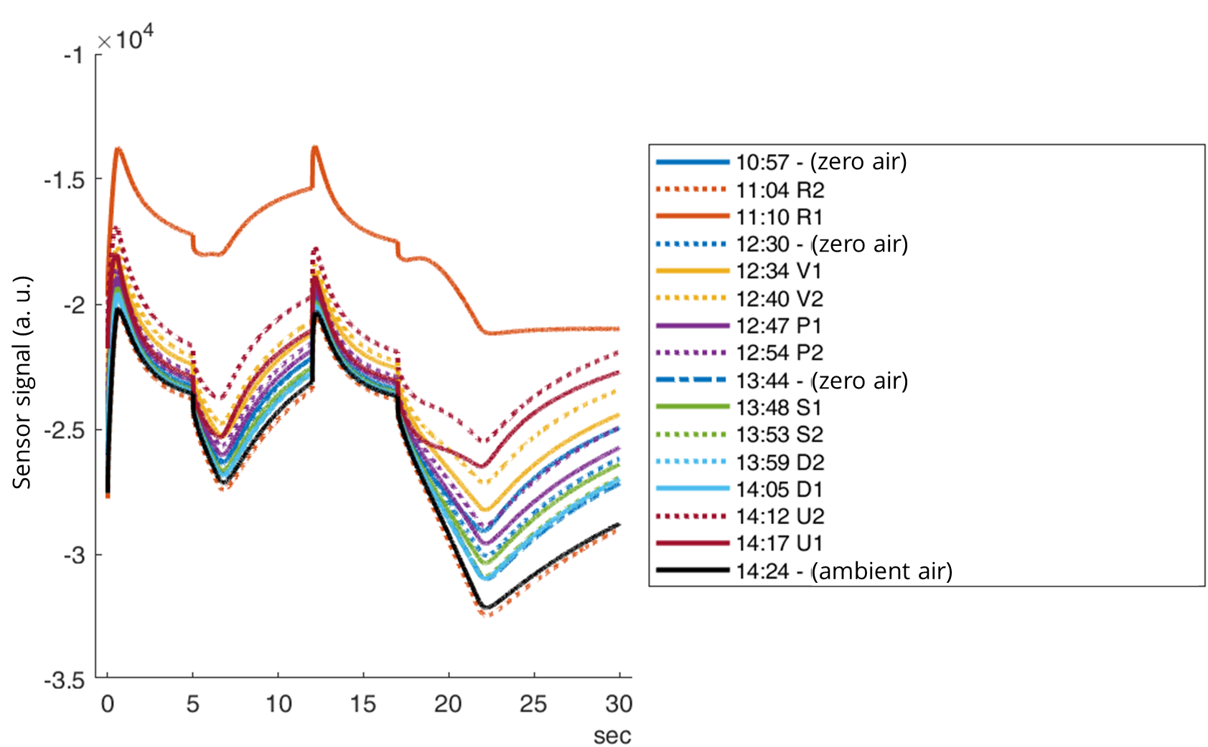 Ein Bild, das Haushaltsgerät enthält.

Figure 4: Training data set without zero offset effect (left). Sensor system during sample application (right).

* + 1. Data aggregation and mixed installations

In order to assess the obtained measurements and derive relevant information, aggregation of measurements and auxiliary data (plant operation, weather) is important. The results can be graphically represented via a user interface, fed into existing control room software or used to directly influence operation parameters in a control loop if the overall infrastructure allows for real time connectivity and processing.

For distributed installations with emission and impact site measurements, a combined deployment of IOMS and unspecific nodes can give differentiated insight into complex situations. Another possibility is the use of mobile or semi-stationary sensor systems (cf. Fig. 5) to allow for monitoring of temporary situations (maintenance work) or feasibility studies in preparation of fixed installations.

Ein Bild, das Auto, draußen, LKW, Anhänger enthält.
Ein Bild, das drinnen enthält.
Ein Bild, das Licht enthält.

Figure 5: Mobile sensor devices mounted on a vehicle (left) and semi-stationary device (middle) for explorative use in temporary or establishing projects. Lightweight network node with diffusion access (right).

* 1. Conclusions
     1. Standardisation

Current standardisation efforts are important to align methods and technologies in order to achieve reliable data in real-world applications. While there is a set of established methods to objectify human perception, these are limited to statistical evaluation of spot measurements. Continuous measurements or sparse events cannot be detected by these methods, which gives a raison d’être to technical means of odour assessment. Regarding systematic shortcomings of sensor systems, performance criteria have to be defined and made accessible for validation, so that sensor systems will be allowed in official, i.e., legally relevant measurements.

* + 1. Commercialisation

While standardization helps with applicability of sensor systems for relevant problem contexts, the quality criteria and processes have to be laid out to be organisationally and economically feasible for all stakeholders involved. This means primarily that the expenses for reference methods applied for validation purposes must not drive the overall project costs immeasurably. Also, lead times resulting from prior validation must not render timely commissioning of new installations impossible. A possible approach can be a gradual adaptation to the target application, starting with a generic ex-works training for basic information and anomaly detection while fitting an application specific evaluation algorithm in-situ. This results in increasing sophistication without extensive periods lacking useful output data.

Acknowledgments

This work was supported by the German Federal Ministry of Education and Research (BMBF) under FKZ 01IS17087 and by the German Federal Ministry of Economy and Energy (BMWi) under FKZ ZF 4323003WM8.

References

Boeker, P., 2014. On ‘Electronic Nose’ methodology. Sensors and Actuators B 204, 2-17, ISSN 0925-4005. doi: 10.1016/j.snb.2014.07.087

Reimann, P., Schütze, A., 2014, Sensor Arrays, Virtual Multisensors, Data Fusion, and Gas Sensor Data Evaluation. In: Kohl, C.-D., T. Wagner (eds.): Gas Sensing Fundamentals, Springer Series on Chemical Sensors and Biosensors, Volume 15, 2014.

Reimringer, W., Howes, J., Conrad, T., 2016 „Implementation of complex gas sensor systems: Ideas for a structural model,” Sixth Scientific Meeting EuNetAir, Academy of Sciences, Prague, Czech Republic, October 2016. doi: 10.5162/6EuNetAir2016/09.

CEN/TC 264/WG 41 – Electronic sensors for odorant monitoring

CEN/TC 264 WG 42 – Gas sensors. First output: CEN/TS 17660-1:2021. Air quality – Performance evaluation of air quality sensor systems – Part 1: Gaseous pollutants in ambient air

EN 13725:2003. Air quality – Determination of odour concentration by dynamic olfactometry

EN 16841:2016. Ambient air - Determination of odour in ambient air by using field inspection - Part 1: Grid method

TA Luft, 2021. First General Administrative Regulation Pertaining the Federal Immission Control Act (Technical Instructions on Air Quality Control – TA Luft)