|  |  |
| --- | --- |
| cetlogo ***CHEMICAL ENGINEERING TRANSACTIONS***  ***VOL.*** | A publication of  aidiclogo_grande |
| The Italian Association  of Chemical Engineering  Online at www.cetjournal.it |
| Guest Editors:  Copyright © AIDIC Servizi S.r.l. **ISBN** 978-88-95608-xx-x **ISSN** 2283-9216 | |

Estimation of the Odour Emission Capacity of High-load Wastewater

Giacomo Scolieria, Marzio Invernizzia\*; Selena Sironia

a Politecnico di Milano, Department of Chemistry, Materials and Chemical Engineering “Giulio Natta”, Piazza Leonardo da Vinci 32, 20133 Milano, Italy

marzio.invernizzi@polimi.it

The Odour Emission Capacity (OEC) is an experimental parameter that quantifies the odour potential of a liquid, in terms of ouE/m3liquid, based on the stripping of odorants contained in a known amount volume of liquid. The method was implemented for the first time in 1998 by Frechen and Köster and standardized in 2015 in the German technical standard VDI Guideline 3885/1. In particular, the sampling steps of gas phase for the dynamic olfatctometry analysis were fixed at 2, 6, 16 and 32 minutes.

This work aims to propose a modified methodology to evaluate this parameter in wastewater which come from the sewer systems and industrial wastewater treatment plants (WWTP) characterized by high odour load (e.g. oil-refinery desalter water, oil-well water).

The implementation of a system of dilution for the sampled gas, has appeared to be an important aspect to take into account in case of high odorous load, because it allows to perform the analysis also with smaller liquid volume (i.e. 1 L), a necessary condition for lab logistics and safety considerations as the safeguard of the involved operator’s health (e.g. panel members, lab analysts). In order to improve the accuracy of the result and optimize the methodology, a different approach was studied through the increase in the number of odour concentration measurements and the modification of the sampling times. Results show that increasing the time of analysis from 32 min to 2 days, the trend of the time-varying integral of OEC reaches a *quasi*-stationarity respect the same curve associated to the OEC estimated with the standard methodology.

* 1. Introduction

In the research field of environmental odours a parameter that is widely used for the characterization of the odours emitted by civil and industrial wastewater treatment plant is the Odour Emission Capacity (Frechen, 2009; Giuliani et al., 2015; Pandan et al., 2017). This parameter assesses the odour potential of a liquid. In fact, the method defines OEC as the total amount of odorants, which can be stripped from 1 m3 of the liquid under given standardized conditions (Frechen and Köster, 1998; VDI, 2017). The OEC is expressed in ouE/m3liquid and is measured on a known amount volume of wastewater, which owes its olfactory characteristics to the volatile organic and inorganic compounds dissolved in it (Frechen, 2009, 2012; Frechen and Köster, 1998).

The elaboration of different olfactometric analysis is the keystone for the experimental assessment as Odour Emission Capacity and Hydrocarbon Odour Emission Capacity (HCOEC). For example, the first one requires the evaluation of 4 odour concentrations, measured at 4 different time steps (Frechen, 2012). Instead, the HCOEC is a similar parameter that represents the odour emission potential of a hydrocarbon mixture (e.g. crude oil, gasoline or diesel) expressed in ouE/kghydrocarbon. The estimation of HCOEC needs several odour concentration measurements over a period. Its application is suitable to assess the odour emissions of external floating roof tanks (Invernizzi et al., 2018; Invernizzi and Sironi, 2021). Back to the OEC analysis, its application is mainly suitable for domestic wastewater, where the reduction of odour concentration up to values of the order of 102÷103 ouE/m3 is quite easy in the operating conditions of the analysis. Instead, in the case of wastewater produced by refineries or petrochemical plants, the odorous loads are strongly higher, due to the content of hydrocarbons and sulphurous compounds. The use of the standardized approach, based on the sampling of only 4 bags and a total bubbling time of 32 minutes, can lead to the risk of not achieving a significant decrease of the odour concentration in the period of analysis, leading to the measurement of 4 odour concentration which are comparable among each other. Therefore, the calculated OEC value may be significantly underestimated due to the leak of information related to the low number of odour concentration measurements. Furthermore, from the operating point of view, the guideline establishes that it is necessary to work with a large volume of liquid (30 L) and in the case of refinery and petrochemical’s effluents it might provoke different safety and transportation permits problems, related to the health of lab operators or to the possible explosions that can be generate, due to the different compounds present within the wastewater.

In view of this, in case of particularly high-load wastewaters, it has become necessary to review the operating conditions of the experimental procedure and to readapt the sampling times or to add the number of analysed gas samples. The aim of this experimental work is to compare the standard OEC evaluation of a wastewater coming from a refinery with a modified approach, implemented in order to improve the accuracy of the final result by extending the time of analysis and increasing the quantity of withdrawal of the gas phase for the odour concentration analysis.

* 1. Materials and Methods
     1. Experimental set-up and operative conditions

A specific aliquot of liquid (i.e. 1 L), taken from the outlet of API separators of a refinery WWTP, is used for the experiment. The analysed volume is significative lower than the required volume of VDI, 2017 for the OEC analysis (i.e. 30 L): this is due to lab logistics, safety considerations (e.g. potential H2S content) and the sufficiently high odour concentrations (Scolieri et al., 2021). In particular, some studies highlight the presence of potential dangerous volatile organic compounds (e.g. aromatics) inside wastewater of refineries and petrochemical plant (Wei et al., 2014; Zhang et al., 2018).

The laboratory instrumentation used for experimental tests is listed below:

* glass bubbler, hermetically sealed with a Teflon® gasket, with 2 sealed ports. It is used a glass bubbler dip tube model with porous septum. The volume of bubbler is 1.5 L to respect the proportion between the liquid sample and the headspace volume recommended by the guideline;
* mass flow controller for the neutral gas, with a suitable work range to perform the analysis;
* Teflon® tubes with a 6 mm diameter.

Nitrogen is the chosen stripping gas fluxed in the experimental system because it should be avoided to operate in conditions of explosive atmospheres. Its flow is checked and kept constant at fixed value of 100 L/h by the mass flow controller (MFC). This rate is function of the degree of turbulence, which must be including between 90 h-1 and 110 h-1 (Frechen, 2012).

Downstream of the flow controller, the glass bubbler that contains the liquid sample is positioned. It is fitted with two sealed ports, one dedicated for the gas inlet and the other one for the outlet gas. Through the first port enters a Teflon® tube, which channels nitrogen to the porous septum positioned on the bottom of the bubbler. In the other port, there is a second Teflon® tube, where it is possible to sample the gas phase enriched of the stripped compounds, using a Nalophan™ bag. During the gas sampling it is important to take in account that the odour concentration could be too high for the olfactometer. In order to reduce the high odorous load at the outlet, during the sampling a dynamic dilution of gas sample is done with the auxilium an additive flow of nitrogen, connected to the outlet gas through a T-connection. This application allows to reduce the volume of the analysed liquid sample, from 30 L to 1 L as previously mentioned. Moreover, this arrangement ensures to respect the filling time fixed by the standard (i.e. < 30 s) using a suitable flux rate, that in this case is equal to 700 L/h. For this reason, each measured odour concentrations must be multiplied for the dilution factor (i.e. 8). After the start of bubbling, the 4 “standard” off-gas samples are withdrawn at the standard time intervals, i.e. 2 min, 6 min, 16 min and 32 min, and other 5 at subsequent times, i.e. 60 min (1 h), 240 min (4 h), 480 min (8 h), 1440 min (24 h) and 2880 min (48 h). The odour concentration of each gas sample is then measured according to dynamic olfactometry standard EN 13725:2022 (CEN, 2022). Figure 1 illustrates a sketch of the flows of the experimental apparatus.

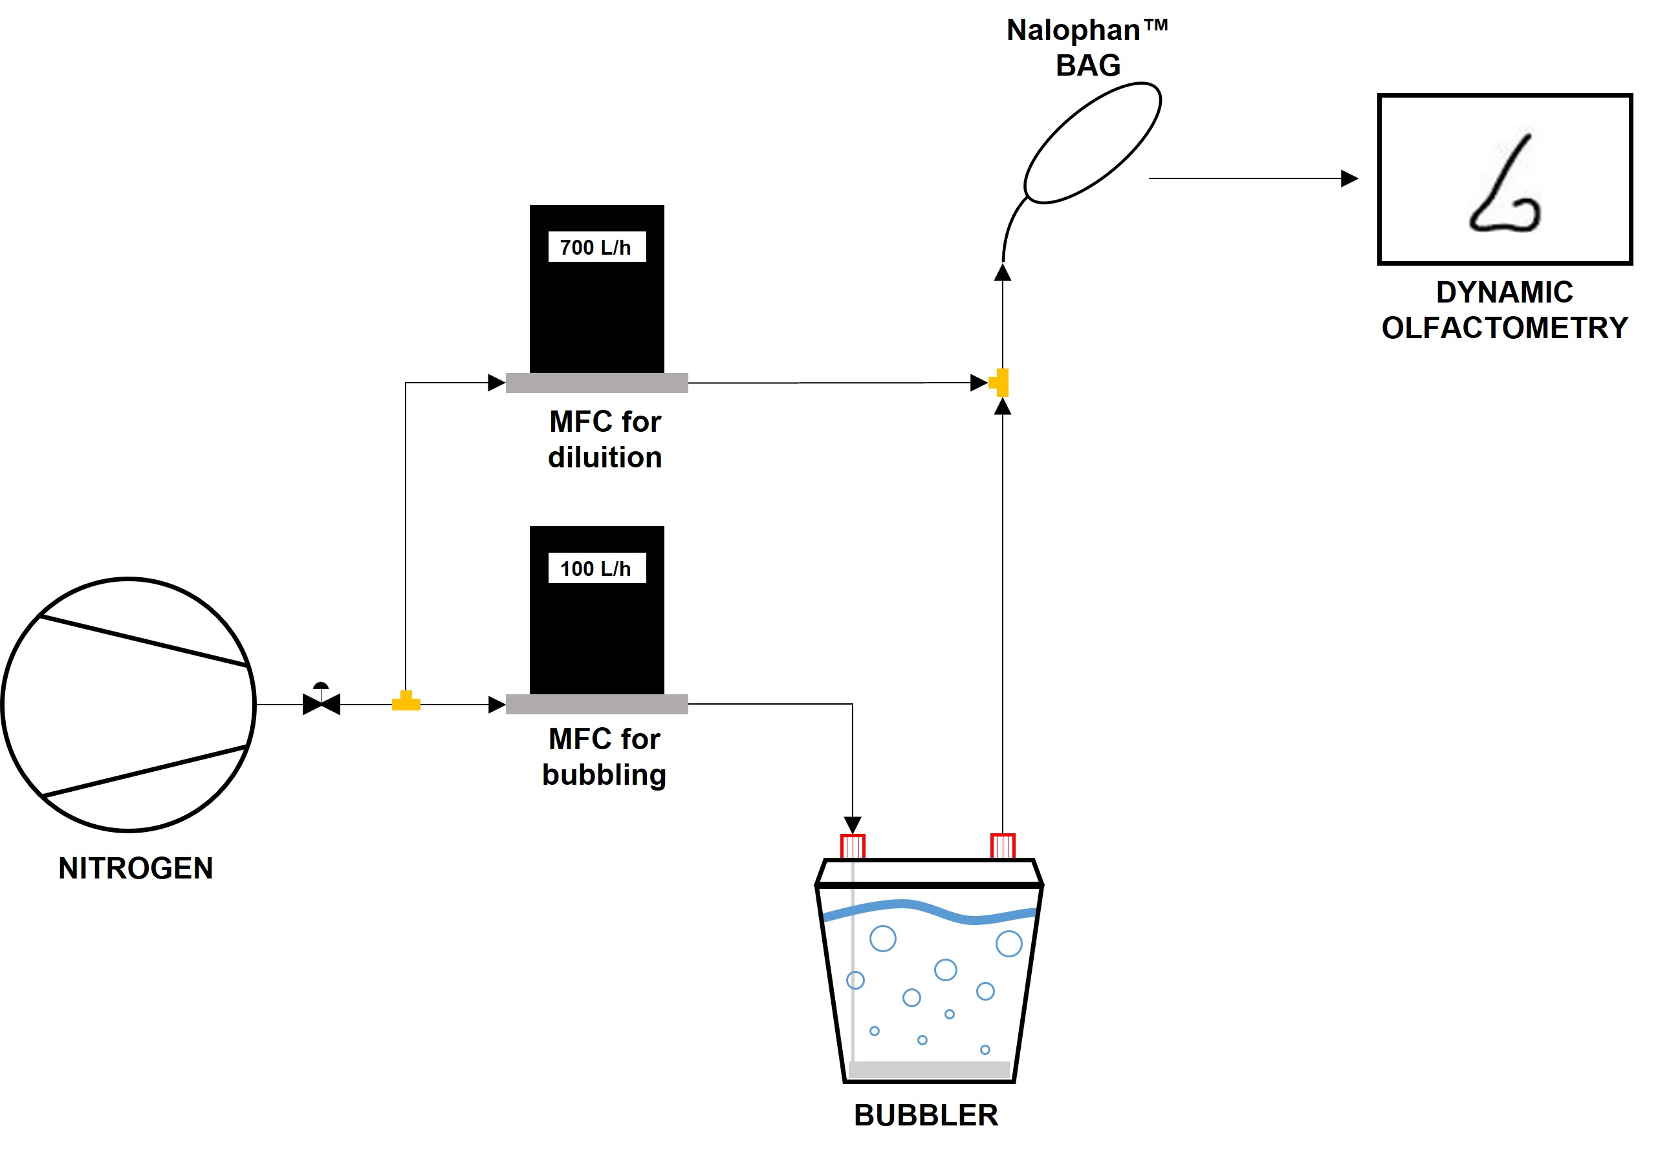

Figure 1. Diagram illustrating the flows of the experimental apparatus

* + 1. Standard OEC measurement

The utilized approach for evaluating the OEC depends on the odour concentration (Cod) of the gas phase related to the evaporated wastewater (Frechen et al., 1998). The estimation of OEC value relating to the examined liquid is based on Eq(1):

|  |  |
| --- | --- |
| $$OEC=\int{\frac{\left(C_{od}\left(t\right)-C_{100}\right)}{V_{liquid}}}∙{dV}_{N_{2}}(t)$$ | (1) |

where Cod(t) is the measured odour concentration at the instant t multiplied for 8 (i.e. the dilution factor), C100 is the reference value of odour concentration lower limit (i.e. 100 ouE/m3), Vliquid is the volume of analysed liquid and dVN2(t) is the infinitesimal volume of fluxed nitrogen at the instant t. Figure 2 shows the measured odour concentrations (yellow squares) of the gas samples taken during the course of the analysis at the time intervals fixed by guideline. The OEC value is the area between the measurement curve and the lower limit of integration, obtained through trapezoid rule, i.e. adding A1, A2, A3 and A4. During the present test the odour concentration never do not fall below C100, consequently, following the standard, it must be added a supplementary area (A5), which is calculated through linear extrapolation in linear scale. Hence, performing the OEC method (Frechen, 2012), the resulting OEC value is equal to 9.5·105 ouE/m3liquid.

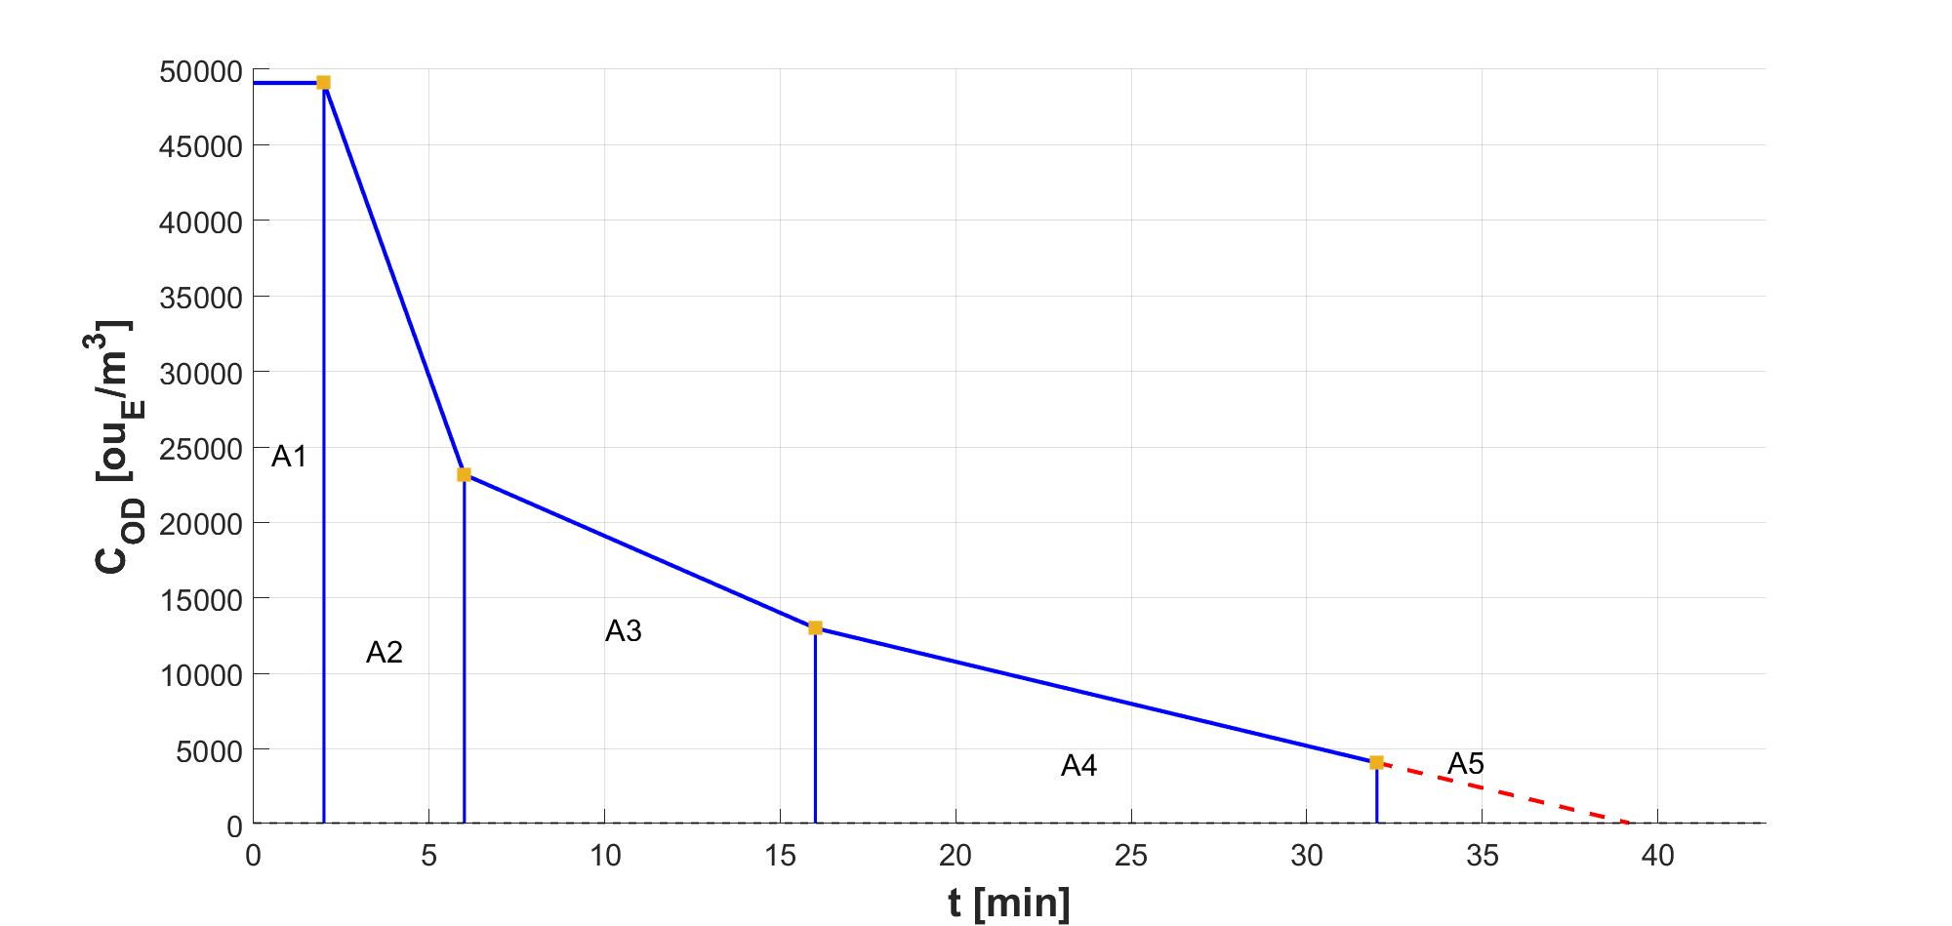

Figure 2. Odour concentration trend during OEC experimental measurement

* + 1. OEC measurement by addition of gas samples

The measurements obtained through the successive gas samples multiplied for the chosen dilution factor are reported in Table 1. To recall, they are collected after 60 min, 240 min, 480 min, 1440 min and 2880 min from the beginning of the test. The overall integral resulting value, considering these additional samples, is equal to 3.5·106 ouE/m3liquid by adding their contribution in the evaluation of OEC, i.e. increasing the number of odour concentrations from 4 to 9 and keeping the same calculation approach exposed in the previous paragraph.

Table 1: Odour concentrations measured with standard procedure and at successive time intervals

|  |  |  |
| --- | --- | --- |
| N° | Cod  [ouE/m3] | Sampling time  [min] |
| 1 | 49096 | 2 |
| 2 | 23168 | 6 |
| 3 | 13000 | 16 |
| 4 | 4096 | 32 |
| 5 | 2168 | 60 |
| 6 | 816 | 240 |
| 7 | 728 | 480 |
| 8 | 480 | 1440 |
| 9 | 287 | 2880 |

* 1. Evaluation of the results

The two experimental tests conducted using the two approaches described in the previous paragraphs, the first one following the technical German standard and the second one through the implementation of a new procedure, that consists of adding a specific number of odour concentrations at successive time intervals. The two obtained OEC values are respectively equal to 9.5·105 ouE/m3liquid and 3.5·106 ouE/m3liquid, whose difference is a factor equal to 3.7.

A different methodology to evaluate the quality of the estimated data is to assess the trend of the time-varying integral of the OEC in function of the bubbling time, avoiding observing the single calculated value with the mathematical approach of trapezoid rule with the risk to loss information. Figure 3 reports the time-varying integral for the presented OEC estimations (whose values are reported in Table 2), where the blue line is the trend of OEC related to the standard method whose duration is 32 min, while the red line represents the OEC’s trend of the new approach whose duration is fixed at 2880 min, i.e. 48 h. From the graph, it appears that after 48 h the first derivative of the red curve is approximately zero, which means a stationary trend, instead the first derivative of blue curve is positive that means an increasing trend.

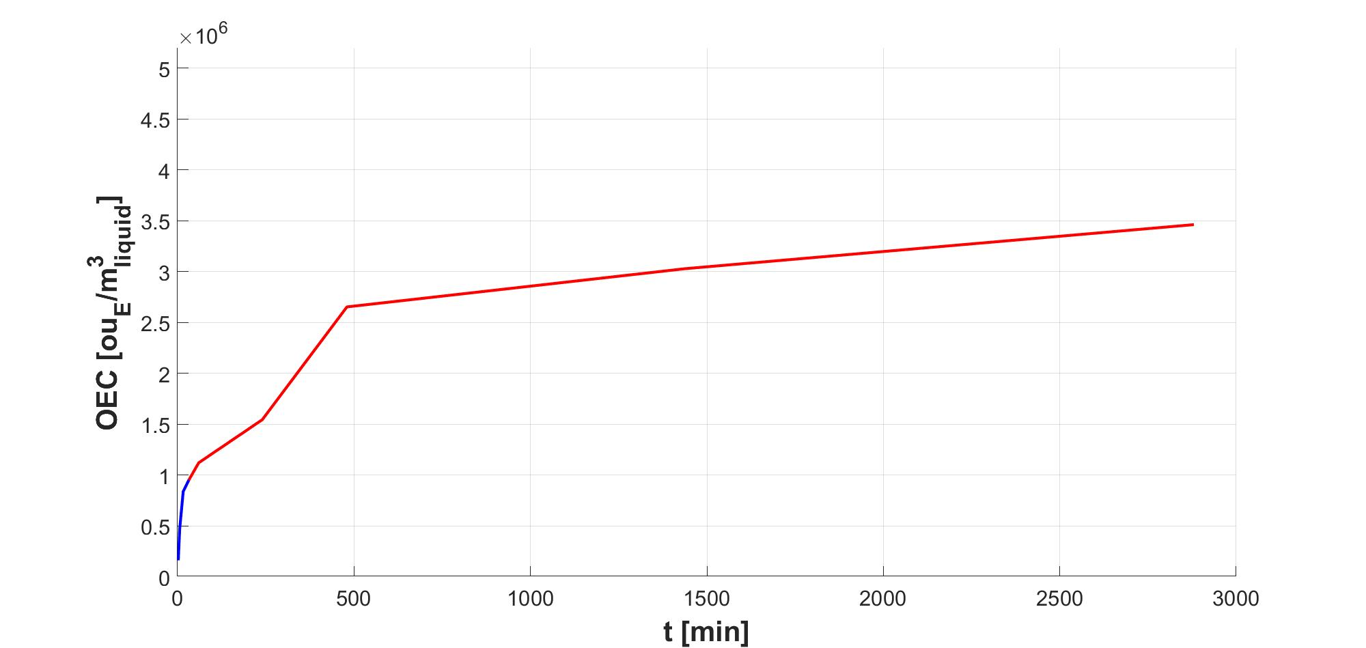

Figure 3. Odour Emission Capacity trends during analysis time

Another consideration could be done evaluating the contribution of each individual trapezium designed by the 9 odour concentration measurements executed during the analysis. Table 2 shows the contribution of each trapezium useful to calculate the OEC value. In this case, the weight of the area, obtained by linear extrapolation is 6%. It can observe that the single contribution of the trapezoids for estimation of OEC value related to the VDI Guideline 3885/1 are always lower than 10% and their sum is the 23% of the total OEC value of the new approach exposed in the present work.

Furthermore, as regards the number of odour samples to analyse through dynamic olfactometry, the results suggest that an OEC of a wastewater from a refinery or a petrochemical plant could be estimated with at least 7 odour concentrations, or for at least 8 hours of bubbling. In this case, the OEC is equal to 2.6·106 ouE/m3liquid, that represents the 77% of the value evaluated with 9 samples.

Table 2: Single contribution of trapezoids to OEC estimated with 9 samples and time-varying integral values

|  |  |  |
| --- | --- | --- |
| N° sample | Single trapezoid contribution | OEC  [ouE/m3liquid] |
| 1 | 5% | 1.6·105 |
| 2 | 7% | 4.7·105 |
| 3 | 9% | 8.4·105 |
| 4 | 7% | 9.5·105 |
| 5 | 4% | 1.1·105 |
| 6 | 12% | 1.5·106 |
| 7 | 8% | 2.6·106 |
| 8 | 23% | 3.0·106 |
| 9 | 20% | 3.5·106 |

* 1. Conclusions

In the environmental odour research field, it is well-known that the estimation of Odour Emission Capacity is an important parameter for a first evaluation of the odorous potential of a liquid. The approach was born to characterize odour impact related to civil wastewater treatment plants and it is standardized in the VDI Guideline 3885/1. The analysis of effluents produced by industrial realities as refineries and petrochemical plants, where hydrocarbons and sulphur compounds are present at high concentrations, shows some limits in the laboratory methodology, safety conditions and estimation of result.

The purpose of this work is to suggest a revised approach more adapt for the evaluation of this type of liquid. First of all, the operating conditions are changed; the glass bubbler volume is 1.5 L, the volume of bubbled liquid was reduced from 30 L to 1 L and consequently the neutral gas flow is adapted at 100 L/h to keep the degree of turbulence in the suggested range. In particular, the neutral gas chosen to be fluxed in the system is not air but nitrogen to reduce the explosion risk. Another important implementation of the system is the introduction of an additional nitrogen flux at the outlet gas to decrease the high odorous load and to respect the filling time of gas sample in the Nalophan™ bag. Starting with the standard OEC analysis of an effluent coming from API separators of a refinery wastewater treatment plant, the odour concentration of the 4 withdrawn gas samples is measured and the related OEC value is evaluated (9.5·105 ouE/m3liquid). The analysis continued up to 2 days of bubbling, during which 5 gaseous samples were taken for the odour concentration measurement at 60 min (1 h), 240 min (4 h), 480 min (8 h), 1440 min (24 h) and 2880 min (48 h). The resulting OEC value, estimated with the same mathematical approach of the standard, is about 4 times higher and equal to 3.5·106 ouE/m3liquid with a potential underestimation, by following the “standard” approach, of 72%. The analysis reported in Table 2 shows that, for the sample under investigation, a good trade-off to reduce the error with a good number of odour concentration is to analyse 7 gaseous sample. Furthermore, the plot of the trend of the time-varying integration of the OEC values in function of analysis time shows that the trend related to the OEC evaluated with 9 gas samples reaches a *quasi-*stationarity, while the standard one shows an increasing trend.

It can conclude that to measure the OEC for high-load wastewater of refinery and petrochemical effluents, the time of bubbling of the analysis system that contains the known volume of liquid should be increased until the time-varying integral reaches a *quasi*-stationary trend.

References

CEN, 2022, *EN 13725:2022 - Stationary source emissions - Determination of odour concentration by dynamic olfactometry and odour emission rate*, Brussels

Frechen, F.-B., 2009, 10 Years of OEC Measurement: Methodology, Application, Results and Future Development, *Odour and VOCs: Measurement, Regulation and Control,* Kassel University Press Kassel, 9-17.

Frechen, F.-B., 2012, Evaluation of OEC Data for Preparation of the New VDI Guideline 3885 / 1*, Chemical Engineering Transactions,* *30*, 19-24

Frechen, F.-B., Köster, W., 1998, Odour emission capacity of wastewaters - standardization of measurement method and application, *Water Science and Technology*, *38(3)*, 61-69

Giuliani, S., Zarra, T., Naddeo, V., Belgiorno, V., 2015, A novel tool for odor emission assessment in wastewater treatment plant, *Desalination and Water Treatment*, *55(3)*, 712-717

Invernizzi, M., Ilare, J., Capelli, L., Sironi, S., 2018, Proposal of a method for evaluating odour emissions from refinery storage tanks, *Chemical Engineering Transactions*, *68*, 49-54

Invernizzi, M., Sironi, S., 2021, Odour Emission Rate Estimation Methods for Hydrocarbon Storage Tanks, *Chemical Engineering Transactions*, *85*, 67-72

Pandan, M. A., Naddeo, V., Zarra, T., Belgiorno, V., Ballesteros, F., 2017, Odour emission capacity as a surrogate parameter for the assessment of river water quality, *WIT Transactions on Ecology and the Environment*, *221*, 43-50

Scolieri, G., Invernizzi, M., Sironi, S., 2021, A crude monte carlo analysis for treating the influence of olfactometric uncertainty, *Chemical Engineering Transactions*, *85*, 85-90

VDI, 2017, *VDI 3885. Olfaktometrie. Messung des Geruchsstofiemissionspotenzials von Flüssigkeiten,* 1-21, Düsseldorf

Wei, W., Cheng, S., Li, G., Wang, G., Wang, H., 2014, Characteristics of volatile organic compounds (VOCs) emitted from a petroleum refinery in Beijing, China, *Atmospheric Environment*, *89*, 358-366

Zhang, Z., Yan, X., Gao, F., Thai, P., Wang, H., Chen, D., Zhou, L., Gong, D., Li, Q., Morawska, L., Wang, B., 2018, Emission and health risk assessment of volatile organic compounds in various processes of a petroleum refinery in the Pearl River Delta, China, *Environmental Pollution*, *238*, 452-461