CHEMICAL ENGINEERING TRANSACTIONS  VOL. | A publication of
The Italian Association
of Chemical Engineering
Online at www.cetjournal.it
Guest Editors:
Copyright © AIDIC Servizi S.r.l.
ISBN 978-88-95608-xx-x ISSN 2283-9216

Sequential odour treatment and microalgal-based lipids production: a novel platform for resource recovery from odour emissions
Cattaneo C. R.ª, Buonerba A.ª, Galang. M. G.ª, Senatore V.ª, Oliva G.ª, Belgiorno V.ª, Naddeo V.ª and Zarra T.^{a*}
ªSanitary Environmental Engineering Division (SEED), Department of Civil Engineering, University of Salerno, via Giovanni Paolo II, Fisciano, SA, Italy

*corresponding author: tzarra@unisa.it
The research presents the microalgal lipids production from odour treatment emissions as innovative platform for resource recovery. The study investigated the sequential treatment of xylene and the production of microalgal lipids that are of interest for biodiesel production. The effect of inlet gas flowrate was assessed in a moving bed bioreactor treating xylene, a mean maximum EC_{xyl} of 0.32±0.25 g xyl m⁻³ h⁻¹, corresponding to a RE_{xyl} of 93% and PCO₂ of 4±2.6 g CO₂ m⁻³ h⁻¹, when working with an inlet gas flowrate of 1.0 L min⁻¹. On the other hand, the PBR recorded a maximum mean EC_{CO2} was 4.86±1.42 g CO₂ m⁻³ h⁻¹ corresponding to a RE _{CO2} of 33.8%. Simultaneously lipids were produced at a maximum mean calculated rate of 5.5 g lipids m⁻³ d⁻¹, as biomass showed a lipid concentration of 12.7%. The results show the feasibility of producing in a circular economy perspective lipid from odour treatment emissions.
  - Introduction
Odour emissions from industrial facilities or any other source (e.g. waste treatment facilities) are composed by a complex mixture of volatile inorganic and organic compounds (e.g. H₂S, NH₃, volatile fatty acids, hydrocarbons, etc.) at trace concentrations (Zarra et al., 2010; Lebrero et al., 2011). In spite of being present in trace concentrations, these emissions can still cause nuisance as many of their components show a very low odour threshold and, moreover, they are of key importance since they may be toxic to humans and the environment (Muñoz et al., 2010; Senatore et al., 2021b). Xylene is listed among the toxic VOCs and, thus, its removal from waste gas stream is fundamental (Gallastegui et al., 2011).
Biological odour treatment is based on the heterotrophic metabolism of a mixed microbial consortia and consequently, their metabolism releases CO₂ and under the current climate change scenario, it is increasingly important to reduce or abate these CO₂ emissions (Senatore et al., 2021a). In addition to the mentioned environmental aspect, the treatment of CO₂ may be also of economic interest, as it can be fixed in algal biomass in order to produce value added products; such as storage lipids (Oliva et al., 2019; Ángeles et al., 2020). The latter are better known as triacylglycerides (TAGs) and are composed of saturated fatty acids and in less extent of unsaturated fatty acids (Sharma et al., 2012). These lipids can undergo a transesterification process to produce biodiesel (Sharma et al., 2012; Senatore et al., 2021c). TAGs are synthetized and accumulated under environmental stress conditions like nutrient deprivation (e.g. limiting nitrogen or phosphorus sources), and a non-limiting presence of a carbon source and light (Ángeles et al., 2020).
Microalgal-based biodiesel has recently gained a vast interest as it was proven to have a higher yield productivity (even 50-fold) than vegetable-based biodiesel production in terms of land demand (Rawat et al., 2013). Moreover, microalgal-based biodiesel does not represent a risk for food security if production escalates (Sharma et al., 2012). Despite these benefits, microalgal-based biodiesel has not been scaled-up to a commercial level yet, because of its economic unfeasibility at the current development state of involved technologies (Rawat et al., 2013).
This study aimed at assessing the feasibility of the integration of xylene treatment and the production of microalgal lipids as a novel platform for resource recovery from waste odorous gas streams in a circular economy perspective. The performance of sequential moving-bed bioreactor (MBBR) and stirred tank photobioreactor (ST-PBR), for xylene abatement, followed by CO₂ abatement and simultaneous lipids production, was investigated. The results confirmed that the system can be used for the biodegradation of volatile organic compounds. Further studies are still ongoing to verify the efficacy to treat mixture of organic and inorganic volatile compounds, mainly responsible for odour annoyance. In particular, the main industrial applications of the investigated bioreactor are related to the treatment of conveyed odour emissions from petrochemical, chemical and environmental facilities plants, to avoid odour impact and also allow the production of alternative energy carriers.
  - Materials and methods
    - Inocula and chemicals
A MBBR was inoculated with activated sludge obtained from a real wastewater treatment plant. On the other hand, a ST-PBR was inoculated with Chlorella vulgaris CCAP 211/11B, purchased from the Culture Collection of Algae and Protozoa (CCAP, Dunberg, Scottland). In the MBBR and the ST-PBR, a synthetic dairy wastewater (DWW) medium was fed to provide nutrients, with the following composition: 2.5 g L⁻¹ powdered milk, 1.4 g L⁻¹ NH₄Cl, 1 g L⁻¹ KH₂PO₄, 50 mg L⁻¹ MgSO₄·7H₂O, 2 g L⁻¹ NaHCO₃, 75.0 mg L⁻¹ CaCl₂·6H₂O. Xylene (≥ 98.5%) was used to feed the activated sludge in the MBBR.
    - Experimental setup
As previously stated, a sequence of a MBBR and PBR was used in this study (Figure 1). The MBBR consisted of a glass-made cylinder with an internal diameter of 165 mm, a height of 520 mm and a working volume of 6.5 L. The reactor was one-third filled with Kaldnes Rings carriers (Amitec ®, Italy). The xylene stream was regulated by a syringe pump, whereas atmospheric air was supplied by an air compressor. Thus, the gas inlet consisted of mixture of air and xylene and injected to the reactor base of MBBR by using stainless-steel gas diffusers.
The PBR is a transparent inert Plexiglass® cylinder which has a working volume of 26 L, an internal diameter of 200 mm and a height of 1000 mm. Reflective panels has been installed around the PBR to ensure a uniform irradiation. The light sources are four LED bulbs. Mixing was provided by a magnetic stirrer placed beneath the reactor. The gas inlet was practically the outlet gas of the MBBR and was inserted through a stainless-steel gas diffuser.

    - Bioreactors performance tests
2.3.1 Assessment of xylene degradation in the MBBR
The degradation of xylene was tested and assessed in two stages at two different inlet gas flowrates, 0.5 and 1.0 L min⁻¹, respectively. In both stages, the MBBR was operated continuously and for 22 days in stage 1; whereas, during stage 2 it was operated for 11 days. Inlet xylene concentrations of 48.6±23.8 and 36.2±24.4 were kept in Stage 1 and 2, respectively. The dilution rate was fixed at 0.038 d⁻¹, since 0.25 L of the mixed liquor were daily exchanged by fresh dairy wastewater (DWW) medium to ensure nutrients non-limiting conditions in the reactor. Xylene and CO₂ concentrations in the inlet and outlet gas streams were daily measured respectively with a GC-PID (Tiger, ION Science, Stafford, TX, USA) and a GC-TCD (TRACE 1300, Thermo Scientific, USA) using 100 µL samples drawn with a Hamilton® GASTIGHT® syringe (Hamilton Co., USA). Moreover, pH, dissolved oxygen (DO) and temperature in the mixed liquor were daily measured using a multiparameter probe (Hanna Instruments, Italy). The concentration of total suspended solids (TSS) was twice-a-week measured according to APHA standards (APHA et al., 2017). NO₃⁻-N and PO₄³⁻-P concentrations were determined by an ion chromatograph (ICS-90, Dionex, USA), equipped with an IonPac AS9-HC column and an AS40 automated sampler (Thermo Fisher Scientific, USA). Ion chromatographic measurements were performed with an injection volume of 10 μL, at a flow rate of 1.0 mL min⁻¹, with an aqueous solution of sodium carbonate 9.0 mM as eluent.

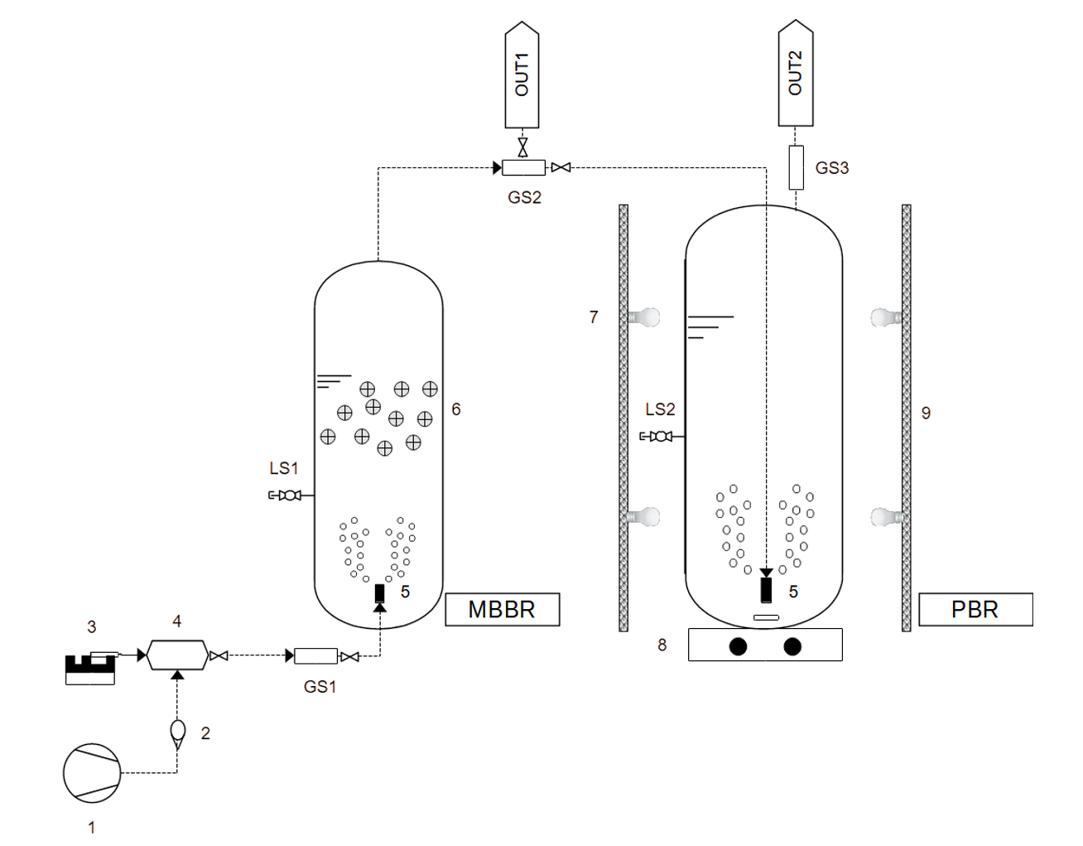
Figure. 1. Sketch of the integrated system for odour treatment (MBBR) and microalgal-based lipids production (PBR). Air compressor (1), rotameter (2), syringe pump (3), mixing chamber (4), air diffusers (5), biofilm carriers (6), LED bulbs (7), magnetic stirrer (8), reflective panels (9). GS#: gas sampling port, LS#: liquid sampling port, OUT#: gas outlet.
2.3.2 Assessment of PBR performance on CO2 fixation and simultaneous lipids production
The PBR was fed with the outlet gas from the MBBR. The dilution rate was fixed at 0.019 d⁻¹, since 0.50 L of the microalgal culture broth were daily exchanged with fresh DWW medium, to ensure nutrients non-limiting conditions in the reactor. Irradiation intensity was kept constant at 9534,71 lux during the whole experiment. Xylene and CO₂ concentrations, anions concentrations, pH, DO and temperature were measured with the same methods used inthe MBBR. As biomass proxy, Chlorophyll a was measured twice a week in UV-VIS spectrophotometry taking a 15 mL sample from the culture broth according to APHA et al., 2017.
A 4 L sample was taken at the end of the experiment to measure the lipids concentration in the microalgae biomass. Biomass was settled using chemical coagulation with FeCl₃, then centrifuged and dried in oven for an hour at 105 °C. Finally, 1 gram of the dried biomass was placed in a Kumagawa extractor thimble to perform the extraction using hexane as a solvent at an extraction time of 2 h. Methanol was added to the solvent at a ratio 1:299. Chlorophyll a was measured in the extract, as an impurity indicator.
    - Performance indicators
For the MBBR, the xylene elimination capacity (EC_{xyl}), xylene removal efficiency (RE_{xyl}), volumetric CO₂ production rate (RCO₂) were calculated using equation (1), (2) and (3), respectively. For the PBR, the CO₂ elimination capacity (EC_{CO2}), CO₂ removal efficiency (RE _{CO2}) were calculated using equation (4) and (5), respectively:

${EC}_{xyl}= \frac{Q*({xyl}_{ in}-{xyl}_{ out})}{V}$ [g Xylene m⁻³ h⁻¹] (1)

${RE}_{xyl}= \frac{({xyl}_{ in}-{xyl}_{ out})}{{xyl }_{in}}×100$ [%] (2)

${PCO}_{2}= \frac{Q*({C0}_{2 out}-{CO}_{2 in})}{V}$ [g CO₂ m⁻³ h⁻¹] (3)

${EC}_{CO2}= \frac{Q*({C0}_{2 in}-{CO}_{2 out})}{V}$ [g CO₂ m⁻³ h⁻¹] (4)

${RE}_{CO2}= \frac{({C0}_{2 in}-{CO}_{2 out})}{{CO}_{2 in}}×100$ [%] (5)

Where:
- xyl _{𝑖𝑛} and xyl _{𝑜𝑢𝑡} stand for the inlet and outlet xylene concentrations (g m⁻³);
- CO_{2 𝑖𝑛} and CO_{2 𝑜𝑢𝑡} are the inlet and outlet CO₂ concentrations (g m⁻³);
- 𝑄 is the inlet gas flow rate (m³ h⁻¹);
- 𝑉 is the bioreactor working volume (m³).

  - Results and discussion
    - Assessment of xylene degradation in the MBBR
In the stage 1, using a gas inlet flow rate of 0.5 L min⁻¹; the EC_{xyl} was found to be in the range of 0.10 – 0.39 g xyl m⁻³ h⁻¹ and a mean EC_{xyl} 0.21±0.07 g xylene m⁻³ h⁻¹ was recorded. Whereas, during stage 2 when working with a gas inlet flow rate of 1.0 L min⁻¹, EC_{xyl} were in the range of 0.09 – 0.96 g xyl m⁻³ h⁻¹ and the recorded mean EC_{xyl} was 0.32±0.25 g xyl m⁻³ h⁻¹ (Figure 2A). The increased gas inlet flow rate influenced the mean and maximum value of the EC, this due to the increased mass transfer of xylene into the aqueous phase supported by the increased turbulence and inlet load (Figure 2B).
Figure. 2. (A) ECxyl (white triangles) and PCO2 (black squares) along both operational stages (divided by the vertical dashed line) in the MBBR; (B) ECxyl vs ILxyl in stage 1 (black traingles) and stage 2 (white circles).

In stage 1, RE_{xyl} showed values in the range of 85.5 – 98.4% and a mean RE_{xyl} of 94.8% was achieved. Similarly, during stage 2, RE_{xyl} showed values in the range of 85.9 – 98.7% and 93.0% of mean RE_{xyl}. These values do not show much difference, most likely because in both stages the system was very close to achieve 100% RE_{xyl}. Moreover, some xylene degradation activity was detected in the PBR, probably because of biomass sorption, increasing in this way the total RE_{xyl} of the overall sequential system (Figure 3).

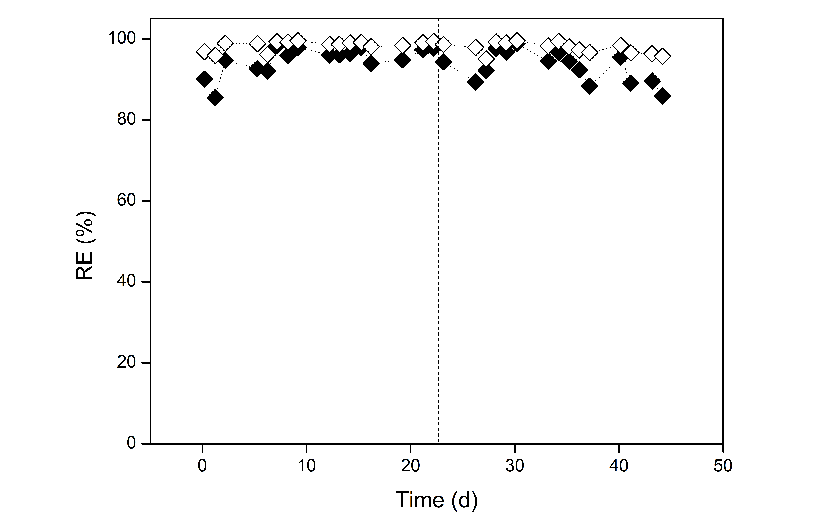
Figure. 3. RExyl in the MBBR (black diamonds) and after the PBR (white diamonds) along both operational stages (divided by the vertical dashed line).

Finally, in the stage1, PCO₂ were in the range of 3.6 – 10.9 g CO₂ m⁻³ h⁻¹ and the recorded mean PCO₂ was 5.7±1.8 g CO₂ m⁻³ h⁻¹, corresponding to a mean mineralization ratio (PCO₂/ EC_{xyl}) of 29.0. Whereas in the stage 2, PCO₂ were in the range of 3.7 – 12.8 g CO₂ m⁻³ h⁻¹ and the recorded mean PCO₂ was 6.4±2.6 g CO₂ m⁻³ h⁻¹, corresponding to a mean mineralization ratio of 30.0. The large dispersion of mean PCO₂ can be explained by the recorded mineralization ratios, that in turn indicate a large CO₂ mass production per unit mass of abated xylene.

    - Assessment of PBR performance on CO₂ fixation and simultaneous lipids production
The continuous fixation of CO₂ was assessed in a PBR which was fed with the outlet gas of the MBBR. In the stage 1 the EC_{CO2} was found to be in the range of -0.79 – 6.07 g CO₂ m⁻³ h⁻¹ and a mean EC_{CO2} 2.57±2.35 g CO₂ m⁻³ h⁻¹ was recorded. Whereas, during stage 2, EC_{CO2} were in the range of 2.28 – 7.46 g CO₂ m⁻³ h⁻¹ and the recorded mean EC_{CO2} was 4.86±1.42 g CO₂ m⁻³ h⁻¹ (Figure 4).
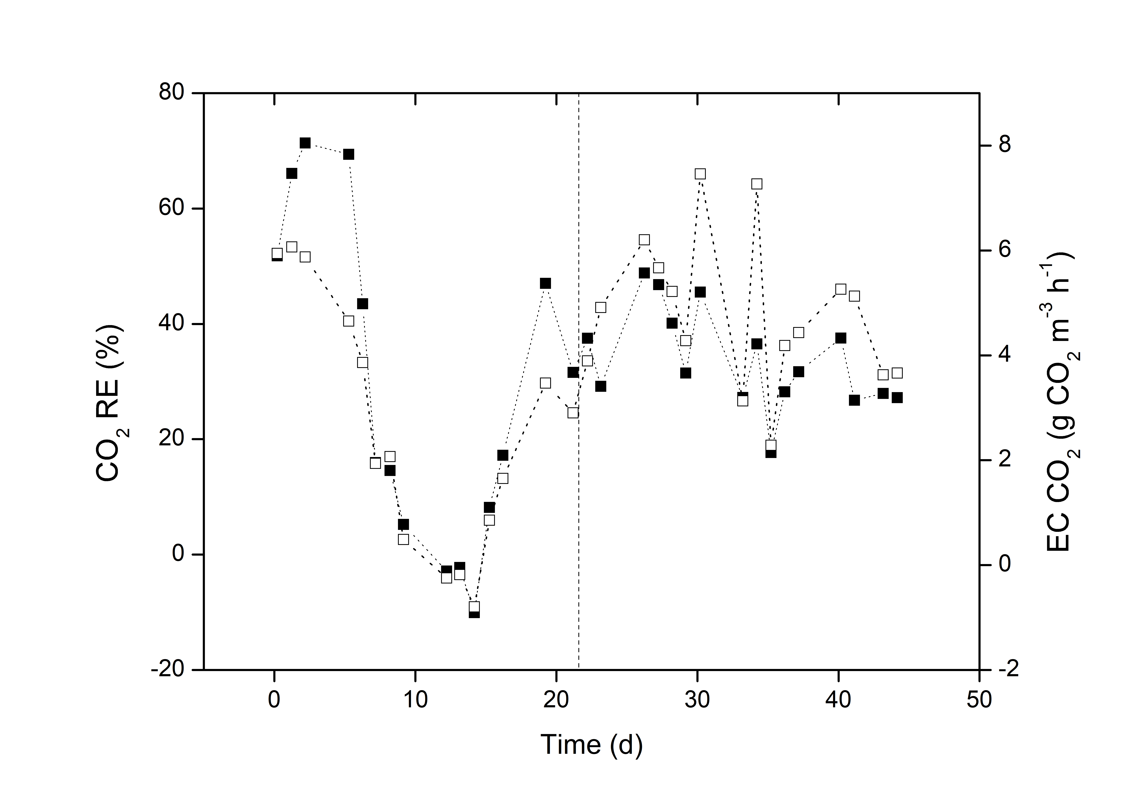
Figure 4. RE CO2 (black squares) and ECCO2 (white squares) along both operational stages (divided by the vertical dashed line).

During stage 1, RE_{CO2} showed values in the range of -10.1 – 71.4% and a mean RE_{CO2} of 28.5±27.9% was achieved. On the contrary, during stage 2, RE_{CO2} showed values in the range of 17.7 – 48.8% and 33.8±8.6% of mean RE _{CO2}. These values follow, of course, the same pattern as those of EC_{CO2}. In this context, the herein recorded RE_{CO2} are lower than those found in literature, most likely due to pH value that remained constant at ~6, as alkalinity is crucial for increasing mass transfer of CO₂ into the aqueous phase. Ángeles et al. (2020) recorded a maximum average RE_{CO2} of 96.3 when working at a pH of ~9.3 in a tubular photobioreactor with a mixed microalgae culture. Similarly, Rodero et al. (2020) obtained a maximum RE_{CO2} of 98.6 % maintaining a pH of ~9.7 in the culture broth and, using a high-rate algal pond inoculated with a mixed culture.
Finally, the sample taken to determine the lipid revealed a lipid concentration of 12.7 % on a dry weight basis. This is a typical value for C. vulgaris cultured with no environmental stress conditions, in this sense, Mujtaba et al. (2012) recorded a mean lipid concentration of ~15% under non nutrients limitation and only photoautotrophically in contrast to ours mixotrophic conditions, due to the use of an organic loaded DWW medium.
If some assumptions such as constant lipid concentrations and negligible growth of bacteria happened in the PBR, so to assume TSS as a trustable algal biomass proxy, we can calculate the lipids productivities achieved in this system; these are: 4.7 and 5.5 g lipids m⁻³ d⁻¹, for stage 1 and 2 respectively.
  - Conclusions
The sequential treatment of xylene and microalgae-based lipids production was investigated and assessed. Increasing the inlet gas flowrate in the MBBR supported a higher mean EC_{xyl} of 0.32±0.25 g xyl m⁻³ h⁻¹ (93% RE_{xyl}) and consequently a higher mean PCO₂ was 6.4±2.6 g CO₂ m⁻³ h⁻¹. Whereas the PBR recorded a maximum mean EC_{CO2} was 4.86±1.42 g CO₂ m⁻³ h⁻¹ (33.8% RE_{CO2}), and simultaneously produced lipids at a maximum mean calculated rate of 5.5 g lipids m⁻³ d⁻¹, as it showed a lipid concentration of 12.7%. This is the first proof-of-concept study showing the ability to produce lipids from xylene and the initial step to further use more complex industrial flue gases.

References
Ángeles R., Arnaiz E., Gutiérrez J., Sepúlveda-Muñoz C. A., Fernández-Ramos O., Muñoz R., Lebrero R., 2020, Optimization of photosynthetic biogas upgrading in closed photobioreactors combined with algal biomass production. Journal of Water Process Engineering, 38. https://doi.org/10.1016/j.jwpe.2020.101554
APHA (American Public Health Association), AWWA (American Water Works Association), and WEF (Water Environment Federation), 2017, Standard Methods for the Examination of Water and Wastewater (R. B. Baird, A. D. Eaton, and E. W. Rice, Eds.; 23rd ed.). APHA. https://doi.org/10.2105/SMWW.2882.216
Gallastegui G., Ávalos Ramirez A., Elías A., Jones J. P., Heitz M., 2011, Performance and macrokinetic analysis of biofiltration of toluene and p-xylene mixtures in a conventional biofilter packed with inert material. Bioresource Technology, 102(17), 7657–7665. https://doi.org/10.1016/j.biortech.2011.05.054
Lebrero R., Bouchy L., Stuetz R., Muǹoz R., 2011, Odor assessment and management in wastewater treatment plants: A review. In Critical Reviews in Environmental Science and Technology (Vol. 41, Issue 10, pp. 915–950). https://doi.org/10.1080/10643380903300000
Mujtaba G., Choi W., Lee C. G., Lee K., 2012, Lipid production by Chlorella vulgaris after a shift from nutrient-rich to nitrogen starvation conditions. Bioresource Technology, 123, 279–283. https://doi.org/10.1016/j.biortech.2012.07.057
Muñoz R., Sivret E. C., Parcsi G., Lebrero R., Wang X., Suffet I. H., Stuetz R. M., 2010, Monitoring techniques for odour abatement assessment. In Water Research (Vol. 44, Issue 18, pp. 5129–5149). Elsevier Ltd. https://doi.org/10.1016/j.watres.2010.06.013
Oliva G., Angeles R., Rodriguez E., Turiel S., Naddeo V., Zarra T., Belgiorno V., Munoz R., Lebrero R., 2019, Comparative evaluation of a biotrickling filter and a tubular photobioreactor for the continuous abatement of toluene. Journal of Hazardous Materials, Vol. 380, Pag. 120860-120870, Elsevier. https://doi.org/10.1016/j.jhazmat.2019.120860.
Rawat I., Ranjith Kumar R., Mutanda T., Bux F., 2013, Biodiesel from microalgae: A critical evaluation from laboratory to large scale production. In Applied Energy (Vol. 103, pp. 444–467). Elsevier Ltd. https://doi.org/10.1016/j.apenergy.2012.10.004
Rodero M. del R., Severi C. A., Rocher-Rivas R., Quijano G., Muñoz R., 2020, Long-term influence of high alkalinity on the performance of photosynthetic biogas upgrading. Fuel, 281. https://doi.org/10.1016/j.fuel.2020.118804
Senatore V., Zarra T., Pahunang R. R., Oliva G., Belgiorno V., Ballesteros F. C., Naddeo V., 2021°, Sustainable odour and greenhouse gas emissions control in wastewater treatment plant by advanced biotechnology-based system. Chemical Engineering Transactions, 85, 25–30. https://doi.org/10.3303/CET2185005
Senatore V., Zarra T., Galang M.G., Oliva G., Buonerba A., Li C.-W., Belgiorno V., Naddeo V., 2021b, Full-Scale Odor Abatement Technologies in Wastewater Treatment Plants (WWTPs): A Review. Water, 13, 3503. https://doi.org/10.3390/w13243503.
Senatore V., Buonerba A., Zarra T., Oliva G., Belgiorno V., Boguniewicz-Zablocka J., Naddeo V., 2021c, Innovative Membrane Photobioreactor for Sustainable CO2 Capture and Utilization. Chemosphere, Elsevier. https://doi.org/10.1016/j.chemosphere.2021.129682.
Sharma K. K., Schuhmann H., Schenk, P. M., 2012, High lipid induction in microalgae for biodiesel production. Energies, 5(5), 1532–1553. https://doi.org/10.3390/en5051532
Zarra T., Naddeo V., Giuliani S., Belgiorno V., 2010, Optimization of ﬁeld inspection method for odour impact assessment. Chemical Engineering Transactions, vol. 23, p. 93-98, ISSN: 1974-9791. https://doi.org/10.3303/CET1123016.

