|  |  |
| --- | --- |
| ***CHEMICAL ENGINEERING TRANSACTIONS***  ***VOL. 95, 2022*** | A publication of |
| The Italian Association  of Chemical Engineering  Online at www.cetjournal.it |
| Guest Editors: Selena Sironi, Laura Capelli  Copyright © 2022, AIDIC Servizi S.r.l. **ISBN** 978-88-95608-94-5; **ISSN** 2283-9216 | |

Assessment of Odour Dispersion Modelling Tools through the Comparison with Field Inspections and Complaints Records

William R. Patiñoa,*, Ondřej Vlčeka, Petra Auterskáb

aCzech Hydrometeorological Institute, Na Šabatce 2050/17, 143 06 Prague, Czech Republic.

bOdour, s.r.o., Karlická 1155, 252 28 Černošice, Czech Republic.

william.patino@chmi.cz

Due to the complex and subjective nature of odour perception, estimating the impact of pollutant sources on the community requires the use of multiple tools. Currently, the European standard EN 16841:2016 - Part 1 describes a technique to evaluate odour in ambient air through sniff testing called the grid method, useful to build datasets comparable with dispersion modelling results. Another methodology to assess the exposure to offensive odours is based on the active participation of the affected community. In the Czech Republic, the AirQ system is being used to collect the complaints of voluntary subjects residing nearby problematic sources. Nevertheless, for this application to give meaningful information, the data has to be cross-checked against wind direction and validated using near-real time output of a dispersion model.

The presented study aimed to evaluate the performance of Lagrangian models AUSTAL and GRAL, and Czech Gaussian model SYMOS by using the field inspection dataset gathered in a pig-fattening farm located in Styria (Austria), and the output of the AirQ system in the vicinity of a feed production industry in the city of Prague. Results show the importance of an appropriate selection of the peak-to-mean factor and provide relevant knowledge for the future consideration of the most suitable dispersion model for odour assessment in the Czech Republic.

* 1. Introduction

Odour management can be accomplished through a series of methods that enable to evaluate the impact of odours and regulate industrial emissions correspondingly. A multi-tool approach has proven to be the best strategy to tackle nuisance in the population (Brancher et al., 2017), that means conducting monitoring campaigns, involving the participation of the community affected, and using the assistance of predictive models.

The grid method explained in EN 16841:2016 - Part 1 characterizes odour exposure in a certain area by identifying the presence or absence of a recognizable odour in a measurement consisting of 60 observations (1 sniff every 10 seconds during 10 minutes). If the odour reaches or exceeds a percentage odour time of 10 % (i.e. 6 or more positive observations), the result is classified as “odour hour”. The survey needs to be carried out considering representative meteorological conditions in a period of 6 to 12 months, during which qualified panel members take 52 or 104 measurements, respectively. At the end, the frequency of odour hours is determined. According to Oettl et al. (2018), this indicator provides results comparable to dispersion modelling, thus allowing to test model performance.

On the other hand, tracking complaints records can help to obtain different information on the annoyance caused by the emission of odorous substances. For example, duration of odour episodes, time of the day, intensity, character, and unpleasantness are some of the variables that would give a better description of the impact of the source. Besides, it makes possible the identification of specific troubling operations and complements model predictions. The AirQ system operates as a mobile phone application that registers complaints from people living in the proximity of sources of odorous substances. Subsequently, complaints are evaluated on the basis of a scoring system with the following criteria: the time of the complaint submission matches with the reported odour episode duration (1 point), the type of odour is relevant (2 points), the episode duration is longer than 3 minutes (1 point), there is a temperature inversion (1 point) and the plume from the source impacts the location of the complaint (5 points). The latter is determined using SYMOS model running on 30-min averages of wind measured at the location of or near the source when a concentration greater than zero is obtained for at least a part of the episode duration.

Various jurisdictions have established odour impact criteria (OIC) which are meant to be used in combination with dispersion modelling tools to calculate separation distances. OIC are composed by a concentration threshold and an exceedance probability, defined based on technical and economic factors, e.g. land use type, industry and offensiveness (Brancher et al., 2017). The latest developments in Lagrangian models, such as AUSTAL and GRAL, allow to calculate odour hour frequencies (analogous to exceedance probabilities), defined as one-hour time intervals in which the modelled peak concentration (assumed to be represented by the 90th percentile) exceeds the odour concentration threshold, usually set at 1 OUE∙m−3. In these models, different approaches are used to obtain a peak-to-mean factor (*R90*): AUSTAL implements a semi-empirical coefficient of 4 recommended by the German TA Luft. GRAL provides the possibility to apply a user-defined ratio or use the Concentration Variance Model (CVM), which estimates a spatially variable ratio from the time evolution of the mean concentration fields and the variance field, assuming a two-parameter Weibull probability density function to describe the instantaneous concentration. Hence, the goal of this study is to combine the results of different odour management approaches to assess the performance of the chosen models.

* 1. Pig-fattening farm in Styria, Austria

Field inspections were carried out with a panel of 15 members in the period between 1st of February and 31st of July, 2017, to obtain 52 observations uniformly distributed between week days and day hours in twelve measurement points. The 95 % confidence interval for the observations was computed to account for sampling error. The results of this experimental set up and input parameters for the models are openly available as supplementary resource of the work published by Oettl et al. (2018). Figure 1 shows a representation of the source and the location of the measurement points, along with the wind rose.

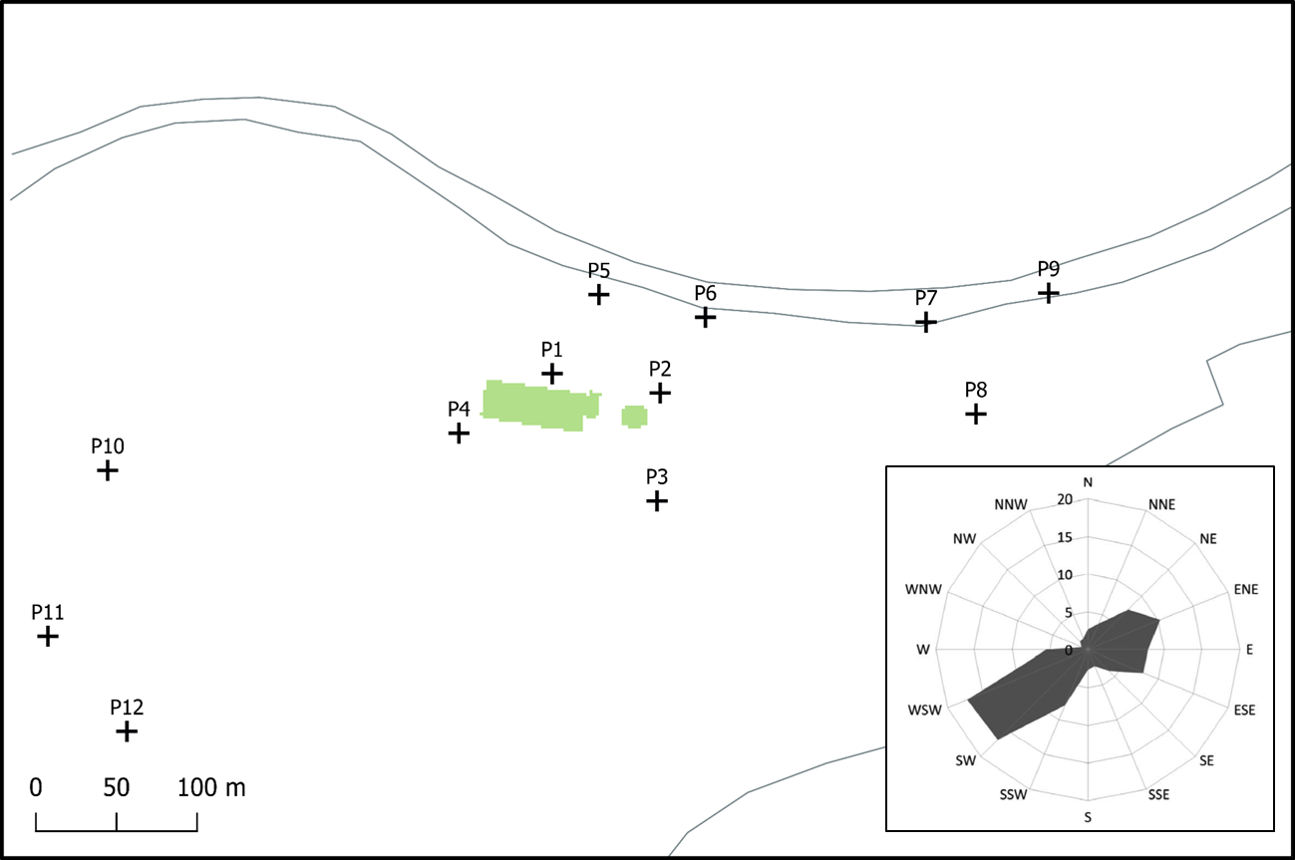

Figure 1: Schematic representation of the pig-fattening farm with reference points and wind rose. Adapted from Oettl et al. (2018).

Modelling was performed using a factor *R90* equal to 1 (meaning no modification to hourly means) and 4, setting a threshold of *Ct*= 1 OUE∙m−3. Additionally, in the case of GRAL, the Concentration Variance Model was tested. Lagrangian models were run including and excluding buildings, while SYMOS was only run without buildings due to a lack of a specialized module. The scheme proposed by Janicke Consulting (2013) to transform the Obukhov stability parameter [m−1] to atmospheric stability classes was employed to derive the meteorological input for SYMOS.

* + 1. Results and discussion

The greatest compliance with the observations was perceived using GRAL model, especially with *R90*= 1 and CVM, which calculated *R90* factors in the range of 1.5-2.8. On the other hand, Figure 2b shows that applying *R90*= 4 lead to a general overestimation of GRAL results. However, this same factor improved the agreement of AUSTAL and SYMOS with the field inspections, compared to the notable underestimation in Figure 2a. Even so, SYMOS results were still out of the uncertainty range of the observed values for more than half of the reference points.

According to Figure 2c, the consideration of buildings tended to increase the frequency of odour hours calculated with GRAL, particularly at reference points 1 and 5, located in the leeward side of the pig farm. This enhanced significantly the accuracy of the model. Conversely, although AUSTAL also predicted a slightly higher value at point 1, results generally worsened when buildings were included, as a modest decrease was observed. Another remark is that neither model showed any impact in the windward side of the building (reference point 4) and measurement points further from the source (7-12) did not present an appreciable change.

Several studies have argued about which value of *R90*would be better to simulate short-term peak concentrations. For instance, Brancher et al. (2020) evaluated the suitability of different methodologies based on the validation against the Uttenweiler pig farm dataset (Bächlin et al., 2002), and concluded that the CVM approach was the most successful replicating the observations, while a constant factor of 4 was well above, particularly under stable conditions in the far-field. Souza et al. (2014) suggested a value of 2.2 for SYMOS validated with the same dataset. Nevertheless the current results show that the capabilities of the dispersion model itself and input characteristics played a bigger role than the selection of *R90*, since both AUSTAL and SYMOS tended to underestimate the measured values in every scenario. Wensauer et al. (2006) had observed that parameters like the type of the source, influence of buildings, and roughness length had a crucial effect in the results of AUSTAL.

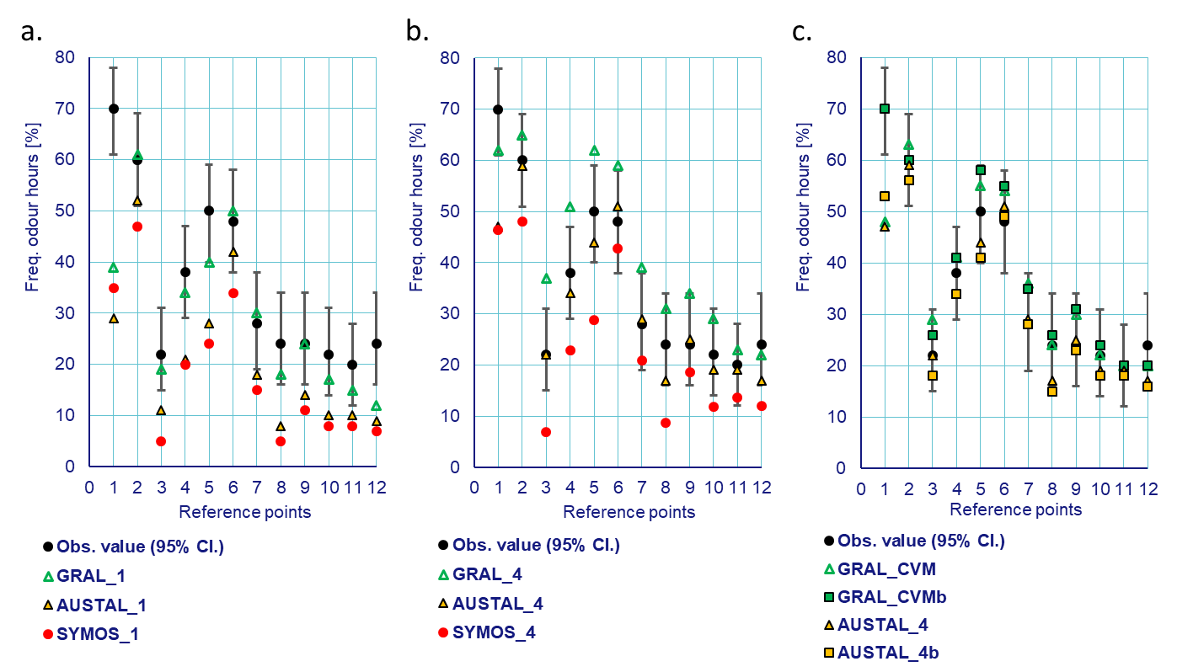

Figure 2: Modelled frequency of odour hours using (a.) R90= 1 and (b.) R90= 4. (c.) Comparison of Lagrangian models implementing CVM and R90= 4 with the inclusion of buildings (squares).

* 1. Feed production industry in Prague, Czech Republic

The source consists of 6 chimneys with a height of 17 m, emitting 270,000 OUE∙s−1 altogether with exit velocities ranging from 2.7 to 6.6 m∙s−1. During the period between September 2018 and December 2019, the AirQ system collected 670 complaints. For optimization purposes, a grid of 200 m was chosen to group the receptors and the modelling domain was restricted to 12 x 10 km, omitting rare complaints, which were further than 8 km away from the source. Consequently, the total number of modelled receptors was reduced to 191, in representation of 648 complaints.

The wind rose and stability parameters were obtained by CALMET pre-processor using available standard meteorological observations. There were predominant winds from the south-west with speeds mainly between 2 and 6 m∙s−1, and a high share of neutral conditions. The methodology described by Patiño and Duong (2022) was implemented to calculate the temperature gradient for SYMOS input as an alternative to stability classes, based on the mixing height estimated by CALMET. Complex terrain was included into the simulations using a roughness length of 0.2 m, characteristic for the outskirts of the city. The models were run to estimate frequency of odour hours, as well as time series of concentrations, using *R90* = 4 in the case of SYMOS and AUSTAL, and the CVM for GRAL.

* + 1. Complaints records

Figure 3 illustrates the duration and intensity of the odour episodes as it was registered by the complainants, categorized in four levels (1-weak to 4-strong). The smallest bubble size represents one “odour hour”, i.e. the perception of odour was longer than 6 minutes. Thus, an odour episode is represented by multiple bubbles growing in size. A change of color within the same episode means there are two complaints overlapped with different duration and intensity. It can be concluded that a great portion of the events were recorded in the early morning and in the evening. The intensity tended to be between 3 and 4 in most of the long-lasting episodes, which indicates a strong and likely annoying odour for the population. After May 2019 complaints were recorded with less frequency due to a change in the operation facilities of the industry.

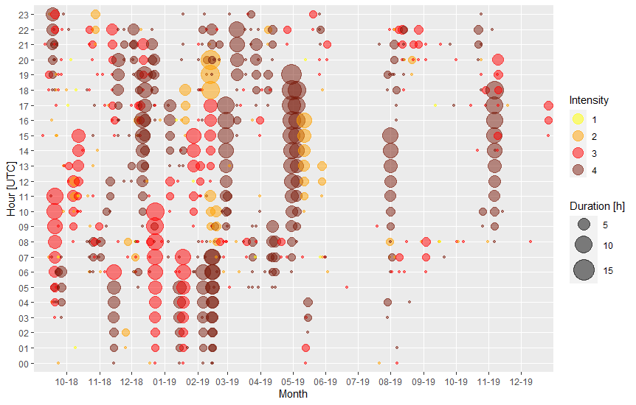

Figure 3: Odour episodes according to the complaints collected in the surroundings of the industry.

* + 1. Re-evaluation of complaints with “odour hour” methodology

In order to perform an assessment of the complaints records only the criterion of plume impaction (5 points) was considered. The comparison shown in Figure 4a illustrates the number of complaints which were deemed to be valid because the model predicted a concentration higher than 0 OUE∙m−3 during the span of the record, as it is established currently in the AirQ system. Nevertheless, it was decided to increase this limit to 1 OUE∙m−3 in Figure 4b to avoid the influence of extremely low concentrations, which are usually noisy data that should not be taken into account for the validation of complaints. The category “other” means that other sources or factors could have caused the complaint, or simply the model was not able to predict the nuisance perceived.

The bar plots show that a small percentage of complaints was not evaluated because records submitted before the beginning of the presumed odour episode were dismissed. Additionally, the AirQ system was not able to cross-check some complaints due to insufficient on-site meteorology. In Figure 4a, SYMOS and AUSTAL simulated a lower amount of valid complaints, while GRAL estimated non-zero concentrations in almost 92 % of the cases. On the other hand, Figure 4b shows a very good agreement between the models, although at most 35 % of the complaints were considered valid. It was observed that changing the threshold could drastically modify the assessment by shifting around half of the complaints from one category to the other. It also indicates that GRAL predictions were greatly influenced by low concentrations.

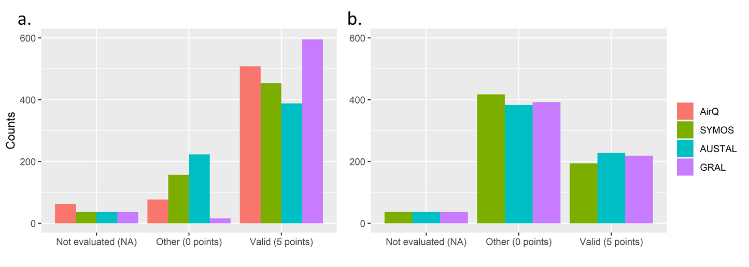

Figure 4: Comparison of model predictions for (a.) Ct = 0 OUE*∙m−3* and (b.) Ct = 1 OUE*∙m−3*.

The maps in Figure 5 associate the evaluation of the complaints in time and space with the frequency of odour hours. Circles represent valid (red) or “other” (blue) complaints, and star shaped symbols highlight the location of complaints with an intensity of 3 or 4. Contours were arranged to match the most common odour impact criteria summarized in Brancher et al. (2017). For a Ct of 1 OUE∙m−3, Canada, Australia and New Zealand set the most stringent value of 0.5 % exceedance probability. Germany and Austria prefer a more conservative approach with allowed exceedances of 15 % to 10 % for the first and 8 % for the latter. Several other countries (e.g. UK, Ireland, Netherlands, Belgium, Italy, France, Spain, Colombia) agree on evaluating odours with an exceedance probability of 2 %, also recognized as the irrelevance criterion for German regulations.

While SYMOS and AUSTAL present a similar pattern of contours, GRAL displays wider separation distances in the near-range and a milder impact of wind direction due to classification of input meteorology. It is also noteworthy that AUSTAL estimated higher frequencies of odour hours as distance increased, as opposed to the other models which reach a frequency of 0.5 % within the domain, following the impact of terrain. This goes in accordance with the findings of Piringer et al. (2015), who demonstrated a factor of 4 could cause significant overestimations at larger distances, especially under stable conditions.

GRAL predictions seem to be more consistent with the distribution of complaints reported within the distance equivalent to a frequency of odour hours of 8 %. Moreover, SYMOS and GRAL models coincide in the validation of 96 complaints with intensities equal or higher than 3 (about 38 % of the complaints with intensities 3-4). Conversely, AUSTAL determined the largest amount of valid complaints with such characteristics, totaling 120 (around 47 %).

At the same time, it is apparent for all models that complaints at a distance greater than the isoline of odour frequency of 2 % were mostly categorized as “other”, with generally low intensities. In this regard, Piringer et al. (2015) stated that OIC composed by low concentration thresholds and high exceedance probabilites should be favoured to target chronic odour exposure and avoid the influence of outliers in the calculation of separation distances, caused by failures in model formulation or meteorological pre-processing. Sommer-Quabach et al. (2014) also agreed that for an exceedance probability of 2 % or less, only few distinct meteorological situations contributed to the determination of the separation distances.

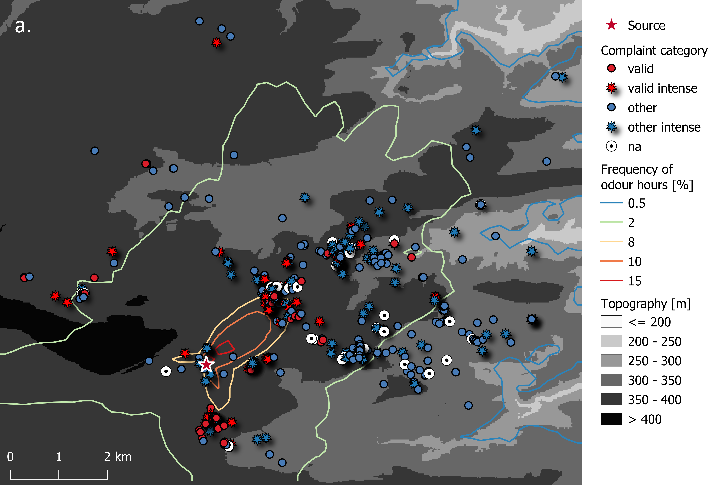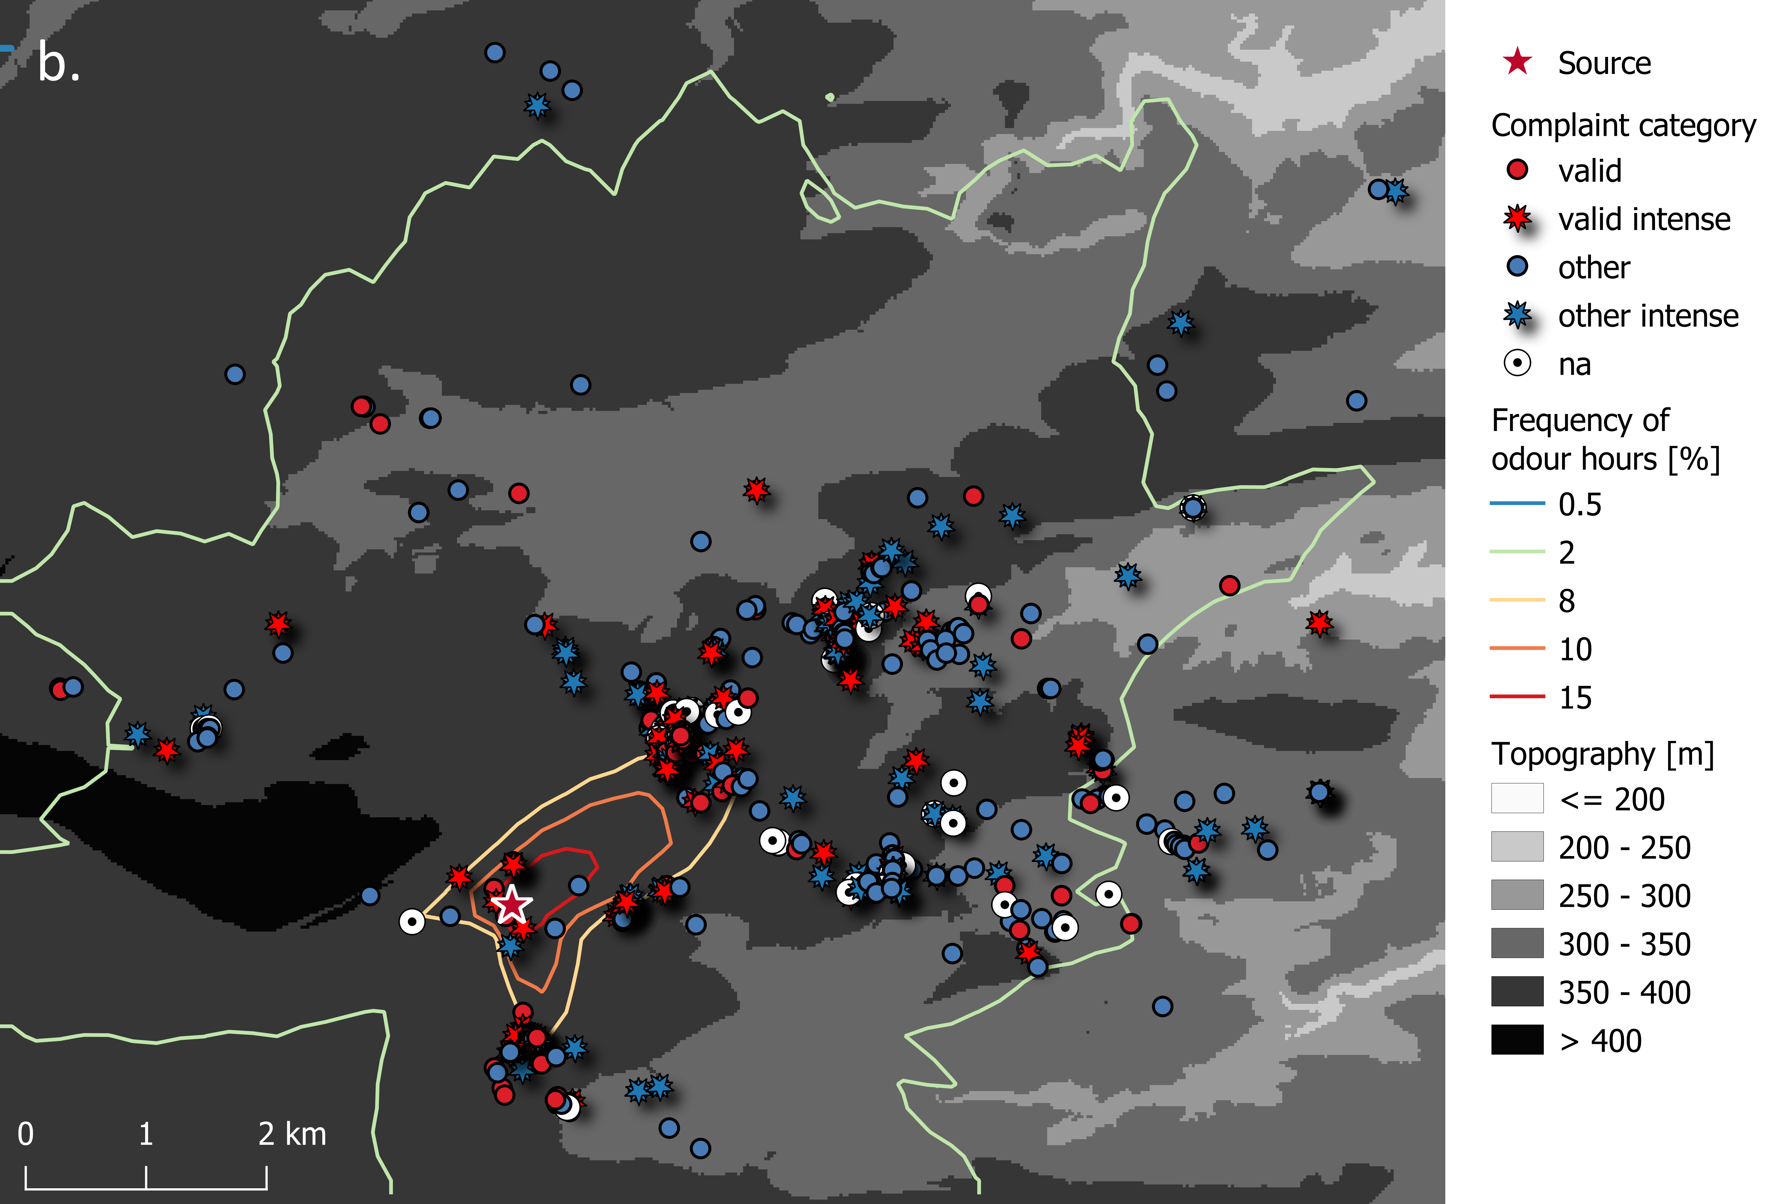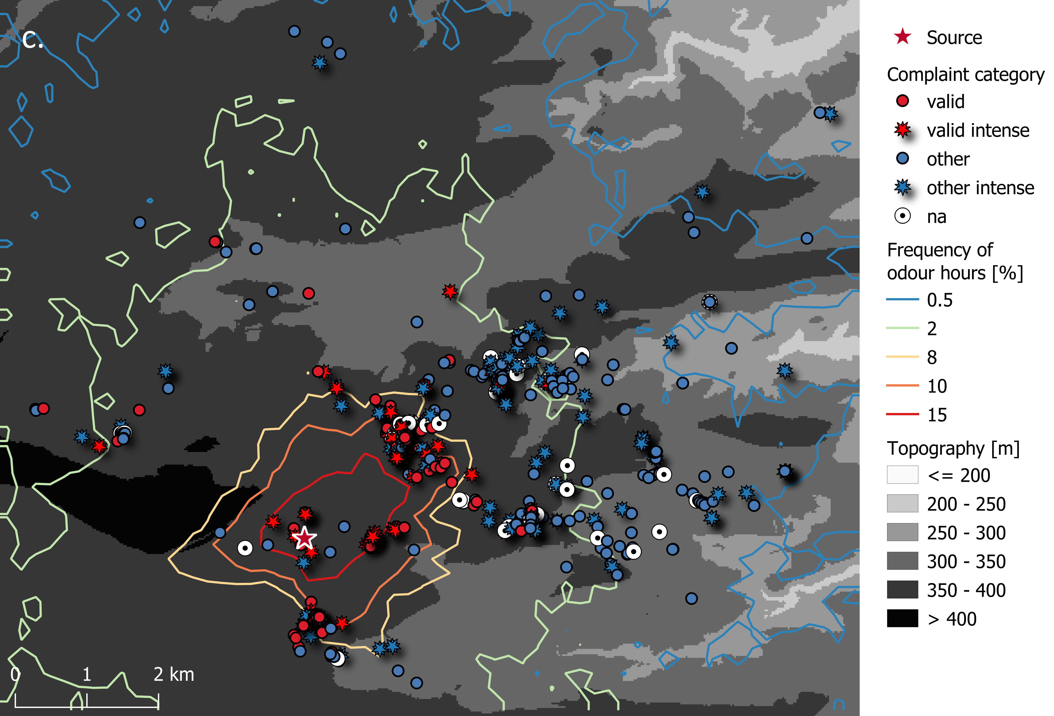

Figure 5: Spatial distribution of complaints categorized according to validity and intensity for (a.) SYMOS, (b.) AUSTAL and (c.) GRAL using Ct = 1 OUE*∙m−3*. *Separation distances correspond to the frequency of odour hours*.

* 1. Conclusions

The comparison of Gaussian and Lagrangian models with field measurements and complaints records indicated important findings regarding model capabilities and the implementation of different peak-to-mean factors. AUSTAL and SYMOS generally underpredicted the frequency of odour hours at the reference points sampled around the pig-fattening farm. Model formulation was considered to be the reason of inconsistencies, given the need of a high peak-to-mean ratio to compensate the estimation of low concentrations. Furthermore, there is an inevitable disagreement between the calculation of mean concentrations, a linear process by definition, and the measurements via field inspections, which represent a nonlinear reality. The best performance was achieved by GRAL using CVM with buildings and AUSTAL using *R90* = 4 without buildings.

On the other hand, the analysis of the feed production industry evidenced a greater agreement between the models using the respective peak-to-mean factors and a concentration threshold of 1 OUE∙m−3, although it also revealed the AirQ system may need to be adjusted for a more accurate assessment. AUSTAL confirmed the validity of almost half of the complaints with high reported intensities, while GRAL and SYMOS asserted to validate 38 % of such complaints. The shortcomings of GRAL could be explained by the use of binned meteorological data to decrease computation time, which restricts the prediction of a detailed time series and smooths off the impact of wind direction. As a future experiment, it would be useful to run the model on transient mode and observe how the evaluation might change. The calculation of separation distances supported the convenience of OIC combining an exceedance probability of 2 % to 8 % and a threshold of 1 OUE∙m−3 to reduce discrepancies between models and avoid nuisance in the population.

Results lead to the conclusion that a methodology like CVM to obtain sub-hourly peak concentrations proved to be more accurate than the use of a constant factor, which can cause overestimations, especially at large distances from the source.

Nomenclature

Ct – threshold concentration, OUE∙m−3

R90 – ratio of 1-h mean to 90th percentile concentration

Acknowledgements

The work was funded by the project of the Technology Agency of the Czech Republic No. TITOMZP903.

References

Bächlin W., Rühling A., Lohmeyer A., 2002, (in German) Preparation of validation data for odour dispersion models - field measurements. Project BWE 20003.

Brancher M., Griffiths K., Franco D., De Melo Lisboa H., 2017, A review of odour impact criteria in selected countries around the world, Chemosphere, 168, 1531–1570.

Brancher M., Hieden A., Baumann-Stanzer K., Schauberger G., Piringer M., 2020, Performance evaluation of approaches to predict sub-hourly peak odour concentrations, Atmospheric Environment: X, 7, 1–20.

EN 16841-1, 2017, Ambient air - Determination of odour in ambient air by using field inspection - Part 1: Grid method.

GOAA, 2008, Guideline on Odour in Ambient Air (GOAA), Detection and Assessment of Odour in Ambient Air.

Janicke Consulting, 2013, Dispersion Model LASAT. Reference/Working Book for Version 3.3.

Oettl D., Kropsch M., Mandl M., 2018, Odour assessment in the vicinity of a pig-fatting farm using field inspections (EN 16841-1) and dispersion modelling, Atmospheric Environment, 181, 54–60.

Patiño W.R., Duong V.M., 2022, Intercomparison of Gaussian Plume Dispersion Models Applied to Sulfur Dioxide Emissions from a Stationary Source in the Suburban Area of Prague, Czech Republic, Environmental Modelling & Assessment, 27, 119–137.

Piringer M., Knaude W., Petz E., Schauberger G., 2015, A comparison of separation distances against odour annoyance calculated with two models, Atmospheric Environment, 116, 22–35.

Sommer-Quabach E., Piringer P., Petz, E. Schauberger G., 2014, Comparability of separation distances between odour sources and residential areas determined by various national odour impact criteria, Atmospheric Environment, 95, 20–28.

Souza F., Hoinaski L., De Melo Lisboa H., 2014, Comparison of AERMOD and SYMOS'97 models for calculating odor dispersion: A study case in Uttenweiler, 1st International Seminar of Odours in the Environment, Santiago, Chile, p. 7.

Wensauer E., Neser S., Rattinger K., Schneider F., 2006, (in German) Application of the TA Luft model austal2000-g to assess emissions from agricultural sources. Publication series of the Bavarian State Institute for Agriculture, 15, 127–143.