CHEMICAL ENGINEERING TRANSACTIONS  VOL. 95, 2022 | A publication of
The Italian Association
of Chemical Engineering
Online at www.cetjournal.it

Guest Editors: Selena Sironi, Laura Capelli
Copyright © 2022, AIDIC Servizi S.r.l.
ISBN 978-88-95608-94-5; ISSN 2283-9216

Resistive Metal Oxide combined with optical gas sensor in an electro-optical nose for odour monitoring
Félix Meléndezª, Patricia Arroyoª, Jaime Gómez-Suárezª, José Pedro Santos^{b}, Jesús Lozanoª,*
ªEscuela de Ingenierías Industriales, Universidad de Extremadura, Badajoz (Spain)
^{b}Instituto de Tecnologías Físicas y de la Información, CSIC, Madrid (Spain)
jesuslozano@unex.es
This paper describes a prototype of artificial olfactory system or electro-optical nose (NEONOSE) containing commercially available MOX and optical (NDIR) gas sensors, forming an array of a total of 13 sensors (six MOX and seven NDIR sensors). The advantage of this configuration is to combine non-specific (MOX) and specific (NDIR) sensors to obtain an orthogonal array of sensors with a wider spectrum of responses. All the electronic circuits have been designed for this application. The prototype consists of two boards (containing different type of sensors) with two microcontrollers that communicates each other by using a digital interface. The Main Board is responsible for collecting the measurements from all the sensors and transmitting them via Bluetooth to a Smartphone. All the sensors that transmit data via I²C bus, which are all the MOX sensors and one of the optical sensors, are located on this board (main). The Secondary Board contains other NDIR sensors and is responsible for processing and sending this data to the Main Board via SPI communication. All the sensors of the Secondary Board are NDIR type. Some of them return the values in analog format, requiring the use of operational amplifiers for signal processing and analog-to-digital converters for data generation. The pre-processed data of all the sensors are sent via Bluetooth to an Android smartphone, where they are collected and stored using an own-developed application. Some measurements with different industrial gases have been done for testing the device.

Keywords: metal-oxide sensors (MOX), optical sensors, electronic nose, smartphone, gas sensors.
  - Introduction
Artificial olfactory systems, commonly known as electronic noses (e-noses), are devices that try to mimic the biological sense of smell but eliminate its subjective component and exhaustion. The most well-known, although often criticized, definition of electronic nose is the following: An e-nose is an instrument, which comprises an array of electronic chemical sensors with partial specificity and an appropriate pattern-recognition system, capable of recognizing simple or complex odors” (Gardner and Bartlett 1992). The parallels between the two are enormous, as an artificial olfactory system reproduces all the stages of a biological one. An e-nose has four main parts (Lozano et al., 2016): the sampling system, that carry the odorous compounds to the next part: the sensing part, which consists of an array of gas sensors; the instrumentation system, where the signals are measured and the data processing stage, where the signals are first pre-processed and pass through a pattern recognition system; and later are classified into previously learned classes by using a wide variety of techniques (Marco and Gutiérrez-Gálvez, 2012; Gutiérrez-Osuna, 2002).

The electronic noses are used in a wide variety of applications and industries (Santos et al. 2018), with a current trend of using low-cost, low-consumption and low-size sensors (Wilson et al., 2009; Karakaya et al., 2020). For example, devices have been developed to monitor urban pollution and odours (Capelli et al., 2014, Suarez et al., 2018), to measure the air exhaled by patients for the early diagnosis of different diseases in medicine (Sánchez-Vicente et al., 2020), for detection of explosives (Gardner, 2004), and for determining the quality properties of food (Loufti et al., 2015) and beverages (Ghasemi-Varnamkhasti et al., 2011).

For all of these applications, there are several types of gas sensors commonly used in electronic noses (Zohora et al., 2013), such as electrochemical, Metal Oxide Semiconductor (MOX), Non-Dispersive Infrared (NDIR), conducting polymer (CP), surface acoustic wave (SAW), and quartz crystal microbalances (QMB) sensors.

This paper describes the Nano-Electro-Optical Nose, or NEONOSE, which is a prototype electronic nose that MOX and NDIR sensors. These two technologies work in different ways. MOX sensors consist of a resistor whose resistive value varies depending on the gas present in the environment. In addition, they operate at a high temperature, so they need a second resistor that functions as a heater. NDIR sensors are based on the refraction of infrared light in the gas, which varies according to the gas present in the environment.
  - Description of the device
This electronic nose consists of two printed circuit boards (PCBs) that communicate with each other via SPI bus using a protocol designed specifically for this application. Each of these boards has the same microcontroller, the PIC32MM0256GPM048 from Microchip Technology Inc. (Chandler, AZ, USA). This is a 32-bit microcontroller that has 32 KB of data memory, 256 KB of program memory, a frequency of 24 MHz, a 24-channel and 12-bit resolution analog-to-digital converter, and several I²C, SPI, and UART communication modules, among other features. The two boards are arranged opposite each other, separated by a gas cell where the sensors of the two boards are located. This cell contains gas inlet and outlet holes and a gasket to make the cell airtight. The description of the device will be done by describing each of its PCBs separately. A block diagram of the NEONOSE is shown in Figure 1.

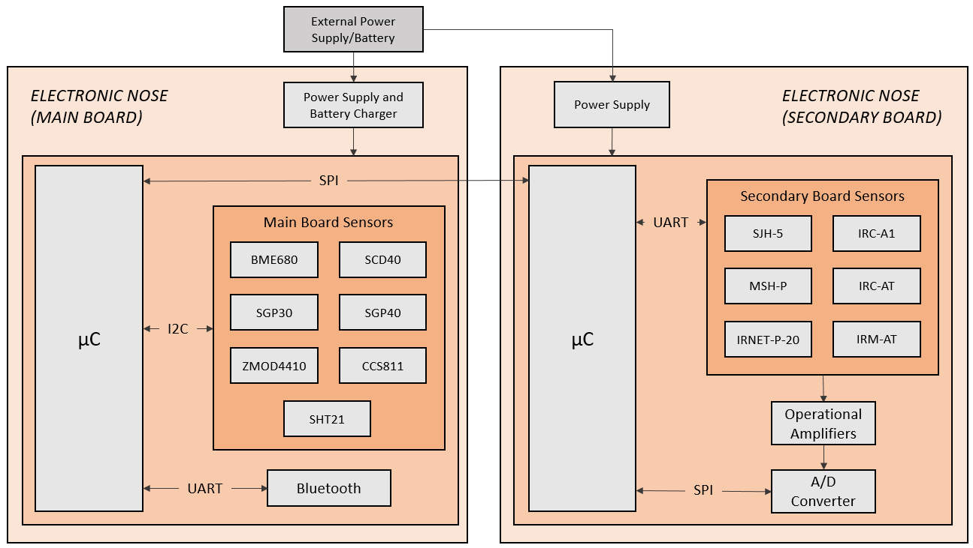
Figure 1: Block diagram of the NEONOSE.
    - Main board
As for the main board, it is shown in Figure 2 left, and this contains all the MOX sensors and one NDIR sensor, as all of these have an I²C communication interface and return data in digital format. These sensors are the following:
- BME680 from Bosch Sensortech GmbH (Germany): MOX sensor that returns values for temperature, relative humidity, pressure and sensor resistive value.
- CCS811 from ScioSense B.V. (The Netherlands): MOX sensor that returns values for carbon dioxide (CO₂), total volatile organic compounds (TVOC) and sensor resistive value.
- ZMOD4410 from Renesas Electronics Corporation (Japan): MOX sensor returning raw resistance values, raw ethanol values, and processed CO₂, TVOC and Air Quality Index (IAQ) values.
- SGP30 from Sensirion AG (Switzerlad): MOX sensor returning CO₂, TVOC, and raw resistive values of H₂ and ethanol.
- Sensirion SGP40: MOX sensor returning raw resistive value from the sensor. The SGP0 can return the air quality index using the manufacturer’s algorithm.
- Sensirion SHT21: MOX sensor that returns temperature and relative humidity values. It is the only sensor that is placed outside the gas cell, in order to compare the temperature and relative humidity values outside and inside the cell.
- Sensirion SCD40: This is the only NDIR sensor on the main board, and returns CO₂, temperature and relative humidity values.

One of the main features of the main board is that it contains a Bluetooth module to transmit data to an Android Smartphone, using an application developed for this nose. The communication follows an ASCII-based communication protocol, in which data and commands can be transmitted and received. The Bluetooth module used is Microchip's RN4871, which is a Bluetooth Low Energy module that enables UART Transparent Service for serial communication.

As for power supplies, this board contains a +3.3 V_{DC} supply, the TPS63001 from Texas Instrument Inc. (Dallas, TX, USA), which draws its power from a +3.7 V_{DC} lithium polymer battery. A +1.8 V_{DC} linear regulator, Microchip's MIC5504, has also been incorporated for components operating at this voltage. Microchip's MCP73831T charger and a micro USB-B connector are integrated for charging the battery.

Finally, other features on the main board include a controller for a solenoid valve, which allows the microcontroller to choose between two gas inputs via the solenoid valve; and an RGB LED to indicate the air quality index by color coding.

    - Secondary board
Regarding the secondary board, it contains the rest of the NDIR sensors. It is responsible for processing and sending the data obtained from the sensors via SPI bus to the main board. This board is shown in Figure 2 right.
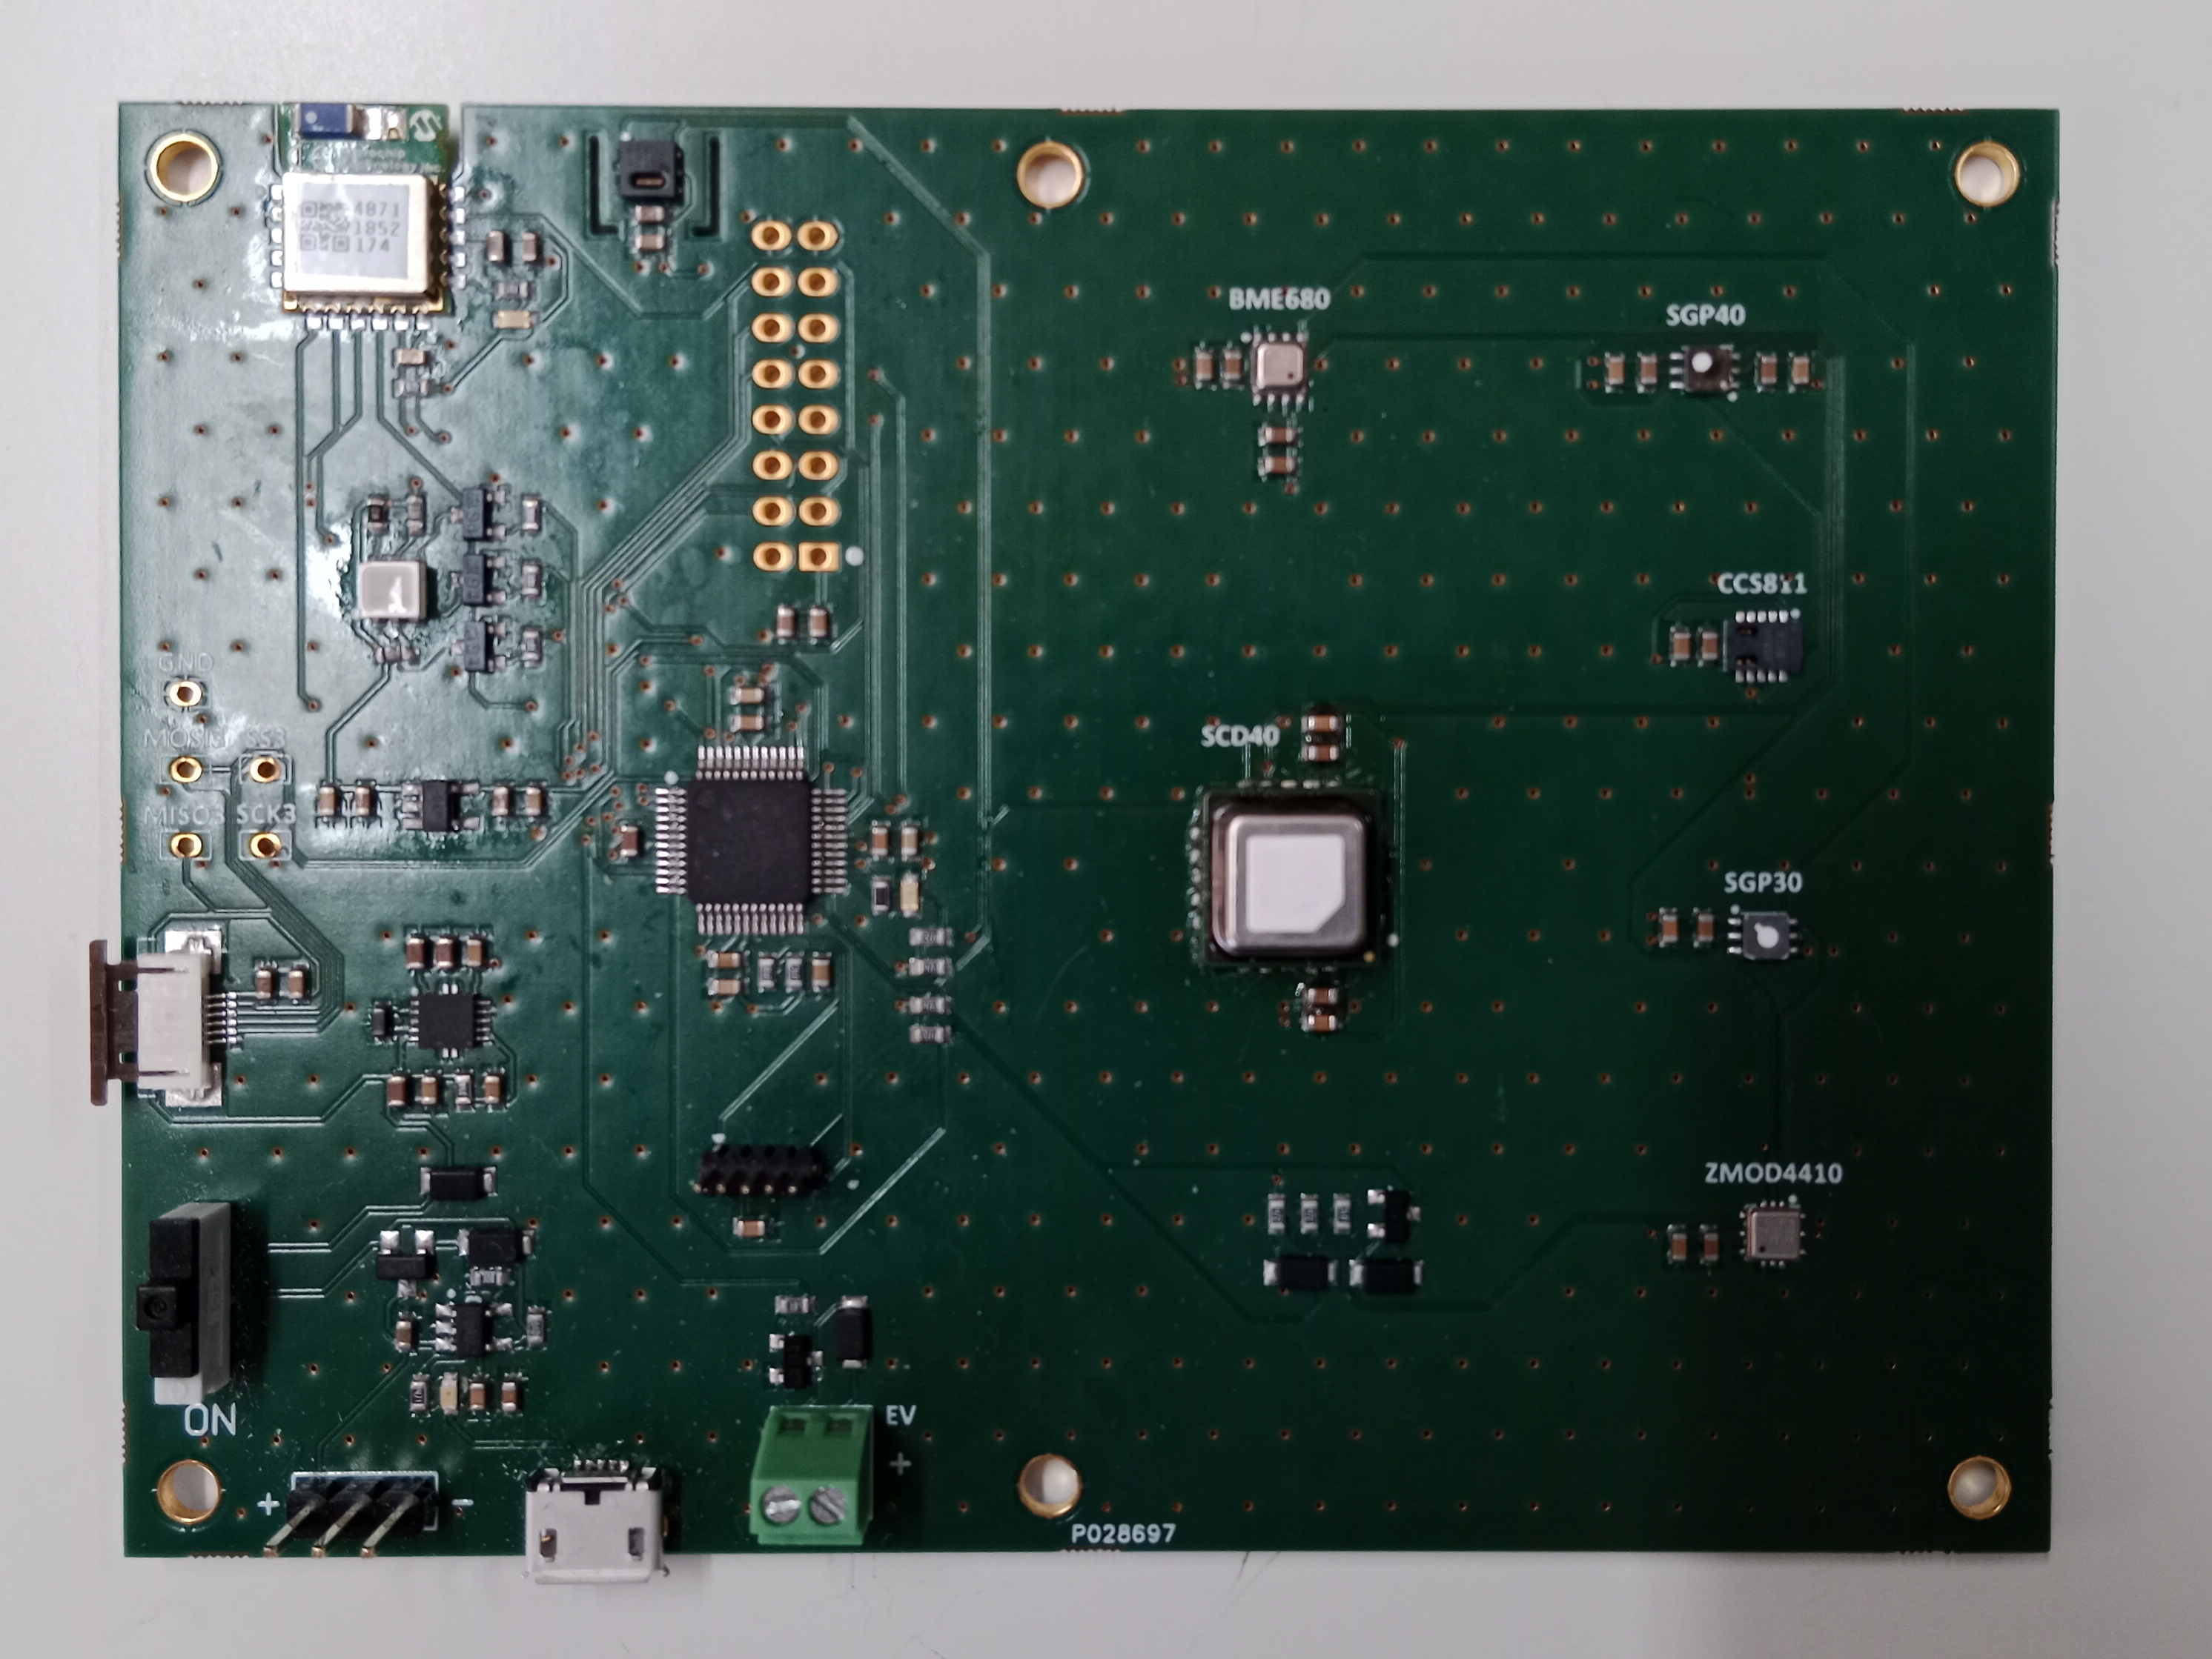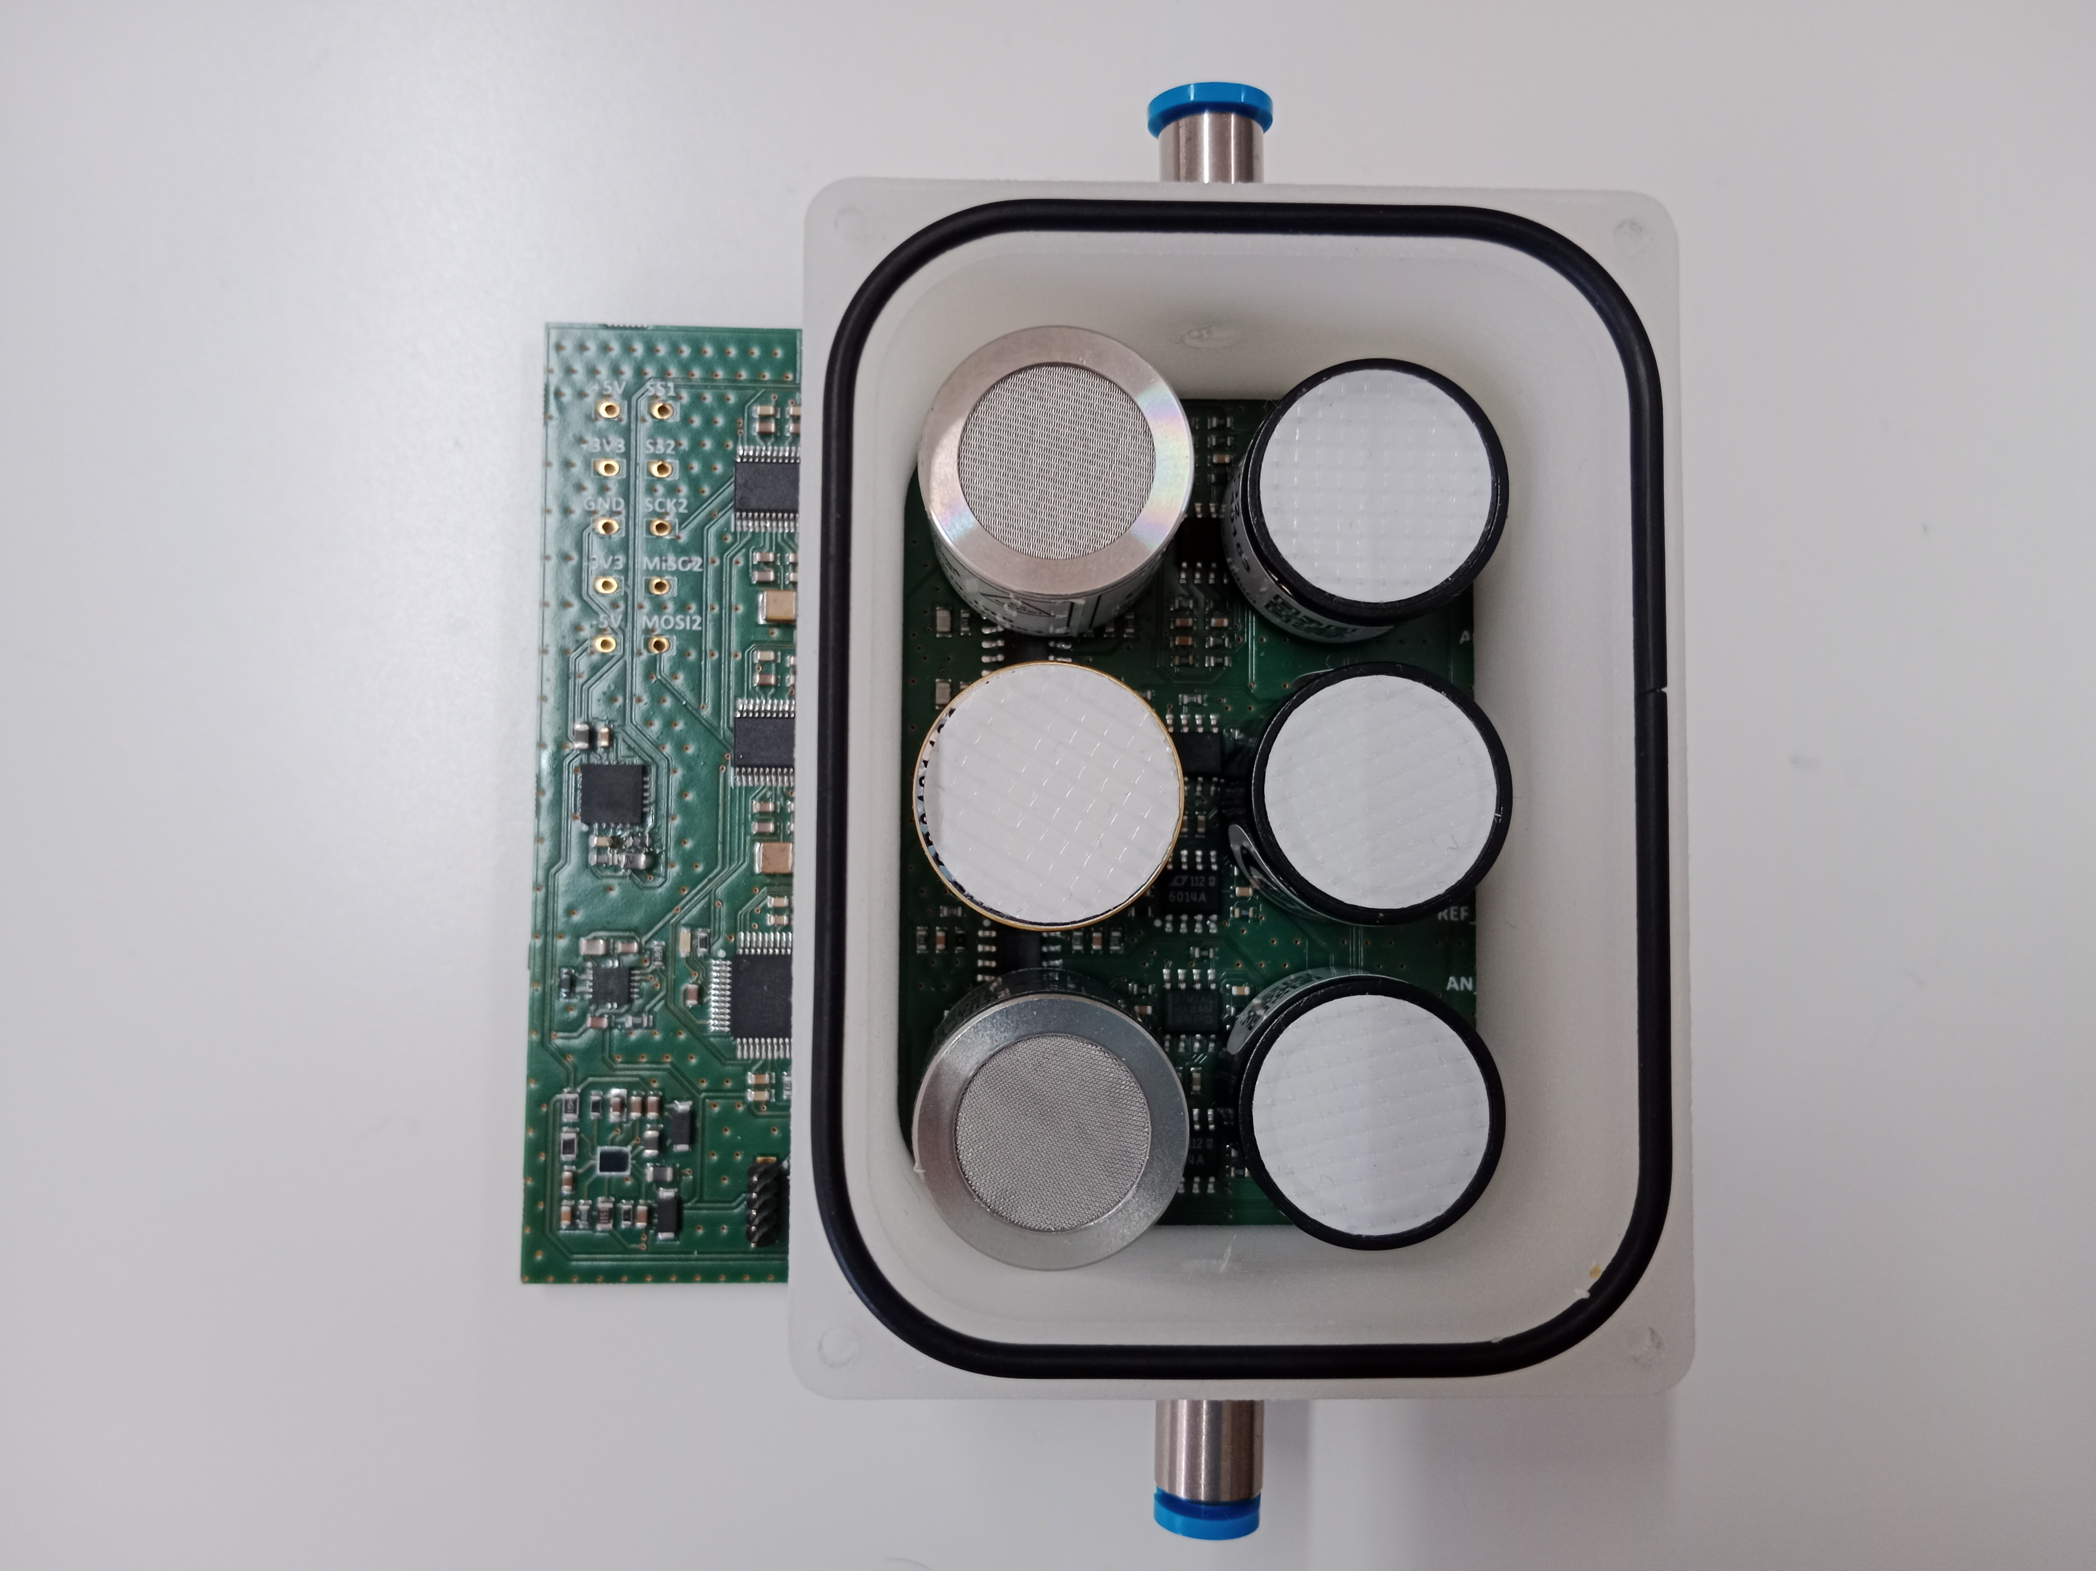
Figure 2: Main board PCB (left) and secondary board PCB with the gas cell (right)

The secondary board contains 6 NDIR sensors and all of them return the results in analog format, 3 of them also return values in digital format through UART communication. These sensors are as follows:
- SJH-5 from Cubic Sensor and Instrument Co., Ltd (China): Methane (CH4) sensor. It has analog signal and UART communication for data acquisition and sensor configuration. It returns two values (one analog and one digital).
- MSH-P from Dynament Limited (UK): Nitrous oxide (N2O) sensor. It has analog signal and UART communication for data acquisition and sensor configuration. It returns two values (one analog and one digital).
- IRNET-P-20 from Nano Enviromental Technology S.r.l (Italy): Methane (CH4) sensor. It has analog signal and UART communication for data acquisition and sensor configuration. Returns two values (one analog and one digital).
- IRC-A1 from Alphasense Ltd (UK): CO2 sensor. Returns three analog values.
- Alphasense IRC-AT: CO2 sensor. Returns three analog values.
- Alphasense IRM-AT: CH4 sensor. Returns three analog values.

Operational amplifiers and analog-to-digital converters have been used to process the data returned by these sensors. The operational amplifiers used are the TLC27M2ACD from Texas Instrument, the LT6014 from Analog Devices Inc. (Wilmington, MA, USA), and the MCP6004 from Microchip. The outputs of these amplifiers are passed to A/D converters.

The analog-to-digital converter used is the ADS8688AT from Texas Instruments. It is a 16-bit successive approximation converter, operates at 500 kSPS and has 8 channels, so it is necessary to use two converters for the twelve analog signals.

As for the voltages at which this board works, several power supplies have been used that adapt the battery voltage to different voltage levels. The ADP5076 from Analog Devices provides two voltages of +5 V_{DC} and -5 V_{DC}; the STBBY-APUR from STMicroelectronics (Switzerland) provides a voltage of +3.3 V_{DC}; and the TPS7A33 from Texas Instrument, with a voltage of -3.3 V_{DC}.
    - Communication protocol
As mentioned above, the transmission of all the data obtained is done through Bluetooth following a communication protocol. According to this protocol, every two seconds all the signals from all the sensors are sent, separated by tabs, giving rise to a table in which each row represents a measurement and each column the measurements of each sensor. Therefore, every 2 seconds, a new row is added to this table.
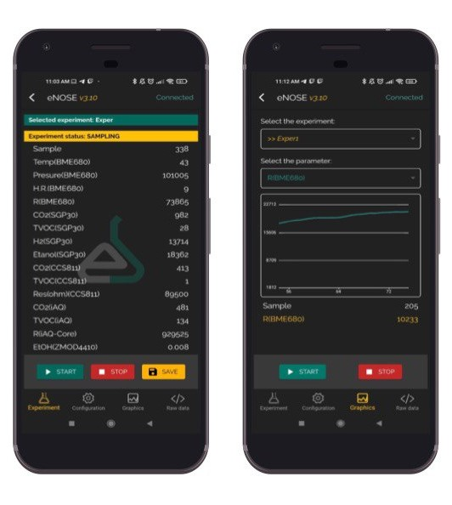
Figure 3. Developed application screenshots. (left) Data from the sensors; (right) Graphic with the time evolution from one of the signals.

The reception of the data is performed in an application for smartphones with Android operating system, specifically designed for this nose The application, called eNoseLab, is shown in Figure 3. This application has a simple user interface consisting with two main sections:
- Configuration section: in this section the sampling time (default is 2 seconds), the desorption time (the time in which the nose is sniffing the reference air or gas) and the adsorption time (the time in which the nose is sniffing the sample) can be configured, being 60 s the default time in the latter two. In addition, information on the set times can also be obtained.
- Experiments section: this is the section where the experiment data are taken. It consists of three buttons, Start, Stop and Save, which allow you to start and stop the experiment and store the data, respectively. It also has the option to manually send other ASCII-based commands, for example, to obtain information about the device (software version, device name, etc).
  - Results
The developed device has been tested by performing some preliminary experiments with industrial gases. Specifically, the compounds acetone, ammonia, dichloromethane, xylene, water and dimethylacetamide were measured. The sampling method used was the static headspace method with effluent transfer. For this purpose, the samples were dissolved in water at a concentration of 2% and kept at 30 ºC during the experiment. Ten repetitions were carried out for each sample. Every repetition is 4 minutes long, 3 minutes of reference air sampling and one minute of target gas sampling. Fig. 3 shows the temporal responses of some of the sensors to seven repetitions of the dimethylacetamide compound.

Subsequently, in order to reduce the dimensionality of the data, a characteristic value was extracted for each of the measurement cycles using the baseline manipulation technique. A principal component analysis (PCA) was then performed for data visualization in a plot. The discrimination capability of the device can be seen in Fig. 4, where the first three principal components (84.7% of explained variance) are plotted. It is noted that clusters from each of the measured compounds are well separated. Some of them are located far (Acetone and Ammonia) and other compounds are plotted near in the PCA (Dichloromethane, Xylene and Dimethylacetamide.
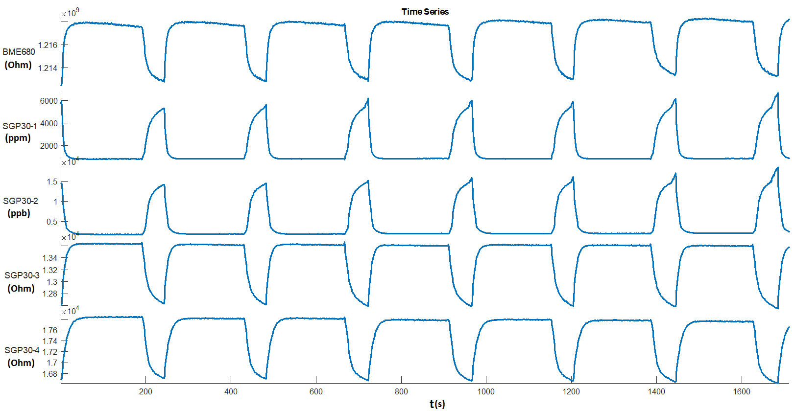
Figure 3. Temporal response of gas sensors to Dimethylacetamide.
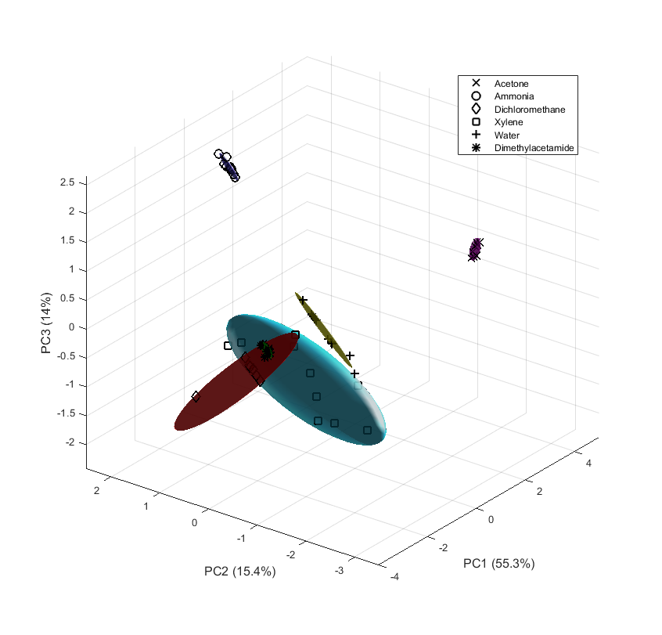
Figure 4. PCA plot with three principal components.
  - Conclusions
A novel electronic nose with optical and resistive gas sensors have been developed and have been tested with some chemical agents. The combination of gas sensors with different principle of functioning could be a good alternative to increase the detection capability maintaining the low cost of the device. The use of specific sensors with high sensitive to some chemical compounds will be used for calibration purposes and to obtain accuracy measurements with less interferences to some target compounds.
Acknowledgments
Authors want to thank the Spanish Ministry of Science and Innovation for supporting the NEOGAS project (PID2019-107697RB) and Junta de Extremadura and FEDER for supporting the grant GR21045.
References
Capelli, L., Sironi, S., & Del Rosso, R. (2014). Electronic noses for environmental monitoring applications. Sensors, 14(11), 19979-20007.
Gardner, J. W., & Bartlett, P. N. (Eds.). (1992). Sensors and sensory systems for an electronic nose. Dordrecht: Kluwer Academic.
Gardner, J. W. (2004). Review of conventional electronic noses and their possible application to the detection of explosives. In Electronic Noses & Sensors for the Detection of Explosives (pp. 1-28). Springer, Dordrecht.
Ghasemi-Varnamkhasti, M., Mohtasebi, S. S., Rodriguez-Mendez, M. L., Lozano, J., Razavi, S. H., & Ahmadi, H. (2011). Potential application of electronic nose technology in brewery. Trends in Food Science & Technology, 22(4), 165-174.
Gutierrez-Osuna, R. (2002). Pattern analysis for machine olfaction: A review. IEEE Sensors journal, 2(3), 189-202.
Karakaya, D., Ulucan, O., & Turkan, M. (2020). Electronic nose and its applications: A survey. International journal of Automation and Computing, 17(2), 179-209.
Loutfi, A., Coradeschi, S., Mani, G. K., Shankar, P., & Rayappan, J. B. B. (2015). Electronic noses for food quality: A review. Journal of Food Engineering, 144, 103-111.
Lozano, J., Santos, J. P., & Horrillo, M. C. (2016). Wine applications with electronic noses. In Electronic Noses and Tongues in Food Science (pp. 137-148). Academic Press.
Marco, S., & Gutierrez-Galvez, A. (2012). Signal and data processing for machine olfaction and chemical sensing: A review. IEEE Sensors Journal, 12(11), 3189-3214.
Sánchez, C., Santos, J. P., & Lozano, J. (2019). Use of electronic noses for diagnosis of digestive and respiratory diseases through the breath. Biosensors, 9(1), 35.
Santos, J.P., Aleixandre, M., Arroyo, P., Suarez, J.I., Lozano J. An Advanced Hand Held Electronic Nose for Ambient Air Applications. Chemical Engineering Transactions 68 (2014), 235-240
Suarez, J.I., Lozano, J., Arroyo, P., Herrero, J.L., Carmona, P. Bluetooth Electronic Nose for Odour Monitoring and Control. Chemical Engineering transactions 68, (2018) 211-216
Wilson, A. D., & Baietto, M. (2009). Applications and advances in electronic-nose technologies. Sensors, 9(7), 5099-5148.
Zohora, S. E., Khan, A. M., & Hundewale, N. (2013). Chemical sensors employed in electronic noses: A review. Advances in computing and information technology, 177-184.

