 CHEMICAL ENGINEERING TRANSACTIONS  VOL. | A publication of  
The Italian Association
of Chemical Engineering
Online at www.cetjournal.it
Guest Editors:
Copyright © AIDIC Servizi S.r.l.
ISBN 978-88-95608-xx-x ISSN 2283-9216

Importance of Musty Odour Character in the Emissions from Anaerobically Stabilized Dewatered Biosolids. Towards the Identification of Unknown Odour Components.
Radoslaw J Barczak ^{a,b,*}, Ruth M. Fisher ^{b}, Richard M. Stuetz ^{b}
ª Faculty of Chemistry, University of Warsaw, 1 Pasteura Street, 02-093 Warsaw, Poland
^{b} UNSW Australia, School of Civil and Environmental Engineering, Sydney, Australia
* corresponding: rbarczak@chem.uw.edu.pl
Odours from stabilized anaerobically digested wastewater sludge – biosolids can cause local community odorous impact. Contributions from some volatile organic compounds (VOCs) to nuisance odours are not well understood. The analytical identification of compounds with low odour detection thresholds (ODTs) at low concentrations, are challenging. The knowledge about the odour composition from biosolids emission is still limited. In this study thirty-six biosolids samples were taken after anaerobic stabilisation and dewatering at a wastewater treatment plant in Sydney, Australia to investigate the musty type of odorous events during gas chromatography (GC) coupled with mass spectrometer detector (MSD) and an olfactory detection port (ODP) analysis. Biosolid cake samples were stored under aerobic conditions in loosely covered trays for a period of 35 days. Emissions were collected onto Tenax TA sorbent tubes using a U.S. EPA flux hood method at storage days 1, 3, 7, 10, 14, 21 and 35. GC-MS/ODP was used to identify musty type odorous events in the biosolids emissions as potential chemical compounds, however without its chemical detection via MSD. Measured odour intensities, classified on a scale from 1 to 4, and odour characters were specified by three ODP assessors. Two musty type odorous events were identified in all biosolid cake emissions. The measured odour intensities of the musty type odorant(s) did not significantly alter as the biosolids were aged, however varied between biosolids cakes. Due to its odour intensity, similarity with biosolids odours, frequency of detection and its likely low ODT two musty odorous events should be considered as a potential odorant(-s) of concern in biosolids emissions.
  - Introduction
Odours are a common occurrence at and around wastewater treatment plants (WWTP), biosolids processing facilities and biosolids application locations (Hayes et al., 2014; Fisher et al., 2018; Bylinski et al., 2019). In order to improve strategies for minimising odour impact on local communities (Hayes et al., 2017), it is necessary to identify odorants and their fate during the biosolids processing, storage and land application. In the past, in many developed countries biosolids were commonly disposed by incineration, ocean dumping, or to landfills (Currie et al., 2003). More recently, following the waste hierarchy beneficial reuse of biosolids to agricultural land are encouraged due to their nutrient content as fertilizers (Collivignarelli et al., 2019). In most countries, the quality of biosolids applied to land is regulated by environmental legislation but its odorous impact has limited regulations. Odour impact is one of the key reasons invoking public concern and complaints during land applications (Bob et al., 2006). The formation of odours during processing, storage, transportation and land application is still an area of research. Odour production in biosolids is a complex process influenced by several factors including, but not limited to, process variables within anaerobic digestion and dewatering processes, as well as the relationships between odour perception and the concentration of odorants (Adams, 2004).
Odours from biosolid emissions are a complicated matrix, containing well known odorants such as volatile sulfur compounds as well as a variety of volatile organic compounds (VOCs) (Fisher et al., 2017). High concentrations of odorants such as sulfur and nitrogen compounds, volatile fatty acids, aldehydes, ketones and indole and skatole (de Luca et al., 1996; Rosenfeld and Suffet, 2004) have been detected in emissions from biosolids and are known malodours. Many of the odorous compounds are a result of organic matter degradation, generating sulfidic and putrid/rancid type odours associated with biosolids (Suffet et al., 2009; Agus et al., 2012). Other odour descriptors associated with sludge digestion are putrescent, greasy, and cabbage-like odors (Agus et al., 2012), while the resultant biosolids may have moldy, musty, fecal and fishy odour characters or qualities (Suffet et al., 2009). Apart from the well-known odorants associated with organic matter degradation, such as sulfur compounds and ammonia, the participation of other VOCs in the overall odour matrix has not been well characterised. Such compounds can contribute to the overall odour properties of emissions, as even low impact odorants that are generally considered unimportant in odour perception can have great significance in total odour perception (Ryan et al., 2008, Barczak et al. 2022). It is therefore essential to identify and quantify the trace VOCs, as these compounds can contribute to the overall odour (Zhou et al., 2016).
Currently, there is a knowledge gap regarding the odorants composition of biosolid odours contributing to earthy/musty/moldy type characters, which Suffet et al. (2009) describes as a one of the 11 dominant odour categories from biosolids emissions. Fisher et al. (2018) included musty/earthy odour type in biosolids processing odour wheel. Musty and moldy type odours are assigned categories in the odorous descriptors related with municipal management facilities: odour wheels dedicated to wastewater, compost, landfill, wastewater collection network (Suffet et al., 2004; Rosenfeld et al., 2007; Suffet and Rosenfeld, 2007; Decottignies et al., 2013; Curren et al., 2016).
This study will detail the identification of odorous signals, responsible for musty type odour characters in biosolids emissions using a combination of analytical and sensorial approaches.
  - Methodology
    - Wastewater biosolids process description
Biosolids samples were collected from a mechanical biological WWTP catering for an equivalent population (EP) of 200 000 located in Sydney, Australia. The biosolids processing included a few steps: primary and waste activated sludge thickening, 1 or 2 days of retention in an acidified feed well and 22 days of retention in primary anaerobic gas mixed mesophilic digesters. Following anaerobic stabilisation, the sludge was dewatered using two high speed centrifuges with the biosolids being conveyed to a storage bay inside a shed.
    - Sampling and sample analysis
The 36 dewatered biosolids cakes with the approximate volume of 10L were sampled from the WWTP just after dewatering. The samples were transported and spread out in a tray with a dimension 0.6 x 0.4 x 0.2 m³. Emission samples were captured on day 1, 3, 7, 10, 14, 21 and 35 as the biosolids were stored in ambient conditions in the trays loosely sealed with a lid. In total 218 emission samples were captured using US EPA dynamic flux hoods operated according to AS/NZS 142 4323.4:2009. High purity nitrogen gas, at 5 L/min, was used to purge the hood for 30 minutes before the emission samples were collected. Emission samples were collected at a constant flow rate (100 mL/min for 10 min) using a calibrated SKC sampling pump (SKC Inc., USA) onto Tenax TA sorbent tubes in triplicate. Each sorbent tube was connected to an additional tube in series in case of breakthrough from the first tube.
Sample analysis was performed using thermal desorption with a gas chromatography combined with a mass spectrometry and an olfactory detection port (ODP). A DB-VRX 150 30m×0.25mm×1.4μm column, was utilised in the gas chromatograph for compound separation. The sorbent tubes were heated at 275°C for 8 min while high purity helium was passed through the sorbent tubes at the flow rate of 50 mL/min to desorb VOCs and pre-concentrated them onto a cold trap by a Peltier cooler. Following the sample transfer, the cold trap was heated to 300°C at 50°C/min heating rate to desorb the VOCs from the cold trap and then injected into the chromatographic column. A split flow of 20.7 mL/min was applied during tube and trap desorption to prevent column overloading. The GC column temperature was initially held at 50°C for 2 mins, then raised at a rate of 15°C/min to 200°C, and then held for 5 minutes. The eluent from the gas chromatograph was split between a mass spectrometer and an ODP. For an assessor to effectively sniff at the port, the split ratio between the MSD and ODP was set at 2:3 (MSD:ODP). Three ODP assessors, named AS1, AS2, AS3, complying with panelist requirements according to European Dynamic Olfactometry standard (EN 13725:2003), were used for the olfactory analysis. Two assessors AS1 and AS2 were trained according to the procedure described elsewhere (Barczak et al., 2018), whilst AS3 had previous experience with ODP analysis. Each ODP assessor analysed one of each triplicate sorbent tubes, the first one from the series of two. Intensities of odours detected from the ODP were recorded using a controller device or by hand with a scale from 1 to 4 (with 1 being the weakest and 4 the strongest odour intensity). Moreover, one assessor extended the scale for additional halves points: 0.5, 1.5, 2.5 and 3.5. ODP assessors used their own odour descriptors based on their own experience as well as descriptors from published compost and wastewater odour wheels (Suffet & Rosenfeld 2007). An ODP signal recording an odorous VOC was assumed to be valid if at least one assessor detected an odour signal at a similar retention time and similar odour character across all samples. The arithmetic means between assessors intensity values was calculated and is the basis for further discussion in the paper. Additionally, two assessors assessed suitable odour descriptors of emission from raw biosolids cake samples prior to emission sampling. The more detailed methodology was described elsewhere (Barczak et al. 2019).
The sensory research used in this project was conducted with approval of the Human Research Ethics Advisory Panel ‘H’ Science and Engineering of The University of New South Wales, Sydney, Australia.
  - Results and discussion
Using the GC-MSD/ODP system the two odour events with similar musty odour character were detected. The first one named M1 has been detected at the median retention time (RT) equal to 11, whilst the second one’s named M2 median RT was 11.74. The M1 odour was detected 192, 178 and 186 times whilst the M2 140, 63 and 118 times by the assessors AS1, AS2 and AS3 respectively (Table 1). The detailed descriptors used by assessors are presented in Table 1. The most common descriptors used for AS1 and AS2 were musty and wet cloth which are close to each other from the odour character perspective. The AS3 has been describing both of two odorous events as oily and only sporadically as chemical, urine and sulfur. Other descriptors periodically used at the identical retention time for assessor AS1 was herbaceous, hospital, sweet and few times assessor was unable to describe odour character; for assessor AS2 were herbaceous, solvent, sweet, hospital and occasionally astringent, roses, putrid, burning. As both of the odour events were not related to any identified peak matching the NIST databases it can be only speculated that their odour character change is based on their concentration or due to the similar retention times of other coeluted chemicals affecting the odour character. In the other authors work the other musty odorant presented in the biosolids emission 2,4,6-Trichloroanisole (TCA) was described with other than musty descriptors (Barczak et all. 2019). The authors described the TCA odorous events such as chemical, hospital, and astringent.
Table 1: Amount of detection and odour descriptors of musty related odorous signals from biosolids emission
Assessor | Number of detections |  | Odour descriptors (percentage% of detection)
 | M1 | M2 | M1 | M2
AS1 | 192 | 140 | Musty (89), wet cloth (5), herbaceous (3), something (3) | Musty (13), wet cloth (46), herbaceous (19), hospital (14), something (5), sweet (2)
AS2 | 178 | 63 | Musty (96), wet cloth (1), herbaceous (1), astringent (1), chemical (1), putrid (1), roses (1) | Musty (74), wet cloth (5), herbaceous (3), solvent (3), sweet (9), hospital (2), burning (1)
AS3 | 186 | 118 | Oily (98), urine (1), sulfur (1) | Oily (96), chemical (4)

The intensities of both musty odorous events over storage time for all 36 biosolids cakes are reported in Figure 1. Both odorous signals were detected in every biosolids cake, however not across the whole storage time. M1 was detected continuously as most of the cakes were aged (no. 5, 11, 14 and 22), however in some cakes (no. 3, 5, 26, 30) it was not detected on the first day of storage, whilst in others (no. 1, 2 and 27) it wasn’t present until later. In cakes no. 6, 23 to no. 30 and cakes no.33 to 36 it was no longer detectable after day 14 and 35 respectively. For some cases the detection was not observed continuously like in cakes 31 and 32 where there was not recorded any signal on day 21.
In some cakes (no. 4, 8, 22 and 25) M2 was not detected on the first day of storage, whereas in others (no. 1, 2 and 27) it wasn’t present until later in the cake ageing. In cakes no. 6, 9, 11, 22 to 25, 27, 29 to 31 and no. 2 to 5, 7, 10, 33, 34 and 36 it was no longer detectable after day 14 and 21, respectively. In two cakes no. 26 and 28 the M2 was detected only once, in both cases on day 7. Two detections were observed in cakes no. 24, 25 and 29.
The intensities of these two musty odour character patterns vary between biosolids cakes. The detection across the whole measurement period is only valid for cake no 14, 18 and 31 but with different intensity trends.
The boxplot of musty odour events odour intensity values in aged biosolids emission averaged between sampling days over 218 samples are shown at Figure 2. The odour intensity of M1 and M2 detected by assessors was typically lower than 3 and 2.5, respectively.
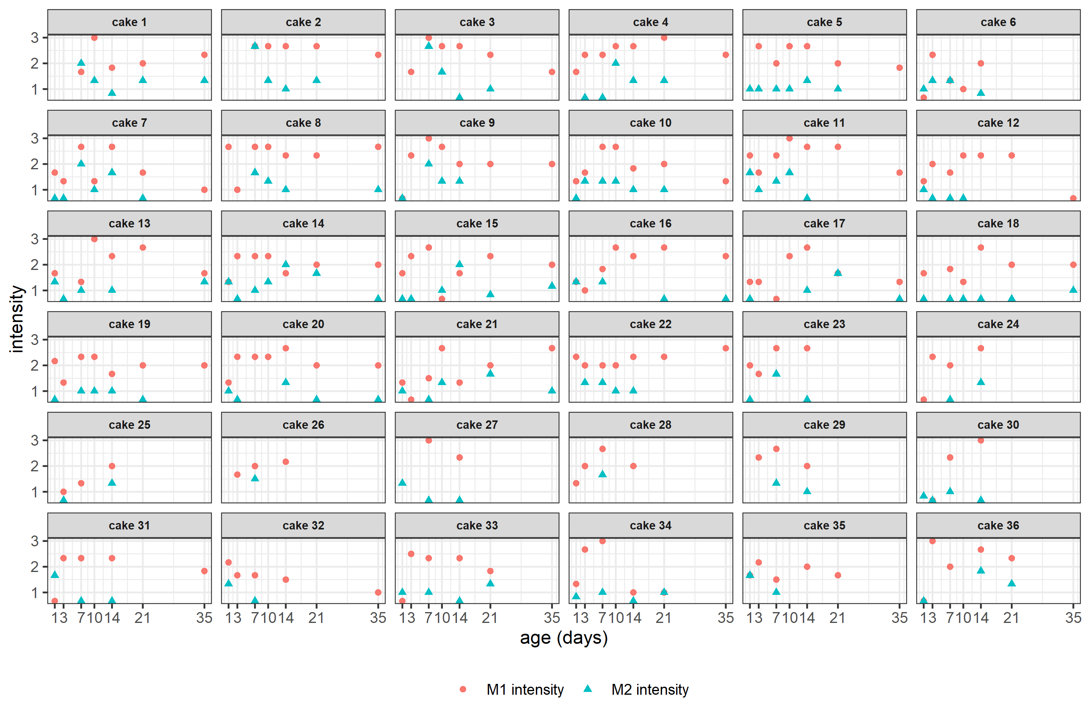
Figure 1: Arithmetic mean of odour intensity values belonging to two odorous signals with musty odour character obtained by gas chromatography coupled with olfactory detection port between 3 assessor’s in the emissions from stabilized biosolids cake after anaerobically digestion of wastewater sludge over storage time.
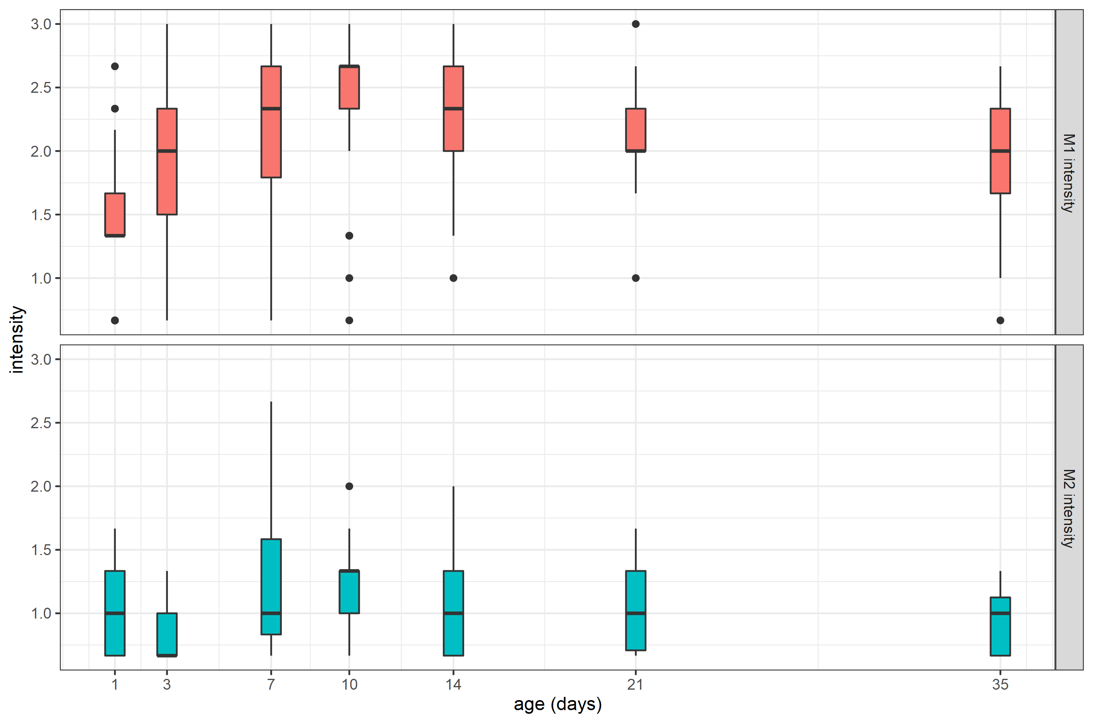
Figure 2: Arithmetic mean of musty odour events odour intensity values obtained by gas chromatography coupled with olfactory detection port between 3 assessor’s in aged biosolids emission averaged between sampling days over 218 samples showing mean and confidence intervals (95%) with ranges indicated by whiskers.
The presence of musty-like potential odorants in this study agree with Suffet et al. (2009) observation about odour nuisance emissions during wastewater biosolids composting conducted at two biosolids composting plants. The authors made sensory assessment and characterisation using Odour Profile Method analysis and reported that the biosolids compost product might be described by earthy, musty, grassy, woody, hay, manure odour type descriptors. Moreover, they observed that after about 20 days of composting earthy and musty odour character dominated and replaced fecal, sewery, and rotten type odours commonly reported in first weeks of composting. In this study two assessors assessed odour descriptors of raw biosolids cake samples prior to emission sampling. Following this study and Suffet’s et al. observations it can be concluded that the musty odour type was most likely masked by fecal, sewery, and rotten odours at the beginning of the biosolid storage. Barczak et al. (2019) described this observation about stored biosolids, where musty and mouldy odour characters become more distinct as the biosolids were stored. They observed that odour character changes as the biosolids are stored from fecal, sewery, and rotten vegetable odour type characters during the first two measurement days to moldy, musty and wet cloth odour type characters becoming dominant from day 7. The detected musty, moldy odour types in the work of Barczak et. al. (2019) may be caused, at least partially, by potential odorant(s) detected in this study due to its presence in emission. In this study the authors were focused on only two odorous events in the GC-MS/ODP analysis. From the chemical perspective to confirm the observation of the masking effect of musty odour type by fecal, sewery, and rotten vegetable odour characters in the raw biosolid emission the analysis of concentrations trends of chemicals responsible for these odours might be helpful. However, such analysis is not part of this work.
One of the attitudes of odours characterization is based on choosing the key odorants from the matrix. Vitko et al. (2016) narrowed down the large number of odorants detected at a WWTP to a manageable number of odorants, something they defined as “most detectable” odorants. Among odorants such as hydrogen sulfide (rotten eggs odour), ammonia, indole and skatole (fecal odour), they indicated two compounds, named 2-Methyl Isoborneol (MIB) and 2-Isopropyl-3-Methoxy-pyrazine (IPMP) as potentially most detectable odorants representing the musty odour character. In this study none of those two odorants were identified. Comparing the retention times of authentic standards of IPMP and MIB it could be confirmed that odorous events M1 and M2 belong to compounds other than MIB or IPMP. Taking into consideration the distinctive musty odour character in biosolids emission, the successful identification of M1 and M2 will allow including it into the potentially key odorants.
Detection of odorous events didn’t correspond to any reasonable signals from MSD. The lack of matches of the particular ions from the area of chromatograms corresponding to odour events might be caused by the low concentrations of potential odorants. Concentrations of those potential odorants might be below the detection limit of the instrument used.

  - Conclusions
Very little is known about musty odour character emissions from biosolids. Apart from well-known odorants such as sulphur and nitrogen compounds, the participation of other VOCs in overall odour mixture should not be unnoticed. Especially when the odour character hardly corresponds to the identified odorants. The detection of compounds with low odour threshold that are present at low concentrations is difficult in chemical analysis. The most popular gas-chromatography devices coupled with common chemical detectors like MS or FID are often not sensitive enough for detection of odorants present in ppb or ppt concentrations. Instead, approaches using combined analytical and sensorial methods are useful in identifying the presence of odorants in emission mixtures. In this study two musty odour character potential odorants were identified in all analysed samples of dewatered biosolids after the anaerobically stabilization process.
Intensity levels of musty character odorants do not show any increasing or decreasing trend as the biosolids were aged, whilst both are consistently present in stored biosolid samples. The potential odorants causing the musty odorous signal seem to be the odorants of importance in biosolids emission due to their low odour thresholds, frequent detection by ODP assessors and their odour character. Moreover, very limited data exists on qualitative analysis of musty type odours. Taking into consideration 36 different biosolids cakes at the different age of storage it could be concluded that due to their intensity and frequency of detection by ODP assessors two musty odorous events should be recognized in the future and be consider as odorants of concern in biosolids emission. Thus, the additional effort should be made to identify all odorants responsible for musty odour character in biosolids emission.
Acknowledgments
This work was supported by a Marie Curie International Outgoing Fellowship under the grant PIOF-GA - 2013-622523 OdourCOB within the seventh European Community Framework Programme, an OPUS-21 no. UMO-2021/41/B/ST8/03440 from National Science Centre, Poland (Radosław Barczak), an Australian Government Research Training Program (RTP) scholarship (Ruth Fisher) and the CRC for Low Carbon living project RP2008 (support by the Cooperative Research Centres program, an Australian Government initiative).
References
Adams, G.M., Witherspoon, J., 2004. Identifying and Controlling Municipal Wastewater Odor: Phase I, Literature Search and Review. IWA Publishing.
Agus, E., Zhang, L., Sedlak, D.L., 2012. A framework for identifying characteristic odor compounds in municipal wastewater effluent. Water Research 46, 5970-5980.
Barczak, R.J., Fisher, R.M., Le-Minh, N., Stuetz, R.M., 2019. Importance of 2,4,6-Trichloroanisole (TCA) as an odorant in the emissions from anaerobically stabilized dewatered biosolids. Chemosphere 236, 124340.
Barczak, R.J., Fisher, R.M., Le-Minh, N., Stuetz, R.M., 2022. Identification of volatile sulfur odorants emitted from ageing wastewater biosolids. Chemosphere 287, 132210.
Bob, F., Jay, W., Zeynep, E., Tim, S., Adams, G., Hargreaves, R., Morton, R., Novak, J., Higgins, M., 2006. Recent findings on biosolids cake odor reduction - midpoint results of werf phase 3 biosolids odor research. Proceedings of the Water Environment Federation 2006, 50-71.
Byliński, H., Barczak, R.J., Gębicki, J., Namieśnik, J., 2019. Monitoring of odors emitted from stabilized dewatered sludge subjected to aging using proton transfer reaction–mass spectrometry. Environmental Science and Pollution Research 26, 5500-5513.
Collivignarelli, M.C., Abba, A., Frattarola, A., Miino, M.C., Padovani, S., Katsoyiannis, I., Torretta, V., 2019. Legislation for the Reuse of Biosolids on Agricultural Land in Europe: Overview. Sustainability 11, 6015.
Curren, J., Hallis, S.A., Snyder, C.L., Suffet, I.H., 2016. Identification and quantification of nuisance odors at a trash transfer station. Waste Management 58, 52-61.
Currie, V.C., Angle, J.S., Hill, R.L., 2003. Biosolids application to soybeans and effects on input and output of nitrogen. Agriculture, Ecosystems & Environment 97, 345-351.
Decottignies, V., Huyard, A., Kelly, R.F., Barillon, B., 2013. Development of a diagnostic tool: The wastewater collection network odour wheel. Water Science and Technology 68, 839-847.
de Luca, S. J.; Idle, C. N.; Chao, A. C., 1996. Quality improvement of biosolids by ferrate(VI) oxidation of offensive odour compounds. Water Science and Technology 33, 119-130.
Fisher, R.M., Barczak, R.J., Alvarez Gaitan, J.P., Le-Minh, N., Stuetz, R.M., 2017. Odorous volatile organic compound (VOC) emissions from ageing anaerobically stabilised biosolids. Water Science and Technology 75, 1617-1624.
Fisher, R.M., Barczak, R.J., Suffet, I.H.M., Hayes, J.E., Stuetz, R.M., 2018. Framework for the use of odour wheels to manage odours throughout wastewater biosolids processing. Science of The Total Environment 634, 214-223.
Hayes, J.E., Fisher, R.M., Stevenson, R.J., Mannebeck, C., Stuetz, R.M., 2017. Unrepresented community odour impact: Improving engagement strategies. Sci Total Environ 609, 1650-1658.
Hayes, J.E., Stevenson, R.J., Stuetz, R.M., 2014. The impact of malodour on communities: A review of assessment techniques. Science of The Total Environment 500–501, 395-407.
Rosenfeld, P.E., Suffet, I.H., 2004. Understanding odorants associated with compost, biomass facilities, and the land application of biosolids. Water Science and Technology, pp. 193-199.
Ryan, D., Prenzler, P.D., Saliba, A.J., Scollary, G.R., 2008. The significance of low impact odorants in global odour perception. Trends in Food Science and Technology 19, 383-389.
Suffet, I.H., Burlingame, G.A., Rosenfeld, P.E., Bruchet, A., 2004. The value of an odor-quality-wheel classification scheme for wastewater treatment plants. Water Science and Technology, pp. 25-32.
Suffet, I.H., Decottignies, V., Senante, E., Bruchet, A., 2009. Sensory Assessment and Characterization of Odor Nuisance Emissions during the Composting of Wastewater Biosolids. Water Environment Research 81, 670-679.
Vitko, T., Suffet, I.H., Zhou, Y., 2016. How OCSD Identified the Most Detectable Odorants. Proceedings of the Water Environment Federation 2016, 659-671.
Zhou, Y., Hallis, S.A., Vitko, T., Suffet, I.H., 2016. Identification, quantification and treatment of fecal odors released into the air at two wastewater treatment plants. Journal of Environmental Management 180, 257-263.

