|  |  |
| --- | --- |
| cetlogo ***CHEMICAL ENGINEERING TRANSACTIONS***  ***VOL. 95, 2022*** | A publication of  aidiclogo_grande |
| The Italian Association  of Chemical Engineering  Online at www.cetjournal.it |
| Guest Editors: Selena Sironi, Laura Capelli  Copyright © 2022, AIDIC Servizi S.r.l. **ISBN** 978-88-95608-94-5; **ISSN** 2283-9216 | |

Optimalisation of odour treatment of a feather processing plant using activated carbon

Kurt Haerensa,\*, Niels J.F. De Baerdemaekera , Jelle De Wispelaereb, Nico Raesa, Toon Van Elsta

aOLFASCAN, Wondelgemkaai 159, 9000 Ghent, Belgium

bKU Leuven, Faculty of Engineering Technology, Gebroeders Desmetstraat 1, 9000 Ghent, Belgium

kurt.haerens@olfascan.com

Effective waste management is key in sustaining the cradle-to-cradle principle by reducing waste to a minimum and by re-using waste as raw material. Application of this concept in the poultry industry can be found in the production of feather meal from feathers. Keratin is a key protein in feathers which can be extracted and processed for the production of protein-rich animal feed. Keratin however has a rigid cellular structure made out of sulphur bridges. Processing feathers to a digestible feed is therefore accompanied by the release of organic and inorganic volatile compounds with an unpleasant odour. To reduce the negative odorous impact on the environment, the feather processing company subjects the odorous gas to an air treatment installation. The installation consists out of a slightly acidic scrubber, followed by an alkaline oxidative scrubber, a condenser and two activated carbon filters.

To determine the effectiveness of the air treatment installation, different activated carbon pilot set-ups were constructed through which process air of the animal feed production was sent. Composition of the in- and outgoing flow of each set-up was weekly investigated via TD-GC-MS, along with the achieved removal efficiency. An investigation method by means of pH measurements was also introduced to monitor the reduction in adsorption capacity of the activated carbon of each set-up.

pH measurements indicated that acidification only gives an indication of saturation when the ingoing airflow is sufficiently rich in acidic compounds. For the set-ups with non-impregnated activated carbon, chemical analysis demonstrated that removal of the alkaline oxidative scrubber and adding dry process air both resulted in faster breakthrough. This effect was more pronounced in case of very high H2S- and SO2-concentration in the ingoing airflow, which resulted in accelerated acidification and saturation. Because the added dry process air was strongly polluted, the influence of relative humidity on the lifespan of a carbon bed could not be determined. Comparison of impregnated and non-impregnated activated carbon demonstrated that impregnation provides a greater buffer for H2S and SO2, but a lower removal efficiency for organic odour components. Consequently, this type of carbon should rather be considered as an alternative to the alkaline oxidative scrubber than to the currently used activated carbon filters. A financial analysis showcased that the use of an impregnated activated carbon filter is more economical, and that replacement of the alkaline oxidative scrubber could be considered.

* 1. Introduction

The valorisation of organic waste to extract essential feed resources such as proteins and polysaccharides is vital in supporting the concept of circular economy (Tesfaye et al., 2017). Extracting proteins from feather waste from the poultry industry stimulates transitioning to a more sustainable animal feed alternative (Prasanthi et al., 2016). The chemical composition of feathers indicates that 40 % of present amino acids are essential feed sources, indicating the useful application of feather meal in animal feed (Hertrampf and Felicitas, 2000). The major issue with feather meal is that feathers have a low digestibility, which can be attributed to the presence of keratin (Van der Poel and El-Boushy, 1990). A detailed look in the structure of keratin reveals the presence of strong disulfide bonds between cysteine molecules (Shavandi et al., 2017).

The production process of feather meal is aimed at loosening the keratin structure into shorter peptide chains so that animals can digest the feather meal via enzymatic hydrolysis (Goerner-Hu et al., 2020). To accomplish this, the production process can be divided into three stages (El Boushy et al., 1990).The first stage changes the protein structure of the feathers into shorter peptide chains via thermal-pressure hydrolysis (Goerner-Hu et al., 2020). Temperature, pressure and reaction time of the hydrolysis procedure need to be properly balanced to ensure a high digestibility and nutritional value (Tesfaye et al., 2017). After hydrolysis, the feathers are air dried, for which the necessary heat for the feather processing company in this study is obtained by heating up a part of the vapours of the hydrolysis process. In the last stage, the feathers are grinded into feather meal, thus lifting the final digestibility up to 70 % (Tesfaye et al., 2017).

During the hydrolysis and air drying step, gases are released from the production process, which consist out of several odorous organic and inorganic volatile compounds (OLFASCAN, 2017). To tackle these odorous gases, released process air is extracted to be treated in an air treatment installation. The air treatment installation consists of several stages (Figure 1).

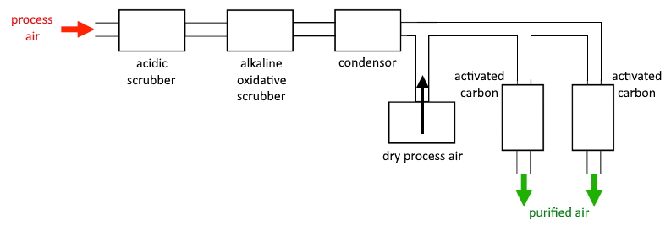

Figure 1: Diagram of air treatment installation at the feather processing company

Despite the presence of this air treatment installation, the feather processing company periodically receives odour complaints from neighbouring companies and residential houses. Investigating the effectiveness of the air treatment installation and possible odorous breakthroughs is key to better understand and finetune the installation. This study aims at analysing the efficiency of the installation by testing several activated carbon set-ups within different stages of the treatment. Weekly TD-GC-MS analyses were executed on the in- and outgoing flow of each set-up. To objectify the adsorption capacity of activated carbon, a new technique involving pH measurements was tested. Results of this research contribute to better understand which air treatment techniques are best suited for specific odorous process flows and which can be economically most interesting. By testing follow-up techniques, effective strategies can be formulated in avoiding odorous breakthroughs and thus odour impact on the surrounding environment.

* 1. Materials and methods
     1. Active carbon set-ups

A total of four active carbon set-ups were mounted in the phases of the air treatment installation (Figure 2). Carbon filter 1 (AC 1) and 2 (AC 2) were installed before and after the alkaline oxidative scrubber. Both filters were consecutively equipped with non-impregnated and impregnated carbon. Carbon filter 3 (AC 3) and 4 (AC 4) were installed after the condenser and acted as surrogates for the full scale active carbon filters in the air treatment installation. The coal type for these filters was non-impregnated, as this is also the coal type of the full scale filters. The difference between AC 3 and AC 4 is the different process air to dry air ratio (1/1 for AC 3 and 2/1 for AC 4), in order to test the effect of relative humidity on the adsorption capacity of activated carbon.

Tubing and dimensions of the activated carbon set-ups were chosen to mimic the total flow rate of the process air (35,000 m³/h), and the active carbon volume of the full scale filters (27 m³ per filter), whilst respecting a process air residence time for the set-ups that is four times lower than that of the full scale filters (calculated at 2.78 s). Taking these factors into account, 40 mm PVC tubing needed to be fitted to attain a flow rate of 37,5 m³/h per carbon set-up. The carbon set-ups needed to have 7.29 l of active carbon, which was mounted in a PVC column with an inner diameter of 185 mm and a height of 270 mm.

The experiment with non-impregnated coal (AC 1 – AC 4) went on from 12/03/2021 till 30/04/2021. The experiment with impregnated coal (AC 1 and AC 2) went on from 06/05/2021 till 02/06/2021. The air temperature during both experimental periods was on average respectively 13,8 °C and 17,8 °C, while the emission temperature of the process air was on average 40 °C. It is therefore safe to assume that the difference of 4 °C in air temperature between the two experimental periods will have had a negligible effect on the emission results.

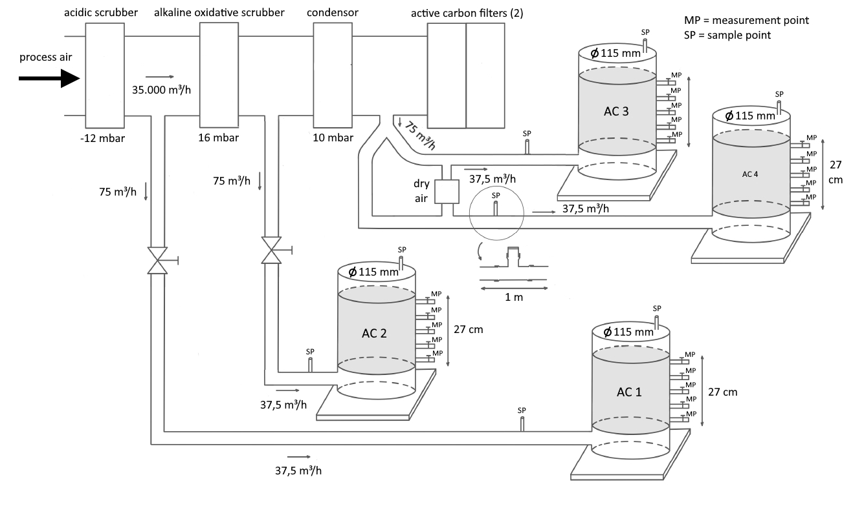

Figure 2: Active carbon set-ups within the stages of the air treatment installation

* + 1. Chemical analysis

On a weekly basis, an air sample was taken before and after each active carbon set-up (Figure 2 – sample points (SP)). To collect the air sample, a Nalophane sampling bag was mounted into an airtight receptacle (barrel), filling the bag with air by creating an under pressure in the receptacle according to the lung principle (Guillot, 2012). In the OLFASCAN laboratory, the air samples were transferred onto a Carbon Graphitised sorbent tube. The sorbent tubes were then analysed directly with the TD-GC-MS (Markes TD100, Shimadzu GC 2010-plus and Shimadzu MS GP2010 SE), to identify and quantify concentrations of volatile organic compounds (VOC).

Aside from the volatile compound screening, H2S- and SO2-concentrations were also registered weekly at the in- and outgoing flow of each carbon set-up via GASTEC detector tubes.

* + 1. pH measurements

pH measurements were tested as an alternative method to chemical analysis to monitor the active carbon lifetime, by analysing the acidity through the active carbon. Throughout the active carbon set-ups, carbon samples were taken (Figure 2 – measurement points (MP)). A total of 10 grams of active carbon was taken from the samples and mixed with 100 ml demineralised water at room temperature. The pH of the mixture was measured with a WTW pH/Cond 3320 multimeter and a SenTix 41 pH-electrode.

* 1. Results and discussion
     1. Active carbon screening via chemical analysis

The VOC- and H2S/SO2-concentrations from the in- and outgoing flow from each carbon set-up were determined to calculate the respective removal efficiency. Results are visualised for the carbon set-ups with non-impregnated coal (Figure 3), and impregnated coal (Figure 4).

Results with non-impregnated coal indicate that the VOC removal efficiency of AC 1 diminishes at a higher rate than of AC 2, resulting in a VOC-removal efficiency for AC 1 of 47 % versus 61 % for AC 2 after 7 weeks (Figure 3). When compared to the H2S/SO2 removal efficiency, AC 1 shows reduced efficiency after 4 weeks, to level off at an efficiency of 47 % after 7 weeks. The H2S/SO2 removal efficiency of AC 2 is 100 % for around 5 weeks, and drops to an efficiency of 96 % after 7 weeks. An explanation can be found in the position of both carbon set-ups. AC 1 treats process air after passing the slightly acidic scrubber, which mainly reduces ammonia-concentrations (Ashtari et al., 2016), while AC 2 treats process air after also passing the alkaline oxidative scubber, which reduces H2S- and SO2-concentrations (McInnes et al., 1990). As a result, the H2S- and SO2-load for AC 2 is about 12 times lower than for AC 1, explaining (i) the high H2S/SO2 removal efficiency of AC 2, and (ii) the higher VOC-removal efficiency of AC 2 over AC 1. AC 2 can absorb more units VOC on the same coal volume as AC 1, which saturates faster due to the higher H2S- and SO2-concentrations. For this type of process air, the experiment highlighted the need for an effective H2S/SO2 removal technique to allow for a higher VOC removal from a consecutive active carbon filter.

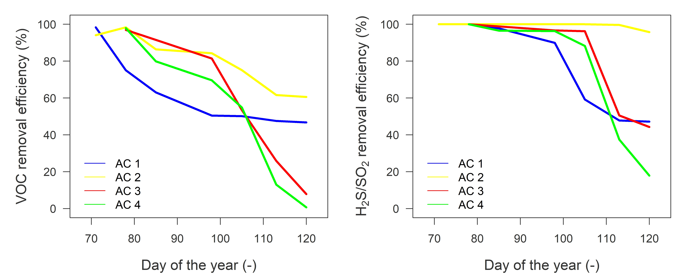

Figure 3: VOC and H2S/SO2 removal efficiency of the active carbon set-ups with non-impregnated coal

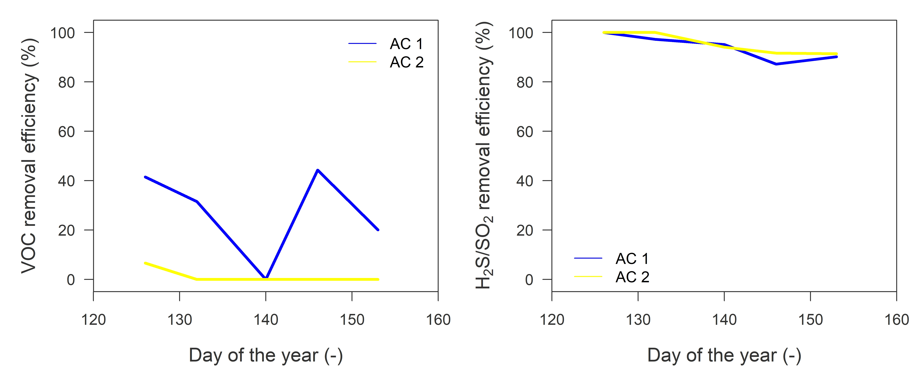

Figure 4: VOC and H2S/SO2 removal efficiency of the active carbon set-ups with impregnated coal

Results with non-impregnated coal also highlight the reduced VOC-removal efficiency of AC 3 and AC 4 over AC 2 (Figure 3). A sharp decline in VOC removal efficiency is visible for AC 3 and AC 4 after 4 weeks, which coincides with a steep drop in H2S/SO2 removal efficiency of AC 3 and AC 4. At the end of the 7 week experiment period, VOC removal efficiency of AC 3 was reduced to 8 %, and 1 % for AC 4. An explanation here can be found in the addition of dry air to the ingoing flow of AC 3 and AC 4. The idea was to mimic the effect of adding the same dry air to the ingoing flow of the full scale carbon filters (Figure 1), as a means to lower the relative humidity of the air for the carbon set-ups. Active carbon filters operate best under relative humidity’s below 65 % (Gong and Keener, 1993). However, the relative humidity of the added ‘dry air’ was equal to 95,6 %, resulting in a total humidity of 96,7 %. The added dry air was also taken from the hydrolysis process, meaning that the air was rich in VOC, H2S and SO2, adding an increased VOC-, H2S- and SO2-load to the process air coming from the alkaline oxidative scrubber. Adding this type of dry air did not reduce the relative humidity and increased the VOC-load, resulting in a faster breakthrough of the active carbon filter set-ups. This result was immediately communicated to the feather processing company to close off the added dry air flow to the carbon filters. To determine whether the addition of dry air can be beneficial for the lifetime of these carbon filters, a non-diluted dry air experiment with a relative humidity lower than 60 % should be executed.

Results with impregnated coal showcase that the VOC-removal efficiency of AC 2 decreases to zero after 1 week, while the removal efficiency of AC 1 fluctuates around 20 % (Figure 4). This result was expected as impregnated coal is insufficient in the removal of volatile organic compounds (datasheet coal manufacturer). Both coals were impregnated to sufficiently capture H2S- and SO2-concentrations, with an overall efficiency of respectively 90 % and 92 % for AC 1 and AC 2 after 6 weeks (Figure 4). However, the ingoing H2S- and SO2-load for AC 1 is 8 times higher than of AC 2 as AC 1 was installed before the alkaline oxidative scrubber and AC 2 behind it. This showcases that non-impregnated coal is as effective in reducing H2S- and SO2-concentrations as an alkaline oxidative scrubber. Conducting a basic cost comparison of two impregnated active carbon filters (cost € 50,000 according to coal manufacturer) versus one alkaline oxidative scrubber (€ 3,125/production week according to feather processing company) delivered the following result (Eq 1):

|  |  |
| --- | --- |
| $${WC}_{AC}= \left(\left({\left(\frac{{TC}_{AC}}{{WC}_{S}}\right)}/{L_{full to pilot}}\right).L_{pilot exp}^{-1}\right).{TC}_{S}= \left(\left({\left(\frac{50,000}{3,125}\right)}/4\right).6^{-1}\right).3,125=2,083$$ | (1) |

With WCAC weekly production cost active carbon, TCAC total cost active carbon, WCS weekly production cost alkaline oxidative scrubber, Lfull to pilot lifetime ratio of full scale active carbon over pilot test (ratio of 4) and Lpilot exp lifetime of active carbon pilot test according to experiment results (6 weeks). According to the cost comparison, the weekly cost is decreased with € 1,042 by replacing the scrubber with two impregnated carbon filters.

* + 1. Active carbon screening via pH measurements

The adsorption effectiveness of the carbon set-ups (non-impregnated and impregnated) was monitored via weekly-based pH-measurements to determine if acidification of the coal can be representative for the lifetime of the coal (Figure 5).

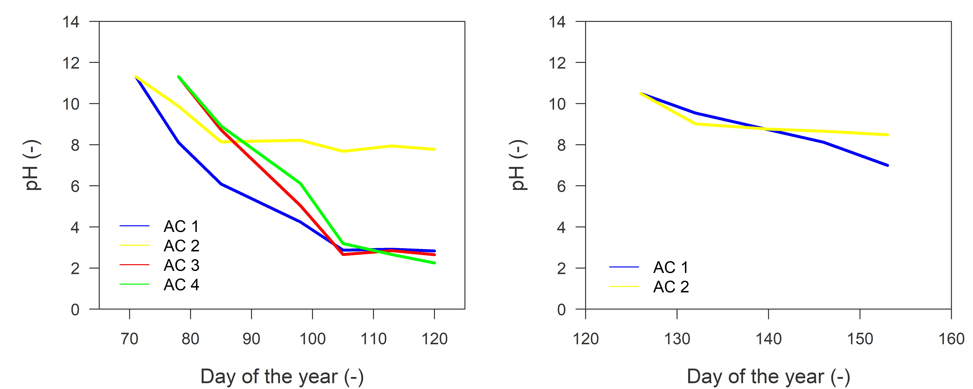

Figure 5: pH measurements on coal of the non-impregnated and impregnated carbon set-ups

Results indicate a significant trend in acidification of the non-impregnated coal of AC 1, AC 3 and AC 4. After 4 weeks, pH decreased to a value of 3 and remained stable afterwards. This result coincides with the distinct decrease in H2S/SO2 removal efficiency after 4 weeks for these three carbon set-ups (Figure 3). pH of AC 2 also dropped over 4 weeks, but levelled-off at a value of 7 (neutral), thus showing a less distinctive pattern. An explanation can be found in the position of the carbon set-ups. The H2S- and SO2- load of AC 2 is much lower due to the presence of the alkaline oxidative scrubber. AC 1 is installed before this scrubber and AC 3 and AC 4 get an increased H2S- and SO2- load from the addition of the dry process air. Consequently, pH-measurements can only be representative for the lifetime of the coal if the ingoing flow contains sufficient amounts of acidic components (such as H2S and SO2, which in case of moist airflows can create H2SO4).

Impregnated coal also showcases a reduced decrease in pH, stabilising around the neutral value of 7 (Figure 5). This is because the impregnated coal was specifically chosen to adsorb the acidic components H2S and SO2, resulting in less acidification when demineralised water was used to desorb the components. The pH-results thus conform the enormous capacity of impregnated coal to capture acidic components.

* 1. Conclusion

Using different set-ups of non-impregnated and impregnated active carbon filters, the effectiveness and follow-up strategy of an air treatment installation of a feather processing company was examined. Removal efficiency and absorption rate of the coal was examined through time via chemical screening and pH measurements. Results indicated that a high and prolonged VOC-removal efficiency by non-impregnated active carbon can be accomplished in feather process air if acidic components like H2S and SO2 are prior removed. The experiment highlighted that impregnated carbon serves as an effective H2S and SO2 removal technique, and that it is financially more interesting than a alkaline oxidative scrubber. VOC-removal efficiency of non-impregnated carbon filters for moist feather process air might additionally be increased by supplying non-diluted dry air, though this needs to be experimentally confirmed. Lastly, pH measurements can serve as an interesting and fast screening tool to follow up on the adsorption capacity of the coal if the ingoing flow is sufficiently saturated with acidic components.

References

Ashtari A.K., Majd A.M.S., Riskowski G.L., Mukthar S., Zhao L., 2016, Removing ammonia from air with a constant pH, slightly acidic water spray wet scrubber using recycled scrubbing solution, Frontiers of Environmental Science & Engineering, 10(6), 3.

El-Boushy A.R., Van der Poel A.F.B., walraven O.E.D., 1990, Fetaher meal – A biological watse: Its processing and utilization as a feedstuff for poultry, Biological Wastes, 32(1), 39–74.

Goerner-HU X., Scott E.L., Seeger T., Schneider O., Bitter J.H., 2020, Reaction stages of feather hydrolysis: Factors that influence availability for enzymatic hydrolysis and cystine conservation during thermal pressure hydrolysis, Biotechnology and Bioprocess Engineering, 25(5), 749–757.

Gong R., Keener T. C., 1993, A qualitative analysis of the effects of water vapor on multicomponent vapor-phase carbon adsorption, Air & Waste, 43(6), 864–872.

Guillot J.M., 2012, Odour measurement: Focus on main remaining limits due to sampling, Chemical Engineering Transactions, 30, 295–300.

Hertrampf J.W., Felicitas P., 2000, Handbook on ingredients for aquaculture feeds. 1, Springer Science, Dordrecht.

McInnes R., Jameson K., Austin D., 1990, Scrubbing toxic inorganics, Chemical Engineering, 116–121.

OLFASCAN, 2017, Rapport aan het pluimen verwerkend bedrijf, Ghent, Belgium.

Prasanthi N., Bhargavi S., Machiraju P.V.S., Chicken Feather waste – A threat to the environment, International Journal of Innovative Research in Science, Engineering and Technology, 5(9), 16759–16764.

Shavandi A., Silva T.H., Bekhit A.A., Bekhit A., et al., 2017, Keratin: Dissolution, extraction and biomedical application, Biomaterials Science 5(9), 1699–1735.

Tesfaye T., Sithole B., Ramjugernath D., 2017, Valorisation of chicken feathers: a review on recycling and recovery route – current status and future prospects, Clean Technologies and Environmental Policy, 19(10), 2363–2378.

Van der Poel A.F.B., El-Boushy A.R., 1990, Processing methods for feather meal and aspects of quality, Netherlands Journal of Agricultural Science, 38(4), 681–695.