 CHEMICAL ENGINEERING TRANSACTIONS  VOL. 95, 2022 | A publication of  
The Italian Association
of Chemical Engineering
Online at www.cetjournal.it

Guest Editors: Selena Sironi, Laura Capelli
Copyright © 2022, AIDIC Servizi S.r.l.
ISBN 978-88-95608-94-5; ISSN 2283-9216

Comparison of two Analytical Systems for Continuous Monitoring of ppb to ppm-levels of Formaldehyde in Air
Audrey Grandjean^{a,b,*}, Damien Bazinª, Franck Amietª, Stéphane Le Calvé^{b}
ªChromatotec, 15 Rue d’Artiguelongue, Saint-Antoine, France
^{b}ICPEES – CNRS/University of Strasbourg, 25 rue Becquerel, Strasbourg, France
*audrey.grandjean@chromatotec.com
Accurate and continuous monitoring of indoor air quality is crucial to understand and prevent airborne diseases, since humans spend most of their routine time indoors. Aldehydes are of particular interest as they are irritants and usually present in indoor air at concentrations from 2 to 10 times higher than in outdoor air. Formaldehyde, the most abundant one, is classified as carcinogenic category 1B under European Regulation (EC) No 1272/2008. In indoor air, aldehydes mainly originate from construction materials such as plywood, insulating materials and paints. Some aldehydes have a pungent and fruity odour at high concentrations but may be undetected at low concentration. To be able to implement preventive measures, there is a need for continuous, fast, accurate and robust techniques for quantification of aldehydes in indoor air.
In this work, two different systems which have been developed for monitoring of formaldehyde and other aldehydes are presented: a portable microdevice based on the derivatization of formaldehyde for continuous fluorometric detection, and an Automatic Gas 2D-chromatograph equipped with a thermodesorption unit and flame ionization detector (auto-TD-GC-FID). These techniques were compared under laboratory-controlled measurements. The portable microdevice specifically quantifies formaldehyde down to ppb levels. It is compact and uses a specific aqueous reagent to convert formaldehyde into a fluorescent product, 100 mL enabling a continuous monitoring for 4 days. The auto-TD-GC-FID is an automatic gas chromatograph permitting formaldehyde and acetaldehyde quantification from ppb to ppm levels. It runs continuously with successive 15-min cycles. This instrument only requires a power supply and gas generators or gas cylinders of hydrogen, air, and nitrogen. Our experimental results demonstrate that both analytical devices quantify formaldehyde accurately.
  - Introduction
Since humans spend most of their time indoors, the quality of the air we breathe has a considerable impact on our health condition. Formaldehyde is a major pollutant in indoor air (Salthammer et al., 2010). Because of its high solubility and reactivity, it can cause severe damage to the respiratory tracks when inhaled, trigger allergic skin reactions, and irritate the mucosal surface of the eyes. Its implication in allergenic diseases in children has been reported before (Yu et al., 2020) and the International Agency for Research on Cancer (IARC) classified it as carcinogenic in 2004. It is also present outdoors and has been described as one of the most relevant carcinogens in the environment (Lui et al., 2017). Nevertheless, since it is used in many industrial processes, building materials and household products are notable sources of formaldehyde indoors. Particleboard, plywood, glues, adhesives, paper product coatings and some insulation materials have been identified as emissive materials (Salthammer, 2019).
Because of its acute toxicity, regulations have been established. In France, an exposure limit of
30 μg m⁻³ for chronic exposure and 100 µg m⁻³ for acute exposure of 1 to 4 hours is recommended. These limits are easily exceeded. In Europe, occupational exposure threshold values are fixed higher: 370 µg m⁻³ for chronic exposure (8 h) and 740 µg m⁻³ for acute exposure (15 min) according to the (EU) Directive 2019/983.
In the last decades, numerous techniques have been developed to determine airborne formaldehyde concentration (Dugheri et al., 2021b). Table 1 summarizes a few techniques that are being used for this purpose. The reference method (ISO 16000-3) consists of air sampling through a DNPH tube and subsequent analysis by HPLC-UV after solvent elution. This off-line technique is accurate and very sensitive but is time-consuming and requires bulky, expensive equipment and a trained operator. Alternative methods oriented towards near real-time detection include acetylacetone/fluorescence techniques, PTR-MS, and auto-TD-GC-FID. Portability is also a key point for in-field monitoring: techniques involving chromotropic acid/colorimetry or acetylacetone/fluorescence make it possible. Besides, interferences may hinder analysis. O₃ and NOx interfere with the DNPH method, H₂O with PTR-MS, other carbonyl species with FT-IR, and phenol/alcohols/aromatic hydrocarbons with chromotropic acid/colorimetry. Hence, there is still room for improvement to develop an accurate, autonomous, and interference-free instrument.
The objective of this study was to compare the performances of an auto-TD-GC-FID, used for continuous monitoring of formaldehyde and not yet described in the literature, with those of a portable microfluidic analyser already described and validated by Trocquet et al. (2019). For this purpose, two types of standard gas generators were used under laboratory-controlled conditions, i.e., two permeation systems operating either with paraformaldehyde or an aqueous formaldehyde solution.
Table 1: Existing techniques for the analysis of airborne formaldehyde (non-exhaustive list)
Analytical System | Method | On-line or Off-line | Temporal resolution | Concentration  (in µg m⁻³) | Reference
 | DNPH tube + HPLC/UV | off-line | Hours/days | 0.6–15,000 | (ISO 16000-3, 2011)
 | GC-MS | off-line | - | 0.02–15,000 | (Bono et al., 2010)
 | PTR/MS | on-line | 36 s | 0.6–1,230 | (Inomata et al., 2008)
 | Chromotropic acid + colorimetry | on-line | 7 min | 2.5–430 | (Pretto et al., 2000)
 | Infrared spectrometry | on-line | 10 s | 1.2–12,300 | (Dugheri et al., 2021a)
Aerolaser AL4021 | Acetylacetone + fluorescence |  | 1.5 min | 0.19–3,690 | (Hak et al., 2005)
microF | Annular flow + acetylacetone + fluorescence | on-line | 1 s | 1.2–400 | (Trocquet et al., 2019; this work)
airmoHCHO | auto-TD-GC-FID | on-line | 15 min | 1.2-12,300 | This work
  - Set-ups and experimental conditions
The devices and the experimental conditions are described below.
    - Overall setup for the detection of gaseous formaldehyde at various concentrations
The setup used for the simultaneous quantification of gaseous formaldehyde by the two analysers is represented in Figure 1.
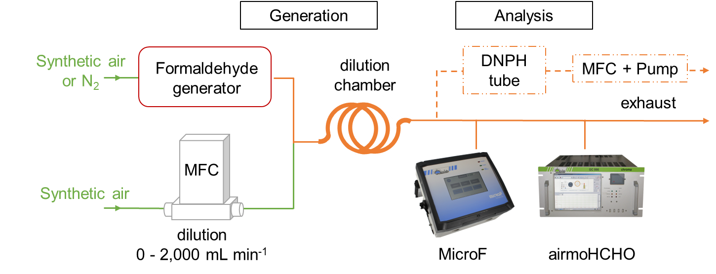
Figure 1: Schematic representation of the gaseous formaldehyde generation coupled to the simultaneous analysis by different analytical tools at various concentrations of formaldehyde. MFC: Mass Flow Controller

A stream of synthetic air or N₂ was injected into a formaldehyde generator (detailed in section 2.2) to generate a constant concentration of gaseous formaldehyde. This gas mixture was then diluted by another gas stream of synthetic air, its flow rate being adjusted to vary the final gaseous formaldehyde concentration. The initial concentration was diluted up to 28 times to achieve values in the range of indoor air exposition, i.e., from 116 to 5 µg m⁻³ or 83 to 4 µg m⁻³ depending on the generator. A long tubing ensured an efficient homogenization of the gas mixture prior analysis. Then, a microfluidic formaldehyde analyser (microF, Chromatotec, Val-de-Virvée, France) and an auto-TD-GC-FID (airmoHCHO, Chromatotec, Val-de-Virvée, France) monitored the resulting gaseous formaldehyde concentration. The analysis at various concentrations were conducted in the daytime. Generated gaseous formaldehyde levels were quantified by means of the reference method ISO 16000-3, based on active sampling with DNPH tubes followed by HPLC-UV analysis. During the night, sampling was carried out on DNPH tube (LpDNPH S10L Cartridge 1mL, Rev., 350mg SPE Tube 505361-U, Sigma-aldrich, Saint-Louis, Missouri, United States) for gaseous sample volumes in the range of 30–80 L (dashed path on Figure 1).
    - Gaseous Formaldehyde generators
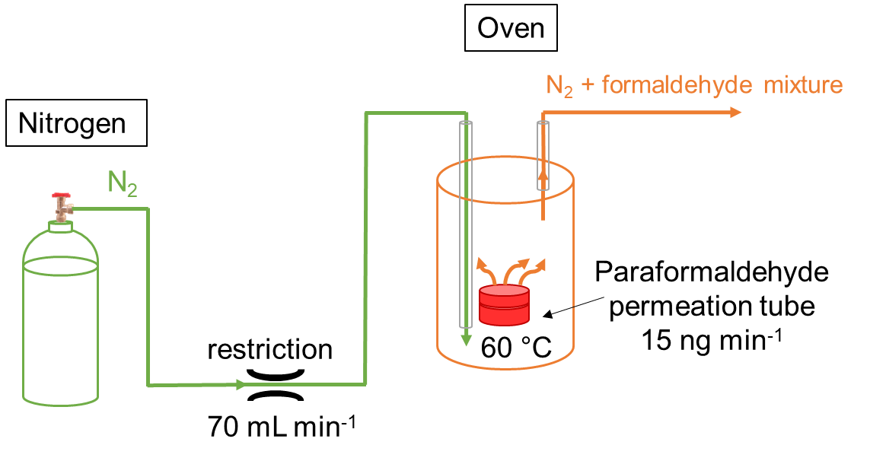 | 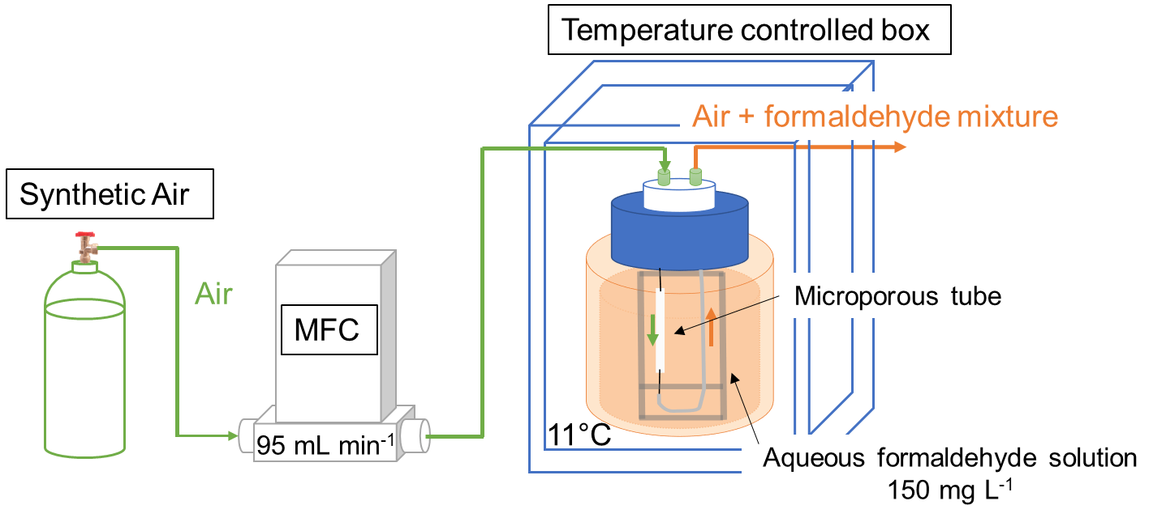
(a) | (b)
Figure 2: Gas formaldehyde generators operating with a permeation system using: (a) paraformaldehyde; (b) an aqueous formaldehyde solution.
Two different gas generators of formaldehyde were used for the experiments:
- A paraformaldehyde permeation tube (Figure 2a) which is heated at 60°C and supplied by a constant flow of nitrogen gas. When heated, the permeation tube emits formaldehyde at a very stable rate. This system is integrated in the airmoHCHO instrument and is initially used for automatic internal calibration. At 70 mL min⁻¹ and 60 °C, the low emission tube generated formaldehyde at a constant concentration of 153
µg m⁻³, determined using the DNPH derivatization method, and with a relative humidity of 1,2 %.
- A permeation system using an aqueous formaldehyde solution (Figure 2b) which was recently developed by Becker et al. ( 2022). It consists of a hydrophobic microporous tube immersed into an aqueous formaldehyde solution. A stream of synthetic air flows inside the microporous tube and sweeps away the vapor of formaldehyde formed at the vicinity of the liquid through the pores. The whole system is regulated in temperature. The flow rate was set at 95 mL min⁻¹, the temperature at 11 °C and the concentration of the formaldehyde solution at 150 mg L⁻¹. In the conditions used, it generated 83 µg m⁻³ of formaldehyde (again measured with the DNPH method) at a relative humidity of approximately 39%.
    - On-line formaldehyde analysers
The principle of the microfluidic formaldehyde analyser is represented in figure 3a. This device is based on the continuous detection of 3,5-diacetyl-1,4-dihydrolutidine (DDL), a product of the reaction of formaldehyde with fluoral-P (or acetylacetone solution) (Guglielmino et al., 2017). The steps of the analysis are the following: First, air is pumped and co-injected with the aqueous solution of fluoral-P into a 530 µm ID capillary column. Due to the high solubility of formaldehyde and the wide exchange surface allowed by the annular flow, gaseous formaldehyde is trapped into the aqueous solution. The gas/liquid mixture then crosses a microporous tube which permits the release of the gas phase. The liquid reagent and formaldehyde mixture enter an oven set at 65°C for about 3.5 min. The reaction between the two compounds occurs to form DDL, a fluorescent molecule. Finally, DDL fluorescence is excited at 415 nm by a LED, and the emitted photons are collected at 530 nm and amplified by a photomultiplier (Trocquet et al., 2019).
Figure 3b illustrates the steps of an analysis by the auto-TD-GC-FID system. During a 15 min cycle, the air sample is pumped through a 3-adsorption phase trap specific for low molecular weight compounds, before being thermodesorbed and injected into a metallic capillary column for separation and detection. Heavy VOCs are retained in a precolumn before being backflushed while lighter VOCs are separated in the 30 meters column. At this point, the separated pollutants reach a methaniser where they are reduced into methane. All the converted compounds are ultimately detected by an FID.
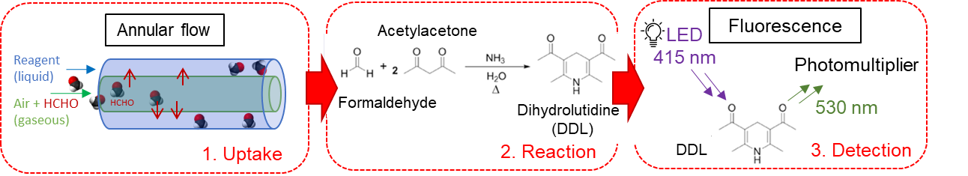
(a)
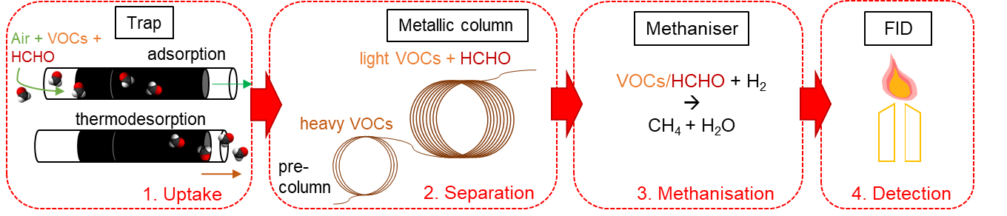
(b)
Figure 3: Simplified schemes of the formaldehyde analysers (a) microF (b) airmoHCHO (auto-TD-GC-FID).
VOC: Volatile Organic Compound. FID: Flame Ionisation Detector
  - Results
    - Typical signals
In the case of microF (Figure 4a), each analysis started with a rinsing step and blank measurement. Formaldehyde concentration in air is proportional to the fluorescence signal once the blank signal is subtracted.
The resulting signal of the airmoHCHO is a chromatogram. Figure 4b shows an example of formaldehyde analysis obtained with the permeation system using an aqueous formaldehyde solution stabilized with methanol. In the order of elution, the peaks correspond to formaldehyde in the first few seconds, followed by methanol at about 210 seconds. Other light VOCs can be detected such as propane and acetaldehyde. In the current study, when using the permeation oven source, formaldehyde was the only compound detected. When using the permeation system with the aqueous formaldehyde solution, as in Figure 4b, both formaldehyde and methanol were detected.
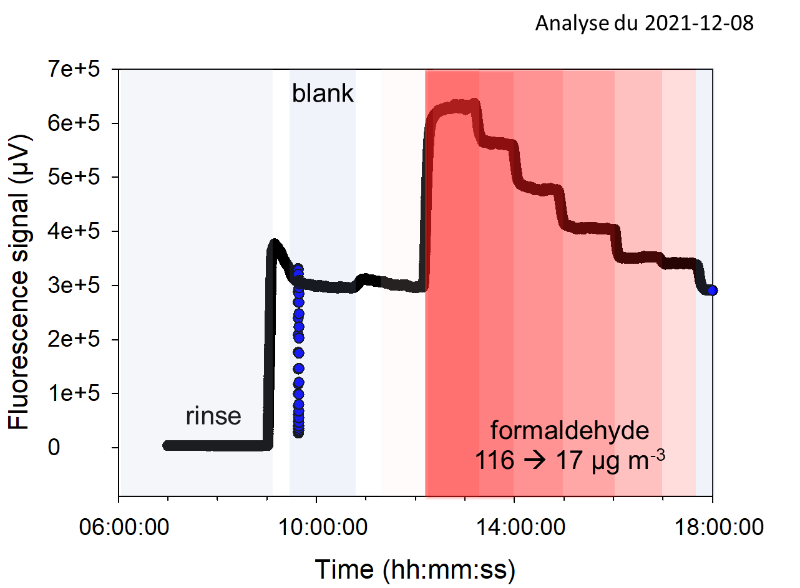 | 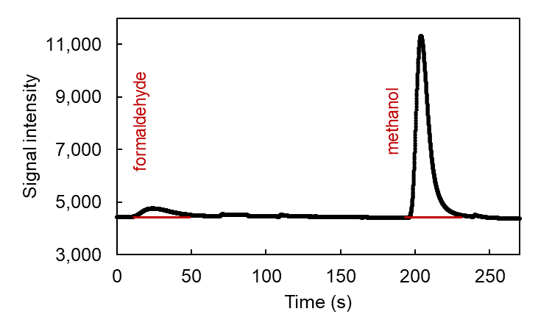
(a) | (b)
Figure 4: Raw signals obtained from the two analysers (a) microF signal for formaldehyde at concentrations varying from 116 to 17 µg m⁻³ (b) airmoHCHO chromatogram for a formaldehyde concentration of 83 µg m⁻³
    - Calibration curves
Figure 5a and 5b shows the calibration curves obtained for both analysers using the paraformaldehyde permeation tube for concentration varying from 5 µg m⁻³ to 116 µg m⁻³. These experimental results show that there was a perfect correlation between the peak area or the fluorescence intensity and the generated gaseous formaldehyde concentration which have been verified with the ISO 16000-3 DNPH method.
In the case of the permeation system using an aqueous formaldehyde solution (Figure 5c and 5d) concentrations varied from 4 to 83 µg m⁻³. Signals of both instruments were also correlated with the gaseous formaldehyde concentration. For MicroF, fluorescence increases linearly with the formaldehyde concentration in the gas phase while some disturbances were observed for airmoHCHO. The measurements were made in decreasing concentration by progressive dilution with dry air, which gradually lowered the relative humidity from 39 to 6%. However, inside the airmoHCHO preconcentrator trap, there is a possible adsorption competition between the formaldehyde and water molecules. We can assume that some of the adsorbed water does not desorb and disrupts the next analytical run, considering the high formaldehyde solubility in water.
 | MicroF | AirmoHCHO
Paraformaldehyde | 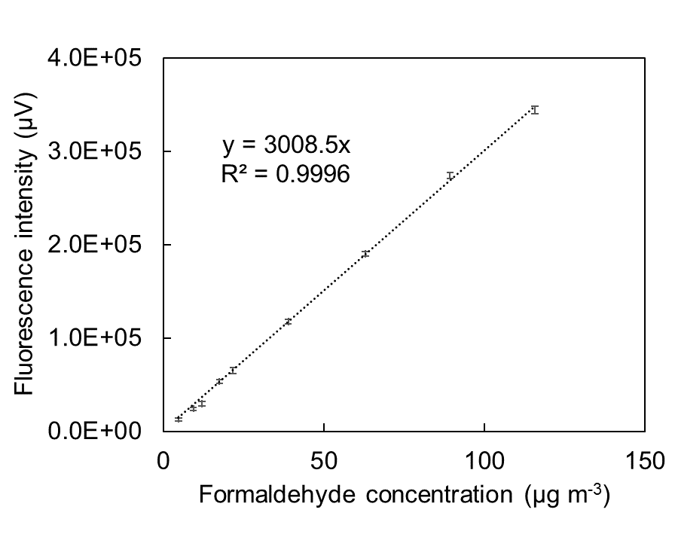 | 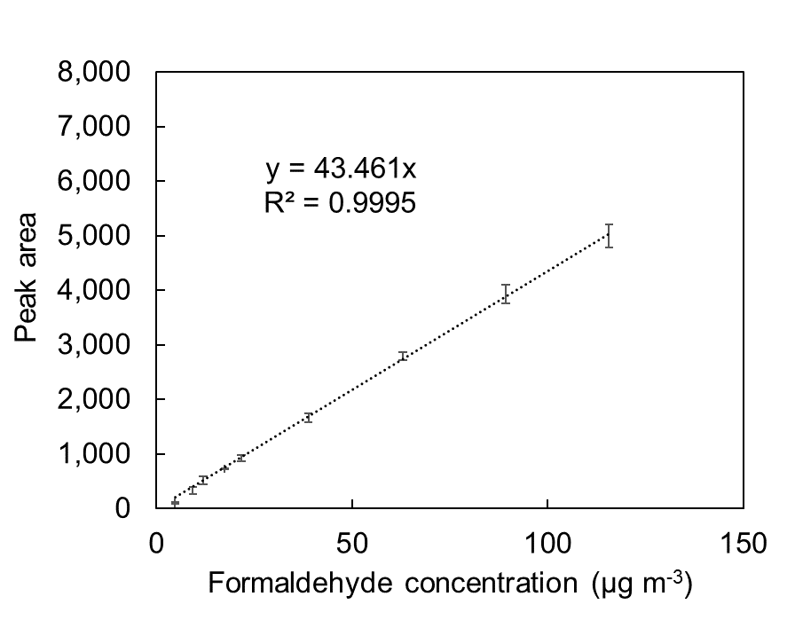
 | (a) | (b)
Aqueous formaldehyde solution | 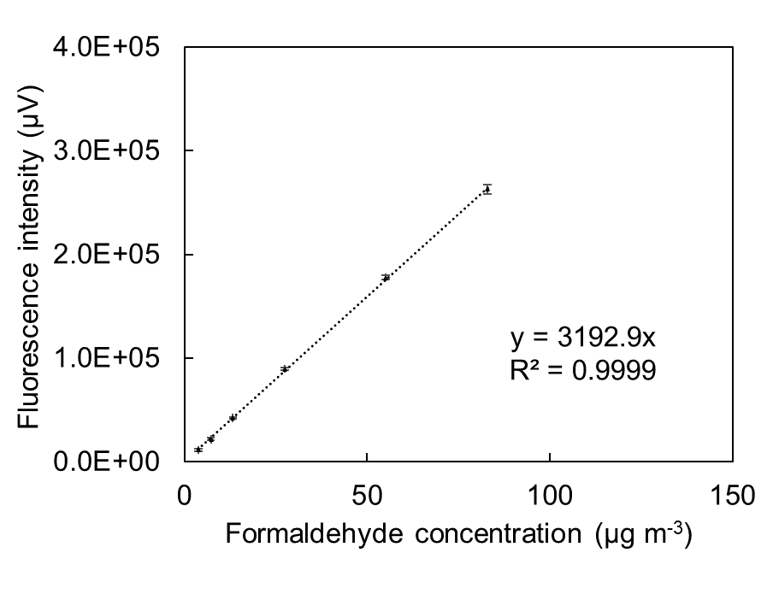 | 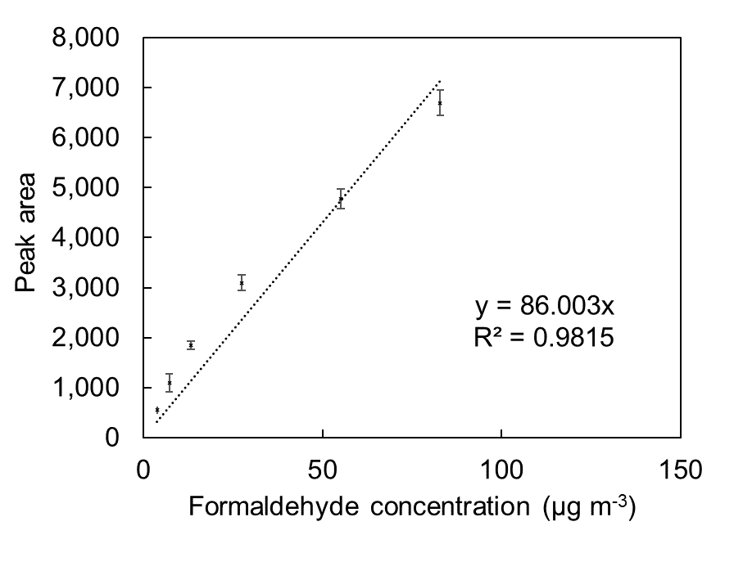
 | (c) | (d)
Figure 5: Linear regression of the obtained signals (peak area for the airmoHCHO and signal intensity for the microF) as a function of the formaldehyde concentration generated using paraformaldehyde or the aqueous formaldehyde solution permeation system. The vertical quoted errors correspond to the standard deviation on the corresponding analyser.
    - Comparison between the two gas generators and the two formaldehyde analysers
Figure 6a represents the calibration curves plotted for both types of gaseous formaldehyde generators. It shows the consistency of microF response regardless of the type of gas generator. Figure 6b is derived from the results obtained with the paraformaldehyde permeation tube dilutions. In the typical range of indoor air exposition values, there is an excellent correlation between the two instruments, as displayed in Figure 6b.
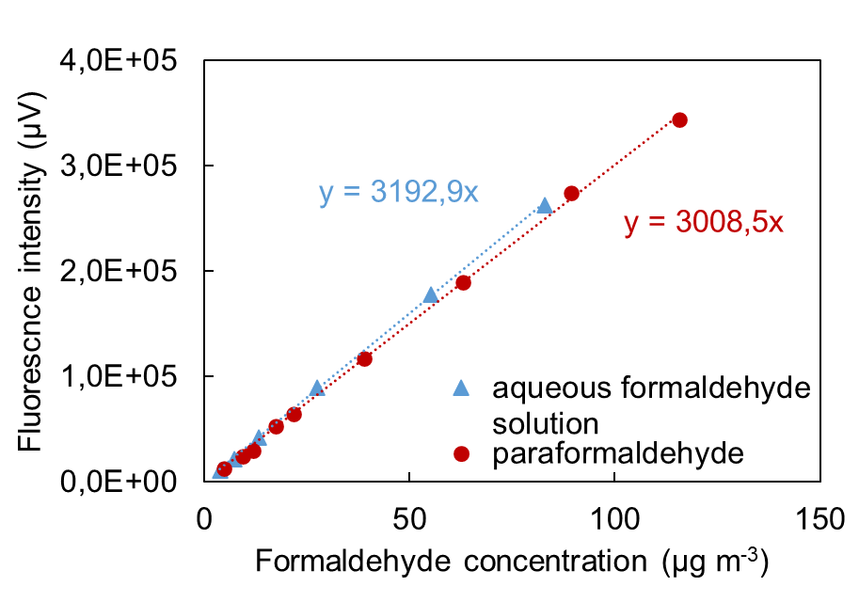 | 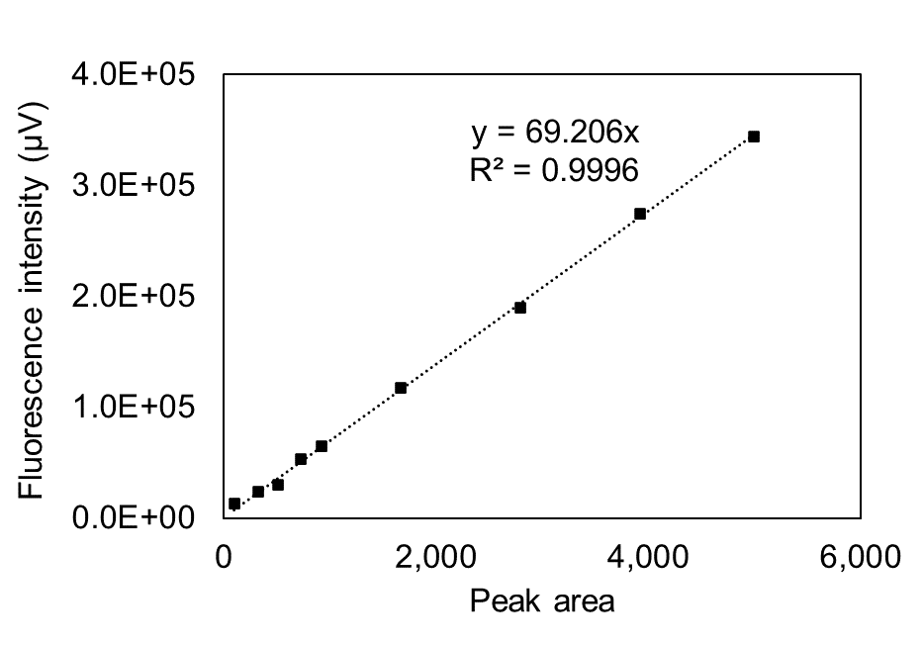
(a) | (b)
Figure 6: (a) MicroF intensity for various formaldehyde concentrations generated by the paraformaldehyde and the aqueous formaldehyde permeation systems (b) MicroF signal vs. AirmoHCHO response for the paraformaldehyde permeation tube
  - Conclusion and perspectives
As expected, both analysers respond linearly to different concentration of formaldehyde from each gaseous formaldehyde generator. The microF has a shorter temporal resolution (few seconds) compared to the airmoHCHO which runs cycles every 15 minutes. The auto-TD-GC-FID is more suitable to industrial environment or outdoor environment since it runs autonomously and requires continuous supply of hydrogen, nitrogen, and air. Furthermore, its detection range covers typical indoor levels of formaldehyde to very high concentration (up to 12,300 µg m⁻³). On the other hand, microF is a portable device designed for temporary monitoring of formaldehyde in schools, homes, or working environments. It has a detection range from 1.2 to 400 µg m⁻³ and an operator is required to change consumables at least every 3-4 days.
During our experiments, we noticed that the sharp changes in humidity when diluting moist formaldehyde with a dry gas might have affected the airmoHCHO performances. Humidity is usually overlooked by users and manufacturers of instruments but its impact on formaldehyde analysis is worth being investigated further.
Acknowledgments
This study was supported by the CIFRE programme between SME Chromatotec (Val-de-Virvée, France) and the French National Association of Research and Technology (ANRT, grant number 2020/0977).
References
Directive (EU) 2019/983 of the European Parliament and of the Council of 5 June 2019 amending Directive 2004/37/EC on the protection of workers from the risks related to exposure of carcinogens or mutagens at work, Available at <eur-lex.europa.eu/legal-content/N/TXT/?uri=uriserv:OJ.L_.2019.164.01.0023.01.ENG>
Becker A., Lohmann N., Serra C.A., Le Calvé, S., 2022, Development of a Portable and Modular Gas Generator: Application to Formaldehyde Analysis. Chemosensors, 10, 131.
Bono R., Degan R., Pazzi M., Romanazzi V., Rovere, R., 2010, Benzene and formaldehyde in air of two winter Olympic venues of “Torino 2006.”, Environment International, 36, 269–275.
Dugheri S., Massi D., Mucci N., Berti N., Cappelli G., Arcangeli, G., 2021a, Formalin safety in anatomic pathology workflow and integrated air monitoring systems for the formaldehyde occupational exposure assessment, International Journal of Occupational Medicine and Environmental Health, 34, 319–338.
Dugheri S., Massi D., Mucci N., Marrubini G., Cappelli G., Speltini A., Bonferoni M.C., Arcangeli G., 2021b) Exposure to airborne formaldehyde: Sampling and analytical methods—A review, Trends in Environmental Analytical Chemistry, 29, e00116.
Guglielmino M., Allouch A., Serra C.A., Calvé, S.L., 2017, Development of microfluidic analytical method for on-line gaseous Formaldehyde detection, Sensors and Actuators B: Chemical, 243, 963–970.
Hak, C., Pundt, I., Trick, S., Kern, C., Platt, U., Dommen, J., Ordóñez C., Prévôt A. S. H., Junkermann W., Astorga-Lloréns C., Larsen B.R., Mellqvist J., Strandberg A., Yu Y., Galle B., Kleffmann J., Lörzer J. C., Braathen G. O., Volkamer R., 2005, Intercomparison of four different in-situ techniques for ambient formaldehyde measurements in urban air, Atmospheric Chemistry and Physics, 5, 2881–2900.
Inomata S., Tanimoto H., Kameyama S., Tsunogai U., Irie H., Kanaya Y., Wang Z., 2008, Technical Note: Determination of formaldehyde mixing ratios in air with PTR-MS: laboratory experiments and field measurements, Atmospheric Chemistry and Physics, 8, 273–284.
International Agency for Research on Cancer, 2004, IARC Monographs on the Evaluation of Carcinogenic Risks to Humans - Formaldehyde, 2-Butoxyethanol and 1-tert-Butoxypropan-2-ol, Vol 88
Lui K.H., Ho S.S.H., Louie P.K.K., Chan C.S., Lee S.C., Hu D., Chan P.W., Lee J.C.W., Ho K.F., 2017, Seasonal behavior of carbonyls and source characterization of formaldehyde (HCHO) in ambient air, Atmospheric Environment, 152, 51–60.
Pretto A., Milani M.R., Cardoso A.A., 2000, Colorimetric determination of formaldehyde in air using a hanging drop of chromotropic acid, Journal of Environmental Monitoring, 2, 566–570.
Salthammer T., 2019, Formaldehyde sources, formaldehyde concentrations and air exchange rates in European housings, Building and Environment, 150, 219–232.
Salthammer T., Mentese S., Marutzky R., 2010, Formaldehyde in the Indoor Environment, Chemical Reviews, 110, 2536–2572.
Trocquet C., Bernhardt P., Guglielmino M., Malandain I., Liaud C., Englaro S., et Calvé S.L., 2019, Near Real-Time Monitoring of Formaldehyde in a Low-Energy School Building, Atmosphere, 10, 763.
Yu L., Wang B., Cheng M., Yang M., Gan S., Fan L., Wang G., Chen W., 2020, Association between indoor formaldehyde exposure and asthma: A systematic review and meta-analysis of observational studies, Indoor Air, 30, 682–690.

